Responsive web design

Quelle: [https://www.webfx.com/blog/web-design/what-is-responsive-web-design/#work](https://www.webfx.com/blog/web-design/what-is-responsive-web-design/%23work)

# What is responsive web design?

Responsive web design, also called RWD design, describes a modern web design approach that allows websites and pages to render (or display) on all devices and screen sizes, by automatically adapting to the screen, whether it’s a desktop, laptop, tablet or smartphone.

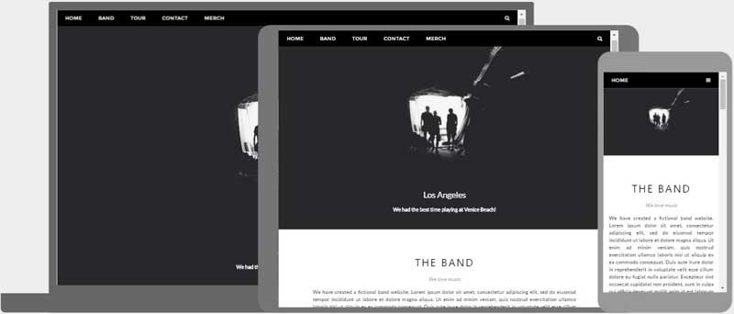

Ein Bild, das Text enthält.

# How does it work?

Responsive web design works through CSS, using various settings to serve different style properties depending on the screen size, orientation, resolution, color capability and other properties of the user’s device.

# Benefits of a responsive web site

One site for every device  
Whether viewed on a 27-inch iMac with a wireless connection or from the screen of your Android phone, the website will be configured for the user’s optimal viewing pleasure.

## Optimal design for the device

With the responsive web design approach, all images, fonts, and other HTML elements will be scaled appropriately, maximizing whatever screen size the user has.

## No need for redirects

Other options towards designing for multiple devices require the use of redirects to send the user to the appropriate version of a web page.