https://blog.csdn.net/u011182575/article/details/80821418
Navicat Premium 12连接MySQL数据库出现Authentication plugin 'caching_sha2_password' cannot be loaded的解决方案 ZJtoprs20181

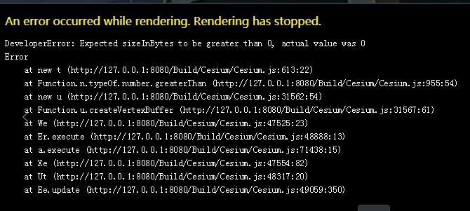
Cesium老版问题：
内存溢出了
创建顶点缓冲区失败了
加载的数据量太大了
显存还有限制，显存不会无限大

解决Cesium1.50对gltf2.0/3dtiles数据读取的问题
https://www.jianshu.com/p/e0e0a62c5726

跨域传参
https://www.jianshu.com/p/e558f4115c82
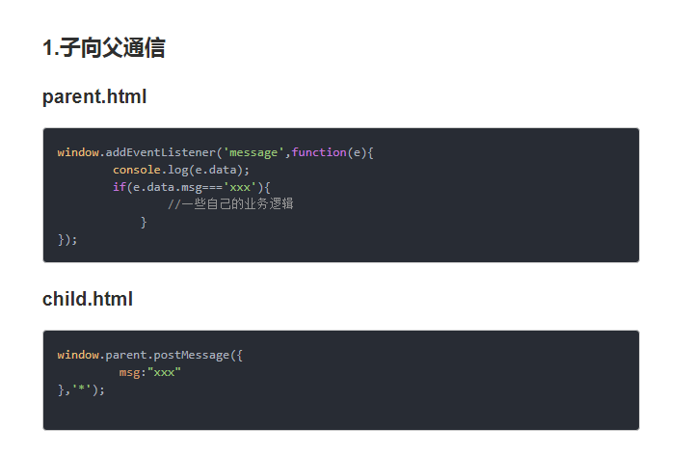
3Dtiles 位置偏移
var tileset = new zccity.Cesium3DTileset({
url: 'http://120.55.98.170:8090/Apps/jzjm/tileset.json',
maximumScreenSpaceError: 32,
maximumNumberOfLoadedTiles: 1024,
});

tileset.readyPromise.then(function () {
var cartographic = zccity.Cartographic.fromCartesian(tileset.boundingSphere.center);

var lng = zccity.Math.toDegrees(cartographic.longitude); //经度值 弧度转经纬度
var lat = zccity.Math.toDegrees(cartographic.latitude); //纬度值

var surface = zccity.Cartesian3.fromRadians(cartographic.longitude, cartographic.latitude, 0.0);

var offset = zccity.Cartesian3.fromDegrees(lng, lat, 26);
var translation = zccity.Cartesian3.subtract(offset, surface, new zccity.Cartesian3());
tileset.modelMatrix = zccity.Matrix4.fromTranslation(translation);
tileset1.modelMatrix = zccity.Matrix4.fromTranslation(translation);
tileset2.modelMatrix = zccity.Matrix4.fromTranslation(translation);
viewer.scene.primitives.add(tileset);
viewer.scene.primitives.add(tileset1);
viewer.scene.primitives.add(tileset2);
viewer.flyTo(tileset);
}).otherwise(function (error) {
throw (error);
});

