- Introduction

In research from Horvath and Raj (2018), they found out that, from so many literatures, dating back to the 1960s, it seems that chronological age has an outstanding effect on genome-wide DNA methylation levels²⁻⁹. It means that our genome-wide DNA methylation levels will change over aging. In academic words, “the methylation states of millions of the 28 million CpG dinucleotides in the human genome were seen to change with age.” (Horvath and Raj, 2018). There are possible two underlying factors that could change the DNA methylation. (Vijg and Campisi, 2008; Fraga et al., 2005).
The first one is the environmental factor, “it is possible that environmental exposure will over time activate cellular programs associated with consistent and predictable changes in the epigenome.” (Hannum et al., 2013). For instance, it has been shown that stress would change the gene expression patterns via some specific changes in DNA methylation (Murgatroyd et al., 2009). Another factor might be the spontaneous epigenetic changes. These kinds of changes may happen with or without environmental stress, which would cause an unpredictable difference in the epigenome between aging individuals (Hannum et al., 2013). “Spontaneous changes may be caused by chemical agents that disrupt DNA methyl groups or through errors in copying methylation states during DNA replication. Both mechanisms lead to differences between the methylomes of aging individuals, suggesting that quantitative measurements of methylome states may identify factors involved with slowed or accelerated rates of aging.” (Hannum et al., 2013).

From this finding, we can have an idea of using the genome-wide DNA methylation levels in human beings’ body to predict their chronological age. Thus, we need to have a measurement of genome-wide DNA methylation levels in our body. According to an article, methylation could be recorded as a fraction between zero and one, which is “the frequency of methylation of a given CpG marker across the population of blood cells taken from a single individual.” (Hannum et al., 2013).

Here is a density plot of methylation fraction values for the marker cg16867657, separated by young (green) and old (blue) individuals from the article “Genome-wide Methylation Profiles Reveal Quantitative Views of Human Aging Rates” (Hannum et al., 2013).

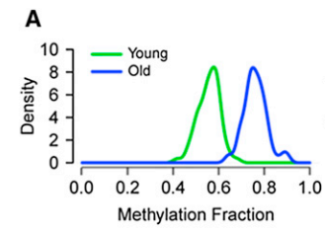

We can the methylation fraction values for the marker cg16867657 from the old people are higher than the young people, which would indicate some positive relationship between methylation faction and chronological age.

The reason for us to tend to predict/measure human aging from molecular profiles is because “The ability to measure human aging from molecular profiles has practical implications in many fields, including disease prevention and treatment, forensics, and extension of life.” (Hannum et al., 2013). Also, from this predicting or measuring, we might find out a well-known fact that “women tend to live longer than men, and lifestyle choices such as smoking and physical fitness can hasten or delay the aging process.” (Austad, 2006; Blair et al., 1989). Another key point is that methylation is also linked to some age-associated diseases such as metabolic disease (Barres and Zierath, 2011) and cancer (Jones and Laird, 1999; Esteller, 2008).

Our goal in this paper is to see how accurately we can predict human beings’ chronological age from DNA methylation; what can be improved from our baseline model (which would be introduced in the methodology part); Do the predictors (DNA methylation) work equally across sexes.

- Data

2.1 Overview of the data set

Our data is from 8 cohorts and it can be found on the NCBI website (NCBI - WWW Error Blocked Diagnostic, 2022). Since the data has already filtered, thus, the potential predictors (the frequency of methylation of a given CpG marker across the population of blood cells taken from a single individual) for each cohort would be the same. Here, we have 23758 CpG markers and 2773 observations from 8 cohorts. We also have each observation’s age, sex, and cohort code. A Simple data description should be the following:

- Age: The person’s chronological age.
- Sex: F or M (F stands for female and M stands for male).
- GEO: The cohort code, which is to differentiate which cohort is the observation from. The eight codes are: "GSE40279", "GSE41169", "GSE42861", "GSE53740", "GSE72773", "GSE72775", "GSE72777", "GSE78874" respectively.
- 23758 CpG markers’ DNA methylation fraction: Range from zero to one, representing the frequency of methylation of a given CpG marker across the population of blood cells taken from a single individual.

The original eight datasets (not yet filtered) could be found in the links below:

GSE40279: https://www.ncbi.nlm.nih.gov/geo/query/acc.cgi?acc=GSE40279
GSE72775: https://www.ncbi.nlm.nih.gov/geo/query/acc.cgi?acc=GSE72775
GSE78874: https://www.ncbi.nlm.nih.gov/geo/query/acc.cgi?acc=GSE78874
GSE41169: https://www.ncbi.nlm.nih.gov/geo/query/acc.cgi?acc=GSE41169
GSE42861: https://www.ncbi.nlm.nih.gov/geo/query/acc.cgi?acc=GSE42861
GSE53740: https://www.ncbi.nlm.nih.gov/geo/query/acc.cgi?acc=GSE53740
GSE72773: https://www.ncbi.nlm.nih.gov/geo/query/acc.cgi?acc=GSE72773
GSE72777: https://www.ncbi.nlm.nih.gov/geo/query/acc.cgi?acc=GSE72777

  - Due with NAs
Unfortunately, we have missing values for the Sex variable of 98 observations. These 98 observations are all from the cohort “GSE53740”. For simplicity, we can just remove these 98 observations from our data set since 98 is just a small number for 2773 observations. We would not lose too much information from these 98 observations. After removing there 98 observations, we should have 2675 observations in total. Then, we can use these 2675 observations to do some EDA and modeling.

- EDA
Here are four figures for the EDA:
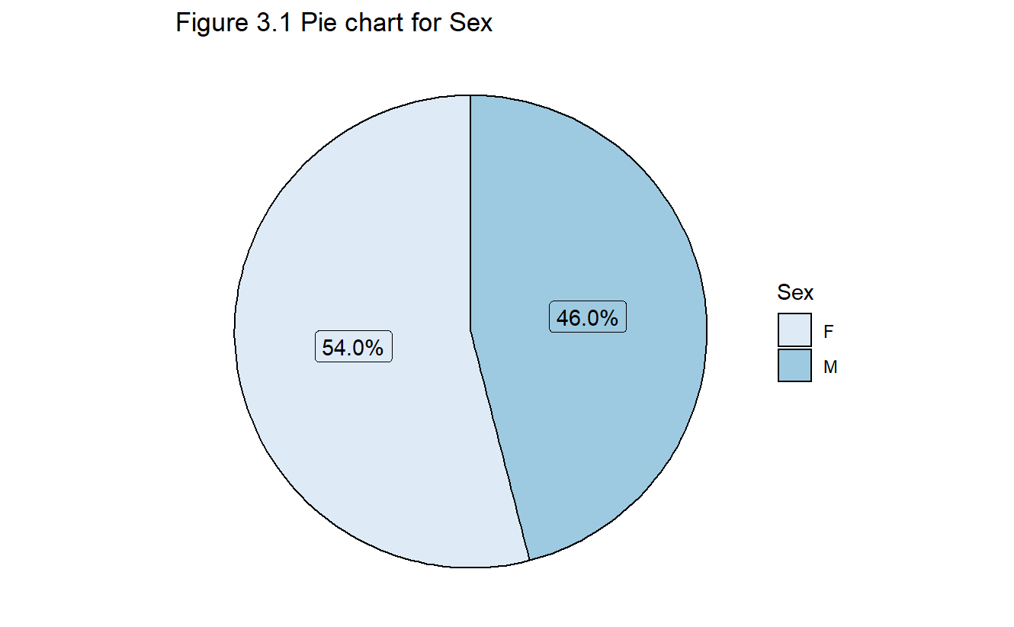
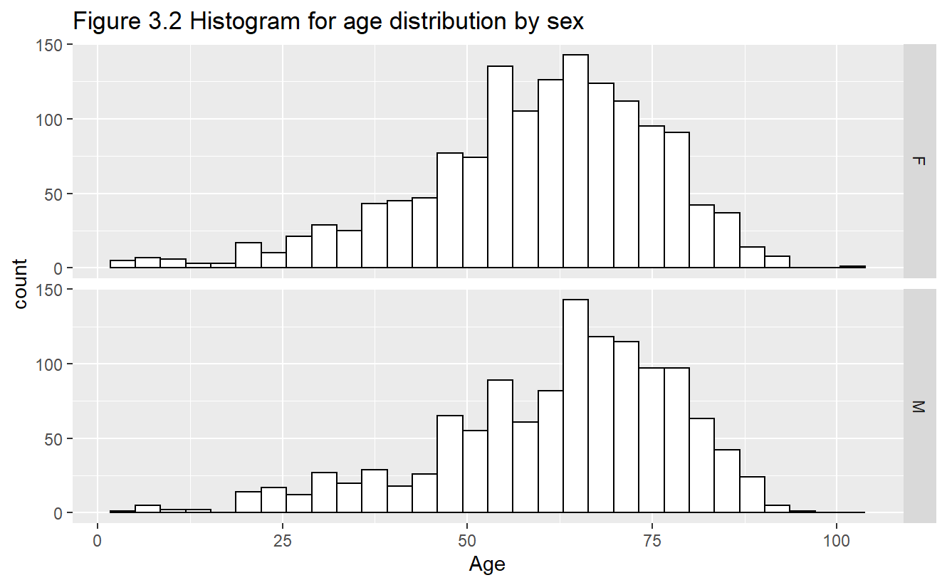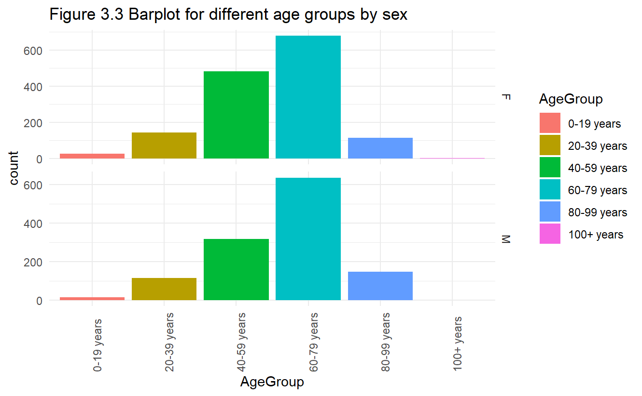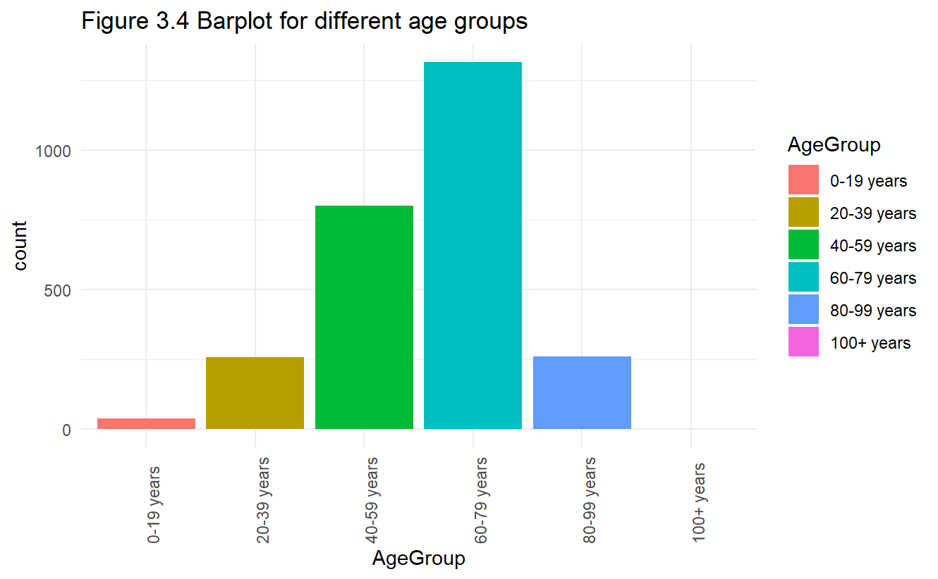
From these four figures, we can see that our gender(sex) distribution is around 50% and 50%, from figure 3.1, which is good. The age distribution shows that it would not be influenced so much by the sex from figure 3.2 and 3.3. However, from figure 3.3 and 3.4, we can see that most of observations’ age is from 60-79 years old, and there is a lack of observations from 0-19 years old, which is not that good since we hope there are enough observations for each age group. Below is a table to show the detail statistic of the data.
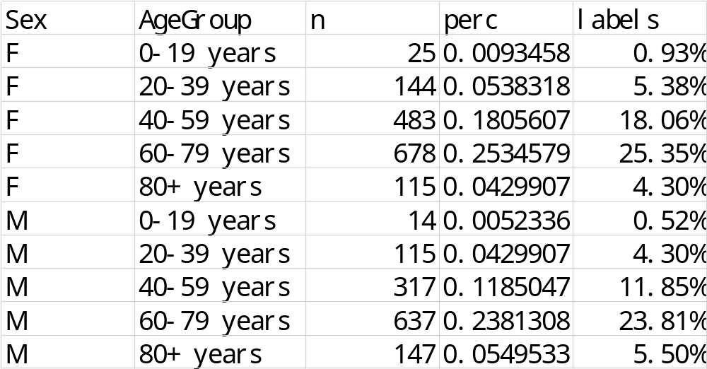

From this table, we could see the same problem which we found from the figure 3.3 and 3.4. There are too few observations for the age group 0-19 years, only 39 observations in this age group across the eight cohorts. This might influence our performance of predicting this age group people’s age since there is lack of data in this age group. However, we don’t actually know if this would have a big difference in the performance of predicting. Thus, we can just accept this data structure and do a modeling.

- Methodology

OLS Regression (not workable)

After we explore a little bit about our data, we can start modeling. The first common model we might want to use would be the ordinary least squares (OLS) regression. The model form is the following:
This equation shows that the response y_i (age) for the ith observation is a function of d+1 constants (the \beta s), here d is 23758 since we have 23758 CpG markers, values of the d predictors for the ith observation, and an error term e_i. The term beta_0 is the intercept. If we write it to as matrix form, it would be the following:
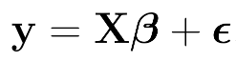 ,
Where y is a column vector of N elements, X is a N * (d+1) matrix, here our N is 2675 since we have 2675 observations. The e is just a column of error terms.

To get our model parameters (\beta s) estimates, we need to minimize the residual sum of squares (RSS), the sum of the square of the difference between the actual and the predicted value. The solution for the model parameters estimates would be the following:
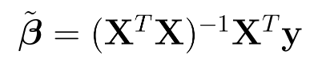
Then we want get our predicted values as the following:
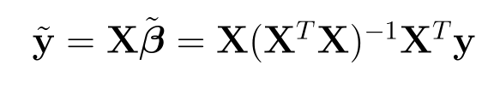

Although OLS regression is very popular and easy to use, it becomes unavailable when the X^TX is not invertible. This situation would happen when our number of predictors is more than our number of observations. In our case, the number of predictors is 23758 and the number of observations is 2675. The number of predictors is quite larger than the number of observations, which means OLS regression is not suitable for our case. Another point for unavailable OLS regression is that we have so many predictors and we don’t know whether these predictors are highly correlated or not. If they are highly correlated of each other, we cannot use OLS regression since the columns of X matrix would become not linearly independent, which would make the regression coefficients unreliable. This problem is called multicollinearity. Both of above situations are very common in fields like bioinformatics, chemical and drug analysis, and neuroimaging data analysis (Krishan, 2019).

Fortunately, there are many other methods can solve these two problems. One of the famous approaches is PCA regression (PCR), which is to use principal component analysis to create a smaller, uncorrelated set of new features and then use them to perform regression (Krishan, 2019). Another better option than PCR is the partial least square (PLS). Since one drawback of PCR is the selected principal components may not be much relevant for predicting the response variables but PLS is looking for those components of X that are more relevant for Y (Krishan, 2019). However, both PCR and PLS are hard to interpret. Penalized maximum likelihood estimation like ridge regression solves this problem. Thus, we might need to use Ridge regression, Lasso regression and elastic net as our baseline model since they are all penalized maximum likelihood estimation.

  - Baseline model (ridge, lasso, elastic)

In OLS regression, we need to estimate our parameters $\beta$s by minimizing the following loss function:
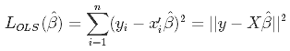
After we get the parameters estimates, we need to consider two significant characteristics of our estimators, the bias and the variance (Oleszak, 2019). The bias is the difference between the expected estimator and the true population parameter:
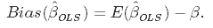
The bias is to measure the accuracy of the estimates while variance is to measure the spread or uncertainty of the estimates. The variance is the following:
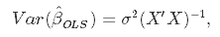
where the $\sigma^2$ (variance of the error term) could be estimated from the residuals as the following:
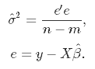
Both the bias and the variance are wished to be as low as possible since large values of them will result in poor predictions. The model’s error can be decomposed into tree part as the following:
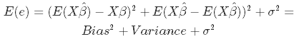
We can see the first part is the bias and second part is the variance and third part is the unexplainable part.

The OLS estimator has the property that the estimators are unbiased but the variance will be large in some case. Like the cases mentioned above, the predictors are highly correlated with other or the number of predictors is close to the number of observations, which means m is approaches n. In our case, m is larger than n, thus OLS is not possible. These two cases will both cause high variance, which would make poor prediction.

The solution to this problem is to reduce variance by introducing some bias. It is called bias-variance trade-off. This approach is called regularization and it could increase the performance of prediction when we have too many predictors or the predictors are highly correlated with each other. Here is a plot to show the bias-variance trade-off:
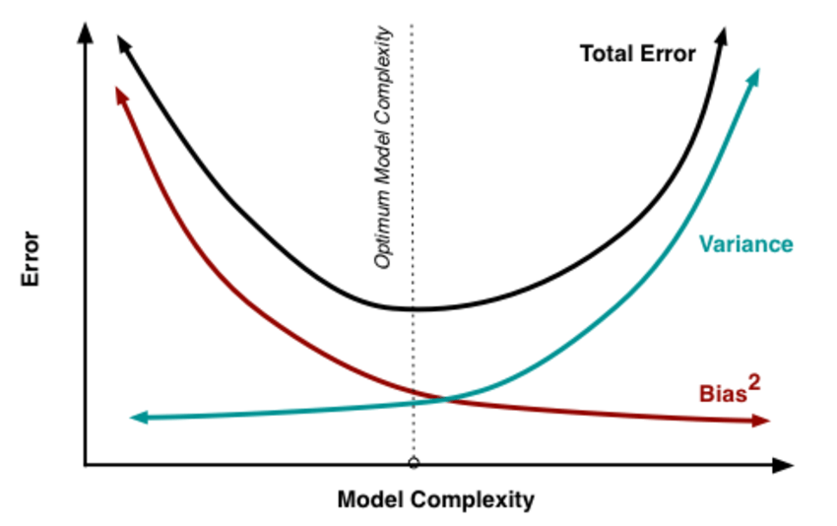
Source: researchgate.net
The model complexity could be thought as the number of predictors. As we can see, the number of predictors increases, the variance will increase while the bias will decrease but the total error will increase too. The OLS regression is the right-hand side of the plot since OLS regression is desired to be unbiased, which would have a large variance and total error. Thus, we need to regularize, which means we should increase some bias to lower the variance so that the total error will be at the lowest point, the optimum model complexity point.

Ridge regression
Ridge regression is one of regularization method. Ridge regression is to reduce complexity in this way: Instead of directly removing the useless predictors (low effect), ridge regression is to penalize the coefficients of the useless predictors (low effect) so that the useless predictors are kept in the model and model complexity is also decreasing.

The mathematic algorithm of ridge regression is the following:
In ridge regression the OLS loss function is the following:
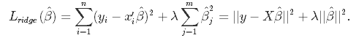
We need to minimize this OLS loss function. As we can see, we need minimize both the sum of squared residuals and the penalized term, $\lambda \sum$.
By solving this, we can get $\hat\beta_{ridge} = (X'X+\lambda I)^{-1}(X'Y)$, where I denotes the identity matrix.

The $\lambda$ parameter is the regularization penalty. We can see that:
- As $\lambda \rightarrow 0, \quad \hat\beta_{ridge} \rightarrow \hat\beta_{OLS}$;
- As $\lambda \rightarrow \infty, \quad \hat\beta_{ridge} \rightarrow 0$.

Thus, if we set $\lambda$ to be zero, it is same as the OLS. If we increase the value of lambda, we will penalize more about the coefficients.

In this way, we could have the new bias and the new variance as following:
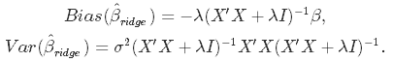
From these two new formulas, we can see that when the $\lambda$ is increasing, the variance will decrease and the bias will increase. Thus, if we choose an optimal value of $\lambda$, the total error will drop down and become optimal. The choice of $\lambda$ will be talked about later.

Lasso Regression

Lasso regression is similar to ridge regression. The difference of lasso regression is lasso regression is to make the useless coefficients to be zero so that some predictors will be removed from the model while ridge regression will keep all the predictors. To make this happen, the loss function of lasso regression is the following:
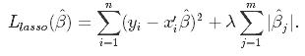
We can see the loss function is similar to ridge regression. The only difference is the penalty term. In lasso regression, it penalizes the sum of the absolute values of the coefficients while ridge regression penalizes the sum of squared coefficients. Except the difference of penalty term, everything of lasso regression is similar to ridge regression.

Both lasso regression and ridge regression can solve the problem of correlated predictors and too many predictors. However, one might be better in a specific case. Lasso might be better when there are only few significant predictors among all the predictors while ridge might be better when most of the predictors have significant impact on the response. In practice, we don’t know which case we are in; thus, we might use a combination of these two regressions. That is called elastic net.

Elastic Net

Elastic net is the combination of ridge regression and lasso regression. Its loss function is the following:
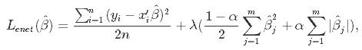
Where $\alpha$ is the mixing parameter between ridge and lasso. When $\alpha$=0, it is ridge regression; when $\alpha$=1, it is lasso regression.

As we can see, in elastic net, we will have two parameter, $\lambda$ and $\alpha$. $\lambda$ is the penalty parameter, determine the size of penalty. $\alpha$ is the mixing parameter, is like which regression you want to be close to. If we set $\alpha$ to be close to 1, our model will be close to lasso; if we set it to be close to zero, our model will be close to ridge. Thus, there are two parameters for us to tune when we want to use elastic net to model. Fortunately, the glmnet package allows us to tune the $\lambda$ through cross-validation for a fixed $\alpha$. So, we only need to set a fixed $\alpha$ to start modeling. We can set $\alpha$ to be 0.5.

Apply Elastic Net to our data (LOOCV)

Since our data is made up of eight cohorts, we need to consider cohort information. Thus, we can use leave-one-out cross-validation (LOOCV) to do modeling and prediction. The algorithm is the following: First, we cheat the first cohort’s data as a testing data set and the rest seven cohorts’ data as training data set. We use elastic net model on the training data set and use the testing data to do prediction. Second, we cheat the second cohort’s data as a testing data set and the rest seven cohorts’ data as training data set. We use elastic net model on the training data set and use the testing data to do prediction. We do this process for all the eight cohorts. Then we would have all the predictions for the eight cohorts. For all these eight elastic net models, we should set $\alpha$ to be 0.5 and use cross validation to find the best $\lambda$.

After we have all the predictions, we can plot the predictions v.s. true age and calculate RMSE. “RMSE is the square root of the averaged squared difference between the actual value and the predicted value of the target variable. It gives the average prediction error made by the model, thus decrease the RMSE value to increase the accuracy of the model.” (GeeksforGeeks, 2021).

  - Sex consideration

Since we didn’t cheat sex(gender) as a predictor, we don’t know if sex will have a significant impact on our response(age). The direct way to check if sex variable has significant impact is to cheat sex as factor variable and add it into our baseline model, elastic net. However, the coefficient of sex variable in the elastic net model will always be set to be zero or vert close to zero, which means the sex variable is not significant. Another way to check is to see the prediction by the baseline model v.s true age plot group by sex and the prediction by the model which is sex added v.s true age plot group by sex. Here are some plots to check:
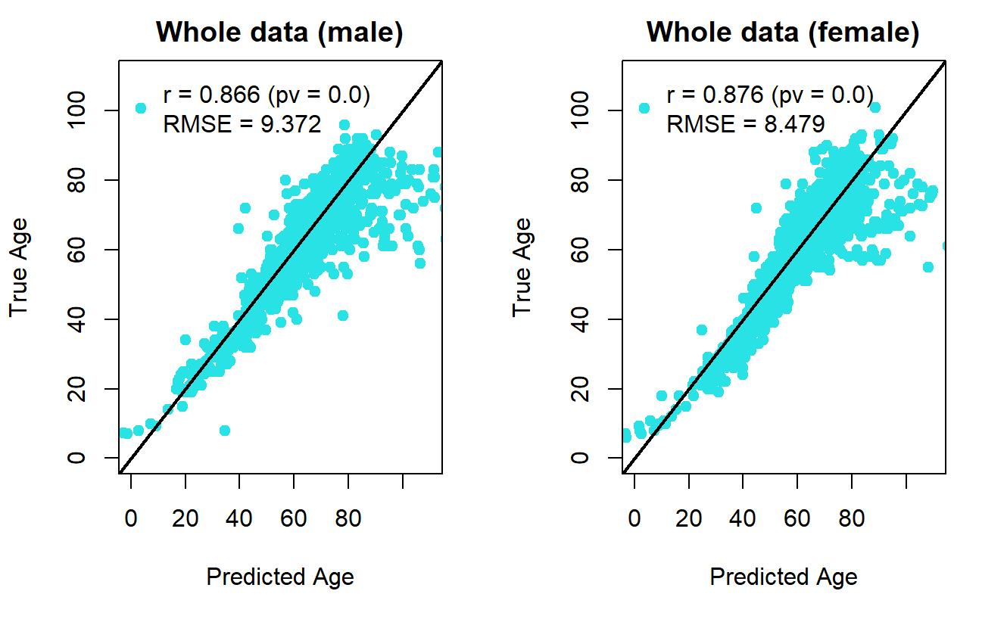

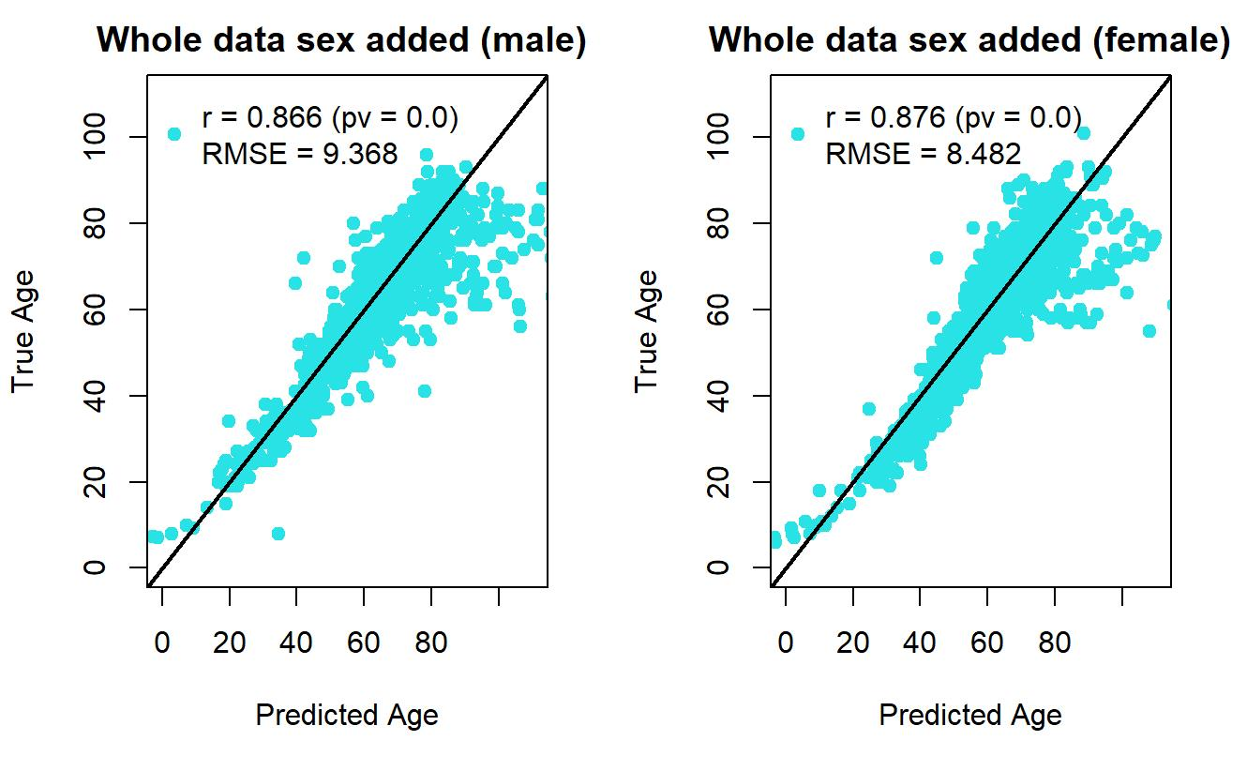
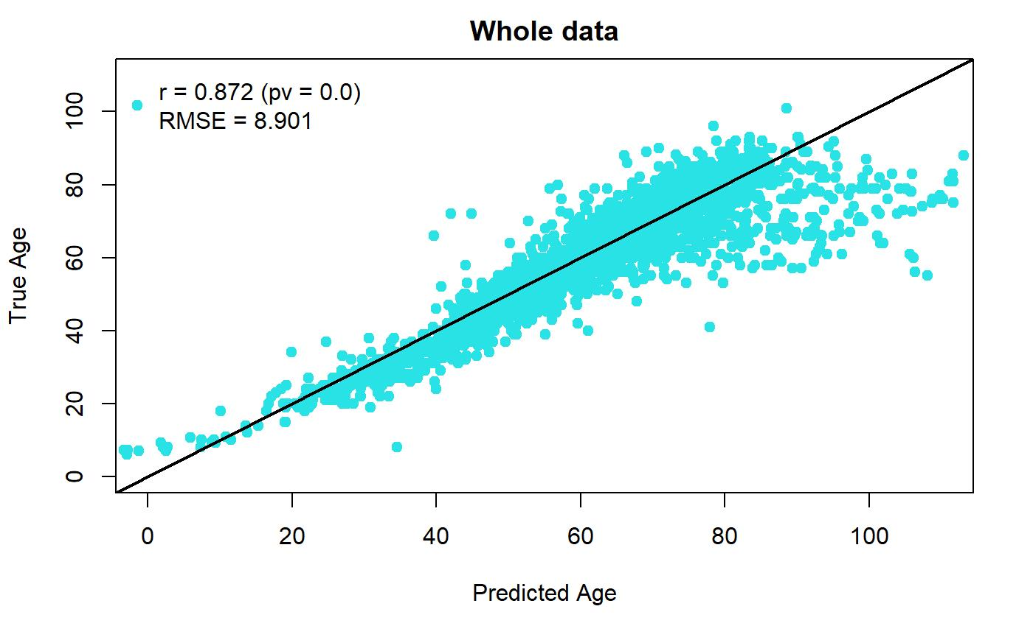
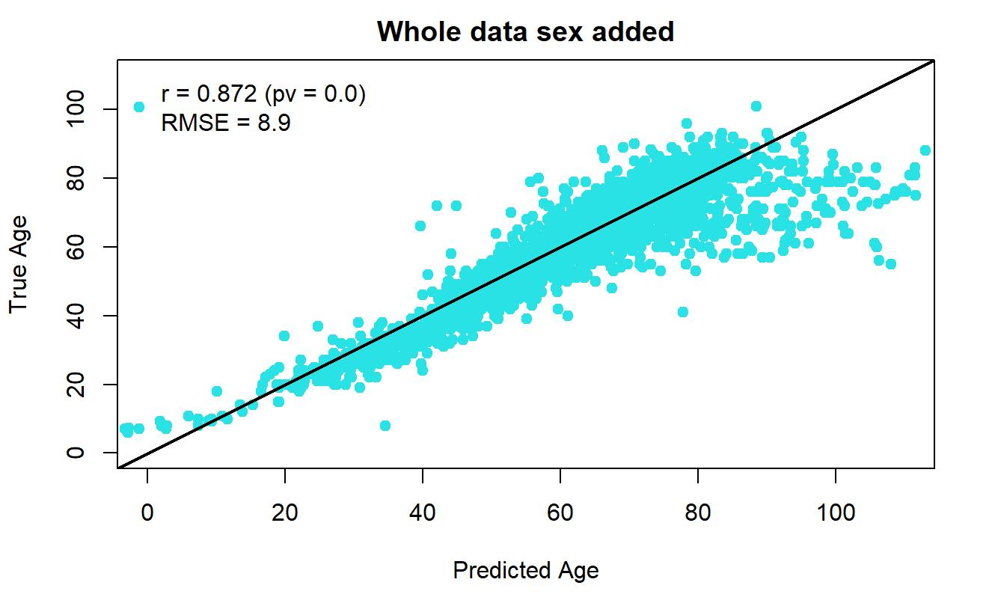
From those plots above, we can see the prediction performance is almost the same when we cheat sex as a factor predictor in our baseline model. However, simply adding sex as a factor predictor does not consider the interaction between sex variable and CpG methylation fraction variables. Since there are too many CpG methylation fraction variables, it is difficult for us check the existence of the interaction between sex variable and CpG methylation fraction variables for every CpG methylation fraction variable. Thus, we might separate our data into male data and female data. For both male data and female, we both apply LOOCV to them. Then, we should have all the predictions. After separating the data by sex, the prediction performance is the following:
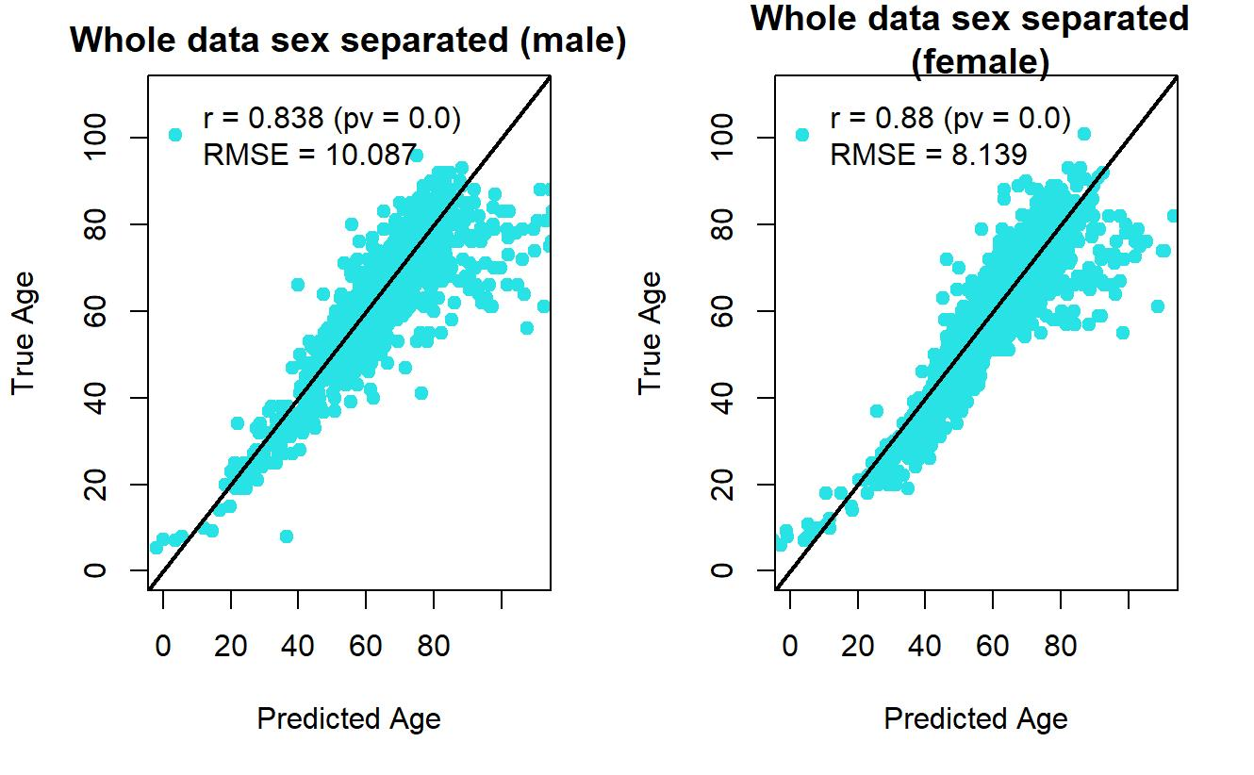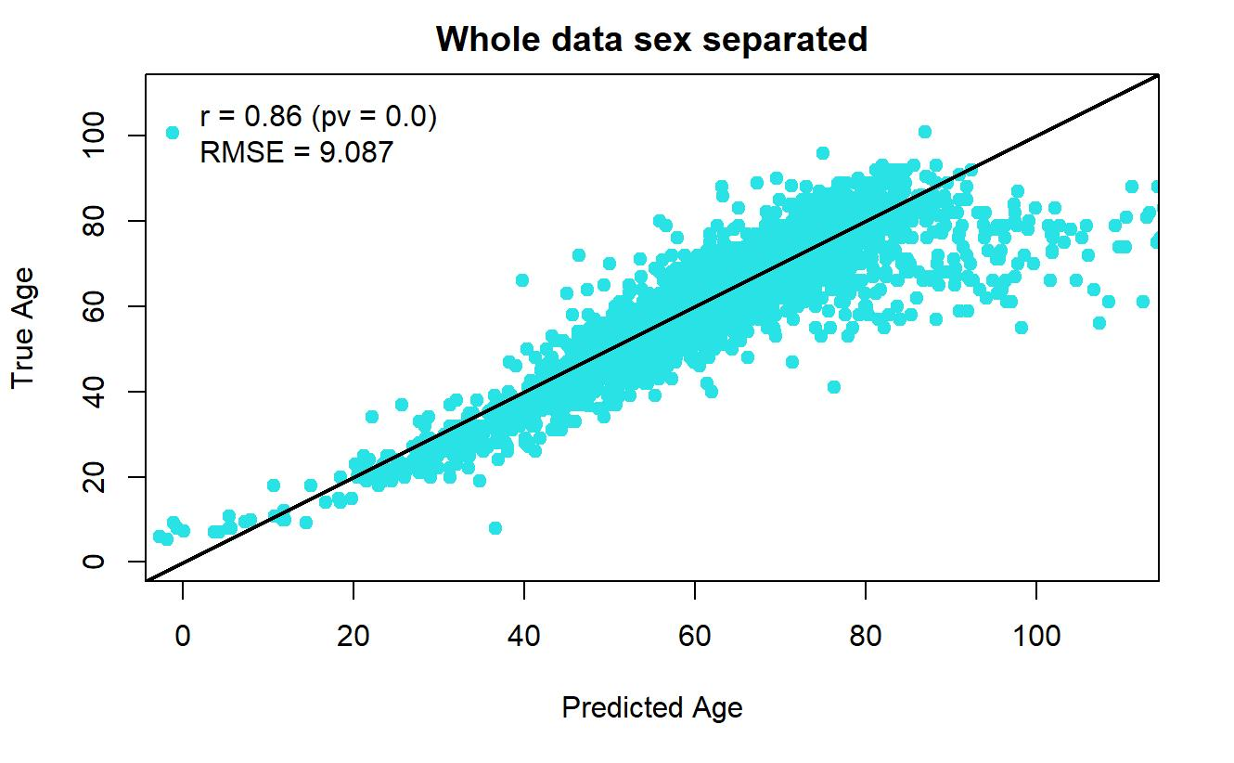From those plots above, it is surprised that the prediction performance for female is improved (RMSE 8.479 to 8.139) but the prediction performance for male drop down (RMSE 9.372 to 10.087). What is more, the overall prediction performance also drops down a little bit (RMSE 8.901 to 9.087).
In conclusion, we don’t need to do anything about the sex variable, since both adding sex variable into our baseline model or separating the data by sex variable do not change the overall prediction performance so much. However, an interesting finding is the prediction performance for female is better than male, which would be further discussed in our discussion section.

  - Best alpha model
As mentioned above, in our baseline model, elastic net, there are two parameters we need to consider about. One is the penalty parameter, $\lambda$, and the other is the mixing parameter, $\alpha$. The $\lambda$ could be tuned by the glmnet package while the $\alpha$ is just set to be 0.5 at the beginning. Thus, we also need to tune the $\alpha$ to see if different alphas set in our baseline model will have different prediction performance. The process to tune the alpha is the following: Since alpha is range from 0 to 1, we can test for 11 alphas first. The 11 alphas are 0,0.1,0.2,…,0.9,1. For each alpha, we apply our baseline model using LOOCV once to our data. Thus, we would have the overall RMSE for each alpha. Here is the 11 RMSE for each alpha:
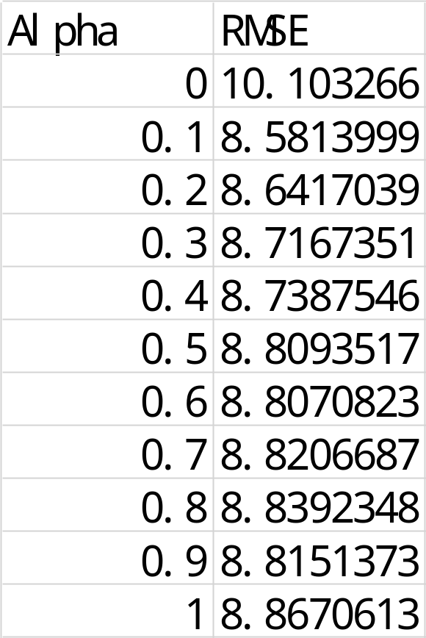

We can see that the alpha set to be 0.1 would have the best prediction performance since its RMSE is the lowest.

We can further to test the prediction performance between alpha set to be 0 and 0.1 or the prediction performance between alpha set to be 0.1 and 0.2. By further testing, we can find out that alpha set to be 0.03 might be the best. Here is the RMSE for each alpha from 0 to 0.1:
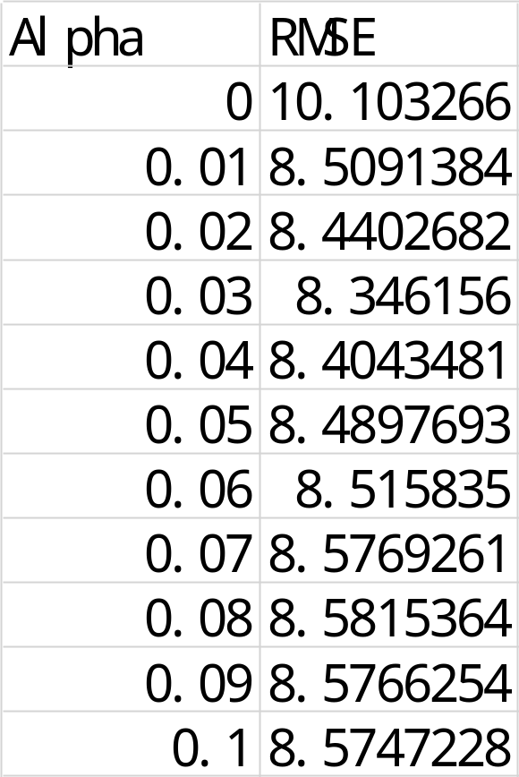

In conclusion, choosing a best alpha for the elastic net model might improve the prediction performance but the improvement is not that much.

  - PCA then elastic net
There are so many feature selection methods we can apply to our data before we running an elastic net model. However, in research from Doherty et al. (2022b), it shows that so many popular selection methods applied before running an elastic net model are not very useful since the prediction performance will not improve. In the research, Correlation-based (Pearson’s r), Multiple hypothesis testing (F-test with FDR), Mutual Information, Gradient Boosting, Linear SVR, Random Forest and PCA are being used to do feature selection respectively before running a elastic net model. All the attempts are not good but one untraditional feature selection method is useful, which is PCA (Principal Component Analysis). PCA is just to convert our predictors into principal components. The maximum number of principal components is equal to the number of observations minus one. In our case, the maximum number of principal components is 2674 since we have 2675 observations. Thus, we might also consider do a PCA first, then run the elastic net.

First, we should do a PCA (do not scaled and not center, since centering and scaling will drop down our prediction performance) on all the predictors (all the methylation fraction). Then we need to decide how many principal components we need to keep to model. Here is how we can choose optimal the number of principal components: each number of principal components will explain different percentage of variance. We can test for 70% to 100%. We will test 70%, 71%, 72%..., 99%, 100%. There are 31 number of principal components we need to test. For each number of these 31 numbers, we run an elastic net model on it, then we can calculate the RMSE for each number. Here is the comparison output:
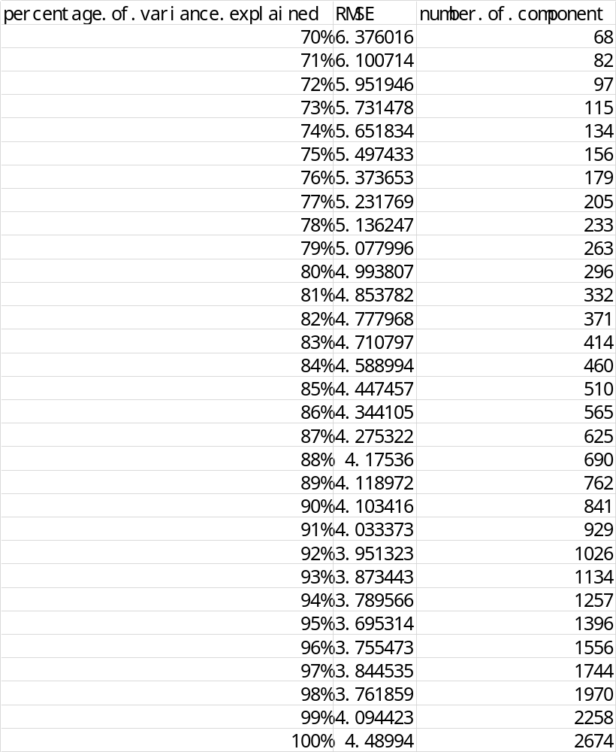

As we can see, when we choose the number of principal components to be 1396, the RMSE will be lowest and it will explain 95% of variance. Thus, we can keep the first 1396 principal components as our new predictors. When we have our new predictors, we just need to apply elastic net (set alpha to be 0.5) to our data via LOOCV again to get the prediction for our response. A PCA-baseline model will bring an overall RMSE to be 8.763. This RMSE is a little bit better than our baseline model (8.901). We can also apply how the best alpha is choosing to this. Finally, we will get a best alpha is 0.24 and its overall RMSE is 8.623. 8.623 is almost the same as 8.763, thus, we can choose the alpha to be 0.5. The prediction performance of this method is very similar to our baseline model and is little bit worse than the best alpha baseline model. In general, this method is also good.

- Results
From the methodology part, we can choose our baseline model, baseline model with a best alpha, and PCA-baseline model (PCA first and then use elastic net model) to do prediction for every cohort. Their prediction performances are the following:

Baseline model
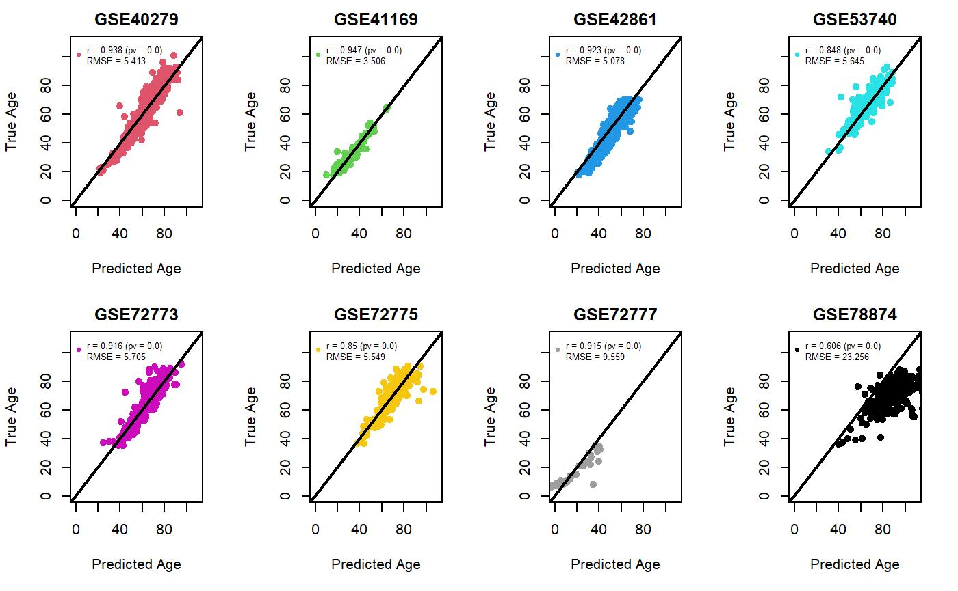

Baseline model with a best alpha
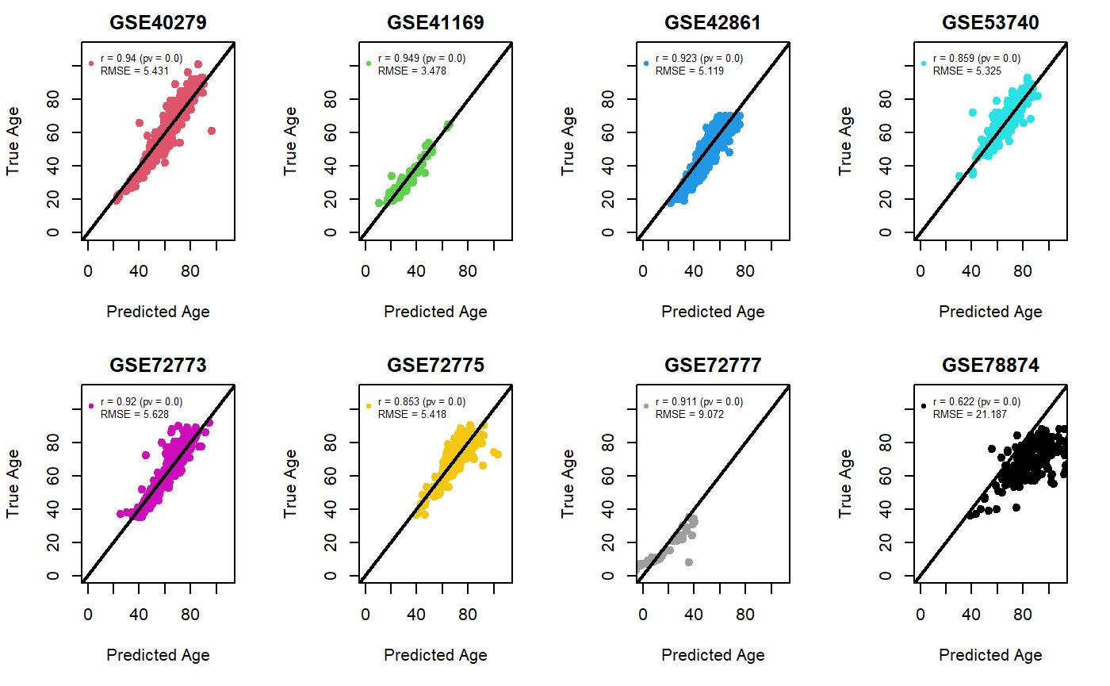
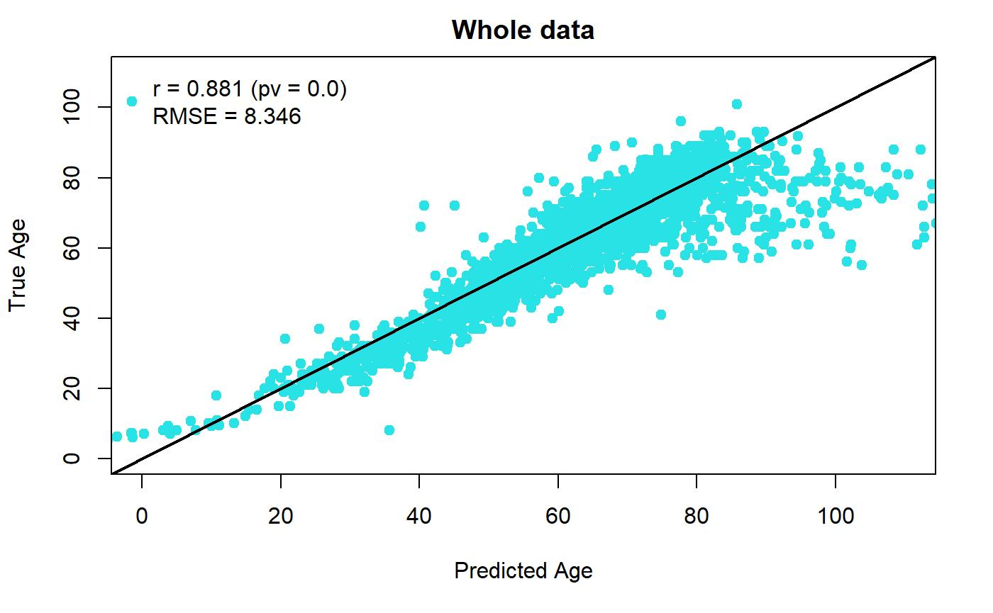

PCA-baseline model (alpha=0.5)
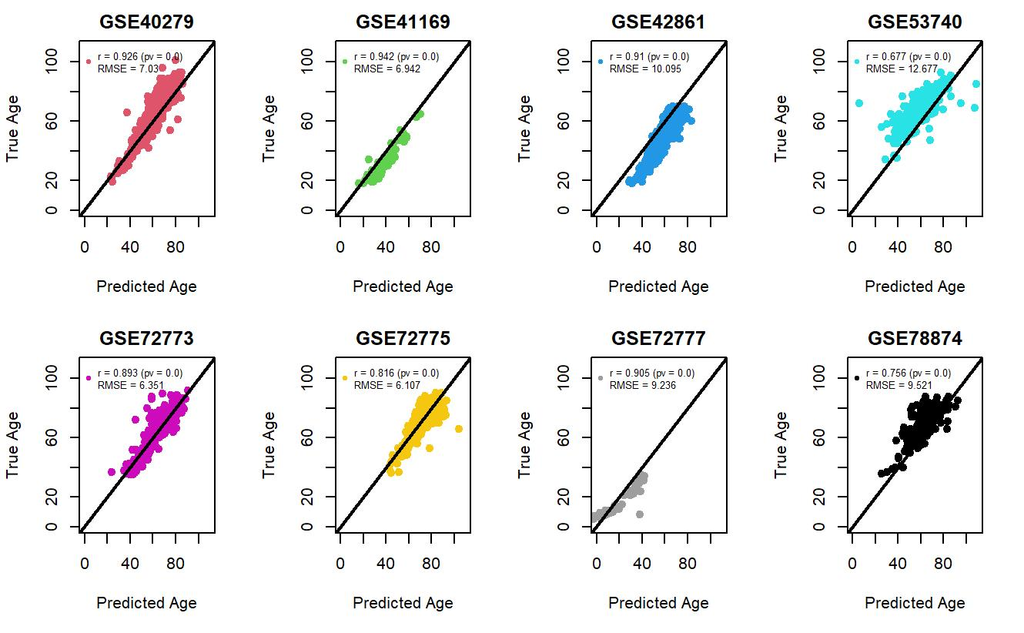
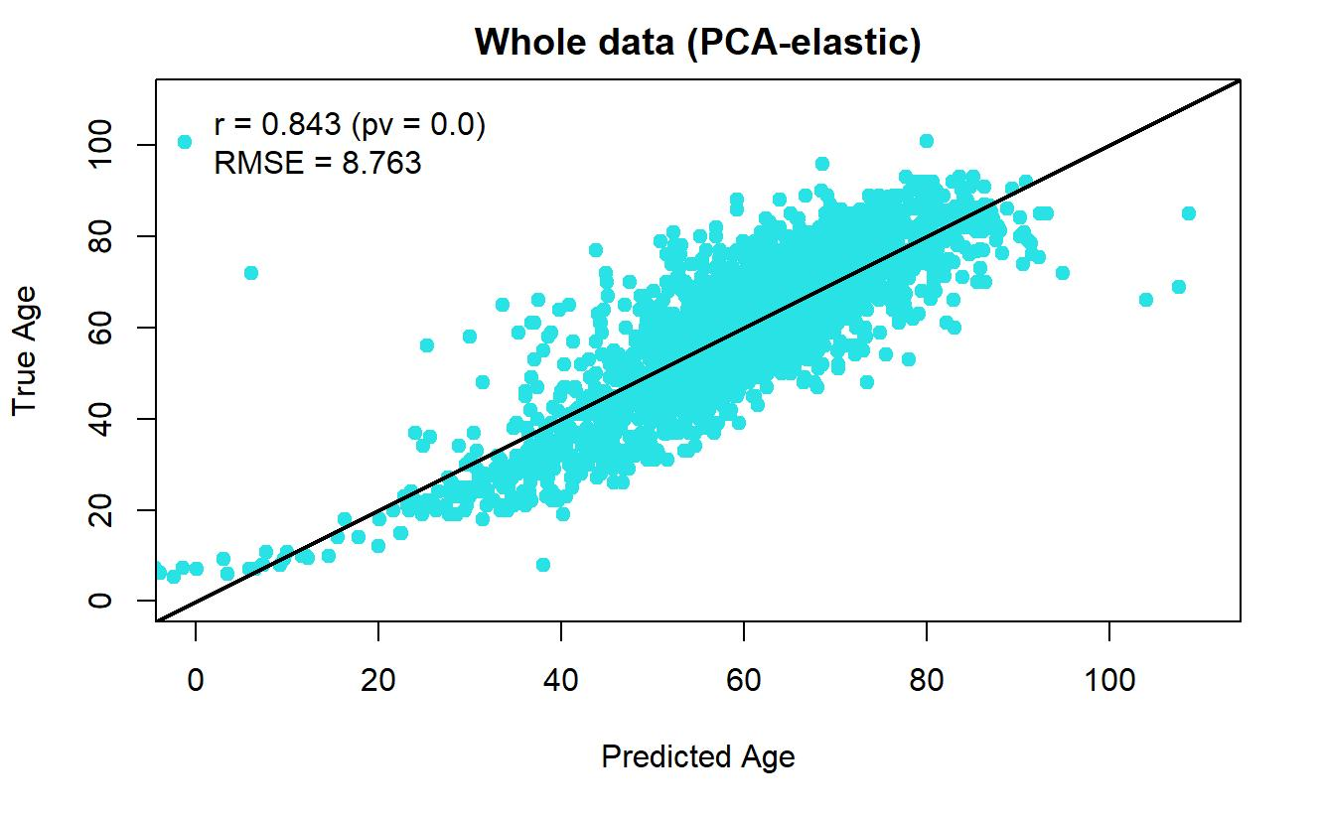

From those plots above, we can see that three methods’ overall prediction performances are almost the same. The only difference is the prediction performances within different cohorts. In the baseline model and the baseline model with a best alpha, the prediction performances in cohort ‘GSE72777’ and ‘GSE78874’ are the worst. However, in the PCA-baseline model, the prediction performances for each cohort are close to each other. Thus, we might need explore a little about the two cohorts ‘GSE72777’ and ‘GSE78874’. This will be discussed in the discussion section.

In conclusion, all the three methods are acceptable since their prediction performances are good in general.

- Discussion
6.1 Current exploration
Remember that there is one interesting finding that the prediction performance for female is better than male shown in section 4.2. If we do go through some literature, we might find out that the reason for this interesting finding happening might be female’s aging rate is lower than male’s aging rate (Hannum et al., 2013).

Another thing we need to explore is that why the prediction performances for cohort ‘GSE72777’ and ‘GSE78874’ by our baseline model or baseline model with a best alpha are not good. We can explore the data structure for these two cohorts. The following plots and tables will show the data structure or these two cohorts:

GSE72777
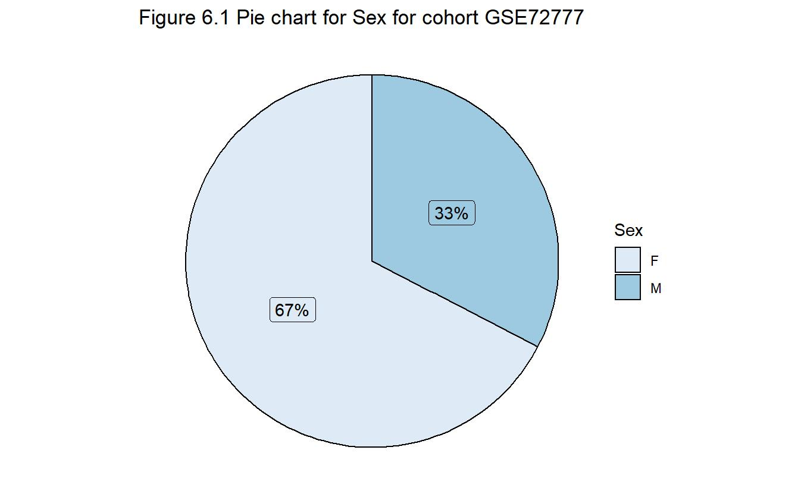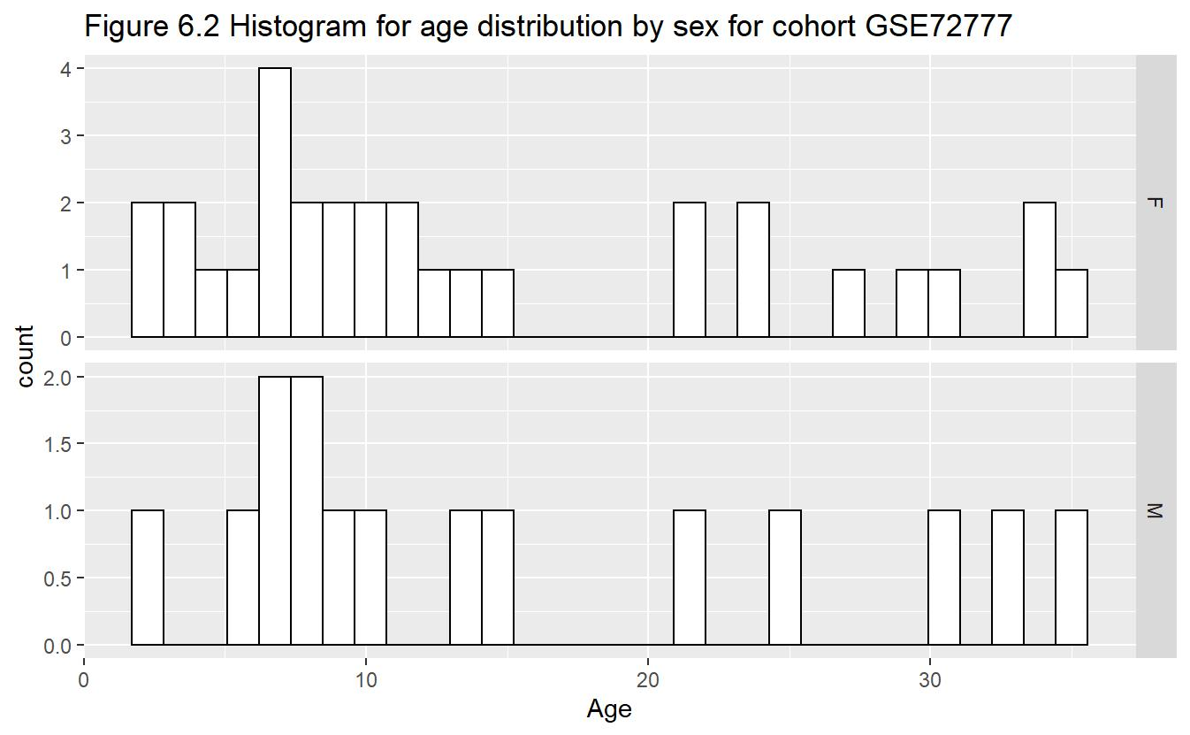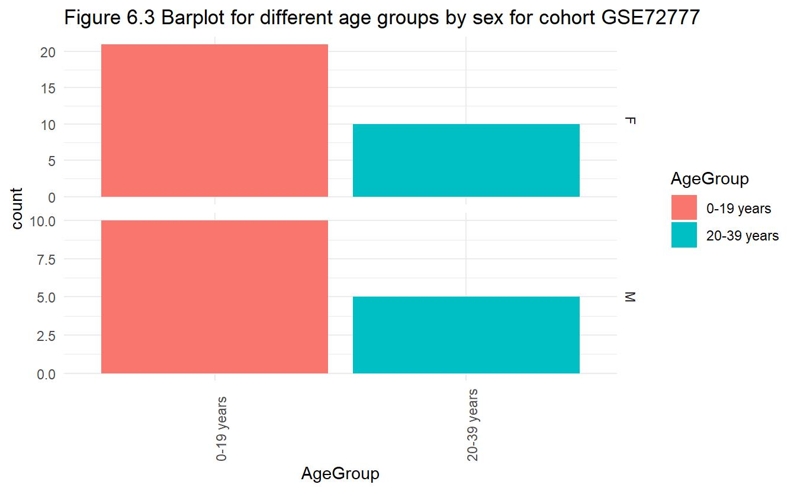

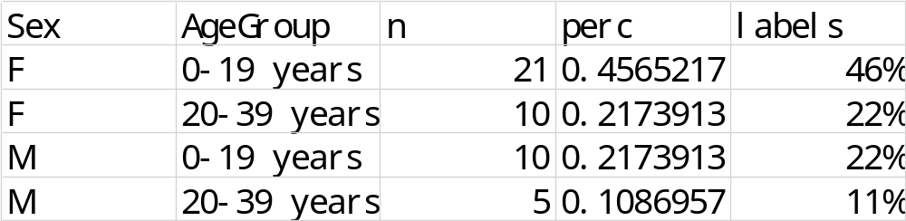

GSE78874
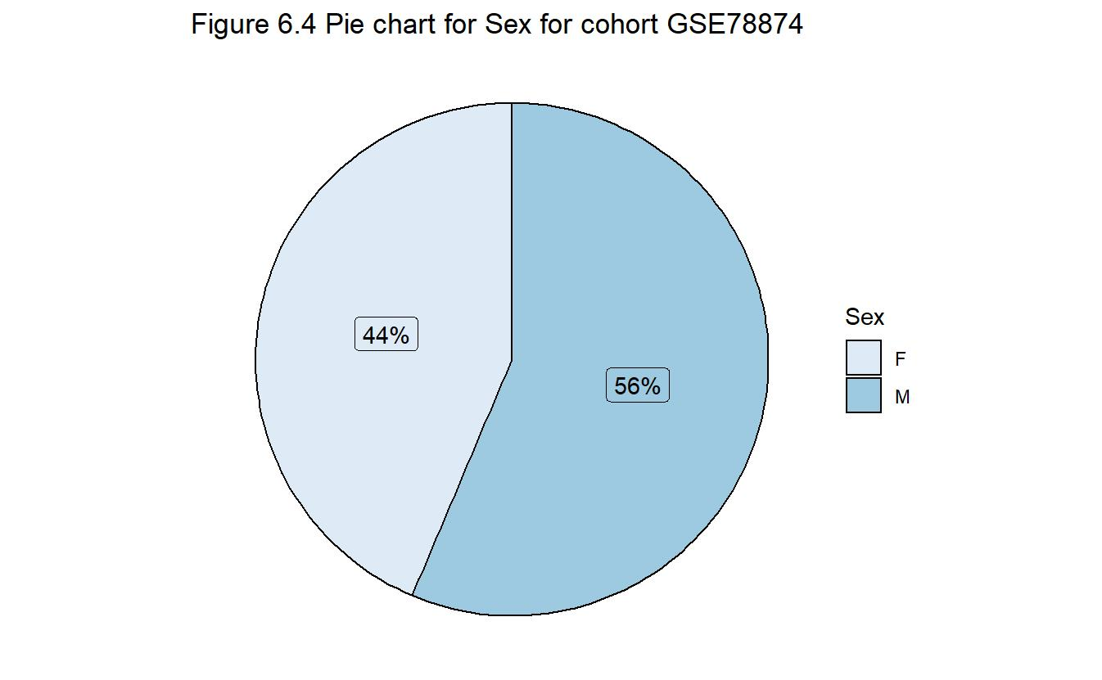
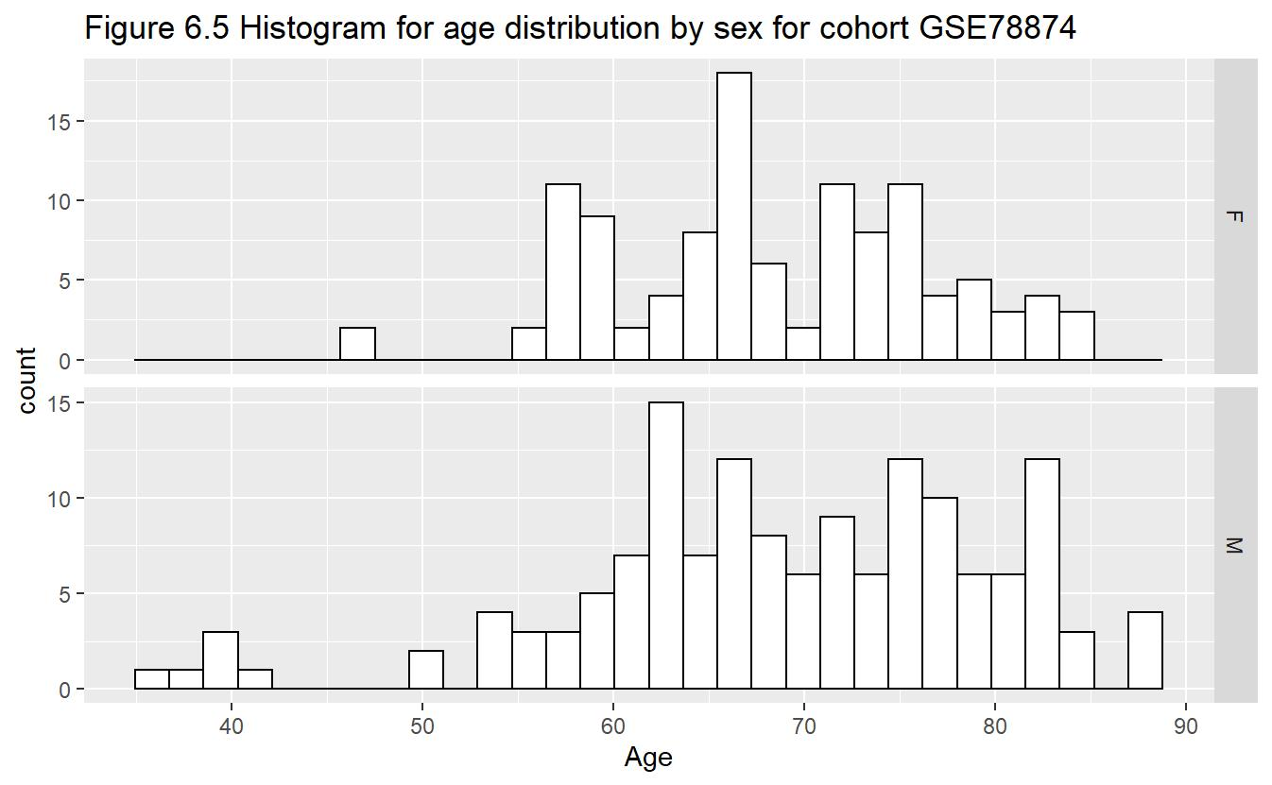

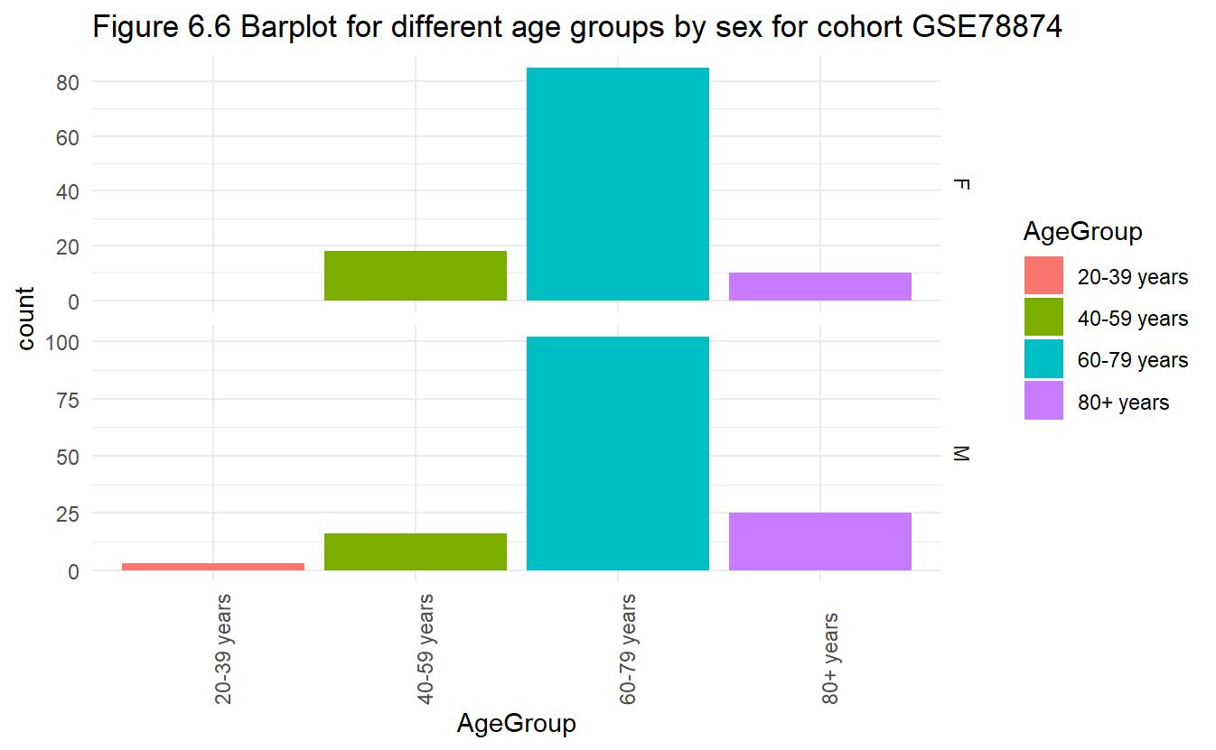
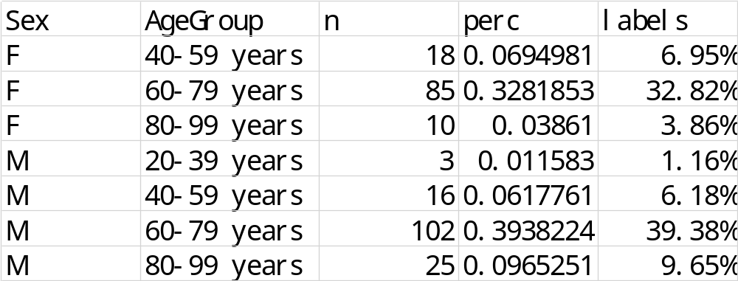

From those plots and tables, we can see that the biggest issue for cohort ‘GSE72777’ is lack of observation. There are only 39 observations in this cohort and it only cover two young age groups. The problem for cohort ‘GSE78874’ is that the data is very skewed since most of data are in the age group 60-79 years. Another most important issue for cohort ‘GSE78874’ is that the data from this cohort is collect from people ‘s saliva samples while other 7 cohort’s data are from people’s blood sample. We can see that the bad prediction performance might caused by shortage of data structure or the different source of data. If we can collect enough data, make the data cover all age groups and make each age group’s observations balanced in some extent in these two cohorts, our prediction performance might be better.

One unofficial way to solve the shortage of data structure might be to mix our data and separate it again in an ideal way. However, this way will be dangerous since it will make us lose cohort information. We still can have a try. We can mix and separate the data in this way:
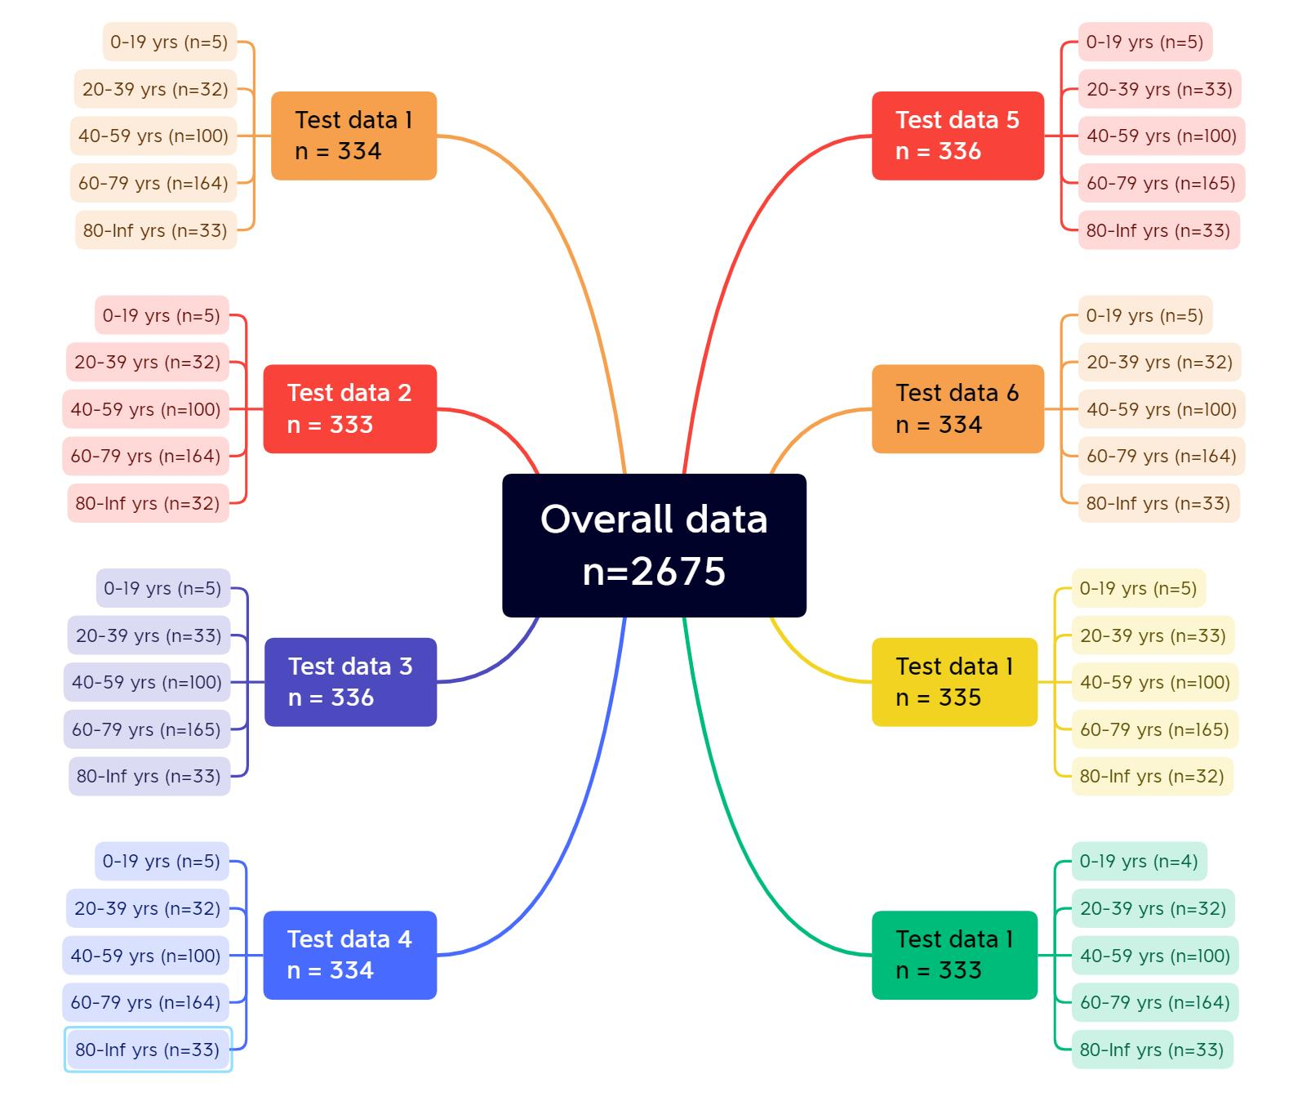
If we mix and separate our data in this way, we still get 8 test data sets, we can cheat them as 8 cohort. In this way, every test data set will be in ideal case. Then we can apply our baseline model via LOOCV to it. We could get the following prediction performance:
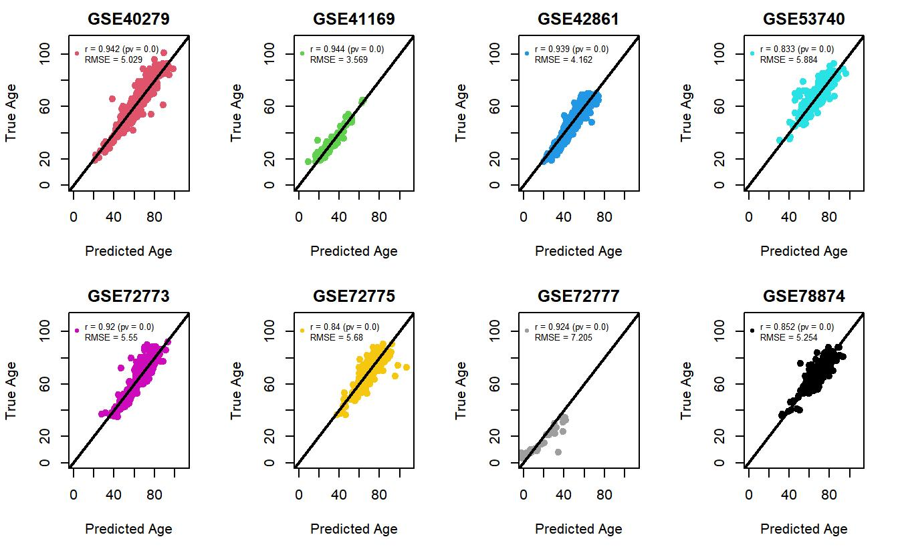
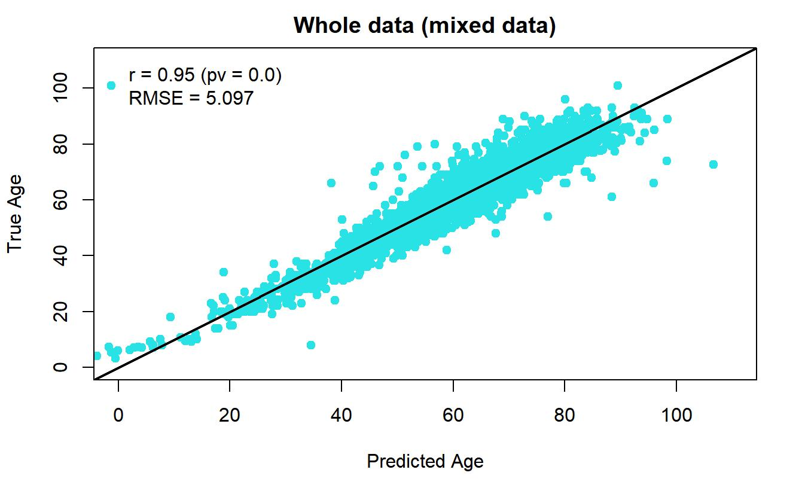
We can see that prediction performance is becoming better, which would make us believe if we can collect some ideal data sets in the future, the prediction performance would be better.

One way to check if the data source of cohort ‘GSE78874’ would have huge influence on prediction performance is to delete this cohort and run again our baseline model via LOOCV on the other 7 cohorts. Here is the prediction performance:
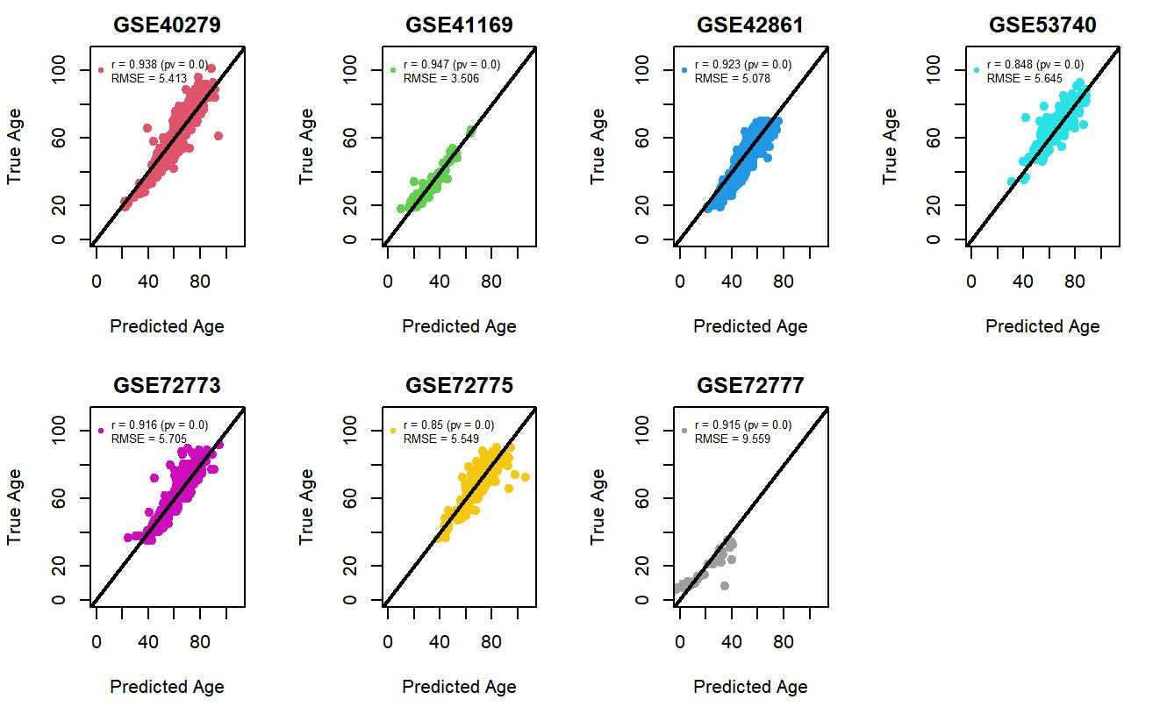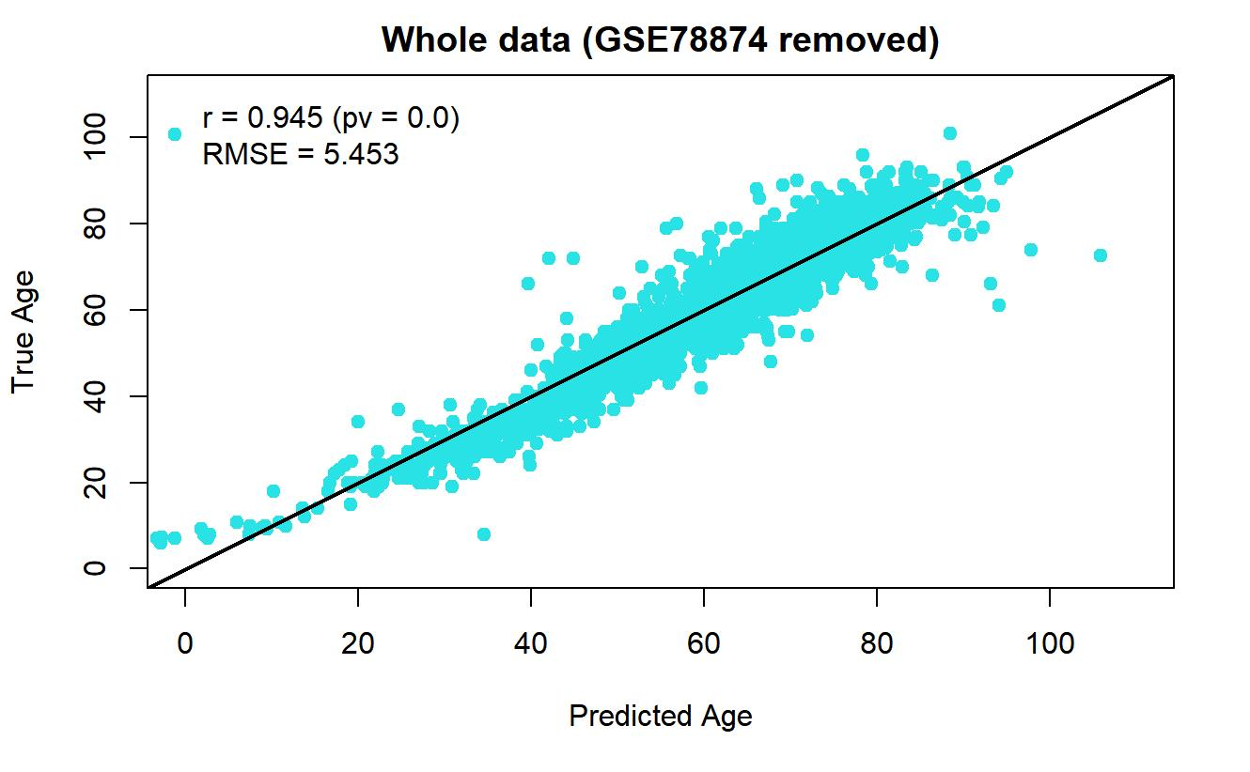
We can see the overall prediction performance improve a lot but the performance for the cohort ‘GSE72777’ is still not very good. Thus, we confirm that the source of our data and the number of observations are both important. We might need to collect all data from same source like blood sample and make sure the number of observations is large enough.

6.2 Limitation and further analysis

In this paper, we just use three methods (just two in different concepts since finding a best alpha is not a brand-new model) and just consider sex variable. We might explore more methods and consider age group variable.

In research from Momeni and Saniee Abadeh (2022), they proposed a adaptive feature selection framework for DNA methylation-based age prediction, which means we can use this framework to do our feature selection and then run a elastic net model.

Another thing we might need to explore in the future is the existence of non-linear associations between CpGs and chronological age. If there is a non-linear association between CpGs and chronological age, should we choose some non-linear method to predict the age?

- Conclusion

Back to our goals, we do can predict age from DNA methylation by the methods introduced in this paper and the accuracy is good in general by looking at the RMSE. Second, we do have some exploration from our baseline model. We proved that a best alpha might improve a little bit. A PCA feature selection first then run the elastic net model also improve a little bit. We also found out that sex variable is not significant in our model. What is more, we found that the biggest issue to drop our prediction performance down is the problem of our data. One is the lack of data and the other is the source of the data is difference.

All in all, we might need more exploration of different methods to check if elastic net model is the best in DNA methylation-based age prediction.

Our first step is to do some EDA after solving the problem of missing values. From the EDA, we can get some basic preview of our data. We can know what our data look like and what is the potential problem of our data (detail will be shown in EDA section).

