UNIVERSITI TUNKU ABDUL RAHMAN
Faculty of Information and Communication Technology



UCCD3223 Mobile Applications Development
(June 2026 Trimester)

Group Assignment 2

Name | Student ID | Course | Practical Group | Group ID | Group Name | Total
LIEW KAIY BIN | 2302391 | CS | P3 | 9 | ReEvent | /100
MAH JUIN HONG | TBC | CS | P3 | 9 | ReEvent | /100
WONG JIE YING | 2401105 | CS | P3 | 9 | ReEvent | /100
WONG LOONG JIE | 2302662 | CS | P3 | 9 | ReEvent | /100

Marking scheme | Marks | Remarks
Program completeness & functionality | X 3
Actual design and creativity | X 1
Potential for civil or commercial use | X 0.5
Tidiness of source code | X 0.5
SUB-TOTAL | /50

Individual marking scheme for Documentation, Presentation and Q&A
Name | Documentation | Presentation | Q&A | Sub-Total
LIEW KAIY BIN | x 2 | x 1.5 | x 1.5 | /50
MAH JUIN HONG | x 2 | x 1.5 | x 1.5 | /50
WONG JIE YING | x 2 | x 1.5 | x 1.5 | /50
WONG LOONG JIE | x 2 | x 1.5 | x 1.5 | /50

Table of Contents
1 Executive Summary and Introduction 1
1.1 Problem and objectives 1
2 Solution Evolution and Originality 2
3 System Architecture and Technology 3
3.1 Remote, public and device services 3
4 Implemented Functionalities and Completeness 4
4.1 End-to-end user journeys 4
4.2 Lifecycle integrity and data boundaries 4
4.3 Matching and impact claims 5
5 UI/UX Design and Creativity 6
5.1 Final UI evidence placeholders 6
5.2 Role workflows and visual continuity 7
6 Team Contributions 8
6.1 GitHub contribution evidence 8
7 Civil and Commercial Potential 9
7.1 Limitations and risks 9
7.2 Future enhancements 9
7.3 Conclusion 9
References 10
Appendix A — Privacy-conscious QR payload contract 11
Appendix B — Circular Matching Excerpt 12
Appendix C — Impact calculation guardrails 13
Appendix D — Server-authoritative lifecycle gateway 14

List of Figures
Figure 1: ReEvent system architecture 3
Figure 2: Authentication and role selection 6
Figure 3: Organiser dashboard and event management 6
Figure 4: Resource editor and persistent photo 6
Figure 5: Digital passport and QR workflow 6
Figure 6: Marketplace and transaction lifecycle 7
Figure 7: Partner map, matching, and workbench 7
Figure 8: Impact dashboard 7
Figure 9: GitHub commit history and contribution evidence 8

List of Tables
Table 1: Assignment minimum-requirement compliance 1
Table 2: Proposal-to-implementation traceability 2
Table 3: Implemented functionality 4
Table 4: Member roles and contributions 8
Table 5: Appendix A — Privacy-conscious QR payload contract metadata 11
Table 6: Appendix B — Circular Matching Excerpt metadata 12
Table 7: Appendix C — Impact calculation guardrails metadata 13
Table 8: Appendix D — Server-authoritative lifecycle gateway metadata 14

Executive Summary and Introduction
ReEvent is a role-based circular event resource platform designed to help organisers, participants, and recovery partners keep event materials in productive use. The implementation combines event and resource records, a circular marketplace, recovery programmes, digital passports, QR-assisted handovers, deterministic matching, and evidence-led impact reporting. It responds directly to Sustainable Development Goal 12 by encouraging responsible consumption, reuse, repair, redistribution, and recycling across an event's resource lifecycle (United Nations, n.d.).

Problem and objectives
Temporary events often create a fragmented trail of banners, furniture, decorations, packaging, equipment, and surplus stock. Their value is lost when ownership, condition, quantity, and recovery options are not visible at the moment a decision is made. ReEvent's objective is to make each item traceable, make circular routes discoverable, and make transaction completion auditable without exposing private identifiers in public QR payloads.
Table 1: Assignment minimum-requirement compliance
Minimum requirement | ReEvent evidence | Status
Custom application icon | ReEvent-specific launcher branding and Android resources are included in the application module. | Completed
Local storage | Room provides account/environment-scoped records; DataStore retains session and preference state; WorkManager supports synchronisation. | Completed
Remote or public data source | Supabase provides authentication, Postgres, Storage and RPC endpoints; the public website resolves passport URLs; MapTiler supplies map tiles. | Completed

Solution Evolution and Originality
The proposal established the circular-event problem and three-role experience. The implementation retains that identity while developing the prototype into a structured operational workflow. The result is an event-specific exchange rather than a generic resale application: resources remain connected to an origin event, a responsible custodian, a programme or transaction, and an auditable outcome.
Table 2: Proposal-to-implementation traceability
Proposal direction | Implemented evolution | Reason for change
Landing concept | Editorial role-aware entry and session restoration. | Clarifies the next action and reduces navigation ambiguity.
Organiser, participant and partner roles | Role routing and role-specific navigation/workspaces. | Separates responsibilities and least-privilege actions.
Organiser recovery dashboard | Event/resource management plus completed-outcome impact views. | Connects management data to verifiable lifecycle events.
Circular marketplace | Published listings with quantity-aware, server-authoritative requests. | Prevents optimistic local state from becoming the source of truth.
Resource editor and photo capture | Typed resource records and persisted photo metadata/storage. | Improves traceability beyond a visual prototype.
Digital passport and QR | Opaque-token HTTPS verifier with legacy-code safeguards. | Avoids exposing resource or account identifiers.
AI recovery match | Deterministic Smart/Circular Matching with explanations. | Produces transparent and reproducible recommendations.
Partner map/network | Partner discovery, programmes, geocoding controls and map presentation. | Turns discovery into a programme request workflow.
Impact dashboard | Metrics from completed transactions and documented factors only. | Proposal values are illustrative, not evidence of achieved impact.
Originality lies in the combination of event provenance, resource condition, circular-route matching, public passport verification, controlled custody transfers, and conservative impact visibility. These elements turn circular recovery into a traceable workflow that can be understood by organisers, participants, partners, and members of the public.

System Architecture and Technology
ReEvent uses a layered Kotlin architecture. Jetpack Compose renders adaptive role-based screens; ViewModels and use cases coordinate interaction; repository interfaces isolate storage and network details; and pure domain policies implement matching, QR validation, and impact summaries. Hilt supplies dependencies, Room caches account/environment-scoped state, DataStore persists lightweight preferences, and WorkManager coordinates background work.
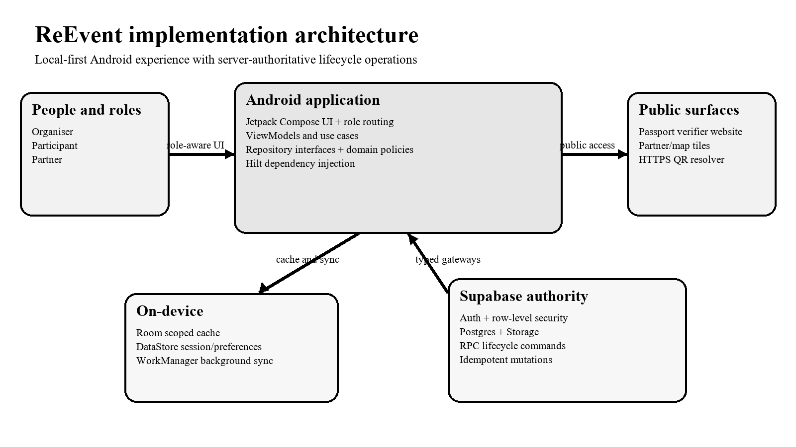
Figure 1: ReEvent system architecture

Remote, public and device services
Supabase Auth, Postgres, Storage, row-level security, and typed RPC gateways provide the authoritative multi-user boundary. Critical lifecycle mutations include idempotency keys and are not completed offline. The public website resolves opaque passport tokens without revealing private record identifiers. MapLibre/MapTiler supports partner discovery, ZXing renders QR codes, and ML Kit supports scanning.
The local-first design improves responsiveness and read availability, while server authority protects shared quantities, permissions, custody, and completion states from conflicting device-side assumptions. Clear package boundaries, typed models, repository interfaces, and focused domain policies keep the implementation organised and make individual features easier to maintain.

Implemented Functionalities and Completeness

End-to-end user journeys
An organiser can authenticate, create an event, record a resource and photo, publish it or route it to a programme, review requests, authorise a handover, and observe the completed outcome. A participant can discover a listing, request an eligible quantity, follow the handover/receipt or return path, and display an authorised passport. A partner can publish recovery programmes, appear in discovery, receive compatible requests, and operate the relevant workbench. Public users can resolve a valid passport URL through the verifier website.
Table 3: Implemented functionality
Capability | Implementation | Status
Authentication and role routing | Supabase-backed identity, session handling and role-specific destinations. | Completed
Events and resources | Typed models, Room/cache boundaries, create/edit/status workflows and validation. | Completed
Resource photos | Persisted local/remote metadata and Storage integration. | Completed
Marketplace | Published listings, request quantities, eligibility and server-side lifecycle decisions. | Completed
Digital passports and QR | Opaque HTTPS v1 payloads, validation and public verifier routing. | Completed
Partner programmes/map | Programme authoring/discovery, map presentation and geocoding safeguards. | Completed
Smart/Circular Matching | Deterministic condition/material/location ranking with explanations. | Completed
Impact dashboard | Completed-transaction summaries and guarded numeric estimates. | Completed
Offline behaviour | Scoped cache and read continuity; shared mutations remain online-only to protect consistency. | Completed
Account deletion | Coordinated server and application deletion workflow. | Completed
Public passport website | Public resolution of authorised passport links through opaque tokens. | Completed

Lifecycle integrity and data boundaries
A lifecycle command gateway turns user intent into typed Supabase RPC calls. The server validates actors, resource side, quantities, open listings, category/condition acceptance, custody, and state transitions. Idempotency keys make retries safe and prevent the same client intention from being applied as a different operation. Failure codes are classified so the UI can distinguish retryable transport problems from terminal rule violations.

Matching and impact claims
Smart/Circular Matching uses a deterministic rules engine. It rejects inactive or empty resources, orders routes by condition, filters active programmes by material, considers location compatibility, and returns an explanation for the recommended route. The transparent result helps users understand why reuse, donation, repair, resale, or recycling is suggested.
Impact totals are derived from completed transactions and valid impact records. The only current numeric emissions estimate is a demonstration for completed plastic/acrylic recycling recorded in kilograms, using a documented factor of 1.59710826 kgCO2e per kilogram. The factor is derived from UK Government 2025 conversion-factor material and is presented as a conservative product estimate, not a full life-cycle assessment (Department for Energy Security and Net Zero, 2025). When evidence is absent, the application displays an unavailable reason instead of inventing a value.

UI/UX Design and Creativity
The implementation evolves the proposal into an editorial, task-focused interface. Role-specific navigation reduces irrelevant choices; prominent states explain loading, emptiness, connectivity, permission, and validation outcomes; and adaptive Compose layouts support different phone dimensions. Dark green, neutral surfaces, strong hierarchy, and restrained cards preserve the sustainability identity without allowing decoration to obscure workflow state.

Final UI evidence placeholders
The reserved figure areas below are sized for screenshots from the final ReEvent application. The existing captions are connected to the automatic List of Figures and can be retained when each image is inserted.
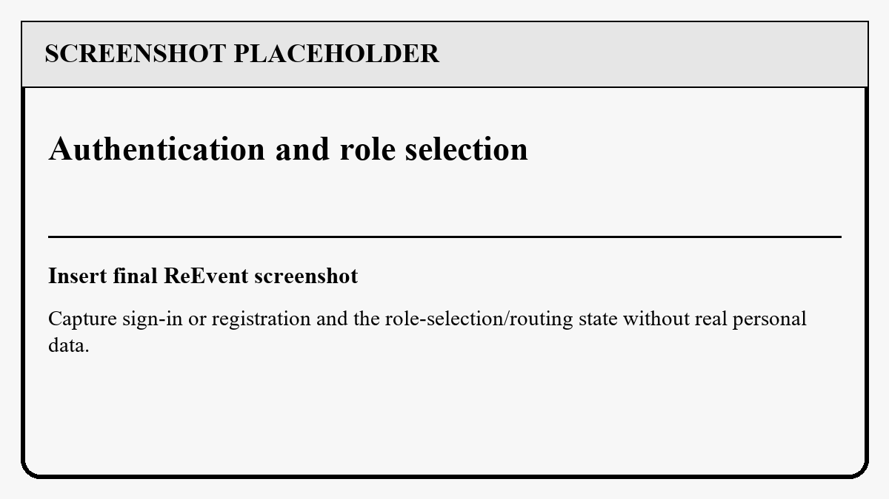  Figure 2: Authentication and role selection | 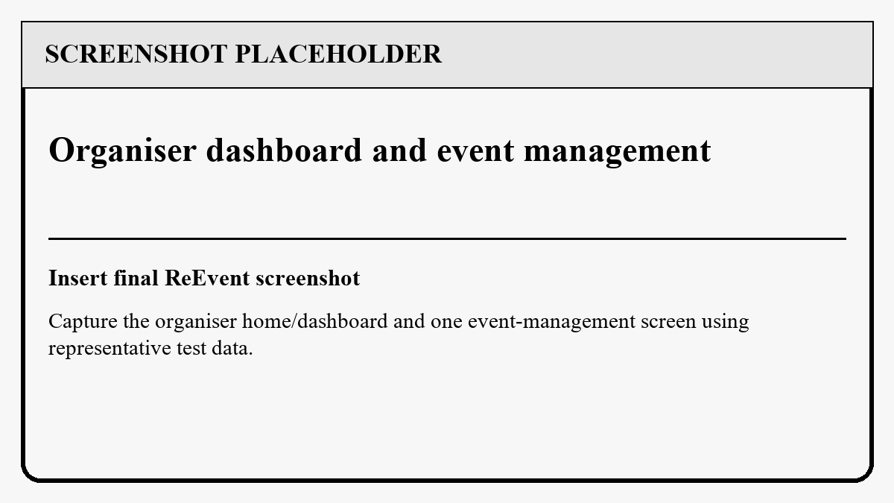  Figure 3: Organiser dashboard and event management
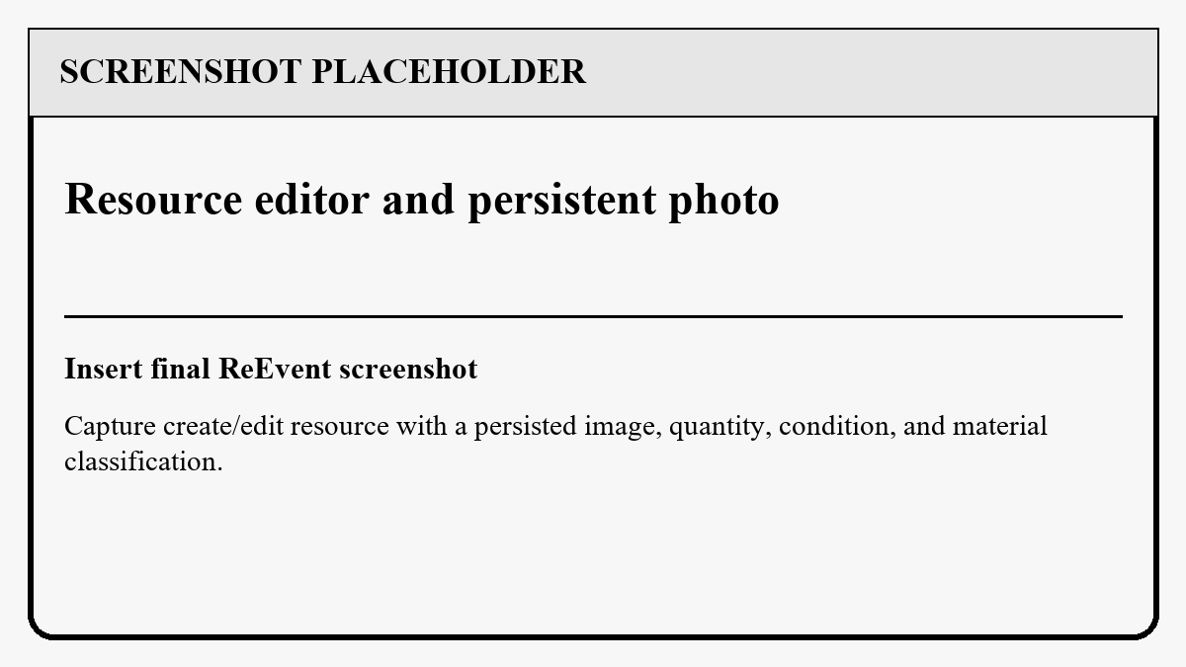  Figure 4: Resource editor and persistent photo | 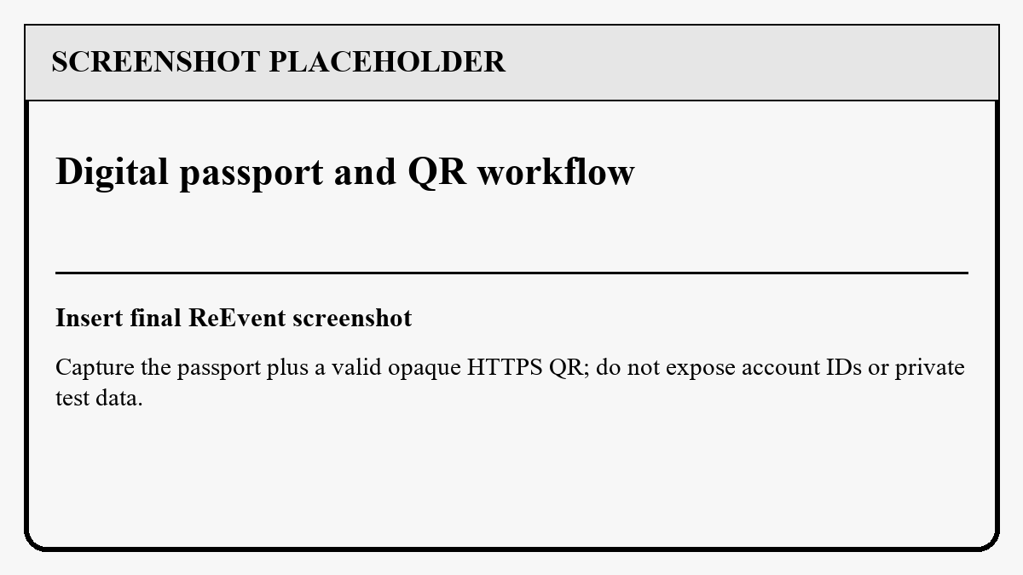  Figure 5: Digital passport and QR workflow

Role workflows and visual continuity
The organiser's view emphasises event and recovery management; the participant's view emphasises discovery, requests, passports and returns; and the partner's view emphasises programmes, compatible resources and operational decisions. The following placeholders cover the remaining recovery, matching and impact surfaces.
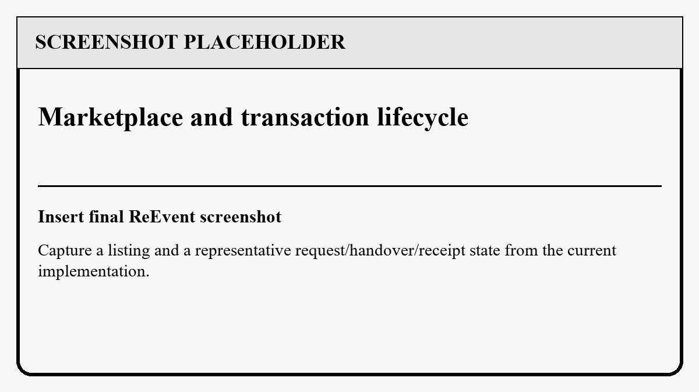  Figure 6: Marketplace and transaction lifecycle | 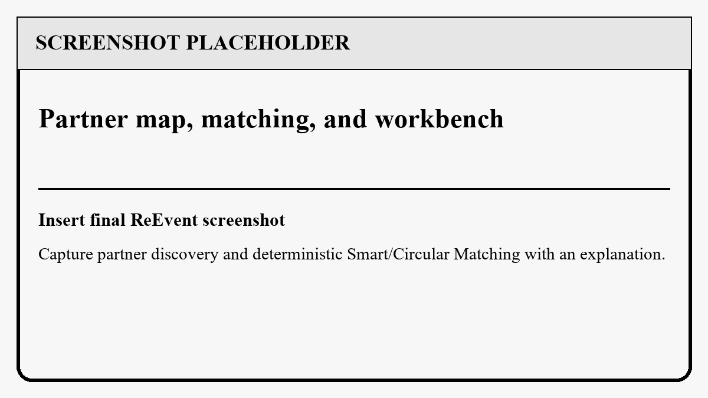  Figure 7: Partner map, matching, and workbench
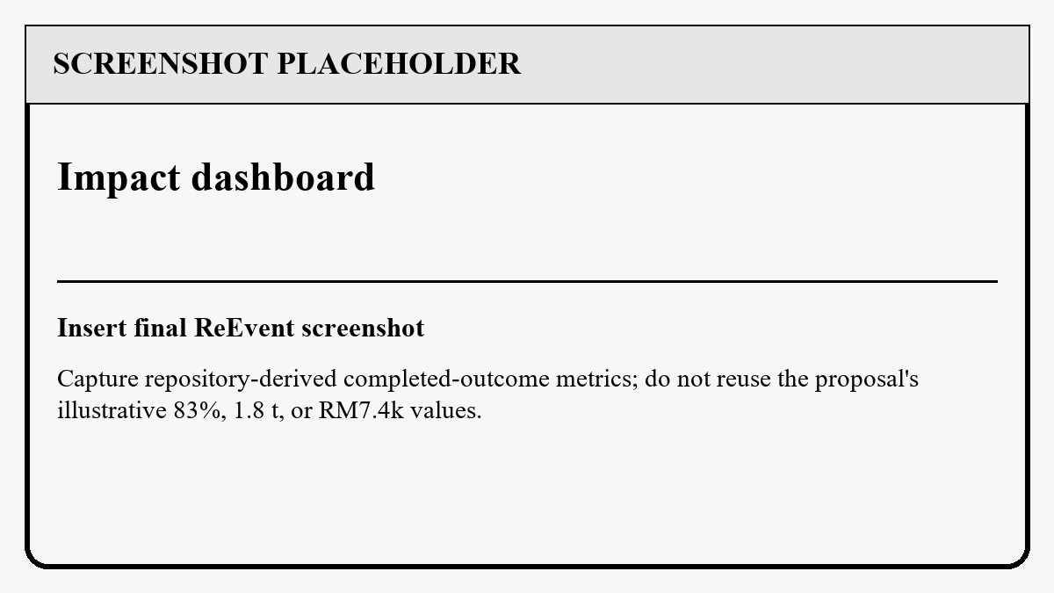  Figure 8: Impact dashboard | Reserved for an additional screenshot if required.
The placeholders preserve consistent image proportions and caption positions across the seven key interfaces.

Team Contributions
Development responsibilities were divided by feature area and integrated through the shared ReEvent repository. Each member contributed to a distinct part of the implemented workflow while supporting integration and review across the application.
Table 4: Member roles and contributions
Member | Primary contribution areas
Liew Kaiy Bin (2302391) | Core platform, authentication, persistence, Supabase integration, and application integration.
Mah Juin Hong | Marketplace, listing interactions, and partner programme workflows.
Wong Jie Ying (2401105) | Event and resource lifecycle, interface implementation, photos, passports, and QR workflow.
Wong Loong Jie (2302662) | Circular matching, impact reporting, quality review, and deployment preparation.

GitHub contribution evidence
The figure below is reserved for a GitHub commit-history or contributor-insights screenshot that shows the repository and the contribution record for all group members.
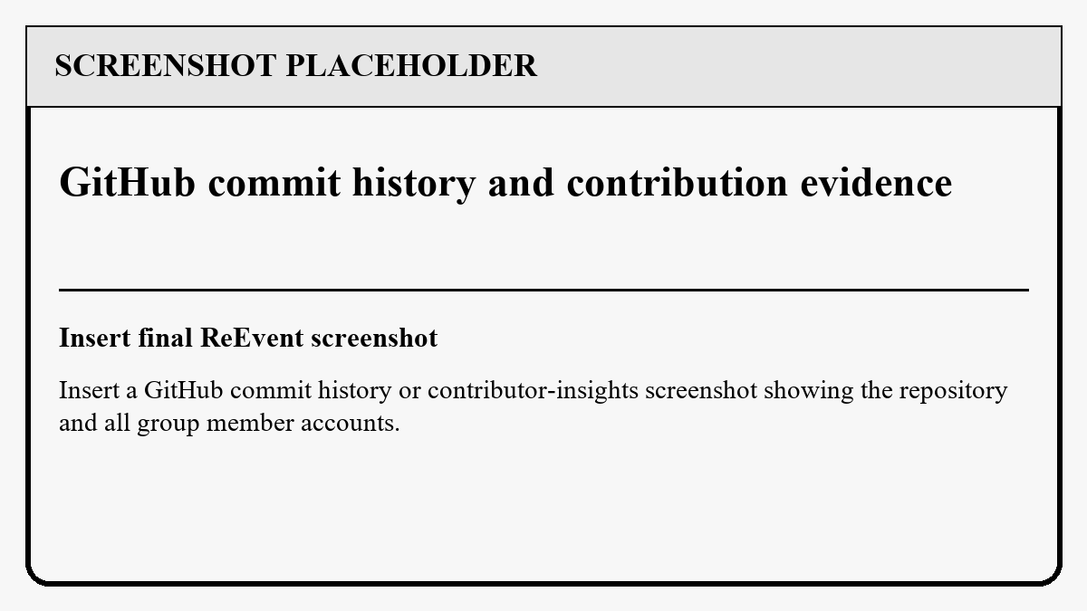
Figure 9: GitHub commit history and contribution evidence

Civil and Commercial Potential
ReEvent can support universities, municipal councils, event organisers, venues, NGOs, reuse networks, repairers and recycling partners. A campus could retain ownership and condition history for reusable staging assets; a venue could expose surplus resources after an exhibition; and a recovery partner could publish accepted materials, service areas and programme rules. Commercial pathways include organisation workspaces, managed partner networks, compliance exports, verified material passports, and service fees for coordinated recovery, while civil deployments may prioritise open access and community redistribution.

Limitations and risks
Shared lifecycle actions and public passport verification require network access because authoritative quantities, permissions, and custody changes are held by the server.
Map and geocoding functions depend on provider availability, valid configuration, usage quotas, attribution, and service terms.
Impact figures depend on accurate resource quantities, compatible measurement units, completed transaction records, and documented conversion factors.
Public passport access requires controlled token issuance, revocation, privacy review, and operational monitoring.
The value of programme matching grows with the number and coverage of participating recovery partners.

Future enhancements
Future releases can extend organisation-level dashboards, downloadable sustainability reports, multilingual content, accessibility options, partner onboarding tools, and additional material conversion factors. With sufficient consented historical data, the existing transparent matching rules could also support an optional learned ranking layer while retaining explanations and a deterministic fallback. Wider deployment can include production monitoring and additional mobile distribution channels.

Conclusion
ReEvent delivers a complete circular event-resource workflow with role-aware journeys, traceable resources, authoritative lifecycle commands, privacy-conscious passports, deterministic recovery matching, and evidence-led impact reporting. By connecting organisers, participants, and recovery partners around the same resource history, the application converts the proposal's circular-event concept into a practical platform that supports responsible consumption and recovery decisions.

References
Department for Energy Security and Net Zero. (2025). Greenhouse gas reporting: Conversion factors 2025. UK Government. https://www.gov.uk/government/publications/greenhouse-gas-reporting-conversion-factors-2025
ReEvent Group. (2026). ReEvent proposal [Unpublished group assignment proposal]. Universiti Tunku Abdul Rahman.
United Nations. (n.d.). Goal 12: Ensure sustainable consumption and production patterns. Sustainable Development Goals. https://sdgs.un.org/goals/goal12

Appendix A — Privacy-conscious QR payload contract
Table 5: Appendix A — Privacy-conscious QR payload contract metadata
File path | Purpose | Contributor
ReEvent\app\src\main\java\com\reevent\app\feature\passports\PassportQrPayload.kt | Creates and validates the canonical HTTPS verifier URL while rejecting malformed or unconfigured values. | Wong Jie Ying

47 is Validation.Canonical -> RenderResult.Ready(value)
48 Validation.Legacy -> RenderResult.Unavailable(
49 "This legacy passport must be reissued before it can be shown as a return QR."
50 )
51 is Validation.Invalid -> RenderResult.Unavailable(
52 "This passport is not a renderable ReEvent v1 QR. Refresh it or ask the organiser to reissue it."
53 )
54 }
55 }
56
57 /** Returns a renderable v1 QR URL only when this build has a valid HTTPS verifier host. */
58 fun canonicalPayload(publicBaseUrl: String, publicToken: String): String? {
59 if (!tokenPattern.matches(publicToken)) return null
60 val base = configuredBaseUri(publicBaseUrl) ?: return null
61 val basePath = base.rawPath.orEmpty().trimEnd('/')
62 return "${base.scheme}://${base.authority}$basePath/$PATH_SEGMENT/$VERSION_SEGMENT/$publicToken"
63 }
64
65 fun validate(payload: String, publicBaseUrl: String): Validation {
66 val value = payload.trim()
67 if (value != payload || value.isEmpty()) return Validation.Invalid("Use the complete ReEvent passport QR value.")
68 if (value.startsWith("reevent://")) return validateLegacy(value)
69
70 val configuredBase = configuredBaseUri(publicBaseUrl)
71 ?: return Validation.Invalid("Passport verifier is not configured in this build. Configure PUBLIC_BASE_URL before scanning v1 codes.")
72 val uri = parseUri(value) ?: return Validation.Invalid("This is not a valid ReEvent passport QR code.")
73 val basePath = configuredBase.rawPath.orEmpty().trimEnd('/')
74 val expectedPrefix = "$basePath/$PATH_SEGMENT/$VERSION_SEGMENT/"
75 val token = uri.rawPath?.removePrefix(expectedPrefix)
76
77 return if (
78 uri.scheme.equals("https", ignoreCase = true) &&
79 uri.host.equals(configuredBase.host, ignoreCase = true) &&
Excerpt note: This is a focused implementation excerpt rather than a complete source listing. The repository version remains authoritative.

Appendix B — Circular Matching Excerpt
Table 6: Appendix B — Circular Matching Excerpt metadata
File path | Purpose | Contributor
ReEvent\app\src\main\java\com\reevent\app\feature\matching\CircularRecommendationEngine.kt | Ranks eligible recovery routes by resource state, material compatibility and location, returning an explanation rather than an opaque AI score. | Wong Loong Jie

11 fun recommend(
12 resource: ResourceItem,
13 programmes: List<CircularProgramme>,
14 eventLocation: String = ""
15 ): RecommendationResult {
16 if (resource.status != ResourceStatus.ACTIVE) {
17 return RecommendationResult(
18 primary = null,
19 alternatives = emptyList(),
20 ineligibilityReason = "This resource is not available for a new recovery route."
21 )
22 }
23 if (resource.quantity <= 0.0) {
24 return RecommendationResult(
25 primary = null,
26 alternatives = emptyList(),
27 ineligibilityReason = "This resource has no available quantity for a new recovery route."
28 )
29 }
30
31 val rankedProgrammes = rankProgrammes(resource, programmes, eventLocation)
32 val usedProgrammeTypes = mutableSetOf<ProgrammeType>()
33 val candidates = actionOrder(resource.condition).mapNotNull { action ->
Excerpt note: This is a focused implementation excerpt rather than a complete source listing. The repository version remains authoritative.

Appendix C — Impact calculation guardrails
Table 7: Appendix C — Impact calculation guardrails metadata
File path | Purpose | Contributor
ReEvent\app\src\main\java\com\reevent\app\feature\impact\ImpactCalculator.kt | Uses completed transactions and valid impact records, and reports why estimates are unavailable. | Wong Loong Jie

11 fun summarize(
12 resources: List<ResourceItem>,
13 transactions: List<CircularTransaction>,
14 records: List<ImpactRecord>
15 ): ImpactDashboardState {
16 val completed = transactions.filter { it.status == TransactionStatus.COMPLETED }
17 val reused = completed.count { it.type == TransactionType.BORROW || it.type == TransactionType.RENT }
18 val repaired = completed.count { it.type == TransactionType.REPAIR }
19 val donated = completed.count { it.type == TransactionType.DONATE }
20 val recycled = completed.count { it.type == TransactionType.RECYCLE }
21 val recovered = resources.count { it.status == ResourceStatus.RECOVERED }
22 val rate = resources.takeIf { it.isNotEmpty() }?.let { recovered.toFloat() / it.size }
23 val completedTransactionIds = completed.map(CircularTransaction::id).toSet()
24 val validRecords = records.filter {
25 it.transactionId in completedTransactionIds &&
26 (it.materialDivertedKg == null || it.materialDivertedKg.isFinite() && it.materialDivertedKg >= 0) &&
27 (it.emissionsAvoidedKg == null || it.emissionsAvoidedKg.isFinite() && it.emissionsAvoidedKg >= 0) &&
28 it.recoinsTransferred >= 0 && it.recoinsRewarded >= 0
29 }
30 val hasRecords = validRecords.isNotEmpty()
31 val estimatedTransactionIds = validRecords
32 .filter { it.materialDivertedKg != null || it.emissionsAvoidedKg != null }
33 .map(ImpactRecord::transactionId)
34 .toSet()
35 val hasCompletedOutcomeWithoutEstimate = completed.any { it.id !in estimatedTransactionIds }
36 val channels = listOf(reused, repaired, donated, recycled)
37 val channelTotal = channels.sum()
38 val badge = when {
39 recovered == 0 -> null
40 rate != null && rate >= 0.75f -> ImpactBadge.HIGH_RECOVERY
41 recovered >= 3 -> ImpactBadge.CIRCULAR_STARTER
42 else -> ImpactBadge.FIRST_RECOVERY
Excerpt note: This is a focused implementation excerpt rather than a complete source listing. The repository version remains authoritative.

Appendix D — Server-authoritative lifecycle gateway
Table 8: Appendix D — Server-authoritative lifecycle gateway metadata
File path | Purpose | Contributor
ReEvent\app\src\main\java\com\reevent\app\core\network\LifecycleCommandGateway.kt | Converts typed commands into idempotent Supabase RPC requests so shared lifecycle state is decided by the server. | Liew Kaiy Bin

46 interface LifecycleCommandGateway {
47 fun isConfigured(): Boolean
48 suspend fun resolvePublishedListingId(resourceId: String): String
49 suspend fun execute(
50 type: LifecycleCommandType,
51 payload: LifecycleCommandPayload,
52 idempotencyKey: String
53 ): CircularTransaction
54 }
55
56 @Singleton
57 class SupabaseLifecycleCommandGateway @Inject constructor(
58 private val authGateway: SupabaseAuthGateway
59 ) : LifecycleCommandGateway {
60 override fun isConfigured(): Boolean = authGateway.isConfigured()
61
62 override suspend fun resolvePublishedListingId(resourceId: String): String =
63 authGateway.withConfiguredClient { client ->
64 client.from("marketplace_listings").select {
65 filter {
66 eq("resource_id", resourceId)
67 eq("status", "PUBLISHED")
68 }
69 }.decodeSingle<ListingReference>().id
70 }
71
72 override suspend fun execute(
73 type: LifecycleCommandType,
74 payload: LifecycleCommandPayload,
75 idempotencyKey: String
76 ): CircularTransaction = when (type) {
77 LifecycleCommandType.REQUEST_MARKETPLACE -> rpc(
78 "request_listing_transaction",
79 buildJsonObject {
80 put("p_listing_id", payload.require(LifecycleCommandPayload::listingId, "listingId"))
81 put("p_transaction_type", payload.require(LifecycleCommandPayload::transactionType, "transactionType"))
82 put("p_quantity", payload.require(LifecycleCommandPayload::quantity, "quantity"))
83 put("p_counter_resource_id", payload.counterResourceId?.let(::JsonPrimitive) ?: JsonNull)
84 put("p_request_reason", payload.reason?.let(::JsonPrimitive) ?: JsonNull)
85 put("p_idempotency_key", idempotencyKey)
86 }
87 )
Excerpt note: This is a focused implementation excerpt rather than a complete source listing. The repository version remains authoritative.

