With the prepared disk, the Ceph cluster was configured directly from the Proxmox web interface. First, the necessary Ceph packages were installed on each node. The initial cluster configuration was then defined, setting the public network to the 172.25.5.0/24 subnet and designating pmox01 as the first Ceph Monitor (MON). To ensure high availability and a stable quorum, monitors were subsequently created on pmox02 and pmox03 (Figure X.5). 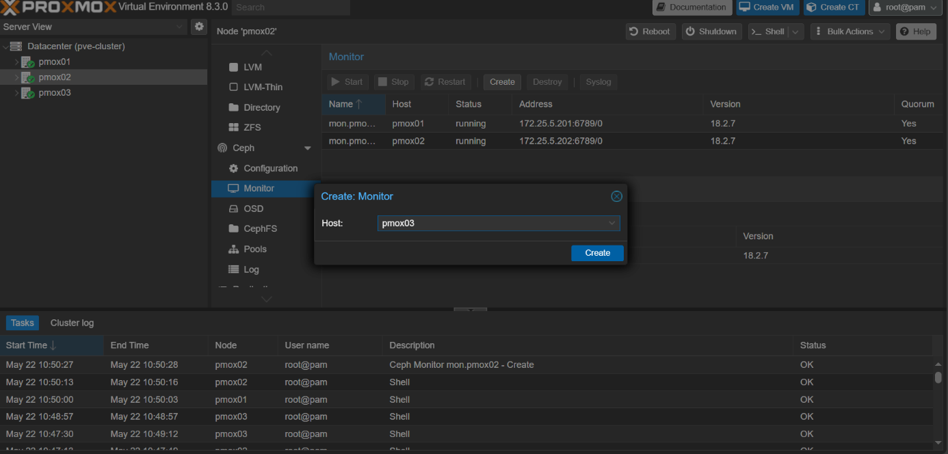
Figure X.5: Creation of Additional Ceph Monitors for Quorum
The core of the storage infrastructure was built by creating the OSDs. On each of the three nodes, the newly created partition (/dev/sda4) was selected and transformed into an OSD, contributing its capacity to the distributed storage pool (Figure X.6).
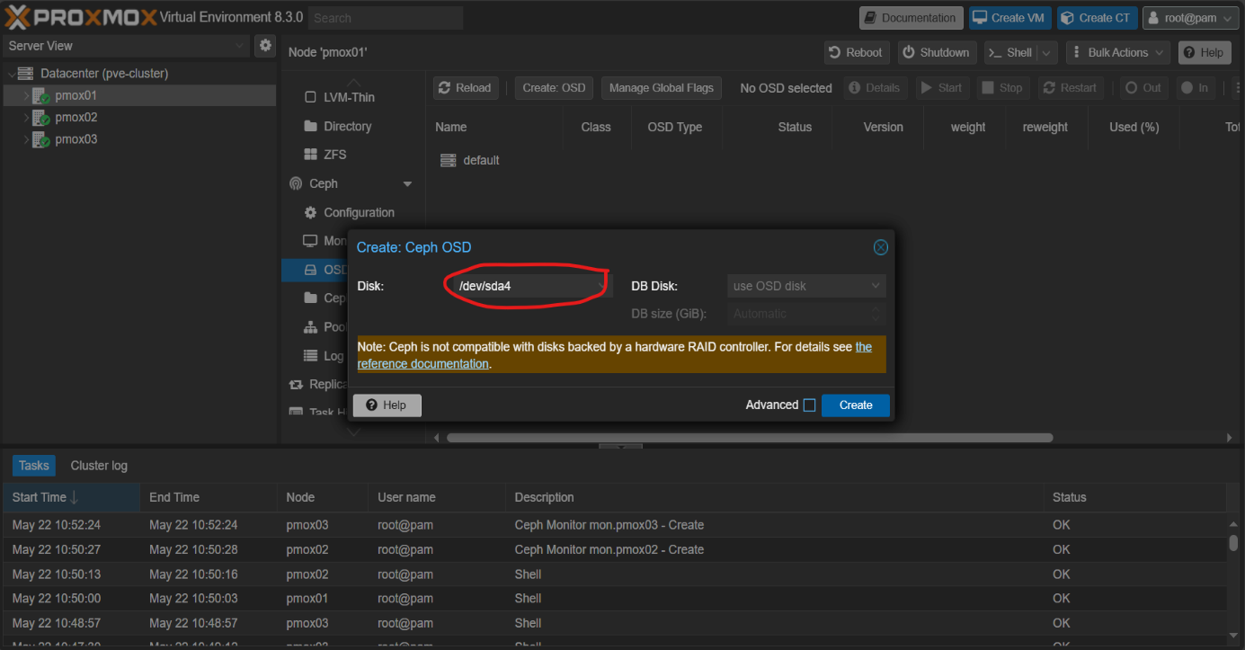
Figure X.6: Creating a Ceph Object Storage Daemon (OSD) on the Prepared Partition
With the underlying storage infrastructure in place, two distinct types of storage were provisioned. First, a replicated pool named pmoxpool01 was created to provide resilient block storage (RBD) for virtual machine disks. As shown in Figure X.7, this pool was configured with a replication size of three and a minimum size of two. This configuration directly fulfills the research objective of ensuring data resilience, as the system can tolerate the complete failure of one node without data loss for stored VM disks.
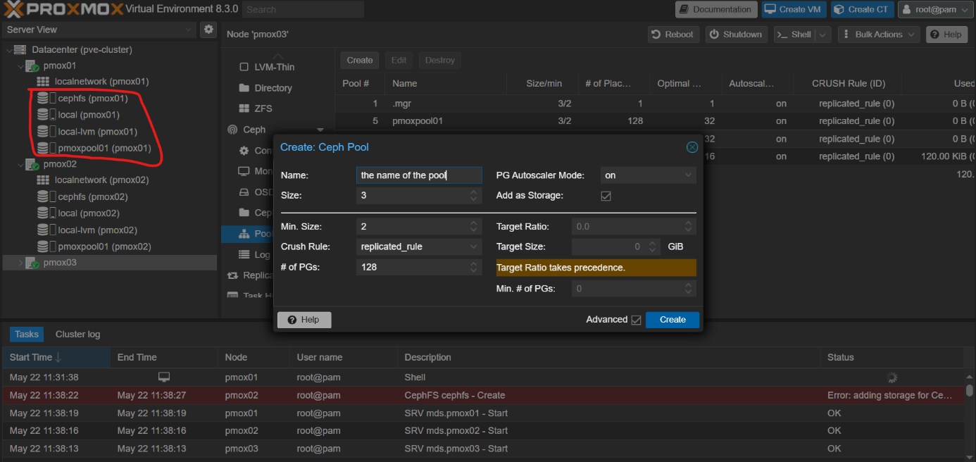
Figure X.7: Creation and Configuration of the 'pmoxpool01' Replicated Pool
Second, to provide shared file storage, a CephFS file system named cephfs was created (Figure X.8). This process involved setting up the necessary data and metadata pools and deploying redundant Metadata Servers (MDS) across the cluster for fault tolerance.
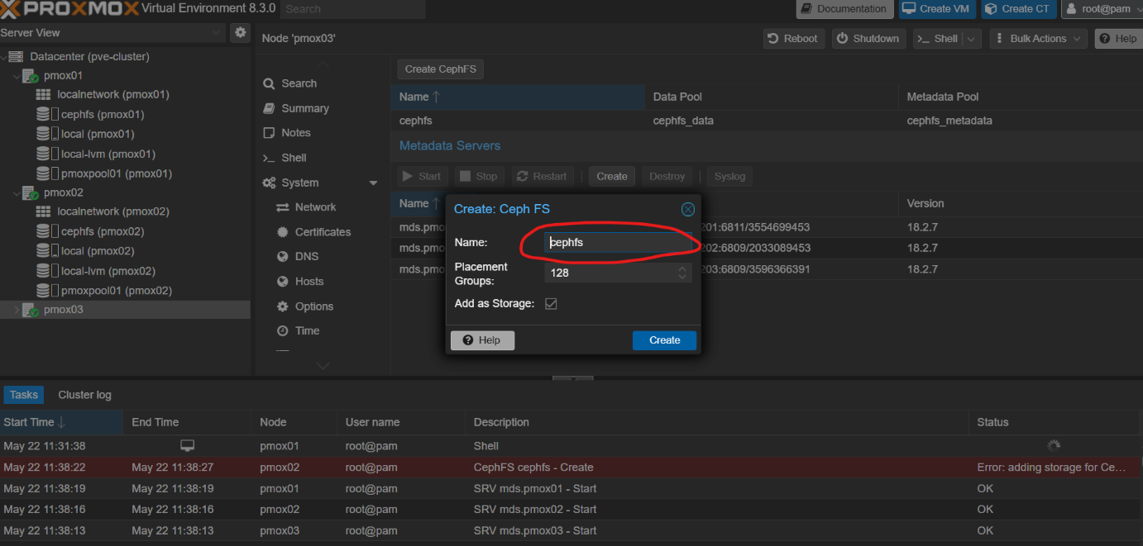
Figure X.8: Creation of the CephFS File System
With the OSDs contributing storage, the MONs ensuring quorum, the replicated pool providing resilient block devices, and CephFS offering shared file storage, the hyper-converged storage layer is now complete. The culmination of these steps is a unified, resilient, and fully operational storage platform integrated directly within the Proxmox cluster.
X.3.5.2 Automated Backups for Data Protection
While High Availability protects against immediate service loss, automated backups are essential for disaster recovery and protection against data corruption or accidental deletion. A pool-based backup strategy was implemented to streamline this process for the Kubernetes cluster.
- Creating a Resource Pool: A resource pool named Backup-vms-pool was created specifically for the virtual machines comprising the Kubernetes environment (Figure X.16).
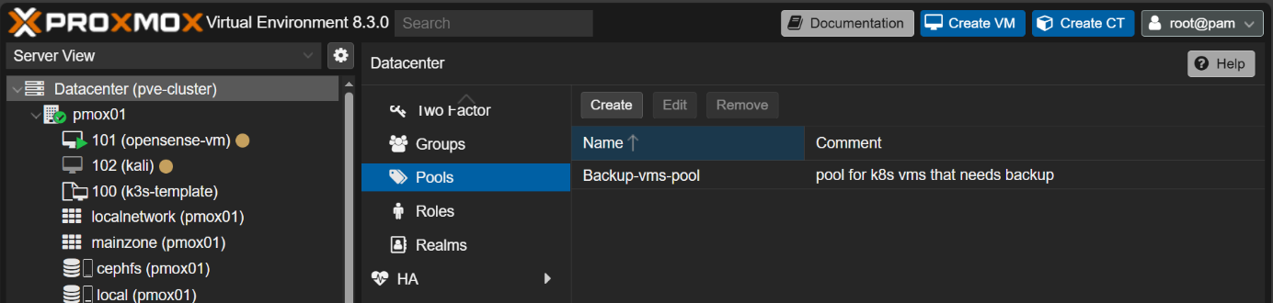
Figure X.16: Creation of the Backup-vms-pool
All control-plane and worker-node VMs were added as members to this pool, providing a single entity to target for backup operations (Figure X.19).
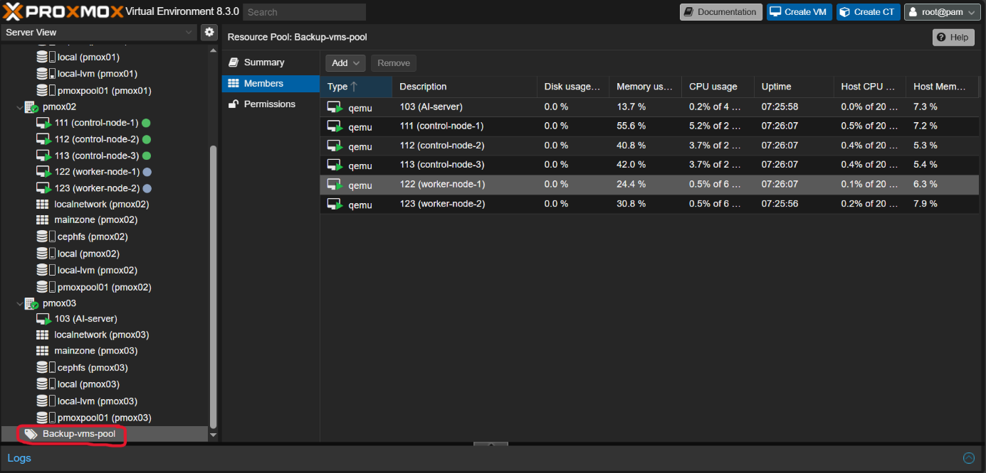
Figure X.19: The members of the Backup-vms-pool
- Configuring the Backup Job: A scheduled backup job was configured to target this specific pool. As detailed in Figure X.20, the job was set up with the following key parameters:
  - Selection Mode: Pool based, targeting the Backup-vms-pool.
  - Storage: cephfs, leveraging the distributed and resilient file system created earlier to store the backup archives.
  - Schedule: A frequent schedule (*/30, every 30 minutes) was configured to minimize potential data loss.
  - Mode: Snapshot, ensuring live, point-in-time consistency of the running VMs without requiring downtime.
  - Compression: ZSTD, providing a good balance between backup speed and storage efficiency.
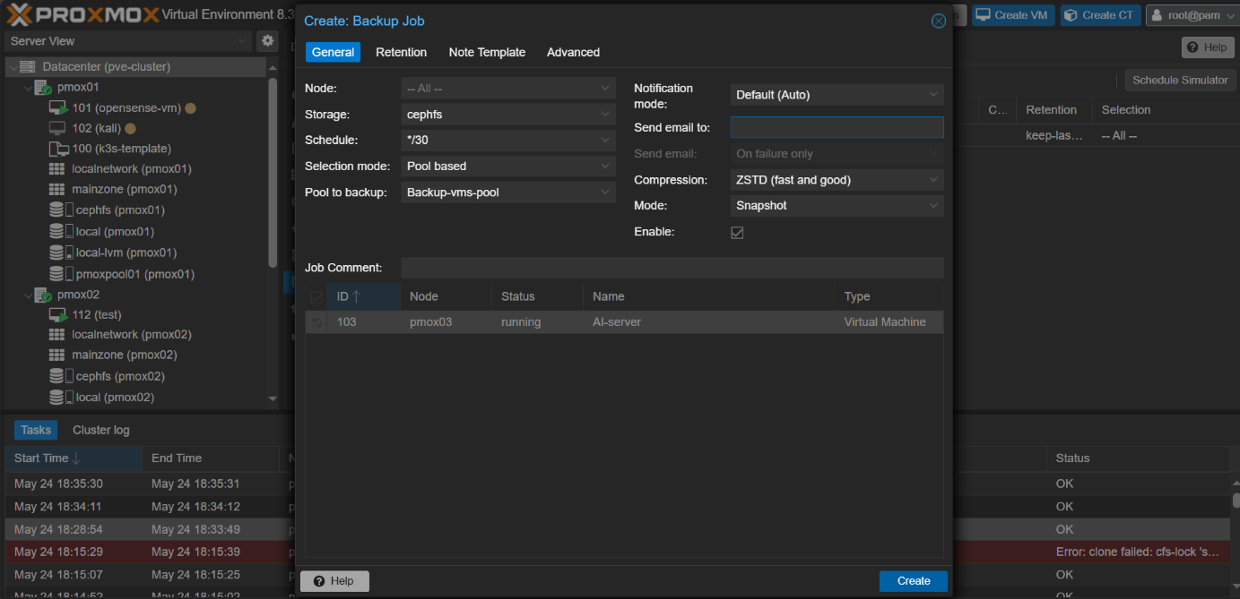
Figure X.20: Configuration of the pool-based backup job
Together, the HA and automated backup configurations create a multi-layered resilience strategy, protecting the system against both immediate hardware failures and long-term data loss, thereby ensuring the integrity and availability of the entire platform.

X.5.4 System Maintenance and Backup Strategy
A two-tiered backup strategy was implemented to ensure both high-frequency data protection for critical workloads and comprehensive disaster recovery for the entire system.
- High-Frequency Snapshot Backups: A backup job was configured to protect the most critical, dynamic workloads, including the Kubernetes cluster nodes and the AI-server. As shown in Figure X.28, this job targets the Backup-vms-pool, runs every 30 minutes, and uses the Snapshot mode. This method creates live, point-in-time backups with minimal performance impact, which is ideal for ensuring a low Recovery Point Objective (RPO) for essential services.
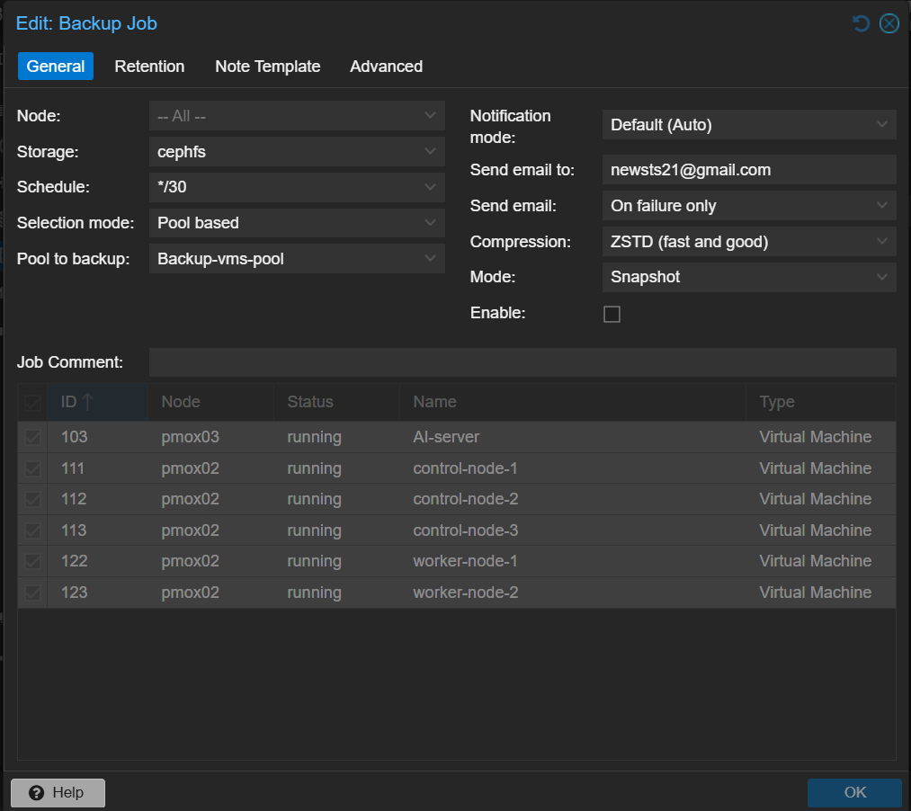
Figure X.28: The high-frequency snapshot backup job configured for the critical Backup-vms-pool.
- Daily Full Backups: A second, more comprehensive backup job was configured to protect every virtual machine on the platform. This job, detailed in Figure X.29, runs daily during an off-peak window (21:00) and uses the Stop mode. By briefly powering down each VM, this method guarantees absolute data consistency for the backup, making it suitable for full disaster recovery, albeit with a brief service interruption.
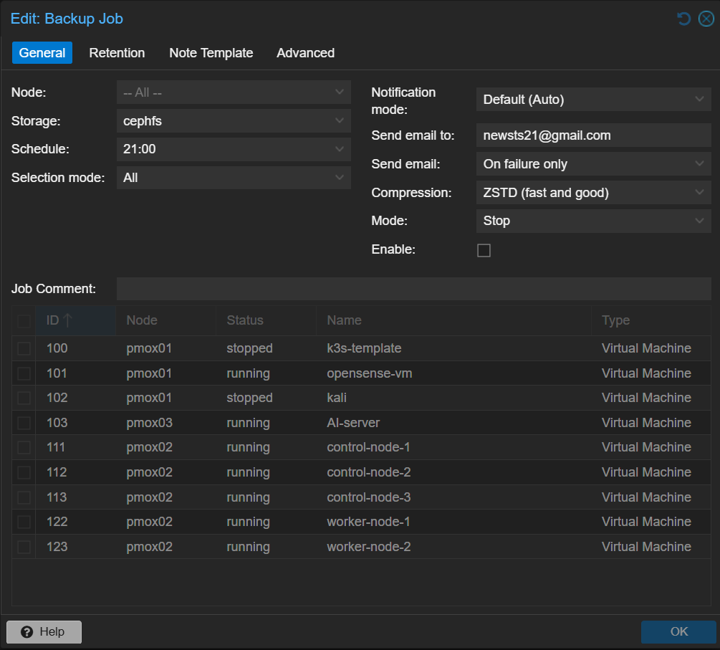
Figure X.29: The daily stop-mode backup job configured for all virtual machines.
Both backup jobs leverage the resilient cephfs storage backend, ensuring the backup data itself is stored in a distributed and fault-tolerant manner. This multi-layered strategy provides a robust solution for system maintenance and data integrity.
After install proxmox, ceph in the new physical hardware and preparing the physical disks and configurating the network of the new proxmox node throughout an automated ansible play book that we use early in .. we add the new node in the cluster and we config ceph by adding the osds and monitoring and metadata servers and the new node in the mainHA group and Apply SDN through the cluster to automatically add the result shown in figure X.Y and figure X.Y shows result before adding new node, that shows that automation-Driven Scalability is valable through the hyperviser cluster, then by simply adding specific parameter of the new worker node of k3s to terraform secript and apply it, terraform automatically notice that all 5 k3s nodes are available except this new worker node than it decide to add only this new node and that shows automatically-provisioning of vms and the final result is in figure X.Y and after adding the ip address of new worker node in file hosts.ini under [node] in the open source ansible script the k3s is automatically adding

X.6.2 Scenario 2: Multi-Layered Fault Tolerance
This scenario simulates hardware and software failures to test the multi-layered high-availability architecture.
- Hypervisor-Layer Failure (Proxmox HA): The newly added host, pmox04, was abruptly powered off. The Proxmox HA manager detected the failure and, as shown in Figure X.33, automatically migrated the worker-node-3 VM (ID 124) to a surviving host (pmox01). This seamless migration is possible because the VM's disk resides on the shared Ceph storage, accessible from all cluster nodes.
Figure X.33: Proxmox HA failover in action. The worker-node-3 VM is automatically migrated from the failed host pmox04 (left) to the healthy host pmox01 (right).
- Container-Layer Failure (k3s HA): Next, a critical control-plane node, control-node-1, was shut down. The k3s cluster's resilience was immediately evident. Figure X.34 shows the kubectl get nodes output, where control-node-1 is correctly identified as NotReady. Despite this, the cluster remains fully operational because the etcd cluster maintains quorum and Kube-vip has automatically moved the control-plane's virtual IP to a healthy master.
Figure X.34: Kubernetes cluster status during a control-plane failure, with control-node-1 showing as NotReady.
- Service Availability Verification: The ultimate test of resilience is continued application availability. As confirmed in Figure X.35, even with a master node down, all application pods for the Prometheus and Grafana monitoring stack remain in a Running state, and their LoadBalancer services are still active and exposing their external IPs. The platform successfully weathered the failure with no loss of application service.
Figure X.35: Application pods and services remain fully operational during the control-plane node failure.
This test validates the critical concept of multi-layered resilience. Both the virtualization and container orchestration layers responded autonomously to failures, working in concert to maintain infrastructure and application availability.
X.6.3 Scenario 3: End-to-End Application Deployment
This scenario uses the deployment of the Prometheus and Grafana monitoring stack as a concrete example of deploying a complex, multi-component microservices application.
- Initiation and Deployment: The entire monitoring stack was deployed by executing a single helm install command, referencing the community-approved kube-prometheus-stack chart.
- Kubernetes and MetalLB in Action: Helm translated the chart into a series of Kubernetes objects (Deployments, DaemonSets, StatefulSets, Services, etc.). The k3s scheduler distributed the pods across the cluster's worker nodes. Critically, MetalLB detected the Service objects of type LoadBalancer defined in the chart for Grafana and Prometheus and assigned them stable external IP addresses from its pool, as previously shown in Figure X.35.
- Result: The successful deployment resulted in a comprehensive, enterprise-grade monitoring solution being installed and made accessible on the network with a single command. This validates the platform's ability to abstract immense complexity and provide a simple, powerful mechanism for managing the lifecycle of cloud-native applications.

