Windows Health Monitor
A guide to how the script works
WindowsHealthMonitor.ps1, version 2.4.0
With diagrams, worked examples from your own run, and exercises
Prepared for Benn
29 October 2026
Contents
1 About this guide
2 The big picture
3 Background: what DISM and SFC do
4 The two PowerShells
5 A tour of the script file
6 PowerShell essentials, with examples from the script
7 Walking through a run
8 Your run on 29 October 2026, annotated
9 Reference
10 Lessons from the bugs we fixed
11 Try it yourself
12 Glossary
Each chapter title above is a link. In Word, hold Ctrl and click to follow it.

1 About this guide
This guide explains how WindowsHealthMonitor.ps1 works, from the big picture down to individual lines of PowerShell. It goes with the commented copy of the script in C:\temp: the comments explain each part where it sits in the code, and this guide shows how the parts fit together, with diagrams and a worked example from your own run.
You do not need to read it in one go. A good order is:
- Chapters 2 to 4 for the background: what the script is for, what DISM and SFC do, and why there are two PowerShells.
- Chapter 5 for a tour of the file, so you know where everything lives.
- Chapter 6 for the PowerShell techniques the script uses, each shown with an example from the script.
- Chapter 7 for a step-by-step walk through one run, with a diagram for every decision.
- Chapter 8 to see all of that in your own run of 29 October 2026.
- Chapters 9 to 12 for reference: options, result codes, the bugs we fixed along the way, exercises and a glossary.

1.1 Reading the diagrams
Every diagram uses the same colours, so you can tell at a glance what kind of step you are looking at:
Colour | Meaning | Example
Dark blue (filled) | The start or end of a run | "Exit with the result code"
Light blue | Something the script does | "DISM /ScanHealth"
Green | A healthy result, or a report the script writes | "Code 0: healthy"
Amber | A warning: something to act on, but not a failure | "Code 6: restart first"
Red | An error or a failed repair | "Code 3: not repairable"
Purple | Stored data: memory, files, logs | "Component store"
Diamond | A decision: the script follows one of the arrows | "Exit code 0 or 3010?"

TIP
Open the script in an editor that shows line numbers, such as Visual Studio Code or Notepad++, next to this guide. Line numbers in this guide refer to version 2.4.0 of the script (1,195 lines, including the comments). The comments never change what the script does.

2 The big picture

2.1 What problem does the script solve?
Windows keeps thousands of its own files under protection: the programs and libraries that make Windows work. They can be damaged by a power cut during an update, a failing disk, faulty memory, a bad driver or malware. Damaged system files cause strange faults: settings pages that will not open, updates that keep failing, crashes with no obvious cause.
Windows includes two tools to check and repair those files, DISM and SFC. Running them by hand works, but it is slow, the order matters, and their output is easy to misread. The script does the job for you: it runs the tools in the right order, decides automatically what each result means, repairs only when something is actually wrong, confirms every repair with a second scan, and writes clear reports.

2.2 One run in one picture
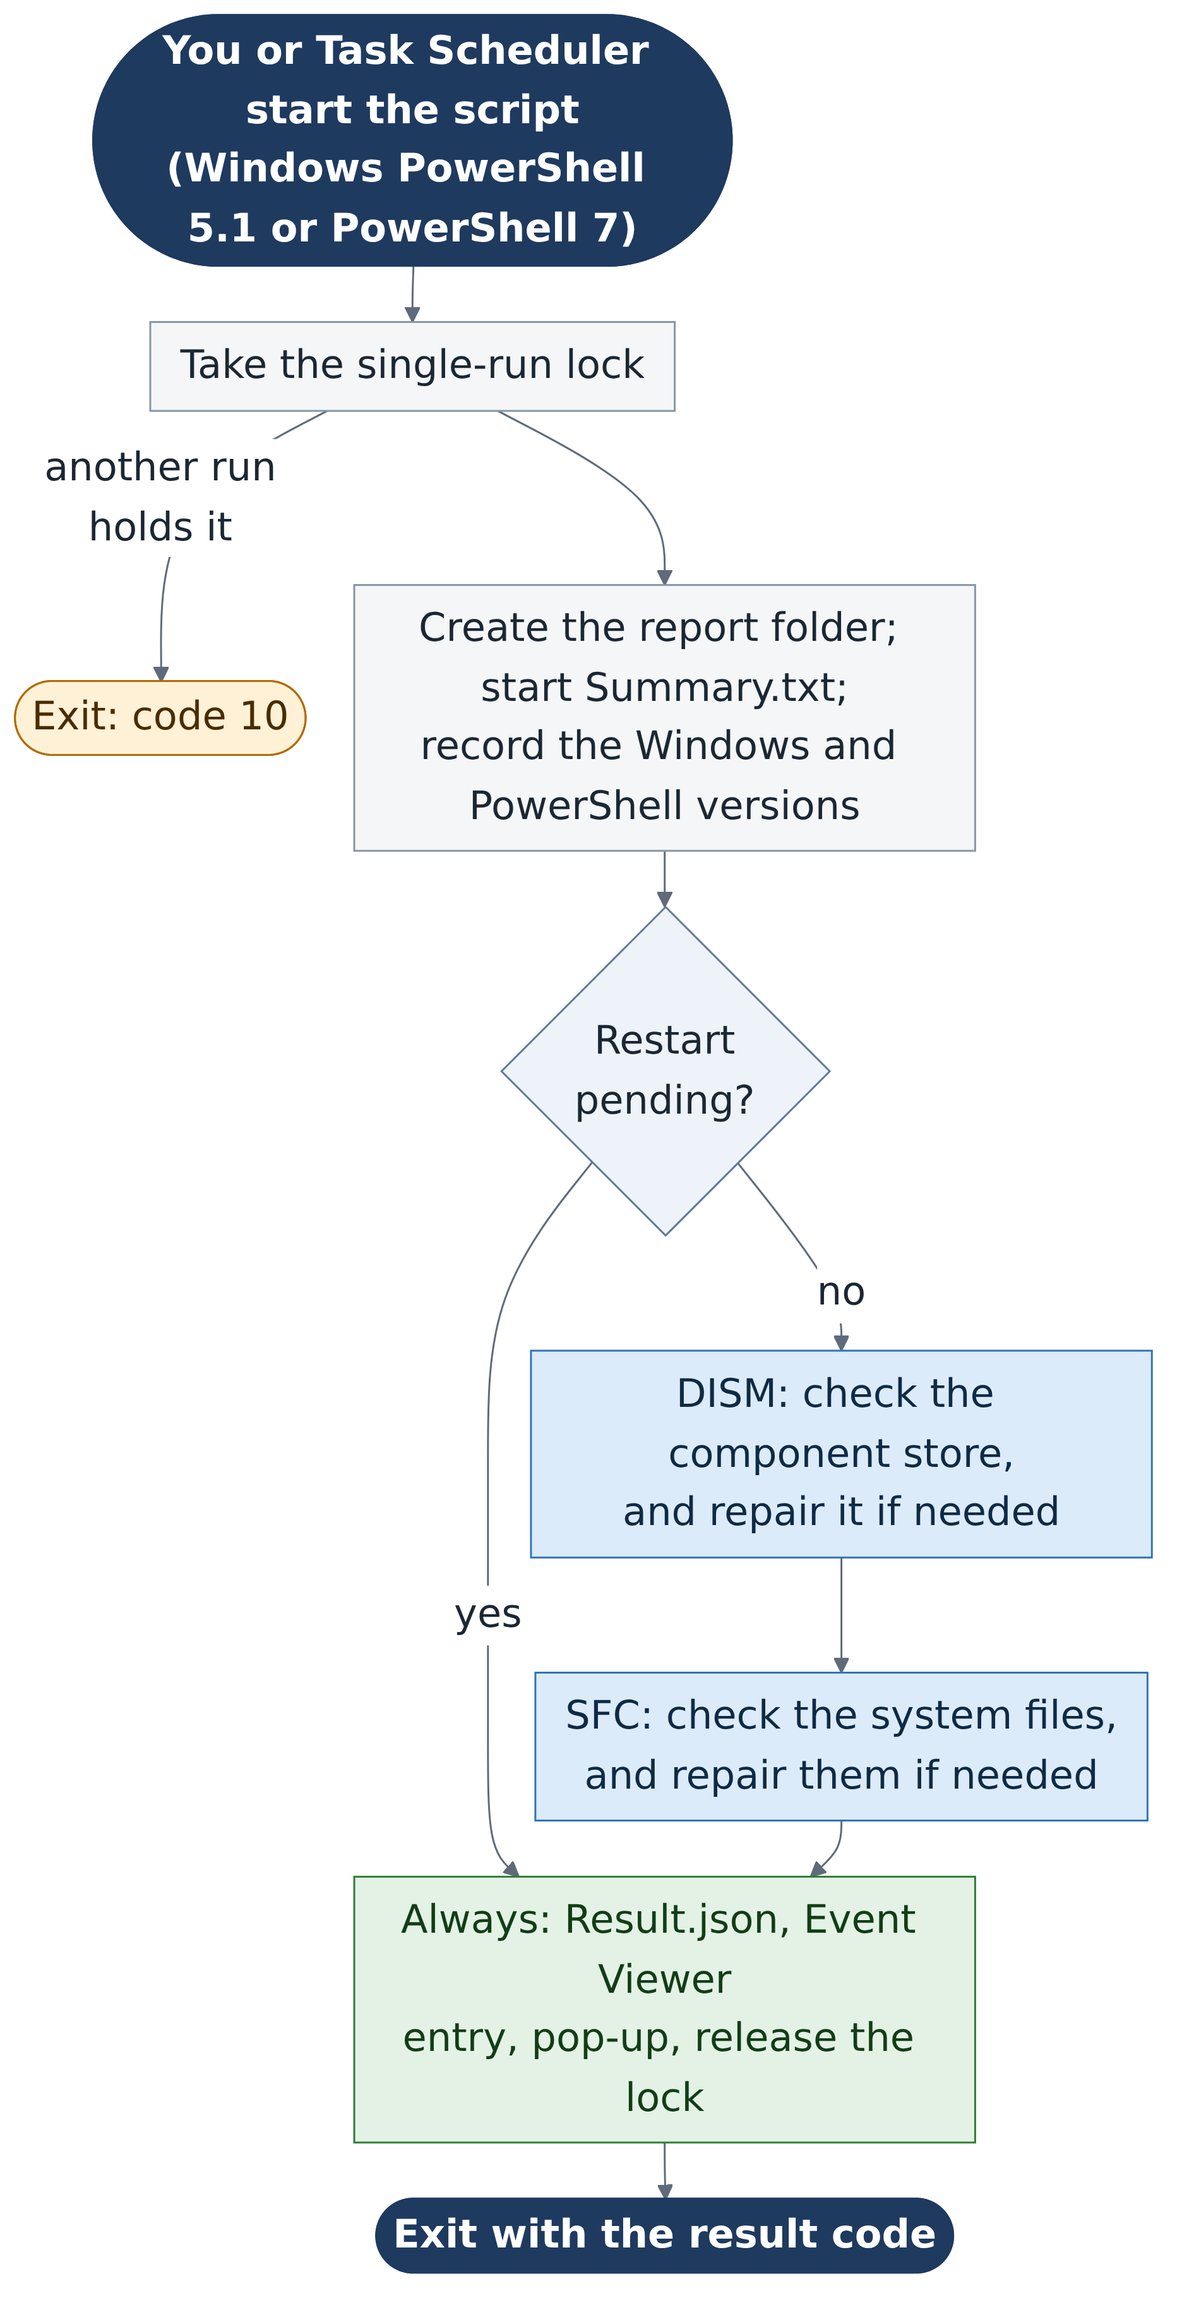
Figure 1. Everything that happens in one run, from start to finish.
Reading the diagram from the top:
- Start. You run the script by hand, or Task Scheduler runs it on a timetable, in either Windows PowerShell 5.1 or PowerShell 7 (chapter 4).
- The lock. Only one copy may run at a time. A second copy finds the lock taken and stops with result code 10.
- Reports. The script creates a dated folder for this run's reports and starts writing Summary.txt.
- Versions and pre-flight. It records the Windows and PowerShell versions, then checks two things that would make the results unreliable: a pending restart, and very low disk space.
- DISM, then SFC. The core of the script (chapters 7.7 and 7.8).
- Always. Whatever happened, it writes Result.json, an Event Viewer entry and a pop-up, releases the lock and exits with a result code.

2.3 The rules the script follows
Five design rules run through the whole script. Once you know them, many details make sense:
Rule | What it means in practice
Confirm, do not assume | A repair counts only when a second scan confirms it. DISM /RestoreHealth is followed by another /ScanHealth; SFC /scannow by another /verifyonly.
Check the exit code before the text | A program's exit code must show success before the script trusts the words it printed.
Fail visibly | The verdict starts as "failed" and only changes when a check finishes. An unrecognised result becomes code 5 (review), never code 0 (healthy).
Always report | The reports, Event Viewer entry and lock release sit in a finally block, which runs even after an unexpected error.
Never make things worse | Read-only checks come first; only one copy runs at a time; runs are skipped while a restart is pending; Windows is never restarted automatically.

3 Background: what DISM and SFC do

3.1 Master copies and working copies
Windows keeps two sets of its system files. The component store, in C:\Windows\WinSxS, holds the master copy of every Windows component. The protected system files in C:\Windows\System32 and other folders are the working copies that Windows actually runs.
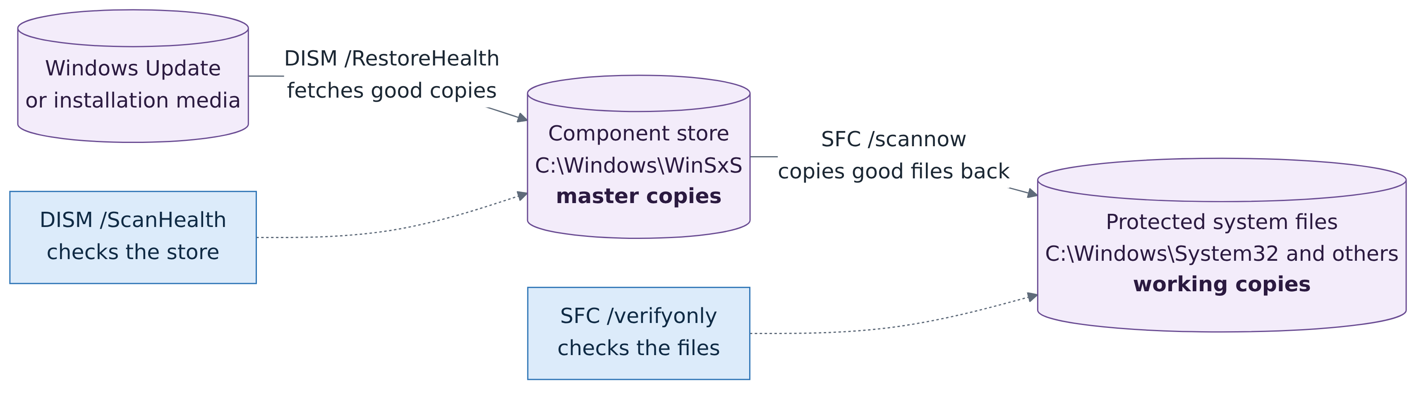
Figure 2. SFC repairs the working copies from the store; DISM repairs the store itself.
Think of a library. The component store is the reference collection that never leaves the building; the system files are the copies on loan. SFC compares each loaned copy with the reference copy and replaces any that are damaged. But if a reference copy is itself damaged, SFC would faithfully copy the damage. DISM checks the reference collection and, if necessary, orders fresh copies from the publisher: Windows Update, or installation media you supply.
KEY IDEA
That is why the order matters: DISM first, then SFC. Repair the masters before using them to repair the working copies.

3.2 The four commands the script uses
Command | What it does | Changes anything? | Time on your PC
DISM /Online /Cleanup-Image /ScanHealth | Thoroughly checks the component store and says whether it is healthy, repairable or not repairable. | No | About 1 minute
DISM /Online /Cleanup-Image /RestoreHealth | Repairs the component store, downloading good copies from Windows Update (or from -RepairSource). | Yes | Typically 5 to 30 minutes
sfc /verifyonly | Checks every protected system file against the store. | No | About 1 minute
sfc /scannow | Checks the protected files and repairs any that are damaged. | Yes | Typically 5 to 15 minutes

/Online means "the copy of Windows that is running now" (as opposed to an offline image file). The script also adds /English to DISM so that its messages are always in English, whatever language Windows uses; the script recognises results by their wording.

3.3 How a tool reports its result
Every program reports back in two ways. Its exit code is a number it hands back when it finishes: by convention 0 means success and anything else means a problem. Its output is the text it prints. The script uses both:
- DISM: the exit code must show success (0, or 3010, which means "success, but restart Windows"); then the text says what state the store is in.
- SFC: Microsoft does not document SFC's exit codes, so the text decides the result. The script still records any unusual exit code as a note.

4 The two PowerShells
Windows 11 has two separate programs called PowerShell, and the difference matters to this script.
 | Windows PowerShell 5.1 | PowerShell 7
Program | powershell.exe | pwsh.exe
Comes with Windows? | Yes, built in | No, installed separately
Updated? | No. Frozen at 5.1; it cannot be upgraded or removed | Yes, several times a year (7.6.9 is current)
Built on | .NET Framework 4.8 | Modern .NET (cross-platform)
On your PC | C:\Windows\System32\WindowsPowerShell\v1.0 | Microsoft Store version, 7.6.9

Typing powershell.exe in any window, including a PowerShell 7 window, starts Windows PowerShell 5.1 as a separate program. Typing pwsh starts PowerShell 7. That is why some of your runs reported 5.1 even though your terminal was 7.6.9.

4.1 Which PowerShell runs the script?
PowerShell 7. The project targets the latest stable PowerShell 7, and the scheduled task should start the script with pwsh.exe. Version 2.4 also still runs in Windows PowerShell 5.1, but that is no longer a requirement, so later versions may use PowerShell 7 features that 5.1 lacks. Each run records which PowerShell ran it, in the first lines of Summary.txt and in Result.json:
The two possible first lines
PowerShell: Windows PowerShell 5.1.26100.9711 (C:\WINDOWS\System32\WindowsPowerShell\v1.0\powershell.exe).
PowerShell: PowerShell 7.6.9 (C:\Program Files\WindowsApps\Microsoft.PowerShell_7.6.9.0_x64__...\pwsh.exe).

Keep PowerShell 7 up to date separately; yours comes from the Microsoft Store, which updates it automatically. One catch matters for the scheduled task: a Store app is installed for your account only, so a task that runs as SYSTEM, or "whether user is logged on or not", may not be able to start it. Installing PowerShell 7 for the whole computer with WinGet avoids that; the version 2.5 plan covers the choice.
KEY IDEA
One job per tool. Version 2.2 tried to check and install PowerShell 7 updates as well, then restart itself in PowerShell 7. That roughly doubled the script and added internet and installer failures that had nothing to do with DISM or SFC, so version 2.4 removed it. The health monitor now does one job: check and repair Windows.

4.2 Windows PowerShell 5.1 compatibility
PowerShell reads ("parses") the whole file before it runs any of it. PowerShell 7 added some new syntax, such as the shortcut $a ? $b : $c, which Windows PowerShell 5.1 cannot read: one such line would make 5.1 reject the entire file. Version 2.4 still avoids that syntax, and where PowerShell 7 can do something better it checks which edition is running: for example, $process.Kill($true) stops a whole tree of processes in PowerShell 7, while under 5.1 it uses Windows' taskkill program instead. Now that 5.1 support is no longer required, later versions can simply use the PowerShell 7 way, which makes the script shorter and simpler.

5 A tour of the script file
The script is one text file of 1,195 lines. It falls into six numbered sections, plus the help text at the top:
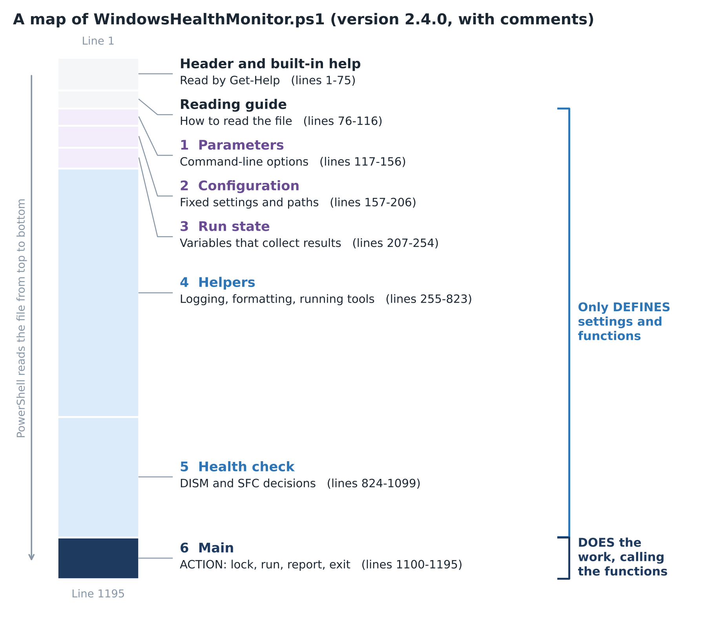
Figure 3. Where everything lives. Sections 1 to 5 only define things; section 6 does the work.
KEY IDEA
Defining is not doing. A function definition such as function Invoke-HealthCheck { ... } only teaches PowerShell a new command; nothing happens until something calls it. That is why the first 1,100 or so lines do nothing on their own. The action starts at section 6, Main (line 1100), which calls the functions defined above it.

5.1 The sections
Section | Lines | What it contains
Header and help | 1-75 | The #requires lines (PowerShell 5.1 or later, administrator rights) and the built-in help that Get-Help displays: description, result codes, options and examples.
Reading guide | 76-116 | A map of the file and a crib sheet of PowerShell basics.
1 Parameters | 117-156 | The command-line options, with their allowed values and defaults.
2 Configuration | 157-206 | Fixed settings: version number, lock name, paths to DISM and SFC, report folder names, and advice for common DISM errors.
3 Run state | 207-254 | Variables that collect the run's findings: the verdict, steps, tool runs, notes, PowerShell details and DISM/SFC states.
4 Helpers | 255-823 | Reusable functions: logging, the verdict, exit codes, reading tool output, running a tool, the pending-restart check, CBS.log, old reports, Event Viewer, the pop-up and Result.json.
5 Health check | 824-1099 | The DISM and SFC logic: Invoke-HealthCheck and Invoke-SfcScannow.
6 Main | 1100-1195 | The lock, the report folder, the check itself, and the finally block that always reports.

5.2 Every function at a glance
The script has 24 functions. Their names follow PowerShell's Verb-Noun convention, so the verb tells you the kind of job: Get fetches information, Set changes something, Test answers yes or no, Invoke runs something, Format and ConvertFrom reshape data, Add, Write, Export, Save and Show produce output.
Function | Section | Job | Called by
Write-Summary | 4 | Log a time-stamped line to the screen and Summary.txt | Almost everything
Add-Step | 4 | Record a finished check for Result.json | Health check
Set-Outcome | 4 | Set the run's verdict: result code, severity, message | Health check, Main
Add-Note | 4 | Record an observation that does not change the verdict | Various
Test-DismExitCode | 4 | Is DISM's exit code a success code (0 or 3010)? | Invoke-HealthCheck
Test-SfcExitCode | 4 | Note an unexpected SFC exit code | Health check
Get-ExitCodeHex | 4 | Show an exit code as 0x800F081F etc. | Invoke-Tool, Get-DismHint
Get-DismHint | 4 | Advice for a DISM error code | Invoke-HealthCheck
ConvertFrom-ToolOutput | 4 | Raw bytes to clean text (encoding, progress lines) | Invoke-Tool
Format-Duration | 4 | 62 seconds to "1 min 2 s" | Invoke-Tool, Main
Get-RunContext | 4 | User, 64-bit, session, script path | Save-ResultFile
Invoke-Tool | 4 | Run DISM or SFC with a time limit; save its report | Health check
Get-DismScanState | 4 | DISM's message to Healthy / Repairable / NotRepairable | Invoke-HealthCheck
Get-SfcState | 4 | SFC's message to Clean / Repaired / ViolationsFound... | Health check
Format-Size, Format-DriveSpace | 4 | The free-space line | Invoke-HealthCheck
Get-PendingRestartReason | 4 | Is Windows waiting for a restart? | Invoke-HealthCheck
Export-CbsSrLine | 4 | Copy this run's SFC lines from CBS.log | Invoke-SfcScannow
Remove-OldRunFolder | 4 | Delete reports older than 90 days | Main
Write-HealthEvent | 4 | Write the Event Viewer entry | Main
Show-ResultPopup | 4 | Show the 60-second pop-up | Main
Save-ResultFile | 4 | Write Result.json | Main
Invoke-SfcScannow | 5 | The repairing SFC scan and its confirmation | Invoke-HealthCheck
Invoke-HealthCheck | 5 | The whole DISM and SFC sequence | Main

6 PowerShell essentials, with examples from the script
This chapter explains the PowerShell techniques the script relies on. Each one comes with a real example from the script, so you will recognise it when you meet it.

6.1 Variables and scope
A variable holds a value and starts with $: $RunFolder, $scan, $exitCode. A variable created inside a function normally disappears when the function finishes; that is its scope. To share a variable between functions, the script keeps it in the script's own scope with the prefix $script:.
From sections 3 and 4
# Created once, in section 3:
$script:Notes = New-Object System.Collections.Generic.List[string]

function Add-Note {
param([Parameter(Mandatory)][string]$Text)
$script:Notes.Add($Text) # every function adds to the same list
Write-Summary "NOTE: $Text"
}

WATCH OUT
PowerShell variable names ignore capitals: $Run, $run and $RUN are the same variable. It is easy to overwrite a variable by accident this way.

6.2 Functions and parameters
A function is a named, reusable block of code. Its param(...) block lists its inputs, and attributes in square brackets check them before the function runs:
From Set-Outcome, and a call to it
function Set-Outcome {
param(
[Parameter(Mandatory)][int]$Code,
[Parameter(Mandatory)]
[ValidateSet('Information', 'Warning', 'Error')][string]$Type,
[Parameter(Mandatory)][string]$Message
)
...
}

Set-Outcome -Code 0 -Type Information -Message 'No problems found. ...'

- [Parameter(Mandatory)]: the caller must supply this input.
- [int], [string]: the type of value expected: a whole number, or text.
- [ValidateSet(...)]: only the listed words are accepted; anything else is an error.
- [switch]: an on/off option, such as -NoPopup. Typing it means on.
The script itself has a param(...) block too (section 1). Those are the options you can type on the command line.

6.3 Hashtables, ordered tables and objects
A hashtable stores name = value pairs. The script uses one to look up advice for DISM error codes:
From section 2
$DismErrorHints = @{
'0x800F081F' = 'DISM could not find the repair files. ...'
'0x800F0906' = 'DISM could not download the repair files. ...'
}
$DismErrorHints['0x800F081F'] # gives the first message

[ordered]@{ ... } is the same but keeps the entries in the order written, which keeps Result.json readable. [pscustomobject]@{ ... } creates an object with named properties, like a record card. Invoke-Tool returns one describing each tool run, and the caller reads its properties with a dot: $scan.ExitCode, $scan.TimedOut, $scan.Text.

6.4 Text: quotes, expressions and the format operator
You write | You get | Why
'Folder: $RunFolder' | Folder: $RunFolder | Single quotes: text exactly as typed
"Folder: $RunFolder" | Folder: C:\temp\Logs\... | Double quotes: variables are filled in
"Code $($scan.ExitCodeHex)" | Code 0x00000000 | $( ) runs an expression inside the text
'{0} {1}' -f $time, $text | 10:11:21 Running... | -f fills {0}, {1} ... with the values

6.5 Comparisons and regular expressions
Comparison operators are words: -eq (equals), -ne (not equal), -lt and -gt (less, greater), -ge (at least), -like (wildcards such as *\WindowsApps\*) and -match (a regular expression: a small pattern language for text).
From Get-DismScanState and Get-LatestPowerShellVersion
if ($Text -match 'No component store corruption detected') { return 'Healthy' }

if ($tag -notmatch '^v?(\d+\.\d+\.\d+)$') { throw "Unexpected tag '$tag'." }
return [version]$Matches[1] # 'v7.6.9' -> 7.6.9

Pattern piece | Means
^ and $ | The start and the end of the text
v? | An optional letter v
\d+ | One or more digits
\. | A real full stop (a bare . means "any character")
( ... ) | Capture this part; it appears in $Matches[1]

KEY IDEA
Why convert to [version]? As text, "7.6.10" sorts before "7.6.9" because the character 1 comes before 9. As a version, 7.6.10 is correctly newer. The script always compares versions as [version] values.

6.6 The pipeline
The | symbol passes the output of one command into the next. The script uses it to filter, pick and discard:
Three pipelines from the script
$lines = $text -split "`r`n|`n|`r" | Where-Object { $_ -notmatch '...progress bar...' }
$run | Select-Object Name, ExitCode, ExitCodeHex, TimedOut, DurationSeconds, OutputFile
New-Item -ItemType Directory -Path $RunFolder -Force | Out-Null

- Where-Object { ... } keeps only items for which the test is true. Inside the braces, $_ means "the current item".
- Select-Object keeps only the listed properties.
- | Out-Null throws the output away so that it does not clutter the screen.

6.7 Errors: Stop, try, catch and finally
By default PowerShell prints many errors and carries on, which can leave a script working with bad data. The script changes that at the top:
$ErrorActionPreference = 'Stop' # every error stops the current step
Set-StrictMode -Version 2.0 # using an unset variable is an error, not 'empty'

Errors then jump to the nearest catch block. A finally block runs whatever happened, which is how the script guarantees its reports:
The shape of section 6 (Main)
try {
Invoke-HealthCheck # the real work
}
catch {
Set-Outcome -Code 1 -Type Error -Message "The script failed at line ..."
}
finally {
Save-ResultFile # always happens
...
}

6.8 Using .NET directly
PowerShell is built on Microsoft's .NET platform, and can use any .NET type directly. [Type]::Member calls a built-in method of a type; New-Object creates a new object of a type.
[Environment]::Is64BitProcess # true or false
[Convert]::ToBase64String($bytes) # bytes to Base64 text
$mutex = New-Object System.Threading.Mutex($false, $MutexName)
$psi = New-Object System.Diagnostics.ProcessStartInfo

The script uses .NET where PowerShell's own commands fall short: the Process class to run DISM and SFC safely (chapter 7.6), the Mutex class for the lock (chapter 7.2), and Encoding classes to decode tool output.

6.9 Exit codes
Every program hands back a number when it finishes, its exit code. The script reads DISM's and SFC's exit codes, and hands back its own result code the same way. A small function decides whether DISM's code means success:
From Test-DismExitCode, and the script's last line
function Test-DismExitCode {
param([Parameter(Mandatory)]$Run)
if ($Run.ExitCode -eq 3010) { # success, but restart Windows
$script:State.RestartRecommended = $true
}
return ($Run.ExitCode -eq 0 -or $Run.ExitCode -eq 3010)
}

exit $script:Outcome.Code # the last line of the script

-or means "either is true". The function returns $true for 0 and 3010 and $false for anything else. The script's own exit line is what Task Scheduler shows as "Last Run Result".

7 Walking through a run
This chapter follows one run from start to finish, in the order things happen.

7.1 Starting: options and settings
When the script starts, PowerShell first fills in its parameters. Anything you did not type takes its default: -SfcMode VerifyThenRepair, DISM limit 120 minutes, SFC limit 90 minutes, keep reports 90 days. The [ValidateSet] and [ValidateRange] attributes reject bad values before anything else happens.
Sections 2 and 3 then set the fixed configuration and create the empty run state. Note one subtle line: the verdict starts as a failure.
From section 3
$script:Outcome = [pscustomobject]@{
Code = 1
Type = 'Error'
Message = 'The health check stopped before it reached a result.'
}

If the script were to stop unexpectedly part-way through, the report would truthfully say it failed. Only a finished check can replace this with a real verdict. This is the "fail visibly" rule in action.

7.2 The single-run lock
Running DISM twice at the same time would at best waste time and at worst interfere with a repair. The script prevents it with a mutex: a lock provided by Windows that only one process can hold at a time.
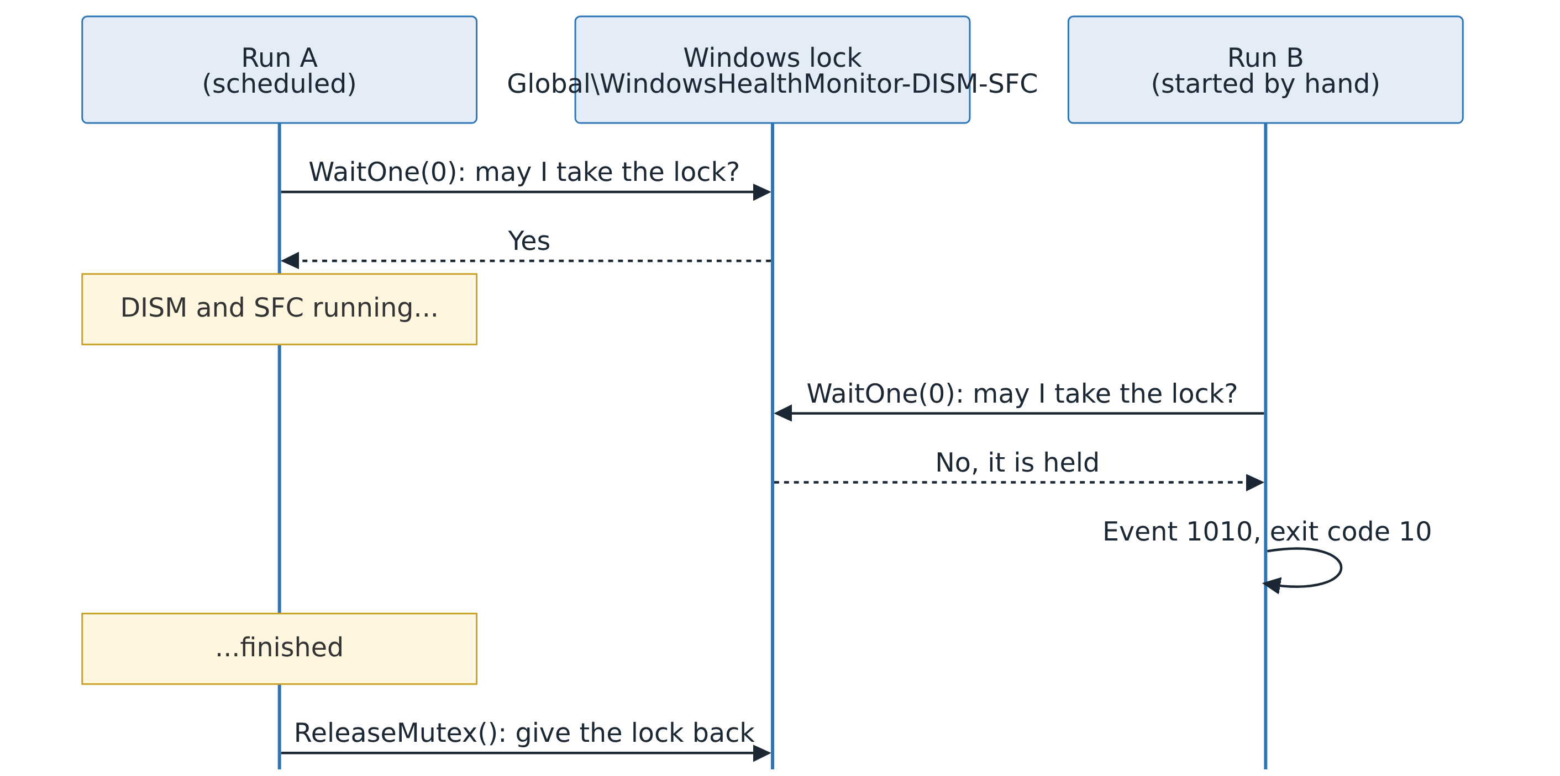
Figure 4. A second run finds the lock taken and leaves immediately with result code 10.
From section 6
$mutex = New-Object System.Threading.Mutex($false, $MutexName)
$hasLock = $mutex.WaitOne(0) # 0 = do not wait; answer immediately

The lock's name starts with Global\, so every sign-in session shares it: a scheduled run and a run in your own window cannot overlap. If a run is ever killed while holding the lock, Windows marks the lock abandoned, and the next run takes it over safely.

7.3 The report folder and logging
Next, the script creates the run's folder, for example C:\temp\Logs\2026-10-29_101120, named after the start time so that folders sort by date. From here on, every Write-Summary call goes both to the screen and to Summary.txt:
function Write-Summary {
param([Parameter(Mandatory)][string]$Text)
$line = '{0} {1}' -f (Get-Date -Format 'yyyy-MM-dd HH:mm:ss'), $Text
if ($script:SummaryAvailable) {
Add-Content -LiteralPath $SummaryFile -Value $line -Encoding UTF8
}
Write-Host $line
}

Start-Transcript also records everything shown on screen into Full-Transcript.txt, together with a header showing which PowerShell ran the script. Your transcript's header line "Host Application: ...WindowsApps\Microsoft.PowerShell_7.6.9.0..." is how you can tell the Store version ran it.

7.4 Recording the versions
Next, the script records the Windows version (from the registry) and which PowerShell is running it, using $PSVersionTable, PowerShell's built-in description of itself, and the path of the running program. Nothing is downloaded or installed:
From section 6 (Main)
$script:PowerShellInfo.Path = (Get-Process -Id $PID).Path # $PID = this program's ID
$editionName = if ($script:PowerShellInfo.Edition -eq 'Core') { 'PowerShell' } else { 'Windows PowerShell' }
Write-Summary "PowerShell: $editionName $($script:PowerShellInfo.Version) (...)"

$PSVersionTable.PSEdition is Desktop in Windows PowerShell 5.1 and Core in PowerShell 7. Notice the if used as a value: $x = if (test) { a } else { b } stores whichever result applies.

7.5 Pre-flight checks
Before running anything, Invoke-HealthCheck checks whether Windows is waiting to restart. While servicing work is queued, DISM and SFC can report problems that a restart would fix, so the script skips the checks (result code 6) rather than report misleading results.
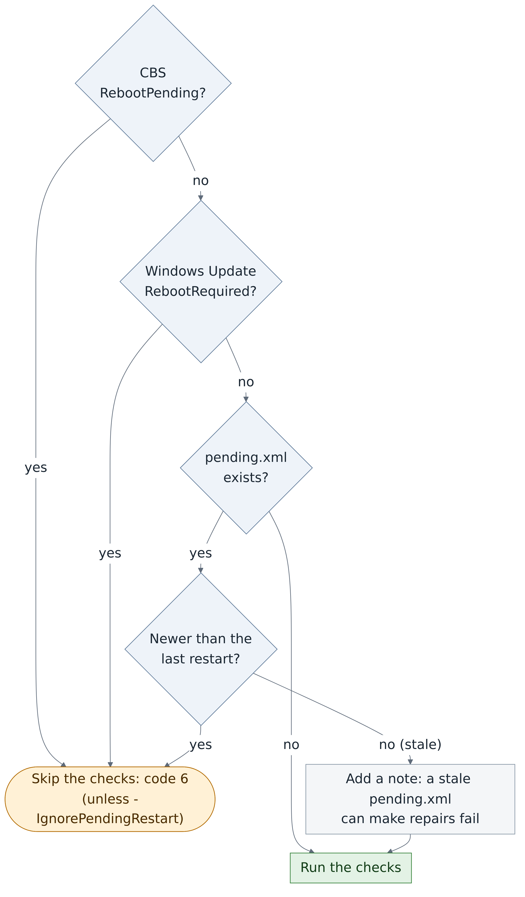
Figure 5. The pending-restart check. Only signals that affect DISM and SFC can skip a run.
The registry keys are checked with Test-Path 'HKLM:\...'. PowerShell presents the registry as a drive, so a key can be tested like a folder. One signal is deliberately ignored: a registry value called PendingFileRenameOperations, which many installers leave behind permanently. Checking it would skip every run; that was one of the bugs in Copilot's version.
The script then reads the free space on the Windows drive, using the same units as File Explorer, and warns below 10 GB, because DISM needs working space for repairs.

7.6 Running a tool safely: Invoke-Tool
Every DISM and SFC run goes through Invoke-Tool. It is the most technical function in the script, because running another program reliably is harder than it looks.
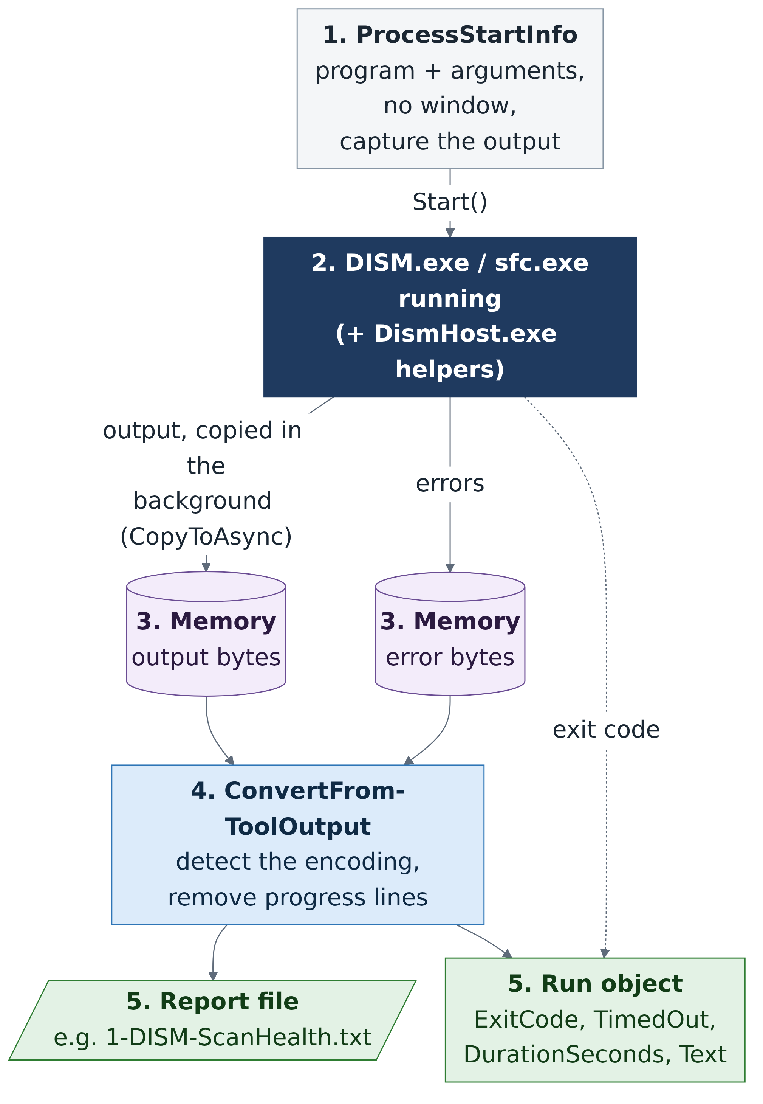
Figure 6. How Invoke-Tool runs a tool and captures what it prints.
- ProcessStartInfo describes what to run: the program, its arguments, no extra window, and "send me the output" instead of printing it to the screen.
- Start() starts the tool.
- CopyToAsync copies the tool's output into memory in the background while it runs. This matters more than it seems: a program's output passes through a small buffer, and if nobody empties it, the buffer fills and the program freezes, waiting for space that never comes.
- ConvertFrom-ToolOutput turns the raw bytes into clean text (see below).
- The function writes the tool's report file and returns a run object: exit code, time taken, whether it timed out, and the text.

Time limits
WaitForExit(milliseconds) waits for the tool, but only up to its limit (120 minutes for DISM, 90 for SFC). If the tool overruns, the script stops it and its helper processes: DISM starts DismHost.exe helpers, so stopping DISM.exe alone would leave them running. PowerShell 7 does this with $process.Kill($true), where $true means "the whole process tree". The output captured so far is kept, and the run ends with result code 7.

Text encodings: the bug that broke version 1
Computers store text as numbers called bytes, and there is more than one way to do it. DISM writes one byte per letter. SFC, when its output is captured, writes two bytes per letter (an encoding called UTF-16LE), and for ordinary English letters the second byte is always zero.
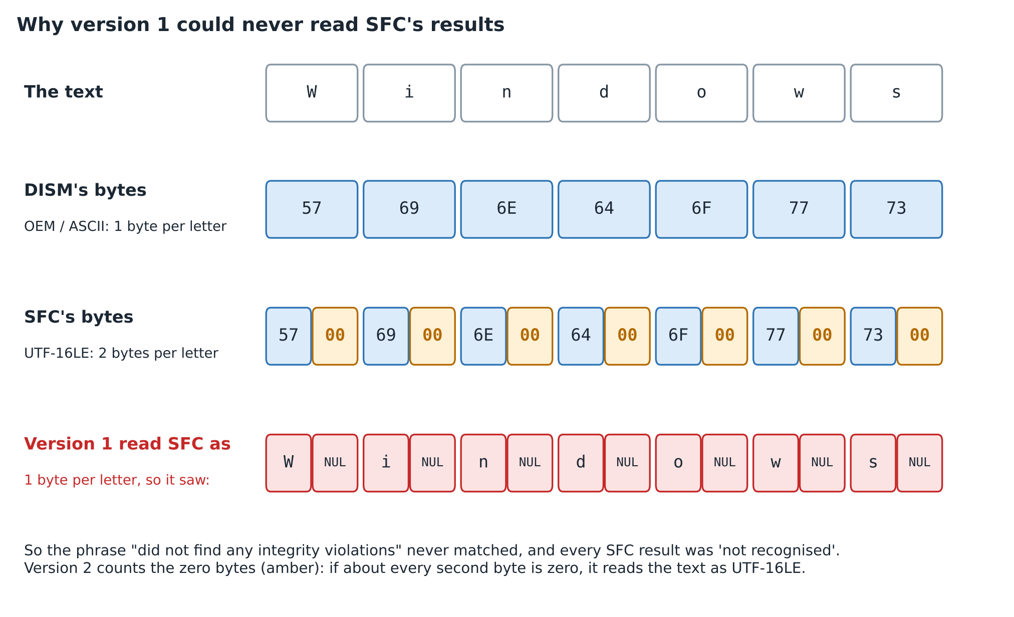
Figure 7. The same word as DISM and SFC store it, and what version 1 mistakenly saw.
Version 1 of the script decoded SFC's bytes as if they were one byte per letter, so every letter came out followed by an invisible NUL character. The text "did not find any integrity violations" could never match, and every SFC result was "not recognised". ConvertFrom-ToolOutput now counts the zero bytes: if about every second byte is zero, the text is UTF-16LE. It also recognises a byte-order mark, a short marker some programs put at the start of a file to announce the encoding.

Progress bars
DISM redraws its progress bar by sending a "carriage return" character, which moves back to the start of the line, followed by the new bar. Captured, that becomes dozens of progress lines and blank lines. The function removes the progress lines with regular expressions and collapses runs of blank lines. Your DISM report went from 120 lines to 10 with nothing lost.

7.7 The DISM stage
With the safety machinery in place, Invoke-HealthCheck runs DISM:
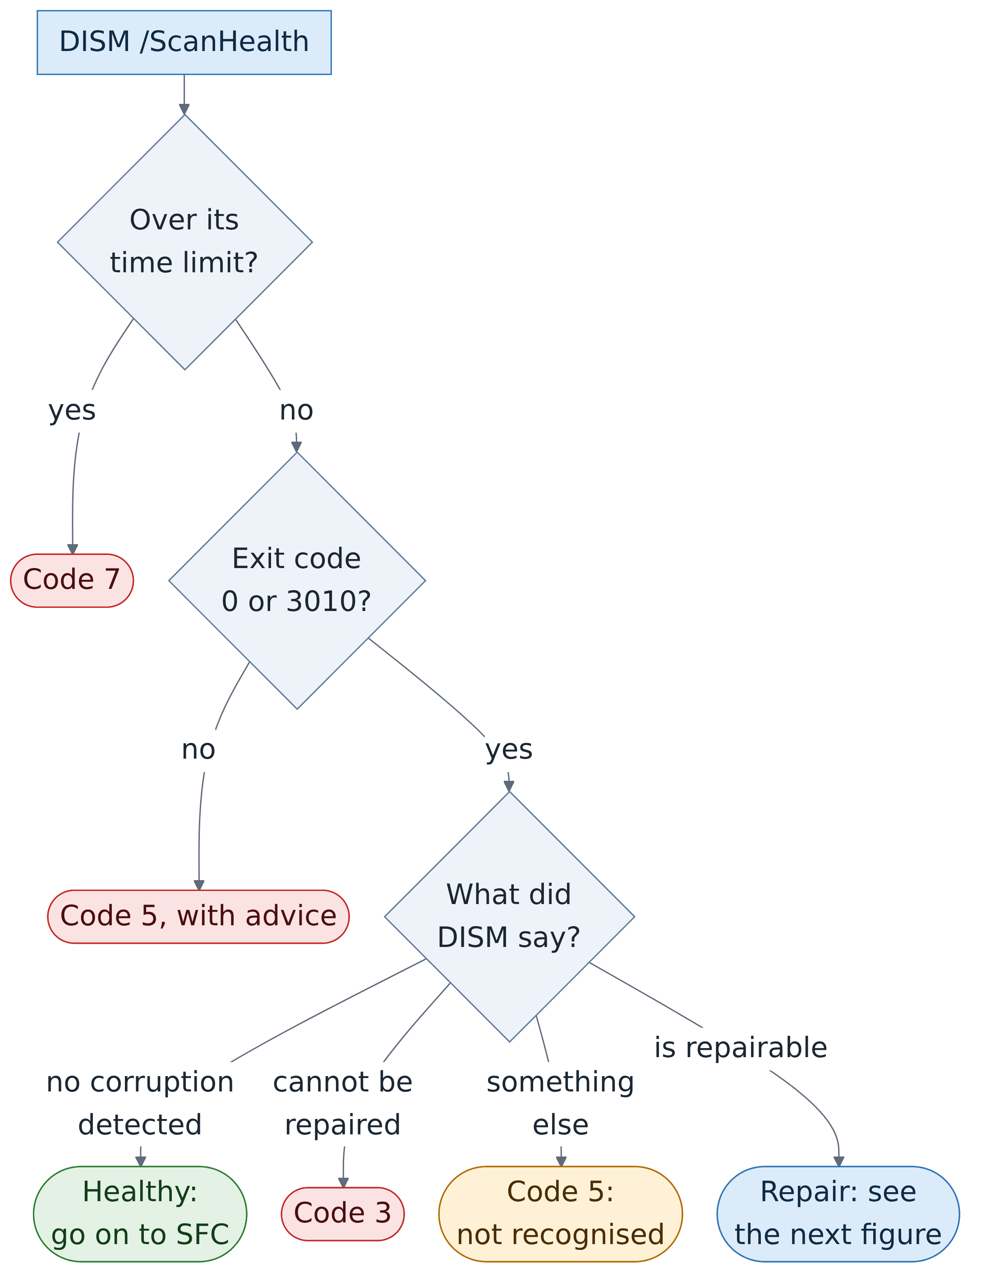
Figure 8. The DISM check, and the result code each path produces.
Follow the diagram from the top. Three checks come before the script believes anything DISM says: did it finish in time, was its exit code a success code, and was its message one the script recognises? Only then does it act:
- Healthy: go on to SFC. This is what happened in your run.
- Not repairable: stop with code 3. DISM cannot fix it without a repair source, so the message suggests -RepairSource or Windows' own "Fix problems using Windows Update".
- Repairable: run the repair, shown in the next figure.
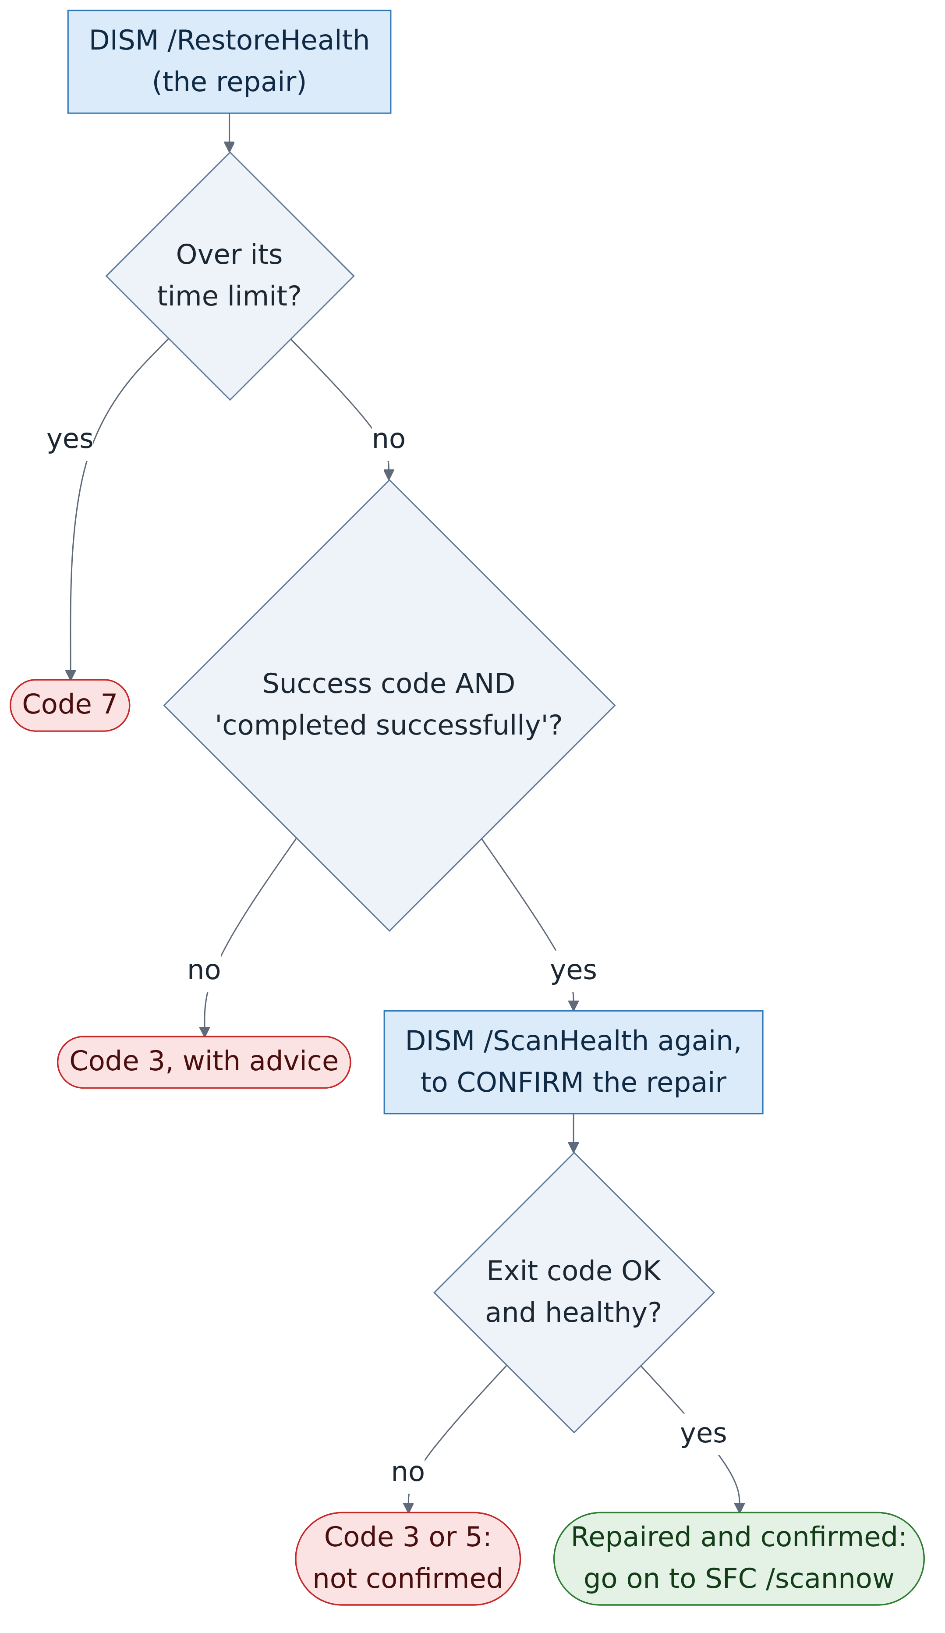
Figure 9. The DISM repair. It counts only when a second scan confirms it.
The repair, /RestoreHealth, must finish in time, return a success code and say "The restore operation completed successfully". Even then, the script scans again, and accepts the repair only if that second scan finds the store healthy.
Notice how often return appears in the code. Each return leaves the function as soon as the outcome is known, so every path ends in exactly one Set-Outcome.

7.8 The SFC stage
SFC runs next, unless DISM found a problem it could not fix:
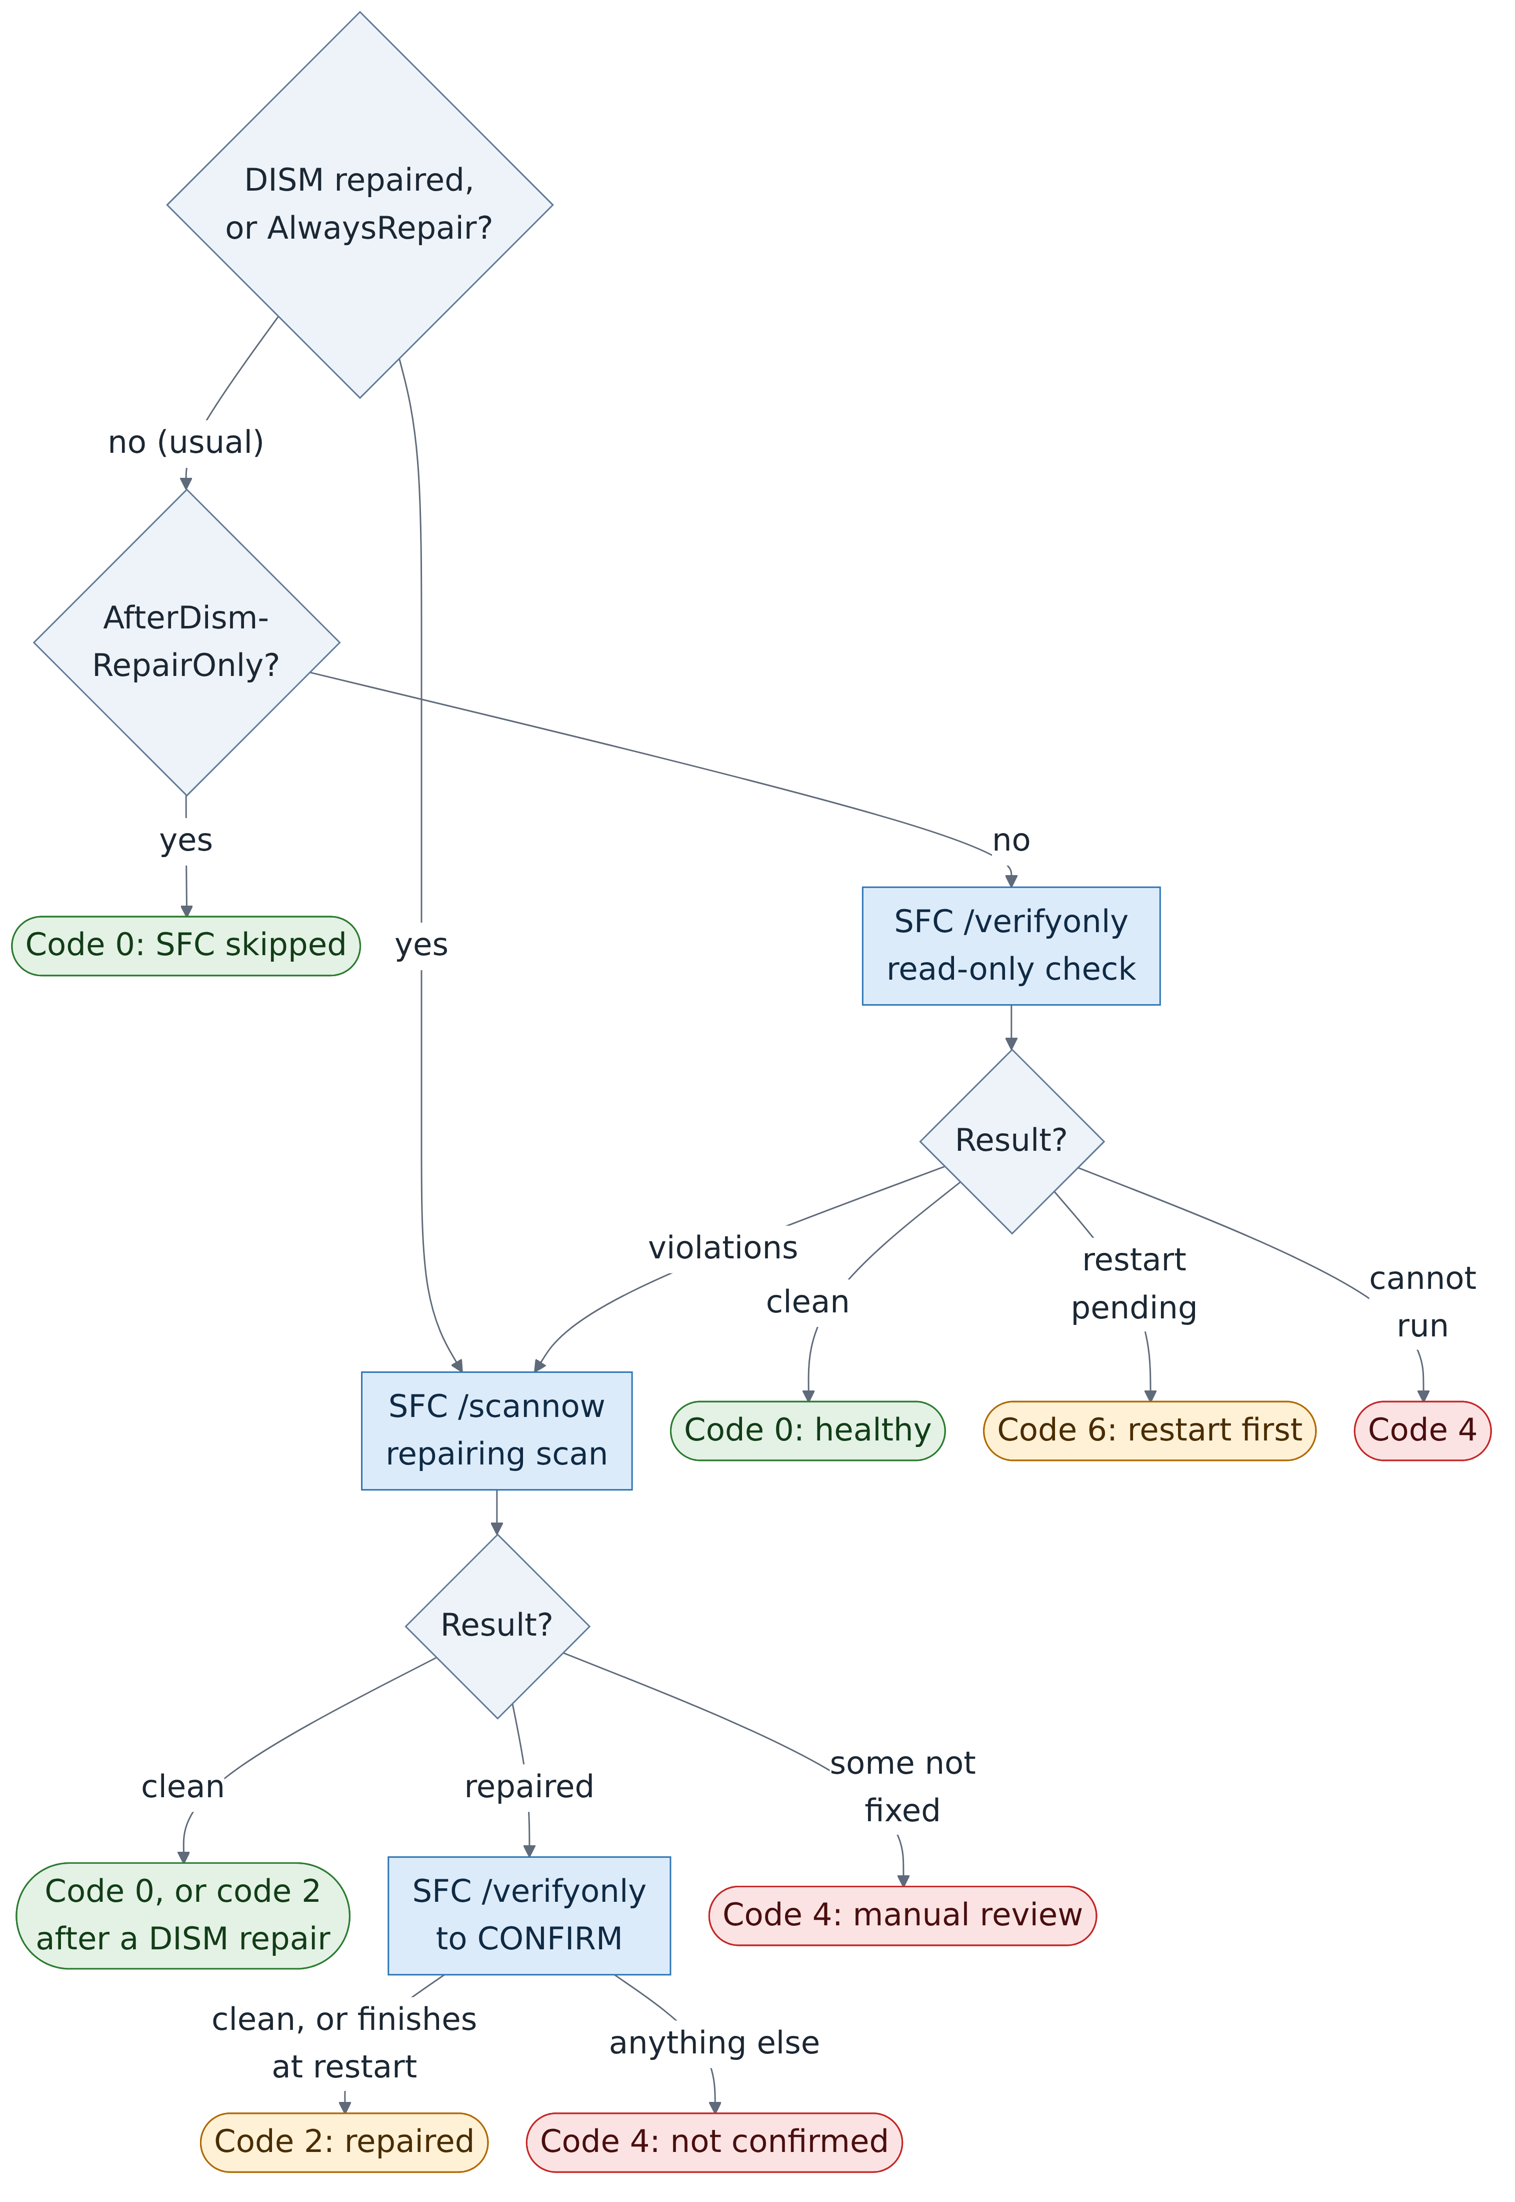
Figure 10. The SFC stage. The read-only check comes first; the repairing scan runs only when needed.
Normally the script starts with sfc /verifyonly, which only looks. If it finds violations, Invoke-SfcScannow runs the repairing scan, sfc /scannow, copies SFC's own log lines for this run from CBS.log into SFC-CBS-Details.txt, and, if SFC says it repaired files, confirms with another /verifyonly.
After a DISM repair the script goes straight to /scannow, because the files may have been copied from damaged masters before the repair. -SfcMode lets you change this behaviour (chapter 9).

7.9 Finishing: the reports that always happen
Whatever happened above, section 6's finally block runs:
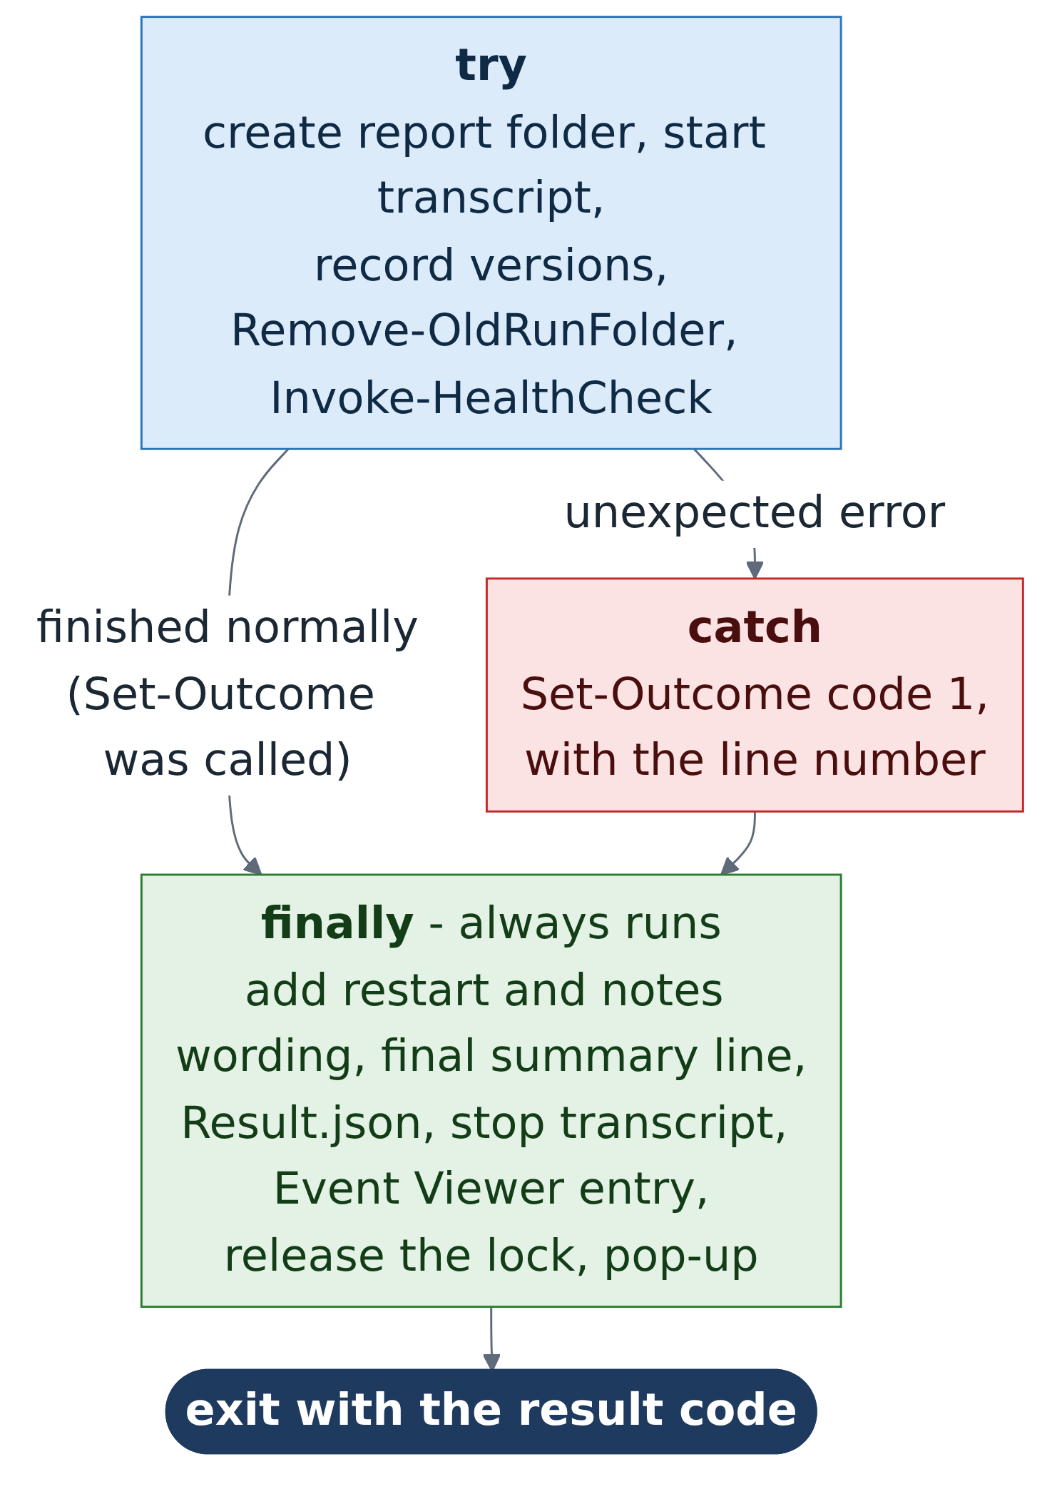
Figure 11. try, catch and finally in the main section.
- It adds to the verdict's message if a restart is needed or notes were recorded.
- It writes the final "Finished in ..." line to Summary.txt.
- It writes Result.json (see chapter 8).
- It stops the transcript.
- It writes the Event Viewer entry: Windows Logs > Application, source WindowsHealthMonitor, event ID 1000 plus the result code.
- It releases the lock (before the pop-up, which can wait up to a minute).
- It shows the pop-up, unless the run is in session 0, where no one could see it.
- Finally, exit hands the result code back to whoever started the script. Task Scheduler shows it as "Last Run Result".
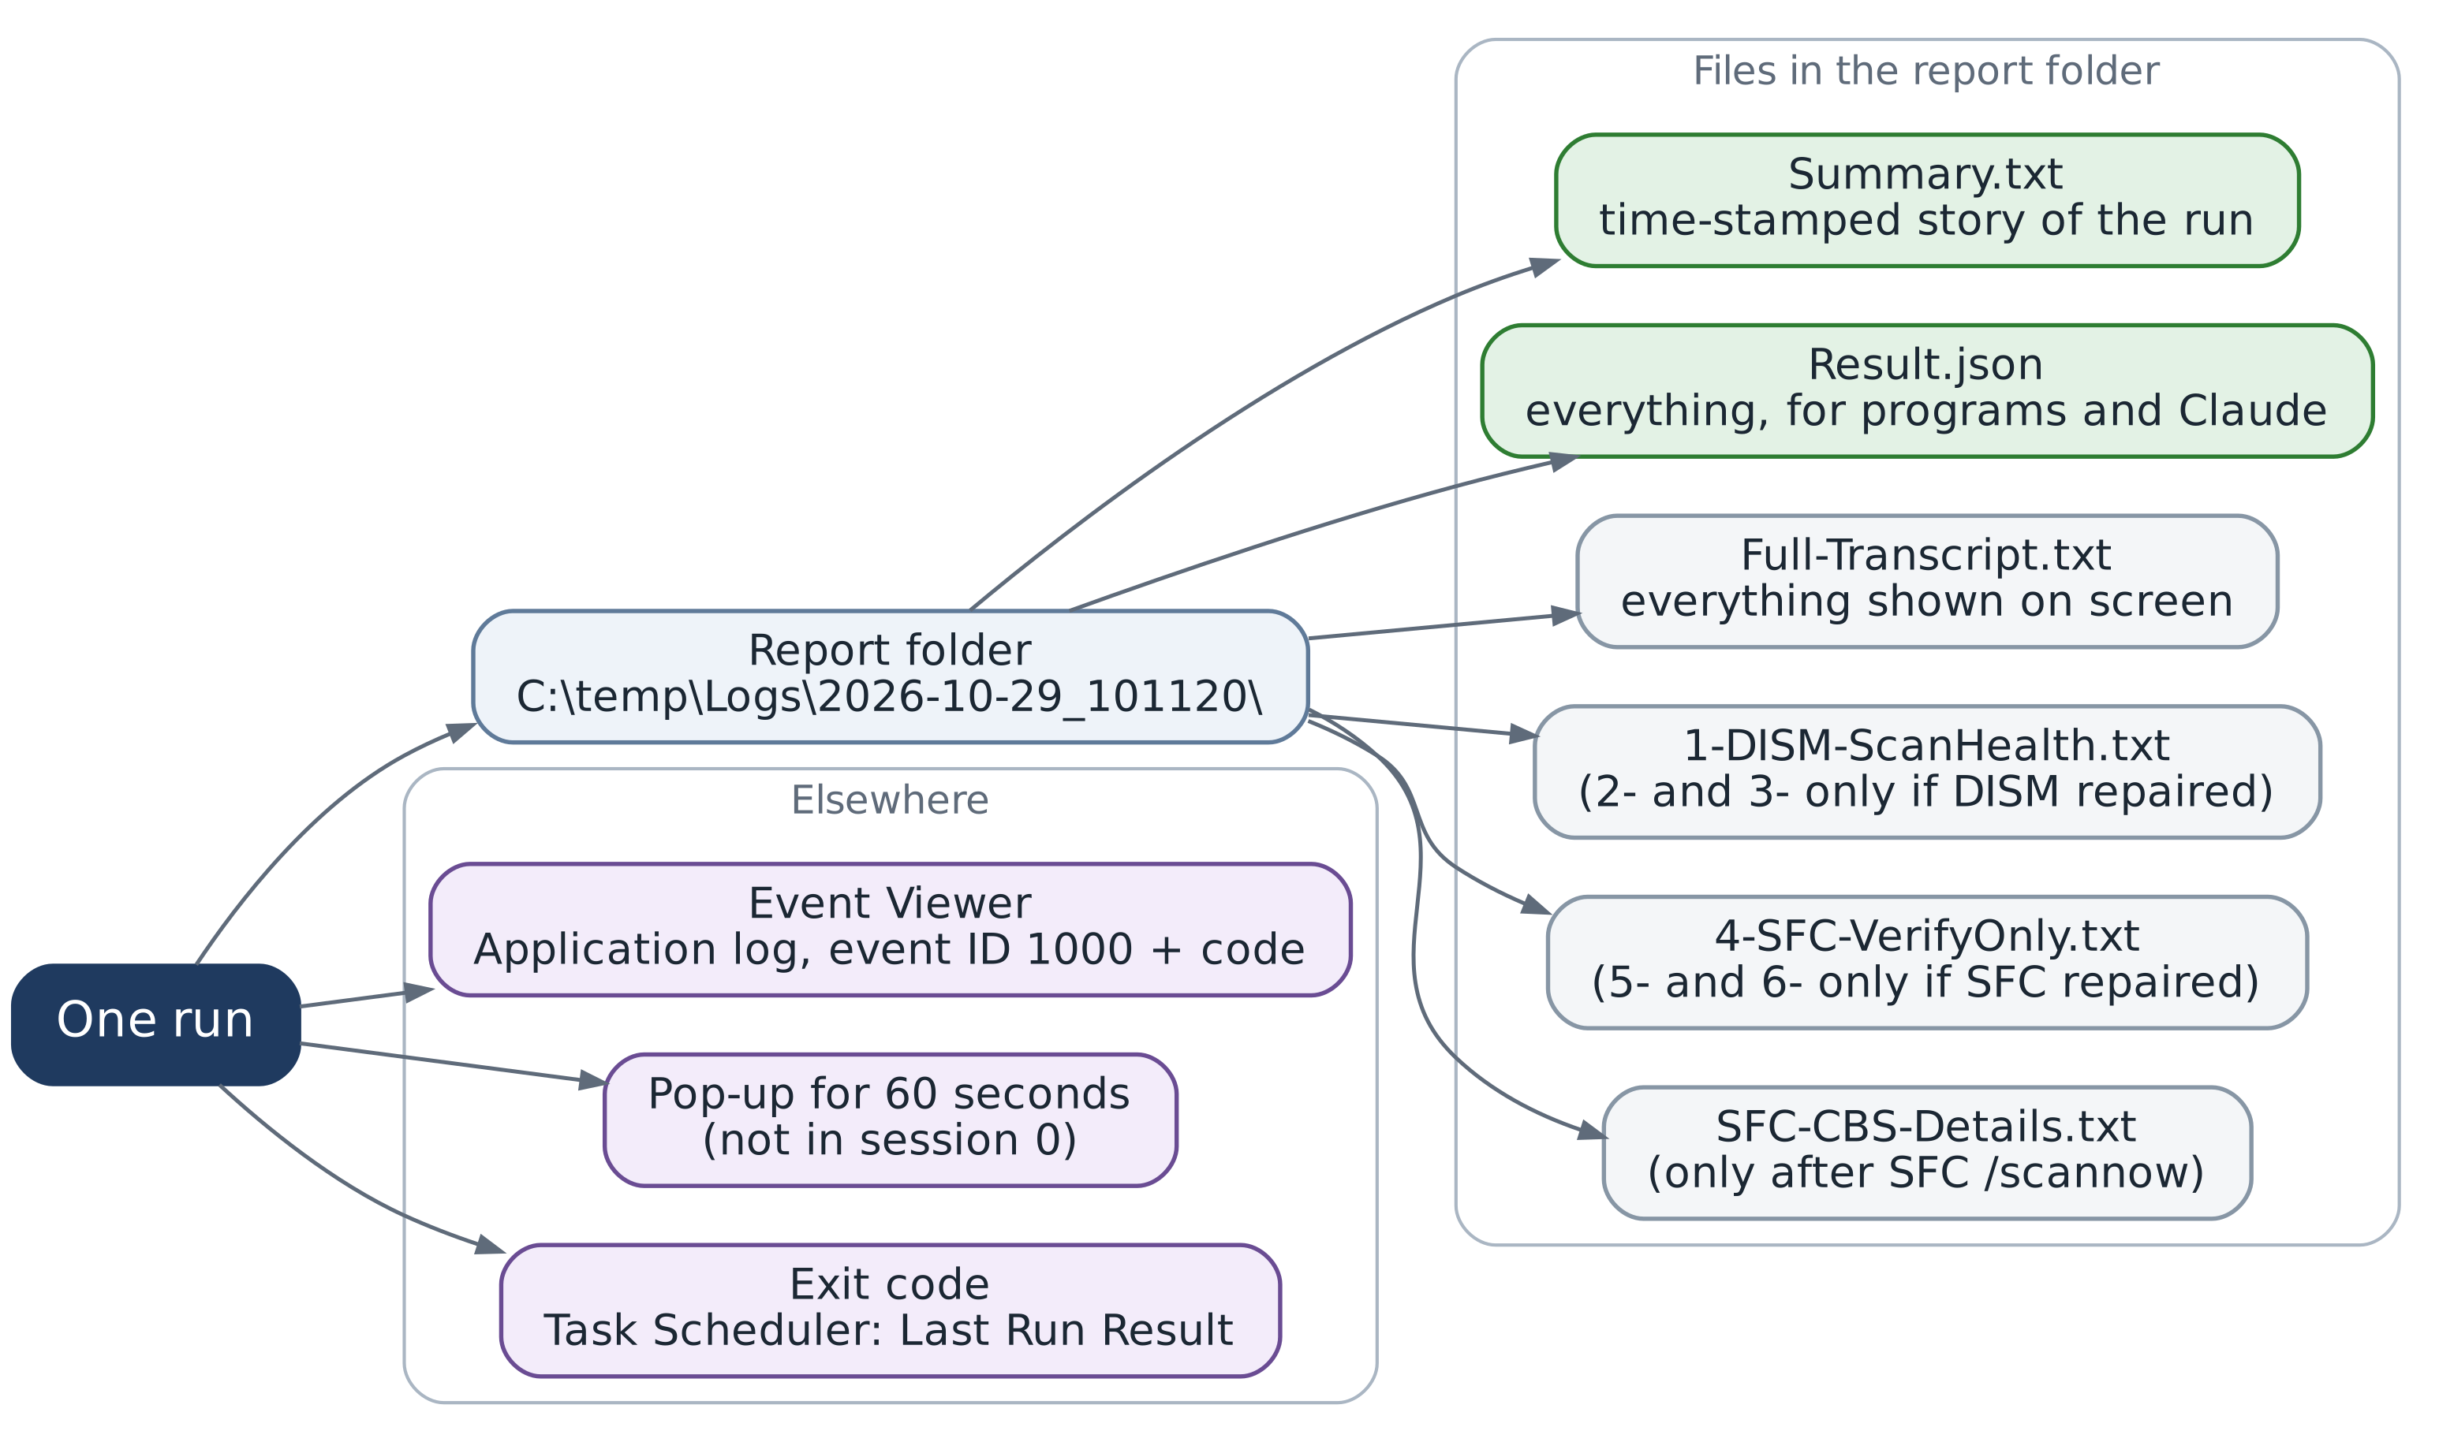
Figure 12. Everything one run produces.

8 Your run on 29 October 2026, annotated
Here is everything from chapter 7, seen in your own run, which started at 10:11:20 and finished two minutes later with result code 0. That run used version 2.2.0; version 2.4.0 produces the same lines, except for a simpler PowerShell line (chapter 4).
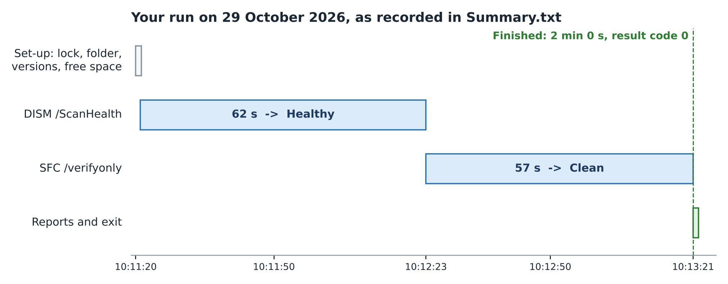
Figure 13. Where the two minutes went.

8.1 Summary.txt, line by line
Summary.txt says | Written by | What it tells you
Windows Health Monitor 2.2.0 started on NEW (Microsoft Windows 11 Pro 26H2, build 26300.9711). | Main | Version, computer name and Windows build, read from the registry.
SFC mode: VerifyThenRepair. Reports: C:\temp\Logs\2026-10-29_101120 | Main | The default SFC mode and this run's folder.
PowerShell: running 7.6.9 (Core, MicrosoftStore), started from Windows PowerShell 5.1.26100.9711; ... | Main | Which PowerShell ran the checks. In 2.4.0 this reads "PowerShell: PowerShell 7.6.9 (path)".
Windows drive (C:) has 1.32 TB free of 1.82 TB (72.8% free). ... | Format-DriveSpace | Plenty of space. No restart was pending (that check prints nothing when all is well).
Running DISM /ScanHealth... | Invoke-Tool | DISM starts.
DISM /ScanHealth finished in 1 min 2 s with exit code 0 (0x00000000). | Invoke-Tool | Finished in time, with a success code.
Component store state: Healthy. | Invoke-HealthCheck | "No component store corruption detected" was recognised.
Running SFC /verifyonly... | Invoke-Tool | The read-only SFC check starts.
SFC /verifyonly finished in 57 s with exit code 0 (0x00000000). | Invoke-Tool | Finished in time.
SFC /verifyonly result: Clean. | Invoke-HealthCheck | "did not find any integrity violations" was recognised, which version 1 could never do.
OUTCOME [0]: No problems found. ... | Set-Outcome | The verdict: healthy.
Finished in 2 min 0 s with result code 0. | Main (finally) | Done. Event ID 1000 went to Event Viewer.

8.2 Result.json, the important parts
Result.json holds the same story in a form programs can read. The most useful fields:
Field | Your value | Meaning
ExitCode / Severity | 0 / Information | The verdict
State.DismInitialState / DismConfirmedState | Healthy / Healthy | DISM before and after (they differ only after a repair)
State.SfcInitialState / SfcConfirmedState | Clean / Clean | SFC before and after
PowerShell (section) | 7.6.9, Core | Which PowerShell ran it (2.4.0 records the version, edition and path)
RunContext.SessionId | 4 | Your desktop session (0 would mean an invisible service session)
ToolRuns[0].DurationSeconds | 62 | DISM's time
Notes | (empty) | Nothing needed your attention

9 Reference

9.1 Command-line options
Option | Values (default first) | What it does
-SfcMode | VerifyThenRepair, AlwaysRepair, AfterDismRepairOnly | How SFC runs: read-only check first; always repair; or only after a DISM repair (the version 1 behaviour).
-RepairSource | e.g. WIM:D:\sources\install.wim:6 | Where DISM gets good files when Windows Update cannot supply them. Adds /LimitAccess.
-DismTimeoutMinutes | 120 (10 to 600) | Time limit for each DISM run.
-SfcTimeoutMinutes | 90 (10 to 600) | Time limit for each SFC run.
-RetainDays | 90 (0 to 3650; 0 keeps all) | How long to keep report folders.
-IgnorePendingRestart | switch | Run even when a restart is pending (results may be unreliable).
-NoPopup | switch | No pop-up at the end.

Example: always run the repairing SFC scan, without a pop-up
pwsh -NoProfile -ExecutionPolicy Bypass -File "C:\temp\WindowsHealthMonitor.ps1" `
-SfcMode AlwaysRepair -NoPopup

9.2 Result codes
Code | Severity | Event ID | Meaning | What to do
0 | Information | 1000 | Healthy: nothing needed repairing | Nothing
1 | Error | 1001 | The script itself failed | Read the line number in Summary.txt
2 | Warning | 1002 | Corruption found, repaired and confirmed | Restart Windows when convenient
3 | Error | 1003 | The component store could not be repaired | Try -RepairSource, or Settings > System > Recovery
4 | Error | 1004 | SFC could not repair every file, or could not run | Read SFC-CBS-Details.txt
5 | Error / Warning | 1005 | DISM failed, or a result was not recognised | Read the tool's report file
6 | Warning | 1006 | A restart is pending; checks skipped | Restart Windows and run again
7 | Error | 1007 | A tool ran over its time limit | Restart Windows and run again
10 | Information | 1010 | Another run was already in progress | Nothing

9.3 Report files
File | When | Contents
Summary.txt | Every run | The time-stamped story of the run, and any notes.
Result.json | Every run | Everything, in a form programs (and Claude) can read.
Full-Transcript.txt | Every run | Everything shown on screen, with a header naming the PowerShell used.
1-DISM-ScanHealth.txt | Every run | The command, exit code and cleaned output of the first DISM scan.
2-DISM-RestoreHealth.txt, 3-DISM-ScanHealth-Confirm.txt | Only if DISM repaired | The repair and its confirmation scan.
4-SFC-VerifyOnly.txt | Normal runs | The read-only SFC check.
5-SFC-Scannow.txt, 6-SFC-VerifyOnly-Confirm.txt | Only if SFC repaired | The repairing scan and its confirmation.
SFC-CBS-Details.txt | After SFC /scannow | SFC's own lines from CBS.log for this run only.

10 Lessons from the bugs we fixed
The script reached version 2.4 by finding and fixing real bugs, several of them subtle. Each one teaches something worth remembering.
Where | What went wrong | Why | The fix and the lesson
Version 1 | SFC's results were never recognised. | SFC writes UTF-16LE; the script decoded it as one byte per letter. | Detect the encoding from the bytes. Lesson: check how a program encodes its output.
Version 1 | SFC ran only after a DISM repair. | The logic tied SFC to DISM finding corruption. | Run a read-only SFC check every time. Lesson: damaged files and a damaged store are separate problems.
Version 1 | Repairs were trusted without checking. | Only the exit code was examined. | Confirmation scans. Lesson: confirm, do not assume.
Version 1 | DISM could be reported as failed when it had worked. | In 5.1, 2>&1 with 'Stop' turns any error-stream line into a script error. | Run tools through the .NET Process class.
Copilot's 2.0 | A real DISM error crashed the script and deleted its output. | Error codes are negative numbers; converting them straight to an unsigned number fails. | Re-read the same four bytes with BitConverter. Lesson: test the failure paths, not just success.
Copilot's 2.0 | Would probably skip every run. | It treated PendingFileRenameOperations as a pending restart; many PCs always have it. | Check only signals that affect servicing.
Version 2.1 | "Result.json could not be written: Argument types do not match". | Wrapping a .NET List[object] in @() triggers a PowerShell bug. | Use .ToArray(). Lesson: test every step, including the last one.
Version 2.1 | 113 blank lines in the DISM report. | Each progress-bar update left an empty line behind. | Collapse runs of blank lines.
Version 2.1 | The script ran in 5.1 although you use 7.6.9. | powershell.exe always starts 5.1. | Explained; 2.4 works correctly in either.
Version 2.2 | The script grew a PowerShell 7 updater and hand-over. | Updating PowerShell is a separate job, with its own failures. | Removed in 2.4. Lesson: keep a tool to one job.
Version 2.4 (simulation) | Advice said "Look up DISM error 0x00000000". | A success code with an unrecognised message has no error to look up. | Point to the report file instead. Lesson: simulate the rare paths.

11 Try it yourself
These short exercises let you explore the ideas in this guide in your own PowerShell 7 window. None of them changes anything on your PC.
TRY IT
1. Read the script's built-in help. The comment block at the top of the script becomes this help:
Get-Help C:\temp\WindowsHealthMonitor.ps1 -Full

TRY IT
2. Open the latest Result.json as an object and look at its parts with a dot:
$latest = Get-ChildItem C:\temp\Logs -Directory | Sort-Object Name | Select-Object -Last 1
$r = Get-Content (Join-Path $latest.FullName 'Result.json') -Raw | ConvertFrom-Json
$r.Message
$r.State
$r.ToolRuns | Format-Table Name, ExitCode, DurationSeconds

TRY IT
3. See the Event Viewer entries the script has written:
$filter = @{ LogName = 'Application'; ProviderName = 'WindowsHealthMonitor' }
Get-WinEvent -FilterHashtable $filter -MaxEvents 5 |
Format-List TimeCreated, Id, LevelDisplayName, Message

TRY IT
4. See the encoding difference from chapter 7.6 for yourself:
# DISM-style, one byte per letter: 57 69
[Text.Encoding]::ASCII.GetBytes('Wi') | ForEach-Object { '{0:X2}' -f $_ }
# SFC-style, two bytes per letter: 57 00 69 00
[Text.Encoding]::Unicode.GetBytes('Wi') | ForEach-Object { '{0:X2}' -f $_ }

TRY IT
5. Why versions are compared as [version]:
'7.6.10' -gt '7.6.9' # False: compared as text
[version]'7.6.10' -gt [version]'7.6.9' # True: compared as versions

TRY IT
6. Regular expressions and $Matches:
'v7.6.9' -match '^v?(\d+\.\d+\.\d+)$'
$Matches[1] # 7.6.9

TRY IT
7. Which PowerShell is this? Type this in a PowerShell 7 window, then in a Windows PowerShell window:
$PSVersionTable.PSEdition # Core, or Desktop
$PSVersionTable.PSVersion
(Get-Process -Id $PID).Path

TRY IT
8. Variable names ignore capitals:
$Run = 'first'; $run = 'second'; $Run # second

12 Glossary
Term | Meaning
Byte | The basic unit of computer storage: a number from 0 to 255, often written in hexadecimal (00 to FF).
Byte-order mark (BOM) | A short marker at the start of some text files that announces their encoding.
CBS.log | Windows' servicing log, C:\Windows\Logs\CBS\CBS.log. SFC writes its detailed lines there, marked [SR].
COM object | An older kind of Windows component that PowerShell can use, such as WScript.Shell for the pop-up.
Component store | C:\Windows\WinSxS: the master copies of all Windows components.
DISM | Deployment Image Servicing and Management: checks and repairs the component store.
Encoding | The rule for storing text as bytes, such as ASCII (one byte per letter) or UTF-16LE (two).
Exit code | The number a program hands back when it finishes. 0 usually means success.
Function | A named, reusable block of code, defined with function Verb-Noun { ... }.
Hashtable | A table of name = value pairs, written @{ ... }.
Hexadecimal | Base-16 numbers using 0 to 9 and A to F; 0x800F081F is an example.
JSON | A plain-text data format that programs can read reliably; used for Result.json.
Mutex | A lock that only one process can hold at a time.
Parameter | An input to a script or function, such as -SfcMode.
Pipeline | Passing one command's output to the next with |.
Process | A running program. One program can start helper processes (a process tree).
Regular expression | A pattern for matching text, used with -match.
Scope | Where a variable is visible. $script: makes it visible throughout the script.
Session 0 | The Windows session where services and unattended tasks run; it has no visible desktop.
SFC | System File Checker: checks and repairs protected system files.
Standard output / error | The two text streams a program writes to: normal output and error messages.
Transcript | A copy of everything shown in the PowerShell window, made by Start-Transcript.
UTF-16LE | An encoding with two bytes per character; SFC uses it when its output is captured.

