**MEDIAN**

**Description of the median**

**Characteristics and qualities of median**

**Merits and demerits of median**

**Significance of Median**

**Interpretation of median**

**Finding median for discrete and continuous data using –standard formulae,graphically (cumulative frequency curve,ogive ( less than and more than curve),median of unknown**

The **MEDIAN,** denoted Md, is the middle value of the sample when the data are ranked in order according to size.

* Connor has defined as “ The median is that value of the variable which divides the group into two equal parts, one part comprising of all values greater, and the other, all values less than median”
* It’s the value separating higher half from the lower half of a data sample.

**Characteristics and qualities of median**

1. It is equal to or exceeded by half the value of distribution and vise versa
2. It uses only one value in the distribution. It is not therefore influenced by extreme values
3. It cannot be used for further mathematical processes
4. It is an actual value occurring in the distribution (unless it is computed by averaging the two middle items of an even number distribution)
5. It can be computed even if the data is incomplete e.g. in determining the median salary of group of executive. It may prove impossible to discover the salary of highest paid executive but since this value will not affect the value of median item it is still possible to determine the median salary.

**Merits of median**

* It is easy to compute and understand.
* It can also be computed in case of frequency distribution with open ended classes.
* It is not affected by extreme values ( outliers) and also interdependent of range or dispersion of the data.
* It can be determined graphically.
* It is only suitable average when the data are qualitative & it is possible to rank various items according to qualitative characteristics.
* It can be calculated easily by watching the data.
* In some cases median gives better result than mean.

**Demerits of Median**

* For computing median data needs to be arranged in ascending or descending order.
* It is not based on all the observations of the data.
* It can not be given further algebraic treatment.
* It is affected by fluctuation of sampling.
* It is not accurate when the data is not large.
* In some cases median is determined approximately as the mid-point of two observations whereas for mean this does not happen.

**Significance of Median**

The median represents the middle value in a dataset. The median is important because it gives us an idea of where the center value is located in a dataset. The median tends to be more useful to calculate than the mean when a distribution is skewed and/or has outliers (extreme scores)

**Interpretation of median**

**Finding median for discrete and continuous data using –standard formulae,graphically (cumulative frequency curve,ogive ( less than and more than curve),median of unknown**

Median for ungrouped data

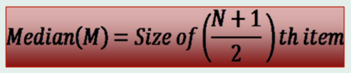

**Example – 2, 3, 1, 4, 5.**

*When arranged 1, 2,3,4,5*

**STEPS**

1. Arrange them in numerical order *1,2,****3****,4,5*
2. Locate or find the middle item

In a situation where n is equal to even numbers take the two scores in the middle position add them and divide by two

**MEDIAN IN EVEN NUMBERS**

Find the median in even numbers is not easy because the median is not the number given in the series. To obtain a median in even numbers you need to find the mean of the two numbers which lies either side of the median

This is obtain by adding the two numbers and dividing the total by two

Example 2,3,4,5,**6,7**,8,9,10,11

Median = 6, 7

= 13/2

= 6.5

N + 1 = Nth Position

2

**e.g.** 2,3,4,5,6,7,8,9,10

= N + 1 = 9+1

2

= 10/2

= 5

$∴$ Therefore the result item it will take you to the median position which is **6**

2,3,4,5,**6**,7,8,9,10

For Grouped Data:

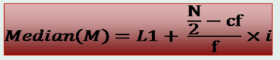

**GROUPED DATA**

**MEDIAN OF GROUPED DATA**

|  |  |  |
| --- | --- | --- |
| **Classes** | **Frequency** | **Cumulative frequency** |
| 21-25 | 6 | 6 |
| 26-30 | 17 | 23 |
| 31-35 | 22 | 45 |
| 36-40 | 34 | 79 |
| 41-45 | 20 | 99 |
| 46-50 | 12 | 111 |
| 51-55 | 5 | **116** |
|  | **116** |  |

**STEPS**

1. Apply the formula **N/2** in order to obtain the position of the median ( Where **N** = total number of item) 116/2 = 58
2. Formula **Mdn** = **L1 + (N/2- CF ) x**

***f***

***Where:***

where,

* l = lower limit of median class
* cf = cumulative frequency of the class preceding the median class
* f = frequency of the median class
* h or i = class interval

**Mdn** = **L1 + (n/2- Cf) x**

***f***

***Where:***

Mdn

L1 = Lower limit class of median

n/2= Median position

Cf = Cumulative frequency below median class

f = Frequency of the median class

*i* = Class interval

**Mdn** = **L1 + (n/2- Cf ) x**

**f**

**=**36+ (116/2-45) x 5

*=* 36+ (58-45) X 5

34

= 36+13/34

= (0.382) x 5

= 1.911

= 36 + (1.911)

**= 37.911**

**The diagrammatic method- The cumulative frequency curve (O’give)**

The cumulative frequency curve also known as the o’give is used to obtain the median graphically.

**Finding Median Graphically**

| **Marks** | **Conversion into exclusive series** | **No. of students** | **Cumulative Frequency** |
| --- | --- | --- | --- |
| (x) |  | (f) | (C.M) |
| 410-419 | 409.5-419.5 | 14 | 14 |
| 420-429 | 419.5-429.5 | 20 | 34 |
| 430-439 | 429.5-439.5 | 42 | 76 |
| 440-449 | 439.5-449.5 | 54 | 130 |
| 450-459 | 449.5-459.5 | 45 | 175 |
| 460-469 | 459.5-469.5 | 18 | 193 |
| 470-479 | 469.5-479.5 | 7 | 200 |

The median value of a series may be determinded through the graphic presentation of data in the form of Ogives.This can be done in 2 ways.

1. Presenting the data graphically in the form of 'less than' ogive or 'more than' ogive .  
2. Presenting the data graphically and simultaneously in the form of 'less than' and 'more than' ogives.The two ogives are drawn together.

1. Less than Ogive approach

Marks Cumulative Frequency (C.M)

Less than 419.5 14

Less than 429.5 34

Less than 439.5 76

Less than 449.5 130

Less than 459.5 175

Less than 469.5 193

Less than 479.5 200

Steps involved in calculating median using less than Ogive approach –

Steps

1. Convert the series into a 'less than ' cumulative frequency distribution as shown above .

2. Let N be the total number of students who's data is given.N will also be the cumulative frequency of the last interval.Find the (N/2)th item(student) and mark it on the y-axis.In this case the (N/2)th item (student) is 200/2 = 100th student.

3. Draw a perpendicular from 100 to the right to cut the Ogive curve at point A.

4.From point A where the Ogive curve is cut, draw a perpendicular on the x-axis. The point at which it touches the x-axis will be the median value of the series as shown in the graph.

**Example**

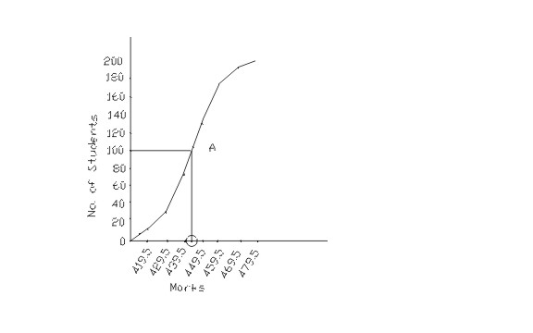

More than Ogive approach

| **Marks** | **Cumulative Frequency (C.M)** |
| --- | --- |
| More than 409.5 | 200 |
| More than 419.5 | 186 |
| More than 429.5 | 166 |
| More than 439.5 | 124 |
| More than 449.5 | 70 |
| More than 459.5 | 25 |
| More than 469.5 | 7 |
| More than 479.5 | 0 |

Steps involved in calculating median using more than Ogive approach -  
1. Convert the series into a 'more than ' cumulative frequency distribution as shown above .  
2. Let N be the total number of students who's data is given.N will also be the cumulative frequency of the last interval.Find the (N/2)th item(student) and mark it on the y-axis.In this case the (N/2)th item (student) is 200/2 = 100th student.  
3. Draw a perpendicular from 100 to the right to cut the Ogive curve at point A.  
4.From point A where the Ogive curve is cut, draw a perpendicular on the x-axis. The point at which it touches the x-axis will be the median value of the series as shown in the graph.

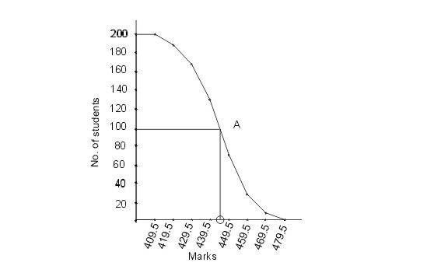

2.Less than and more than Ogive approach

Another way of graphical determination of median is through simultaneous graphic presentation of both the less than and more than Ogives.

1.Mark the point A where the Ogive curves cut each other.  
2.Draw a perpendicular from A on the x-axis. The corresponding value on the x-axis would be the median value.

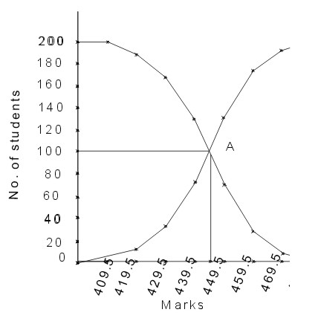ssasd

**MODE**

Description of mode

* Mode is a term used to designate the most frequent discrete data (it is a value of variant which has the greatest frequency)

It is the number that has occured more times in any other number

* Mode is also the mid-point for the class containing the largest number of class frequencies.

**Types of modes**

1. **Unimodal**

This is a set of data with one mode which means there is only one value e.g 14,15,16,17,15,18,15,19

15 is the only value repeating itself

1. **Bi modal**

Is a set of data with two modes,that means there are two data values that are having the highest frequencies e.g 8,13,13,14,15,17,17,19

13 and 17 are repeating twice in the given data set.

1. **Trimodal**

This is a set of data with three modes .This means there are three data values that are having the highest frequency

e.g 2,2,2,3,4,4,5,6,5,4,7,5,8

2,4,5 are the three values that are repeating thrice in the given data set.

1. **Multimodal**

This is a set of data with four or more than four modes

E.g 100,80,80,95,95,100,90,90,100,95

Data set 80,90,95,100 are multimodal because they are repeated twice in the given set

**Characteristics and qualities of mode**

It is the most frequent value in the distribution it is the point of greatest density. the value of the mode is established by the predominant frequency not by the value in the distribution.

**Significance of Mode**

Mode is most useful **as a measure of central tendency when examining categorical data**, such as models of cars or flavors of soda

**Interpretation of mode**

**Finding ,mode for discrete and continuous data using –standard formulae,graphically (histogram)**

**Merits of Mode**

1. It is simple to calculate.

2. In individual or discrete distribution it can be located by mere inspection.

3. It is easy to understand. Everyone is used to the idea of average size of a garment, an average American etc.

4. It is not isolated like the median as it is the most common item.

5. Like the Average mean, it is not a value which cannot be found in the series.

6. It is not necessary to know all the items. What we need the point of maximum density frequency.

7. It is not affected by sampling fluctuations.

8. It is the best representative of data

9. It is not at all affected by extreme value.

10. The value of mode can also be determined graphically.

11. It is usually an actual value of an important part of the series.

**Demerits of Mode**

1. It is ill defined.

2. It is not based on all observations.

3. It is not capable of further algebraic treatment.

4. It is not a good representative of the data.

5. Sometimes there are more than one values of mode.

6. Mode is affected to a great extent by sampling fluctuations.

7. Choice of grouping has great influence on the value of mode.

**Mode of ungrouped data**

EXAMPLE

Find the mode in the following figures **2, 4, 6, 2, 8, 2, 10, 2**

The mode in the series of figures is 2

**Mode of grouped frequency distribution**

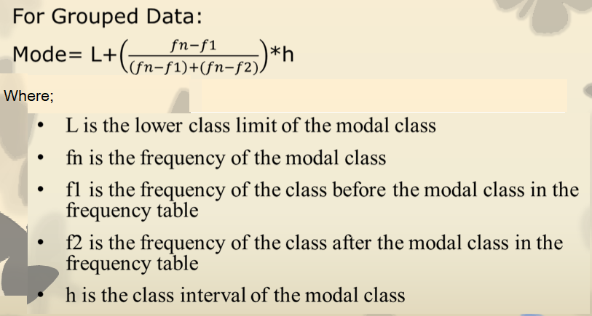

**Example;** Find the modal class and the actual mode of the data set below;

|  |  |  |  |  |  |  |  |  |  |  |
| --- | --- | --- | --- | --- | --- | --- | --- | --- | --- | --- |
| Number | 1-3 | 4-6 | 7-9 | 10-12 | 13-15 | 16-18 | 19-21 | 22-24 | 25-27 | 28-30 |
| Frequency | 7 | 6 | 4 | 9 | 2 | 8 | 1 | 2 | 3 | 2 |

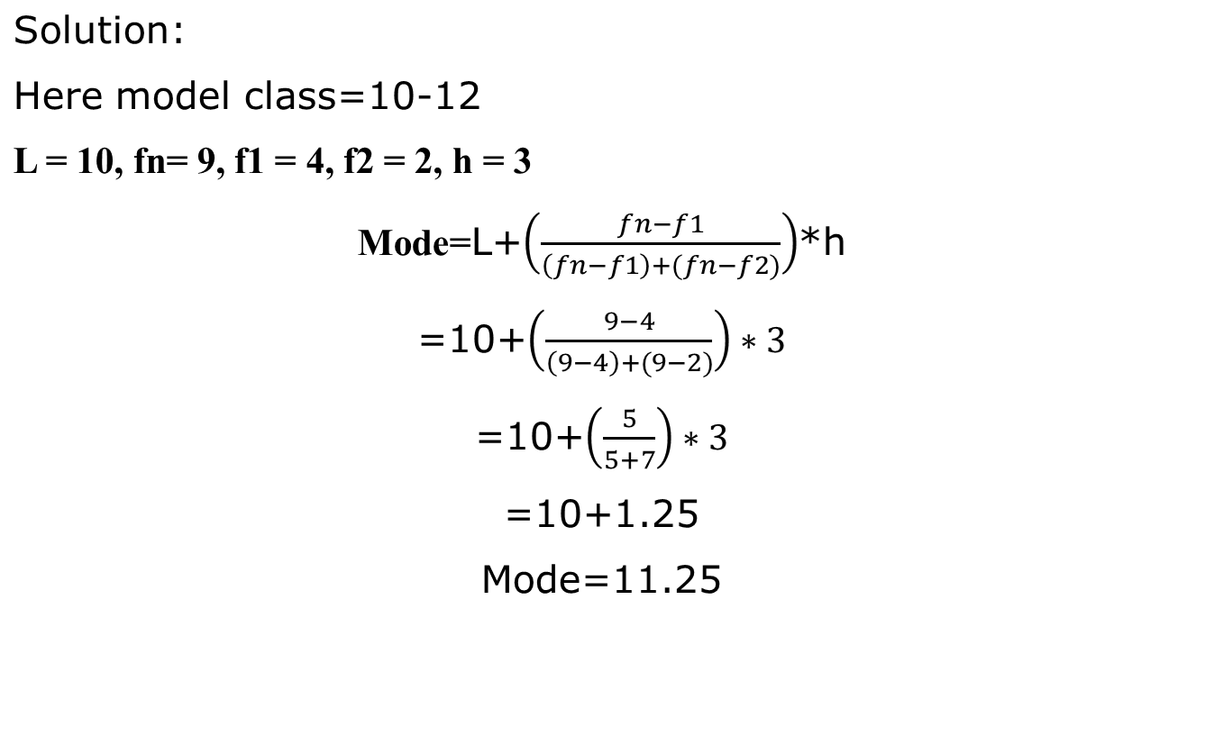

Find a mode in a grouped data

|  |  |
| --- | --- |
| **Classes** | **Frequency** |
| 21-25 | 6 |
| 26-30 | 17 |
| 31-35 | 22 |
| 36-40 | 34 |
| 41-45 | 20 |
| 46-50 | 12 |
| 51-55 | 5 |
|  | **116** |

**Z** = **L1 + (f1- f0 ) x**

**2f1-f0-f2**

**Where**

Z **=** Mode

L1 = Lower limit of modal class

f1= Number of items or frequency of modal class

fo = Frequency before the modal class

f2 = Frequency after the modal class

*i* = Class interval

**STEPS**

1. Construct a group frequency distribution as given
2. Locate the modal class. this is a class with highest frequency density
3. Substitute the formula

**Z** = **L1 + (f1- f0 ) x**

**2f1-f0-f2**

*=* 36+ (34-22) X 5

2x(34)-22-20

= 36 + 12 x 5

26

= 0.4615 x 5

= 36 + 0.54615 x 5

= 38.30

= **38**

**The mode graphically- Histogram**

The mode can be determined graphically using a histogram.

**Steps**

1. Plot the frequencies on the y-axis against the class on the x-axis
2. Identify the highest bar and draw a diagonal from the top right hand corner to the point where the top of the adjacent bar to the left touches x. Draw a corresponding diagonal on the opposite from top left to the bar on the right
3. Where the two diagonal intercept draw a perpendicular line to the x-axis, the value is the mode

**Example**

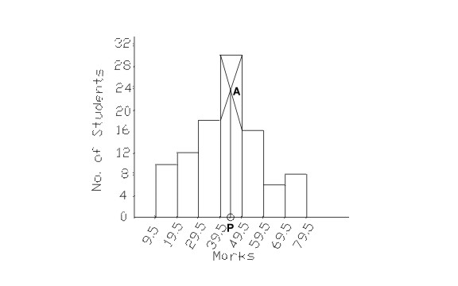

**Harmonic mean**

**Description of harmonic mean**

Harmonic mean is a type of numerical average that is usually used in situations when the average rate or rate of change needs to be calculated. Harmonic mean is one of the three Pythagorean means.

It is calculated by dividing the number of observations by the reciprocal of each number in the series.

*Harmonic mean is quotient of “number of the given values” and “sum of the reciprocals of*

*the given values”.*

Characteristics and qualities of Harmonic mean

Merits and demerits of Harmonic mean

Significance of harmonic mean

Interpretation of harmonic mean

Finding harmonic mean for discrete and continuous data

**Merits of Harmonic Mean**

The harmonic mean is completely based on observations and is very useful in averaging certain types of rates. Other merits of the harmonic mean are given below.

* As the value of harmonic mean remains fixed thus, it is rigidly defined.
* Even if there is a sample fluctuation, the harmonic mean does not get significantly affected.
* It is based on all the observations of a series i.e. it cannot be calculated ignoring any item of a series
* It is capable of further algebraic treatment.
* It gives better result when the ends to be achieved are the same for the different means adopted.
* It gives the greatest weight to the smallest item of a series.
* It can be calculated even when a series contains any negative value.
* It makes a skewed distribution a normal one.
* It gives a curve straighter than that of the arithmetic and geometric mean.

**Demerits of Harmonic Mean**

To calculate the harmonic mean, all elements of the series must be known. In case of unknown elements, we cannot determine the harmonic mean. Given below are other demerits of harmonic mean.

* The method to calculate the harmonic mean can be lengthy and complicated.
* If any term of the given series is 0 then the harmonic mean cannot be calculated
* The extreme values in a series greatly affect the harmonic mean.
* It is not easy to understand by a man of ordinary prudence.
* Its calculation is cumbersome as it involves finding out of the reciprocals of the numbers.
* It does not give better and accurate results when the means adopted are the same for the different ends achieved.
* Its algebraic treatment is very much limited and not far and wide as that of the arithmetic mean.
* It is greatly affected by the values of the extreme items.
* It can not be calculated, if any, of the items is zero.

**What are the characteristics of harmonic mean?**

The Harmonic Mean (HM) is defined as the reciprocal of the arithmetic mean of the reciprocals of the observations. Harmonic mean gives less weightage to the larger values and more weightage to the smaller values to balance the values properly

**Significance of Harmonic mean**

The harmonic mean helps to find multiplicative or divisor relationships between fractions without worrying about common denominators. Harmonic means are often used in averaging things like rates (e.g., the average travel speed given a duration of several trips)

A harmonic mean is **rigidly defined**. It is based upon all the observations. The fluctuations of the observations do not affect the harmonic mean. More weight is given to smaller items

**Application of harmonic mean**

Harmonic means are often used in **averaging things like rates** (e.g., the average travel speed given a duration of several trips). The weighted harmonic mean is used in finance to average multiples like the price-earnings ratio because it gives equal weight to each data point.

**How to Find Harmonic Mean?**

We can follow the steps given below to find the harmonic mean of the terms in a particular observation set.

* **Step 1:**Take the reciprocal of each item in the given data set.
* **Step 2:** Count the total number of items whose harmonic mean has to be determined. This will be n.
* **Step 3:** Add all the reciprocal items.
* **Step 4:** Divide the value obtained in step 2 by the value from step 3. The resultant will give us the harmonic mean of the required number of terms.

Example:

Calculate the harmonic mean of the numbers: 13.5, 14.5, 14.8, 15.2 and 16.1

|  |  |
| --- | --- |
| *x* | 1  x |
| 13.2 | 0.0758 |
| 14.2 | 0.0704 |
| 14.8 | 0.0676 |
| 15.2 | 0.0658 |
| 16.1 | 0.0621 |

Total 0.3417

H = n =5/0.3417 =14.6

∑ (1/X)

H = n

1/x1 + 1/x2 + 1/x2 + 1/xn

Find the harmonic mean of the following 4 ,5 ,8 , 10

X 1/x

4 0.25

5 0.20

8 0.125

10 0.10

Total 0.675

H = n

∑ ( 1/X1 ) =4/0.625 = 5.93

Harmonic Mean for frequency distribution

HM = ∑ f

∑ f/x

Ages ( x ) f f/x

4 10 2.5

5 6 1.2

6 8 1.33

7 4 0.57

Total 28 5.6

H.M = 28/5.6 = 5

Harmonic mean in a grouped data

Marks f x (mid point ) f/x

10 – 20 6 15 0.4

20 – 30 14 25 0.56

30 – 40 22 35 0.629

40 – 50 7 45 0.16

50 – 60 1 55 0.02

Total 50 1.769

Hm = ∑f

∑ ( f/x) = 50/1.769 = 28.26

**Geometric mean**

Description of geometric mean

Characteristics and qualities of geometric mean

Merits and demerits of geometric mean

Significance of geometric mean

Interpretation of geometric mean

Finding geometric mean for discrete and continuous data

Relationship between mean,median,mode

Finding mean ,median,mode,harmonic mean and geometric mean using computer

**Description of geometric mean**

In Mathematics, the Geometric Mean (GM) is the average value or mean which signifies the central tendency of the set of numbers by finding the product of their values. Basically, we multiply the numbers altogether and take the nth root of the multiplied numbers, where n is the total number of data values. For example: for a given set of two numbers such as 3 and 1, the geometric mean is equal to √(3×1) = √3 = 1.732.

In other words, the geometric mean is defined as the nth root of the product of n numbers. It is noted that the geometric mean is different from the arithmetic mean. Because, in arithmetic mean, we add the data values and then divide it by the total number of values. But in geometric mean, we multiply the given data values and then take the root with the radical index for the total number of data values. For example, if we have two data, take the square root, or if we have three data, then take the cube root, or else if we have four data values, then take the 4th root, and so on.

The geometric mean is an average calculated by multiplying a set of numbers and taking the *n*th root, where *n* is the number of items

**Characteristics and qualities of Geometric mean**

The geometric mean is **less than the arithmetic mean**, G. M<A. M.

The product of the items remains unchanged if each item is replaced by the geometric mean.

The geometric mean of the ratio of corresponding observations in two series is equal to the ratios of their geometric means.

**Merits of Geometric mean**

• It is rigidly defined.

• It is based on all the observations of the series.

• It is suitable for measuring the relative changes.

• It gives more weights to the small values and less weights to the large values.

• It is used in averaging the ratios, percentages and in determining the rate gradual increase and decrease.

• It is capable of further algebraic treatment

* The fluctuations of the observations do not affect the geometric mean
* It gives more weight to small items
* It is not affected by extreme values.

**Demerits of Geometric mean**

• It is not easy to understand by a man of ordinary prudence as it involves logarithmic operations. As such it is not popular like that of arithmetic average.

• It is difficult to calculate as it involves finding out of the root of the products of certain values either directly, or through logarithmic operations.

• It cannot be calculated, if the number of negative values is odd.

• It cannot be calculated, if any value of a series is zero.

• At times it gives a value which may not be found in the series, and may even be assured or impracticable

**What is geometric significance?**

It just means **how you can interpret geometrically something about the topic under discussion**. As there are many aspects to geometry, there are many ways to interpret things geometrically.

**Interpretation of geometric mean**

Basically, we multiply the numbers altogether and take the nth root of the multiplied numbers, where n is the total number of data values. For example: for a given set of two numbers such as 3 and 1, the geometric mean is equal to **√(3×1) = √3 = 1.732**

**How to Find the Geometric Mean**

Example

Multiplying a product of a number i.e *3

4,12,36,108,324,972

Find the geometric mean of 4 and 36

G = √a,b √4.36 = √4 =2 √36 = 6

2*6 = 12

Example of adding a given number to a product ie 6

7 ,13,19,25,31,37,43,49

G = a+b

2

Calculate geometric mean of 19 and 31

= 19 + 43 =62

2 2 =31

The formula for the geometric mean is the following;

Formula for the geometric mean.

Where:

* X = the values of your variable.
* n = the number of values in your dataset.

To describe this process using words, the geometric mean is the nth root of the product of n values.

To find the geometric mean, multiply all your values together and then take a root of it. The root depends on the number of values in your dataset. If you have two values, take the square root. With three values take the cube root. With four values, take the 4th root, and so on.

All of your data must have positive values. For any given dataset, the geometric mean is almost always less than the arithmetic mean. The exception occurs when your dataset contains identical numbers (e.g., all 5s). In that case, the geometric mean equals the arithmetic mean.

Let’s work through several examples with step-by-step instructions.

Example with Two Values

Imagine you have two values of 5 and 20 and need to find the geometric mean.

Gx = n√ x1 * X2 * X3 * ………..xn

Gx = (x1*X2*………..Xn)1/n

=√ 5 * 20

n=2

1/n = ½ =0.5

GX = ( 5*100) ^0.5

Example with Three Values

Suppose you have three values 5, 12, 22.

* Multiply the three numbers: 5 *12 * 22 = 1320.
* Because there are three values, take the cube root of 1320, which equals 10.97.

Therefore, the geometric mean of these three numbers is the following:

Example calculations of the geometric mean with three values.

**Example 3**: What is the geometric mean of 4,8 ,3,9 and 17?

First, multiply the numbers together and then take the 5th root (because there are 5 numbers) = (4 * 8 * 3 * 9 * 17)(1/5) = 6.81

**Example 4:** What is the geometric mean of 1/2, 1/4, 1/5, 9/72 and 7/4?  
First, multiply the numbers together and then take the 5th root: (1/2*1/4*1/5*9/72*7/4)(1/5) = 0.35.

**Find the geometric mean of the following data.**

|  |  |
| --- | --- |
| **Weight of ear head x ( g)** | **Log x** |
| **45** | **1.653** |
| **60** | **1.778** |
| **48** | **1.681** |
| **100** | **2.000** |
| **65** | **1.813** |
| **Total** | **8.925** |

Solution: Here n=5

GM =  Antilog ∑ logxi

n

= Antilog 8.925/5

= Antilog 1.785

= 60.95

Therefore the G.M of the given data is 60.95

**Geometric mean for grouped data**

|  |  |  |  |  |
| --- | --- | --- | --- | --- |
| **Weights of ear heads (g)** | **No of ear heads (f)** | **Mid x** | **Log x** | **f log x** |
| 60-80 | 22 | 70 | 1.845 | 40.59 |
| 80-100 | 38 | 90 | 1.954 | 74.25 |
| 100-120 | 45 | 110 | 2.041 | 91.85 |
| 120-140 | 35 | 130 | 2.114 | 73.99 |
| 140-160 | 20 | 150 | 2.176 | 43.52 |
| **Total** | **160** |  |  | **324.2** |

From the given data, n = 160

We know that the G.M for the grouped data is

GM = Antilog ∑f logxi

n

GM = Antilog ( 324.2 /160 )

GM = Antilog ( 2.02625 )

GM = 106.23

Therefore, the G.M = 106.23

The following is the distribution of marks obtained by 109 students in a subject in an institution.Find the geometric mean

Marks

**Empirical Relation Between Mean, Median And Mode**

The formula to define the relation between mean, median, and mode in a moderately skewed distribution is 3 (median) = mode + 2 mean. The proof of the [mean, median, mode formula](https://www.cuemath.com/mean-median-mode-formula/) can be understood using Karl Pearson’s formula, which states:

* In the case of a moderately skewed distribution, i.e. in general, the difference between mean and mode is equal to three times the difference between the mean and median. Thus, in this case, the empirical relationship is expressed as, Mean – Mode = 3 (Mean – Median).
* In the case of a frequency distribution that has a symmetrical frequency curve, the empirical relation states that mean = median = mode.
* In the case of a positively skewed frequency distribution curve, mean > median > mode.
* In the case of negatively skewed frequency distribution, mean < median < mode.

(Mean - Median) = 1/3 (Mean - Mode)

3 (Mean - Median) = (Mean - Mode)

3 Mean - 3 Median = Mean - Mode

3 Median = 3 Mean - Mean + Mode

3 Median = 2 Mean + Mode

A distribution in which the values of mean, median and mode coincide (i.e. mean = median = mode) is known as a symmetrical distribution. Conversely, when values of mean, median and mode are not equal the distribution is known as asymmetrical or skewed distribution. In moderately skewed or asymmetrical distribution a very important relationship exists among these three measures of central tendency. In such distributions the distance between the mean and median is about one-third of the distance between the mean and mode. Karl Pearson expressed this relationship as:

**Mean -mode = 3 [mean - median]**

**or**

**3median = mode +2 mean**

***mode*=3*median*−2*mean*.**

Example 1: It is given that in a moderately skewed distribution, median = 10 and mean = 12. Using these values, find the approximate value of the mode.

**Solution:** We know that the relation between mean, median, and mode in a moderately skewed distribution is 3 median = mode + 2 mean. Let us take mode to be ‘x’. We have been given that the median = 10 and mean = 12. Now, using the relationship between mean, mode, and median we get,

3 × 10 = x + 2 × 12

30 = x + 24

x = 30-24

x = 6

Therefore, the value of mode is 6.

Q.1. If the value of mean and mode are 10 and 7 respectively, find the value of median using the formula of the relation between mean, median, and mode.

11

9

8

10

Q.2. For a negatively skewed distribution, state whether the following values of mean, median, and mode are possible or not.

Mean = 12

Median = 18

Mode = 8

Yes

* No

**Calculate Mode**

Mean = 30

Median = 35 Mode = ?

using emphirical formula

**3 median = mode + 2 mean**

∴ Mode = 3 median - 2 mean

⇒3(35)−2(30)

⇒105−60

=45

∴ The mode is 45.

**Calculate Median**

Given, mode=12.4 and mean =10.5

Emperical formula is:

mode=3×median−2×mean

Substituting the values, we get

12.4=3×median −2(10.5)

⇒12.4=3× median −21

⇒3×median =33.4

⇒Median =11.13

The median is 11.13.

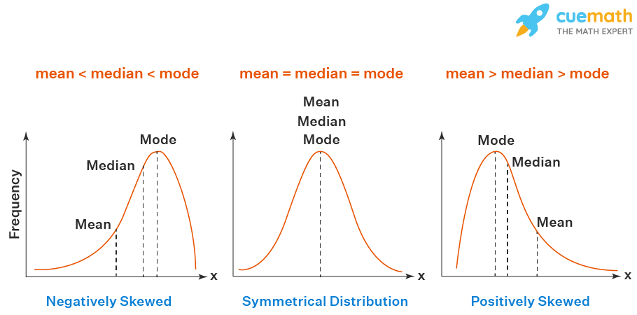

If a frequency distribution graph has a symmetrical frequency curve, then mean, median and mode will be equal.

**For Positively Skewed Frequency Distribution**

In case of a positively skewed frequency distribution, the mean is always greater than median and the median is always greater than the mode.

**For Negatively Skewed Frequency Distribution**

In case of a negatively skewed frequency distribution, the mean is always lesser than median and the median is always lesser than the mode.

**Practice questions**

The following table gives information about the marks obtained by 110 students in an examination.

|  |  |  |  |  |  |
| --- | --- | --- | --- | --- | --- |
| Class | 0-10 | 10-20 | 20-30 | 30-40 | 40-50 |
| Frequency | 12 | 28 | 32 | 25 | 13 |

Find the mean marks of the students using the assumed mean method.

**Solution:**

|  |  |  |  |  |
| --- | --- | --- | --- | --- |
| Class (CI) | Frequency (fi) | Class mark (xi) | di = xi – a | fidi |
| 0-10 | 12 | 5 | 5 – 25 = – 20 | -240 |
| 10-20 | 28 | 15 | 15 – 25 = – 10 | -280 |
| 20-30 | 32 | 25 = a | 25-25 = 0 | 0 |
| 30-40 | 25 | 35 | 35-25 = 10 | 250 |
| 40-50 | 13 | 45 | 45-25 = 20 | 260 |
| Total | Σfi =110 |  |  | Σfidi = -10 |

Assumed mean = a = 25

Mean of the data:

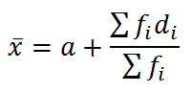

= 25 + (-10/ 110)

= 25 -( 1/11)

= (275-1)/11

= 274/11

=24.9

Hence, the mean marks of the students are 24.9.

**Example 2:**

The table below gives information about the percentage distribution of female employees in a company of various branches and a number of departments.

|  |  |
| --- | --- |
| Percentage of female employees | Number of departments |
| 5-15 | 1 |
| 15-25 | 2 |
| 25-35 | 4 |
| 35-45 | 4 |
| 45-55 | 7 |
| 55-65 | 11 |
| 65-75 | 6 |

Find the mean percentage of female employees by the assumed mean method.

**Solution:**

|  |  |  |  |  |
| --- | --- | --- | --- | --- |
| Percentage of female employees (CI) | Number of departments (fi) | Class mark (xi) | di = xi – a | fidi |
| 5-15 | 1 | 10 | -30 | -30 |
| 15-25 | 2 | 20 | -20 | -40 |
| 25-35 | 4 | 30 | -10 | -40 |
| 35-45 | 4 | 40 = a | 0 | 0 |
| 45-55 | 7 | 50 | 10 | 70 |
| 55-65 | 11 | 60 | 20 | 220 |
| 65-75 | 6 | 70 | 30 | 180 |
| Total | Σfi =35 |  |  | Σfidi = 360 |

Assumed mean = a = 40

Mean = a+ (Σfidi /Σfi)

=40+ (360/35)

= 40+(72/7)

= 40 + 10.28

=50.28 (approx)

Hence, the mean percentage of female employees is 50.28.