**DENTAL CHAIR**

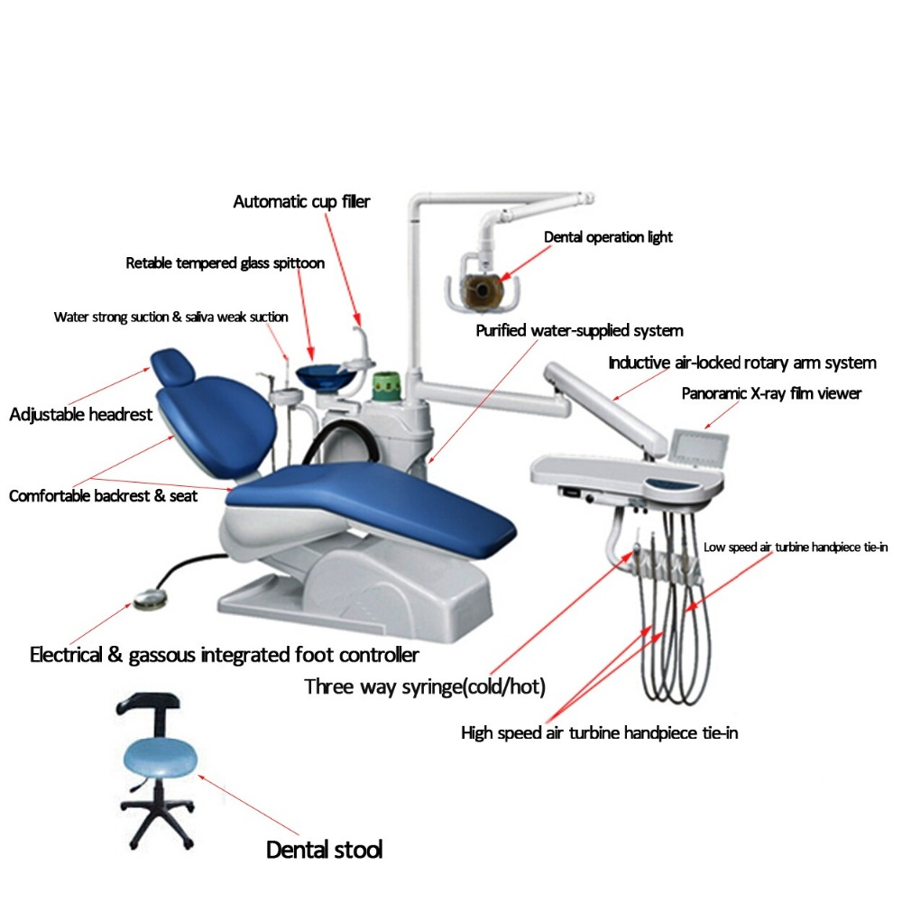

**Supplies to dental department**

* Electricity
* Water
* Compressed air
* Under pressure (vacuum)
* Drainage

**Various dental hand pieces**

* Micro motor hand piece
* Turbine hand piece
* Sprayvit
* Surgery hand piece
* Ultrasonic hand piece
* Fibre optic light
* Suction nozzle
* Cuspidor bowl

A dental chair is a chair in which a patient sits and a clinician can treat the patient by looking into his/her mouth easily. And it comprises of an electrically operated, retractable patient seating chair to which compressed air, water line, micrometer, spittoon bowl an overhead light is attached.

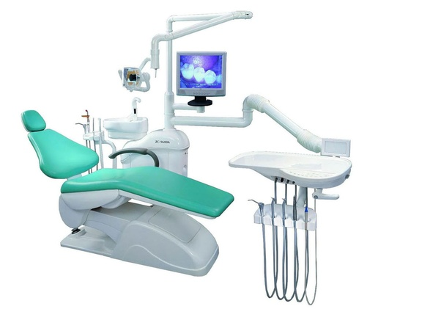

There are two types of dental chairs are available such as a portable and non-portable dental chair. And the non-portable dental chair is classified into three types which are general dental chair, pediatric dental chair, and a surgical dental chair.

Dental chair possesses multiple parts in it. In below I listed it and explain the function of these dental chair parts.

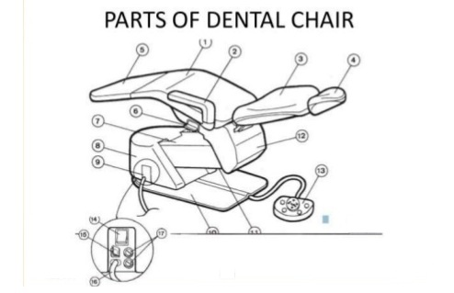

1. Dental light is used to illuminate the oral cavity

2.Dental chair controls

3. Disposable glass holder used to hold the disposable glass which is used for the patients

4.Spittoon bowl used for the patient to spit saliva during dental procedures

5. Air-water syringe frequently used to clean a tooth surface during treatment

6. Bracket Table is used to hold the hand instruments and other materials

7.X-ray viewer helps in the examination and interpretation of the patient’s radiographs

8. Foot control motor is used by the dentist when both of his/her hands are engaged

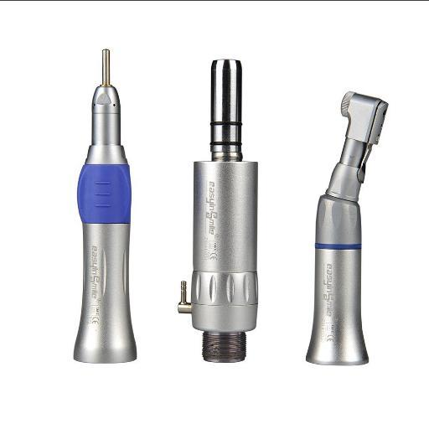

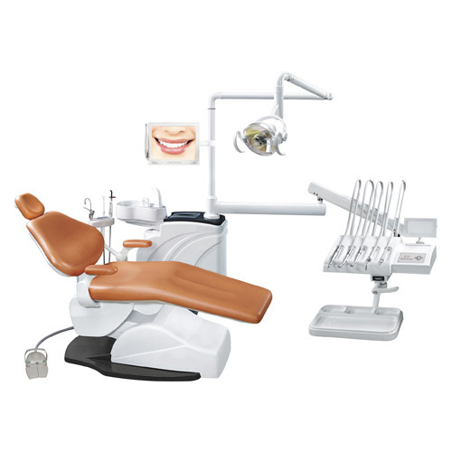

Dental unit layout

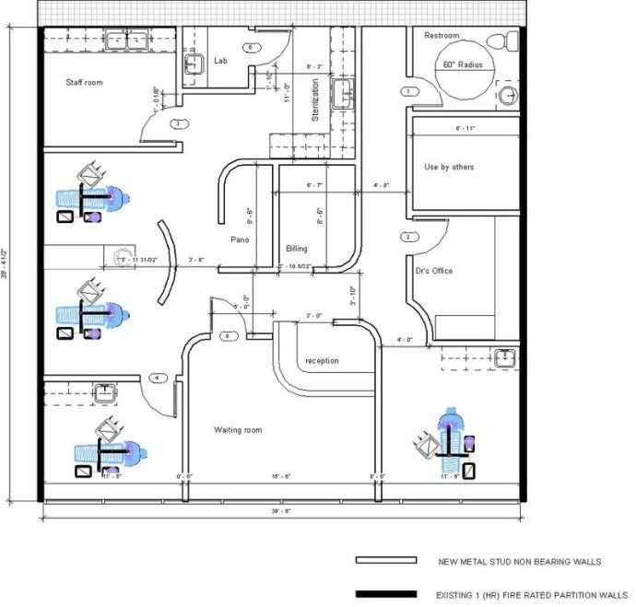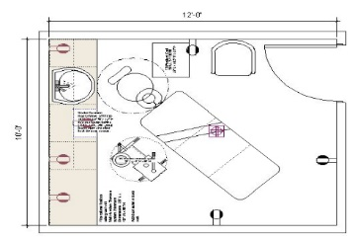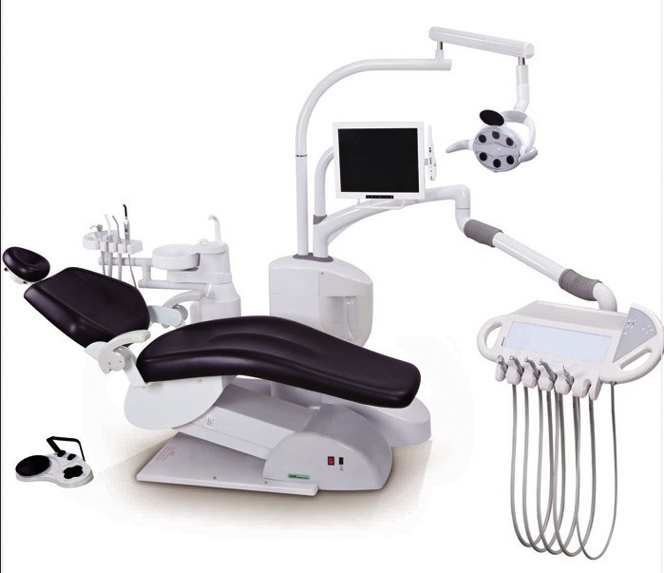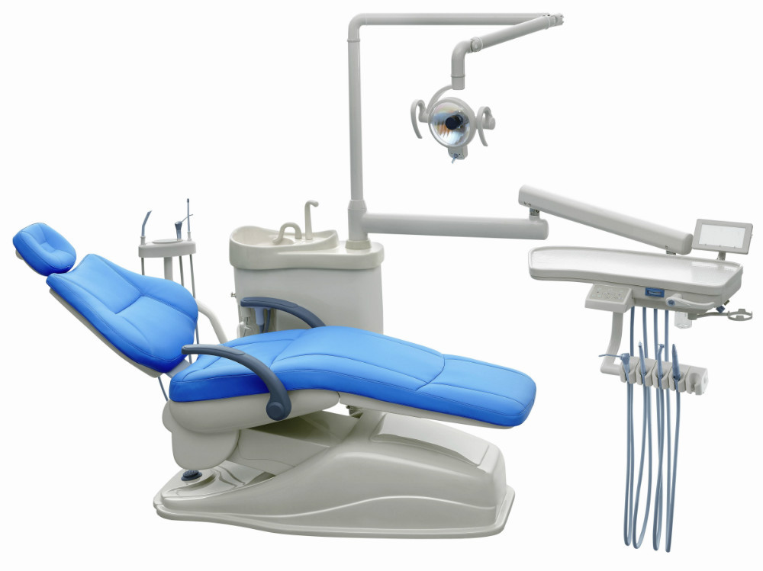

**Revision questions**

1. Name two main dental diseases, state the causes and prevention
2. Name various sections in dental unit and name the functions
3. With the aid of a diagram, explain backward and forward movement of a dental chair
4. With the aid of a diagram explain up and downward movement of a dental chair
5. State supplies to the dental unit and state their functions
6. Name 10 major pats of dental chair.
7. Name various dental hand pieces and state their supplies
8. Discuss maintenance of a dental chair