Good afternoon, Dr Stella
I trust you are well
I wanted to send you this confirming the updated agenda for the IT event happening next week Wednesday to Friday August 13th 15th: 9am to 3pm daily.

Event Brief
Careers in Tech
We are launching a new IT program designed to inspire and empower individuals to thrive in South Africa’s evolving technology landscape. This platform aims to bring together aspiring and experienced tech professionals, fostering collaboration, skills development, and career growth. Through engaging talks, insightful interviews, and interactive challenges, participants will gain practical knowledge while building valuable networks. The program will serve as a launchpad for careers in diverse areas such as full-stack development, project management, UX/UI design, and more. By connecting learners with industry experts, we hope to bridge the gap between academic knowledge and real-world application, helping participants confidently take their next step in the tech industry.
Date: 13-15 August 2025 (Wednesday to Friday)
Time: 9am – 3pm ( Each Day): We will also be responsible and assist with setup and set down

Attendees:
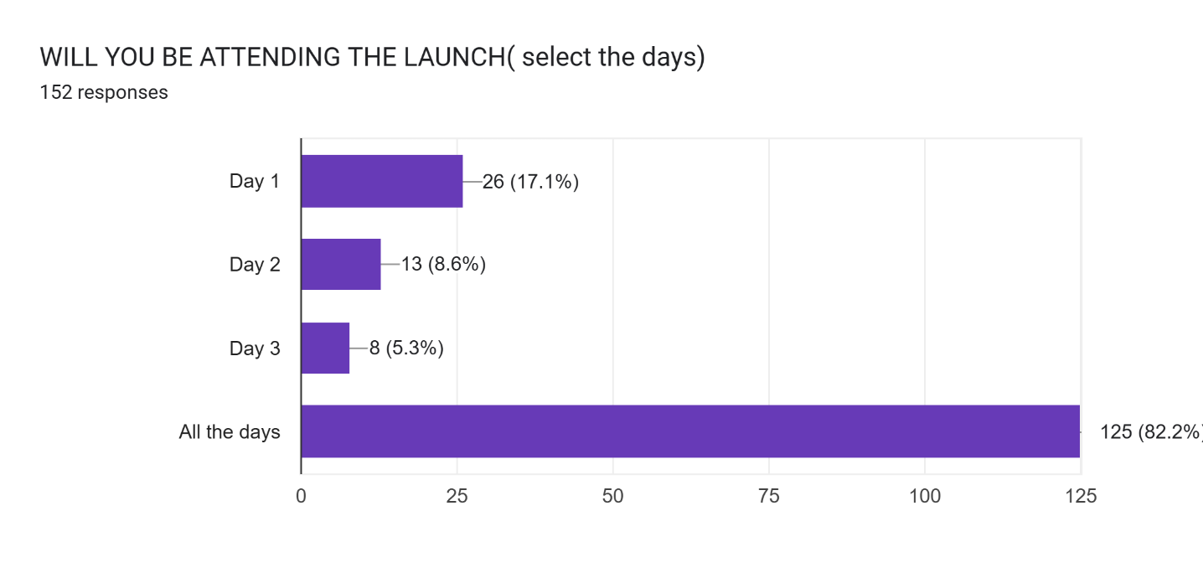
*Please note that all attendees that registered are students of MSA*
Full attendee/Guest List also shared with security previously
Below is a list of all the guest speakers we are expecting over the three
>13 August 2025:
1. Souzah Razario: IT Business Analyst: Cell: 0719561549
2. Kyle Ndlovu: Software Developer - Discovery + 15 accompanied guests Cell: 0624607085
3. Davies Adetiba: 060 926 1820
>14 August 2025:
1. Kyle Ndlovu: Software Developer - Discovery + 15 accompanied guestsCell: 0624607085
2. Mr Wamashudu Sigogo: Software Developer Cell: 082 611 1003
3. Mr Tunde Ojo Aromokudu: CEO @ Prosite Plan Africa Cell: 0829037099
4. Mr Adam Ankeli: Project Manager @ Lucyd Cell: 074 639 4176
5. Mrs Boitumelo Shabalala: Project Manager Cell: 072 2266134
6. Miss Lisakhanya Zweni: Software Engineer Cell 0836365550
7. Mrs Saloshnie Naidoo: CEO @ Home2Home Cell: 0824480169
8. Davies Adetiba: 060 926 1820

Friday 15 August 2025
8. Miss Rudo Malungisa: Business Process Improvement Specialist Cell:0726864147
1. Naledi Tlhakudi - 084 393 1363
2. Nkanyiso Sigwaza - 072 911 5157
3. Dr Natalie Raphil - 082 415 0757
4. Tamara Refeditse - 07677764535
5. KK Malekele - 077 868 45713
6. Davies Adetiba: 060 926 1820

Please find A list of all confirmed venues for the event
DAY 1: Lecture theatre 3
DAY 2: SEMINAR ROOMS 12 AND 13
DAY 3: LECTURE THEATER 6

Find below attached Email Confirmation from timetabling and scheduling:
