Hello friends.

Thank you for helping us with this annotation.

Here are the rules.

You’ll be getting one of these zip files.

You want to right-click on it, choose “Extract All…” -> “Extract”, and you should see 30 “.jpg” images.

Then, open the image with MS Paint. Right-click on the image, select “Open with” -> “Paint”.

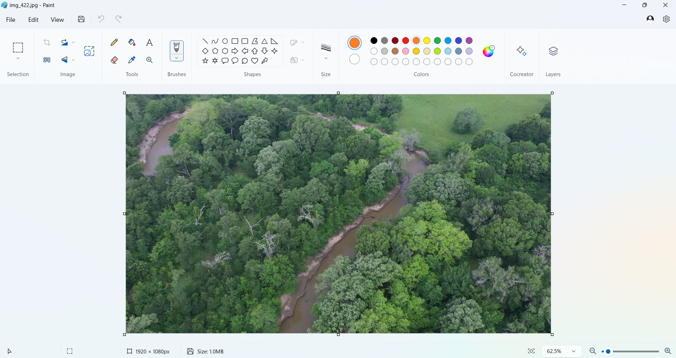

Pick this color, and color in the debris in the river.

Save, and move on to the next image. In once you are done with all 30, right-click on the folder, and “Compress to ZIP File”, and send the “.zip” file back to us.

Thank you for your participation. If you will, come back for more, because we have 1200 images.