Consensus and Dissension on the Power of Monetary Policy
What 75 Macroeconomic Models Have to Say *

William B. English
Yale University
Robert J. Tetlow
Board of Governors of the Federal Reserve System
Connor M. Brennan
University of Chicago

October 24, 2025
Abstract
The appropriate calibration of monetary policy requires an evaluation of the size and timing of the effects of policy changes on the economy. Despite decades of research, significant uncertainty about those effects remains. Using a large collection of structural macroeconomic models and three different monetary policy rules, we simulate the effects of monetary policy shocks on the size and timing of fluctuations in output and inflation. We then relate those effects to a set of model and non-model attributes, including the monetary policy rule employed, specific model features such as nominal and real rigidities, and other non-model features, such as whether the model is estimated or calibrated, when the model was formulated, and the backgrounds of the authors. We find that the range of the resulting impulse responses is wide, with some models showing very rapid and large effects, while others show much more gradual or more modest effects. Not surprisingly, we find larger and more persistent effects when the policy reaction function has more inertia. In addition, the effects of policy are more drawn out when the model is estimated rather than calibrated and if the authors include central bank staff. Even after accounting for these and other attributes, there remains considerable variation in the effects of policy across models. We conclude that policymakers need to be humble about their knowledge of the effects of monetary policy and approach their policy decisions with a risk management framework
_________
* The views expressed are those of the authors and do not reflect the views of the Board of Governors of the Federal Reserve System, the Federal Open Market Committee, or members of their staffs. We thank Jake Scott and Bennett Fees for outstanding research assistance. We are grateful to Volker Wieland, Alexander Dueck, and Kai Long Liu for their help in working with the Macroeconomic Model Data Base. Corresponding author: Bill English: william.b.english@yale.edu. Tetlow: rtetlow.econ@gmail.com. Brennan: cmbrennan@uchicago.edu

Introduction
For central banks to choose the appropriate stance of monetary policy to achieve their objectives, they need a reliable understanding of the magnitude and timing of the effects of monetary policy on output, employment, and inflation. For example, if monetary policy has large effects that emerge with short lags, then policymakers will choose modest adjustments to the stance of policy in response to economic developments. But if monetary policy has smaller effects that operate with a substantial lag, then policymakers will want to adjust policy more forcefully over time, and more in response to anticipated changes in the economic outlook than current conditions.
The distinction is more than hypothetical, as recent experience ably demonstrates. As the Federal Reserve rapidly increased interest rates in response to high inflation during the pandemic, policymakers emphasized that lags in the effects of policy meant that policy tightening would need to cease well before inflation returned to target to avoid overshooting that would result in an undesirably large decline in output and employment (Powell, 2023). On the other hand, some policymakers argued that the lags might be relatively short, suggesting less need to be concerned about such outcomes (Waller, 2023). Despite these ambiguities, policymakers must do their best to judge the anticipated effects of changes in monetary policy and choose their policy settings accordingly.
In this paper, we show that there is a very wide range of estimates for the size and timing of the effects of monetary policy. To do so, we summarize the effects of monetary policy shocks on a wide range of structural macroeconomic models of the United States economy, as published in papers in leading economic journals over the past few decades. For each of our 75, mostly New Keynesian dynamic stochastic general equilibrium (DSGE) models, we carry out two classes of monetary policy experiments. The first class of experiments is one-time shocks to each of three simple monetary policy rules, from which we construct impulse response functions. The second class of experiments is more persistent: a permanent reduction in the target rate of inflation.
We divide the attributes of the models in our sample into two categories. One category covers aspects of model structure, such as the types of nominal rigidities embedded within each model, and the real rigidities or channels through which monetary policy might be amplified or propagated. The second category captures background aspects of the methodology behind the models, such as whether they were estimated or calibrated, the historical period from which each model was formulated, and related matters.
Armed with these data, we use regression analysis to identify which model characteristics are associated with the magnitudes and timing of monetary policy. We standardize monetary policy across models, applying to each model three simple policy rules that differ in the persistence they impart to monetary shocks and in their feedback on real variables. Not surprisingly, the quantitative effects vary depending on the monetary policy reaction function, with inertial reaction functions leading to larger effects on output and inflation as well as longer lags. The modeling of sticky wages and wage and price indexation influences the effects on output and inflation, but by less than one might expect. We also find that output effects are larger in models that include real rigidities, such as a wealth or net worth channel, although with relatively little pass-through to the size of effects on inflation. In terms of timing, we find that the peak effects of monetary policy on output are later for models that are estimated, as opposed to calibrated. And that the timing of peak effects is later for models that have central bank authors, although this phenomenon appears to have waned in recent years. In the case of inflation, more recent models tend to have more rapid transmission.
Even after accounting for the effects of the various attributes, the unexplained variation across models remains large: the R²s in our regressions are less than 50 percent, and often much less. Thus, models often intended for use in policy analysis, differ widely in their assessments of the impact of monetary policy, even after accounting for differences in modeling and in non-model attributes. Within the New Keynesian (NK) paradigm, the exploration in modeling that began with the establishment of the canonical three-equation model (Rotemberg and Woodford, 1997; Clarida, Galí and Gertler, 1999; McCallum and Nelson, 1999) has produced a plethora of contributions, but with a wide range of quantitative results. To some extent, this range likely reflects broader research trends, as the literature has increasingly moved away from testing and rejecting models (or specifications) toward theory-centric research designed to illustrate the features of particular microfoundations. It also likely reflects time variation in the underlying data generating process, including the conduct of monetary policy, and difficulties in isolating the origins and timing of shifts.
The implication for monetary economists is, at a minimum, that the search for a workhorse quantitative model of the US economy continues. We would also argue that the ambiguity revealed in this paper regarding the power of monetary policy should serve as a warning to policymakers of the need to be humble in policymaking and to approach policy with a risk management approach, taking account of outcomes in which monetary policy proves to work more or less rapidly, or has more or less power, than anticipated.
The scope of the paper is ambitious but limited even so. Among the omissions we highlight is nonlinear or path-dependent effects, necessitated by the fact that all our models are linear. Similarly, while we can investigate how the vintage of a model – that is, the historical period that influenced the model’s construction – affects its properties, we cannot isolate time variation in the strength or speed of monetary policy. Lastly, while we study the effects of monetary policy shocks on the economy, the heterogeneity of models implies that cross-model comparisons of how monetary policy responds to non-monetary shocks is beyond the scope of this paper. That said, while the literature makes clear that exogenous monetary policy shocks explain only a limited proportion of the variance in output in the U.S., the power and speed of transmission of monetary policy shocks is material for a wider set of phenomena.
The remainder of this paper is organized as follows: the next section provides a helicopter tour—brief and incomplete—of the evolution of thought regarding the macroeconomic features that influence the power and speed of monetary policy. That survey leads to the construction of our attributes data, covered in the third section, which also discusses our methodological approach. The results of our analysis are divided between sections 4 and 5. A sixth and final section offers some brief concluding remarks. Appendix A provides a list of the models used in this paper, while Appendix B contains supplementary tables and related information.

Modeling monetary transmission
The starting point of any analysis of the power of monetary policy is the question of why monetary policy matters at all. That topic commences with the neoclassical synthesis, which grafted Keynesian short-run dynamics to the frictionless neoclassical growth model. The glue that held the two together was nominal rigidities: In particular, if prices (and wages) could not adjust instantaneously, a monetary policy shock would result not just in fluctuations in prices and nominal wages, leaving output and employment undisturbed, but would induce adjustments in real activity and employment. Most of the literature of the last few decades has adopted the assumption of sticky prices or other nominal rigidities.
Jumping ahead in time, sticky prices alone turned out to be a thin reed upon which to build a theory of monetary business cycles. Among other findings, Fuhrer and Moore (1995) showed that the persistence of inflation found in the data could not be generated by price-level stickiness alone. Indexation of prices—staggering by another name—was one solution. Adding wage stickiness could also aid in the propagation of shocks (Erceg et al., 2000). Early NK models exhibited a “divine coincidence” in which stabilizing inflation was tantamount to stabilizing output, contrary to conventional thought. The inclusion of a real rigidity re-established the short-run tradeoff between stabilizing inflation and stabilizing output (Blanchard and Galí, 2007).
The past twenty years have been marked by the ascent of DSGE modeling, which added microfoundations, scale, and empirical validation to their largely semi-structural predecessors (see, especially, Smets and Wouters (2007) and Christiano et al. (2005)). One cost, among others, of these indisputable advances was added complexity and associated difficulties in discriminating between hypotheses regarding the sources of business cycle fluctuations.
Channels through which interest rate changes affect the real economy can be usefully divided into neoclassical and non-neoclassical (Boivin et al., 2011, table 1, p. 375). Neoclassical channels include intertemporal substitution—easily the most prevalent channel among New Keynesian models—the user cost of capital channel (Hayashi, 1982), the wealth channel (Chodorow-Reich et al., 2021), and for open-economy models, the exchange rate channel (Obstfeld and Rogoff, 1998). Each of these operates through short-term interest rates changing the terms of exchange between current domestic expenditures and something else: future expenditures, the valuation of claims on assets, or expenditures on foreign-sourced goods and services. Expectations of future interest rates and associated economic conditions—and thus the anticipated propagation of shocks—are at the center of each of these channels. Non-neoclassical channels capture the implications real rigidities—exemplified by financial frictions—that could amplify or propagate shocks via their effects on, for example, the state of household balance sheets, through collateral constraints on bank lending, or through the value of bank charters.
The uncertainty surrounding the effects of monetary policy uncovered in this paper likely reflects, in part, changes in modeling over time owing to the evolving structure of the economy. As noted above, the DSGE boom resulted in larger, more complex models, which to some extent led to disagreement on the origins of economic fluctuations. Economic history in general, and the ebb and flow of inflation in particular, imply different implications of nominal frictions, as captured, for example, by the optimum frequency of price and wage adjustments. Changes in industrial mix, in financial structure, in regulation, and in monetary policy communication can all affect the size and timing of policy effects (see, e.g., Carlino and DeFina, 1998; Cecchetti, 1999; Doh and Foerster, 2022; Havranek and Rusnak, 2018).

Methodological Approach
We consider a broad range of structural macroeconomic models employed in the literature to gain an understanding of how researchers have isolated the effects of monetary policy on the economy. This is challenging for a number of reasons. One needs to collect the models under a common platform, ensure that they have consistent measures of output and inflation, and that they are well behaved under the governance of a class of monetary policy rules. Once that is achieved, one can study monetary policy shocks for their effects on nominal interest rates, output, inflation and real interest rates across the models.

3.1 The models
Fortunately, an accessible database has been put together (Wieland et al., 2012; Wieland et al., 2016). The Macroeconomic Model Data Base (MMB) archives a wide array of macroeconomic models, based on papers published over the last 25 years or so, with a common front end that facilitates model comparisons. We augment the MMB models with a small set of monetary policy rules, carry out orthogonalized shocks to the policy rules, and compute the impulse response functions (IRFs). These IRFs, or transformations of them, form much of the data for our analysis.
One important issue is the selection of models to be used. Our aim is to select models that encompass the range of conventional views regarding the dynamics of the US economy. The MMB includes 61 estimated models of the United States, which suits our objectives well. It also includes 43 calibrated models, of which we include the ones that are calibrated to US economic dynamics. The database also includes a small set of multi-country models. We retain those multi-country models that were intended to capture open economy aspects of the US economy, eight in total. Finally, while the bulk of the models in the MMB are linear rational expectations models, we include 11 calibrated or estimated models of the US economy that employ adaptive learning.
Because we are interested in analyzing as much of the modern modeling literature as practicable, our inclination in curation is to retain as many models from the MMB as possible. Even so, we drop several models from our analysis, for a variety of reasons. First, some papers include more than one version of the model under study, often to serve as the benchmark for an added model feature, or to match the model to different scenarios. In such cases, we include only one model in our analysis, choosing the version of the model upon which the paper in question was focused so long as that model was suited to our examination of the effects of monetary policy shocks. Second, some models could not be solved under some of our monetary policy rules, so no results were available for those cases. Ultimately, in our full sample we used 75 models, which with our policy rules resulted in 217 observations for the quantitative measures derived from our policy experiments. See Appendix A for a list of the models included in the analysis.

3.2 The policy rules
Ultimately, the dynamic effects of monetary policy are jointly determined by the structural features of the non-monetary aspects of the economy and by the conduct of monetary policy, as governed by the monetary policy rule. To investigate this dependency, and to ensure that our results are not idiosyncratic functions of a particular specification, we use three rules, standardized across our models. The first is the familiar Taylor (1993) rule (TR):
$$i_{t}=1.5*\left(π_{t}^{4}-π_{t}^{*}\right)+0.5*y_{t}+u_{t}$$
where i is the annualized nominal federal funds rate, $π^{4}$ is four-quarter inflation, $π^{*}$is the target rate of inflation, $y$ is the output gap, and u is a disturbance term. Second, an inertial version of the Taylor rule (ITR):
$$i_{t}=0.75*i_{t-1}+(1-0.75)[1.5*{(π}_{t}^{4}{-π}_{t}^{*})+0.5*y_{t}]+u_{t}$$
And finally, a growth rule (GR), which employs monetary feedback on the (four-quarter) change in output in an effort at reducing dependence on potentially mismeasured estimates of the output gap, also with inertia:
$$i_{t}=0.75*i_{t-1}+(1-0.75)[1.5*{(π}_{t}^{4}-π_{t}^{*})+0.5\left(y_{t}-y_{t-4}\right)]+u_{t}$$
Besides being in common use for monetary policy experiments, these three rules encompass the classic issues in monetary policy with simple rules (Taylor and Williams, 2011). In particular, each respects the Taylor principle and features feedback on a real variable in addition to inflation. They also span two conventional specification issues in monetary economics with simple rules, namely, the question of persistence in the setting of monetary policy, and feedback on the level versus the difference of a real variable. For future reference, it is worth noting that, all else equal, the GR generally imparts more persistence to the properties of any given model than the ITR and that both are more inherently persistent than the TR.

3.3 Data construction
As noted above, we construct data based on the results of two classes of monetary policy experiments, one transitory, the other persistent. This section summarizes those experiments and the data extracted from them.

3.3.1 Summary measures
The IRFs we construct are multivariate depictions of quantitative phenomena. To encapsulate the results, we compress the time dimension into a collection of univariate measures that capture the size of the effects for the horizon over which monetary policy is commonly thought to affect the economy (which we take to be 20 quarters). Thus, we focus on the cumulative response of the variables that are objectives of monetary policy—output and inflation—over five years, in response to monetary policy inputs over the same period. So, for example, measures of key interest to us will be the cumulative increase in output and inflation, relative to the cumulative reduction in real interest rates over the same horizon, as initiated by a one-time, one-percentage-point negative shock to the disturbance term in each of the policy rules. The output or inflation response is thus normalized to the endogenous response of real interest rates, and thus represents a measure of the power of monetary policy in a particular model, under the governance of a given policy rule.
Similarly, we construct data from experiments where the target rate of inflation is permanently reduced by one percentage point, calculating the annualized cumulative output loss from each of these disinflation experiments and dividing by the reduction in inflation in percentage points after five years. This is a standard calculation of a sacrifice ratio (see, e.g., Ball, 1994; Tetlow, 2022). In a sense, it abstracts from the real interest rates necessary to induce the output and inflation movements to focus on the interaction between the two. It is thus a natural complement to y-slope and π-slope.
Crudely speaking, one way to think of these is in terms of the undergraduate textbook representation of monetary policy, which removes the time dimension of economics. In that rendition, monetary policy is about the elasticities implied by the slopes of the aggregate demand function and the Phillips curve. We follow in this tradition. Even so, we separately devote considerable attention to the question of timing. How long, according to our set of models, does it take for monetary policy to have its maximum effect on inflation and output? We measure this by the number of quarters at which the effects on output and inflation reach their peaks. Table 1 summarizes the construction of our elasticity variables and timing variables.

Table 1
Construction of Macroeconomic Outcome Variables
Elasticity variables* |  | Timing variables
y-slope | Ratio of the cumulative sum of changes in output to the cumulative sum of changes in the real interest rate** | y-timing | The quarter in which the output impulse-response function reaches its peak value
π-slope | Ratio of the cumulative sum of changes in inflation to the cumulative sum of changes in the real interest rate** | π-timing | The quarter in which the inflation impulse-response function reaches its peak value.
sacratio | Ratio of the cumulative annualized loss in output scaled by the reduction in inflation, from a simulation of a permanent reduction in the target rate of inflation.
Notes: * Calculations carried out at quarter 20 of each simulation. ** Real interest rate is computed in a model-consistent fashion for each model using period-by-period simulated values of nominal interest rates and inflation. Source: authors’ calculations based on simulations of MMB models.

3.3.2 Model attributes
To explore the sources of the differences in the effects of monetary policy across the models, we construct a set of attribute variables, focusing on those attributes that could reasonably be expected to influence the effects of monetary policy on the economy. The structure of the wage-price block of a model should influence the effect of monetary policy on inflation. For example, all of the models employ sticky prices, of some sort, broadly defined, while some also employ sticky wages; some models also include indexation in either price or wage setting. In addition, many models incorporate interest sensitivity of aggregate demand through intertemporal substitution in consumption, but many have other channels for monetary policy as well. For example, as noted, some models are open-economy, and so have an exchange rate channel; others have financial channels, including operating through bank credit, household wealth, or firm net worth. All else equal, each of these attributes could lead to larger effects of changes in the policy interest rate on output. Larger effects on output could also mean larger effects on inflation, all else equal, since inflation in the models is generally affected by the expected level of economic activity.
Some non-model attributes could also be important. As noted above, estimated models appear to have more gradual responses to monetary policy shocks than calibrated models. More broadly, larger models might capture more economic interactions between the real and nominal sides of the economy, which arguably would better match the data, and possibly result in more gradual effects of monetary policy on activity and inflation. The vintage of the model—that is, when it was constructed or published, could also matter for the impulse response functions. Over the years prior to the pandemic, inflation became more stable near target, implying a flatter empirical Phillips curve that would suggest smaller effects of monetary policy on inflation in more recent models than in models from the 1990s. Finally, it seems possible that economists at central banks, because their work is particularly policy-focused, would make different modeling decisions (for example, being more inclined than others to “let the data speak” and not be unduly constrained by theoretical considerations) that would have implications for the impulse-response functions.
Based on this reasoning, we collected data on the model and non-model attributes shown in Table 2 for each of our models.
Table 2
Model and non-model attribute variables
Variable | Average value
Model attributes: Nominal rigidities
1. Price stickiness (any source) | 1.00
2. Sticky wages | 0.59
3. Price indexation* | 0.50
4. Wage indexation* | 0.35
Model attributes: Real rigidities
5. Channels (any source) | 0.63
- Net worth | 0.27
- Wealth | 0.29
- Bank credit | 0.44
- Open Economy | 0.11
Non-model attributes
- At least one central bank author | 0.71
- Estimated model | 0.58
- Number of structural equations | 22.4
- Early vintage publication (< 2000) | 0.08
- Middle vintage publication (2000 – 2007) | 0.19
- Late vintage publication (> 2007) | 0.72
- Early sample estimation data (< 1980)** | 0.67
- Late sample estimation data (1980+)** | 0.33
Notes: * Price (or wage) indexation implies sticky prices (or wages); the converse is not always true. n = 217. **Estimated models, for which n=131; otherwise, n = 217. Source: authors’ calculations.

Results

4.1 Aggregate results
Figure 1 shows the impulse response functions for output, inflation, and the nominal federal funds rate in response to a 100-basis-point (negative) shock to the federal funds rate for our complete set of models and all three policy reaction functions. Looking across the impulse-response functions, the median effects on output and inflation, shown by the red dashed lines, are of reasonable size, with maximum effects on output of about 0.2 percent and cumulative effects on output across 20 quarters of roughly 1 percent, while the median maximum effect on inflation is a bit less than 0.1 percentage point, with the median cumulative effect over 20 quarters running well under 1 percentage point. Somewhat surprisingly, given the conventional view that monetary policy works with significant lags, the maximum effects are typically reached within one or two quarters. These median results are broadly similar to those seen in well-known medium-scale estimated models, such as Smets and Wouters (2007)—shown by the blue dashed lines. They are also broadly comparable to the results of a simple VAR—shown by the black dashed lines—although the VAR effects are larger and come with larger lags. That said, there is a strikingly wide range of results across models, with peak effects varying from essentially no effect at all to effects well over 2 percent on output and over 1 percentage point on inflation. Moreover, in many cases the peak effects occur immediately, whereas they are realized only after four quarters or more in others.
As we will discuss below, the breadth of results reflects both the different policy rules used and the model and non-model attributes outlined in the previous section. Regarding the latter, for present purposes, we note significant differences between the results of estimated and calibrated models. The figures show results for calibrated models in orange and those for estimated models in green. It is clear that calibrated models tend to produce large, short-lived responses, relative to their estimated counterparts. To some extent this reflects the fact that at least some calibrated models are intended less to capture the timing of monetary phenomena and more to illustrate the channels and mechanisms through which policy may work. Estimated models tend to exhibit more gradual adjustments to monetary policy shocks, consistent with the empirical lags found using the narrative approach (Romer and Romer, 2023) or market measures of policy surprises (Bauer and Swanson, 2022; Swanson, 2024).
Figure 1
Impulse Responses
(Full sample of models; all policy rules)
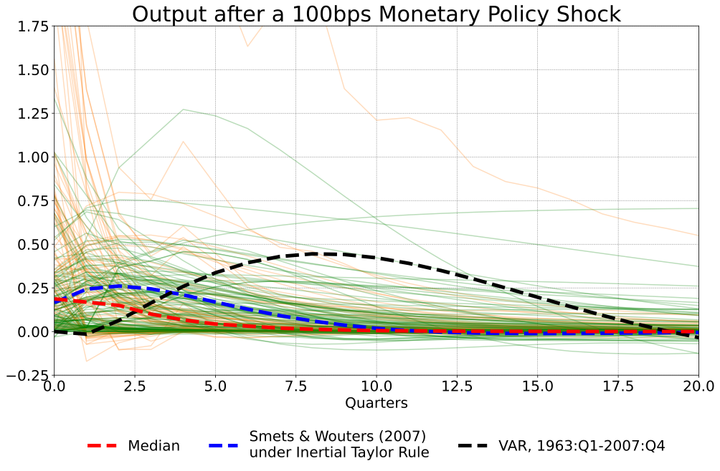
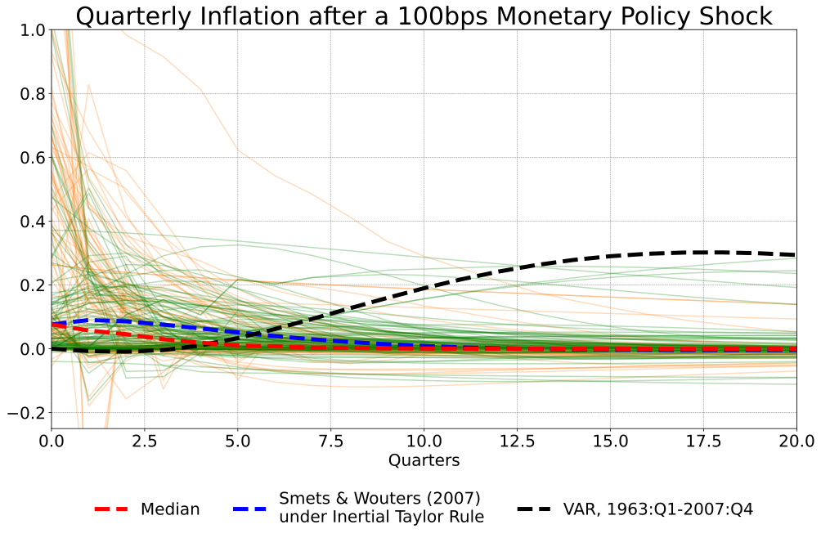
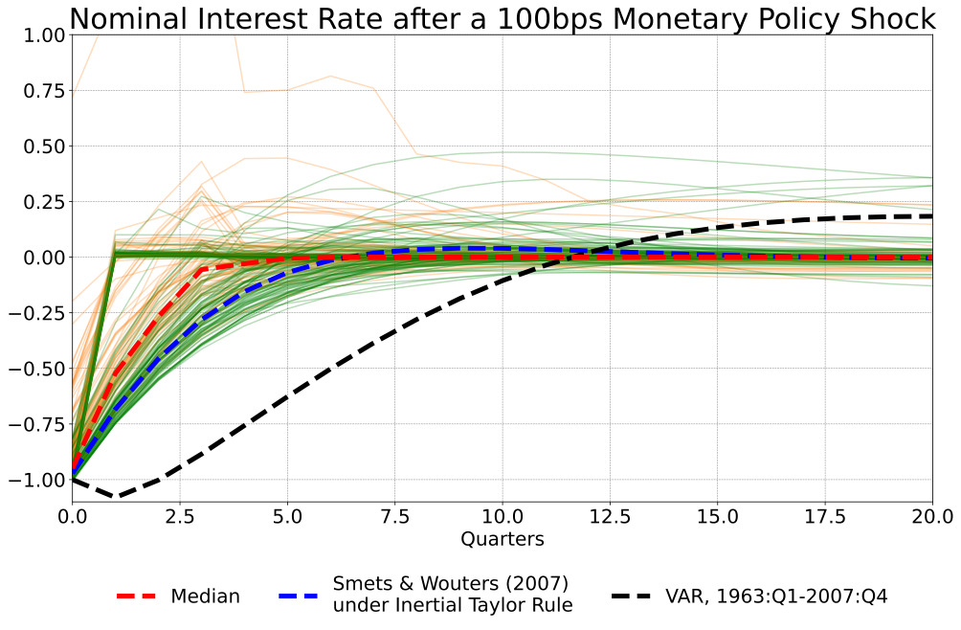
Note: Green lines are for estimated models; orange lines are for calibrated models. Source: Authors’ calculations.

4.2 The influence of policy design
Figure 1 shows impulse responses for the full sample of models under the governance of each of our three monetary policy reaction functions. Figures 2-4 show the same IRFs, but separately for each policy rule. We also include responses of a vector autoregression (VAR) estimated from 1963:Q1 to 2007:Q4 to provide an empirical base against which to compare model results. The effects on output and inflation are smallest for the TR, shown in Figure 2, largely reflecting the absence of propagation originating from the rule itself (shown in the lower panel). The muted dynamic response of output and inflation to the shock under the TR implies that, in a great many models, particularly the calibrated models, the internal propagation mechanism—that is, the propagation that comes from sources other than the policy rule—is weak. Taken at face value, this finding suggests that the persistence typically found in the data is a manifestation of policy itself.
As Figures 3 and 4 show, the effects are generally larger and longer-lived for the ITR and the GR, consistent with the partial adjustment embodied in those rules. That said, it is still the case that for any given rule, the impulse response functions span a wide range. And despite the wide range of model responses, no response captures the empirical VAR baseline. Most of the remainder of this paper explores some of the reasons for this dispersion of results.

Figure 2
Impulse Responses
(Full sample of models; Taylor rule)
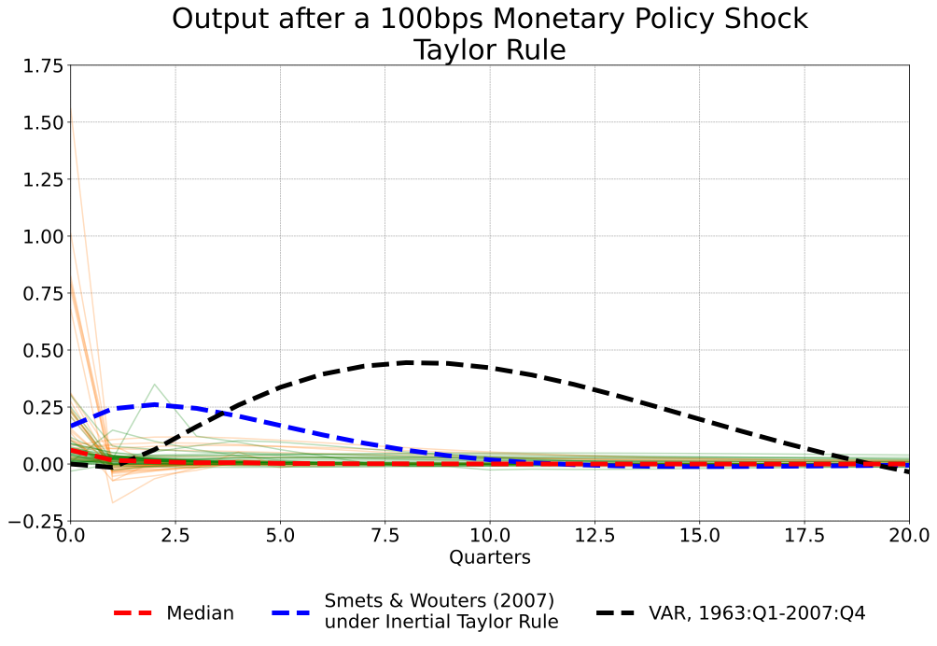
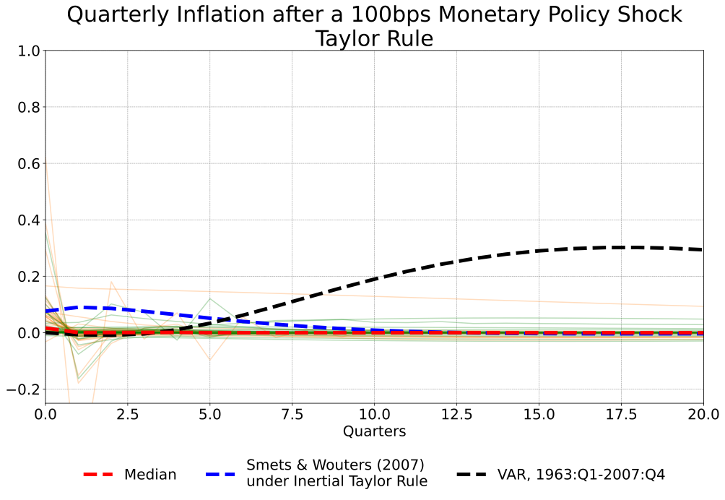
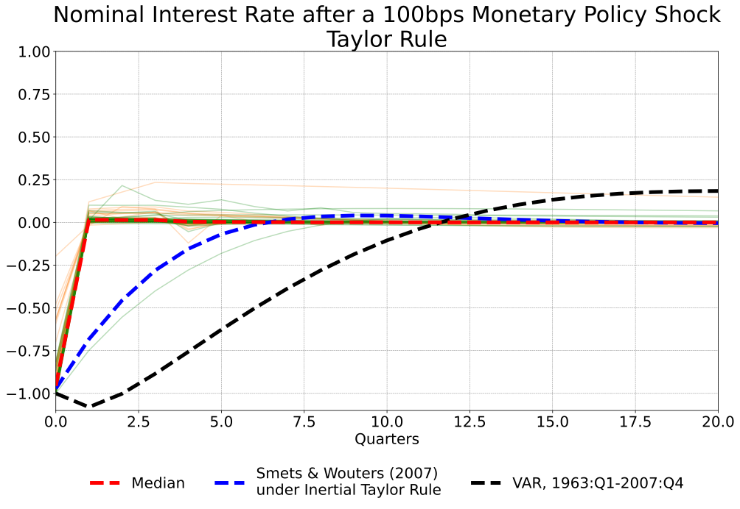
Note: Green lines are for estimated models, orange lines are for calibrated models. Source: authors’ calculations.
Figure 3
Impulse Responses
(Full sample of models; inertial Taylor rule)
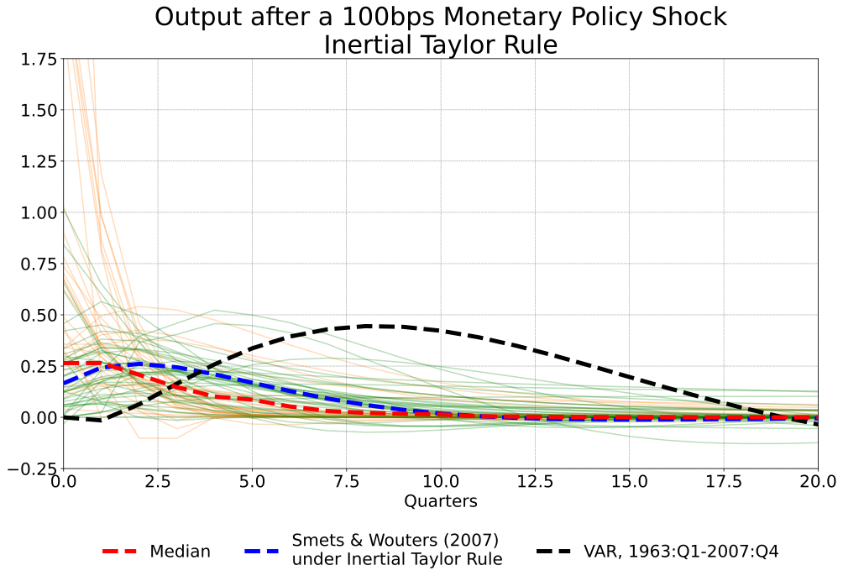
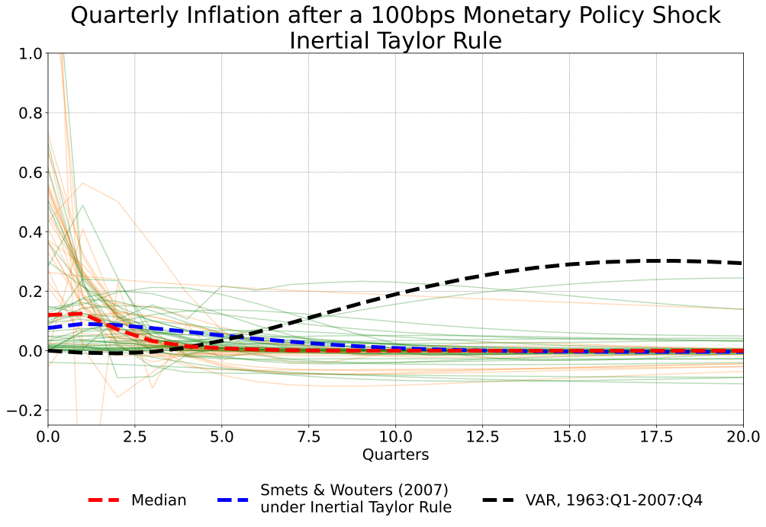
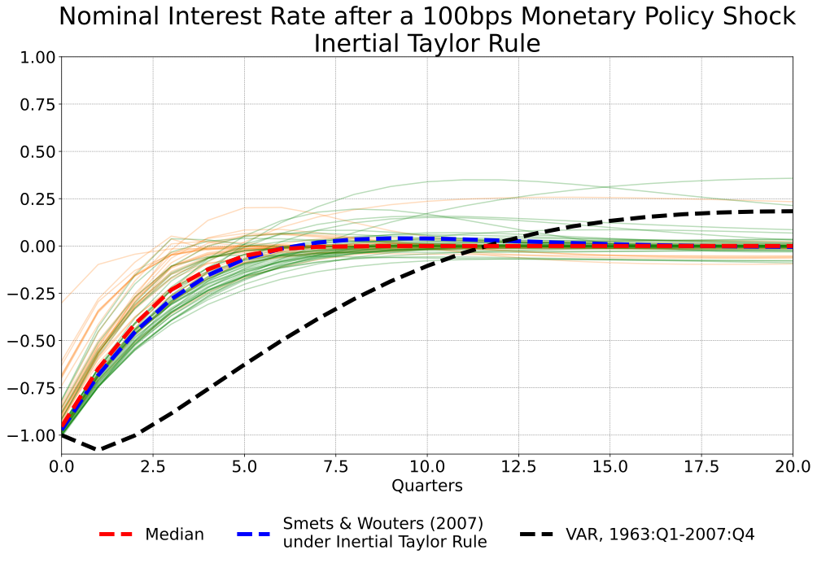
Note: Green lines are for estimated models, orange lines are for calibrated models. Source: authors’ calculations
Figure 4
Impulse Responses
(Full sample of models; Growth rule)
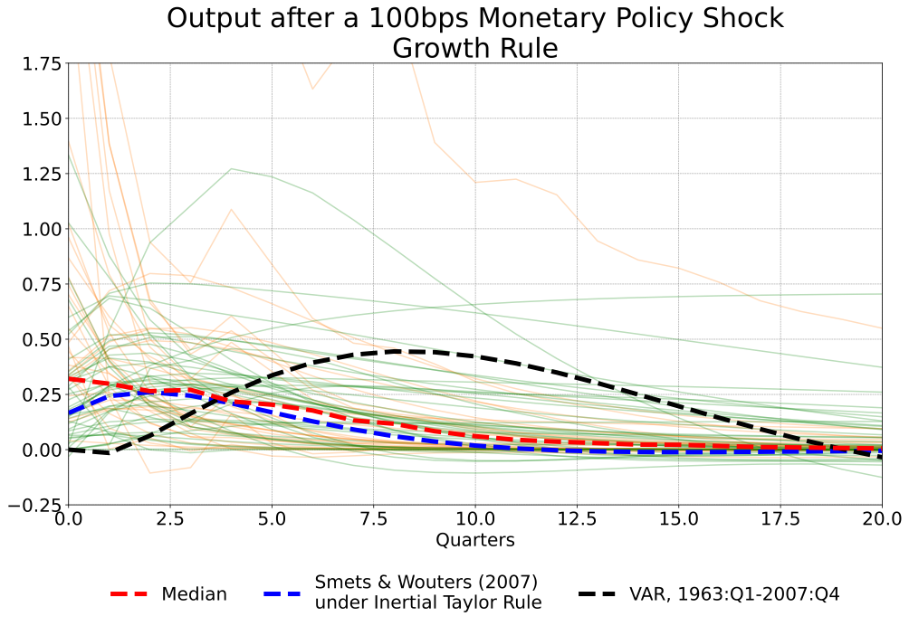
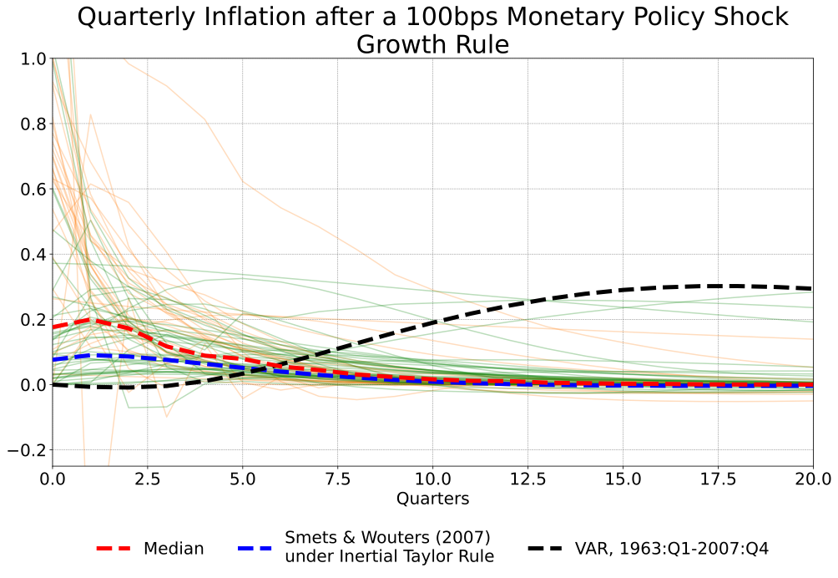
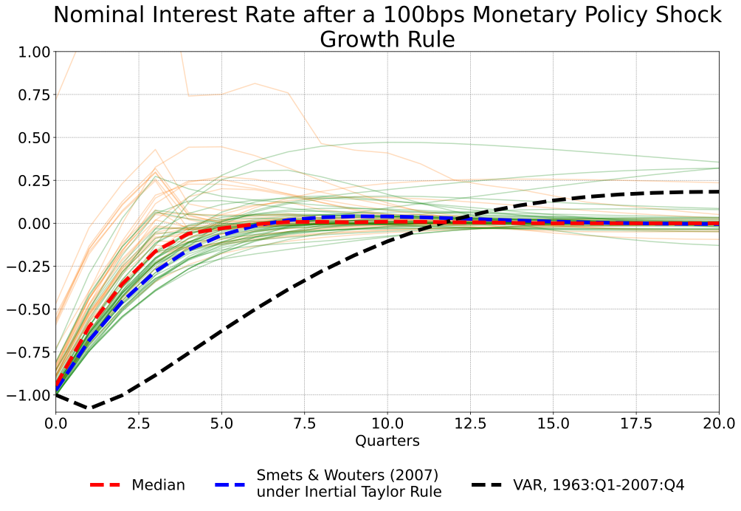
Note: Green lines are for estimated models, orange lines are for calibrated models. Source: Authors’ calculations.
Table 3 is a quantitative depiction of the phenomena displayed in Figures 2-4. In particular, it presents descriptive statistics for the elasticity and timing variables, as defined in Table 1, including a breakdown of the results for the full sample of models, the upper panel, and subsamples covering calibrated and estimated models, the bottom two panels.
Table 3
Summary statistics for the constructed data
Full sample
 | y-slope | π-slope | sacratio | y-timing | π-timing
Mean | -1.02 | -0.29 | 14.50 | 2.24 | 2.49
Median | -0.53 | -0.21 | 4.15 | 1.00 | 1.00
Std deviation | 1.89 | 1.46 | 45.90 | 2.26 | 3.28
Skewness | -0.88 | 9.80 | 5.99 | 5.34 | 4.27
N | 217 | 217 | 192 | 217 | 217
Calibrated models
 | y-slope | π-slope | sacratio | y-timing | π-timing
Mean | -1.34 | -0.27 | 10.27 | 1.38 | 1.26
Median | -0.65 | -0.30 | 3.44 | 1.00 | 1.00
Std deviation | 2.51 | 2.14 | 24.71 | 0.81 | 0.74
Skewness | 0.22 | 7.56 | 3.54 | 1.93 | 3.79
N | 91 | 91 | 75 | 91 | 91
Estimated models
 | y-slope | π-slope | sacratio | y-timing | π-timing
Mean | -0.79 | -0.31 | 17.21 | 2.87 | 3.37
Median | -0.51 | -0.16 | 4.65 | 2.00 | 2.00
Std deviation | 1.21 | 0.60 | 55.32 | 2.73 | 4.04
Skewness | -5.19 | -5.03 | 5.32 | 4.62 | 3.31
N | 126 | 126 | 117 | 126 | 126
Notes: See Table 1 for definitions of variables. Source: authors’ calculations based on simulations of MMB models.

On average, monetary policy is faster and (at least for output) more powerful in the calibrated models than estimated models. That is, the cumulative effects of a given cumulative change in real interest rates on output (as measured by y-slope) are larger for the calibrated models. In addition, the output cost of disinflation—that is, the sacrifice ratio—is smaller for the calibrated models. And all of this comes earlier for the calibrated models, meaning at lower values of y-timing and π-timing. Taken at face value, these results suggest that the developers of calibrated models have greater faith in the power of monetary policy than the data suggest. That said, even the estimated models are not consistent with Milton Friedman’s characterization of the lags of monetary policy as “long and variable” (Nelson, 2020, p. 141), at with regard to length: The mean lag for the timing of the peak output response for estimated models is less than three quarters.
Tables 4 and 5 decompose these statistics by the monetary policy rule that generated them. Several observations arise from this decomposition. First, Table 4 demonstrates that the greater power of calibrated models regarding output described above reflects larger effects for the TR and ITR, while there is little difference based on the GR. This result presumably stems from the output term in the GR being written, as the name suggests, in terms of growth rates, as opposed to levels of output. Second, the persistence implied by the ITR, and especially the GR, results in larger absolute values of y-slope and π-slope for both the calibrated and estimated models. This is not as obvious a result as might seem on the surface, as y-slope and π-slope are scaled to the magnitude of the movement in real rates that each policy rule elicits. Third, the results for sacrifice ratios indicate that higher values of y-slope and π-slope do not necessarily translate into lower sacrifice ratios. Indeed, the sacrifice ratios are smaller on balance for the calibrated models and there is much less variability in sacrifice ratios among calibrated models.

Table 4
Summary statistics for macroeconomic elasticity variables
(by policy rule and model type)
Calibrated models
 | y-slope |  |  | π-slope |  |  | sacratio
Rules -> | Taylor | Inertial | Growth | Taylor | Inertial | Growth | Taylor | Inertial | Growth
Mean | -0.99 | -1.69 | -1.33 | 0.55 | -0.43 | -0.90 | 10.57 | 8.88 | 11.36
Median | -0.30 | -0.64 | -0.70 | -0.05 | -0.32 | -0.67 | 3.43 | 3.01 | 3.72
Std Deviation | 1.41 | 2.48 | 3.29 | 3.41 | 0.58 | 1.02 | 27.67 | 23.79 | 23.41
Skewness | -2.75 | -3.45 | 2.03 | 5.14 | -1.45 | 1.03 | 3.17 | 4.31 | 3.27
N | 30 | 30 | 31 | 30 | 30 | 31 | 25 | 25 | 25
Estimated models
 | y-slope |  |  | π-slope |  |  | sacratio
Rules -> | Taylor | Inertial | Growth | Taylor | Inertial | Growth | Taylor | Inertial | Growth
Mean | -0.29 | -0.69 | -1.35 | -0.13 | -0.21 | -0.58 | 17.60 | 19.25 | 14.81
Median | -0.13 | -0.54 | -0.86 | -0.03 | -0.16 | -0.37 | 2.31 | 4.33 | 6.20
Std Deviation | 0.39 | 0.55 | 1.83 | 0.37 | 0.38 | 0.84 | 63.66 | 63.39 | 36.51
Skewness | -1.95 | -1.73 | -3.55 | -3.05 | -1.06 | -4.57 | 4.72 | 5.14 | 5.18
N | 40 | 43 | 43 | 40 | 43 | 43 | 37 | 40 | 40
Notes: See Table 1 for variable definitions. Source: authors’ calculations based on simulations of MMB models.
Turning to the timing results, Table 5 shows that the differences in timing conditioned on the policy rule are strongly affected by whether the model is calibrated or estimated. For the calibrated models, there are only modest differences in timing across the three policy rules, with all the rules implying a median peak effect in the period of the shock. The results are more mixed for the estimated models.

Table 5
Summary statistics for timing of peak outcome variables
(by policy rule and model type)
Calibrated models
 | y-timing |  |  | π-timing
Policy rules -> | Taylor | Inertial | Growth | Taylor | Inertial | Growth
Mean | 1.30 | 1.37 | 1.48 | 1.10 | 1.27 | 1.42
Median | 1.00 | 1.00 | 1.00 | 1.00 | 1.00 | 1.00
Std deviation | 0.84 | 0.72 | 0.89 | 0.31 | 0.64 | 1.06
Skewness | 2.63 | 1.61 | 1.49 | 2.67 | 2.14 | 3.05
N | 30 | 30 | 31 | 30 | 30 | 31
Estimated models
 | y-timing |  |  | π-timing
Policy rules -> | Taylor | Inertial | Growth | Taylor | Inertial | Growth
Mean | 1.90 | 2.93 | 3.70 | 3.20 | 3.16 | 3.74
Median | 1.00 | 2.00 | 3.00 | 1.50 | 2.00 | 2.00
Std deviation | 1.97 | 1.71 | 3.75 | 3.78 | 3.66 | 4.65
Skewness | 2.52 | 1.18 | 4.41 | 2.19 | 3.18 | 3.77
N | 40 | 43 | 43 | 40 | 43 | 43
Notes: See Table 1 for definitions of variables. Source: authors’ calculations based on simulations of MMB models.

Not surprisingly, the mean lags for these models are longest for the GR, although the longer average lag is accompanied by notably higher variability—in terms of standard deviation and skewness—of the peak timing across models under the GR. Finally, mean lags are longer for inflation than output among estimated models. This is consistent with the conventional view, captured in the VAR model impulse responses shown in figures 2-4, that slack in labor and goods markets takes time to have effects on inflation—but it does not hold for calibrated models (Fuhrer and Moore, 1995).
There is greater variation in peak timing across rules for the estimated models, as captured by the standard deviations. This difference is a manifestation of the need for intrinsic persistence to capture the data in estimated models. Calibrated models, almost by definition, fit the data more loosely than estimated models, where autocorrelated shocks do more of the work in establishing that fit.

The effects of model and non-model attributes
Given the wide range of the size and timing of the effects of monetary policy across models, it is natural to consider which model and non-model attributes contribute to these diverse outcomes. To test for these contributions, we regress our variables summarizing the effects of monetary policy on the model and non-model attribute variables described in Section 3.
5.1. Baseline results
Figures 2 through 4 in the previous section illustrated the importance of the policy rule and estimation vs calibration for the IRFs. We can quantify this influence with regression analysis. However, because, as Tables 3-5 show, the data include large and asymmetric outliers, we cannot use ordinary least squares. Accordingly, when the dependent variable is y-slope, π-slope, or sacratio, we employ a robust least squares (RLS) approach; in particular, we use the M-regression of Huber (1973), estimated using iteratively reweighted least squares. The three columns to the left of Table 6 provide a quantitative assessment of the influence of the three rules and estimation. Note that the slope conditional on the Taylor rule is captured by the constant term, whereas the slope conditional on the other two rules is the constant term plus the coefficient for the inertial Taylor or growth rules, as applicable.
As can be seen, external propagation—that is, propagation imparted by policy, as opposed to the non-policy dynamics of models—increases the (absolute) y-slope and π-slope, relative to the Taylor rule. Similarly, the propagation of policy shocks from the ITR and GR increases the sacrifice ratio. The effects of estimation versus calibration are relatively small, but estimated models are associated with smaller effects of policy on inflation and larger sacrifice ratios.
OLS would be likewise ill-suited for similar regression analysis of y-timing and π-timing, since these dependent variables are nonnegative integers and exhibit over-dispersion. To ensure consistent parameter estimates and greater asymptotic efficiency, we therefore employ negative binomial regression for these cases. The two columns to the right of the table show the influence of the policy rules and estimation on the timing of peak effects on output and inflation. As one might expect, the larger magnitude of effects on output implied by the ITR and GR reach a peak somewhat later than under the Taylor rule. However, for inflation, the timing of the effects is not greatly changed – that is, the coefficients on the ITR and GR variables are relatively small and of limited significance. Given that our slope variables normalize for the magnitude of real interest rate changes and that, under rational expectations with modest discounting, the precise dynamics of output will not matter very much for inflation responses, this result is less surprising than might appear on the surface. Also not surprising, given the earlier discussion of the IRFs, the timing of the effects of policy are significantly different across estimated and calibrated models, with the lags significantly longer for the estimated models.

Table 6
Effects of policy rules and estimation on elasticities and peak timing
 | Elasticities† |  |  | Timing††
 | y-slope | π-slope | sacratio | y-timing | π-timing
Constant | -0.30***  (0.07) | -0.10***  (0.03) | 2.10***  (0.72) | 0.08  (0.11) | 0.15  (0.14)
Inertial Taylor rule | -0.27***  (0.08) | -0.17***  (0.04) | 1.47*  (0.83) | 0.27**  (0.13) | 0.05  (0.15)
Growth rule | -0.37***  (0.08) | -0.38***  (0.04) | 2.75***  (0.83) | 0.45***  (0.210) | 0.20  (0.16)
Estimated | 0.01  (0.07) | 0.09***  (0.03) | 1.17*  (0.69) | 0.69***  (0.11) | 0.98***  (0.14)
$$R^{2}$$ | 0.04 | 0.16 | 0.04 | 0.16 | 0.11
$${\overline{R}}^{2}$$ | 0.02 | 0.14 | 0.02 | 0.14 | 0.09
$$R_{w}^{2}$$ | 0.13 | 0.40 | 0.09 | -- | --
$$N$$ | 217 | 217 | 192 | 217 | 217
Notes: † Robust least squares. Robust standard errors in parentheses. RLS settings: M-estimation, bisquare with tuning=4.685, Huber scaling. †† Negative binomial regressions corrected for overdispersion where appropriate, QML, GLM covariances. Estimated slope of variable of interest under the Taylor rule is captured by the constant term. The slope under the governance of the other rules is the constant term plus the value shown for each rule. *,**,*** indicate statistical significance at 10, 5, and 1 percent, respectively. See Table 1 for definitions.

5.2. Effects of model and non-model attributes
The results presented in the previous section show that some model attributes – the policy rules – and one of the non-model attributes – estimation – are associated with significant differences in the size and timing of the effects of monetary policy. In this section we broaden our investigation to consider the explanatory variables introduced in Section 3 that apply less generically to specific models. We start with the three groups of explanatory variables classified in Table 2: nominal rigidities, real rigidities (or channels of monetary transmission), and non-model attributes. We use those results to identify variables that appear to be associated with different effects of monetary policy shocks on inflation and output, and then we combine those variables in a final set of regressions to show the strongest overall relationships.
Except where otherwise stated, all of the regressions in this section cover the full sample of models and include as controls the variables shown in Table 6; namely, a constant term, dummy variables for the ITR and GR policy rules and a dummy for estimated models.
5.2.1. Nominal rigidities
Table 7 summarizes the effects of nominal rigidities on our five outcome variables. Because all our models have sticky prices of some sort, the rows of the table show the marginal effect of the variables listed in the left-hand column. While nominal rigidities appear to have little statistical relation with the timing variables, we find reasonable results for our elasticity variables.
The first two rows show the influence of sticky wages interacted with wage indexation and sticky wages without indexation, respectively, for the five outcome variables. In part because these are marginal effects, they are best considered collectively. The coefficient on sticky wages with indexation is large and positive for π-slope, suggesting that models with such attributes are associated with smaller effects of monetary policy on inflation. This result might seem surprising on its face, but while sticky prices and wages are conventionally thought to slow down the adjustment of price and wage levels, it does not follow from that hypothesis that it takes larger movements in real interest rates to produce a given change in inflation rates over time. Meanwhile, the coefficient on sticky wages without indexation is large and positive for y-slope, implying that the lack of wage indexation reduces the power of monetary policy on output, all else equal.
More interesting in this regard, perhaps, is the large positive (and significant) coefficient for sacratio. As noted, y-slope and π-slope capture the change in real interest rates needed to produce a given movement in output and inflation respectively. Sacratio “integrates out” the real interest rate by calculating the (cumulative) change in real output needed to produce a given change in inflation. The sacratio column shows that sticky wages with indexation increases the output cost of disinflation—again, relative to a model without those features—while price indexation, on its own, works in the opposite direction. These results are consistent with the conventional notion that sticky wages are more costly than sticky prices, all else equal, because they militate against establishing a path for the real wage that is consistent with full employment. More generally, taken together, these results show that combinations of nominal rigidities are needed to explain the various features of the data, as the literature has contended.
Turning to the timing variables, the measures of wage and price stickiness have generally small and statistically insignificant effects. This result is somewhat surprising, since one might expect that wage and price stickiness would slow the adjustments in inflation, at least, and so push out the timing of the maximum effects. However, it appears that once one takes account of different policy rules and estimation, which have significant effects on timing, as noted in Table 6, the differences in the modeling of prices and wages do not matter significantly.
Table 7
Effects of Model Nominal Rigidities on Macro Outcomes
(full sample)
Elasticities† Timing††
 | y-slope | π-slope | sacratio | y-timing | π-timing
Sticky wage*index | 0.002  (0.15) | 0.25***  (0.06) | 2.84**  (1.12) | 0.20  (0.16) | -0.23  (0.18)
Sticky wage*(1-index) | 0.51***  (0.13) | 0.05  (0.06) | -0.86  (0.89) | 0.01  (0.14) | 0.10  (0.17)
Price indexation | 0.21  (0.13) | -0.09  (0.06) | -1.97**  (0.95) | -0.05  (0.14) | -0.04  (0.16)
$$R^{2}$$ | 0.11 | 0.20 | 0.06 | 0.17 | 0.13
$${\overline{R}}^{2}$$ | 0.09 | 0.18 | 0.03 | 0.14 | 0.11
$$R_{w}^{2}$$ | 0.21 | 0.37 | 0.14 | - | -
S.E.E. | 1.85 | 1.44 | 47.5 | 2.09 | 3.10
$$N$$ | 217 | 217 | 192 | 217 | 217
Notes: † Robust least squares. Robust standard errors in parentheses. RLS settings: M-estimation, bisquare with tuning=4.685, Huber scaling. †† Negative binomial QML regressions corrected for overdispersion where appropriate, GLM covariances. Regressions include dummy variables for policy rules and for estimated models as controls. *,**,*** indicate statistical significance at 10, 5, and 1 percent, respectively. See Table 1 for definitions of variables.

5.2.2. Real rigidities
Table 8 shows the results of regressing our outcome variables on the real rigidity variables. As the left-hand column indicates, while our four variables—wealth, bank credit, net worth and open economy—do not significantly affect y-slope on their own, they do significantly increase the (absolute) effects of real interest rates on output in combination. This is as one might expect. The results for effects on inflation are not as strong. Once again, to the extent that our models embrace the conventional property associated with the canonical NK Phillips curve that current inflation is simply the discounted sum of future output gaps, the non-significance of real rigidities for π-slope is not surprising: once real rigidities are accounted for in their effects on y-slope, there is nothing left to be explained. It is interesting in this regard that the one interaction term which is significant for π-slope is the variable which is not significant for y-slope. None of these variables appear to influence the sacrifice ratio, which tells us that everything to do with real rigidities is captured by the effect on what real interest rates are necessary to generate a given amount of output fluctuations; the influence of those fluctuations on inflation is unaffected. Regarding the timing of the effects of monetary policy, models with wealth effects display more rapid timing of the effects on both output and inflation. This effect could be capturing the speed with which monetary policy affects financial markets, and so wealth effects on spending.

Table 8
Effects of Model Real Rigidities on Macro Outcomes
(full sample)
Elasticities† Timing††
 | y-slope | π-slope | sacratio | y-timing | π-timing
Wealth | 0.01  (0.15) | -0.01  (0.07) | -0.69  (1.15) | -0.30*  (0.18) | -0.62***  (0.22)
Bank Credit | 0.11  (0.16) | 0.11  (0.08) | -2.01  (1.29) | -0.01  (0.18) | -0.14  (0.22)
Net worth | 0.17  (0.32) | 0.26*  (0.15) | 1.97  (2.40) | 0.16  (0.37) | -0.66  (0.47)
Open economy | 0.24  (0.19) | 0.09  (0.09) | 0.97  (1.76) | 0.04  (0.21) | 0.14  (0.24)
Wealth*bank credit | -0.39  (0.24) | -0.23**  (0.11) | 1.23  (1.91) | 0.29  (0.28) | 0.17  (0.35)
Bank credit*net worth | -0.92***  (0.32) | -0.21  (0.16) | 1.23  (2.50) | -0.01  (0.38) | 0.54  (0.48)
Net worth*wealth | -0.49*  (0.28) | -0.06  (0.14) | 0.01  (2.41) | -0.53  (0.34) | 0.02  (0.43)
Wealth*open economy | -0.56*  (0.32) | -0.11  (0.15) | 4.16  (2.87) | 0.39  (0.37) | 0.47  (0.43)
$$R^{2}$$ | 0.20 | 0.21 | 0.06 | 0.18 | 0.17
$${\overline{R}}^{2}$$ | 0.16 | 0.17 | 0.01 | 0.13 | 0.13
$$R_{w}^{2}$$ | 0.37 | 0.39 | 0.15 | -- | --
S.E.E. | 1.86 | 1.47 | 48.2 | 2.11 | 3.06
$$N$$ | 217 | 217 | 192 | 217 | 217
Notes: † Robust least squares. Robust standard errors in parentheses. RLS settings: M-estimation, bisquare with tuning=4.685, Huber scaling. †† Negative binomial QML regressions, corrected for overdispersion where appropriate, , GLM covariances. Regressions include dummy variables for policy rules and for estimated models as controls. *,**,*** indicate statistical significance at 10, 5, and 1 percent, respectively. See Table 1 for definitions of variables.

5.2.3. Non-model attributes
In Table 9, we regress the outcome variables on our non-model attribute variables. On their own, recent models (late vintage) have reduced effects on output but small and insignificant effects on inflation. Consistent with those results, sacrifice ratios tend to be smaller in such models.
Strikingly, non-model properties are the one set of variables that tend to have significant effects on the timing of outcomes (other than the choice of policy rule). Monetary policy works faster in more recent models than was the case before, consistent with recent empirical findings. This may reflect the gradual enhancements of public communications in monetary policy in the United States and the associated movements towards inflation targeting. The notion that complexity of models helps to capture persistence in macroeconomic outcomes is not supported by the data, at least insofar the number of equations captures that idea. Perhaps the most intriguing result, however, is our finding that the participation of central bank economists leads to models with significantly longer lags in the effects of monetary policy on output and inflation. These findings are consistent with the empirical research, noted earlier, suggesting longer lags, as well as perhaps reflecting an inherent desire at central banks lean more heavily toward empirical realism, as opposed to theoretical elegance, in an effort to improve policy evaluation. The final variable in the table shows the effect of central bank authors in the most recent period. These models are associated with larger effects of monetary policy on output, but smaller effects on inflation. The smaller effects on inflation may reflect the relatively flat empirical Phillips curves generally found in the recent (though pre-Pandemic) data. These papers also generally have somewhat shorter lags in the effects on inflation – reversing more than half of the effect of central bank authors alone, and suggesting a smaller effect of central bank authors in more recent years.

Table 9
Effects of Non-Model Attributes on Macro Outcomes
(full sample)
Elasticities† Timing††
 | y-slope | π-slope | sacratio | y-timing | π-timing
Central bank authors | 0.16  (0.21) | -0.15  (0.09) | -0.82  (1.40) | 0.72***  (0.20) | 1.07***  (0.18)
Ln(Number of equations) | -0.02  (0.09) | 0.04  (0.04) | -0.86  (0.65) | 0.12  (0.07) | -0.01  (0.07)
Middle vintage | 0.16  (0.22) | -0.10  (0.10) | -1.90  (1.50) | -0.23  (0.20) | -0.40**  (0.19)
Late vintage | 0.71**  (0.28) | -0.17  (0.12) | -3.33*  (1.85) | -0.08  (0.27) | -0.44*  (0.25)
Central bank authors*Late vintage | -0.61**  (0.26) | 0.27**  (0.11) | 1.80  (1.70) | -0.25  (0.24) | -0.69***  (0.22)
$$R^{2}$$ | 0.11 | 0.20 | 0.05 | 0.23 | 0.40
$${\overline{R}}^{2}$$ | 0.07 | 0.17 | 0.01 | 0.20 | 0.38
$$R_{w}^{2}$$ | 0.20 | 0.35 | 0.13 | - | -
S.E.E. | 1.89 | 1.45 | 48.20 | 2.02 | 2.59
$$N$$ | 217 | 217 | 192 | 217 | 217
Notes: † Robust least squares. Robust standard errors in parentheses. RLS settings: M-estimation, bisquare with tuning=4.685, Huber scaling. †† Negative binomial QML regressions, corrected for overdispersion where appropriate, GLM covariances. Regressions include dummy variables for policy rules and for estimated models as controls. ‘Early estimation’ is interacted with ‘estimated’, where applicable *,**,*** indicate statistical significance at 10, 5, and 1 percent, respectively. See Table 1 for definitions of variables.

5.3.6. Including a broad range of explanatory variables
Looking across Tables 7-9, it appears that the nominal stickiness variables, some of variables capturing additional channels for monetary policy – particularly those capturing more than one additional channel – and the variables for central bank authors and vintage are related to the size and timing of the effects of monetary policy shocks, Table 10 shows the results of regressions of each of the outcome measures on the 13 explanatory variables that enter at least one of the regressions in Tables 7-9 at a 10 percent level of significance.
Many of the results shown in Table 10 are consistent with those seen earlier. Looking first at the timing variables, the results are very similar. The most notable change is that the variable accounting for wealth effects is no longer significant in either of the timing regressions. This change appears to reflect omitted variable bias in the earlier regression: The wealth variable is strongly negatively related to the central bank author variable, and when the latter is included, the coefficient on the wealth variable declines sharply in size and significance. In addition, there are two variables – price indexation and bank credit*net worth – that are significant at the 10 percent level in the π-timing regression in Table 10. Price indexation is associated with longer lags in the effects of monetary policy on inflation, as one might expect, since indexation should make inflation respond more sluggishly to shocks. However, it isn’t clear why models with both bank credit and net worth effects should have longer inflation lags.
Turning to the three slope variables, the results for the nominal stickiness variables are similar to those seen in Table 9. The results for the real stickiness variables are fairly similar, with two of the variables associated with larger effects of monetary policy on output, as one might expect. That said, the wealth*bank credit variable no longer enters significantly in the regressions for either y-slope or π-slope, and the wealth*open economy variable is now significant in the sacrifice ratio regression. The results for the non-model attribute variables are the most changed, with the coefficients on late vintage and central bank authors*late vintage considerably smaller and now insignificant in the output regression. Central bank authors are now associated with a significant increase in the effects of monetary policy on inflation, but that effect is offset in late vintage papers. In the case of the sacrifice ratio, none of the non-model attribute variables enter significantly in Table 10, but only one was marginally significant earlier.
To sum up, we find that the modeling of wage and price stickiness matters for the size, but not the timing, of the effects of monetary policy on the economy. Models that include additional channels of monetary policy transmission tend to display larger effects of monetary policy on output, but – somewhat surprisingly – not on inflation. Papers with central bank authors generally show larger effects of monetary policy on inflation, though this relationship has waned in recent years. Central bank authors are also associated with longer lags in the effects of monetary policy on both output and inflation, though these timing effects have also diminished somewhat in recent years.

Table 10
Relationship with a range of model variables
(full sample)
Elasticities† Timing††
 | y-slope | π-slope | sacratio | y-timing | π-timing
Sticky wage*index | 0.21  (0.15) | 0.22***  (0.07) | 3.40***  (1.25) | 0.12  (0.15) | 0.08  (0.13)
Sticky wage*(1-index) | 0.41***  (0.13) | 0.07  (0.06) | -0.13  (1.02) | -0.00  (0.13) | 0.16  (0.12)
Price indexation | 0.14  (0.12) | -0.10  (0.06) | -1.76*  (1.02) | 0.01  (0.12) | 0.21*  (0.11)
Wealth | -0.44***  (0.16) | -0.12  (0.08) | -0.66  (1.25) | -0.03  (0.17) | -0.18  (0.15)
Net worth | 0.07  (0.33) | 0.15  (0.16) | 1.46  (2.57) | -0.16  (0.33) | -0.48  (0.32)
Wealth*bank credit | -0.03  (0.21) | -0.08  (0.10) | 0.06  (1.63) | 0.13  (0.22) | 0.07  (0.20)
Bank credit*net worth | -0.85***  (0.32) | -0.12  (0.16) | 0.16  (2.44) | 0.28  (0.32) | 0.55*  (0.31)
Net worth*wealth | -0.17  (0.28) | -0.03  (0.14) | 0.86  (2.44) | -0.39  (0.29) | -0.07  (0.27)
Wealth*open economy | 0.22  (0.28) | 0.05  (0.14) | 6.20**  (2.48) | 0.34  (0.29) | 0.34  (0.26)
Central bank authors | -0.31  (0.20) | -0.19**  (0.10) | 0.99  (1.54) | 0.71***  (0.21) | 1.01***  (0.18)
Middle vintage | -0.04  (0.21) | -0.07  (0.10) | -1.62  (1.65) | -0.22  (0.20) | - 0.53***  (0.18)
Late vintage | 0.33  (0.26) | -0.10  (0.13) | -1.31  (2.03) | -0.03  (0.27) | -0.58**  (0.24)
Central bank authors*late vintage | -0.12  (0.24) | 0.21*  (0.12) | -2.13  (1.83) | -0.24  (0.25) | -0.71***  (0.22)
$$R^{2}$$ | 0.25 | 0.24 | 0.09 | 0.24 | 0.39
$${\overline{R}}^{2}$$ | 0.19 | 0.18 | 0.01 | 0.19 | 0.34
$$R_{w}^{2}$$ | 0.44 | 0.41 | 0.20 | -- | --
S.E.E. | 1.86 | 1.49 | 48.63 | 2.04 | 2.67
$$N$$ | 217 | 217 | 192 | 217 | 217
Notes: † Robust least squares. Robust standard errors in parentheses. RLS settings: M-estimation, bisquare with tuning=4.685, Huber scaling, median centered. †† Negative binomial QML regressions, corrected for overdispersion where appropriate, GLM covariances. Regressions include dummy variables for policy rules and for estimated models as controls. *,**,*** indicate statistical significance at 10, 5, and 1 percent, respectively. See Table 1 for definitions of variables.

Concluding remarks
The previous sections showed that a range of model and non-model attributes can help explain a portion of the differences in the size and timing of the estimated effects of monetary policy in ways that are generally consistent with macroeconomic theory. However, even taking account of the effects of the attributes, there is a substantial amount of variance in the estimated effects. For example, the regressions shown in Table 11, had unweighted R²s ranging from about 10 to about 40 percent. That is, even taking account of the attributes, a substantial majority of the differences in the slope and timing variables across models remains unexplained. Thus, it seems that the models in our sample – which are drawn from the macroeconomic literature of the past few decades – can differ greatly in their implications for the effects of monetary policy, even taking account of differences in the structure of the models and non-model attributes.
The large differences across models that we observe have important implications for monetary policymakers. When evaluating policy alternatives, the selection of the model or models used for the analysis is critical. Policymakers should choose models that have reasonable properties rather than models in the tails of the distribution of monetary policy effects. In doing so, they should be guided by assessments of past policy experiences and non-structural evidence on the timing and extent of the effects of monetary policy actions. The more plausible lags that we found in the models with authors from central banks suggest that this may be understood. Of course, given the considerable uncertainty about the effects of policy found here, policymakers should try to ensure that their decisions are robust, in the sense that they yield good outcomes in a range of models (Levin, Weiland, and Williams, 1999; Levin and Williams, 2003; Taylor and Weiland, 2012). However, even in such robustness exercises, models with unreasonable properties should presumably be downweighed or excluded. That said, policymakers need to be humble about their understanding of the effects of policy, and they should employ a risk management approach, taking account of possible costs of outcomes in which monetary policy proves to work more or less rapidly than expected and has more or less power than anticipated.

References

*Alessandri, Piergiorgio; Oscar Jorda and Fabrizio Venditti (2023). “Decomposing the Monetary Policy Multiplier,” Federal Reserve Bank of San Francisco working paper No. 2023-14

Ascari, Guido and T. Haber (2021) “Nonlinearities, state dependent prices and the transmission mechanism of monetary policy” Economic Journal,132: 37-57.

Ball, Laurence (1994) “What determines the sacrifice ratio?” In: N. Gregory Mankiw (ed.) Monetary Policy (Chicago and Cambridge: University of Chicago Press and NBER), pp. 155-193.

Ball, Laurence; N. Gregory Mankiw and David Romer (1988) “The New Keynesian Economics and the Output-Inflation Trade-off” Brookings Papers on Economic Activity,1: 1-65.

*Benigno, Pierpaolo and Gauti Eggertsson (2023) “It’s Baaack: The Surge in Inflation in the 2020s and the Return of the Non-Linear Phillips Curve,” NBER Working Paper 31.

Bernanke, Ben S. and Mark Gertler (1995) “Inside the Black Box: The Credit Channel of Monetary Policy Transmission," Journal of Economic Perspectives,9(3): 27–48.

Bernanke, Ben S.; Mark Gertler and Simon Gilchrist (1999) “The financial accelerator in a quantitative business cycle framework” Chapter 21 in: John B. Taylor and Michael Woodford (eds.) Handbook of Macroeconomics (Amsterdam: North Holland),Volume 1C, pp. 1341-1393.

Bauer, Michael D. and Eric T. Swanson (2023), "A Reassessment of Monetary Policy Surprises and High-Frequency Identification," in Martin Eichenbaum, Erik Hurst, and Jonathan A. Parker (eds.) NBER Macroeconomics Annual 2022, vol. 37, pp. 87–155.

*Baumeister, Christiane and James D. Hamilton (2018), "Inference in Structural Vector Autoregressions When the Identifying Assumptions Are Not Fully Believed: Re-evaluating the Role of Monetary Policy in Economic Fluctuations," Journal of Monetary Economics,100(5): 48–65

Benati, Luca and Paolo Surico (2009) “VAR Analysis and the Great Moderation” American Economic Review,99(4): 1636-1652

*Blanchard, Olivier (2025) “Convergence? Thoughts about the Evolution of Mainstream Macroeconomics over the last 40 Years” Peterson Institute for International Economics working paper no. 25-8 (May).

Blanchard, Olivier and Jordi Galí (2007) “Real wage rigidities and the New Keynesian Model” Journal of Money, Credit and Banking,39(s1): 35-65.

Boivin, Jean; Michael T. Kiley, and Fredric S. Mishkin (2010) “How Has the Monetary Transmission Mechanism Evolved Over Time?” Chapter 8 in Benjamin M. Friedman and Michael Woodford (eds.) Handbook of Monetary Economics, volume 3A, pp. 369-422.

*Born, Benjamin and Johannes Pfeifer (2018) “The New Keynesian wage Phillips curve” Calvo vs. Rotemberg” Macroeconomic Dynamics,24(5): 1-25. http://dx.doi.org/10.1017/S1365100518000615

*Buda, Gergely; Vasco M. Carvalho, Giancarlo Corsetti, Joao B. Duarte, Stephen Hansen, Afonso S. Moura, Alvaro Ortiz, Tomasa Rodrigo, Jose V. Ropdriguez Mora, and Guiilherme Alves da Silva (2023). “Short and Variable Lags,” Unpublished manuscript, Barcelona School of Economics.

*Caldara, Dario and Edward Herbst (2016). “Monetary Policy, Real Activity, and Credit Spreads: Evidence from Bayesian Proxy SVARs,” FEDS Working Paper No. 2016-049.

Carlino, Gerald and Robert Defina (1998). “The Differential Regional Effects of Monetary Policy,” Review of Economics and Statistics 80, pp. 572-587.

*Carpenter, Seth B., Michael Feroli, David Mericle, Linda L. Tesar, and Kenneth D. West (2025)). “Monetary Policy Transmission to Real Activity” paper presented the US Monetary Policy Forum, Chicago Booth School of Business (March 7).

*Cecchetti, Stephen G. (1999). “Legal Structure, Financial Structure, and the Monetary Policy Transmission Mechanism,” Federal Reserve Bank of New York Economic Policy Review,5

Chari, V.V.; Patrick J. Kehoe and Ellen R. McGrattan (2009) “New Keynesian Models: Not Yet Useful for Policy Analysis” American Economic Journal: Macroeconomics,1(1): 242-26.

Christiano Lawrence, Martin Eichenbaum, and Charles L. Evans (1999), "Monetary Policy Shocks: What Have We Learned and to What End?" Chapter 2 in John B. Taylor and Michael Woodford, eds., Handbook of Macroeconomics, vol. 1 (Amsterdam: North-Holland), Volume 1A, pp. 65–148;

*Coibion, Olivier (2012), "Are the Effects of Monetary Policy Shocks Big or Small?" American Economic Journal: Macroeconomics, vol. 4 (April), pp. 1–32.

Chodorow-Reich, Gabriel; Plamen T. Nenow and Alp Simsek (2021) “Stock market wealth and the real economy: a local labor market approach” American Economic Review,111(5): 1613-157.

Cooper, Daniel (2013) “House price fluctuations: the role of housing wealth as borrowing collateral” Review of Economics and Statistics,95(4): 1183-1197.

*De Groot, Oliver; Falk Mazelis, Roberto Motto, and Annukka Ristiniemi (2022). “A toolkit for computing Constrained Optimal Policy Projections (COPPs),” CEPR Discussion Paper No. 16865.

Doh, Taeyoung and Andrew T. Foerster (2022). “Have Lags in Monetary Policy Transmission Shortened?” Kansas City Fed Economic Bulletin, December.

*Duck, Alexander and Fabio Verona (date?). “Robust frequency-based monetary policy rules,” unpublished manuscript.

Evans, George W. and Seppo Honkapohja (2005) “An interview with Thomas J. Sargent” Macroeconomic Dynamics,9: 561-583.

*Fabo, Brian; Martina Jancokova, Elisabeth Kempf, and Lubos Pastor (2021). “Fifty shades of QE: Comparing findings of central bankers and academics,” Journal of Monetary Economics 120, pp. 1-20.

Federal Reserve Board (2024) Monetary Policy Report (July 5) Washington, D.C.: Board of Governors of the Federal Reserve System.

Friedman, Milton (1961) “The Lag in the Effect of Monetary Policy.” Journal of Political Economy,69(5): 447-466.

Fuhrer, Jeffrey and George Moore (1995) “Inflation Persistence” Quarterly Journal of Economics,110(1):127-159

Gertler, Mark and Peter Karadi (2015). “Monetary Policy Surprises, Credit Costs, and Economic Activity,” American Economic Journal: Macroeconomics 7, pp. 44-76.

Glandon, Philip J.; Kenneth Kuttner, Sandeep Mazumder, and Caleb Stroup (2023). Journal of Economic Literature,61(3):1088-1126.

Havranek, Tomas, and Marek Rusnak (2013). “Transmission Lags of Monetary Policy: A Meta-Analysis.” International Journal of Central Banking,9(4): 39-75.

Hayashi, Fumio (1982) “Tobin’s Marginal q and Average q: a Neoclassical Interpretation” Econometrica,50(10: 213-224.

*Hong, Gee Hee; Matthew Klepacz, Ernesto Pasten and Raphale Schoenle (2023) “The Real Effects of Monetary Shocks: Evidence from Micro Pricing Moments.” Journal of Monetary Economics,139: 1-20.

Keen, Benjamin D. and Evan F. Koenig (2018) “How Robust are Popular Models of Nominal Frictions?” Journal of Money, Credit and Banking,50(6): 1299-1342.

*Laforte, Jean-Philippe (2018). “Overview of the changes to the FRB/US model (2018),” FEDS Notes, December 7.

Levin, Andrew T. and John C. Williams (2003). “Robust monetary policy with competing reference models,” Journal of Monetary Economics,50(5): 945-975.

Levin, Andrew T.; Volker Wieland, and John C. Williams (1999). “Robustness of Simple Monetary Policy Rules under Model Uncertainty,” in Monetary Policy Rules, John B. Taylor, editor. Chicago: University of Chicago Press for the NBER.

Lubik, Thomas A. and Frank Schorfheide (2004) “Testing for Indeterminancy: An Application to U.S. Monetary Policy” American Economic Review,94(1): 190-217.

McCallum, Bennett T. and Edward Nelson (1999) “An Optimizing IS-LM Specification for Monetary Policy and Business Cycle Analysis.” Journal of Money, Credit and Banking,31(3): 296-316.

*Mateju, Jakub (2019). “What Drives the Strength of Monetary Policy Transmission?” International Journal of Central Banking,15(3): 59-87.

*Nakamura, Emi and Jón Steinsson (2013) “Price rigidity: microeconomic evidence and macroeconomic implications” Annual Review of Economics,5: 133-163.

Nelson, Edward (2020) Milton Friedman and the Economic Debate in the United States, 1932-1972, vol. 1 (Chicago: University of Chicago Press).

Obstfeld, Maurice and Kenneth Rogoff (1998) Foundations of International Macroeconomics (Cambridge, MA: MIT Press).

Orphanides, Athanasios and John C. Williams (2002). “Robust Monetary Policy Rules with Unknown Natural Rates,” Brookings Papers on Economic Activity,2.

Orphanides, Athanasios (2003) “Historical Monetary Policy Analysis and the Taylor Rule” Journal of Monetary Economics, 50: 983-1022.

Powell, Jerome (2023). Press Conference Transcript, December 13.

*Ramey, Valerie (2016). “Macroeconomic Shocks and Their Propagation” in John B. Taylor and Harald Uhlig (eds.) Handbook of Macroeconomics, vol 2 (Amsterdam: North-Holland), pp. 71-162.

Romer, Christina D. and David H. Romer (2023). “Presidential Address: Does Monetary Policy Matter? The Narrative Approach after 35 Years.” American Economic Review 113(6).

Rudebusch, Glenn (1995). “What Are the Lags in Monetary Policy?” FRB San Francisco Weekly Letter, February 3.

Sims, Christopher A. and Tao Zha (2006) “Were There Regime Switches in U.S. Monetary Policy?” American Economic Review,96(1): 54-81

*Svensson, Lars E.O. (2003). “What is Wrong with Taylor Rules? Using Judgment in Monetary Policy with Targeting Rules.” Journal of Economic Literature,41(2): 426-477.

Taylor, John (1993). “Discretion versus policy rules in practice,” Carnegie-Rochester Conference Series on Public Policy, 39, pp. 195-214.

Taylor, John and Volker Wieland (2012). “Surprising Comparative Properties of Monetary Models: Results from a New Model Database,” Review of Economics and Statistics 94, pp. 800-816.

Taylor, John B. and John C. Williams (2011) “ Simple and Robust Rules for Monetary Policy” in Benjamin M. Friedman and Michael Woodford (eds.) Handbook of Monetary Economics, volume 3B (Amsterdam: North-Holland), pp. 829-859.

Tenreyro, Sylvana and Gregory Thwaites (2016) “Pushing on a string: U.S. monetary policy is less powerful in recessions” American Economic Journal: Macroeconomics,8(4): 43-74.

Tetlow, Robert J. (2022) “How large is the output cost of disinflation?” Finance and Economics Discussion Series working paper no. 2022-079 (November).

Waller, Christopher J. (2023). “Big Shocks Travel Fast: Why Policy Lags May Be Shorter Than You Think,” Remarks at The Money Marketeers of New York University, July 13.

Wieland, Volker; Tobias Cwik, Gernot J. Müller, Sebastian Schmidt and Maik Wolters (2012), "A New comparative approach to macroeconomic modeling and policy analysis", Journal of Economic Behavior and Organization,83(3): 523-541.

Wieland, Volker; Elena Afanasyeva, Meguy Kuete, and Jinh Yuk Yoo (2016). "New methods for macro-financial model comparison and policy analysis." In John B. Taylor and Harald Uhlig (eds.) Handbook of Macroeconomics vol. 2 (Amsterdam: North-Holland), pp. 1241-1319

Wooldridge, Jeffrey M. (1997) “Quasi-Likelihood Methods for Count Data” Chapter 8 in M. Hashem Pesaran and P. Schmidt (eds.) Handbook of Applied Econometrics, Volume 2 (Malden, MA: Blackwell), pp. 352-406.

Appendix A
List of models used in this study
Table A1
List of models
MMB mnemonic | Reference
G2_SIGMA08 | Erceg et al. (2008): Trade adjustment and the composition of trade, Journal of Economic Dynamics & Control 32, pp. 2622–2650
G3_CW03 | Coenen and Wieland (2002): Inflation dynamics and international linkages: A model of the United States, the Euro Area and Japan, ECB Working Paper Series 181
G7_TAY93* | Taylor (1993): Macroeconomic Policy in a World Economy
NK_AFL15 | Angeloni et al. (2015): Monetary policy and risk taking, Journal of Economic Dynamics & Control 52, pp. 285–307
NK_BGG99 | Bernanke et al. (1999): The financial accelerator in a quantitative business cycles framework, in: Taylor, J.B., Woodford, M. (eds.), Handbook of Macroeconomics Volume 1C, pp. 1341–1393
NK_BGUS10 | Blanchard and Galí (2010): Labor markets and monetary policy: A new keynesian model with unemployment, American Economics Journal: Macroeconomics 2, pp. 1–30
NK_CFP10 | Carlstrom et al. (2010): Optimal monetary policy in a model with agency costs, Journal of Money, Credit, and Banking 42, pp. 37–40
NK_CGG02 | Clarida et al. (2002): A simple framework for international monetary policy analysis, Journal of Monetary Economics 49, pp. 879–904
NK_CK08 | Christoffel and Kuester (2008): Resuscitating the wage channel in models with unemployment fluctuations, Journal of Monetary Economics 55, pp. 865–887
NK_CW09 | Curdia and Woodford (2009): Credit frictions and optimal monetary policy, BIS Working Paper 278
NK_DEFK17* | Del Negro et al. (2017): The Great Escape? A Quantitative Evaluation of the Fed’s Liquidity Facilities, American Economic Review 107, pp. 824–57
NK_DT12* | De Fiore and Tristani (2008): Optimal monetary policy in a model of the credit channel, The Economic Journal 123, pp. 906–931
NK_ET14 | Ellison and Tischbirek (2014): Unconventional government debt purchases as a supplement to conventional monetary policy, Journal of Economic Dynamics and Control 43, pp. 199–217
NK_FLMF18* | Filardo et al. (2018): Monetary policy spillovers, global commodity prices and cooperation, BIS Working Paper 696
NK_GHP16 | Gnocci et al. (2016): Housework and fiscal expansions, Journal of Monetary Economics 79, pp. 94–108
NK_GK11 | Gertler and Karadi (2011): A model of unconventional monetary policy, Journal of Monetary Economics 58, pp. 17–34
NK_GK13* | Gertler and Karadi (2013): QE 1 vs. 2 vs. 3. . .: A framework for analyzing large-scale asset purchases as a monetary policy tool, International Journal of Central Banking 9
NK_GLSV07 | Galí et al. (2007): Understanding the effects of government spending on consumption, Journal of the European Economic Association 5, pp. 227–270
NK_GM07 | Goodfriend and McCallum (2007): Banking and interest rates in monetary policy analysis: A quantitative exploration, Journal of Monetary Economics 54, pp. 1480–1507
NK_GSSZ17* | Gilchrist et al. (2017): Inflation dynamics during the financial crisis, American Economic Review 107, pp. 785–823
NK_IR04 | Ireland (2004): Money’s role in the monetary business cycle, Journal of Money, Credit and Banking 36(6), pp. 969–983
NK_KM16 | Krause and Moyen (2016): Public Debt and Changing Inflation Targets, American Economic Journal: Macroeconomics 8, pp. 142–76
NK_KRS12 | Kannan et al. (2012): Monetary and Macroprudential Policy Rules in a Model with House Price Booms, The B.E. Journal of Macroeconomics 12(1), pp. 1–44
NK_KW16 | Kirchner and van Wijnbergen (2016): Fiscal deficits, financial fragility, and the effectiveness of government policies, Journal of Monetary Economics 80, pp. 51–68
NK_MCN99cr | McCallum and Nelson (1999): Performance of operational policy rules in an estimated semi-classical structural model, in: Taylor, J.B. (Ed.), Monetary Policy Rules, pp. 15–56.
NK_MI14 | Michaillat (2014): A theory of countercyclical government multiplier, American Economic Journal: Macroeconomics 6, pp. 190–217
NK_MM10*,** | Meh and Moran (2010): The role of bank capital in the propagation of shocks, Journal of Economic Dynamics and Control 34, pp. 555–576
NK_MPT10 | Monacelli et al. (2010): Unemployment fiscal multipliers, Journal of Monetary Economics 57, pp. 531–553
NK_NS14 | Nakamura and Steinsson (2014): Fiscal stimulus in a monetary union: Evidence from us regions, American Economic Review 4, pp. 753–792
NK_PP17 | Paoli and Paustian (2017): Coordinating monetary and macroprudential policies, Journal of Money, Credit and Banking 49, pp. 319–349
NK_RA16 | Rannenberg (2016): Bank leverage cycles and the external finance premium, Journal of Money, Credit and Banking 48, pp. 1569–1612
NK_RW06 | Ravena and Walsh (2006): Optimal monetary policy with the cost channel, Journal of Monetary Economics 53(2), pp. 199–216
NK_RW97 | Rotemberg and Woodford(1997): An optimization-based econometric framework for the evaluation of monetary policy, NBER Macroeconomics Annual 12, pp. 297–346
NK_ST13 | Stracca (2013): Inside money in general equilibrium: Does it matter for monetary policy?, Macroeconomic Dynamics 17, pp. 563–590
US_ACELm | Atlig et al. (2005): Firm-specific capital, nominal rigidities and the business cycle, CEPR Discussion Papers 4858
US_AJ16 | Ajello (2016): Financial intermediation, investment dynamics, and business cycle fluctuations, American Economic Review 106, pp. 2256–2303
US_BKM12 | Bils et al. (2012): Reset price inflation and the impact of monetary policy shocks, American Economic Review 102, pp. 2798–2825
US_CCF12** | Chen et al. (2012): The Macroeconomic Effects of Large-scale Asset Purchase Programmes, Economic Journal 122(November), pp. F289-F315
US_CCTW10 | Cogan et al. (2010): New Keynesian versus old Keynesian government spending multipliers, Journal of Economic Dynamics and Control 34, pp. 281–295
US_CD08 | Christensen and Dib (2008): The financial accelerator in an estimated New Keynesian model, Review of Economic Dynamics 11, pp. 155–178
US_CET15 | Christiano et al. (2015): Understanding the great recession, American Economic Journal: Macroeconomics 7, 110–167
US_CFOP14 | Carlstrom et al. (2014): Estimating contract indexation in a financial accelerator model, Journal of Economic Dynamics & Control 46, pp. 130–194
US_CFP17exo | Carlstrom et al. (2017): Targeting long rates in a model with segmented markets. American Economic Journal: Macroeconomics 9, pp. 205–42
US_CMR10 | Christiano et al. (2010): Financial factors in economic fluctuations, ECB Working Paper Series 1192
US_CMR14 | Christiano et al. (2014): Risk shocks, American Economic Review 104, pp. 27–65
US_CPS10 | Cogley et al. (2010): Inflation-gap persistence in the US, American Economic Journal: Macroeconomics 2, pp. 43–66
US_DG08 | De Grave (2008): The external finance premium and the macroeconomy: US post-WWII evidence, Journal of Economic Dynamics and Control 32, pp. 3415–3440
US_DNGS15 | Del Negro et al. (2015): Inflation in the Great Recession and New Keynesian Models, American Economic Journal: Macroeconomics 7, pp. 168–96
US_FGKR15 | Fernández-Villaverde et al. (1995): Fiscal volatility shocks and economic activity, American Economic Review 105(11), pp. 3352–3384
US_FM95 | Fuhrer and Moore (1995): Inflation persistence, The Quarterly Journal of Economics 110(1), pp. 127–159
US_FMS134 | Fève et al. (2013): A Pitfall with Estimated DSGE-Based Government Spending Multipliers, American Economic Journal: Macroeconomics 4, pp. 141–178
US_FRB03 | Levin et al. (2003): The performance of forecast-based monetary policy rules under model uncertainty, The American Economic Review 93(3), pp. 622–645
US_FU19 | Fratto and Uhlig (2020): Accounting for post-crisis inflation: A retro analysis, Review of Economic Dynamics 35, pp. 133-153
US_FV15* | Fernández-Villaverde et al. (2015): Estimating dynamic equilibrium models with stochastic volatility, Journal of Econometrics 185, pp. 216–229
US_HL16 | Hollander and Liu (2016): The equity price channel in a New-Keynesian DSGE model with financial frictions and banking, Economic Modelling 52, pp. 375–389
US_IAC05 | Iacoviello (2005): House prices, borrowing constraints, and monetary policy in the business cycle, The American Economic Review 95(3), pp. 739–764
US_IN10 | Iacoviello and Neri (2010): Housing market spillovers: Evidence from an estimated DSGE model, American Economic Journal: Macroeconomics 2, pp. 125–64
US_IR11 | Ireland (2011): A New Keynesian perspective on the Great Recession, Journal of Money, Credit and Banking 43(1), pp. 31–54
US_JPT11 | Justiniano et al. (2011): Investment shocks and the relative price of investment, Review of Economic Dynamics 14, pp. 102–121
US_KK14 | Kliem and Kriwoluzky (2014): Toward a taylor rule of fiscal policy, Review of Economic Dynamics 17, pp. 294–302
US_KS15 | Kriwoluzky and Stoltenberg (2014): Monetary policy and the transaction role of money in the US, Economic Journal 125, pp. 1452–1473
US_LTW17 | Leeper et al. (2017): Clearing up the fiscal multiplier morass, American Economic Review 107, pp. 2409–2454
US_MI07AL | Milani (2007): Expectations, learning and macroeconomic persistence, Journal of Monetary Economics 54, pp. 2065–2082
US_MR07 | Mankiw and Reis (2007): Sticky information in general equilibrium, Journal of the European Economic Association 5(2-3), pp. 603–613
US_OR03 | Orphanides (2003): The quest for prosperity without inflation, Journal of Monetary Economics 50, pp. 633–663
US_OW98 | Orphanides and Wieland (1998): Price stability and monetary policy effectiveness when nominal interest rates are bounded at zero, Finance and Economics Discussion Series 98-35
US_PM08fl | Carabenciov et al. (2008): A small quarterly projection model of the US economy, IMF Working Paper 08/278
US_PV15 | Poutineau and Vermandel (2015): Financial frictions and the extensive margin of activity, Research in Economics 69, pp. 525–554
US_RA07 | Rabanal (2007): Does inflation increase after a monetary policy tightening? answers based on a estimated DSGE model, Journal of Economic Dynamics & Control 31, pp. 906–937
US_RE09 | Reis (2009): A sticky-information general-equilibrium model for policy analysis, Technical Report, NBER
US_RS99 | Rudebusch and Svensson (1999): Policy rules for inflation targeting, in: Taylor, J.B. (Ed.), Monetary Policy Rules, pp. 203–262
US_SW07 | Smets and Wouters (2007): Shocks and Frictions in US Business Cycles: A Bayesian DSGE Approach, The American Economic Review 97(3), pp. 586–606
US_VI16gk | Villa (2016): Financial frictions in the euro area and the united states: A Bayesian assessment, Macroeconomic Dynamics 20, pp. 1313–1340
US_VMDno | Verona et al. (2013): (Un)anticipated monetary policy in a DSGE model with a shadow banking system, International Journal of Central Banking 9, pp. 78–124
US_YR13AL | Rychalovska (2016): The implications of financial frictions and imperfect knowledge in the estimated DSGE model of the U.S. economy, Journal of Economic Dynamics and Control 73, pp. 259 – 282
Notes: * Disinflation unfeasible; sacratio incalculable. **Simulation does not converge under the Taylor rule (NK_MM10, US_CCF12) or the inertial Taylor rule (NK_MM10). ***IRF peak is reached after 100 quarters or more for output (US_ACELm under the Taylor rule, ) or for inflation (US_CMR14 under the Taylor rule, US_MI07AL under the inertial Taylor rule and the growth rule, and US_VI16gk under the Taylor rule).

Appendix B – Results for the Subsample of Estimated Models

Table B1
Effects of policy rules on elasticities and peak timing
(estimated models only)
 | Elasticities† |  |  | Timing††
 | y-slope | π-slope | sacratio | y-timing | π-timing
Constant | -0.22***  (0.07) | -0.04  (0.03) | 2.97***  (0.73) | 0.64***  (0.14) | 1.16***  (0.19)
Inertial Taylor rule | -0.36***  (0.10) | -0.12***  (0.04) | 1.61  (1.02) | 0.43**  (0.20) | -0.01  (0.26)
Growth rule | -0.48***  (0.10) | -0.30***  (0.04) | 3.05***  (1.02) | 0.67***  (0.20) | 0.16  (0.26)
$$R^{2}$$ | 0.10 | 0.17 | 0.04 | 0.07 | 0.004
$${\overline{R}}^{2}$$ | 0.09 | 0.15 | 0.02 | 0.06 | -0.01
$$R_{w}^{2}$$ | 0.22 | 0.37 | 0.10 | -- | --
$$N$$ | 126 | 126 | 117 | 126 | 126
Notes: † Robust least squares. Robust standard errors in parentheses. RLS settings: M-estimation, bisquare with tuning=4.685, Huber scaling, median centered. †† Negative binomial QML regressions, corrected for overdispersion where appropriate, , GLM covariances. Estimated slope of variable of interest under the Taylor rule is captured by the constant term. The slope under the governance of the other rules is the constant term plus the value shown for each rule. *,**,*** indicate statistical significance at 10, 5, and 1 percent, respectively. See Table 1 for definitions of variables.

Table B2
Effects of Model Nominal Rigidities on Macro Outcomes
(estimated models only)
Elasticities† Timing††
 | y-slope | π-slope | sacratio | y-timing | π-timing
Sticky wage*index | -0.08  (0.13) | 0.17***  (0.06) | 1.11  (1.33) | 0.36  (0.22) | -0.37  (0.24)
Sticky wage*(1-index) | 0.12  (0.15) | 0.10  (0.07) | 2.18  (1.52) | 0.05  (0.26) | -0.15  (0.29)
Price indexation | -0.1  (0.14) | -0.002  (0.07) | 2.04  (1.58) | -0.28  (0.24) | -0.28  (0.26)
$$R^{2}$$ | 0.16 | 0.20 | 0.07 | 0.09 | 0.05
$${\overline{R}}^{2}$$ | 0.12 | 0.17 | 0.02 | 0.05 | 0.01
$$R_{w}^{2}$$ | 0.27 | 0.35 | 0.15 | - | -
S.E.E. | 1.18 | 0.58 | 57.7 | 2.66 | 4.02
$$N$$ | 126 | 126 | 126 | 126 | 126
Notes: † Robust least squares. Robust standard errors in parentheses. RLS settings: M-estimation, bisquare with tuning=4.685, Huber scaling. †† Negative binomial QML regressions corrected for overdispersion where appropriate, GLM covariances. Regressions include dummy variables for policy rules and for estimated models as controls. *,**,*** indicate statistical significance at 10, 5, and 1 percent, respectively. See Table 1 for definitions of variables.

Table B3
Effects of Model Properties on Macro Outcomes
(estimated models only)
Elasticities† Timing††
 | y-slope | π-slope | sacratio | y-timing | π-timing
Wealth | -0.03  (0.10) | 0.01  (0.05) | 0.21  (1.03) | -0.36**  (0.18) | -0.63***  (0.22)
Bank Credit | -0.11  (0.12) | -0.00  (0.06) | -1.78  (1.15) | 0.06  (0.21) | -0.16  (0.26)
Net worth | -0.39***  (0.13) | 0.11*  (0.06) | 2.82**  (1.22) | -0.07  (0.22) | -0.35  (0.28)
Open economy | -0.04  (0.16) | -0.03  (0.07) | 1.21  (2.04) | 0.32  (0.26) | 0.38  (0.31)
$$R^{2}$$ | 0.19 | 0.18 | 0.06 | 0.09 | 0.07
$${\overline{R}}^{2}$$ | 0.15 | 0.14 | 0.01 | 0.05 | 0.02
$$R_{w}^{2}$$ | 0.33 | 0.32 | 0.14 | - | -
S.E.E. | 1.16 | 0.60 | 58.0 | 2,67 | 3.99
$$N$$ | 126 | 126 | 117 | 126 | 126
Notes: † Robust least squares. Robust standard errors in parentheses. RLS settings: M-estimation, bisquare with tuning=4.685, Huber scaling. †† Negative binomial QML regressions, corrected for overdispersion where appropriate, GLM covariances. Regressions include dummy variables for policy rules and for estimated models as controls. *,**,*** indicate statistical significance at 10, 5, and 1 percent, respectively. See Table 1 for definitions of variables.

Table B4
Effects of Non-Model Properties on Macro Outcomes
(estimated models only)
Elasticities† Timing††
 | y-slope | π-slope | sacratio | y-timing | π-timing
Central bank authors | -0.38***  (0.10) | 0.02  (0.05) | 2.32***  (0.87) | 0.64***  (0.16) | 0.79***  (0.16)
Number of equations | 0.06  (0.06) | 0.02  (0.03) | -2.27***  (0.72) | 0.02  (0.10) | -0.23***  (0.08)
Early Vintage | 0.37**  (0.17) | -0.10  (0.09) | -1.30  (1.78) | 0.30  (0.27) | 0.94***  (0.22)
Middle Vintage | 0.14  (0.10) | -0.08  (0.05) | 0.52  (1.03) | 0.03  (0.17) | 0.67***  (0.15)
Early estimation | -0.13  (0.09) | -0.04  (0.05) | 0.41  (0.85) | -0.04  (0.15) | 0.06  (0.14)
$$R^{2}$$ | 0.19 | 0.18 | 0.09 | 0.16 | 0.48
$${\overline{R}}^{2}$$ | 0.14 | 0.13 | 0.03 | 0.12 | 0.45
$$R_{w}^{2}$$ | 0.33 | 0.32 | 0.22 | - | -
S.E.E. | 1.21 | 0.60 | 59.2 | 2.57 | 2.98
$$N$$ | 126 | 126 | 117 | 126 | 126
Notes: † Robust least squares. Robust standard errors in parentheses. RLS settings: M-estimation, bisquare with tuning=4.685, Huber scaling. †† Negative binomial QML regressions, corrected for overdispersion where appropriate, GLM covariances. Regressions include dummy variables for policy rules and for estimated models as controls. ‘Early estimation’ is interacted with ‘estimated’, where applicable *,**,*** indicate statistical significance at 10, 5, and 1 percent, respectively. See Table 1 for definitions of variables.

Table B5
Relationship with a range of model variables
(estimated models only)
Elasticities† Timing††
 | y-slope | π-slope | sacratio | y-timing | π-timing
Sticky wages
Wage indexation | -0.16  (0.13) | -0.28***  (0.04) | -0.30  (1.25) | 0.36*  (0.21) | -0.02  (0.19)
Price indexation | -0.30**  (0.14) | 0.32***  (0.04) | 2.24  (1.37) | 0.22  (0.22) | 0.19  (0.20)
Learning | -0.01  (0.24) | -0.55***  (0.07) | -2.88  (2.18) | 0.49  (0.38) | 0.70*  (0.36)
Wealth | -0.11  (0.11) | 0.03  (0.03) | 0.39  (1.05) | -0.09  (0.20) | -0.005  (0.18)
Bank Credit
Net Worth | -0.26***  (0.10) | 0.08**  (0.03) | 1.89**  (0.94) | -0.19  (0.17) | -0.09  (0.17)
Open Economy
Central Bank Authors | -0.29***  (0.11) | 0.07**  (0.03) | 1.42  (0.99) | 0.55***  (0.18) | 0.57***  (0.16)
Log(equations)
Early vintage | -0.01  (0.18) | -0.06  (0.05) | 4.15**  (1.77) | 0.28  (0.28) | 1.42***  (0.26)
Middle vintage | -0.03  (0.11) | -0.01  (0.03) | 3.05***  (1.01) | 0.01  (0.18) | 0.70***  (0.16)
$$R^{2}$$ | 0.21 | 0.31 | 0.13 | 0.19 | 0.40
$${\overline{R}}^{2}$$ | 0.14 | 0.25 | 0.05 | 0.12 | 0.35
$$R_{w}^{2}$$ | 0.41 | 0.71 | 0.29 | -- | --
$$N$$ | 126 | 126 | 117 | 126 | 126
Notes: † Robust least squares. Robust standard errors in parentheses. RLS settings: M-estimation, bisquare with tuning=4.685, MAD scaling, median centered. †† Negative binomial QML regressions, corrected for overdispersion where appropriate, GLM covariances. Estimated slope of variable of interest under the Taylor rule is captured by the constant term. The slope under the governance of the other rules is the constant term plus the value shown for each rule. *,**,*** indicate statistical significance at 10, 5, and 1 percent, respectively. See Table 1 for definitions of variables.

Appendix C (Not for publication)
The implications of alternative RLS estimation settings. Tables C1, C2 and C3 cover y-slope, pi-slope and sacratio, respectively.

Table C1
Tests of Scaling Methods
(y-slope robust regressions; full sample)
Optimization | Bisquare |  |  | Huber-Blsquare
Scaling | MAD(zero) | MAD(median) | Huber | Huber | MAD(zero)
Sticky wages | 0.359***  (0.119) | 0.094  (0.082) | 0.510  (0.133) | 0.519***  (0.178) | 0.418**  (0.198)
Wage indexation | -0.397***  (0.118( | -0.225**  (0.107) | -0.506***  (0.174) | -0.514**  (0.231) | -0.446*  (0.260)
Price indexation | 0.119  (0.118) | 0.056  (0.094) | 0.219*  (0.081) | 0.225  (0.175) | 0.157  (0.197)
Learning | -0.182  (0.350) | -0.269  (0.241) | -0.166  (0.391) | -0.167  (0.519) | -0.178  (0.584)
Estimated | 0.295***  (0.108) | 0.071  (0.074) | 0.417***  (0.120) | 0.423***  (0.160) | 0.338*  (0.180)
$$R^{2}$$ | 0.076 | 0.054 | 0.112 | -0.169 | -0.154
$${\overline{R}}^{2}$$ | 0.045 | 0.022 | 0.082 | -0.208 | -0.192
$$R_{w}^{2}$$ | 0.176 | 0.197 | 0.213 | 0.334 | 0.398
Scale | 0.613 | 0.388 | 0.893 | 0.897 | 0.641
$$N$$ | 217 | 217 | 217 | 217 | 217

Table C2
Tests of Scaling Methods
(pi-slope robust regressions; full sample)
Optimization | Bisquare |  |  | Huber-Blsquare
Scaling | MAD(zero) | MAD(median) | Huber | Huber | MAD(zero)
Sticky wages | 0.034  (0.037) | 0.040  (0.035) | 0.045  (0.054) | 0.044  (0.040) | 0.036  (0.043)
Wage indexation | 0.084*  (0.048) | 0.071  (0.046) | 0.196***  (0.072) | 0.194***  (0.053) | 0.114**  (0.056)
Price indexation | -0.011  (0.036) | -0.004  (0.035) | -0.073  (0.054) | -0.072*  (0.053) | -0.038  (0.042)
Learning | -0.425***  (0.108) | -0.429***  (0.104) | -0.401**  (0.161) | -0.403***  (0.118) | -0.425***  (0.127)
Estimated | 0.045  (0.033) | 0.043  (0.032) | 0.079  (0.049) | 0.081**  (0.036) | 0.045  (0.039)
$$R^{2}$$ | 0.195 | 0.198 | 0.218 | 0.137 | 0.146
$${\overline{R}}^{2}$$ | 0.168 | 0.171 | 0.191 | 0.108 | 0.117
$$R_{w}^{2}$$ | 0.479 | 0.495 | 0.388 | 0.611 | 0.822
Scale | 0.187 | 0.176 | 0.394 | 0.394 | 0.185
$$N$$ | 217 | 217 | 217 | 217 | 217

Table C3
Tests of Scaling Methods
(sacratio robust regressions; full sample)
Optimization | Bisquare |  |  | Huber-Blsquare
Scaling | MAD(zero) | MAD(median) | Huber | Huber | MAD(zero)
Sticky wages | -0.547  (0.835) | -0.544  (0.835) | -0.876  (0.897) | -0.890  (1.148) | -0.650  (2.538)
Wage indexation | 3.243***  (1.183) | 3.242***  (1.182) | 3.769***  (1.270) | 3.815**  (1.626) | 3.418  (3.598)
Price indexation | -2.037**  (0.890) | -2.040**  (0.889) | -1.935**  (0.955) | -1.948  (1.223) | -2.073  (2.704)
Learning | -1.997  (2.325) | -2.002  (2.323) | -1.931  (2.496) | -1.972  (3.196) | -2.090  (7.063)
Estimated | 0.272  (0.782) | 0.269  (0.781) | 0.386  (0.839) | 0.378  (1.074) | 0.270  (2.374)
$$R^{2}$$ | 0.066 | 0.066 | 0.060 | -0.018 | -0.033
$${\overline{R}}^{2}$$ | 0.030 | 0.030 | 0.024 | -0.057 | -0.072
$$R_{w}^{2}$$ | 0.163 | 0.163 | 0.140 | 0.223 | 0.358
Scale | 3.945 | 3.931 | 6.429 | 6.498 | 4.173
$$N$$ | 192 | 192 | 192 | 192 | 192

Alternative version of Table 10 (not for publication – we can choose one or the other)
Table 10a
Relationship with selected model variables
(full sample)
Elasticities† Timing††
 | y-slope | π-slope | sacratio | y-timing | π-timing
Sticky wage*index | 0.12  (0.14) | 0.18***  (0.07) | 3.13***  (1.20)
Sticky wage*(1-index) | 0.29**  (0.12) | 0.03  (0.06) | -0.42  (0.94)
Price indexation | 0.12  (0.12) | -0.10  (0.06) | -1.86*  (0.98)
Wealth |  |  |  | -0.01  (0.12) | -0.16  (0.11)
Net worth | 0.06  (0.33) | 0.15  (0.16) | 1.92  (2.54)
Wealth*bank credit | -0.35**  (0.17) | -0.17**  (0.08) | -0.53  (1.34)
Bank credit*net worth | -0.71**  (0.31) | -0.08  (0.15) | -0.17  (2.39)
Net worth*wealth | -0.37  (0.27) | -0.09  (0.13) | -0.27  (2.34)
Wealth*open economy | -0.13  (0.24) | 0.05  (0.12) | 4.64**  (2.22)
Central bank authors |  |  |  | 0.72***  (0.21) | 1.04***  (0.18)
Middle vintage |  |  |  | -0.15  (0.20) | - 0.37**  (0.18)
Late vintage | 0.45***  (0.14) | -0.03  (0.07) | -0.94  (1.05) | 0.05  (0.27) | -0.39*  (0.24)
Central bank authors*late vintage | -0.33**  (0.13) | 0.05  (0.06) | -0.99  (1.01) | -0.22  (0.25) | -0.73***  (0.22)
$$R^{2}$$ | 0.23 | 0.23 | 0.08 | 0.24 | 0.40
$${\overline{R}}^{2}$$ | 0.19 | 0.18 | 0.02 | 0.21 | 0.37
$$R_{w}^{2}$$ | 0.41 | 0.40 | 0.19 | -- | --
S.E.E. | 1.84 | 1.48 | 48.26 | 2.02 | 2.60
$$N$$ | 217 | 217 | 192 | 217 | 217
Notes: † Robust least squares. Robust standard errors in parentheses. RLS settings: M-estimation, bisquare with tuning=4.685, MAD scaling, median centered. †† Negative binomial QML regressions, corrected for overdispersion where appropriate, GLM covariances. Regressions include dummy variables for policy rules and for estimated models as controls. *,**,*** indicate statistical significance at 10, 5, and 1 percent, respectively. See Table 1 for definitions of variables.

We draw on the model code from the Macroeconomic Model Data Base (MMB) curated by Volker Wieland and his colleagues at the Institute for Monetary and Financial Stability at Goethe University Frankfurt. An excellent resource, the MMB can be found at: https://www.macromodelbase.com/
See Taylor and Williams (2011) for an extensive discussion of the merits of simple monetary policy rules.
As Glandon et al. (2023) describe, models within the DSGE class, which includes most of the MMB model set, frequently have as their primary goal “model fitting” to a set of author-selected stylized facts (p. 1092). This methodological approach reflects the view, often ascribed to Lucas, that standard econometrics was “rejecting too many good models” (Evans and Honkapohja, 2005, interview of Tom Sargent, p. 568). Glandon et al. (2023) report that of the 997 published papers they survey “only 7 percent are aimed at falsifying or corroborating an economic hypothesis” (p. 1096). Also tied up in this is that the stylized facts to which models are fit have shifted as microdata are increasingly employed, such as the micro evidence on the frequency of price adjustment; see, e.g., Nakamura and Steinsson (2013) and references therein.
Postwar U.S. business cycles are commonly divided into two periods, pre- and post-Great Moderation, with less variation and less persistence in the data for the later period. Among the many contributions to the literature on the timing and origins of the GM, Lubik and Schorfheide (2004) estimate a DSGE model with breaks and associate the pre-GM period with indeterminacy driven by monetary policy, meaning the GM stemmed from “good policy.” Sims and Zha (2006) find that their best fitting regime-switching VAR model admits no shifts in model coefficients, attributing the diminished volatility in the GM economy to smaller shocks; that is, the GM came from “good luck.” Benati and Surico (2009) demonstrate that a shift in policy like that described in Lubik and Schorfheide (2004), within a DSGE model, can produce the findings of Sims and Zha (2006).
One reason why exogenous monetary policy shocks are found to explain limited proportions of the variability of output in an advanced economy like the United States is that central bankers have come to understand their roles, in part, as trying not themselves to be a source of shocks. Modern policymakers try instead to guide private agents’ expectations in a manner that is amenable to the achievement of policy goals. It is nonetheless the case that policy that is understood by decisionmakers to be powerful and stabilizing facilitates the efficacy of monetary policy.
Such nominal rigidities include sticky prices, or wages, but could include some other mechanism preventing prices from instantaneously re-establishing equilibrium, as in the growing literature on behavioral economics. Other examples include coordination failures, animal spirits, and indeterminacy of equilibria.
The critique by Chari et al. (2009) of the Smets-Wouters model was in part based on the implausibility of the identification of the shocks. More recently, the addition of news shocks or uncertainty shocks to models has been shown to markedly affect assessments of the sources of business cycle fluctuations.
The wealth channel is not necessarily distinct from channels associated with credit frictions such as the collateral channel. For example, an increase in house prices renders the homeowner better off in terms of household wealth, but they nonetheless may be constrained in their ability to consume out of that wealth. If, however, the rise in house prices relaxes a collateral constraint, homeowners may find that they can borrow more against home equity than had been the case previously. Cooper (2013) shows using PSID data that the effects of rising house prices in the US operate more through relaxing collateral constraints than through a pure wealth effect.
The classification of channels is not unique. Indeed, several of the ones noted here are sometimes collectively referred to as the credit channel. See, e.g., Bernanke and Gertler (1995).
Picking up on a theme advanced by Ball et al (1988), Keen and Koenig (2018) study how different monetary policy regimes in the U.S. imply differences in the optimal setting of prices and wages over time.
For example, the models employ the same naming convention for aggregate macro variables and use the same timing assumptions. Consequently, in many instances it is relatively straightforward to construct standardized monetary policy experiments, particularly for monetary policy shocks carried out with Taylor-type rules.
We generally follow the MMB regarding whether a model is calibrated or estimated (as indicated by model name prefixes where NK designates a calibrated model and US an estimated model for the United States). However, we judged that the models NK_IR04 and NK_MCN99cr involved enough estimation that we coded them as estimated, while US_VMDno was primarily calibrated and thus coded as such.
Many of the models we use include their own model-specific monetary policy rules. However, because comparisons across models using different rules is untenable, we do not use those rules.
The rules, like the models within which they are embedded, are written in terms of deviations from steady-state values. As a result, the equilibrium real interest rate can be taken as zero. Because it is not a subject of interest for our work, we abstract from the nonlinearity implied by the effective lower bound on nominal interest rates. On nonlinearity and state dependence in monetary policy, see, e.g., Tenreyro and Thwaites (2016) and Ascari and Haber (2021).
We note that the Taylor rule is nested within the inertial Taylor rule in that the latter becomes the former once the partial-adjustment parameter is set to zero; that is, the two rules have the same long-run elasticity. Similarly, the growth rule becomes the ITR if one were to zero out the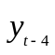term in the GR.
Two much-studied types of rules are not included in our analysis. These are first-difference rules (e.g., Orphanides, 2003) and forecast-based rules (e.g., Levin, Wieland and Williams, 2001). First-difference rules are touted for their robustness against model misspecification. Apart from the fact that robustness is not the subject of this paper, many models are unstable with monetary policy under the governance of first-difference rules. For their part, forecast-based rules can be shown to be equivalent to simple rules that feedback on all the variables that are useful for predicting the forecast variables that appear in the rule. Besides undermining the simplicity that is frequently touted as the advantage of “simple” rules, the conditionality of forecasts on the structure of each of the models impairs comparisons across models.
Because all the models in our database are linear, all results are scalable and thus the magnitude of the shock is of no significance.
For the temporary policy shock IRFs, results are very similar for horizons longer than the five years reported in this paper. There are more substantive differences for the disinflation experiments, which we discuss below.
By construction, the long-run elasticities under the TR and the ITR are identical. However, they can differ in the how the impulse is propagated over time.
The growth rule being written in growth rates of output means there is no level condition, which implies that monetary policy does not, by itself, work to re-establish the closure of output gaps following shocks. It is instead left for the rest of the model to re-establish equilibrium. Depending on the features of the model, that can take time.
Estimated models need to address the sources of persistence in output and inflation in a more direct way than do calibrated models. In parameterizing calibrated models, researchers have more freedom to decide which features of the data they choose to capture.
Specifically, we use a bisquare objective function with the standard tuning parameter of 4.685, which implies redescending of the M-estimator, thereby improving performance. The M-estimator depends on an unknown scale parameter. We use Huber scaling and allow the residual scale to be updated in each iteration of our iterated least squares. M-regression is robust to outliers in the dependent variable of regressions. In most instances, our independent variables are binary.
For the timing regressions, we use a two-step method to correct for overdispersion of the data, as described by Wooldridge (1997). In the first step, we use a Poisson model, regressing the timing variable on one or more independent variables, as applicable, along with a set of controls. The squared residual from that regression (minus one) is then regressed on the fitted values from that regression. If the coefficient on the auxiliary regression is significant, we correct the variance for the second regression using the estimated parameter. Ultimately, we report results from a QMLE negative binomial regression with GLM standard errors, which is robust to misspecification.
A counterpart to Table 6 restricting the sample to estimated models shows similar results. See Appendix B.
To clarify, take the example of the canonical NK model. Solve the intertemporal IS curve forward in time to show that the current output gap is the sum of future real interest rates (times the inverse of the elasticity of intertemporal substitution). Abstracting from the first-period surprise from the shock, under rational expectations this is close to what y-slope measures. Next, solve the NK Phillips curve forward to find that current inflation rate is the discounted sum of expected future output gaps (times the slope the NK Phillips curve). Under RE, all dynamics after the first-period surprise are known. As such, non-monotonic dynamics in inflation will only manifest insofar as there is nonmonotonicity in output dynamics, but these do not occur in the canonical model with standard monetary policy rules
The insufficiency of sticky price levels to produce the sticky inflation conventionally seen in VAR model analyses of business cycles was an early critique of the literature. See, e.g., Fuhrer and Moore (1995).
Recall that we do not know what the counterfactual is for, say, the variable net worth. It is conceivable that a model without wealth has buried within it another real rigidity, possibly not formally modeled, that imparts a stronger friction. That possibility is far less likely for interactions net worth with bank credit.

