**What Do Structural Models Tell Us About the Effects of Monetary Policy?\***

William B. English

Yale University

Robert J. Tetlow

Board of Governors of the Federal Reserve System

Connor M. Brennan

University of Chicago

June 16, 2025

**Abstract**

The appropriate calibration of monetary policy requires an evaluation of the size and timing of the effects of policy changes on the economy. Despite many decades of research, significant uncertainty about those effects remains. We use a large collection of structural macroeconomic models and three different policy rules to simulate the effects of monetary policy shocks on output and inflation. The range of the resulting impulse response functions is quite wide, with some models showing very rapid and large effects, while others show much more gradual or more modest effects. We then examine how the size and timing of the monetary policy effects relate to a set of model attributes, including the monetary policy rule employed, whether the model is estimated or calibrated, specific model features (e.g., the way that prices and wages are set), and other characteristics (e.g., when the model was formulated, and the background of the authors). Not surprisingly, we find larger and more persistent effects when the policy reaction function has more inertia. In addition, the effects of policy are more drawn out when the model is estimated rather than calibrated and if the authors include central bank staff. Even after accounting for model attributes, there remains considerable variation in the effects of policy across models. We conclude that policymakers need to be humble about their knowledge of the effects of changes in policy and approach monetary policy decisions with a risk management framework. For macroeconomic modelers, care should be taken to ensure that conclusions regarding other issues (e.g., fiscal policy or financial intermediation) are not unintentionally colored by model assumptions that impose unusual and perhaps unlikely monetary policy dynamics.

__________

* The views expressed are those of the authors and do not reflect the views of the Board of Governors of the Federal Reserve System, the Federal Open Market Committee, or members of their staffs. We thank Jake Scott and Bennett Fees for outstanding research assistance. We are grateful to Volker Wieland, Alexander Dueck, and Kai Long Liu for their help in working with the Macroeconomic Model Data Base. Corresponding author: Bill English: [william.b.english@yale.edu](mailto:william.b.english@yale.edu). Tetlow: [rtetlow@frb.gov](mailto:rtetlow@frb.gov). Brennan: [cmbrennan@uchicago.edu](mailto:cmbrennan@uchicago.edu)

# Introduction

To decide the appropriate stance of monetary policy in a given economic environment, policymakers need a good understanding of the size and timing of the effects of monetary policy on output, employment, and inflation. For example, if monetary policy has large effects with short lags, then policymakers will want to make modest adjustments to the stance of policy in response to current economic developments. By contrast, if monetary policy has smaller effects that operate with a substantial lag, then policymakers will want to adjust policy more forcefully over time, and more in response to anticipated changes in the economic outlook than current conditions.

The distinction is more than hypothetical, as recent experience ably demonstrates. As the Federal Reserve rapidly increased interest rates in response to high inflation in 2022 and 2023, policymakers emphasized that lags in the effects of policy meant that policy tightening would need to cease well before inflation returned to target to avoid overshooting that would result in an undesirably large decline in output and employment (Powell, 2023). On the other hand, some policymakers argued that the lags might be relatively short, suggesting less need to be concerned about such outcomes (Waller, 2023). Despite these ambiguities, policymakers must do the best they can to judge the likely effects of changes in monetary policy since, at least implicitly, the appropriate calibration of monetary policy depends on that judgement.

This paper shows that, despite a great deal of work done by many economists over recent decades, there remains considerable uncertainty about the size and timing of the effects of monetary policy. We evaluate the profession’s agreement and dissent in the timing and size of the effects of changes in monetary policy on output and inflation by employing a wide range of structural macroeconomic models of the United States economy, as published in papers in leading economic journals over the past few decades.[1] For each of the 76 models we include in the analysis, we carry out two classes of experiments. The first class of experiments is temporary shocks as captured by impulse response functions for a shock to monetary policy using one of three simple monetary policy rules: A traditional Taylor Rule (Taylor, 1993), a Taylor-type rule with added inertia, and a rule with output entering as a growth rate rather than as the output gap.[2] The second class of experiments is more persistent: one-time permanent reductions in the target rate of inflation.

We characterize attributes of the models in our sample using two catagories. One catagory covers aspects of model structure, such as the types of nominal rigidity each model uses, whether the model’s construction assumes indexing of prices or wages, as well as the real rigidities or channels through which monetary policy is thought to propagate. The second category captures broader aspects of the methodology behind the models, such as whether they were estimated or calibrated, the period over which each model was estimated, if applicable, and related matters.

Armed with these data, we use regression analysis to identify which model attributes are associated with the estimated effects of policy. Not surprisingly, the quantitative effects differ considerably depending on the monetary policy reaction function, with inertial reaction functions leading to larger effects on output and inflation. Also not surprisingly, the combination of sticky wages and indexation along with the usual sticky prices materially influences the effects on output and inflation. And output effects are also larger in models that include real rigidities, such as wealth effects or net worth effects. Those model attributes also influence the size of the effects on inflation. In addition, we find that the timing of the peak effects of monetary policy come later for models that are estimated, models that have a central bank author, and models that include adaptive learning. Several features regarding price and wage setting also influence the timing of effects. In the case of inflation, attributes about monetary transmission affect the lags, while larger and more recent models tend to have more rapid transmission.

The unexplained variation across models remains large: the R2’s in these regressions are generally less than 30 percent, and often much less. Thus, models developed by macroeconomists and generally intended for use in policy analysis differ widely in their assessments of the impact of changes in monetary policy, even once the differences in model attributes are taken into account. The implication for monetary economists is, at a minimum, that the search for a workhorse quantitative model of the U.S. economy continues. The exploration in modeling that begun with the establishment of the canonical three-equation New Keynesian model (Rotemberg and Woodford, 1997; Clarida, Gali and Gertler, 1999) has produced a plethora of contributions, but with few indications of convergence on its quantitative aspects. While many models are conceived to demonstrate atomistic contributions to the literature, the variation in models’ key aggregate responses raises concerns about consistency. The implication for policymakers is that they should be humble about their understanding of the effects of policy and approach policymaking with a risk management approach, taking account of outcomes in which monetary policy proves to work more or less rapidly, or has more or less power, than anticipated.

The scope of the paper is ambitious but limited even so. Among the omissions we highlight is nonlinear or path-dependent effects, necessitated by the fact that all our models are linear. Similarly, while we can investigate how the vintage of a model, or the data behind a model, affects its properties, we cannot isolate time variation in the strength or speed of monetary policy. Lastly, while we study the effects of monetary policy shocks on the economy, the heterogeneity of models implies that cross-model comparisons of how monetary policy responds to non-monetary shocks is beyond the scope of this paper. That said, while the literature makes clear that the proportion of the variance in output that is explained by exogenous monetary policy shocks in the U.S. is small, the power and speed of transmission of monetary policy shocks is material for a wider set of phenomena.[3]

The remainder of this paper is organized as follows: the next section provides a review of the literature on identifying the effects of monetary policy on the economy and comparing the effects of monetary policy across models. The third section describes our construction of the data and outlines and our methodological approach. Section four lays out the results of our analysis. The final section offers some brief concluding remarks.

# Literature Review

The starting point of any analysis of the power of monetary policy starts with why monetary policy matters at all, a topic that begins with the neoclassical synthesis, which grafted Keynesian short-run dynamics to the frictionless neoclassical growth model. The glue that held the two together was nominal rigidities: in particular, if prices (and wages) could not adjust instantaneously then a monetary policy shock—a nominal disturbance—would not result in only fluctuations in prices leaving output and employment undisturbed; rather, a portion of the shock would manifest in movements in real activity. Most of the literature of the last few decades has adopted the assumption of sticky prices or likeminded rigidities.[4]

Jumping ahead in time, sticky prices alone turned out to be a thin reed on which to build a theory of monetary business cycles. Among other findings, Fuhrer and Moore (1995) found that persistence of inflation found in the data could not be generated by sticky prices alone. Indexation of prices—staggering by another name—was one solution. Adding wage stickiness could also aid in the propagation of shocks (Erceg *et al.*, (2000),

Boivin et al. (2012), Ramey (2016), and Taylor and Wieland (2012)). Carpenter *et al.* (2025) is a recent demonstration of the utility of consulting several models for guidance on modeling in general and the power of monetary policy in particular.

In part, uncertainty about the effects of monetary policy likely reflects differences in its effects across economies and across time. Changes in industrial mix, in financial structure, in regulations, and in monetary policy communications can all affect the size and timing of policy effects (see, e.g., Carlino and DeFina, 1998; Cecchetti, 1999; Doh and Foerster, 2022; Havranek and Rusnak, 2018).

Channels through which interest rate changes affect the real economy can be usefully divided into neoclassical and non-neoclassical (Boivin *et al.,* 2011, table 1, p. 375). Neoclassical channels include *intertemporal substitution*—easily the most prevalent channel among New Keynesian models—the user *cost of capital* channel (Hayashi, 1982), the *wealth* channel[5] (Chodorow-Reich *et al*., 2021), and for open-economy models, the *exchange rate* channel (Obstfeld and Rogoff, 1998). Each of these operates through short-term interest rates changing the terms of current domestic expenditures relative to something else: future expenditures, the valuation of claims on assets, or expenditures on foreign-sourced goods and services. Expectations of future interest rates and economic conditions—and thus the anticipated propagation of shocks—are at the center of each of these channels. Non-neoclassical channels capture the implications of real rigidities, or wedges, that could amplify or propagate shocks via their effects on the state of household *balance sheets*, through collateral constraints on *bank lending,* or through the value of bank charters.[6]

# Methodological Approach

To better understand how researchers have assessed the effects of monetary policy on the economy, we look at a broad range of structural macroeconomic models employed in the literature. This is challenging for a number of reasons. One needs to collect the models under a common platform, ensure that they have consistent measures of output and inflation, and that they are well behaved under the governance of a class of monetary policy rules. Once that is achieved, one can study monetary policy shocks for their effects on nominal interest rates, output, inflation and real interest rates, across the models.

## 3.1 The models

Fortunately, the Macroeconomic Model Data Base (MMB) has put together an accessible database of macromodels (Wieland *et al*., 2012; Wieland *et al*., 2016). The database is an archive of models based on papers published over the last 25 years or so. It contains the code for a wide array of structural macroeconomic models, with a common front end that facilitates model comparisons.[7] We augment the MMB models with a small set of monetary policy rules, carry out orthogonalized shocks to the policy rules, and compute the impulse response functions (IRFs). These IRFs, or transformations of them, form much of the data for our analysis.

One important issue is the selection of models to be used. Our aim is to select models that capture the dynamics of the US economy; the MMB includes 61 estimated models of the United States, which suits our objectives well.[8] It also includes 43 calibrated models, of which we include the ones that are calibrated to U.S. economic dynamics. The latter models are sometimes relatively simple, frequently close in spirit to the New Keynesian benchmark model. It is an empirical question whether these calibrated models adequately capture the dynamics of the US economy, which we investigate below.[9] The database also includes a small set of multi-country models that are a mix of calibrated and estimated. We retained those multi-country models that were intended to capture open economy aspects of the US economy, eight in total. Finally, while the bulk of the models in the MMB are linear rational expectations models, we include 11 calibrated or estimated models of the US economy that employ adaptive learning*.*

Because we are interested in analyzing as much of the modern Keynesian modeling literature as practicable, our inclination in curation was to retain as many models from the MMB as possible. Even so, we dropped several models from our analysis, for a variety of reasons. First, some papers include more than one version of the model under study, often to serve as the benchmark for an added model feature, or to match the model to different scenarios. In such cases, we included only one model in our analysis, choosing the version of the model upon which the paper in question was focused so long as that model was suited to our examination of the effects of monetary policy shocks. Second, some of the models with adaptive learning were derived from a rational expectations counterpart in the same set. In those cases, so long as the learning mechanism affected the impulse-response functions in a material way, we included the learning version. Finally, we found that a few of the models could not be solved with our monetary policy rules and so had to be dropped. Ultimately, in our full sample we used 75 models, which with our policy rules resulted in 222 observations for the quantitative measures derived from our policy experiments. See Appendix A for a list of the models included in the analysis.

## 3.2 The policy rules

To conduct our analysis, we standardize the monetary policy reaction functions across our models. Ultimately, the dynamic effects of monetary policy are jointly determined by the structural features of the non-monetary aspects of the economy and by the conduct of monetary policy, as governed by the monetary policy rule. To investigate this dependency, and to ensure that our results are not idiosyncratic functions of a particular specification, we use three rules.[10] The first is the standard Taylor (1993) rule (TR):[11]

where *i* is the nominal federal funds rate, is four-quarter inflation, is the target rate of inflation, and is the output gap. Second, an inertial version of the Taylor rule (ITR):

And finally, a growth rule (GR), which employs monetary feedback on the (four-quarter) *change* in output in an effort at reducing dependence on potentially mismeasured estimates of the output gap, also with inertia:

Besides being in common use for monetary policy experiments, these three rules encompass the classic issues in monetary policy with simple rules (Taylor and Williams, 2011).[12] In particular, each respects the Taylor principle and features feedback on a real variable in addition to inflation. They also span two conventional specification issues in monetary economics with simple rules, namely, the question of persistence in the setting of monetary policy, and feedback on the level versus the difference of a real variable.[13] For future reference, it is worth noting that, all else equal, the GR imparts more persistence to the properties of any given model than the ITR and that both are more inherently persistent than the TR.

## 3.3 Data construction

As noted above, we construct data based on the results of two classes of monetary policy experiments, one transitory, the other persistent. This section summarizes those experiments and the data extracted from them.

## 3.3.1 Summary measures

The IRFs we construct are multivariate depictions of quantitative phenomena. To encapsulate the results, we compress the time dimension into a collection of univariate measures that capture the size of the effects for the horizon over which monetary policy is commonly thought to affect the economy (which we take to be 20 quarters).[14] Thus, we focus on the cumulative response of the variables that are *objectives* of monetary policy—output and inflation—over five years, in response to monetary policy *inputs* over the same period. So, for example, measures of key interest to us will be the cumulative increase in output and inflation, in reaction to the cumulative reduction in real interest rates over the same horizon, as initiated by one-time, one-percentage-point negative shocks to each of the policy rules.[15] The output or inflation response is thus normalized to the endogenous real-interest-rate response, and thus represents a measure of the power of monetary policy.

Similarly, we construct data from experiments where the target rate of inflation is permanently reduced by one percentage point, calculating the annualized cumulative output loss from each of these disinflation experiments and dividing by the reduction in inflation in percentage points after five years.[16] This is a standard calculation of a sacrifice ratio (see, e.g., Ball, 1994; Tetlow 2022).

Crudely speaking, one way to think of these is in terms of the undergraduate textbook representation of monetary policy, which removes the time dimension of economics. In that rendition, what monetary policy is about are the *elasticities* implied by the slopes of the aggregate demand function and the Phillips curve. We follow in this tradition. Even so, we devote considerable space to the question of *timing*. How long, according to our set of models, does it take for monetary policy to have its effect on inflation and output? We measure this by the number of quarters at which the effects on output and inflation reach their peaks. Table 1 summarizes these constructions.[17]

|  |  |  |  |
| --- | --- | --- | --- |
| Table 1  **Construction of Macroeconomic Outcome Variables** | | | |
| *Elasticity variables\** | | *Timing variables* | |
| *y-slope* | Ratio of the cumulative sum of changes in output to the cumulative sum of changes in the real interest rate** | *y-timing* | The quarter in which the output impulse-response function reaches its peak value |
| *π-slope* | Ratio of the cumulative sum of changes in inflation to the cumulative sum of changes in the real interest rate** | *π-timing* | The quarter in which the inflation impulse-response function reaches its peak value. |
| *sacratio* | Ratio of the cumulative annualized loss in output scaled by the reduction in inflation, from a simulation of a permanent reduction in the target rate of inflation. |  |  |
| Notes: * Calculations carried out at quarter 20 of each simulation. ** Real interest rate is computed in a model-consistent fashion for each model using period-by-period simulated values of nominal interest rates and inflation. | | | |

Table 2 provides descriptive statistics for the elasticity variables defined in Table 1, including a breakdown of the full sample, in the upper panel, into subsamples covering calibrated and estimated models.[18] On average, monetary policy is faster and more powerful for calibrated models than for estimated model. That is, the cumulative effects of monetary policy on output (as measured by *y-slope*) and inflation (as measured by *π-slope*) are larger for the calibrated models, and correspondingly the output cost of disinflation—that is, the sacrifice ratio—is smaller. And all of this comes earlier, meaning at lower values of *y-timing* and *π-timing*. Evidently, the purveyors of calibrated models have greater faith in the power of monetary policy than the data show, although one must acknowledge that not all calibrated models are meant to be taken seriously as quantitative assessments of monetary policy, as opposed to devices to illustrate the mechanisms by which monetary policy works. That said, even for estimated models, Milton Friedman’s characterization of the lags of monetary policy being “long and variable” (Nelson, 2020, p. 141) holds less for output than for inflation: the mean lag for the timing of the peak output response for estimated models is only about 3 quarters while the mean lag for inflation is about 7½ quarters; the corresponding standard deviations are much larger.

|  |  |  |  |  |  |
| --- | --- | --- | --- | --- | --- |
| Table 2  **Summary statistics for dependent outcome variables** | | | | | |
| **Full sample** | | | | | |
|  | *y-slope* | *π-slope* | *sacratio* | *y-timing* | *π-timing* |
| Mean | -1.53 | -0.99 | 14.30 | 2.30 | 5.03 |
| Median | -0.58 | -0.19 | 4.21 | 1.00 | 1.00 |
| Std deviation | 20.55 | 13.00 | 45.33 | 2.34 | 13.01 |
| Skewness | -5.46 | -11.17 | 6.07 | 4.97 | 5.73 |
| N | 222 | 222 | 197 | 222 | 222 |
| **Calibrated models** | | | | | |
|  | *y-slope* | *π-slope* | *sacratio* | *y-timing* | *π-timing* |
| Mean | -2.59 | -2.00 | 10.27 | 1.38 | 1.42 |
| Median | -0.67 | -0.33 | 3.44 | 1.00 | 1.00 |
| Std deviation | 32.11 | 20.30 | 24.71 | 0.81 | 1.71 |
| Skewness | -3.42 | -7.08 | 3.54 | 1.93 | 7.15 |
| N | 91 | 91 | 75 | 91 | 91 |
| **Estimated models** | | | | | |
|  | *y-slope* | *π-slope* | *sacratio* | *y-timing* | *π-timing* |
| Mean | -0.79 | -0.29 | 16.77 | 2.94 | 7.54 |
| Median | -0.55 | -0.18 | 4.68 | 2.00 | 2.00 |
| Std deviation | 1.66 | 0.87 | 54.21 | 2.81 | 16.43 |
| Skewness | 1.23 | 2.00 | 5.44 | 4.28 | 4.38 |
| N | 131 | 131 | 122 | 131 | 131 |
| Notes: See Table 1 for definitions of variables. Source: authors’ calculations based on simulations of MMB models. | | | | | |

Tables 3 and 4 decompose these statistics by the monetary policy rule that generated them. Several observations arise from this decomposition. First, Table 3 demonstrates that the higher power and speed of calibrated models described above is robust to the policy rule. Second, as one might expect, the persistence implied by the ITR, and especially the GR, results larger absolute values of *y-slope* and *π-slope.* Third, the results for sacrifice ratios, however, indicate that higher values of *y-slope* and *π-slope* do not necessarily translate into lower sacrifice ratios.

|  |  |  |  |  |  |  |  |  |  |
| --- | --- | --- | --- | --- | --- | --- | --- | --- | --- |
| Table 3  **Summary statistics for outcome variables**  (by rule and model type) | | | | | | | | | |
| **Calibrated models** | | | | | | | | | |
|  | *y-slope* | | | *π-slope* | | | *sacratio* | | |
| *Rules ->* | *Taylor* | *Inertial* | *Growth* | *Taylor* | *Inertial* | *Growth* | *Taylor* | *Inertial* | *Growth* |
| Mean | -0.83 | -1.56 | -5.28 | -0.08 | -0.51 | -5.29 | 10.57 | 8.88 | 11.36 |
| Median | -0.26 | -0.72 | -0.84 | -0.08 | -0.36 | -0.80 | 3.43 | 3.01 | 3.72 |
| Std Deviation | 1.12 | 1.84 | 55.48 | 0.27 | 0.64 | 34.91 | 27.67 | 23.79 | 23.41 |
| Skewness | -2.61 | -2.84 | -1.87 | 1.43 | -1.71 | -3.93 | 3.17 | 4.31 | 3.27 |
| N | 30 | 30 | 31 | 30 | 30 | 31 | 25 | 25 | 25 |
| **Estimated models** | | | | | | | | | |
|  | *y-slope* | | | *π-slope* | | | *sacratio* | | |
| *Rules ->* | *Taylor* | *Inertial* | *Growth* | *Taylor* | *Inertial* | *Growth* | *Taylor* | *Inertial* | *Growth* |
| Mean | -0.26 | -0.69 | -1.43 | -0.01 | -0.26 | -0.61 | 16.61 | 19.02 | 14.68 |
| Median | -0.14 | -0.60 | -1.06 | -0.02 | -0.18 | -0.46 | 2.34 | 4.37 | 6.21 |
| Std Deviation | 0.58 | 0.47 | 2.65 | 0.47 | 0.36 | 1.33 | 61.28 | 62.61 | 36.06 |
| Skewness | 1.16 | -1.40 | 1.61 | 2.74 | -1.09 | 2.25 | 4.92 | 5.21 | 5.25 |
| N | 43 | 44 | 44 | 43 | 44 | 44 | 40 | 41 | 41 |
| Notes: See Table 1 for definitions variables. Source: authors’ calculations based on simulations of MMB models. | | | | | | | | | |

Turning to the timing results, Table 4 shows that a principal difference between estimated and calibrated models manifests in the time it takes for monetary policy shocks to reach their peak effect. There are only slight differences in timing by policy rule for calibrated models. When models are required to confront the data directly in estimation, however, we see more variation by rule—and especially so for the peak timing of inflation. There is a lot more variation in peak timing as well, as captured by the standard deviations. This difference is a manifestation of the need for intrinsic persistence to capture the data in estimated models, through, for example, adjustment costs. Calibrated models, almost by definition, fit the data more loosely than estimated models, where autocorrelated shocks do more of the work in establishing that fit.

|  |  |  |  |  |  |  |
| --- | --- | --- | --- | --- | --- | --- |
| Table 4  **Summary statistics for timing variable outcomes**  (by rule and model type) | | | | | | |
| **Calibrated models** | | | | | | |
|  | *y-timing* | | | *π-timing* | | |
| *Policy rules ->* | *Taylor* | *Inertial* | *Growth* | *Taylor* | *Inertial* | *Growth* |
| Mean | 1.30 | 1.37 | 1.48 | 1.57 | 1.27 | 1.42 |
| Median | 1.00 | 1.00 | 1.00 | 1.00 | 1.00 | 1.00 |
| Std deviation | 0.84 | 0.72 | 0.89 | 2.74 | 0.64 | 1.06 |
| Skewness | 2.63 | 1.61 | 1.49 | 5.13 | 2.14 | 3.05 |
| N | 30 | 30 | 31 | 30 | 30 | 31 |
| **Estimated models** | | | | | | |
|  | *y-timing* | | | *π-timing* | | |
| *Policy rules ->* | *Taylor* | *Inertial* | *Growth* | *Taylor* | *Inertial* | *Growth* |
| Mean | 2.18 | 2.93 | 3.68 | 6.67 | 10.02 | 5.91 |
| Median | 1.00 | 2.00 | 3.00 | 2.00 | 2.00 | 2.50 |
| Std deviation | 2.49 | 1.69 | 3.71 | 10.56 | 21.69 | 15.08 |
| Skewness | 2.46 | 1.19 | 4.47 | 2.95 | 3.38 | 5.60 |
| N | 43 | 44 | 44 | 43 | 44 | 44 |
| Notes: See Table 1 for definitions of *{j}-timing*. Source: authors’ calculations based on simulations of MMB models. | | | | | | |

The standard deviations of these aggregate summary variables are generally fairly large, reflecting both the wide range of models and the different policy reaction functions that generate the impulse-response functions. These large standard deviations are driven in part by some extreme values, as reflected in the high skewness of many of the summary statistics.

*3.3.2 Model attributes*

To explore the sources of the differences in the estimated effects of monetary policy across the models, we construct a set of model attribute variables. In choosing the attribute variables to collect, we considered which attributes could reasonably be expected to influence the effects of monetary policy on the economy. Regarding effects of monetary policy on output, many models incorporate interest sensitivity of aggregate demand through intertemporal substitution in consumption, but some of the models have other channels for monetary policy. For example, as noted, several models are open-economy, and so have an exchange rate channel; others have financial channels, including operating through bank credit, household wealth, or firm net worth. All of these attributes could lead to larger effects of changes in the policy interest rate on output, all else equal. Larger effects on output could also mean larger effects on inflation, since inflation in the models is generally affected by the expected level of economic activity. In addition, the structure of the wage-price block of a model will influence the effect of monetary policy on inflation. For example, almost all of the models employ nominal rigidities, with the bulk of them using sticky prices of some sort; while some also employ sticky wages, they vary from model, at times including indexation in either price or wage setting. Additionally, a few feature adaptive learning, under which agents do not have model-consistent expectations but rather learn about the economy and policymakers’ intentions over time. Models of this sort might be expected to have either larger or more gradual effects of policy.[19]

Outside of the structure of the models, some non-model attributes could be important. As noted earlier, estimated models appear to have more gradual responses to monetary policy shocks than calibrated models. More broadly, larger models might capture more economic interactions between the real and nominal sides of the economy, which arguably would better match actual economic dynamics, and possibly result in more gradual effects of monetary policy on activity and inflation. The vintage of the model—that is, when it was constructed or published, could also matter for the impulse response functions. Over the years prior to the pandemic, inflation became more stable near target, implying a flatter Phillips curve that would suggest smaller effects of monetary policy on inflation in more recent models than in models from the 1990s. Finally, it seems possible that economists at central banks, because their work is particularly policy-relevant, would make different modeling decisions (for example, being more inclined than others to “let the data speak” and not be unduly constrained by theoretical considerations) that would have implications for the impulse-response functions.

Based on this reasoning, we collected data on the model attributes shown in Tables 5 and 6.

|  |  |
| --- | --- |
| Table 5  **Model attribute variables** | |
| *Variable* | *Average value* |
| 1. Non-neoclassical transmission channels | 0.61 |
| 1. Net worth | 0.27 |
| 1. Wealth | 0.28 |
| 1. Bank credit | 0.44 |
| 1. Adaptive learning | 0.03 |
| 1. Open Economy | 0.11 |
| 1. Sticky prices (of any sort) | 1.00 |
| 1. Calvo pricing | 0.72 |
| 1. Rotemberg pricing | 0.15 |
| 1. Other forms of price stickiness | 0.14 |
| 1. Sticky wages | 0.59 |
| 1. Price indexation* | 0.51 |
| 1. Wage indexation* | 0.35 |
| 1. Calvo or Rotemberg pricing with indexation | 0.49 |
| 1. Wage stickiness with wage indexation | 0.35 |
| 1. Calvo or Rotemberg pricing with sticky wages* | 0.50 |
| 1. Price indexation and wage indexation | 0.32 |
| Notes: * Price (or wage) indexation implies sticky prices (or wages); the converse is not always true. n = 222. Source: authors’ calculations. | |

|  |  |
| --- | --- |
| Table 6  **Non-model attribute variables** | |
| *Variable* | *Average value* |
| 1. At least one central bank author | 0.72 |
| 1. Estimated model | 0.59 |
| 1. Number of structural equations | 22.3 |
| 1. Early vintage publication (< 2000) | 0.08 |
| 1. Middle vintage publication (2000 – 2007) | 0.20 |
| 1. Late vintage publication (> 2007) | 0.72 |
| 1. Early sample estimation data (< 1980)* | 0.70 |
| 1. Late sample estimation data (1980+)* | 0.30 |
| Notes: * Estimated models, for which n=131; otherwise, n = 222. Source: authors’ calculations. | |

# Preliminary Results

## 4.1 Aggregate results

Figure 1 shows the impulse response functions for output, inflation, and the nominal federal funds rate in response to a 100-basis-point (negative) shock to the federal funds rate for our complete set of models and all three policy reaction functions. Looking across the impulse-response functions, the median effects on output and inflation, shown by the red dashed lines, are of reasonable size, with maximum effects on output of about 0.2 percent and cumulative effects on output across 20 quarters of roughly 1 percent, while the median maximum effect on inflation is a bit less than 0.1 percentage point, with the median cumulative effect over 20 quarters running well under 1 percentage point. Somewhat surprisingly, given the conventional view that monetary policy works with significant lags, the maximum effects are typically reached within just a couple of quarters. These median results are broadly similar to those seen in well-known models, such as Smets and Wouters (2003)—shown by the blue dashed lines. They are also broadly similar to the results of a simple VAR—shown by the black dashed lines—although the VAR effects are larger and come with larger lags. That said, there is a strikingly wide range of results across models, with peak effects varying from essentially no effect at all to effects well over 2 percent on output and over 1 percentage point on inflation. Moreover, in many cases the peak effects occur immediately, whereas they are realized only after four quarters or more in others.

As we will discuss below, the breadth of results reflects in part the model and non-model attributes outlined in the previous section. For present purposes, we note significant differences between the results of estimated and calibrated models. The figures show results for calibrated models in orange and those for estimated models in green. It is clear that calibrated models tend to produce large, short-lived responses, relative to their estimated counterparts. To some extent this reflects the fact that at least some calibrated models are intended less to capture the timing of monetary phenomena and more to illustrate the channels and mechanisms through which policy works. Estimated models tend to exhibit gradual adjustments to monetary policy shocks, more consistent with the empirical lags found using the narrative approach (Romer and Romer, 2023) or market measures of policy surprises (Bauer and Swanson, 2022; Swanson, 2024).

Figure 1

**Impulse Responses**

(full sample of models; all policy rules)

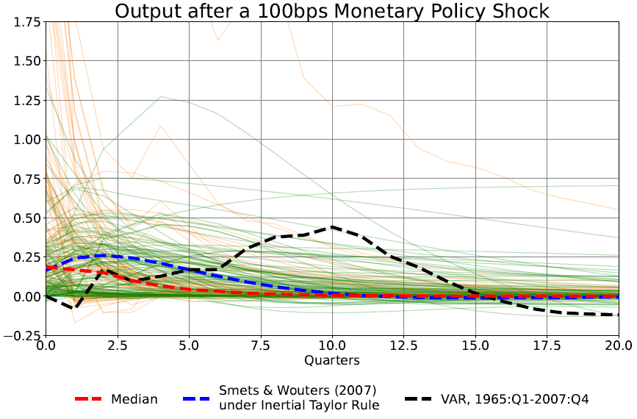

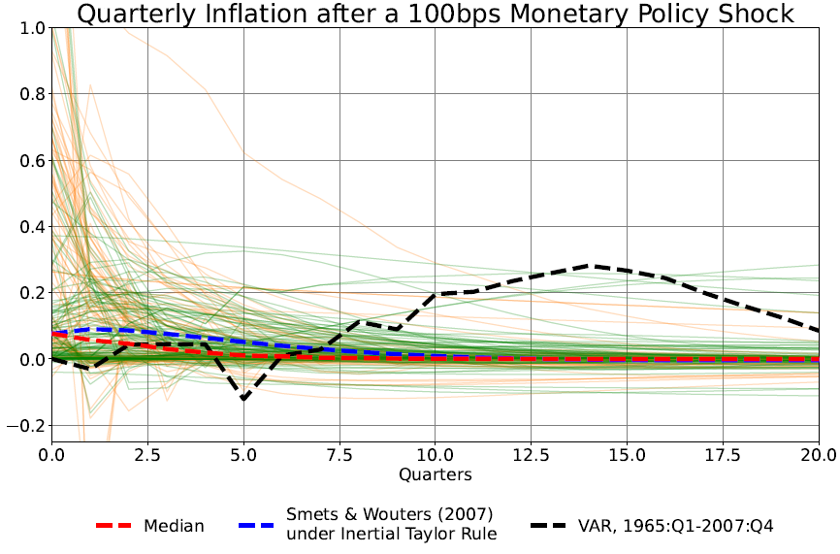

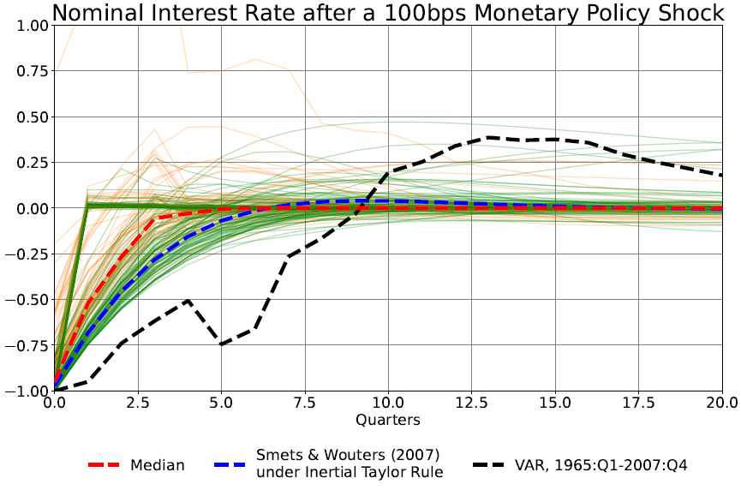

Note: Green lines are for estimated models; orange lines are for calibrated models. Source: Authors’ calculations.

## 4.2 The influence of policy design

Figure 1 showed the impulse responses for the full sample of models under the governance of each of our three monetary policy reaction functions. Figures 2-4 show the same IRFs, but separately for each policy rule. The effects of the monetary policy shock are smallest for the TR, shown in Figure 2, largely reflecting the absence of propagation in the federal funds rate from the rule itself (shown in the bottom panel). The muted dynamic response of output and inflation to the shock under the TR implies that, in a great many models, the internal propagation mechanism—that is, the propagation that comes from sources *other than the policy rule*—is weak.

As Figures 3 and 4 show, the effects are generally larger and longer-lived for the ITR and the GR, consistent with the partial adjustment embodied in those rules.[20] That said, it is still the case that for any given rule, the impulse response functions span a wide range. Most of the remainder of this paper explores some of the reasons for this dispersion of results.

Figure 2

**Impulse Responses**

(full sample of models; Taylor rule)

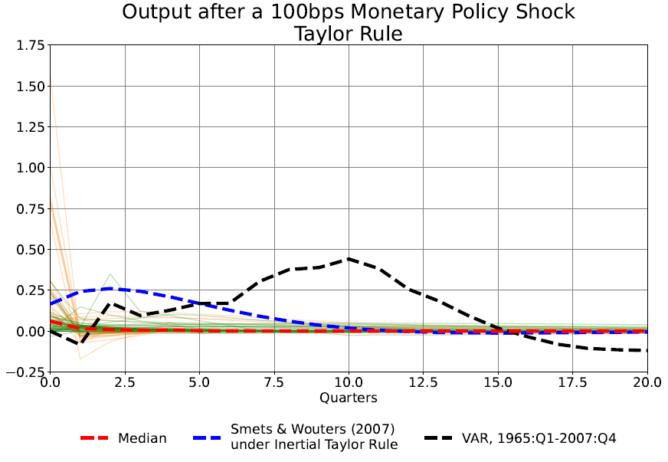

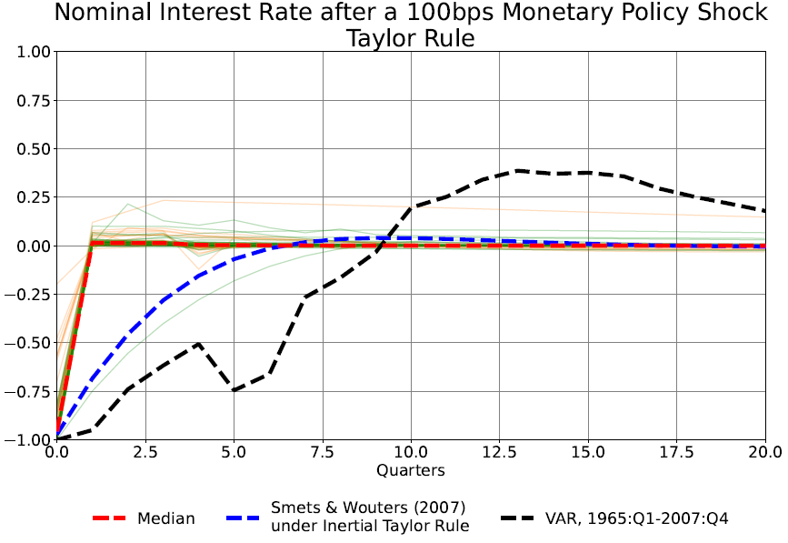

Note: Green lines are for estimated models, orange lines are for calibrated models. Source: authors’ calculations.

Figure 3

**Impulse Responses**

(Full sample of models; inertial Taylor rule)

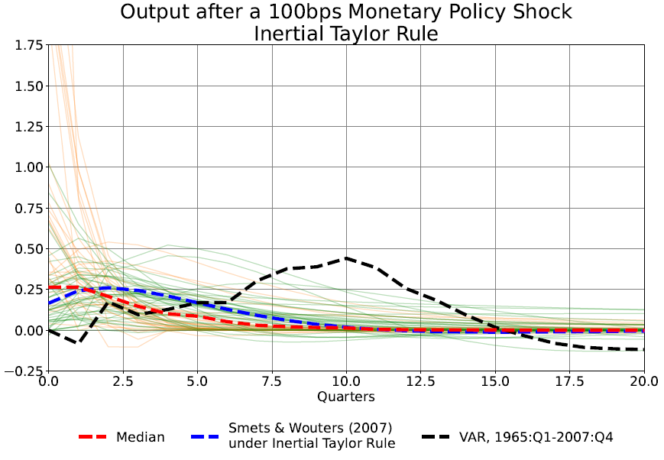

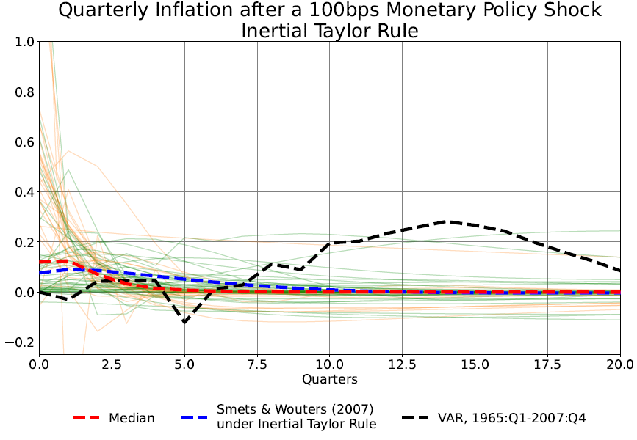

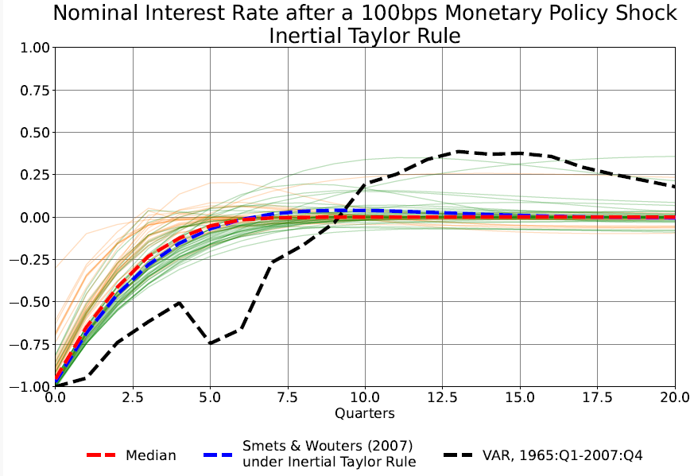

Note: Green lines are for estimated models, orange lines are for calibrated models. Source: authors’ calculations

Figure 4

**Impulse Responses**

(full sample of models; Growth rule)

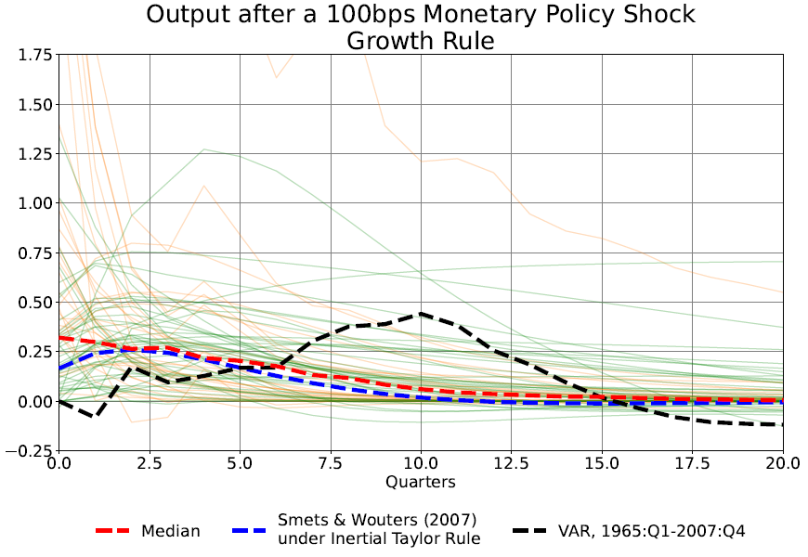

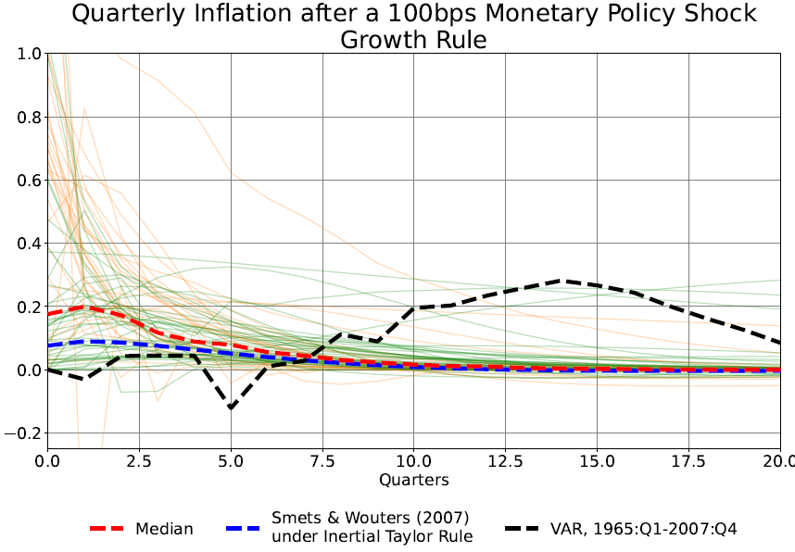

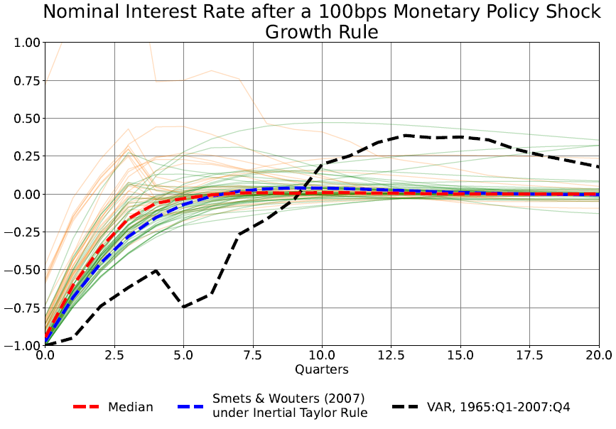

Note: Green lines are for estimated models, orange lines are for calibrated models. Source: Authors’ calculations.

Figures 2 through 4 illustrate the importance of the policy rule for the IRFs. We can quantify this influence with regression analysis. However, because as Tables 2-4 show, the data contain large and asymmetric outliers, we cannot use ordinary least squares for this analysis. Accordingly, when *y-slope*, *π-slope*, or *sacratio* are the dependent variables,we use a robust least squares (RLS) approach; in particular, we use the M-regression of Huber (1973), estimated using iteratively reweighted least squares.[21] Table 7 provides a quantitative RLS assessment of the influence of the three rules of the outcome variables described in Table 3, conditioned on a constant term (capturing the influence of the TR), and dummy variables representing the inertial Taylor rule and growth rule. The slope conditional on the Taylor rule is the constant term, whereas the slope conditional on the other two rules is the constant term plus the coefficient for that rule. As can be seen, *external propagation*—that is, propagation imparted by policy, as opposed to the non-policy dynamics of models—increases the (absolute) *y-slope* and *π-slope,* relative to the Taylor rule.Similarly, the propagation of policy shocks from the inertial Taylor and growth policy rules increases the sacrifice ratio.

OLS would be likewise ill-suited for similar regression analysis on *y-timing* and *π-timing*, since these dependent variables are nonnegative integers and exhibit over-dispersion. To ensure consistent parameter estimates and greater asymptotic efficiency, we therefore employ negative binomial regression for these dependent variables.

|  |  |  |  |
| --- | --- | --- | --- |
| Table 7  **Basic robust least squares results**  (full sample) | | | |
|  | *y-slope* | *π-slope* | *sacratio* |
| Constant | -0.351  (0.063) | -0.061  (0.031) | 2.889  (0.586) |
| Inertial Taylor rule | -0.318  (0.089) | -0.182  (0.044) | 1.533  (0.826) |
| Growth rule | -0.443  (0.088) | -0.433  (0.044) | 2.851  (0.826) |
|  | 0.045 | 0.133 | 0.033 |
|  | 0.036 | 0.125 | 0.022 |
|  | 0.156 | 0.372 | 0.078 |
|  | 222 | 222 | 197 |
| Notes: Robust standard errors in parentheses. RLS settings: M-estimation, bisquare with tuning=4.685, MAD scaling, median centered. Estimated slope of variable of interest under the Taylor rule is captured by the constant term. The slope under the governance of the other rules is the constant term plus the value shown for each rule. See Table 1 for definitions of variables. | | | |

# Results for the effects of model and non-model attributes

Given the wide range of the size and timing of the effects of monetary policy across models that we find, it is natural to consider which model attributes contribute to the diverse outcomes. To test for these contributions, we regress our variables summarizing the effect of monetary policy on the economy on the model and non-model attribute variables described in the previous section.

**5.1. Bivariate exploration**

Given our modest sample size, and the large variance in the impulse-response functions, we start by considering our attribute variables one at a time. Figures 5-9 display the coefficients and their standard errors from regressions of each of our summary variables on dummy variables for the policy rules and one of the above attributes.[22] While the results are somewhat disappointing – many of the attributes don’t have significant effects on the summary variables at the usual levels of significance, some of the expected results stand out. For example, Figure 5 shows that the sensitivity of output to the real interest rate is larger in models with additional transmission channels for monetary policy, including net worth, bank credit, and “other” channels.[23] Some of the price and wage attribute variables are also statistically significant, though their signs are mixed, and the broader measures are not significant. Regarding the non-model attributes, monetary policy has somewhat larger effects in models with authors from central banks, perhaps suggesting the unsurprising inclination on the part of economists engaged in monetary policy work to use models in which monetary policy has significant effects. The other non-model attributes are not associated with significant effects on the impact of monetary policy on output.

Figure 5

**Estimated influence of attribute variables on *y-slope***

(full sample, with rule fixed effects)

Figure 6

**Estimated influence of attribute variables on *π-slope***

(full sample, with rule fixed effects)

Model Attribute Variables:

Figure 7

**Coefficients from Regression of *sacratio* on Attribute Variables**

(full sample, with rule fixed effects)

Model attribute variables:

Figure 8

**Coefficients from Regression of *y-timing* on Attribute Variables**

(full sample, with rule fixed effects)

Model attribute variables:

Non-model attribute variables:

Figure 9

**Coefficients from Regression of *π-timing* on Attribute Variables**

(full sample, with rule fixed effects)

Model attribute variables:

Non-model attribute variables:

One might anticipate similar results for the additional channels variables in Figure 6, which shows the results for *π-slope*, since the effects of monetary policy on inflation operate, at least in part, through effects on output and employment. However, the effects of additional transmission channels are mixed, with the inclusion of wealth effects and bank credit effects associated with smaller impacts of monetary policy on inflation.[24] Moreover, the effect of price stickiness is mixed, depending on the way that the stickiness is modeled. Sticky wages, however, reduce the effects of monetary policy on inflation, as do the indexation of prices and wages, presumably because of the consequent inertia in inflation limits the response to the monetary policy shock. The effects of monetary policy on inflation are smaller for estimated models, consistent with the reduced effect on output shown in Figure 5 (though that effect was not statistically significant at the usual confidence levels). Not surprisingly, given the earlier discussion, models from papers published after 2007 tend to show smaller effects of monetary policy on inflation.

As shown in Figure 7, the size of the sacrifice ratio is not consistently associated with the additional channels for monetary policy transmission.[25] Sticky prices appear to reduce the sacrifice ratio, though the effect depends on the way the stickiness is modeled. Estimated models tend to have larger sacrifice ratios, as do earlier vintage models, while later vintage models have smaller effects.

With regard to timing, as reflected in Figures 8 and 9, the maximum effects of monetary policy on output and inflation come earlier for models with additional channels of monetary policy transmission, with the effect particularly significant for inflation. The faster transmission may reflect the rapid adjustment of asset prices to monetary policy changes, which could speed the economic responses. Models with sticky prices also tend to have more rapid responses to monetary policy, though the effect depends on the form of the stickiness. Wage and price indexation tends to lengthen the lags with which policy affects output and inflation, presumably by giving more inertia to changes in inflation. Not surprisingly, models with adaptive learning have longer lags for both output and inflation. Estimated models have significantly longer lags for both output and inflation as well, presumably because the data tend to point to longer lags, and calibrated models do not always take that on board. Models with central bank authors tend to have longer lags in the effects of policy, consistent with a need by policymakers to have realistic lags in models used for policy analysis. In the case of inflation, lags are a bit shorter in larger models. Finally, the timing of the effects of policy on inflation differ significantly depending on the vintage of the model, with older vintage models having longer lags and more recent models having shorter lags. On balance, lags are about two quarters shorter in the recent models relative to those published before 2000. This shortening of monetary policy lags over time is consistent with the results in Doh et al (2022), though they find that the lags have shortened for both inflation and output responses.

**5.2. Multivariate results**

The simple regression results presented in the previous section offer some glimpses at the mechanisms that might drive the power of monetary policy shocks. But at least some aspects of the propagation of shocks are understood to arise from combinations of some of the factors discussed above. In particular, it is the joint presence of price and wage stickiness, or of stickiness and the indexation thereof, that is sometimes argued as critical for the propagation and amplification of shocks. Accordingly, in Table 8 we show the influence of sticky prices and sticky wages on our outcome variables, with indexation. Because a quantitative assessment of the interaction between multiple sources of nominal frictions depends on several parameters and cross-equation restrictions, we concentrate here on estimated models.[26]

Recalling that both *y-slope* and *π-slope* are negative, let us first consider *π-slope*, shown in panel B of the table. The panel shows that both sticky prices with indexation, column [5], and sticky wages with indexation, [6], reduce the absolute magnitude of inflation reduction per unit of real rate increase, with price stickiness dominating in both magnitude and significance, column [7]. The lower panel of Table 9 shows that the timing of the peak effect on inflation is pushed out by these nominal rigidities. It follows that nominal rigidities with indexation, and especially sticky prices, draw out over time the response of inflation but decrease its magnitude. Instead, as the upper panel of Table 8 shows, both sticky prices with indexation (column [1]), and particularly sticky wages with indexation (column [2]) increase the (absolute) output response to a policy-induced increase in the policy rate. Column [3] confirms that sticky wages dominate the overall effect. In short, nominal rigidities reduce the effects of monetary policy shocks on prices in the short run, inducing real variables to do the adjusting—the standard Keynesian story. This form of the story is familiar from, for example, Erceg *et al.* (2000), which shows how adding sticky wages with indexation to a standard New Keynesian model induces slow adjustment to shocks of the real wage, which in turn accentuates the output response to monetary shocks (Blanchard and Gali, 2007).[27]

Of course, the effects from these combinations of nominal rigidities need to be compared against their counterfactuals. In this regard, we note that column [4] shows that sticky prices and sticky wages without indexation *reduces* the absolute *y-slope*, demonstrating the critical importance of indexation.

Panel C of Table 8 reports the effects of these same combinations of nominal rigidities on the sacrifice ratio.[28] The panel furnishes weak evidence of sticky prices and wages contributing to higher sacrifice ratios than otherwise.[29]

|  |  |  |  |  |  |  |  |  |  |  |
| --- | --- | --- | --- | --- | --- | --- | --- | --- | --- | --- |
| Table 8  **Effects of nominal rigidities on macro outcomes**  (estimated models) | | | | | | | | | | |
| ***Panel A: y-slope*** | | | | | | | | | | |
| Nominal rigidities | | | [1] | | [2] | [3] | | | [4] | |
| Sticky prices† | Without indexation | |  | |  |  | | | 0.315***  (0.109) | |
| Sticky wages |  | |  |  | | | 0.260**  (0.109) | |
| Sticky prices† | With indexation | | -0.163*  (0.083) | |  | 0.090  (0.129) | | |  | |
| Sticky wages |  | | -0.242***  (0.079) | -0.310**  (0.126) | | |  | |
|  |  | | 0.103 | | 0.121 | 0.123 | | | 0.131 | |
|  |  | | 0.082 | | 0.100 | 0.095 | | | 0.103 | |
| ***Panel B: π-slope*** | | | | | | | | | | |
| Nominal rigidities | |  | [5] | | [6] | | [7] | | | [8] |
| Sticky prices† | Without indexation | |  | |  |  | | | -0.116**  (0.054) | |
| Sticky wages |  | |  |  | | | -0.060  (0.054) | |
| Sticky prices† | With indexation | | 0.154***  (0.039) | |  | 0.238***  (0.061) | | |  | |
| Sticky wages |  | | 0.091**  (0.039) | -0.102*  (0.060) | | |  | |
|  |  | | 0.222 | | 0.195 | 0.230 | | | 0.196 | |
|  |  | | 0.204 | | 0.176 | 0.205 | | | 0.170 | |
| ***Panel C: sacrifice ratio*** | | | | | | | | | | |
| Nominal rigidities | | | [9] | [10] | | | [11] | [12] | | |
| Sticky prices† | Without indexation | |  | |  |  | | | -3.713**  (1.018) | |
| Sticky wages |  | |  |  | | | 0.474  (1.084) | |
| Sticky prices† | With indexation | | 1.127  (0.866) | |  | 0.451  (1.512) | | |  | |
| Sticky wages |  | | 1.189  (0.841) | 0.837  (1.463) | | |  | |
|  |  | | 0.050 | | 0.052 | 0.052 | | | 0.118 | |
|  |  | | 0.026 | | 0.028 | 0.020 | | | 0.088 | |
| Notes: Robust least squares. Estimated models, with constants and policy rule dummies. † Sticky prices defined as either Calvo or Rotemberg pricing. Nobs=231 except for sacrifice ratio where Nobs=122. *,**,*** indicate significance at 10, 5 and 1%, respectively. | | | | | | | | | | |

|  |  |  |  |  |  |  |
| --- | --- | --- | --- | --- | --- | --- |
| Table 9  **Effects of nominal rigidities on timing of peak macro responses**  (estimated models) | | | | | | |
| ***y-timing*** | | | | | | |
| Nominal rigidities | | | [1] | [2] | [3] | [4] |
| Sticky prices† | Without indexation | |  |  |  | -0.257**  (0.116) |
| Sticky wages |  |  |  | -0.130  (0.141) |
| Sticky prices† | With indexation | | 0.221**  (0.108) |  | -0.209  (0.148) |  |
| Sticky wages |  | 0.497***  (0.107) | 0.642***  (0.149) |  |
|  |  | | 0.042 | 0.096 | 0.048 | 0.056 |
|  |  | | 0.029 | 0.083 | 0.031 | 0.039 |
| ***π-timing*** | | | | | | |
| Nominal rigidities | |  | [5] | [6] | [7] | [8] |
| Sticky prices† | Without indexation | |  |  |  | -0.872***  (0.188) |
| Sticky wages |  |  |  | -0.323  (0.226) |
| Sticky prices† | With indexation | | 0.911***  (0.166) |  | 0.868***  (0.212) |  |
| Sticky wages |  | 0.601***  (0.180) | 0.072  (0.223) |  |
|  |  | | 0.040 | 0.022 | 0.160 | 0.048 |
|  |  | | 0.026 | 0.009 | 0.145 | 0.031 |
| Notes: Negative binomial regressions, maximum likelihood. Estimated models, with constants and policy rule dummies. † Sticky prices defined as either Calvo or Rotemberg pricing. Nobs=222. *,**,*** indicate significance at 10, 5 and 1%, respectively. | | | | | | |

Since a number of different variables can help explain the differences between the results of the models, we proceed to a stepwise regression approach to pick out a set of model attributes that can best explain those differences.[30] We divide the model attribute variables into two sets, and run the stepwise procedure separately for the variables characterizing the models (the first two sets of attributes listed above) and for the attributes related to the design and estimation of the model (the last set of attributes listed above). We split the attributes in this way because the first set has to do with the structural details of the models themselves, while the second consists of features capturing background beyond the structural details of the model, such as the model’s vintage or whether one or more authors comes from a central bank. We divide our variables in this way in order to not crowd out the actual model features that drive the differences as we learn about the effects of different model backgrounds. The resulting regressions are shown in Tables [6a and 6b].

On the whole, the results from these regressions are similar to those found with the earlier bivariate approach, though some variables become insignificant after the addition of others. As shown in the first column, two of the additional monetary policy channels, wealth and net worth, enter the regression for *y-slope* significantly, with both increasing the size of the (negative) effect of monetary policy on output. Two of the wage/price attributes also enter, with both sticky wages and sticky prices associated with smaller effects of monetary policy on output. Regarding the design and estimation attributes, column 2, only central bank authors enters significantly, and is associated with larger effects of monetary policy. Similarly, for *π-slope*, column 3, two of the additional channel variables enter significantly, but with opposite signs, as in the earlier results, and wage indexation (though not price indexation) is associated with smaller effects of monetary policy on inflation. The results in column 4 show that estimated models tend to have larger inflation effects, and late vintage models tend to have smaller inflation effects. For *sacratio*, column 5, one of the additional channels variables, net worth, enters significantly, and is related to smaller effects of output on inflation. Wage indexation has a similar effect. In this case, adaptive learning also enters significantly, and points to a larger effect of output on inflation. In column 6, three of the attributes related to design and estimation enter significantly. The number of equations is associated with a reduced effect of output on inflation, while central bank authors are associated with an increased effect. Models with an intermediate publication date (2000-2007), rather than the late vintage models found earlier, have smaller effects of output on inflation.

Finally, Tables 10a and 10b provide some evidence on the evidence on the influence of a selection of non-model attribute variables for *y-timing* and *π-timing*, for the full sample and for estimated models, respectively. These findings extend what was discussed above to show which of the variables shown in the columns matters beyond the contribution of the nominal rigidities shown in the left-hand column.[31] Several findings are worthy of note. First, as can be seen, the generation of the models—that is, either the vintage or the estimation period—matter for the timing of output responses for the full sample of models (the upper panel of Table 10a). But that finding fails to carry through to the estimated models (the upper panel of Table 10b). Second, the effects of non-model attribute variables on *π-timing* are more sparse—fewer of these variables are shown to matter empirically—but more unified in that similar results are found for the full sample as for estimated models. Third, the configuration of nominal rigidities does not matter very much for the relevance of non-model attribute variables: for the most part, if a variable is found to be significant for one of the four configurations of nominal rigidities, it tends to be significant for a number of them. Finally and most intriguingly, the most powerfully and reliably significant non-model attribute variable is *CB authors*: having a central bank author on the modeling team pushes out the timing of both the peak output and inflation effects of a monetary policy shock.

|  |  |  |  |  |  |
| --- | --- | --- | --- | --- | --- |
| Table 10a  **Influence of characteristics on timing of peak responses**  (full sample of models) | | | | | |
| *y-timing* | | | | | |
| Nominal rigidities† | Log(neq) | Late vintage | Mid vintage | Early estimation | CB authors |
| Sticky prices with indexation |  | < | < | << | >>> |
| Sticky wages with indexation |  | << | << | < | >>> |
| Both sticky with indexation |  | < | < | < | >>> |
| Both sticky w/o indexation |  | < | < |  | >>> |
| *π-timing* | | | | | |
| Nominal rigidities† | Log(neq) | Late vintage | Mid vintage | Early estimation | CB authors |
| Sticky prices with indexation |  | <<< |  |  | >>> |
| Sticky wages with indexation | <<< |  |  |  | >> |
| Both sticky with indexation | < | <<< |  |  | >>> |
| Both sticky w/o indexation |  |  |  |  | >>> |
| Notes: Negative binomial regressions, maximum likelihood. Full sample, with constants and policy rule dummies as well as the nominal rigidities indicated in the first column. † Sticky prices defined as either Calvo or Rotemberg pricing. Wage stickiness by any means. Nobs=149. >,>>,>>> indicate a positive coefficient with significance at 10, 5 and 1%, respectively; <,<<,<< similarly defined. | | | | | |

|  |  |  |  |  |  |
| --- | --- | --- | --- | --- | --- |
| Table 10b  **Influence of characteristics on timing of peak responses**  (estimated models) | | | | | |
| *y-timing* | | | | | |
| Nominal rigidities† | Log(neq) | Late vintage | Mid vintage | Early estimation | CB authors |
| Sticky prices with indexation |  |  |  |  | >>> |
| Sticky wages with indexation |  |  |  |  | >>> |
| Both sticky with indexation |  |  |  |  | >>> |
| Both sticky w/o indexation |  |  |  |  | >>> |
| *ϖ-timing* | | | | | |
| Nominal rigidities† | Log(neq) | Late vintage | Mid vintage | Early estimation | CB authors |
| Sticky prices with indexation |  | << |  |  | >> |
| Sticky wages with indexation | <<< |  |  |  | >> |
| Both sticky with indexation |  | << |  |  | >> |
| Both sticky w/o indexation |  |  |  |  | >> |
| Notes: Negative binomial regressions, maximum likelihood. Full sample, with constants and policy rule dummies as well as the nominal rigidities indicated in the first column. † Sticky prices defined as either Calvo or Rotemberg pricing. Wage stickiness by any means. Nobs=131. >,>>,>>> indicate a positive coefficient with significance at 10, 5 and 1%, respectively; <,<<,<< similarly defined. | | | | | |

As for the timing of the effects of monetary policy on output, column 4, wage indexation and sticky prices both enter significantly, but with offsetting signs. Adaptive learning enters as well, and it is associated with longer lags in the effects of policy, as one would anticipate. Both estimated models and models with central bank authors have longer lags. The timing of inflation effects (column 5) is influenced by additional channels, with shorter lags for open economy models (perhaps reflecting exchange rate pass-through) and models with wealth effects or net worth effects. By contrast, inflation lags are longer for models with learning and sticky wages, but shorter for models with sticky prices. As for the design and estimation attributes, lags are longer for estimated models and models with central bank authors, but shorter for larger models and models of later vintage.

[Not sure what to say here to sum up. Some of these results seems kind of random to me. I think we would do better combining our categories and trying to tell broader stories.]

# Concluding remarks

The previous sections showed that model and nonmodel attributes can explain only a portion of the differences in the estimated effects of monetary policy. Even taking account of the effects of the attributes, there is a substantial amount of variance in the size and timing of the estimated effects. For example, the regressions of *y-slope* and *π-slope* on the selected attributes in the previous section has a pseudo-R2 of about 50 percent. That is, even taking account of the attributes, about half of the differences in *y-slope* and *π-slope* across models remains unexplained. The unexplained variance in the sacrifice ratio and the timing of peak effects on output and inflation is even larger. Thus, it seems that the models we consider simply differ greatly in their assessments of the effects of monetary policy, even taking account of the structure of the models and the other nonmodel attributes.

The large differences across models that we observe have important implications for both policymakers and researchers. For monetary policymakers interested in evaluating policy alternatives, the selection of the model or models used for policy analysis is critical. Policymakers should choose models that have reasonable properties rather than models in the tails of the distribution of monetary policy effects. In doing so, they should be guided by assessments of past policy experiences and non-structural evidence on the timing and extent of the effects of monetary policy actions. The results we found for models with authors from central banks suggest that this is understood. For example, the FRB/US model commonly used at the Board of Governors for policy analysis (and included in our sample here) has fairly typical cumulative effects of monetary policy on output, and dynamics that build up gradually, broadly similar to those identified by Romer and Romer (2023) and Bauer and Swanson (2023). Of course, given uncertainty about how the economy works, policymakers want their decisions to be robust, in the sense that they yield good outcomes in a range of models (Levin, Weiland, and Williams, 1999; Levin and Williams, 2003; Taylor and Weiland, 2012). However, even in such robustness exercises, models with unreasonable properties should presumably be downweighed or excluded. That said, policymakers need to be humble about their understanding of the effects of policy, and they should employ a risk management approach, taking account of possible costs of outcomes in which monetary policy proves to work more or less rapidly than expected and has more or less power than anticipated.

For macroeconomic modelers, the risk is that modeling decisions made when studying a particular problem of interest could lead to a model that has very unlikely monetary policy dynamics. While the topic under study may not be directly related to monetary policy (e.g., the focus may be on fiscal policy, financial intermediation, etc.), the result could be that the conclusions reached are dependent on the unusual and perhaps unlikely monetary policy dynamics. Modelers should check to be sure that monetary policy effects that are in the tail of the distribution are not driving their results.

# Cochrane and Piazzesi (2022, p. 91) note “Target changes seem to be accompanied by large changes in long-term interest rates…Can the Fed really raise the short rate 1 percent for five years or more, without leading to 1 percent lower inflation that would cancel any effect on longer yields?” “The Fed and Interest Rates: A High Frequency Identification” AER,92(2): 90-95. Talk about the current literature where LR interest rates are important and how it’s been rare for DSGE models to have genuine LR rates.

# Blanchard and Gali (2007), section 4, describes how real rigidities affect the sacrifice ratio: their model, a std NK model but with an anonymous real rigidity in the labor market, the cost of disinflation is “about 10 times larger tha n in the standard model.” References

### Alessandri, Piergiorgio; Oscar Jorda and Fabrizio Venditti (2023). “Decomposing the Monetary Policy Multiplier,” Federal Reserve Bank of San Francisco working paper No. 2023-14

### Ascari, Guido and T. Haber (2021) “Nonlinearities, state dependent prices and the transmission mechanism of monetary policy” *Economic Journal*,132: 37-57.

### Ball, Laurence (1994) “What determines the sacrifice ratio?” In: N. Gregory Mankiw (ed.) *Monetary Policy* (Chicago and Cambridge: University of Chicago Press and NBER), pp. 155-193.

### Benigno, Pierpaolo and Gauti Eggertsson (2023) “It’s Baaack: The Surge in Inflation in the 2020s and the Return of the Non-Linear Phillips Curve,” NBER Working Paper 31.

### Bernanke, Ben S. and Mark Gertler (1995) “Inside the Black Box: The Credit Channel of Monetary Policy Transmission," Journal of Economic Perspectives,9(3):27–48.

### Michael D. Bauer and Eric T. Swanson (2023), "A Reassessment of Monetary Policy Surprises and High-Frequency Identification," in Martin Eichenbaum, Erik Hurst, and Jonathan A. Parker (eds.) *NBER Macroeconomics Annual 2022*, vol. 37, pp. 87–155.

### Baumeister, Christiane and James D. Hamilton (2018), "Inference in Structural Vector Autoregressions When the Identifying Assumptions Are Not Fully Believed: Re-evaluating the Role of Monetary Policy in Economic Fluctuations," *Journal of Monetary Economics*,100(5): 48–65

### Blanchard, Olivier (2025) “Convergence? Thoughts about the Evolution of Mainstream Macroeconomics over the last 40 Years” Peterson Institute for International Economics [working paper no. 25-8](C://Users/m1rjt99/Downloads/wp25-8.pdf) (May).

### Blanchard, Olivier and Jordi Gali (2007) “Real wage rigidities and the New Keynesian Model” *Journal of Money, Credit and Banking*,39(s1): 35-65.

### Boivin, Jean; Michael T. Kiley, and Fredric S. Mishkin (2010) “How Has the Monetary Transmission Mechanism Evolved Over Time?” Chapter 8 in Benjamin M. Friedman and Michael Woodford (eds*.) Handbook of Monetary Economics*, volume 3A, pp. 369-422.

### Born, Benjamin and Johannes Pfeifer (2018) “The New Keynesian wage Phillips curve” Calvo vs. Rotemberg” *Macroeconomic Dynamics*,24(5): 1-25. <http://dx.doi.org/10.1017/S1365100518000615>

### Buda, Gergely; Vasco M. Carvalho, Giancarlo Corsetti, Joao B. Duarte, Stephen Hansen, Afonso S. Moura, Alvaro Ortiz, Tomasa Rodrigo, Jose V. Ropdriguez Mora, and Guiilherme Alves da Silva (2023). “Short and Variable Lags,” Unpublished manuscript, Barcelona School of Economics.

### Caldara, Dario and Edward Herbst (2016). “Monetary Policy, Real Activity, and Credit Spreads: Evidence from Bayesian Proxy SVARs,” FEDS Working Paper No. 2016-049.

### Carlino, Gerald and Robert Defina (1998). “The Differential Regional Effects of Monetary Policy,” *Review of Economics and Statistics* 80, pp. 572-587.

### Carpenter, Seth B.;., Michael Feroli, David Mericle, Linda L. Tesar, and Kenneth D. West (2025)). “Monetary Policy Transmission to Real Activity” paper presented the US Monetary Policy Forum, Chicago Booth School of Business (March 7).

### Cecchetti, Stephen G. (1999). “Legal Structure, Financial Structure, and the Monetary Policy Transmission Mechanism,” Federal Reserve Bank of New York *Economic Policy Review*,5

### Christiano Lawrence Christiano, Martin Eichenbaum, and Charles L. Evans (1999), "Monetary Policy Shocks: What Have We Learned and to What End?" in John B. Taylor and Michael Woodford, eds., *Handbook of Macroeconomics*, vol. 1 (Amsterdam: North-Holland), pp. 65–148;

### Coibion, Olivier (2012), "Are the Effects of Monetary Policy Shocks Big or Small?" *American Economic Journal: Macroeconomics*, vol. 4(April), pp. 1–32.

### Chodorow-Reich, Gabriel; Plamen T. Nenow and Alp Simsek (2021) “Stock market wealth and the real economy: a local labor market approach” American Economic Review,111(5): 1613-157.

### Cooper, Daniel (2013) “House price fluctuations: the role of housing wealth as borrowing collateral” *Review of Economics and Statistics*,95(4): 1183-1197.

### De Groot, Oliver; Falk Mazelis, Roberto Motto, and Annukka Ristiniemi (2022). “A toolkit for computing Constrained Optimal Policy Projections (COPPs),” CEPR Discussion Paper No. 16865.

### Doh, Taeyoung and Andrew T. Foerster (2022). “Have Lags in Monetary Policy Transmission Shortened?” Kansas City Fed *Economic Bulletin*, December.

### Duck, Alexander and Fabio Verona (date?). “Robust frequency-based monetary policy rules,” unpublished manuscript.

### Fabo, Brian; Martina Jancokova, Elisabeth Kempf, and Lubos Pastor (2021). “Fifty shades of QE: Comparing findings of central bankers and academics,” *Journal of Monetary Economics* 120, pp. 1-20.

### FRB San Francisco Weekly Letter (1995). “What Are the Lags in Monetary Policy?” February 3.

### Federal Reserve Board (2024) [*Monetary Policy Report*](https://www.federalreserve.gov/monetarypolicy/files/20240705_mprfullreport.pdf) (July 5) Washington, D.C.: Board of Governors of the Federal Reserve System.

### Friedman, Milton (1961) “The Lag in the Effect of Monetary Policy.” *Journal of Political Economy*,69(5): 447-466.

### Fuhrer, Jeffrey and George Moore (1995) “Inflation Persistence” *Quarterly Journal of Economics*,110(1):127-159

### Gertler, Mark and Peter Karadi (2015). “Monetary Policy Surprises, Credit Costs, and Economic Activity,” *American Economic Journal: Macroeconomics* 7, pp. 44-76.

### Glandon, Philip J.; Kenneth Kuttner, Sandeep Mazumder, and Caleb Stroup (2023). *Journal of Economic Literature*,61(3):1088-1126.

### Havranek, Tomas, and Marek Rusnak (2013). “Transmission Lags of Monetary Policy: A Meta-Analysis.” *International Journal of Central Banking*,9(4): 39-75.

### Hayashi, Fumio (1982) “Tobin’s Marginal q and Average q: a Neoclassical Interpretation” *Econometrica*,50(10: 213-224.

### Laforte, Jean-Philippe (2018). “Overview of the changes to the FRB/US model (2018),” FEDS Notes, December 7.

### Levin, Andrew T. and John C. Williams (2003). “Robust monetary policy with competing reference models,” *Journal of Monetary Economics*,50(5): 945-975.

### Levin, Andrew T.; Volker Wieland, and John C. Williams (1999). “Robustness of Simple Monetary Policy Rules under Model Uncertainty,” in *Monetary Policy Rules*, John B. Taylor, editor. Chicago: University of Chicago Press for the NBER.

### Mateju, Jakub (2019). “What Drives the Strength of Monetary Policy Transmission?” *International Journal of Central Banking*,15(3): 59-87.

### Nelson, Edward (2020) Milton Friedman and the Economic Debate in the United States, 1932-1972, vol. 1 (Chicago: University of Chicago Press).

### Obstfeld, Maurice and Kenneth Rogoff (1998) *Foundations of International Macroeconomics* (Cambridge, MA: MIT Press).

### Orphanides, Athanasios and John C. Williams (2002). “Robust Monetary Policy Rules with Unknown Natural Rates,” *Brookings Papers on Economic Activity,*2.

### Orphanides, Athanasios (2003) “Historical Monetary Policy Analysis and the Taylor Rule” *Journal of Monetary Economics*,50: 983-1022.

### Ramey, Valerie (2016). “Macroeconomic Shocks and Their Propagation” in John B. Taylor and Harald Uhlig (eds.) *Handbook of Macroeconomics*, vol 2 (Amsterdam: North-Holland), pp. 71-162.

### Romer, Christina D. and David H. Romer (2023). “Presidential Address: Does Monetary Policy Matter? The Narrative Approach after 35 Years.” *American Economic Review* 113(6).

### Svensson, Lars E.O. (2003) “What is Wrong with Taylor Rules? Using Judgment in Monetary Policy with Targeting Rules.” *Journal of Economic Literature*,41(2): 426-477.

### Taylor, John and Volker Wieland (2012). “Surprising Comparative Properties of Monetary Models: Results from a New Model Database,” *Review of Economics and Statistics* 94, pp. 800-816.

### Taylor, John B. and John C. Williams (2011) “ Simple and Robust Rules for Monetary Policy” in Benjamin M. Friedman and Michael Woodford (eds.) *Handbook of Monetary Economics*, volume 3B (Amsterdam: North-Holland), pp. 829-859.

### Tenreyro, Sylvana and Gregory Thwaites (2016) “Pushing on a string: U.S. monetary policy is less powerful in recessions” *American Economic Journal: Macroeconomics*,8(4): 43-74.

### Tetlow, Robert J. (2022) “How large is the output cost of disinflation?” Finance and Economics Discussion Series working paper no. 2022-079 (November).

### Waller, Christopher J. (2023). “Big Shocks Travel Fast: Why Policy Lags May Be Shorter Than You Think,” Remarks at The Money Marketeers of New York University, July 13.

### Weiland, Volker; Tobias Cwik, Gernot J. Müller, Sebastian Schmidt and Maik Wolters (2012), "A New comparative approach to macroeconomic modeling and policy analysis", *Journal of Economic Behavior and Organization*,83(3): 523-541.

### Wieland, Volker; Elena Afanasyeva, Meguy Kuete, and Jinh Yuk Yoo (2016). "New methods for macro-financial model comparison and policy analysis." In John B. Taylor and Harald Uhlig (eds.) *Handbook of Macroeconomics* vol. 2 (Amsterdam: North-Holland), pp. 1241-1319

**Appendix A**

List of models used in this study

|  |  |
| --- | --- |
| Table A1  **List of models** | |
| *MMB mnemonic* | *Reference* |
| G2_SIGMA08 | Erceg et al. (2008): Trade adjustment and the composition of trade, *Journal of Economic Dynamics & Control* 32, pp. 2622–2650 |
| G3_CW03 | Coenen and Wieland (2002): Inflation dynamics and international linkages: A model of the United States, the Euro Area and Japan, *ECB Working Paper Series* 181 |
| G7_TAY93* | Taylor (1993): *Macroeconomic Policy in a World Economy* |
| NK_AFL15 | Angeloni et al. (2015): Monetary policy and risk taking, *Journal of Economic Dynamics & Control* 52, pp. 285–307 |
| NK_BGG99 | Bernanke et al. (1999): The financial accelerator in a quantitative business cycles framework, in: Taylor, J.B., Woodford, M. (eds.), *Handbook of Macroeconomics Volume 1C*, pp. 1341–1393 |
| NK_BGUS10 | Blanchard and Galí (2010): Labor markets and monetary policy: A new keynesian model with unemployment, *American Economics Journal: Macroeconomics* 2, pp. 1–30 |
| NK_CFP10 | Carlstrom et al. (2010): Optimal monetary policy in a model with agency costs, *Journal of Money, Credit, and Banking* 42, pp. 37–40 |
| NK_CGG02 | Clarida et al. (2002): A simple framework for international monetary policy analysis, *Journal of Monetary Economics* 49, pp. 879–904 |
| NK_CK08 | Christoffel and Kuester (2008): Resuscitating the wage channel in models with unemployment fluctuations, *Journal of Monetary Economics* 55, pp. 865–887 |
| NK_CW09 | Curdia and Woodford (2009): Credit frictions and optimal monetary policy, *BIS Working Paper* 278 |
| NK_DEFK17* | Del Negro et al. (2017): The Great Escape? A Quantitative Evaluation of the Fed’s Liquidity Facilities, *American Economic Review* 107, pp. 824–57 |
| NK_DT12* | De Fiore and Tristani (2008): Optimal monetary policy in a model of the credit channel, *The Economic Journal* 123, pp. 906–931 |
| NK_ET14 | Ellison and Tischbirek (2014): Unconventional government debt purchases as a supplement to conventional monetary policy, *Journal of Economic Dynamics and Control* 43, pp. 199–217 |
| NK_FLMF18* | Filardo et al. (2018): Monetary policy spillovers, global commodity prices and cooperation, *BIS Working Paper* 696 |
| NK_GHP16 | Gnocci et al. (2016): Housework and fiscal expansions, *Journal of Monetary Economics* 79, pp. 94–108 |
| NK_GK11 | Gertler and Karadi (2011): A model of unconventional monetary policy, *Journal of Monetary Economics* 58, pp. 17–34 |
| NK_GK13* | Gertler and Karadi (2013): QE 1 vs. 2 vs. 3. . .: A framework for analyzing large-scale asset purchases as a monetary policy tool, *International Journal of Central Banking* 9 |
| NK_GLSV07 | Galí et al. (2007): Understanding the effects of government spending on consumption, *Journal of the European Economic Association* 5, pp. 227–270 |
| NK_GM07 | Goodfriend and McCallum (2007): Banking and interest rates in monetary policy analysis: A quantitative exploration, *Journal of Monetary Economics* 54, pp. 1480–1507 |
| NK_GSSZ17* | Gilchrist et al. (2017): Inflation dynamics during the financial crisis, *American Economic Review* 107, pp. 785–823 |
| NK_IR04 | Ireland (2004): Money’s role in the monetary business cycle, *Journal of Money, Credit and Banking* 36(6), pp. 969–983 |
| NK_KM16 | Krause and Moyen (2016): Public Debt and Changing Inflation Targets, *American Economic Journal: Macroeconomics* 8, pp. 142–76 |
| NK_KRS12 | Kannan et al. (2012): Monetary and Macroprudential Policy Rules in a Model with House Price Booms, *The B.E. Journal of Macroeconomics* 12(1), pp. 1–44 |
| NK_KW16 | Kirchner and van Wijnbergen (2016): Fiscal deficits, financial fragility, and the effectiveness of government policies, *Journal of Monetary Economics* 80, pp. 51–68 |
| NK_MCN99cr | McCallum and Nelson (1999): Performance of operational policy rules in an estimated semi-classical structural model, in: Taylor, J.B. (Ed.), *Monetary Policy Rules*, pp. 15–56. |
| NK_MI14 | Michaillat (2014): A theory of countercyclical government multiplier, *American Economic Journal: Macroeconomics* 6, pp. 190–217 |
| NK_MM10*,** | Meh and Moran (2010): The role of bank capital in the propagation of shocks, *Journal of Economic Dynamics and Control* 34, pp. 555–576 |
| NK_MPT10 | Monacelli et al. (2010): Unemployment fiscal multipliers, *Journal of Monetary Economics* 57, pp. 531–553 |
| NK_NS14 | Nakamura and Steinsson (2014): Fiscal stimulus in a monetary union: Evidence from us regions, *American Economic Review* 4, pp. 753–792 |
| NK_PP17 | Paoli and Paustian (2017): Coordinating monetary and macroprudential policies, *Journal of Money, Credit and Banking* 49, pp. 319–349 |
| NK_RA16 | Rannenberg (2016): Bank leverage cycles and the external finance premium, *Journal of Money, Credit and Banking* 48, pp. 1569–1612 |
| NK_RW06 | Ravena and Walsh (2006): Optimal monetary policy with the cost channel, *Journal of Monetary Economics* 53(2), pp. 199–216 |
| NK_RW97 | Rotemberg and Woodford(1997): An optimization-based econometric framework for the evaluation of monetary policy, *NBER Macroeconomics Annual* 12, pp. 297–346 |
| NK_ST13 | Stracca (2013): Inside money in general equilibrium: Does it matter for monetary policy?, *Macroeconomic Dynamics* 17, pp. 563–590 |
| US_ACELm | Atlig et al. (2005): Firm-specific capital, nominal rigidities and the business cycle, *CEPR Discussion Papers* 4858 |
| US_AJ16 | Ajello (2016): Financial intermediation, investment dynamics, and business cycle fluctuations, *American Economic Review* 106, pp. 2256–2303 |
| US_BKM12 | Bils et al. (2012): Reset price inflation and the impact of monetary policy shocks, *American Economic Review* 102, pp. 2798–2825 |
| US_CCF12** | Chen et al. (2012): The Macroeconomic Effects of Large-scale Asset Purchase Programmes, *Economic Journal* 122(November), pp. F289-F315 |
| US_CCTW10 | Cogan et al. (2010): New Keynesian versus old Keynesian government spending multipliers, *Journal of Economic Dynamics and Control* 34, pp. 281–295 |
| US_CD08 | Christensen and Dib (2008): The financial accelerator in an estimated New Keynesian model, *Review of Economic Dynamics* 11, pp. 155–178 |
| US_CET15 | Christiano et al. (2015): Understanding the great recession, *American Economic Journal: Macroeconomics* 7, 110–167 |
| US_CFOP14 | Carlstrom et al. (2014): Estimating contract indexation in a financial accelerator model, *Journal of Economic Dynamics & Control* 46, pp. 130–194 |
| US_CFP17exo | Carlstrom et al. (2017): Targeting long rates in a model with segmented markets. American Economic Journal: Macroeconomics 9, pp. 205–42 |
| US_CMR10 | Christiano et al. (2010): Financial factors in economic fluctuations, *ECB Working Paper Series* 1192 |
| US_CMR14 | Christiano et al. (2014): Risk shocks, *American Economic Review* 104, pp. 27–65 |
| US_CPS10 | Cogley et al. (2010): Inflation-gap persistence in the US, *American Economic Journal: Macroeconomics* 2, pp. 43–66 |
| US_DG08 | De Grave (2008): The external finance premium and the macroeconomy: US post-WWII evidence, *Journal of Economic Dynamics and Control* 32, pp. 3415–3440 |
| US_DNGS15 | Del Negro et al. (2015): Inflation in the Great Recession and New Keynesian Models, *American Economic Journal: Macroeconomics* 7, pp. 168–96 |
| US_FGKR15 | Fernández-Villaverde et al. (1995): Fiscal volatility shocks and economic activity, *American Economic Review* 105(11), pp. 3352–3384 |
| US_FM95 | Fuhrer and Moore (1995): Inflation persistence, *The Quarterly Journal of Economics* 110(1), pp. 127–159 |
| US_FMS134 | Fève et al. (2013): A Pitfall with Estimated DSGE-Based Government Spending Multipliers, *American Economic Journal: Macroeconomics* 4, pp. 141–178 |
| US_FRB03 | Levin et al. (2003): The performance of forecast-based monetary policy rules under model uncertainty, *The American Economic Review* 93(3), pp. 622–645 |
| US_FU19 | Fratto and Uhlig (2020): Accounting for post-crisis inflation: A retro analysis, *Review of Economic Dynamics* 35, pp. 133-153 |
| US_FV15* | Fernández-Villaverde et al. (2015): Estimating dynamic equilibrium models with stochastic volatility, *Journal of Econometrics* 185, pp. 216–229 |
| US_HL16 | Hollander and Liu (2016): The equity price channel in a New-Keynesian DSGE model with financial frictions and banking, *Economic Modelling* 52, pp. 375–389 |
| US_IAC05 | Iacoviello (2005): House prices, borrowing constraints, and monetary policy in the business cycle, *The American Economic Review* 95(3), pp. 739–764 |
| US_IN10 | Iacoviello and Neri (2010): Housing market spillovers: Evidence from an estimated DSGE model, *American Economic Journal: Macroeconomics* 2, pp. 125–64 |
| US_IR11 | Ireland (2011): A New Keynesian perspective on the Great Recession, *Journal of Money, Credit and Banking* 43(1), pp. 31–54 |
| US_JPT11 | Justiniano et al. (2011): Investment shocks and the relative price of investment, *Review of Economic Dynamics* 14, pp. 102–121 |
| US_KK14 | Kliem and Kriwoluzky (2014): Toward a taylor rule of fiscal policy, *Review of Economic Dynamics* 17, pp. 294–302 |
| US_KS15 | Kriwoluzky and Stoltenberg (2014): Monetary policy and the transaction role of money in the US, *Economic Journal* 125, pp. 1452–1473 |
| US_LTW17 | Leeper et al. (2017): Clearing up the fiscal multiplier morass, *American Economic Review* 107, pp. 2409–2454 |
| US_MI07AL | Milani (2007): Expectations, learning and macroeconomic persistence, *Journal of Monetary Economics* 54, pp. 2065–2082 |
| US_MR07 | Mankiw and Reis (2007): Sticky information in general equilibrium, *Journal of the European Economic Association* 5(2-3), pp. 603–613 |
| US_OR03 | Orphanides (2003): The quest for prosperity without inflation, *Journal of Monetary Economics* 50, pp. 633–663 |
| US_OW98 | Orphanides and Wieland (1998): Price stability and monetary policy effectiveness when nominal interest rates are bounded at zero, *Finance and Economics Discussion Series* 98-35 |
| US_PM08fl | Carabenciov et al. (2008): A small quarterly projection model of the US economy, *IMF Working Paper* 08/278 |
| US_PV15 | Poutineau and Vermandel (2015): Financial frictions and the extensive margin of activity, *Research in Economics* 69, pp. 525–554 |
| US_RA07 | Rabanal (2007): Does inflation increase after a monetary policy tightening? answers based on a estimated DSGE model, *Journal of Economic Dynamics & Control* 31, pp. 906–937 |
| US_RE09 | Reis (2009): A sticky-information general-equilibrium model for policy analysis, *Technical Report*,NBER |
| US_RS99 | Rudebusch and Svensson (1999): Policy rules for inflation targeting, in: Taylor, J.B. (Ed.), *Monetary Policy Rules*, pp. 203–262 |
| US_SW07 | Smets and Wouters (2007): Shocks and Frictions in US Business Cycles: A Bayesian DSGE Approach, *The American Economic Review* 97(3), pp. 586–606 |
| US_VI16gk | Villa (2016): Financial frictions in the euro area and the united states: A Bayesian assessment, *Macroeconomic Dynamics* 20, pp. 1313–1340 |
| US_VMDno | Verona et al. (2013): (Un)anticipated monetary policy in a DSGE model with a shadow banking system, *International Journal of Central Banking* 9, pp. 78–124 |
| US_YR13AL | Rychalovska (2016): The implications of financial frictions and imperfect knowledge in the estimated DSGE model of the U.S. economy, *Journal of Economic Dynamics and Control* 73, pp. 259 – 282 |
| Notes: * Disinflation unfeasible; *sacratio* incalculable. ** IRF does not converge under the Taylor rule. | |

1. We draw on the model code from the Macroeconomic Model Data Base (MMB) curated by Volker Wieland and his colleagues at the Institute for Monetary and Financial Stability at Goethe University Frankfurt. An excellent resource, find the MMB at: <https://www.macromodelbase.com/>
2. See Taylor and Williams (2011) for an extensive discussion of the merits of simple monetary policy rules.
3. One reason why (exogenous) monetary policy shocks are found to explain only small proportions of the variability of output in an advanced economy like the United States is that central bankers have come to understand their roles, in part, as trying not to be a source of shocks. Modern policymakers try instead to guide private agents’ expectations in a manner that is amenable to the achievement of policy goals. It is nonetheless understood that policy that is well understood to be powerful and stabilizing will facilitate the efficacy of monetary policy.
4. Such nominal rigidities include sticky prices, or wages, but could include some other mechanism preventing prices from instantaneously re-establishing equilibrium, as in the growing literature on behavioral economics. Other examples include coordination failures, animal spirits and indeterminacy of equilibrium.
5. The wealth channel is not necessarily distinct from channels associated with credit frictions such as the collateral channel. For example, an increase in house prices renders the homeowner better off in terms of household wealth, but they nonetheless may be constrained in their ability to consume out of that wealth. If, however, the rise in house prices relaxes a collateral constraint, homeowners may find that they can borrow more against home equity than had been the case previously. Cooper (2013) shows using PSID data that the effects of rising house prices in the U.S. operate more through relaxing collateral constraints than through a pure wealth effect.
6. The classification of channels is not unique. Indeed, several of the ones noted here are sometimes collectively referred to as the *credit channel*. See, e.g., Bernanke and Gertler (1995).
7. For example, the models employ the same naming convention for aggregate macro variables and use the same timing assumptions. Consequently, in many instances it is relatively straightforward to construct standardized monetary policy experiments, particularly for monetary policy shocks carried out with Taylor-type rules. In contrast, it is not at all straightforward to apply a comparable shock to the non-monetary equations of a wide set of models because idiosyncrasies in the construction of models impair comparability.
8. The MMB also includes estimated models of the Euro area. We omit these models from our analysis.
9. We generally use the MMB’s categorization of estimated versus calibrated models, as indicated by model names, shown in Appendix A, which start with NK for calibrated models and US for estimated models for the United States. Of course, many models have some calibrated parameters and others that are estimated. We judged that the models NK_IR04 and NK_MCN99cr involved a significant enough amount of estimation that we count them as estimated. On the other hand, we judged that US_VMDno was primarily calibrated and so listed it as such.
10. Many of the models we use include their own model-specific monetary policy rules. However, because comparisons across models using different rules is untenable, we do not use those rules.
11. The rules, like the models within which they are embedded, are written in terms of deviations from steady-state values. As a result, the equilibrium real interest rate can be taken as zero. Because it is not a subject of interest for our work, we abstract from the nonlinearity implied by the effective lower bound on nominal interest rates. On nonlinearity and state dependence in monetary policy, see, e.g., Tenreyro and Thwaites (2016) and Ascari and Haber (2021).
12. We note that the Taylor rule is nested within the inertial Taylor rule in that the latter becomes the former once the partial-adjustment parameter is set to zero; that is, the two rules have the same long-run elasticity. Similarly, the growth rule becomes the ITR if one were to zero out theterm in the GR.
13. Two much-studied types of rules are not included in our analysis. These are first-difference rules (e.g., Orphanides, 2003) and forecast-based rules (e.g., Levin, Wieland and Williams, 2001). First-difference rules are touted for their robustness against model misspecification. Besides robustness not being the subject of this paper, many models are unstable with monetary policy under the governance of first-difference rules. For their part, forecast-based rules can be shown to be equivalent to simple rules that feedback on *all* the variables that are useful for predicting the forecast variables that appear in the rule. Besides undermining the simplicity that is frequently touted as the advantage of “simple” rules, the conditionality of forecasts on the structure of each of the models impairs comparisons across models.
14. Because the sign of the effects can change over time, we truncate sums at the earlier of 20 quarters or the date at which the sign of the IRF changes (ignoring sign changes in the first four quarters to abstract from possible nonfundamental model-specific aberrations, such as the well-known “price puzzle”).
15. Because all the models in our database are linear, all results are scalable and thus the magnitude of the shock is of no significance.
16. For the temporary policy shock IRFs, results are very similar for horizons longer than the five years reported in this paper. There are more substantive differences for the disinflation experiments, which we discuss below.
17. We also examined the timing of the minimum value of the real interest rate, but that was, unsurprisingly, almost always the quarter of the shock.
18. The median values for *y-slope*, *π-slope*, and *sacratio* are similar for horizons of 40 or 60 quarters. Mean values and standard deviations are somewhat larger for these longer horizons, as is skewness for *y-slope* and *π-slope*. Even so, the regression results described in the next section are similar for longer horizons owing to the robust regression methods employed. The exception is for the sacrifice ratio, which we discuss in section [x] .
19. In the canonical linear NK model, the optimal targeting rule depends on policymakers’ preferences and the slope of the NK Phillips curve; the specifics of the intertemporal IS curve matter only for how the optimal policy is implemented. This is not a general result however and does not apply for the Taylor-type rules we use here.
20. By construction, the long-run elasticities under the TR and the ITR are identical. However, they can differ in the how the impulse is distributed over time.
21. Specifically, we use a bisquare objective function with the standard tuning parameter of 4.685, which implies redescending of the M-estimator, thereby improving performance. We also initialize the residual scale using the normalized median absolute deviation of median-centered residuals and allow the residual scale to be updated in each iteration of our iterated least squares. M-regression is robust to outliers in the dependent variable of regressions. In most instances, our independent variables are binary.
22. Results using the 40- and 60-quarter cumulative effects are generally similar, though the standard errors on some coefficients are larger and the effects of learning are also larger.
23. Note that the value of *y-slope* is negative, so negative coefficients indicate a greater sensitivity of output to monetary policy.
24. As in the previous footnote, *π-slope* is negative, so positive coefficients indicate a reduced sensitivity of inflation to monetary policy.
25. Since output and inflation move in the same direction following a monetary policy shock, *sacratio* is positive, and negative coefficients indicate a smaller output cost of reducing inflation.
26. Estimates for the full sample of models are qualitatively similar but weaker, especially for *y-slope.* See Table [A8] in the online appendix for details.
27. The upper panel of Table 9 shows that each of sticky prices with indexation and sticky wages with indexation, on their own, pushes out the timing of peak response of output to a monetary policy shock. The effect is parallel to the influence of these variables on the timing of inflation, shown in the lower panel of the same table.
28. Note that the sacrifice ratio is positive. See Table 1 for its definition and the methodology behind its construction.
29. The evidence, such that it is, arises mostly from the observation that sticky prices *without indexation* contributes *reduces* the sacrifice ratio, column [12]. That said, the signs of all the other estimated coefficients are as expected.
30. At each step, our approach is to add the variable not in the regression from the previous step that enters with the smallest p-level, so long as the p-level is 10 percent or less, then drop from the regression any variable included in the regression that now has a p-level above 15 percent. We continue in this way until we have a list of variables that enter with a p-value of 15 percent or less. All regressions include the dummy variables for the policy rules. As before, regressions for *y-slope,* *π-slope*, and *sacratio* employ robust least squares, while regressions for the timing variables employ negative binomial regressions.
31. For compactness—and because the contribution non-model attribute variables do not render themselves to obvious priors—we omit the coefficient estimates and focus on the sign and significance.