MMK280 Brand Management

Brand Audit and Launch Activation

The Pokémon Company


Trimester 2, 2026

Student Name | Ben Nguyen
Student Number | 225443664
Assignment Word Count | 1894

Table of Contents
1. Background 3
1.1 Company Background 3
1.2 Market Situation 3
1.3 Brand Vision 3
2. Consumer Profile and Positioning Strategy 4
2.1. Consumer Profile 4
4
2.2. Point of Parity 5
2.3. Point of Difference 5
2.4. Perceptual Map 5
2.5. Brand Mantra 5
3. Brand Inventory 6
4. Brand Exploratory 9
4.1. Brand Identity 9
4.1.1. Brand Salience 9
4.2. Brand Meaning 10
4.2.1. Brand Performance 10
4.2.2. Brand Imagery 10
4.3. Brand Responses 10
4.3.1. Brand Judgements 10
4.3.2. Brand Feelings 10
4.4. Brand Relationship 11
4.4.1. Brand Resonance 11
5. Launch Activation Strategy 11
5.1 Launch Activation Concept 11
5.2 Target Audience Alignment 11
5.3 Brand Touchpoints 12
5.4 Marketing Communications Design 12
5.5 Evaluation and Justification 13
References 14

1. Background

Company Background
The Pokémon Company was established in Japan in 1998 to manage the Pokémon brand, which originated with Pokémon Red and Green in 1996. The company manages video games, the Pokémon Trading Card Game, animation, mobile applications, merchandise, licensing and retail, developing Pokémon into a global entertainment brand (The Pokémon Company, 2024).
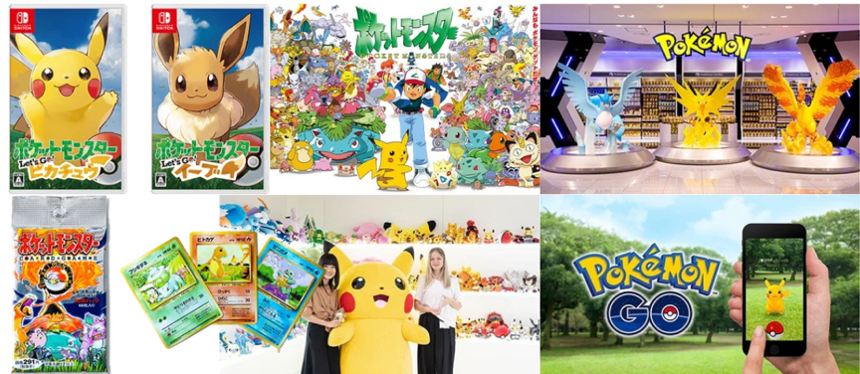
Figure 1: Pokémon Brand Ecosystem
Source: (The Pokemon Company, 2024)

Market Situation

Pokémon holds a strong position in the global entertainment market. More than 85 billion Pokémon Trading Card Game cards have been distributed across over 90 countries and regions (The Pokémon Company, 2026). The brand generated approximately US$12 billion in licensed retail sales and ranked seventh in License Global’s Top Global Licensors 2025 (Hart, 2026). Within trading cards, Pokémon ranked second by GMV on TCGplayer in Q2 2026, while competitors include Magic: The Gathering, Yu-Gi-Oh! and emerging creature-collection games such as Palworld (Day, 2026; Velzen, 2024).

Brand Vision

The Pokémon Company Group’s vision is “Bringing the world together through Pokémon” (The Pokémon Company, n.d.). This reflects its aim to connect consumers across countries, generations and shared interests. Pokémon GO demonstrates this through social interaction and community experiences (Lawler-Sagarin et al., 2023).

2. Consumer Profile and Positioning Strategy

2.1. Consumer Profile
Psychographic
Values: Social connection, entertainment, self-expression.
Aspirations: Connect through shared interests.
Anxieties/Challenges: Limited income, expects fresh experiences.
Kevin Chung Nguyen


Education
- Bachelor of Business
Work/Study Experience
- Retail worker

Background

I grew up with Pokémon and still enjoy discovering, collecting and sharing it with friends.
Age: 21
Gender: Male
Marital status: Single
Income: $35,000 -$50,000/year
Location: Melbourne, VIC, Australia

Demographics
Media Habits
TikTok, YouTube and Instagram.

Goals:Discover content, releases and fan communities

Hobbies and Interests
- Gaming, Pokémon, TCG, anime, socialising
Favourite brands
- Pokémon, Nintendo, Uniqlo, LEGO
Influences
- Friends, fan communities and reviews

Personal Preferences
1. Social

2. Curious

3. Tech-savvy

Key Characteristics
Figure 2: Consumer Profile

Buyer Behaviour
Purchase occasion: New Pokémon releases, special editions, events.
Benefits sought: Entertainment, social connection and discovery.

User status: Existing Pokémon fan
Usage rate: Regular user

2.2. Point of Parity

Pokémon shares associations with interactive entertainment and collectible franchises, including gaming, character-based entertainment and collecting. Similar to Yu-Gi-Oh! and Palworld, Pokémon offers distinctive characters, interactive gameplay and collecting, establishing its membership within the entertainment and collectible market.

2.3. Point of Difference

Pokémon differentiates through its collectible creatures and consumer connections. Its “Gotta Catch ’Em All!” concept reinforces discovery and collecting across games, trading cards and animation (Sheldon, 2026; Saxena, 2024). Combined with its three-decade history, these strengthen nostalgia and differentiate Pokémon through collectability and emotional connection (Amano, 2022).

2.4. Perceptual Map

Table 1: Perceptual Map of Pokémon
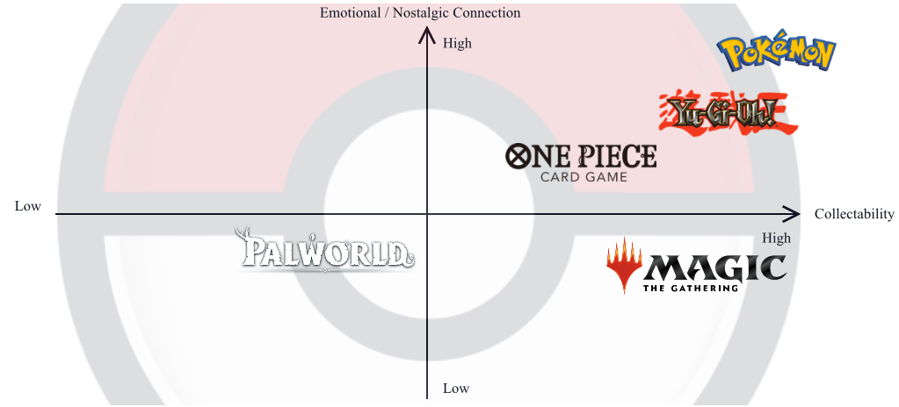

2.5. Brand Mantra

 | Emotional Modifier | Descriptive Modifier | Brand Function
Pokémon | Joyful | Shared | Discovery

3. Brand Inventory
Table 2: Pokémon Brand Element Evaluation
Brand Element | Memorability | Meaningfulness | Likeability | Transferability | Adaptability | Protectability
Brand name:  Pokémon | Distinctive and recognisable (Arbitration and Mediation Center, 2001) | Reflects “Pocket Monsters” (Amadi, 2024). | Builds positive familiarity. | Works across brand categories. | Relevant across generations. | Trademark protected (Arbitration and Mediation Center, 2001)
Logo: Pokémon Wordmark | Distinctive colours support recognition (Peate, 2021). | Signals brand variety (Song et al., 2022). | Supports favourable attitudes (Song et al., 2022). | Works across brand touchpoints. | Retains core visual identity. | Trademark protected (Pokémon, n.d.).
Symbol: Poké Ball | Simple, distinctive visual cue. | Symbolises catching and collecting. Allison (2006). | Approachable circular design (Jiang et al., 2016). | Works across brand categories. | Retains recognisable form. | Registered trademark (USPTO, 2026).
Characters: Pikachu | Strong visual recognition (Gomez et al., 2019). | Represents companionship (Tobin, 2004). | Supports emotional appeal (Tobin, 2004). | Works across brand categories. | Adaptable yet recognisable. | Proprietary character. (Arbitration and Mediation Center, 2001)
Slogans: “Gotta Catch ’Em All!” | Recognisable Pokémon expression (Katsuno & Maret, 2004). | Communicates collecting (Allison, 2006). | Encourages engagement (Allison, 2006). | Works across media. | Reused in new campaigns (Pokémon, 2025). | Distinctive slogan.
Jingle: Pokémon center healing sound | Strengthens audio recognition (Jackson, 2003). | Signals recovery during gameplays (Collins, 2013). | Reinforces positive experiences (Collins, 2013). | Works across games. | Adapts to audio styles. | Proprietary audio asset.
Video Game Packaging | Consistent visuals aid recognition. | Communicates game identity. | Creates visual appeal. (Orth & Malkewitz, 2008) | Works across game releases. | Artwork evolves by release. | Uses protected brand assets.
Table 3: Pokémon Brand Elements and 7Ps
7Ps | Brand Element Application | Consumer Meaning & Appeal
Product | Logo, characters and symbols appear across games and merchandise. | Reinforces familiarity and collecting.
Price | Products are offered at different price points. | Improves accessibility for young adults with limited income.
Place | Brand elements remain consistent across channels. | Supports recognition across touchpoints.
Promotion | Pikachu, logo and slogan appear across campaigns. | Appeals through familiarity and nostalgia.
People | Characters and symbols are shared across fan communities. | Supports social connection.
Process | Familiar visual and audio cues support brand interactions. | Creates a consistent Pokémon experience.
Physical Evidence | Packaging and merchandise display Pokémon visual assets. | Makes brand identity tangible.

Overall, these brand elements strongly appeal to young-adult fans through familiarity, nostalgia, collecting and social connection.

4. Brand Exploratory

Community
Active Engagement
Repeat purchase
Emotional Attachment
Gaming, Entertainment, Collecting, Merchandise
Engaging gameplay
Collecting
Product variety
Distinctive design
Multiple price points
Fans & collectors
Gaming & collecting
Fun & adventurous
Nostalgia & childhood memories
Quality
Credibility
Superiority

Nostalgia
Fun
Excitement
Social connection
RESONANCE
FEELINGS
JUDGEMENTS
PERFORMANCE
IMAGERY
SALIENCE

Figure 3: Pokémon CBBE Framework

4.1. Brand Identity

4.1.1. Brand Salience
Pokémon demonstrates strong depth of awareness, with experienced adults showing distinct and consistent visual responses to Pokémon following extensive childhood exposure (Gomez et al., 2019). However, this evidence primarily represents existing fans. Pokémon also maintains broad awareness across different consumption contexts, with current consumer engagement spanning trading cards, video games and online communities (Amarotti & Gaillot, 2026).

4.2. Brand Meaning

4.2.1. Brand Performance
Pokémon delivers performance through diverse game features, including collecting, battling, exploration and social interaction, providing multiple ways for young-adult fans to engage with the brand (Assunção et al., 2017). Catching new Pokémon particularly influences player behaviour (Arjoranta et al., 2020). However, performance quality is inconsistent, as Pokémon Scarlet received a 3.5/10 user score, with consumers frequently criticising technical issues and graphics (Metacritic, 2022).

4.2.2. Brand Imagery
Pokémon’s imagery reflects a fan and collector culture, with gaming, collecting and trading forming key consumer practices (Allison, 2006). Its imagery is also shaped by childhood experiences, as childhood brand nostalgia influences consumers’ beliefs about Pokémon (Harborth & Pape, 2019). Together, these associations reinforce Pokémon’s playful and adventurous image, although nostalgia may be less relevant to newer consumers.

4.3. Brand Responses

4.3.1. Brand Judgements
Pokémon generates mixed consumer judgements. Quality is weakened by technical issues in recent games (Metacritic, 2022), while its long-established presence may contribute to perceived credibility. Its distinctive collecting culture and nostalgic value strengthen superiority among existing fans (Allison, 2006; Harborth & Pape, 2019), although these advantages may be less meaningful to new consumers.

4.3.2. Brand Feelings
For existing young-adult fans, Pokémon evokes nostalgia, fun, excitement and social connection. Childhood brand nostalgia strengthens their emotional response to Pokémon (Harborth & Pape, 2019), while collecting and trading create opportunities for shared experiences with other fans (Allison, 2006). These feelings align strongly with the target consumer’s desire for entertainment, discovery and social connection.

4.4. Brand Relationship

4.4.1. Brand Resonance
Pokémon demonstrates strong resonance among existing young-adult fans through long-term loyalty and active engagement. Most respondents continued playing Pokémon despite many beginning with earlier generations (Assunção et al., 2017). Fans also create communities, tournaments and online content beyond official products (Assunção et al., 2017; Geraghty, 2017), demonstrating an enduring relationship that extends beyond purchase.

5. Launch Activation Strategy

5.1 Launch Activation Concept

The brand exploratory identified an opportunity to convert Pokémon’s strong recognition and nostalgic associations among existing young-adult fans into renewed engagement with the brand. The proposed activation, There’s Only One Pokémon, uses these established associations to generate interest in Pokémon Wind and Waves. The controversy surrounding Palworld’s similarities to Pokémon generated substantial online attention, creating an opportunity to use this existing discourse as a social media hook (Galante, 2024). By directly comparing the two brands, the activation aims to reignite this existing debate, encouraging fans to comment, share and express their perceptions of Pokémon. This creates the potential for a new wave of social media discussion while redirecting attention towards Pokémon Wind and Waves.

5.2 Target Audience Alignment

The activation targets young-adult Pokémon fans aged 18-24 who grew up with the franchise and continue to engage with gaming and collecting. Childhood brand nostalgia influences young adults’ perceptions of Pokémon (Harborth & Pape, 2019), making familiar characters such as Pikachu an effective cue for reconnecting with previous experiences. The Pokémon–Palworld comparison provides a fresh and provocative social media hook, aligning with the target audience’s interest in gaming content and online discussion. The catching and collecting message also reconnects them with familiar Pokémon experiences, while the interactive format encourages commenting and sharing with others. This combination also addresses the target consumer’s expectation for fresh experiences. While Pikachu and catching provide familiarity and nostalgia, the Palworld comparison introduces a more current and unexpected element. The activation therefore balances familiarity with novelty, helping the new release feel connected to consumers’ existing Pokémon experiences without simply repeating them.

5.3 Brand Touchpoints

The activation will run across TikTok, Instagram Reels and YouTube Shorts, reaching the target audience on platforms they regularly use through short-form content. The opening question encourages viewers to stop, recognise and compare the characters. Consumers are then exposed to nostalgic catching and collecting scenes before the reveal of Pokémon Wind and Waves. A call-to-action directs interested consumers to the official game page to learn more about the new release. Comments and shares extend the comparison beyond the original video, potentially generating further discussion around Pokémon and Palworld.

5.4 Marketing Communications Design

The video uses a short-form, fast-paced format designed to capture attention within the first few seconds. Pikachu and a similar-looking Palworld character appear side by side with the question, “In your mind, which one is Pikachu?” The video then zooms in on Pikachu before transitioning to Poké Balls and familiar catching and collecting scenes with the message, “When was the last time you caught a Pokémon?” The video transitions into Pokémon Wind and Waves gameplay, followed by “Do you want to catch them again?” Consistent use of Pokémon characters, visual elements and familiar experiences maintains brand recognition while connecting nostalgia directly to the new game.
Figure 4: Visual Similarity Between Sparkit and Pikachu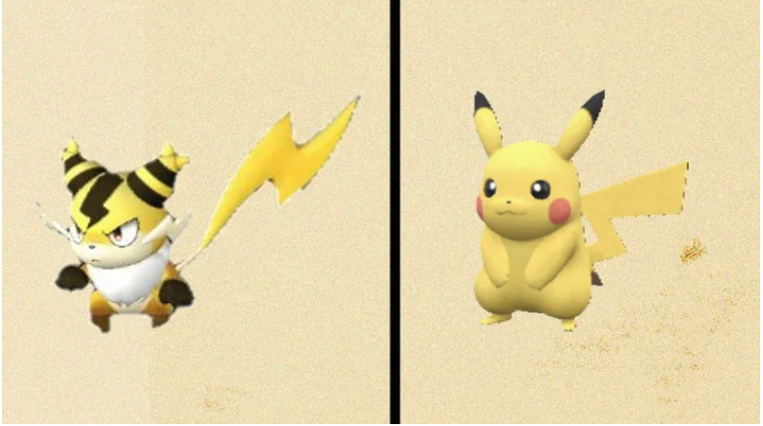
Source: (Greenwald, 2024)

5.5 Evaluation and Justification

The activation builds on the CBBE strengths identified in the brand exploratory while addressing the opportunity to convert existing awareness and nostalgia into renewed engagement. Rather than creating new associations, the activation uses familiar brand assets and experiences already meaningful to existing fans. The communication moves consumers from recognising Pikachu, to recalling catching and collecting experiences, and finally to discovering Pokémon Wind and Waves. This allows existing associations with Pokémon to be transferred to the new release. Using Pikachu as the opening cue reinforces brand salience through a highly recognizable character. Familiar catching and collecting experiences strengthen brand meaning by reinforcing associations already connected with Pokémon. The nostalgic transition is designed to generate positive brand responses among young-adult fans before connecting these associations with Pokémon Wind and Waves. Finally, the interactive comparison encourages consumers to participate and engage with the campaign, supporting stronger brand resonance. Effectiveness can be evaluated through video completion rate, engagement rate, click-throughs to the game page.

References
Allison, A. (2006). Millennial monsters. University of California Press.
Amadi, D. (2024, November 7). Origin of Pokémon. TC Game. https://tcgame.com.au/blogs/pokemon/origin-of-pokemon
Amano, T. (2022, September). The Pokémon Company: Evolving into an everlasting brand - case - faculty & research - Harvard Business School. Www.Hbs.Edu. https://www.hbs.edu/faculty/Pages/item.aspx?num=62732
Anna Amarotti and Ann-Derrick Gaillot. (2026, June 17). What marketers can learn from Pokémon’s 30th anniversary. Meltwater. https://www.meltwater.com/en/blog/pokemon-marketing-analysis-30th-anniversary-lessons
Arbitration and Mediation Center. (2001, January 29). WIPO domain name decision: D2000-1219. Wipo.Int. https://www.wipo.int/amc/en/domains/decisions/html/2000/d2000-1219.html
Arjoranta, J., Kari, T., & Salo, M. (2020). Exploring features of the pervasive game pokémon GO that enable behavior change: Qualitative study. JMIR Serious Games, 8(2), e15967. PubMed Central. https://doi.org/10.2196/15967
Assunção, C., Brown, M., & Workman, R. (2017). Pokémon is evolving! An investigation into the development of the pokémon community and expectations for the future of the franchise. Press Start, 4(1). https://www.researchgate.net/publication/317640817_Pokemon_is_Evolving_An_investigation_into_the_development_of_the_Pokemon_community_and_expectations_for_the_future_of_the_franchise
Collins, K. (2013). Playing with sound. The MIT Press.
Day, P. (2026, July 22). Best-selling trading card games, Q2 2026. TCGplayer, Inc. Tcgplayer.Com. https://seller.tcgplayer.com/blog/best-selling-trading-card-games-q2-2026
Galante, S. (2024). National Research Group. Nrgmr.Com. https://www.nrgmr.com/our-thinking/gaming/The-palworld-phenomenon-three-reasons-for-its-rise
Geraghty, L. (2017). Can pikachu die? Online fan conspiracy theories and the pokémon gaming universe. Journal of Fandom Studies, The, 5(1), 3–20. https://doi.org/10.1386/jfs.5.1.3_1
Gomez, J., Barnett, M., & Grill-Spector, K. (2019). Extensive childhood experience with Pokémon suggests eccentricity drives organization of visual cortex. Nature Human Behaviour, 3(6), 611–624. https://doi.org/10.1038/s41562-019-0592-8
Greenwald, W. (2024, January 30). Palworld’s 11 most shameless pokemon knock-offs. PCMag Australia. https://au.pcmag.com/games/103632/palworlds-11-most-shameless-pokemon-knock-offs
Harborth, D., & Pape, S. (2019). How nostalgic feelings impact pokémon go players – integrating childhood brand nostalgia into the technology acceptance theory. Behaviour & Information Technology, 39(12), 1–21. https://doi.org/10.1080/0144929x.2019.1662486
Hart, I. (2026, May 26). Pokémon celebrates 30 years. License Global. https://www.licenseglobal.com/entertainment/pokemon-celebrates-30-years
JIANG, Y., GORN, G. J., GALLI, M., & CHATTOPADHYAY, A. (2016). Does your company have the right logo? How and why circular- and angular-logo shapes influence brand attribute judgments. Journal of Consumer Research, 42(5), 709–726. https://www.jstor.org/stable/26570244
Jackson, D. M., & Fulberg, P. (2003). Sonic branding : an introduction / Daniel M. Jackson ; edited by Paul Fulberg. Palgrave Macmillan.
Katsuno , H., & Maret, J. (2004). 5. Localizing the Pokémon TV series for the American market. Pikachu’s Global Adventure, 80–107. https://doi.org/10.1515/9780822385813-005
Lawler-Sagarin, K. A., Sagarin, B. J., & Pederson, A. (2023). Enhanced community through augmented reality: Social benefits of pokémon go. Psychological Reports, 128(5), 3428–3440. https://doi.org/10.1177/00332941231197155
Orth, U. R., & Malkewitz, K. (2008). Holistic package design and consumer brand impressions. Journal of Marketing, 72(3), 64–81. https://doi.org/10.1509/jmkg.72.3.064
Peate, S. (2021, July 7). The story of the pokémon logo symbol. Fabrik Brands. https://fabrikbrands.com/branding-matters/logofile/pokemon-symbol-and-pokemon-logo-history/
Saxena, P. (2024, June 3). The pokémon company: Business insights, competitive advantage, and global impact. ResearchGate. https://www.researchgate.net/publication/395238960_The_Pokemon_Company_Business_Insights_Competitive_Advantage_and_Global_Impact
Sheldon, P. (2026, February 23). How Pokémon stays relevant... And lucrative - MediaCat UK. MediaCat UK. https://mediacat.uk/how-pokemon-stays-relevant-and-lucrative/#
Song, J. F., Xu, F. K., & Jiang, Y. (2022). The colorful company: Effects of brand logo colorfulness on consumer judgments. Psychology & Marketing, 39(8). https://doi.org/10.1002/mar.21674
The Pokemon Company. (2024). History. The Pokémon Company. https://corporate.pokemon.co.jp/en/aboutus/history/
The Pokémon Company. (n.d.). Philosophy. The Pokémon Company. Retrieved 7 September 2026, from https://corporate.pokemon.co.jp/en/aboutus/philosophy/
The Pokémon Company. (2026, September 7). Pokémon in figures. The Pokémon Company. https://corporate.pokemon.co.jp/en/aboutus/figures/
Tobin, J. (2004). Pikachu′s global adventure: The rise and fall of Pokemon. Dukeupress.Edu. https://www.dukeupress.edu/pikachus-global-adventure
United States Patent and Trademark Office. (2026). USPTO TTABVUE. Trademark trial and appeal board inquiry system. Uspto.Gov. https://ttabvue.uspto.gov/ttabvue/v?pnam=Nintendo+of+America+Inc
Velzen, A. (2024, September 27). Nintendo’s patents were designed to take on Palworld | Opinion. GamesIndustry.Biz. https://www.gamesindustry.biz/nintendos-patents-were-designed-to-take-on-palworld

