# Translations Builder

Power BI as a platform provides effective features for Internationalization and localization making it possible to build multi-language reports. For example, you can design a Power BI report that renders in English for some users while rendering in Spanish, French, German or Dutch for other users. If an organization has the requirement of building Power BI reports that support multiple languages, it's no longer necessary to clone and maintain a separate PBIX project file for each language. Instead, the organization can increase reuse and lower report maintenance by designing and implementing multi-language reports.

Translations Builder is an external tool created for Power BI Desktop specifically to assist report authors and dataset authors with tasks associated with creating translations and building multi-language reports. **As a user**, you can install Translations Builder and use it together with Power BI Desktop to build and test datasets and reports that support multiple languages. **As a developer**, you can clone the GitHub repository with the Translations Builder source code and extend this application to meet whatever translation and localization requirements your organization faces.

To begin using Translations Builder as a user, start by walking through the [**Installation Guide**](https://github.com/PowerBiDevCamp/TranslationsBuilder/blob/main/Docs/Installation%20Guide.md) to ensure you get Translations Builder up and running on the Windows PC where you have installed Power BI Desktop. After you get the tool installed, it is recommended to work through the Hands-on Lab so you can quick understand the end-to-end process of creating translations in Power BI Desktop and then testing them in the Power BI Service. You should also review the [**User Guide**](https://github.com/PowerBiDevCamp/TranslationsBuilder/blob/main/Docs/User%20Guide.md) which walks you through basic operations as well as advanced procedures.

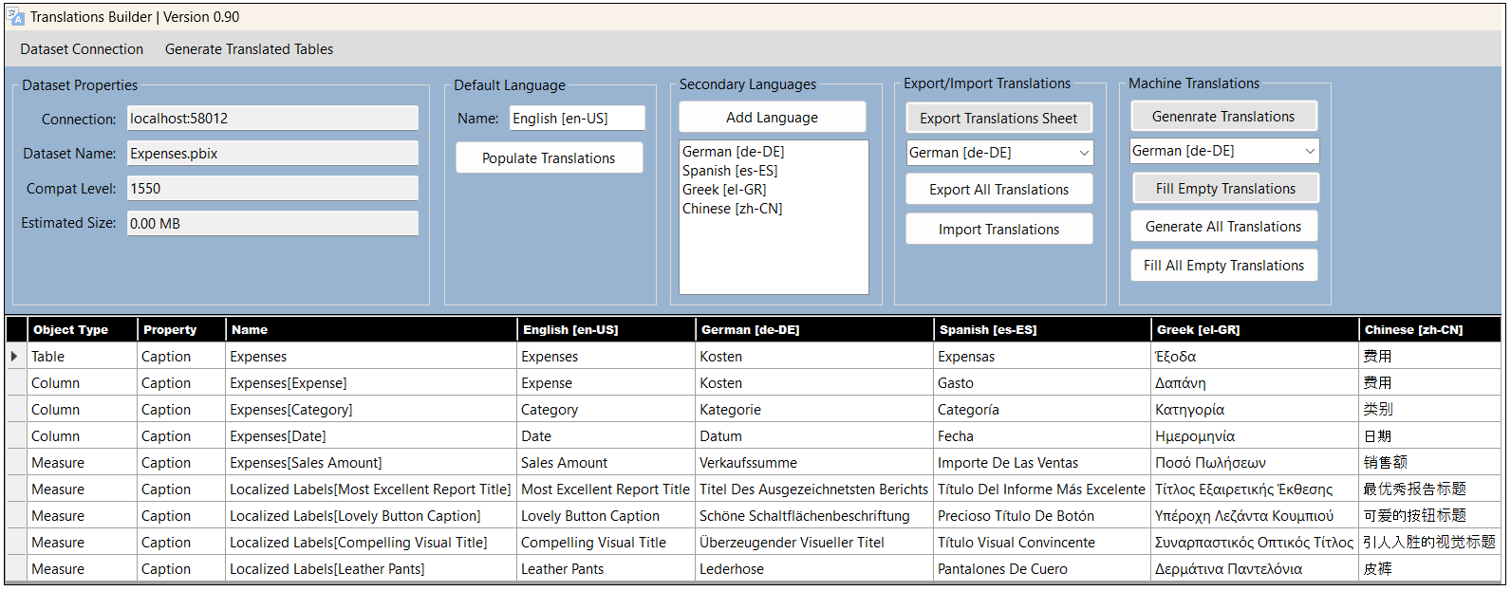

If you are interested in what really goes on behind the scenes with Translations Builder and Power BI translations, you should read [**Understanding Translations in Power BI**](https://github.com/PowerBiDevCamp/TranslationsBuilder/blob/main/Docs/Understanding%20Translations%20in%20Power%20BI.md). This article is designed to build your conceptual understanding of how all the pieces fit together.

Translations Builder is a Windows application developed using .NET 6, C# and the Tabular Object Model (TOM). To begin working with Translations Builder as a developer, you should clone the Translations Builder GitHub repository. Once you have downloaded the Translation Builder project files, you should be able start it up using Visual Studio 2022. You can review the [**Developer Guide**](https://github.com/PowerBiDevCamp/TranslationsBuilder/blob/main/Docs/Developer%20Guide.md) for more information.