**Game Design Document for:**

# Gladiator

All work Copyright ©2022 by Woolford Studios LTD

Version # 1.00

Friday, March 04, 2022**Table of Contents**

Gladiator 1

Project Management 2

Version 1.10 3

Game Overview 3

Philosophy/ theme/ morals 4

Philosophical point #1 4

Philosophical point #2 4

Gameplay Loop 4

What is it 4

Mechanics 4

Punching 4

Shop 4

Enemy Spawning 4

Healing 4

Health Potions 4

Weapons 5

Enemies Health and Damage 5

Planning 5

What I planned 5

Why I planned 5

How I planned 5

The Game Idea 5

Arena 5

Weapons 6

# Project Management

## Version 1.10

# Game Overview

## Philosophy/ theme/ morals

I like the idea of the vr game GORN. It is a gladiator wave game and I enjoy these types of games. I want to make an endless game which will only end when you die. I want a range of medieval weapons to stick to the theme

## Philosophical point #1

The game is to show of my skills I have developed over the past weeks in developing and while I do it, show off my modeling and learn how to add animations into the game.

## Philosophical point #2

I’m trying to achieve an immersive game which can be played for hours at a time. I will look at gladiator rings in films, video games (such as cod zombies) and even read descriptions of them from books

# Gameplay Loop

## What is it

The Gameplay loop of Gladiator is: Killing, Earn Points, Spend Points. While doing this you will have to make sure you are not killed, always keep an eye on your health and seeing how long you can last in an endless forever getting harder game

## Mechanics

There isn’t many mechanics of this game but each of them is complex in their own way:

### Punching

You can punch enemies. This is done by using left mouse button and was created by checking colliders and using trigger collisions. This will give you points to spend in the shop.

### Shop

You can buy 3 different items, a mace, a sword and health potions. This is done by creating a class called Items and inside an enumerator with all the items, how much they cost and their functions

### Enemy Spawning

The enemies can spawn in set locations picked randomly. They will spawn in front of your eye and all at once to create a menacing atmosphere.

### Healing

You gain 10 health every 5 seconds automatically. This is done with coroutines so that you can wait seconds. There is another 5 second cooldown meaning you get 10hp every 10 seconds.

### Health Potions

The second form of healing is Health Potions. You can buy these for a low price of 5000 points. This can be gathered after killing around 20 enemies. This is done by a function called “Heal()” which will deduct one from your health potion pot and increase your health by 50. You must have at least one before it can be used.

### Weapons

Even though you can’t see them, buying a mace or a sword will do a significant amount more damage. For example, your base damage is 150. Buying a mace will add 850, increasing your damage to 1000. A sword, which is more expensive, will add 1350, increasing your damage to 1500.

### Enemies Health and Damage

After every round, the enemies will gain 100 more damage, but, if it is above round 9, it will also multiple their health by 1.1. After some rounds this will create significant difficulty. The enemies have a base damage of 49, meaning it will take 3 hits to kill you.

# Planning

## What I planned

I planned out what the arena you fought in would be, how the enemies would look, the weapons you’d be able to pick from and the game idea.

## Why I planned

I planned out specific stuff because I wanted to make sure I had an idea instead of jumping into the game and doing it blindly.

## How I planned

I planned differently depending on what it was. For example, I made a mood board for certain items, and some was just discussions on reddit.

### The Game Idea

The game idea is a mix between Call Of Duty zombies mode and the game Gorn. This is because they are both big successful franchises

### Arena

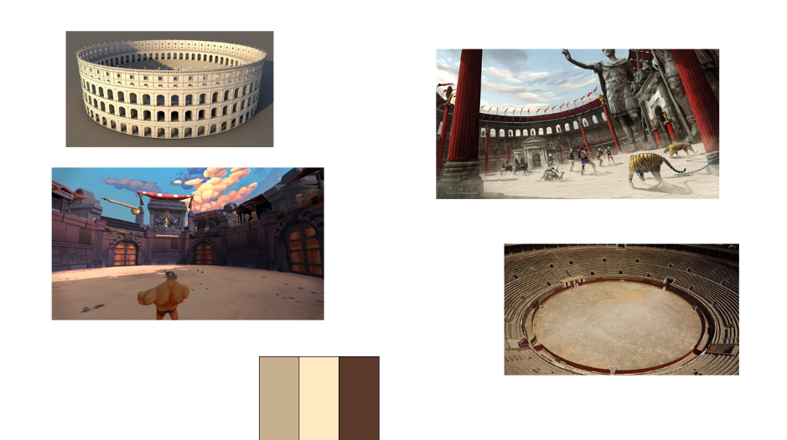I planned out the arena by making a mood board of games, real world and concept art. From this I saw they are all enclosed and are circular, which sounds obvious, but some of the smaller details on how the there is no roof and they have menacing looks. Also, the colours used helped me decided what material to use on my model in the prototype

### Weapons

I checked out a game called Gorn to figure out what types of weapons there are and how you acquire them. I saw mostly fantasy type weapons such as sword, maces, bows and even magic. My original plan was to add a fireball however I never added to it since Health Potions was “fantasy” enough for me