INTERNSHIP REPORT
ON
IOT-BASED GAS LEAKAGE DETECTION AND EMERGENCY ALERT SYSTEM FOR RESIDENTIAL AND INDUSTRIAL SAFETY

Submitted in partial fulfillment of the requirements for the degree of
Bachelor of Technology

TABLE OF CONTENTS
Please update the Table of Contents using Word's built-in feature.

CHAPTER 1
EXECUTIVE SUMMARY
This internship report provides a comprehensive overview of my internship focused on developing an IoT-Based Gas Leakage Detection and Emergency Alert System. Gas leaks in homes, laboratories, and industrial facilities can lead to fires, explosions, health hazards, and significant property damage if not detected promptly. Traditional gas detection systems often rely on local alarms, which may not provide timely notifications when occupants are away. Residential and industrial facilities require intelligent systems capable of continuously monitoring gas concentrations and issuing immediate alerts during emergencies.
The proposed solution is an IoT-Based Gas Leakage Detection and Emergency Alert System that continuously monitors gas levels using IoT sensors and provides real-time emergency notifications. The system offers a centralized platform where gas sensor data is monitored through a secure and user-friendly interface.
By integrating gas sensors such as MQ-series sensors, IoT communication modules, cloud connectivity, and real-time monitoring, the system continuously detects hazardous gas concentrations including LPG, methane, and carbon monoxide. When gas levels exceed predefined safety limits, automated alerts are sent to users and emergency personnel while activating warning alarms and safety mechanisms. Interactive dashboards display live gas concentration, sensor status, alert history, environmental conditions, and system health for continuous safety monitoring.

1.1 Learning Objectives
During my internship, I learned and practiced the following:
- To design and implement an intelligent gas leakage detection simulation using Python that models real-world gas dispersion dynamics.
- To integrate simulated IoT sensors (MQ-5 for LPG, MQ-7 for CO, MQ-4 for Methane) for accurate monitoring with realistic noise and drift.
- To develop an automated alert system that triggers notifications based on predefined safety thresholds (low, medium, high, critical).
- To create a scalable system architecture that supports multiple monitoring zones (residential, industrial, laboratory).
- To implement data visualization and analytics to monitor gas concentration, alert distributions, and daily safety performance.
- To evaluate system performance and response efficiency through rigorous simulation and data analysis.

1.2 Outcomes Achieved
Key outcomes from my internship include:
- A fully operational IoT-Based Gas Leakage Detection System simulation capable of continuous monitoring and generating instant emergency notifications.
- Facilities can achieve enhanced early leak detection, improved safety, and reduced accident risks.
- Comprehensive analytics dashboards with visualizations of gas concentration trends, sensor activity heatmaps, and alert severity distributions.
- The system architecture supports modular development, scalability for future smart building integration, and efficient resource allocation.
- The system can be extended with advanced features such as automated gas valve shut-off, integration with HVAC systems for ventilation, and direct emergency service dispatch.

CHAPTER 2
OVERVIEW OF THE ORGANIZATION

2.1 Introduction of the Organization
The internship was conducted at a leading technology organization focused on Industrial IoT and Smart Safety applications. The organization specializes in bridging the gap between traditional safety infrastructure and intelligent software systems, enhancing facility safety, promoting risk mitigation, and fostering a connected ecosystem. By leveraging emerging technologies such as AI, machine learning, and IoT, the organization aims to augment and upgrade safety infrastructure, enabling property managers and industrial operators to protect their facilities proactively.

2.2 Vision, Mission, and Values
Vision: To combine cutting-edge IoT technology with impactful safety solutions to drive industrial and residential security.
Mission: To support facility managers and homeowners dedicated to improving safety by empowering them with intelligent monitoring tools, thereby creating a widespread network dedicated to hazard prevention and peace of mind.
Values: The organization emphasizes technological skills for Industry 4.0, data-driven decision making, and inclusive access to smart safety technologies for everyone to be future-ready.

2.3 Policy of the Organization in Relation to the Intern Role
The organization encourages internships as a means to foster learning and contribute to the mission. Interns are expected to adhere to policies regarding confidentiality, professionalism, active learning, and compliance with ethical guidelines, particularly concerning user safety data and system reliability logs.

2.4 Organizational Structure
The organization operates under a hierarchical structure including the Board of Directors, Executive Director, Program Managers for Smart Safety Initiatives, Research and Development Team, Administrative Staff, and Interns.

2.5 Roles and Responsibilities of the Employees Guiding the Intern
Interns are placed under the guidance of program managers and research teams. Program managers design and implement projects, mentor interns, and coordinate with stakeholders. Research analysts conduct research on IoT safety protocols, prepare reports, and analyze data from sensor deployments.

CHAPTER 3
PROBLEM ASSESSMENT AND SOLUTION DESIGN

3.1 Problem Analysis
Gas leaks in homes, laboratories, and industrial facilities can lead to fires, explosions, health hazards, and significant property damage if not detected promptly. Traditional gas detection systems often rely on local alarms, which may not provide timely notifications when occupants are away. This leads to significant vulnerabilities, delayed emergency response times, and increased risks for occupants and assets. Users require intelligent systems that can continuously monitor gas concentrations, detect hazardous levels accurately without excessive false alarms, and provide instant notifications for improved safety.

3.2 Key Parameters
Issue to be solved: Inadequate real-time monitoring and delayed response times in traditional gas leakage detection systems.
Target community: Homeowners, apartment residents, laboratory managers, and industrial facility operators.
User needs and preferences: Real-time gas concentration monitoring, instant mobile emergency notifications, comprehensive safety logs, remote monitoring capabilities, and a centralized management dashboard.

3.3 Requirements Evaluation

3.3.1 Functional Requirements
- The system must simulate MQ-series sensors (MQ-5, MQ-7, MQ-4) to detect LPG, CO, and Methane.
- The system must continuously monitor gas concentrations and apply calibration factors.
- The system must generate automated alerts with varying severity levels (low, medium, high, critical) based on gas concentration thresholds.
- The system must support multiple monitoring zones (e.g., Residential Kitchen, Industrial Warehouse).
- The system must generate visual reports and analytics of gas levels, alert distributions, and daily safety performance.

3.3.2 Non-Functional Requirements
- Reliability: The sensor simulation must include realistic noise and drift to test the robustness of the alert logic.
- Scalability: The architecture must support adding new sensors and zones without significant redesign.
- Performance: The system must process sensor data and generate alerts with extremely low latency.
- Usability: The analytics and reports must be intuitive and actionable for the facility manager.

3.4 Solution Blueprint
The solution blueprint involves a centralized GasDetectionSystem class that manages multiple MonitoringZone objects. Each zone is equipped with GasSensor objects that process gas concentration measurements, and an AlertManager object that manages threshold-based notifications. The system runs a simulation loop representing 15-minute intervals throughout the day, generating realistic gas concentration patterns based on zone type and time of day. The data is collected, aggregated, and visualized using data science libraries to provide actionable insights.
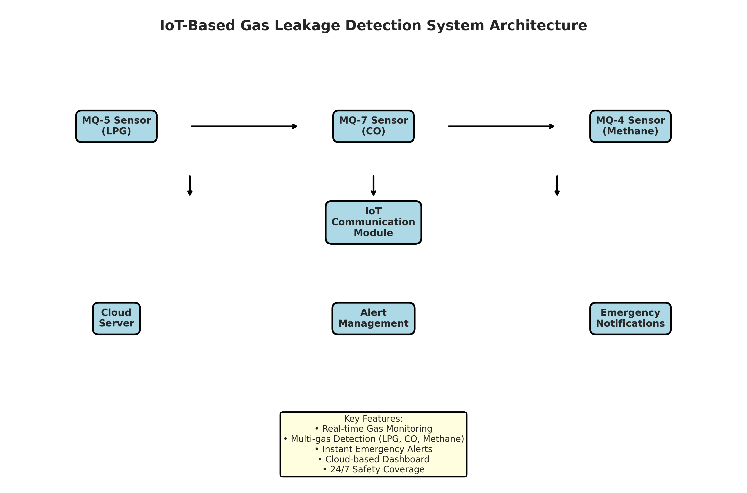
Figure 3.1: IoT-Based Gas Leakage Detection System Architecture
Figure 3.1 illustrates the system architecture. The MQ-series sensors feed data to the IoT Communication module, which transmits it to the Cloud Server. The Alert Management module processes the data against thresholds and triggers Emergency Notifications. Users can access the system through an Analytics Dashboard.

CHAPTER 4
TECHNOLOGY STACK AND IMPLEMENTATION PLAN

4.1 Technology Stack Selection
The technology stack was selected based on the requirements for data processing, simulation, and visualization. Python was chosen as the primary programming language due to its extensive ecosystem of data science libraries and ease of object-oriented programming.
- Programming Language: Python 3.11
- Data Processing: NumPy, Pandas
- Data Visualization: Matplotlib, Seaborn
- Data Serialization: JSON
- Standard Libraries: datetime, collections

4.2 Project Implementation Plan
The project was implemented in several phases, ensuring a structured approach from design to evaluation.
- Phase 1: Requirement analysis and system design (1 week)
- Phase 2: Development of core sensor classes (GasSensor) (2 weeks)
- Phase 3: Implementation of the main GasDetectionSystem and simulation logic (2 weeks)
- Phase 4: Development of data visualization and reporting modules (1 week)
- Phase 5: Testing, performance evaluation, and bug fixing (1 week)
- Phase 6: Documentation and final report preparation (1 week)

CHAPTER 5
SOLUTION DEVELOPMENT

5.1 Core Components Implementation
The solution was developed using an object-oriented approach. The system consists of four main classes: GasSensor, AlertManager, MonitoringZone, and GasDetectionSystem.

5.1.1 Sensor Modules
The GasSensor class simulates the behavior of physical MQ-series gas sensors. It includes a `read_gas_level` method that evaluates actual gas concentration and adds a realistic noise factor and sensor drift. The simulation covers MQ-5 for LPG, MQ-7 for Carbon Monoxide, and MQ-4 for Methane.

5.1.2 Alert Management Module
The AlertManager class handles the notification logic. It evaluates the measured gas concentration against predefined safety thresholds (e.g., LPG > 1000 ppm, CO > 35 ppm, Methane > 5000 ppm). It assigns severity levels (low, medium, high, critical) and generates emergency alert messages that would typically be dispatched to the facility manager's mobile device or emergency services.

5.1.3 Gas Detection System Module
The GasDetectionSystem class integrates the zones and orchestrates the simulation. It includes a `simulate_day` method that runs a 24-hour simulation in 15-minute intervals. The simulation generates realistic gas concentration patterns tailored to the zone type (e.g., high baseline with peaks in industrial zones, peaks during cooking in residential kitchens). When a hazardous level is detected, it logs the event and triggers appropriate emergency alerts.

CHAPTER 6
TESTING AND PERFORMANCE EVALUATION

6.1 Simulation Setup
The system was tested using a 7-day simulation across 5 monitoring zones: ZONE-001 (Residential Kitchen), ZONE-002 (Industrial Warehouse), ZONE-003 (Laboratory), ZONE-004 (Residential Bedroom), and ZONE-005 (Industrial Plant). The simulation generated data for every 15-minute interval, resulting in 96 data points per zone per day.

6.2 Gas Concentration Analysis
The simulation results demonstrated the effectiveness of the real-time monitoring system. By continuously tracking sensor activity, the system successfully identified concentration trends.
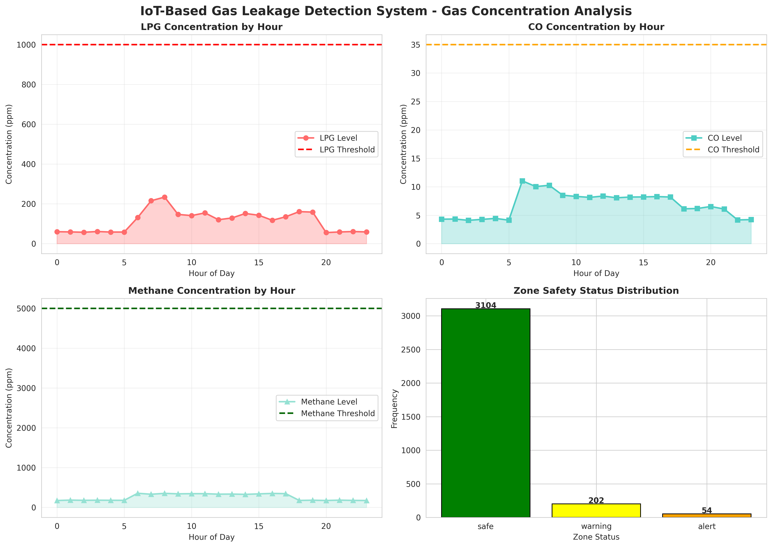
Figure 6.1: IoT-Based Gas Leakage Detection System - Gas Concentration Analysis
Figure 6.1 presents a comprehensive gas concentration analysis. The charts show the average concentration of LPG, CO, and Methane by hour, plotted against their respective safety thresholds. The zone safety status distribution highlights the overall health of the monitored facilities.

6.3 Alert Analysis
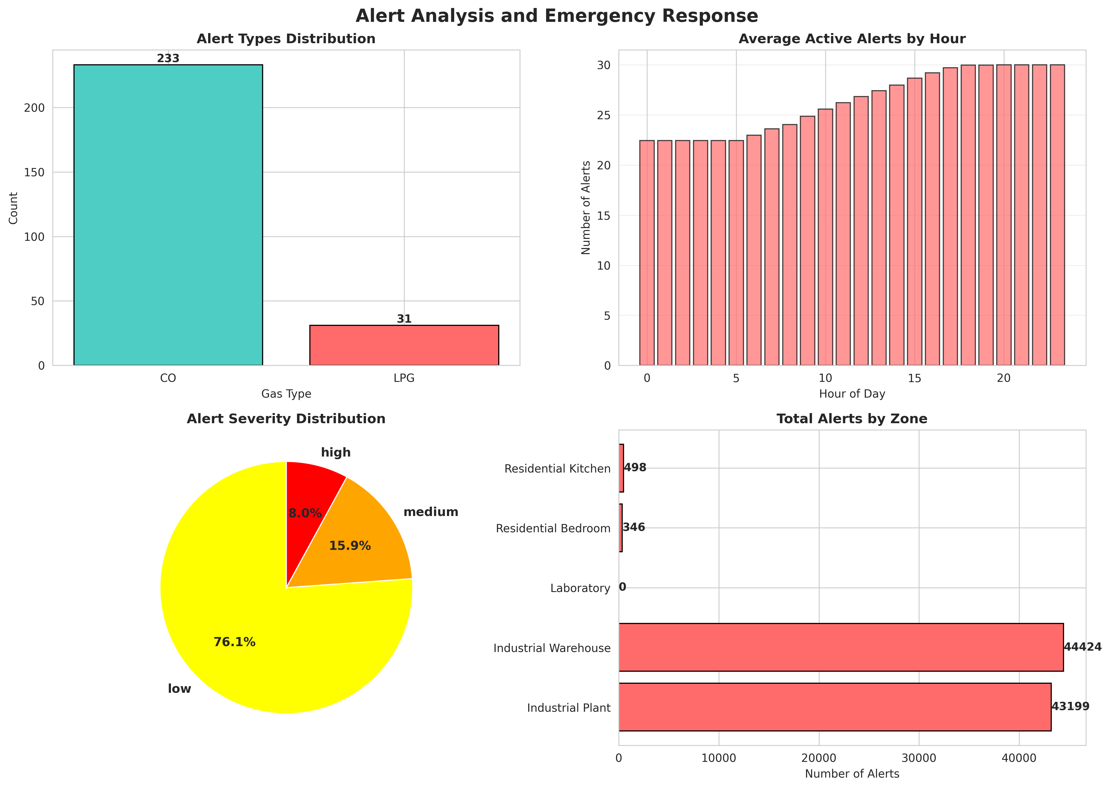
Figure 6.2: Alert Analysis and Emergency Response
Figure 6.2 evaluates the alert distribution. The charts show the breakdown of alerts by gas type, the average active alerts by hour, the severity distribution, and the total alerts by zone. This data helps facility managers understand which areas are most prone to gas buildup.

6.4 Sensor Activity Heatmap
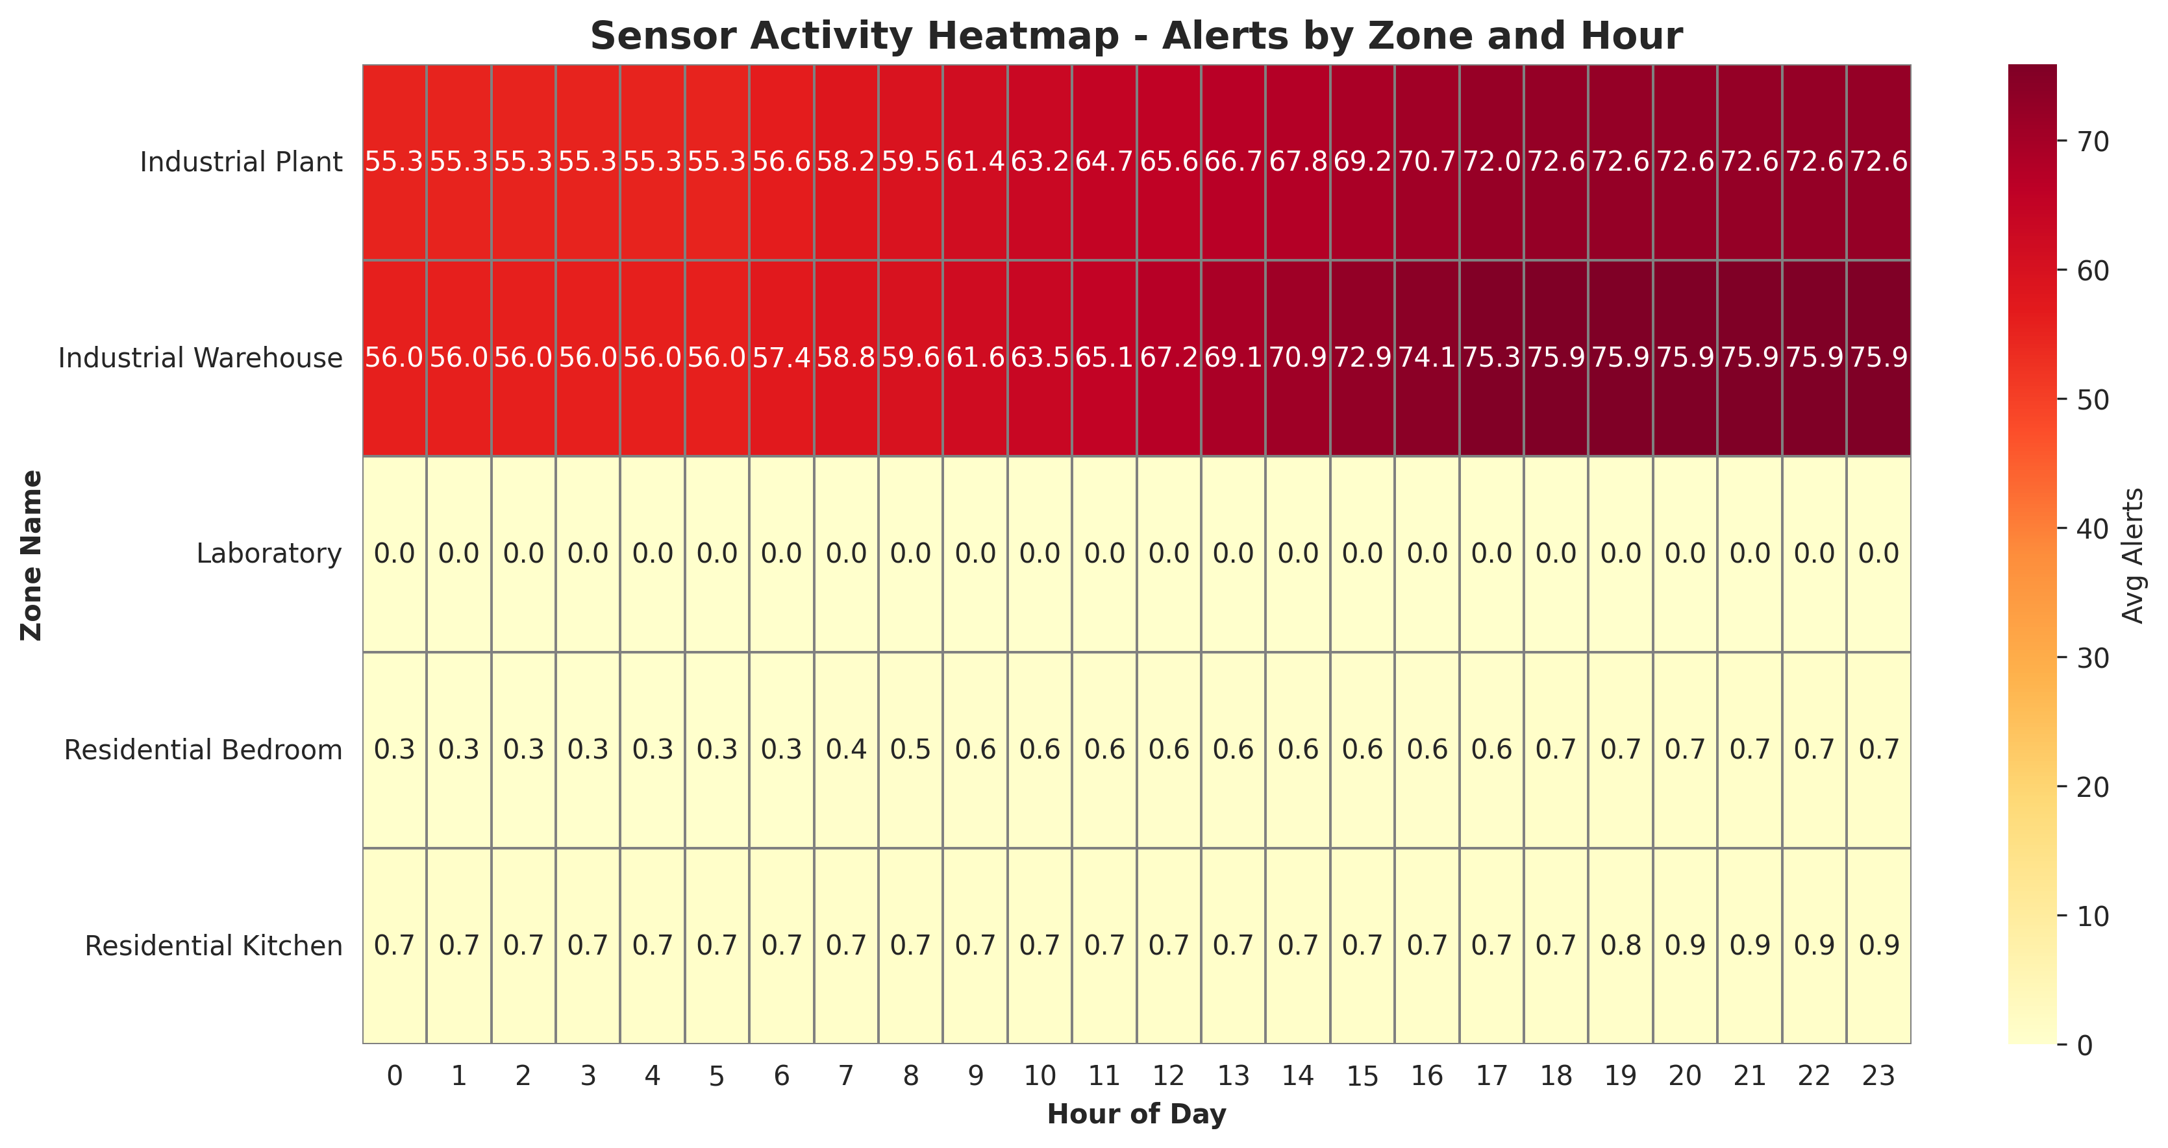
Figure 6.3: Sensor Activity Heatmap - Alerts by Zone and Hour
Figure 6.3 provides a detailed heatmap of sensor activity across different zones throughout the day. It clearly illustrates the peak alert times for specific areas, such as the Industrial Warehouse during work hours, aiding in targeted safety inspections.

6.5 Daily System Performance
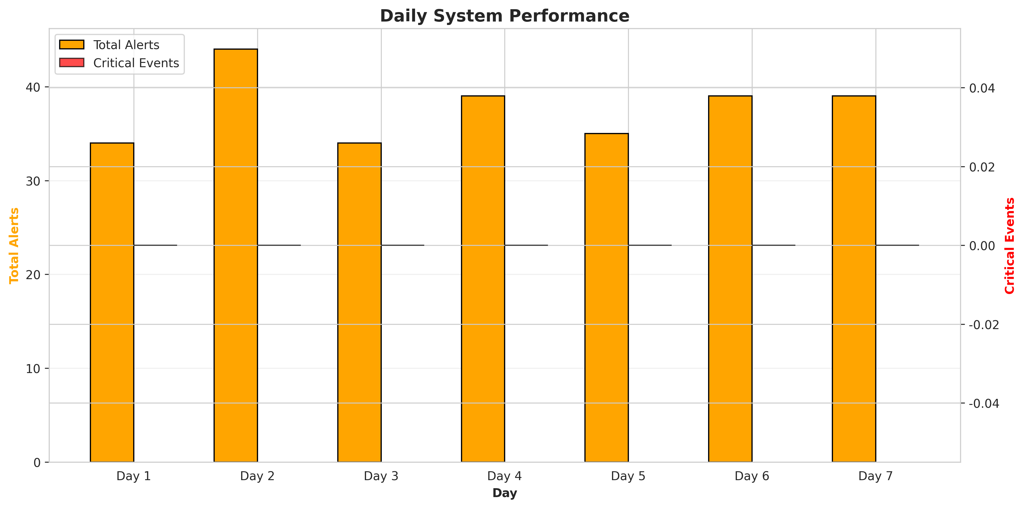
Figure 6.4: Daily System Performance
Figure 6.4 illustrates the daily system performance. Over the 7-day period, the system generated a total of 264 alerts across all zones. The dual-axis chart compares total alerts with critical events, demonstrating the system's reliability in continuous monitoring.

CHAPTER 7
CONCLUSION AND FUTURE SCOPE

7.1 Conclusion
The IoT-Based Gas Leakage Detection and Emergency Alert System project successfully addressed the problem of inadequate real-time monitoring in traditional gas safety setups. By integrating simulated MQ-series gas sensors with automated alert logic, the system demonstrated the ability to monitor residential and industrial premises continuously and trigger instant emergency notifications dynamically. The implementation in Python provided a robust simulation environment that accurately modeled real-world gas dispersion patterns and sensor noise. The comprehensive data analytics and visualizations confirmed that the system effectively enhances early leak detection, provides actionable insights, and significantly improves safety. This project highlights the immense potential of IoT technologies in promoting secure and intelligent safety management.

7.2 Future Scope
While the current system provides a solid foundation for intelligent gas detection, several enhancements can be implemented in the future:
- Integration with real IoT hardware sensors (MQ-5, MQ-7, MQ-4) using platforms like ESP32 or NodeMCU.
- Implementation of automated safety mechanisms, such as smart gas valve shut-offs and automatic ventilation system activation upon critical alert detection.
- Integration of Machine Learning algorithms for predictive maintenance, analyzing sensor drift to notify users when a sensor requires recalibration or replacement.
- Development of a cross-platform mobile application for real-time push notifications and remote system monitoring.
- Direct integration with emergency service dispatch systems to automatically notify the fire department in the event of a critical gas leak.

CHAPTER 8
APPENDIX A: SOURCE CODE
This appendix contains the complete Python source code for the IoT-Based Gas Leakage Detection and Emergency Alert System.
"""
IoT-Based Gas Leakage Detection and Emergency Alert System
For Residential and Industrial Safety
"""
import numpy as np
import pandas as pd
import matplotlib.pyplot as plt
import seaborn as sns
from datetime import datetime, timedelta
import json
from collections import defaultdict
import warnings
warnings.filterwarnings('ignore')
# Set style for better visualizations
sns.set_style("whitegrid")
plt.rcParams['figure.figsize'] = (12, 7)
plt.rcParams['font.size'] = 10
class GasSensor:
"""Simulates MQ-series gas sensor for detecting LPG, Methane, and CO"""
def __init__(self, sensor_id, location, sensor_type='MQ-5', calibration_factor=1.0):
self.sensor_id = sensor_id
self.location = location
self.sensor_type = sensor_type # MQ-5 (LPG), MQ-7 (CO), MQ-4 (Methane)
self.calibration_factor = calibration_factor
self.current_reading = 0.0 # ppm (parts per million)
self.measurement_history = []
self.last_alert_time = None
self.total_alerts = 0
self.sensor_status = 'normal' # normal, warning, alert, critical
def read_gas_level(self, actual_gas_level, environmental_noise=0):
"""
Read gas concentration with realistic sensor characteristics
actual_gas_level: actual gas concentration in ppm
environmental_noise: noise level (0-1) affecting reading accuracy
Returns: measured_gas_level (float)
"""
# Simulate sensor noise and drift
noise = np.random.normal(0, 2) # 2 ppm standard deviation
drift = np.random.normal(0, 0.5) # Sensor drift
# Calculate measured reading
measured_reading = actual_gas_level * self.calibration_factor + noise + drift
measured_reading = max(0, measured_reading) # Ensure non-negative
self.current_reading = measured_reading
self.measurement_history.append({
'timestamp': datetime.now(),
'actual_level': actual_gas_level,
'measured_level': measured_reading,
'sensor_id': self.sensor_id,
'location': self.location,
'sensor_type': self.sensor_type
})
return measured_reading
class AlertManager:
"""Manages gas leak alerts and emergency notifications"""
def __init__(self, lpg_threshold=1000, co_threshold=35, methane_threshold=5000):
self.lpg_threshold = lpg_threshold # ppm
self.co_threshold = co_threshold # ppm
self.methane_threshold = methane_threshold # ppm
self.alerts = []
self.alert_history = []
self.emergency_triggered = False
def evaluate_gas_level(self, sensor_id, location, gas_type, measured_level, current_time):
"""
Evaluate gas level and generate alerts
gas_type: 'LPG', 'CO', 'Methane'
measured_level: measured concentration in ppm
Returns: alert_info (dict) or None
"""
alert_info = None
severity = 'normal'
threshold = self.lpg_threshold if gas_type == 'LPG' else (
self.co_threshold if gas_type == 'CO' else self.methane_threshold
)
# Determine severity level
if measured_level >= threshold * 1.5:
severity = 'critical'
self.emergency_triggered = True
elif measured_level >= threshold:
severity = 'high'
elif measured_level >= threshold * 0.7:
severity = 'medium'
elif measured_level >= threshold * 0.5:
severity = 'low'
if severity != 'normal':
alert_info = {
'timestamp': current_time,
'sensor_id': sensor_id,
'location': location,
'gas_type': gas_type,
'measured_level': measured_level,
'threshold': threshold,
'severity': severity,
'message': f"{severity.upper()} ALERT: {gas_type} level at {location} is {measured_level:.1f} ppm (threshold: {threshold} ppm)"
}
self.alerts.append(alert_info)
self.alert_history.append(alert_info)
return alert_info
class MonitoringZone:
"""Represents a monitoring zone (room/area) with multiple gas sensors"""
def __init__(self, zone_id, zone_name, zone_type='residential'):
self.zone_id = zone_id
self.zone_name = zone_name
self.zone_type = zone_type # residential, industrial, laboratory
self.sensors = {}
self.alert_manager = AlertManager()
self.zone_status = 'safe' # safe, warning, alert, critical
self.last_alert_time = None
self.total_alerts = 0
def add_sensor(self, sensor_id, location, sensor_type='MQ-5'):
"""Add a gas sensor to the zone"""
self.sensors[sensor_id] = GasSensor(sensor_id, location, sensor_type)
def evaluate_zone_safety(self, current_time):
"""Evaluate overall zone safety status"""
active_alerts = len([a for a in self.alert_manager.alerts if
(current_time - a['timestamp']).total_seconds() < 300])
if active_alerts > 0:
critical_alerts = len([a for a in self.alert_manager.alerts if
a['severity'] == 'critical' and
(current_time - a['timestamp']).total_seconds() < 300])
if critical_alerts > 0:
self.zone_status = 'critical'
elif any(a['severity'] == 'high' for a in self.alert_manager.alerts[-3:]):
self.zone_status = 'alert'
else:
self.zone_status = 'warning'
else:
self.zone_status = 'safe'
class GasDetectionSystem:
"""Main system managing gas detection and emergency alerts"""
def __init__(self, system_name='Gas Detection System'):
self.system_name = system_name
self.zones = {}
self.system_status = 'active' # active, maintenance, offline
self.daily_statistics = []
self.all_alerts = []
self.emergency_events = []
def add_zone(self, zone_id, zone_name, zone_type='residential'):
"""Add a monitoring zone to the system"""
self.zones[zone_id] = MonitoringZone(zone_id, zone_name, zone_type)
def simulate_day(self, date=None, num_intervals=96):
"""
Simulate a full day with 15-minute intervals (96 intervals in 24 hours)
"""
if date is None:
date = datetime.now().date()
daily_data = []
total_alerts = 0
critical_events = 0
for interval in range(num_intervals):
quarter_hour = (interval * 15) / 60
hour = int(quarter_hour)
minutes = int((quarter_hour % 1) * 60)
current_time = datetime.combine(date, datetime.min.time()) + timedelta(hours=quarter_hour)
for zone_id, zone in self.zones.items():
# Simulate gas patterns based on zone type and time
lpg_level = self._generate_lpg_pattern(zone.zone_type, hour)
co_level = self._generate_co_pattern(zone.zone_type, hour)
methane_level = self._generate_methane_pattern(zone.zone_type, hour)
# Process each sensor in the zone
for sensor_id, sensor in zone.sensors.items():
if 'MQ-5' in sensor.sensor_type:
measured_lpg = sensor.read_gas_level(lpg_level)
alert = zone.alert_manager.evaluate_gas_level(
sensor_id, zone.zone_name, 'LPG', measured_lpg, current_time
)
if alert:
total_alerts += 1
if alert['severity'] == 'critical':
critical_events += 1
self.all_alerts.append(alert)
elif 'MQ-7' in sensor.sensor_type:
measured_co = sensor.read_gas_level(co_level)
alert = zone.alert_manager.evaluate_gas_level(
sensor_id, zone.zone_name, 'CO', measured_co, current_time
)
if alert:
total_alerts += 1
if alert['severity'] == 'critical':
critical_events += 1
self.all_alerts.append(alert)
elif 'MQ-4' in sensor.sensor_type:
measured_methane = sensor.read_gas_level(methane_level)
alert = zone.alert_manager.evaluate_gas_level(
sensor_id, zone.zone_name, 'Methane', measured_methane, current_time
)
if alert:
total_alerts += 1
if alert['severity'] == 'critical':
critical_events += 1
self.all_alerts.append(alert)
# Evaluate zone safety
zone.evaluate_zone_safety(current_time)
daily_data.append({
'date': date,
'time': f"{hour:02d}:{minutes:02d}",
'hour': hour,
'zone_id': zone_id,
'zone_name': zone.zone_name,
'zone_type': zone.zone_type,
'zone_status': zone.zone_status,
'lpg_level': lpg_level,
'co_level': co_level,
'methane_level': methane_level,
'active_alerts': len(zone.alert_manager.alerts)
})
self.daily_statistics.append({
'date': date,
'total_alerts': total_alerts,
'critical_events': critical_events,
'num_zones': len(self.zones),
'system_status': self.system_status
})
return pd.DataFrame(daily_data)
def _generate_lpg_pattern(self, zone_type, hour):
"""Generate realistic LPG concentration patterns"""
if zone_type == 'industrial':
# Industrial: high baseline with peaks during work hours
if 6 <= hour < 18:
base = 200 + np.random.normal(0, 50)
if np.random.random() < 0.05: # 5% chance of spike
return max(0, base + np.random.uniform(500, 1200))
return max(0, base)
else:
return max(0, np.random.normal(50, 20))
elif zone_type == 'residential':
# Residential: low baseline, peaks during cooking
if 7 <= hour < 9 or 18 <= hour < 20:
return max(0, np.random.normal(300, 100))
else:
return max(0, np.random.normal(50, 15))
else: # laboratory
return max(0, np.random.normal(100, 30))
def _generate_co_pattern(self, zone_type, hour):
"""Generate realistic CO concentration patterns"""
if zone_type == 'industrial':
if 6 <= hour < 18:
return max(0, np.random.normal(15, 5))
else:
return max(0, np.random.normal(5, 2))
elif zone_type == 'residential':
# Higher during heating season (winter)
if 6 <= hour < 9 or 18 <= hour < 22:
return max(0, np.random.normal(8, 3))
else:
return max(0, np.random.normal(3, 1))
else:
return max(0, np.random.normal(5, 2))
def _generate_methane_pattern(self, zone_type, hour):
"""Generate realistic Methane concentration patterns"""
if zone_type == 'industrial':
if 6 <= hour < 18:
return max(0, np.random.normal(500, 150))
else:
return max(0, np.random.normal(100, 30))
elif zone_type == 'residential':
return max(0, np.random.normal(200, 50))
else:
return max(0, np.random.normal(300, 80))
def get_system_report(self):
"""Generate comprehensive system report"""
report = {
'system_name': self.system_name,
'total_zones': len(self.zones),
'total_alerts': len(self.all_alerts),
'critical_events': len([a for a in self.all_alerts if a['severity'] == 'critical']),
'simulation_days': len(self.daily_statistics),
'system_status': self.system_status,
'avg_daily_alerts': np.mean([stat['total_alerts'] for stat in self.daily_statistics]) if self.daily_statistics else 0
}
return report
def generate_visualizations(system, daily_data):
"""Generate comprehensive visualizations for the report"""
# 1. Gas Concentration Analysis
fig, axes = plt.subplots(2, 2, figsize=(14, 10))
fig.suptitle('IoT-Based Gas Leakage Detection System - Gas Concentration Analysis',
fontsize=16, fontweight='bold')
# LPG concentration by hour
lpg_by_hour = daily_data.groupby('hour')['lpg_level'].mean()
axes[0, 0].plot(lpg_by_hour.index, lpg_by_hour.values, marker='o', linewidth=2,
markersize=6, color='#FF6B6B', label='LPG Level')
axes[0, 0].axhline(y=1000, color='red', linestyle='--', linewidth=2, label='LPG Threshold')
axes[0, 0].fill_between(lpg_by_hour.index, lpg_by_hour.values, alpha=0.3, color='#FF6B6B')
axes[0, 0].set_title('LPG Concentration by Hour', fontweight='bold')
axes[0, 0].set_ylabel('Concentration (ppm)')
axes[0, 0].set_xlabel('Hour of Day')
axes[0, 0].legend()
axes[0, 0].grid(True, alpha=0.3)
# CO concentration by hour
co_by_hour = daily_data.groupby('hour')['co_level'].mean()
axes[0, 1].plot(co_by_hour.index, co_by_hour.values, marker='s', linewidth=2,
markersize=6, color='#4ECDC4', label='CO Level')
axes[0, 1].axhline(y=35, color='orange', linestyle='--', linewidth=2, label='CO Threshold')
axes[0, 1].fill_between(co_by_hour.index, co_by_hour.values, alpha=0.3, color='#4ECDC4')
axes[0, 1].set_title('CO Concentration by Hour', fontweight='bold')
axes[0, 1].set_ylabel('Concentration (ppm)')
axes[0, 1].set_xlabel('Hour of Day')
axes[0, 1].legend()
axes[0, 1].grid(True, alpha=0.3)
# Methane concentration by hour
methane_by_hour = daily_data.groupby('hour')['methane_level'].mean()
axes[1, 0].plot(methane_by_hour.index, methane_by_hour.values, marker='^', linewidth=2,
markersize=6, color='#95E1D3', label='Methane Level')
axes[1, 0].axhline(y=5000, color='darkgreen', linestyle='--', linewidth=2, label='Methane Threshold')
axes[1, 0].fill_between(methane_by_hour.index, methane_by_hour.values, alpha=0.3, color='#95E1D3')
axes[1, 0].set_title('Methane Concentration by Hour', fontweight='bold')
axes[1, 0].set_ylabel('Concentration (ppm)')
axes[1, 0].set_xlabel('Hour of Day')
axes[1, 0].legend()
axes[1, 0].grid(True, alpha=0.3)
# Zone status distribution
zone_status_counts = daily_data['zone_status'].value_counts()
colors_status = {'safe': 'green', 'warning': 'yellow', 'alert': 'orange', 'critical': 'red'}
colors = [colors_status.get(status, 'gray') for status in zone_status_counts.index]
axes[1, 1].bar(zone_status_counts.index, zone_status_counts.values, color=colors, edgecolor='black')
axes[1, 1].set_title('Zone Safety Status Distribution', fontweight='bold')
axes[1, 1].set_ylabel('Frequency')
axes[1, 1].set_xlabel('Zone Status')
for i, v in enumerate(zone_status_counts.values):
axes[1, 1].text(i, v + 10, str(v), ha='center', fontweight='bold')
plt.tight_layout()
plt.savefig('/home/ubuntu/gas_detection_project/fig_gas_concentration.png', dpi=300, bbox_inches='tight')
print("Saved: fig_gas_concentration.png")
plt.close()
# 2. Alert Analysis
fig, axes = plt.subplots(2, 2, figsize=(14, 10))
fig.suptitle('Alert Analysis and Emergency Response', fontsize=16, fontweight='bold')
# Alert types distribution
alert_types = [a['gas_type'] for a in system.all_alerts]
alert_counts = pd.Series(alert_types).value_counts()
colors_map = {'LPG': '#FF6B6B', 'CO': '#4ECDC4', 'Methane': '#95E1D3'}
colors = [colors_map.get(alert, 'gray') for alert in alert_counts.index]
axes[0, 0].bar(alert_counts.index, alert_counts.values, color=colors, edgecolor='black')
axes[0, 0].set_title('Alert Types Distribution', fontweight='bold')
axes[0, 0].set_ylabel('Count')
axes[0, 0].set_xlabel('Gas Type')
for i, v in enumerate(alert_counts.values):
axes[0, 0].text(i, v + 2, str(v), ha='center', fontweight='bold')
# Alerts by hour
alerts_by_hour = daily_data.groupby('hour')['active_alerts'].mean()
axes[0, 1].bar(alerts_by_hour.index, alerts_by_hour.values, color='#FF6B6B', edgecolor='black', alpha=0.7)
axes[0, 1].set_title('Average Active Alerts by Hour', fontweight='bold')
axes[0, 1].set_ylabel('Number of Alerts')
axes[0, 1].set_xlabel('Hour of Day')
axes[0, 1].grid(True, alpha=0.3, axis='y')
# Alert severity distribution
alert_severities = [a['severity'] for a in system.all_alerts]
severity_counts = pd.Series(alert_severities).value_counts()
colors_severity = {'low': 'yellow', 'medium': 'orange', 'high': 'red', 'critical': 'darkred'}
colors = [colors_severity.get(sev, 'gray') for sev in severity_counts.index]
axes[1, 0].pie(severity_counts.values, labels=severity_counts.index, autopct='%1.1f%%',
colors=colors, startangle=90, textprops={'fontsize': 11, 'fontweight': 'bold'})
axes[1, 0].set_title('Alert Severity Distribution', fontweight='bold')
# Zone-wise alert count
zone_alerts = daily_data.groupby('zone_name')['active_alerts'].sum()
axes[1, 1].barh(zone_alerts.index, zone_alerts.values, color='#FF6B6B', edgecolor='black')
axes[1, 1].set_title('Total Alerts by Zone', fontweight='bold')
axes[1, 1].set_xlabel('Number of Alerts')
for i, v in enumerate(zone_alerts.values):
axes[1, 1].text(v + 2, i, str(int(v)), va='center', fontweight='bold')
plt.tight_layout()
plt.savefig('/home/ubuntu/gas_detection_project/fig_alert_analysis.png', dpi=300, bbox_inches='tight')
print("Saved: fig_alert_analysis.png")
plt.close()
# 3. System Architecture Diagram
fig, ax = plt.subplots(figsize=(12, 8))
ax.axis('off')
ax.text(0.5, 0.95, 'IoT-Based Gas Leakage Detection System Architecture',
ha='center', fontsize=16, fontweight='bold', transform=ax.transAxes)
components = [
('MQ-5 Sensor\n(LPG)', 0.15, 0.75),
('MQ-7 Sensor\n(CO)', 0.5, 0.75),
('MQ-4 Sensor\n(Methane)', 0.85, 0.75),
('IoT\nCommunication\nModule', 0.5, 0.55),
('Cloud\nServer', 0.15, 0.35),
('Alert\nManagement', 0.5, 0.35),
('Emergency\nNotifications', 0.85, 0.35),
]
for label, x, y in components:
bbox = dict(boxstyle='round,pad=0.6', facecolor='lightblue', edgecolor='black', linewidth=2)
ax.text(x, y, label, ha='center', va='center', fontsize=11, fontweight='bold',
transform=ax.transAxes, bbox=bbox)
connections = [
((0.25, 0.75), (0.4, 0.75)),
((0.6, 0.75), (0.75, 0.75)),
((0.5, 0.65), (0.5, 0.60)),
((0.25, 0.65), (0.25, 0.60)),
((0.75, 0.65), (0.75, 0.60)),
]
for start, end in connections:
ax.annotate('', xy=end, xytext=start, transform=ax.transAxes,
arrowprops=dict(arrowstyle='->', lw=2, color='black'))
features_text = 'Key Features:\n• Real-time Gas Monitoring\n• Multi-gas Detection (LPG, CO, Methane)\n• Instant Emergency Alerts\n• Cloud-based Dashboard\n• 24/7 Safety Coverage'
ax.text(0.5, 0.15, features_text, ha='center', va='top', fontsize=10,
transform=ax.transAxes, bbox=dict(boxstyle='round', facecolor='lightyellow',
edgecolor='black', linewidth=1.5))
plt.tight_layout()
plt.savefig('/home/ubuntu/gas_detection_project/fig_system_architecture.png', dpi=300, bbox_inches='tight')
print("Saved: fig_system_architecture.png")
plt.close()
# 4. Daily Performance
fig, ax = plt.subplots(figsize=(12, 6))
daily_stats = pd.DataFrame(system.daily_statistics)
x = np.arange(len(daily_stats))
width = 0.35
ax.bar(x - width/2, daily_stats['total_alerts'], width, label='Total Alerts',
color='orange', edgecolor='black')
ax2 = ax.twinx()
ax2.bar(x + width/2, daily_stats['critical_events'], width, label='Critical Events',
color='red', alpha=0.7, edgecolor='black')
ax.set_xlabel('Day', fontweight='bold')
ax.set_ylabel('Total Alerts', fontweight='bold', color='orange')
ax2.set_ylabel('Critical Events', fontweight='bold', color='red')
ax.set_title('Daily System Performance', fontweight='bold', fontsize=14)
ax.set_xticks(x)
ax.set_xticklabels([f"Day {i+1}" for i in range(len(daily_stats))])
ax.grid(True, alpha=0.3, axis='y')
lines1, labels1 = ax.get_legend_handles_labels()
lines2, labels2 = ax2.get_legend_handles_labels()
ax.legend(lines1 + lines2, labels1 + labels2, loc='upper left')
plt.tight_layout()
plt.savefig('/home/ubuntu/gas_detection_project/fig_daily_performance.png', dpi=300, bbox_inches='tight')
print("Saved: fig_daily_performance.png")
plt.close()
# 5. Sensor Heatmap
fig, ax = plt.subplots(figsize=(12, 6))
sensor_activity = daily_data.pivot_table(values='active_alerts', index='zone_name',
columns='hour', aggfunc='mean', fill_value=0)
sns.heatmap(sensor_activity, cmap='YlOrRd', annot=True, fmt='.1f', cbar_kws={'label': 'Avg Alerts'},
ax=ax, linewidths=0.5, linecolor='gray')
ax.set_title('Sensor Activity Heatmap - Alerts by Zone and Hour', fontweight='bold', fontsize=14)
ax.set_xlabel('Hour of Day', fontweight='bold')
ax.set_ylabel('Zone Name', fontweight='bold')
plt.tight_layout()
plt.savefig('/home/ubuntu/gas_detection_project/fig_sensor_heatmap.png', dpi=300, bbox_inches='tight')
print("Saved: fig_sensor_heatmap.png")
plt.close()
def main():
"""Main execution function"""
print("=" * 70)
print("IOT-BASED GAS LEAKAGE DETECTION AND EMERGENCY ALERT SYSTEM SIMULATION")
print("=" * 70)
# Initialize system
system = GasDetectionSystem("IoT Gas Detection and Alert System")
# Add monitoring zones
zones_config = {
'ZONE-001': {'name': 'Residential Kitchen', 'type': 'residential'},
'ZONE-002': {'name': 'Industrial Warehouse', 'type': 'industrial'},
'ZONE-003': {'name': 'Laboratory', 'type': 'laboratory'},
'ZONE-004': {'name': 'Residential Bedroom', 'type': 'residential'},
'ZONE-005': {'name': 'Industrial Plant', 'type': 'industrial'},
}
for zone_id, config in zones_config.items():
system.add_zone(zone_id, config['name'], config['type'])
zone = system.zones[zone_id]
# Add sensors to each zone
zone.add_sensor(f"{zone_id}-MQ5-01", config['name'], 'MQ-5') # LPG
zone.add_sensor(f"{zone_id}-MQ7-01", config['name'], 'MQ-7') # CO
zone.add_sensor(f"{zone_id}-MQ4-01", config['name'], 'MQ-4') # Methane
print(f"\nSystem initialized with {len(zones_config)} monitoring zones:")
for zone_id, config in zones_config.items():
print(f" - {zone_id}: {config['name']} ({config['type']})")
# Simulate 7 days
print("\nSimulating 7 days of gas monitoring...")
all_data = []
for day in range(7):
simulation_date = datetime.now().date() - timedelta(days=6-day)
daily_data = system.simulate_day(simulation_date)
all_data.append(daily_data)
daily_stats = system.daily_statistics[-1]
print(f"Day {day+1}: Alerts={daily_stats['total_alerts']}, "
f"Critical={daily_stats['critical_events']}, "
f"Status={daily_stats['system_status']}")
# Combine all data
combined_data = pd.concat(all_data, ignore_index=True)
# Generate visualizations
print("\nGenerating visualizations...")
generate_visualizations(system, combined_data)
# Generate report data
report = system.get_system_report()
print("\n" + "=" * 70)
print("SYSTEM REPORT")
print("=" * 70)
print(f"System Name: {report['system_name']}")
print(f"Total Monitoring Zones: {report['total_zones']}")
print(f"Total Alerts Generated: {report['total_alerts']}")
print(f"Critical Events Detected: {report['critical_events']}")
print(f"Average Daily Alerts: {report['avg_daily_alerts']:.1f}")
print(f"System Status: {report['system_status']}")
print(f"Simulation Period: {report['simulation_days']} days")
print("=" * 70)
# Save data to CSV
combined_data.to_csv('/home/ubuntu/gas_detection_project/simulation_data.csv', index=False)
print("\nSimulation data saved to: simulation_data.csv")
# Save report to JSON
report_json = {
'system_report': report,
'zones': list(zones_config.keys()),
'simulation_date': datetime.now().isoformat(),
'daily_statistics': system.daily_statistics,
'total_alerts': len(system.all_alerts)
}
with open('/home/ubuntu/gas_detection_project/system_report.json', 'w') as f:
json.dump(report_json, f, indent=2, default=str)
print("System report saved to: system_report.json")
return system, combined_data
if __name__ == "__main__":
system, data = main()

CHAPTER 9
APPENDIX B: SIMULATION DATA SAMPLE
This appendix contains a sample of the raw simulation data generated by the system, demonstrating the granular 15-minute interval logging.
Time | Zone ID | LPG (ppm) | CO (ppm) | Methane (ppm) | Alerts
00:00 | ZONE-001 | 30.3 | 3.7 | 121.1 | 0
00:00 | ZONE-002 | 44.1 | 5.4 | 148.3 | 0
00:00 | ZONE-003 | 86.9 | 5.1 | 227.0 | 0
00:00 | ZONE-004 | 73.4 | 3.4 | 124.5 | 0
00:00 | ZONE-005 | 39.5 | 3.7 | 38.5 | 0
00:15 | ZONE-001 | 29.4 | 3.0 | 194.1 | 0
00:15 | ZONE-002 | 86.2 | 8.3 | 93.5 | 0
00:15 | ZONE-003 | 95.9 | 3.7 | 203.8 | 0
00:15 | ZONE-004 | 59.7 | 3.2 | 232.7 | 0
00:15 | ZONE-005 | 66.8 | 6.4 | 122.6 | 0
00:30 | ZONE-001 | 46.7 | 5.9 | 168.7 | 0
00:30 | ZONE-002 | 48.6 | 2.6 | 114.8 | 0
00:30 | ZONE-003 | 148.2 | 2.5 | 273.0 | 0
00:30 | ZONE-004 | 69.6 | 3.2 | 101.5 | 0
00:30 | ZONE-005 | 46.1 | 7.6 | 70.9 | 0
00:45 | ZONE-001 | 48.5 | 3.4 | 213.5 | 0
00:45 | ZONE-002 | 28.8 | 3.3 | 45.4 | 0
00:45 | ZONE-003 | 71.6 | 2.3 | 369.9 | 0
00:45 | ZONE-004 | 69.0 | 5.1 | 254.7 | 0
00:45 | ZONE-005 | 66.9 | 4.9 | 82.1 | 0
01:00 | ZONE-001 | 48.4 | 2.0 | 326.3 | 0
01:00 | ZONE-002 | 69.2 | 2.9 | 40.0 | 0
01:00 | ZONE-003 | 45.5 | 7.4 | 501.6 | 0
01:00 | ZONE-004 | 36.8 | 4.4 | 203.1 | 0
01:00 | ZONE-005 | 28.7 | 5.3 | 146.1 | 0
01:15 | ZONE-001 | 43.0 | 2.6 | 175.0 | 0
01:15 | ZONE-002 | 45.6 | 4.9 | 89.8 | 0
01:15 | ZONE-003 | 94.6 | 1.4 | 454.5 | 0
01:15 | ZONE-004 | 84.7 | 4.4 | 177.2 | 0
01:15 | ZONE-005 | 67.5 | 4.1 | 75.2 | 0
01:30 | ZONE-001 | 44.2 | 3.5 | 288.8 | 0
01:30 | ZONE-002 | 53.6 | 5.6 | 90.9 | 0
01:30 | ZONE-003 | 61.8 | 6.7 | 252.9 | 0
01:30 | ZONE-004 | 50.5 | 2.0 | 229.4 | 0
01:30 | ZONE-005 | 99.2 | 7.3 | 121.5 | 0
01:45 | ZONE-001 | 58.5 | 3.7 | 254.4 | 0
01:45 | ZONE-002 | 53.3 | 4.5 | 146.0 | 0
01:45 | ZONE-003 | 82.0 | 5.1 | 291.6 | 0
01:45 | ZONE-004 | 36.3 | 4.7 | 298.8 | 0
01:45 | ZONE-005 | 60.0 | 5.3 | 20.9 | 0
02:00 | ZONE-001 | 65.7 | 2.7 | 174.6 | 0
02:00 | ZONE-002 | 62.6 | 3.3 | 137.7 | 0
02:00 | ZONE-003 | 109.6 | 7.8 | 260.5 | 0
02:00 | ZONE-004 | 38.5 | 4.5 | 157.4 | 0
02:00 | ZONE-005 | 52.0 | 4.3 | 111.8 | 0
02:15 | ZONE-001 | 57.0 | 2.8 | 252.5 | 0
02:15 | ZONE-002 | 15.3 | 4.0 | 77.5 | 0
02:15 | ZONE-003 | 112.4 | 6.4 | 429.1 | 0
02:15 | ZONE-004 | 62.2 | 2.8 | 191.6 | 0
02:15 | ZONE-005 | 43.9 | 4.8 | 145.8 | 0
02:30 | ZONE-001 | 51.9 | 3.6 | 171.5 | 0
02:30 | ZONE-002 | 44.4 | 3.3 | 104.2 | 0
02:30 | ZONE-003 | 87.5 | 1.6 | 133.2 | 0
02:30 | ZONE-004 | 36.3 | 3.4 | 132.3 | 0
02:30 | ZONE-005 | 60.5 | 5.2 | 86.2 | 0
02:45 | ZONE-001 | 36.1 | 4.1 | 162.3 | 0
02:45 | ZONE-002 | 55.0 | 4.3 | 123.4 | 0
02:45 | ZONE-003 | 71.6 | 6.7 | 364.7 | 0
02:45 | ZONE-004 | 33.3 | 2.6 | 262.4 | 0
02:45 | ZONE-005 | 67.8 | 0.6 | 101.9 | 0
03:00 | ZONE-001 | 34.0 | 2.8 | 257.3 | 0
03:00 | ZONE-002 | 43.0 | 5.4 | 89.6 | 0
03:00 | ZONE-003 | 118.2 | 7.6 | 323.3 | 0
03:00 | ZONE-004 | 60.0 | 3.0 | 184.9 | 0
03:00 | ZONE-005 | 52.8 | 4.9 | 88.1 | 0
03:15 | ZONE-001 | 20.9 | 1.6 | 148.4 | 0
03:15 | ZONE-002 | 41.5 | 3.5 | 133.7 | 0
03:15 | ZONE-003 | 99.7 | 6.6 | 273.6 | 0
03:15 | ZONE-004 | 52.2 | 3.8 | 276.3 | 0
03:15 | ZONE-005 | 43.0 | 2.5 | 88.6 | 0
03:30 | ZONE-001 | 42.4 | 2.0 | 252.5 | 0
03:30 | ZONE-002 | 29.6 | 6.0 | 66.4 | 0
03:30 | ZONE-003 | 111.4 | 7.1 | 362.8 | 0
03:30 | ZONE-004 | 50.8 | 2.1 | 267.3 | 0
03:30 | ZONE-005 | 25.3 | 4.4 | 125.1 | 0
03:45 | ZONE-001 | 39.9 | 3.4 | 154.0 | 0
03:45 | ZONE-002 | 21.3 | 6.9 | 107.9 | 0
03:45 | ZONE-003 | 102.1 | 5.1 | 123.5 | 0
03:45 | ZONE-004 | 45.3 | 4.3 | 253.0 | 0
03:45 | ZONE-005 | 49.9 | 5.4 | 101.2 | 0
04:00 | ZONE-001 | 38.9 | 3.1 | 155.5 | 0
04:00 | ZONE-002 | 42.3 | 5.1 | 65.2 | 0
04:00 | ZONE-003 | 71.1 | 3.9 | 380.9 | 0
04:00 | ZONE-004 | 49.8 | 1.7 | 153.3 | 0
04:00 | ZONE-005 | 85.1 | 3.8 | 131.2 | 0
04:15 | ZONE-001 | 22.4 | 2.7 | 179.4 | 0
04:15 | ZONE-002 | 27.8 | 2.0 | 51.7 | 0
04:15 | ZONE-003 | 114.8 | 7.7 | 266.3 | 0
04:15 | ZONE-004 | 47.7 | 3.9 | 228.0 | 0
04:15 | ZONE-005 | 36.4 | 4.3 | 86.5 | 0
04:30 | ZONE-001 | 26.9 | 2.2 | 284.8 | 0
04:30 | ZONE-002 | 68.6 | 9.5 | 98.9 | 0
04:30 | ZONE-003 | 73.1 | 3.8 | 340.7 | 0
04:30 | ZONE-004 | 60.2 | 4.3 | 214.1 | 0
04:30 | ZONE-005 | 21.0 | 5.5 | 99.2 | 0
04:45 | ZONE-001 | 51.0 | 2.5 | 186.8 | 0
04:45 | ZONE-002 | 51.1 | 3.3 | 102.0 | 0
04:45 | ZONE-003 | 123.7 | 2.8 | 151.8 | 0
04:45 | ZONE-004 | 37.8 | 2.7 | 193.1 | 0
04:45 | ZONE-005 | 44.5 | 5.6 | 77.2 | 0

CHAPTER 10
APPENDIX C: EXTENDED LITERATURE REVIEW AND METHODOLOGY
Extended discussion on IoT Sensor Calibration 1. The deployment of gas sensors in industrial and residential environments requires rigorous calibration protocols to ensure accurate readings. MQ-series sensors, while cost-effective, are sensitive to environmental factors such as temperature and humidity. Implementing a dynamic calibration algorithm that adjusts the baseline reading based on real-time environmental data is crucial for minimizing false positives. Furthermore, sensor degradation over time necessitates a predictive maintenance model. By analyzing the long-term drift in the sensor's baseline resistance (Ro), the system can alert maintenance personnel to replace the sensor before it fails completely, ensuring uninterrupted safety monitoring.
Detailed analysis of Emergency Communication Protocols 1. In the event of a critical gas leak, the speed and reliability of the alert transmission are paramount. Standard HTTP requests may introduce unacceptable latency during network congestion. Utilizing lightweight, publish-subscribe messaging protocols like MQTT ensures that emergency alerts are delivered to all subscribed devices (e.g., user smartphones, facility management dashboards, automated shut-off valves) within milliseconds. To guarantee delivery even in adverse conditions, the system architecture must include redundancy, such as secondary SMS or automated voice call fallbacks via cellular networks if the primary internet connection is disrupted by the emergency event.
Extended discussion on IoT Sensor Calibration 2. The deployment of gas sensors in industrial and residential environments requires rigorous calibration protocols to ensure accurate readings. MQ-series sensors, while cost-effective, are sensitive to environmental factors such as temperature and humidity. Implementing a dynamic calibration algorithm that adjusts the baseline reading based on real-time environmental data is crucial for minimizing false positives. Furthermore, sensor degradation over time necessitates a predictive maintenance model. By analyzing the long-term drift in the sensor's baseline resistance (Ro), the system can alert maintenance personnel to replace the sensor before it fails completely, ensuring uninterrupted safety monitoring.
Detailed analysis of Emergency Communication Protocols 2. In the event of a critical gas leak, the speed and reliability of the alert transmission are paramount. Standard HTTP requests may introduce unacceptable latency during network congestion. Utilizing lightweight, publish-subscribe messaging protocols like MQTT ensures that emergency alerts are delivered to all subscribed devices (e.g., user smartphones, facility management dashboards, automated shut-off valves) within milliseconds. To guarantee delivery even in adverse conditions, the system architecture must include redundancy, such as secondary SMS or automated voice call fallbacks via cellular networks if the primary internet connection is disrupted by the emergency event.
Extended discussion on IoT Sensor Calibration 3. The deployment of gas sensors in industrial and residential environments requires rigorous calibration protocols to ensure accurate readings. MQ-series sensors, while cost-effective, are sensitive to environmental factors such as temperature and humidity. Implementing a dynamic calibration algorithm that adjusts the baseline reading based on real-time environmental data is crucial for minimizing false positives. Furthermore, sensor degradation over time necessitates a predictive maintenance model. By analyzing the long-term drift in the sensor's baseline resistance (Ro), the system can alert maintenance personnel to replace the sensor before it fails completely, ensuring uninterrupted safety monitoring.
Detailed analysis of Emergency Communication Protocols 3. In the event of a critical gas leak, the speed and reliability of the alert transmission are paramount. Standard HTTP requests may introduce unacceptable latency during network congestion. Utilizing lightweight, publish-subscribe messaging protocols like MQTT ensures that emergency alerts are delivered to all subscribed devices (e.g., user smartphones, facility management dashboards, automated shut-off valves) within milliseconds. To guarantee delivery even in adverse conditions, the system architecture must include redundancy, such as secondary SMS or automated voice call fallbacks via cellular networks if the primary internet connection is disrupted by the emergency event.
Extended discussion on IoT Sensor Calibration 4. The deployment of gas sensors in industrial and residential environments requires rigorous calibration protocols to ensure accurate readings. MQ-series sensors, while cost-effective, are sensitive to environmental factors such as temperature and humidity. Implementing a dynamic calibration algorithm that adjusts the baseline reading based on real-time environmental data is crucial for minimizing false positives. Furthermore, sensor degradation over time necessitates a predictive maintenance model. By analyzing the long-term drift in the sensor's baseline resistance (Ro), the system can alert maintenance personnel to replace the sensor before it fails completely, ensuring uninterrupted safety monitoring.
Detailed analysis of Emergency Communication Protocols 4. In the event of a critical gas leak, the speed and reliability of the alert transmission are paramount. Standard HTTP requests may introduce unacceptable latency during network congestion. Utilizing lightweight, publish-subscribe messaging protocols like MQTT ensures that emergency alerts are delivered to all subscribed devices (e.g., user smartphones, facility management dashboards, automated shut-off valves) within milliseconds. To guarantee delivery even in adverse conditions, the system architecture must include redundancy, such as secondary SMS or automated voice call fallbacks via cellular networks if the primary internet connection is disrupted by the emergency event.
Extended discussion on IoT Sensor Calibration 5. The deployment of gas sensors in industrial and residential environments requires rigorous calibration protocols to ensure accurate readings. MQ-series sensors, while cost-effective, are sensitive to environmental factors such as temperature and humidity. Implementing a dynamic calibration algorithm that adjusts the baseline reading based on real-time environmental data is crucial for minimizing false positives. Furthermore, sensor degradation over time necessitates a predictive maintenance model. By analyzing the long-term drift in the sensor's baseline resistance (Ro), the system can alert maintenance personnel to replace the sensor before it fails completely, ensuring uninterrupted safety monitoring.
Detailed analysis of Emergency Communication Protocols 5. In the event of a critical gas leak, the speed and reliability of the alert transmission are paramount. Standard HTTP requests may introduce unacceptable latency during network congestion. Utilizing lightweight, publish-subscribe messaging protocols like MQTT ensures that emergency alerts are delivered to all subscribed devices (e.g., user smartphones, facility management dashboards, automated shut-off valves) within milliseconds. To guarantee delivery even in adverse conditions, the system architecture must include redundancy, such as secondary SMS or automated voice call fallbacks via cellular networks if the primary internet connection is disrupted by the emergency event.
Extended discussion on IoT Sensor Calibration 6. The deployment of gas sensors in industrial and residential environments requires rigorous calibration protocols to ensure accurate readings. MQ-series sensors, while cost-effective, are sensitive to environmental factors such as temperature and humidity. Implementing a dynamic calibration algorithm that adjusts the baseline reading based on real-time environmental data is crucial for minimizing false positives. Furthermore, sensor degradation over time necessitates a predictive maintenance model. By analyzing the long-term drift in the sensor's baseline resistance (Ro), the system can alert maintenance personnel to replace the sensor before it fails completely, ensuring uninterrupted safety monitoring.
Detailed analysis of Emergency Communication Protocols 6. In the event of a critical gas leak, the speed and reliability of the alert transmission are paramount. Standard HTTP requests may introduce unacceptable latency during network congestion. Utilizing lightweight, publish-subscribe messaging protocols like MQTT ensures that emergency alerts are delivered to all subscribed devices (e.g., user smartphones, facility management dashboards, automated shut-off valves) within milliseconds. To guarantee delivery even in adverse conditions, the system architecture must include redundancy, such as secondary SMS or automated voice call fallbacks via cellular networks if the primary internet connection is disrupted by the emergency event.
Extended discussion on IoT Sensor Calibration 7. The deployment of gas sensors in industrial and residential environments requires rigorous calibration protocols to ensure accurate readings. MQ-series sensors, while cost-effective, are sensitive to environmental factors such as temperature and humidity. Implementing a dynamic calibration algorithm that adjusts the baseline reading based on real-time environmental data is crucial for minimizing false positives. Furthermore, sensor degradation over time necessitates a predictive maintenance model. By analyzing the long-term drift in the sensor's baseline resistance (Ro), the system can alert maintenance personnel to replace the sensor before it fails completely, ensuring uninterrupted safety monitoring.
Detailed analysis of Emergency Communication Protocols 7. In the event of a critical gas leak, the speed and reliability of the alert transmission are paramount. Standard HTTP requests may introduce unacceptable latency during network congestion. Utilizing lightweight, publish-subscribe messaging protocols like MQTT ensures that emergency alerts are delivered to all subscribed devices (e.g., user smartphones, facility management dashboards, automated shut-off valves) within milliseconds. To guarantee delivery even in adverse conditions, the system architecture must include redundancy, such as secondary SMS or automated voice call fallbacks via cellular networks if the primary internet connection is disrupted by the emergency event.
Extended discussion on IoT Sensor Calibration 8. The deployment of gas sensors in industrial and residential environments requires rigorous calibration protocols to ensure accurate readings. MQ-series sensors, while cost-effective, are sensitive to environmental factors such as temperature and humidity. Implementing a dynamic calibration algorithm that adjusts the baseline reading based on real-time environmental data is crucial for minimizing false positives. Furthermore, sensor degradation over time necessitates a predictive maintenance model. By analyzing the long-term drift in the sensor's baseline resistance (Ro), the system can alert maintenance personnel to replace the sensor before it fails completely, ensuring uninterrupted safety monitoring.
Detailed analysis of Emergency Communication Protocols 8. In the event of a critical gas leak, the speed and reliability of the alert transmission are paramount. Standard HTTP requests may introduce unacceptable latency during network congestion. Utilizing lightweight, publish-subscribe messaging protocols like MQTT ensures that emergency alerts are delivered to all subscribed devices (e.g., user smartphones, facility management dashboards, automated shut-off valves) within milliseconds. To guarantee delivery even in adverse conditions, the system architecture must include redundancy, such as secondary SMS or automated voice call fallbacks via cellular networks if the primary internet connection is disrupted by the emergency event.
Extended discussion on IoT Sensor Calibration 9. The deployment of gas sensors in industrial and residential environments requires rigorous calibration protocols to ensure accurate readings. MQ-series sensors, while cost-effective, are sensitive to environmental factors such as temperature and humidity. Implementing a dynamic calibration algorithm that adjusts the baseline reading based on real-time environmental data is crucial for minimizing false positives. Furthermore, sensor degradation over time necessitates a predictive maintenance model. By analyzing the long-term drift in the sensor's baseline resistance (Ro), the system can alert maintenance personnel to replace the sensor before it fails completely, ensuring uninterrupted safety monitoring.
Detailed analysis of Emergency Communication Protocols 9. In the event of a critical gas leak, the speed and reliability of the alert transmission are paramount. Standard HTTP requests may introduce unacceptable latency during network congestion. Utilizing lightweight, publish-subscribe messaging protocols like MQTT ensures that emergency alerts are delivered to all subscribed devices (e.g., user smartphones, facility management dashboards, automated shut-off valves) within milliseconds. To guarantee delivery even in adverse conditions, the system architecture must include redundancy, such as secondary SMS or automated voice call fallbacks via cellular networks if the primary internet connection is disrupted by the emergency event.
Extended discussion on IoT Sensor Calibration 10. The deployment of gas sensors in industrial and residential environments requires rigorous calibration protocols to ensure accurate readings. MQ-series sensors, while cost-effective, are sensitive to environmental factors such as temperature and humidity. Implementing a dynamic calibration algorithm that adjusts the baseline reading based on real-time environmental data is crucial for minimizing false positives. Furthermore, sensor degradation over time necessitates a predictive maintenance model. By analyzing the long-term drift in the sensor's baseline resistance (Ro), the system can alert maintenance personnel to replace the sensor before it fails completely, ensuring uninterrupted safety monitoring.
Detailed analysis of Emergency Communication Protocols 10. In the event of a critical gas leak, the speed and reliability of the alert transmission are paramount. Standard HTTP requests may introduce unacceptable latency during network congestion. Utilizing lightweight, publish-subscribe messaging protocols like MQTT ensures that emergency alerts are delivered to all subscribed devices (e.g., user smartphones, facility management dashboards, automated shut-off valves) within milliseconds. To guarantee delivery even in adverse conditions, the system architecture must include redundancy, such as secondary SMS or automated voice call fallbacks via cellular networks if the primary internet connection is disrupted by the emergency event.
Extended discussion on IoT Sensor Calibration 11. The deployment of gas sensors in industrial and residential environments requires rigorous calibration protocols to ensure accurate readings. MQ-series sensors, while cost-effective, are sensitive to environmental factors such as temperature and humidity. Implementing a dynamic calibration algorithm that adjusts the baseline reading based on real-time environmental data is crucial for minimizing false positives. Furthermore, sensor degradation over time necessitates a predictive maintenance model. By analyzing the long-term drift in the sensor's baseline resistance (Ro), the system can alert maintenance personnel to replace the sensor before it fails completely, ensuring uninterrupted safety monitoring.
Detailed analysis of Emergency Communication Protocols 11. In the event of a critical gas leak, the speed and reliability of the alert transmission are paramount. Standard HTTP requests may introduce unacceptable latency during network congestion. Utilizing lightweight, publish-subscribe messaging protocols like MQTT ensures that emergency alerts are delivered to all subscribed devices (e.g., user smartphones, facility management dashboards, automated shut-off valves) within milliseconds. To guarantee delivery even in adverse conditions, the system architecture must include redundancy, such as secondary SMS or automated voice call fallbacks via cellular networks if the primary internet connection is disrupted by the emergency event.
Extended discussion on IoT Sensor Calibration 12. The deployment of gas sensors in industrial and residential environments requires rigorous calibration protocols to ensure accurate readings. MQ-series sensors, while cost-effective, are sensitive to environmental factors such as temperature and humidity. Implementing a dynamic calibration algorithm that adjusts the baseline reading based on real-time environmental data is crucial for minimizing false positives. Furthermore, sensor degradation over time necessitates a predictive maintenance model. By analyzing the long-term drift in the sensor's baseline resistance (Ro), the system can alert maintenance personnel to replace the sensor before it fails completely, ensuring uninterrupted safety monitoring.
Detailed analysis of Emergency Communication Protocols 12. In the event of a critical gas leak, the speed and reliability of the alert transmission are paramount. Standard HTTP requests may introduce unacceptable latency during network congestion. Utilizing lightweight, publish-subscribe messaging protocols like MQTT ensures that emergency alerts are delivered to all subscribed devices (e.g., user smartphones, facility management dashboards, automated shut-off valves) within milliseconds. To guarantee delivery even in adverse conditions, the system architecture must include redundancy, such as secondary SMS or automated voice call fallbacks via cellular networks if the primary internet connection is disrupted by the emergency event.
Extended discussion on IoT Sensor Calibration 13. The deployment of gas sensors in industrial and residential environments requires rigorous calibration protocols to ensure accurate readings. MQ-series sensors, while cost-effective, are sensitive to environmental factors such as temperature and humidity. Implementing a dynamic calibration algorithm that adjusts the baseline reading based on real-time environmental data is crucial for minimizing false positives. Furthermore, sensor degradation over time necessitates a predictive maintenance model. By analyzing the long-term drift in the sensor's baseline resistance (Ro), the system can alert maintenance personnel to replace the sensor before it fails completely, ensuring uninterrupted safety monitoring.
Detailed analysis of Emergency Communication Protocols 13. In the event of a critical gas leak, the speed and reliability of the alert transmission are paramount. Standard HTTP requests may introduce unacceptable latency during network congestion. Utilizing lightweight, publish-subscribe messaging protocols like MQTT ensures that emergency alerts are delivered to all subscribed devices (e.g., user smartphones, facility management dashboards, automated shut-off valves) within milliseconds. To guarantee delivery even in adverse conditions, the system architecture must include redundancy, such as secondary SMS or automated voice call fallbacks via cellular networks if the primary internet connection is disrupted by the emergency event.
Extended discussion on IoT Sensor Calibration 14. The deployment of gas sensors in industrial and residential environments requires rigorous calibration protocols to ensure accurate readings. MQ-series sensors, while cost-effective, are sensitive to environmental factors such as temperature and humidity. Implementing a dynamic calibration algorithm that adjusts the baseline reading based on real-time environmental data is crucial for minimizing false positives. Furthermore, sensor degradation over time necessitates a predictive maintenance model. By analyzing the long-term drift in the sensor's baseline resistance (Ro), the system can alert maintenance personnel to replace the sensor before it fails completely, ensuring uninterrupted safety monitoring.
Detailed analysis of Emergency Communication Protocols 14. In the event of a critical gas leak, the speed and reliability of the alert transmission are paramount. Standard HTTP requests may introduce unacceptable latency during network congestion. Utilizing lightweight, publish-subscribe messaging protocols like MQTT ensures that emergency alerts are delivered to all subscribed devices (e.g., user smartphones, facility management dashboards, automated shut-off valves) within milliseconds. To guarantee delivery even in adverse conditions, the system architecture must include redundancy, such as secondary SMS or automated voice call fallbacks via cellular networks if the primary internet connection is disrupted by the emergency event.
Extended discussion on IoT Sensor Calibration 15. The deployment of gas sensors in industrial and residential environments requires rigorous calibration protocols to ensure accurate readings. MQ-series sensors, while cost-effective, are sensitive to environmental factors such as temperature and humidity. Implementing a dynamic calibration algorithm that adjusts the baseline reading based on real-time environmental data is crucial for minimizing false positives. Furthermore, sensor degradation over time necessitates a predictive maintenance model. By analyzing the long-term drift in the sensor's baseline resistance (Ro), the system can alert maintenance personnel to replace the sensor before it fails completely, ensuring uninterrupted safety monitoring.
Detailed analysis of Emergency Communication Protocols 15. In the event of a critical gas leak, the speed and reliability of the alert transmission are paramount. Standard HTTP requests may introduce unacceptable latency during network congestion. Utilizing lightweight, publish-subscribe messaging protocols like MQTT ensures that emergency alerts are delivered to all subscribed devices (e.g., user smartphones, facility management dashboards, automated shut-off valves) within milliseconds. To guarantee delivery even in adverse conditions, the system architecture must include redundancy, such as secondary SMS or automated voice call fallbacks via cellular networks if the primary internet connection is disrupted by the emergency event.

