ATOS Prediction Report

# ATOS SE Prediction

## Prediction for the next 14 days for ATOS SE

This table shows

| **Day** | **Date** | **Median** | **Lower** | **Upper** |
| --- | --- | --- | --- | --- |
| 1 | 2025-08-26 | 47.62586 | 45.91825 | 50.75175 |
| 2 | 2025-08-27 | 47.42671 | 43.62234 | 51.65155 |
| 3 | 2025-08-28 | 47.10146 | 43.02727 | 51.93396 |
| 4 | 2025-08-29 | 46.76943 | 42.36592 | 52.29764 |
| 5 | 2025-09-01 | 46.56340 | 41.61548 | 52.00350 |
| 6 | 2025-09-02 | 46.16899 | 41.16495 | 51.60560 |
| 7 | 2025-09-03 | 45.76831 | 40.72935 | 51.90112 |
| 8 | 2025-09-04 | 45.66797 | 40.40591 | 51.52693 |
| 9 | 2025-09-05 | 45.29259 | 39.69887 | 51.25034 |
| 10 | 2025-09-08 | 45.22718 | 39.49209 | 51.43017 |
| 11 | 2025-09-09 | 44.61123 | 38.62987 | 51.14105 |
| 12 | 2025-09-10 | 44.50365 | 38.77930 | 51.53225 |
| 13 | 2025-09-11 | 44.36412 | 38.14900 | 51.56809 |
| 14 | 2025-09-12 | 43.82673 | 37.61081 | 51.35250 |

## Upper Forecast Graph

This graph shows the upper forecast of ATOS SE over the next 14 days with the previous 14 days actuals.

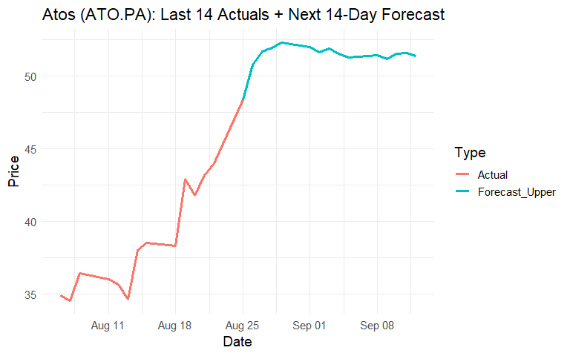

## Median Forecast Graph

This graph shows the median forecast of ATOS SE over the next 14 days with the previous 14 days actuals.

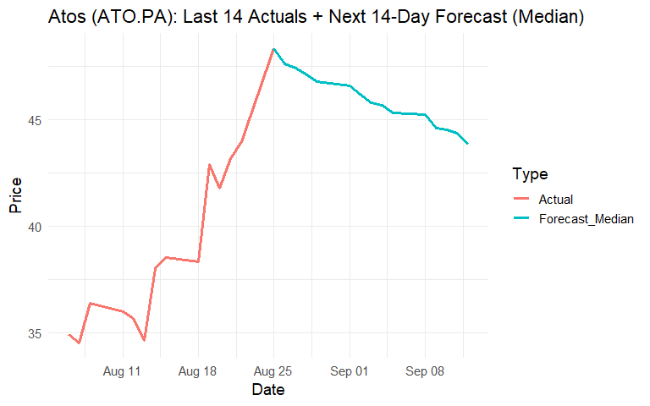

## Lower Forecast Graph

This graph shows the lower forecast of ATOS SE over the next 14 days with the previous 14 days actuals.

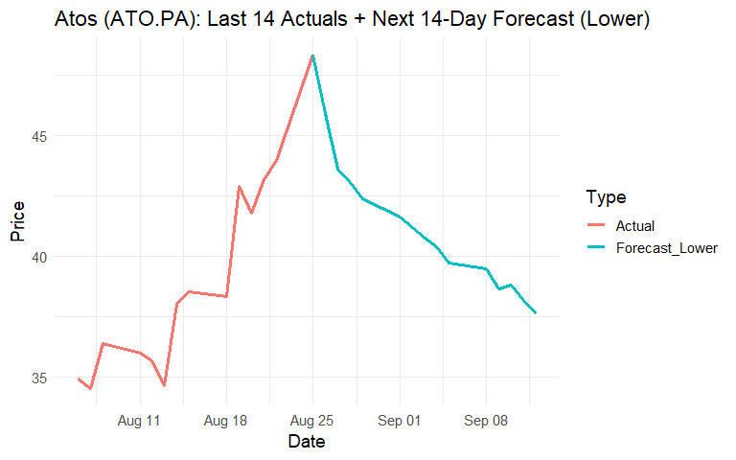

## Differences Actual vs Model

This table shows the difference between actual data vs model data. The data is adjusted as we move forward, so differences in previous rows impacts future differences.

| **Date** | **Median** | **Upper** | **Lower** | **Actual** | **Median_Diff** | **Lower_Diff** | **Upper_Diff** |
| --- | --- | --- | --- | --- | --- | --- | --- |
| 2025-08-25 | 43.6 | 46.2 | 41.8 | 48.3 | -4.8 | -6.6 | -2.2 |
| 2025-08-26 | 47.6 | 50.8 | 45.9 | Not Available | Not Available | Not Available | Not Available |
| 2025-08-27 | 47.4 | 51.7 | 43.6 | Not Available | Not Available | Not Available | Not Available |
| 2025-08-28 | 47.1 | 51.9 | 43.0 | Not Available | Not Available | Not Available | Not Available |
| 2025-08-29 | 46.8 | 52.3 | 42.4 | Not Available | Not Available | Not Available | Not Available |
| 2025-09-01 | 46.6 | 52.0 | 41.6 | Not Available | Not Available | Not Available | Not Available |
| 2025-09-02 | 46.2 | 51.6 | 41.2 | Not Available | Not Available | Not Available | Not Available |
| 2025-09-03 | 45.8 | 51.9 | 40.7 | Not Available | Not Available | Not Available | Not Available |
| 2025-09-04 | 45.7 | 51.5 | 40.4 | Not Available | Not Available | Not Available | Not Available |
| 2025-09-05 | 45.3 | 51.3 | 39.7 | Not Available | Not Available | Not Available | Not Available |
| 2025-09-08 | 45.2 | 51.4 | 39.5 | Not Available | Not Available | Not Available | Not Available |
| 2025-09-09 | 44.6 | 51.1 | 38.6 | Not Available | Not Available | Not Available | Not Available |
| 2025-09-10 | 44.5 | 51.5 | 38.8 | Not Available | Not Available | Not Available | Not Available |
| 2025-09-11 | 44.4 | 51.6 | 38.1 | Not Available | Not Available | Not Available | Not Available |
| 2025-09-12 | 43.8 | 51.4 | 37.6 | Not Available | Not Available | Not Available | Not Available |

## Median Difference Over Time Graph

This graph shows the difference between the median value predicted and the actual result.

## `geom_line()`: Each group consists of only one observation.  
## ℹ Do you need to adjust the group aesthetic?

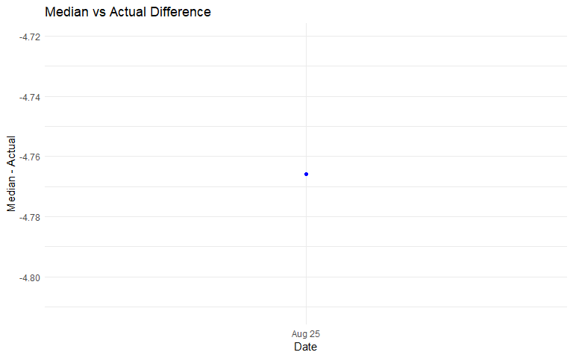

## Lower Difference Over Time Graph

This graph shows the difference between the lower predicted value and the actual result.

## `geom_line()`: Each group consists of only one observation.  
## ℹ Do you need to adjust the group aesthetic?

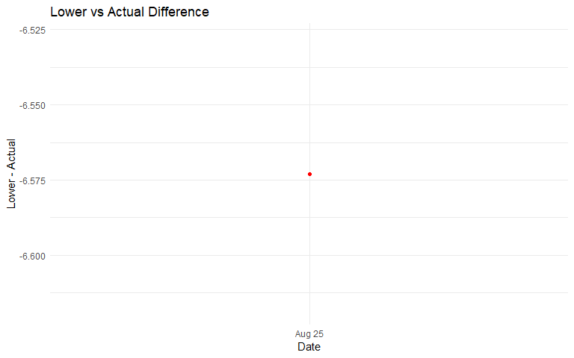

## Upper Difference Over Time Graph

This graph shows the difference between the upper predicted value and the actual result.

## `geom_line()`: Each group consists of only one observation.  
## ℹ Do you need to adjust the group aesthetic?

