ATOS Prediction Report

# ATOS SE Prediction

## Prediction for the next 14 days for ATOS SE

This table shows

| **Day** | **Date** | **Median** | **Lower** | **Upper** |
| --- | --- | --- | --- | --- |
| 1 | 2025-08-28 | 44.79326 | 42.90675 | 47.42325 |
| 2 | 2025-08-29 | 45.05209 | 41.30693 | 49.15782 |
| 3 | 2025-09-01 | 44.78888 | 41.13872 | 48.92381 |
| 4 | 2025-09-02 | 44.43112 | 40.54256 | 49.53469 |
| 5 | 2025-09-03 | 44.51303 | 39.86523 | 49.59308 |
| 6 | 2025-09-04 | 44.23184 | 39.12876 | 49.48389 |
| 7 | 2025-09-05 | 43.96178 | 38.94820 | 49.38198 |
| 8 | 2025-09-08 | 43.64993 | 38.26370 | 49.54560 |
| 9 | 2025-09-09 | 43.23798 | 38.14878 | 48.94527 |
| 10 | 2025-09-10 | 42.88278 | 37.83182 | 49.52850 |
| 11 | 2025-09-11 | 42.63074 | 37.43855 | 49.23507 |
| 12 | 2025-09-12 | 42.50901 | 36.69307 | 48.87230 |
| 13 | 2025-09-15 | 42.09232 | 36.44270 | 48.56647 |
| 14 | 2025-09-16 | 41.82761 | 36.11905 | 48.77690 |

## Upper Forecast Graph

This graph shows the upper forecast of ATOS SE over the next 14 days with the previous 14 days actuals.

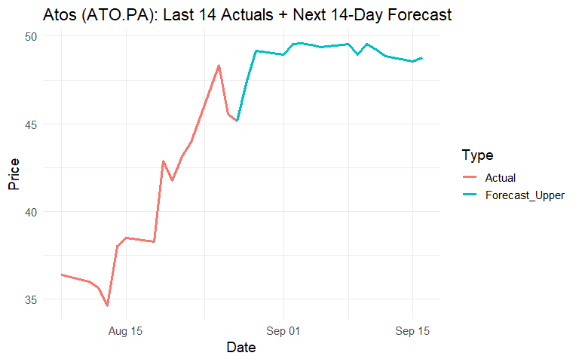

## Median Forecast Graph

This graph shows the median forecast of ATOS SE over the next 14 days with the previous 14 days actuals.

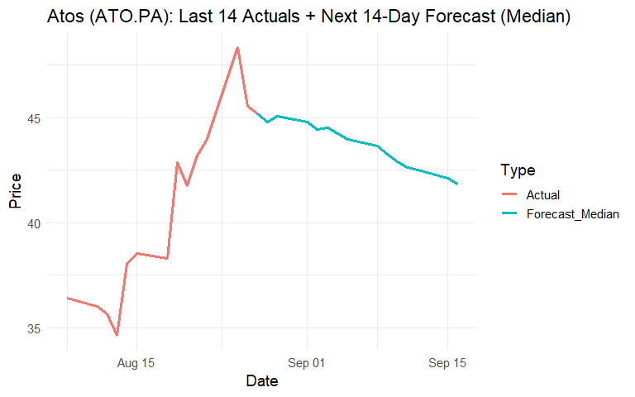

## Lower Forecast Graph

This graph shows the lower forecast of ATOS SE over the next 14 days with the previous 14 days actuals.

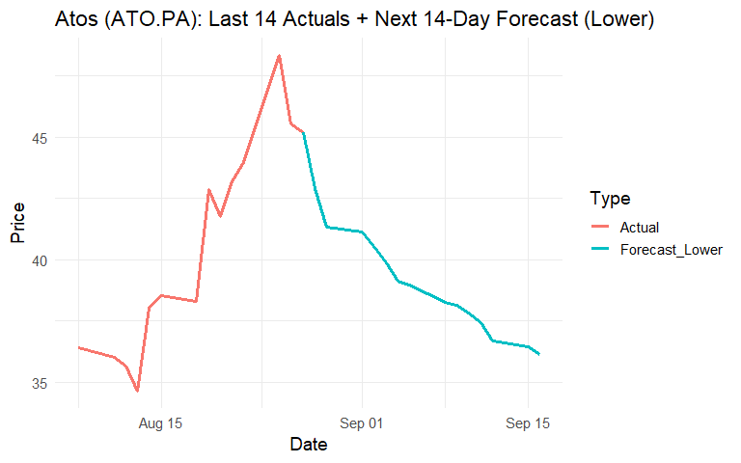

## Differences Actual vs Model

This table shows the difference between actual data vs model data. The data is adjusted as we move forward, so differences in previous rows impacts future differences.

| **Date** | **Median** | **Upper** | **Lower** | **Actual** | **Actual_High** | **Actual_Low** | **Median Residual** | **Low Residual** | **Upper Residual** | **Coverage** | **Weighted_Residual** |
| --- | --- | --- | --- | --- | --- | --- | --- | --- | --- | --- | --- |
| 2025-08-25 | 43.6 | 46.2 | 41.8 | 48.3 | 50.2 | 44.0 | 4.8 | 2.2 | 4.0 | Outside Interval | 4.6 |
| 2025-08-26 | 43.7 | 47.6 | 39.9 | 45.5 | 47.2 | 44.2 | 1.8 | 4.3 | -0.4 | Inside Interval | 2.8 |
| 2025-08-27 | 43.3 | 47.6 | 39.5 | 45.2 | 47.2 | 44.4 | 1.9 | 4.9 | -0.4 | Inside Interval | 3.0 |
| 2025-08-28 | 44.8 | 47.4 | 42.9 | Not Available | Not Available | Not Available | Not Available | Not Available | Not Available | Not Available | Not Available |
| 2025-08-29 | 45.1 | 49.2 | 41.3 | Not Available | Not Available | Not Available | Not Available | Not Available | Not Available | Not Available | Not Available |
| 2025-09-01 | 44.8 | 48.9 | 41.1 | Not Available | Not Available | Not Available | Not Available | Not Available | Not Available | Not Available | Not Available |
| 2025-09-02 | 44.4 | 49.5 | 40.5 | Not Available | Not Available | Not Available | Not Available | Not Available | Not Available | Not Available | Not Available |
| 2025-09-03 | 44.5 | 49.6 | 39.9 | Not Available | Not Available | Not Available | Not Available | Not Available | Not Available | Not Available | Not Available |
| 2025-09-04 | 44.2 | 49.5 | 39.1 | Not Available | Not Available | Not Available | Not Available | Not Available | Not Available | Not Available | Not Available |
| 2025-09-05 | 44.0 | 49.4 | 38.9 | Not Available | Not Available | Not Available | Not Available | Not Available | Not Available | Not Available | Not Available |
| 2025-09-08 | 43.6 | 49.5 | 38.3 | Not Available | Not Available | Not Available | Not Available | Not Available | Not Available | Not Available | Not Available |
| 2025-09-09 | 43.2 | 48.9 | 38.1 | Not Available | Not Available | Not Available | Not Available | Not Available | Not Available | Not Available | Not Available |
| 2025-09-10 | 42.9 | 49.5 | 37.8 | Not Available | Not Available | Not Available | Not Available | Not Available | Not Available | Not Available | Not Available |
| 2025-09-11 | 42.6 | 49.2 | 37.4 | Not Available | Not Available | Not Available | Not Available | Not Available | Not Available | Not Available | Not Available |
| 2025-09-12 | 42.5 | 48.9 | 36.7 | Not Available | Not Available | Not Available | Not Available | Not Available | Not Available | Not Available | Not Available |
| 2025-09-15 | 42.1 | 48.6 | 36.4 | Not Available | Not Available | Not Available | Not Available | Not Available | Not Available | Not Available | Not Available |
| 2025-09-16 | 41.8 | 48.8 | 36.1 | Not Available | Not Available | Not Available | Not Available | Not Available | Not Available | Not Available | Not Available |