RoamReady — Journal & Travel Map
Feature Scope & Data Model (Parked for a Future Coding Session)
Status: Scoped, not built. Post-launch backlog.
Drafted: June 4, 2026

Contents

1. The Concept
Two emotionally sticky features that share one underlying dataset: places this user has actually been.

Journal
Move journaling out of the trip silo and make each entry a first-class, searchable object. An entry can link to a trip and/or a stop, or stand completely alone (a pure road/day reflection). The journal gets its own tab — a "remember & relive" surface, distinct from the "discover & plan" Resources surface.

Travel Map
Two views rendered from the same place-level data:
- States map — a filled-in (choropleth) US map showing visited vs. missing states, with a "37 of 50" counter. This is the headline hook: instant dopamine, works for every user, and quietly drives future trips ("you've never been to the Dakotas").
- Journal map — pins for every place the user has written about, a memory-lane layer toggled on top of the states map.
Design principle: build the data once, render it twice. Lead with the states map; journal pins are a layer on top.

2. Decisions to Lock Before Building
- Entries can stand alone. Linking to a trip/stop is optional, not required — otherwise you lose the "the road through the Rockies was unreal today" entry.
- "Visited" definition. Stopped overnight = solid fill; passed through = striped/light fill. Give the user control. This detail signals you get the culture (RVers argue about this constantly).
- States auto-populate from completed trips, not just from journal entries — so the map fills in just from traveling with RoamReady, whether or not they journal.
- Search is structured-fields-first. Postgres full-text (tsvector) over the body, riding on top of structured columns (state, type, rating). No separate search service needed.

3. Data Model
New Prisma models plus a lightweight derived rollup. Field names align to existing RoamReady conventions (cuid IDs, camelCase, explicit relations).

3.1 JournalEntry
model JournalEntry {
id String @id @default(cuid())
userId String
user User @relation(fields: [userId], references: [id], onDelete: Cascade)

// Optional links — entry can stand alone
tripId String?
trip Trip? @relation(fields: [tripId], references: [id], onDelete: SetNull)
stopId String?
stop Stop? @relation(fields: [stopId], references: [id], onDelete: SetNull)

// Content
title String?
body String // freeform text
rating Int? // 1-5 or thumbs (-1/0/1) — pick one, document it
tags String[] // ["campground","scenic-drive","restaurant","would-return"]

// Captured/derived metadata (denormalized for search + map)
entryDate DateTime // when it happened (user-editable, defaults now)
state String? // 2-letter, resolved from stop or manual
lat Float?
lng Float?
placeName String?

createdAt DateTime @default(now())
updatedAt DateTime @updatedAt

@@index([userId, entryDate])
@@index([userId, state])
@@index([tripId])
@@index([stopId])
}

3.2 Field reference
Field | Type | Notes
userId | String | Owner. Entry lives at the user level, not the trip level.
tripId / stopId | String? | Optional links. onDelete: SetNull keeps the entry alive if the trip/stop is deleted.
body | String | The freeform text. Drives full-text search.
rating | Int? | Liked / didn't like. Decide thumbs vs. 1-5 and stick to it.
tags | String[] | Powers "restaurant I loved" type filters. Suggest a starter set.
entryDate | DateTime | User-editable. The diary feed sorts on this, not createdAt.
state | String? | 2-letter. Denormalized so state filtering doesn't require a join.
lat/lng/placeName | Float?/String? | Denormalized from stop (or manual) so map pins render without joins.

3.3 Visited-states rollup
Two options — start with the derived query, add the cache table only if performance demands it.
Option A (recommended to start): derive on read. Query distinct states from completed-trip stops + standalone journal entries. Simple, always correct, no sync logic.
// Pseudo-query: states this user has touched
// from completed trips' stops + any journal entry with a state
SELECT DISTINCT state FROM (
SELECT s.state, 'overnight' AS visitType
FROM "Stop" s JOIN "Trip" t ON s."tripId" = t.id
WHERE t."userId" = $1 AND t.status = 'COMPLETED'
UNION
SELECT je.state, 'journal' FROM "JournalEntry" je WHERE je."userId" = $1
) q WHERE state IS NOT NULL;
Option B (later, if needed): VisitedState cache table. Materialize the rollup with visitType so the map renders instantly and stores the overnight-vs-passthrough distinction explicitly.
model VisitedState {
id String @id @default(cuid())
userId String
state String // 2-letter
visitType String // "overnight" | "passthrough"
firstSeen DateTime
lastSeen DateTime
user User @relation(fields: [userId], references: [id], onDelete: Cascade)
@@unique([userId, state])
@@index([userId])
}

4. Search & Findability
The whole point: "that RV park in Texas," "the highway I commented on," "the restaurant I loved" must be findable years later. Structured columns do the heavy lifting; full-text catches the rest.
User wants to find… | How it resolves
"RV park in Texas" | state = 'TX' + tag = 'campground', then skim
"Restaurant I loved" | tag = 'restaurant' + rating filter (high)
"Highway I commented on" | full-text match on body
"Everywhere in 2024" | entryDate range filter
"Places I'd return to" | tag = 'would-return' (or rating threshold)
Implementation: add a generated tsvector column over body (+ title, placeName) with a GIN index. Prisma doesn't manage tsvector natively, so add it via a raw migration.
-- raw migration
ALTER TABLE "JournalEntry"
ADD COLUMN search_tsv tsvector
GENERATED ALWAYS AS (
to_tsvector('english',
coalesce(title,'') || ' ' ||
coalesce(body,'') || ' ' ||
coalesce("placeName",''))
) STORED;

CREATE INDEX journal_search_idx
ON "JournalEntry" USING GIN (search_tsv);

5. UI Surfaces
- Journal tab — feed. Reverse-chronological diary view. Filters: state, trip, tag, rating + a search box.
- Journal tab — map layer. Toggle pins for every entry with coordinates on top of the states map.
- Travel Map — states. Choropleth US map, visited (solid) vs passthrough (striped) vs missing, with the "37 of 50" counter. The screenshot-and-share moment.
- Entry composer. Freeform body first; optional "attach to a place / trip" and tags below. Design the standalone empty state and an "attach later" flow.
- Stop detail (existing). Existing per-place comments become JournalEntry rows pre-linked to that stop — backfill path, not a separate system.

6. Suggested Build Sequence
- JournalEntry model + migration; backfill existing per-stop comments into it.
- CRUD endpoints (hardened: Zod .strict() + validateBody, matching Tier-1 pattern).
- Journal feed UI (list + filters), no map yet.
- tsvector column + search.
- Visited-states derived query + choropleth map (the headline).
- Journal pin layer on the map.
- VisitedState cache table only if the derived query is slow at scale.

7. Open Questions to Resolve Later
- Rating model: thumbs vs. 1-5 stars?
- Pro-gated or free? (A 10-year travel map is a strong retention/Pro hook.)
- Choropleth library/approach for the US map (and do we want Canadian provinces for snowbirds crossing the border?).
- Photos in journal entries — in scope for v1 or a later wave? (Storage + cost implications.)
- Sharing: public read-only travel map, reusing the existing Share Trip token pattern?

8. Mockups
Interactive mockups built during the June 4 brainstorm. Two directions were explored for the visited-states map. The geographic version below is the recommended direction.

8.1 Geographic choropleth (recommended)
Real US state outlines, projected with an Albers conic projection and Alaska/Hawaii inset into the lower-left like a standard US map. Solid RV Blue marks overnight stays, the diagonal stripe marks pass-through states, pale gray is not-yet. Tapping a state cycles it through the three statuses; the headline counter reads “27 of 50.” This version triggers the “sticker map” recognition instantly — you can read someone’s travel life from the shape of the fill (a Western roamer who hasn’t cracked the Northeast or Upper Midwest, in the sample data).
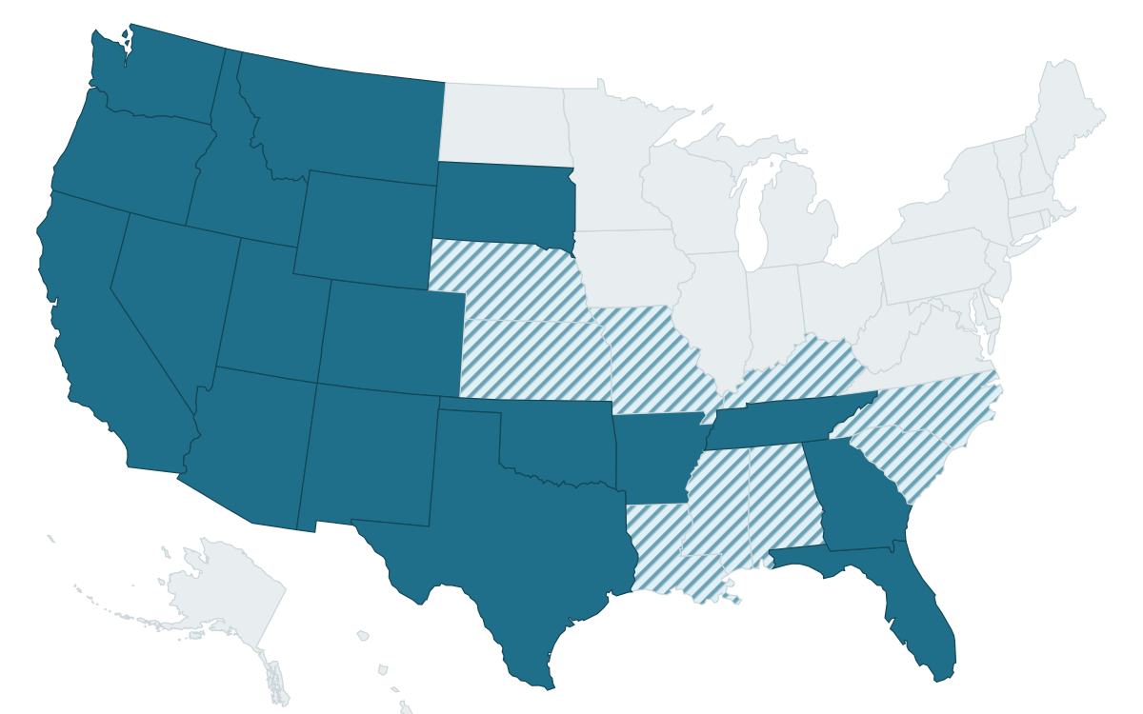
Geographic mockup — sample data, 27 of 50 states. Live file: TravelMapFinal.jsx

8.2 Tile-grid alternative
A “tile grid” version renders each state as an equal-sized rounded square in roughly its real position. Upside: every state stays tappable regardless of size, so Rhode Island and Delaware don’t vanish on mobile. Downside: it loses the emotional sticker-map recognition that the geographic shape delivers. Worth keeping as a fallback or a compact-view toggle, but not the primary. Live file: TravelMapMockup.jsx

8.3 Implementation notes from the mockup
- Bundle the geometry locally. The first build fetched the US outline from a CDN at runtime and failed in sandboxed previews. Ship the TopoJSON (or pre-projected SVG paths) bundled in the app so the map renders instantly and works offline — this is the same lazy-load/bundling discipline already noted for @react-pdf/renderer.
- Tiny states need a tap target. On the geographic map, the Northeast states are hard to tap on mobile. Usual fix: a small clickable dot or a list toggle for the dense Northeast cluster.
- Pine stays reserved. The mockup uses RV Blue for the “visited” fill, not Pine — Pine #3E5540 remains reserved exclusively for booked/confirmed status per the locked design system.

9. Agreed Design (June 4) — Locked
This is the placement and layout decided in the June 4 session. It supersedes the earlier “dedicated Journal tab” thinking in Section 5 — no fifth bottom-nav tab is added.

9.1 Placement
- Journal is a filter pill on the Dashboard. It joins the existing filter row (In Progress · Completed · All · Reservations · Journal). Tapping it swaps the trip-card list for the Journal view, exactly the way Reservations already swaps the list. Everything above the row — brand bar, Pro banner, “Good morning” greeting, Plan-a-new-trip — stays put. No new navigation paradigm; one pill added to a control that already does this job.
- Writing still happens inside a trip. Per-stop feedback prompts plus a “+ Add a freeform journal entry” button live inside each trip; everything written there flows up into the Dashboard Journal view automatically.

9.2 The Journal view (top to bottom)
- Count line + Add entry. “148 entries · 27 states · 9 trips” with a “+ Add entry” button for standalone (trip-less) entries.
- Expandable map banner (“Where we’ve been”). The states choropleth sits at the top of the Journal view as a collapsible header showing the “X of 50 states” counter. Default expanded on first visit so users discover it; remember the user’s collapse preference on return. Overnight = solid RV Blue, passed-through = striped, not-yet = pale gray.
- Search + sort/filter. Search box (“that RV park in Texas”) plus filter chips: All · By trip · By state · Campgrounds · Loved. Structured-fields-first search per Section 4.
- Entry feed. Grouped by trip, with a “General” group for standalone entries. Per-stop entries carry a blue left-edge; freeform entries a gold left-edge with a pencil marker. Cards show state badge, tags, rating, and date. The reserved Pine color appears only on a BOOKED badge.

9.3 The screen
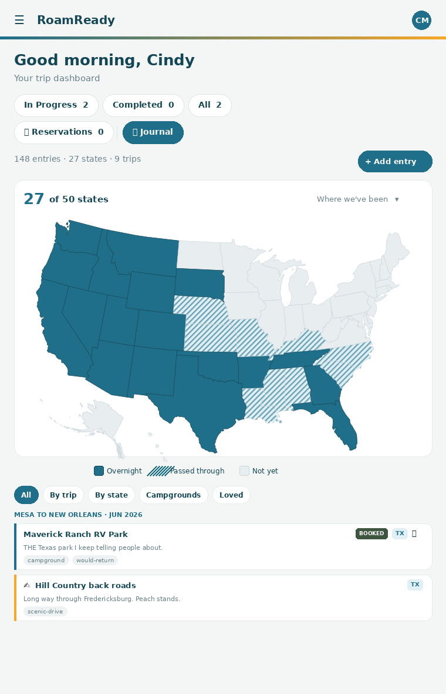
Dashboard › Journal: expandable map banner over the searchable entry feed. Live file: JournalWithMap.jsx

