|  |
| --- |
| **CSCI 3901 - Project** |
| Milestone 1 |
| **Name: Benny Daniel Tharigopala**  **Banner ID: B00899629** |
|  |

# **Project Objective**

The problem at hand is relevant to Genealogy, which is the study of families, family history, and the tracing of their lineages [1]. The project’s problem statement composes of multiple sub-problems, as follows:

1. Input details of individuals and their attributes, Example: Gender.
2. Develop a Family Tree based on user’s input.
3. Compute the relationship between members of a family tree
4. Maintain an archive of media files. The archive contains metadata information and not the actual files themselves.
5. Establish relationships between media files and individuals who belong in a Family Tree.
6. Given a piece of information, relevant to either files in the media archive or individuals in a Family Tree, report the required set of information to the user.

Upon analysis of the problem statements, my observations are as follows. There’re two primary entities in the problem. Individuals (Persons) and Media Files. All operations in the project surround these entities.

# **Problem Analysis**

1. **Input to Program:**
2. Names of individuals
3. Attributes of individuals (Example: Gender & Occupation)
4. Source reference materials for individuals
5. Notes for individuals
6. Location of a media file in a central hard drive
7. Attributes of media files (Example: Year the file was created)
8. Media File identifiers used to uniquely identify files
9. Tags for media files
10. **Transformations to Data:**

No transformations required.

1. **Immediately Processed Data:**

None

1. **Stored Data:**
   1. Information on individuals in a family tree (Name, Attributes, References and Notes)
   2. Information on relations between individuals (Parent – Child / Partner)
   3. Media Files
   4. Information related to the media files stored in a database (Attributes & Tags)
   5. Relations between media files and individuals who appear in the files
2. **Output:**
   1. An individual’s name
   2. A media file’s name
   3. Degree of Cousinship and Removal between two individuals
   4. Ancestors and descendants of an individual
   5. Notes & References relevant to an individual
   6. Media File Identifier(s)
3. **Assumptions:**
   1. An individual’s name contains only alphabets (No Numeric characters and symbols).
   2. Only the location to media files will be stored and not the actual files themselves.
   3. In this project, an individual’s immediate family refers to, **only,** the individual’s immediate children.
   4. No two media files can have the same name or identifier
   5. Dates entered are in the format - **MM/DD/YYYY**
   6. After symmetric dissolution of a partnering relation, the descendants of the individuals involved in the relation are still part of the family tree.
   7. Since we deal with only biological family relations, immediate children related through a partnering relation (but without biological connection to a person) will not be considered the descendants of the person.
4. **Constraints:**

Only biological family relations are considered in this project.

1. **Unique Case(s):**
   1. An individual has multiple partnering relations.

# **Class Diagram**

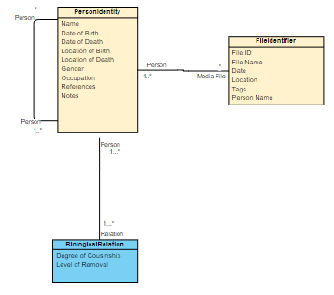

# **Citations**

1. <https://en.wikipedia.org/wiki/Genealogy>