Final Examination
Introduction to Massive Data Analysis Dec. 4, 2019
- (12%) Yes/no questions. You don’t have to justify the answers.
- PCY can handle some data sets without thrashing during the first pass, while A-Priori would run out of main memory and thrash.
- One way to measure the similarity of nodes in a graph with several types of nodes is to start a random walker at one node and allow it to wander, with a ﬁxed probability of restarting at every node.
- The key to understanding what SVD oﬀers is in viewing the r columns of U, Σ, and V as representing concepts that are hidden in the original matrix M.
- PageRank π is the stationary distribution of the Markov chain M i.e. Mπ = π and $\sum_{i}{π_{i}}$= 1.
- (8%) Prove that Pr[h_{π}(C₁) = h_{π}(C₂)] = sim(C₁, C₂), the probability that the minhash function for a random permutation π of rows produces the same value for two sets equals the Jaccard similarity of those sets.
- (8%) Consider a Web site gathering statistics on how many unique users it has seen in each given month. The universal set is the set of logins for that site, and a stream element is generated each time someone logs in. The Flajolet-Martin algorithm can solve this problem if we do not have enough space to maintain the set of elements seen so far. Briefly describe the Flajolet-Martin algorithm and show how it works.
- (4%) In the block-stripe parallel implementation of PageRank, show that the computational cost per iteration of Power method is |M|(1+ε) + (k+1)|r|, where k is the number of block.
- (10%) In the general case, the worst competitive ratio of the BALANCE (many bidders) on-line algorithm is 1–1/e ≈ 0.63.
- (3%) Gives the worst case example with N advertisers of the same budget B, and NB queries in N rounds.
- (7%) Show that the revenue of BALANCE is BN(1–1/e), and thus the competitive ratio is 1–1/e.
- (8%) Here is a collection of twelve baskets. Each contains three of the six items 1 through 6.
{1, 2, 3} {2, 3, 4} {3, 4, 5} {4, 5, 6}
{1, 3, 5} {2, 4, 6} {1, 3, 4} {2, 4, 5}
{3, 5, 6} {1, 2, 4} {2, 3, 5} {3, 4, 6}
Suppose the support threshold is 4. On the first pass of the PCY Algorithm we use a hash table with 11 buckets, and the set {i, j} is hashed to bucket i×j mod 11.
(a) By any method, compute the support for each item and each pair of items.
(b) Which pairs hash to which buckets?
(c) Which buckets are frequent?
(d) Which pairs are counted on the second pass of the PCY Algorithm?
- (8%) In the demonstrative example of LSH for Min-Hash, we divide matrix M into 20 bands of 5 rows. If we had only 15 bands of 5 rows, show that the number of false positives would go down, but the number of false negatives would go up.
- (10%) A demonstrated example of the simple DGIM algorithm is shown in the following figure. Consider k = 10. Then the query asks for the number of 1’s in the ten rightmost bits, which happen to be 0110010110. Let the current timestamp (time of the rightmost bit) be t. Then the two buckets with one 1, having timestamps t − 1 and t − 2 are completely included in the answer. However, the rightmost bucket of size 4, with timestamp t−8 is only partly included. DGIM estimate of the number of 1’s in the last ten positions is thus 6. Of course the correct answer is 5.
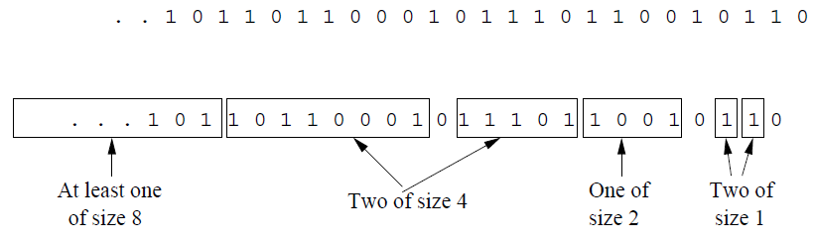
  - (5%) Show that DGIM requires O(log²N) bits to represent a window of N bits.
  - (5%) The estimation error of the simple DGIM is no more than 50%, why?
- (8%) A Bloom filter consists of (i) an array B of n bits, initially all 0’s; (ii) a collection of k hash functions h₁, h₂, . . . , h_{k}. Each hash function maps “key” values to n buckets, corresponding to the n bits of B; (iii) a set S of m key values. The purpose of the Bloom filter is to allow through all stream elements whose keys are in S, while rejecting most of the stream elements whose keys are not in S.
- (2%) Why the Bloom filters guarantee no false negatives?
- (6%) Calculate the probability of false positive rate of Bloom Filter with m keys, n bits, and k hash functions, and determine the optimal k.
- (8%) A market-basket data set has 1 million baskets, each of which has 10 items that are chosen from a set of 100,000 diﬀerent items (not all of which necessarily appear in even one basket). Suppose the support threshold is 100.
- (4%) What are the minimum and maximum numbers of frequent items? Explain your reasoning.
- (4%) What are the minimum and maximum numbers of frequent pairs? Explain your reasoning.
- (8%) Suppose we apply the BALANCE algorithm with bids of 0 or 1 only, to a situation where advertiser A bids on query words x and y, while advertiser B bids on query words x and z. Both have a budget of $2. Identify the sequences of queries that will certainly be handled optimally by the algorithm, and provide a one line explanation.
(a) (2%) yzyy (b) (2%) xyzx (c) (2%) xyyy (d) (2%) xyxz
- (10%)
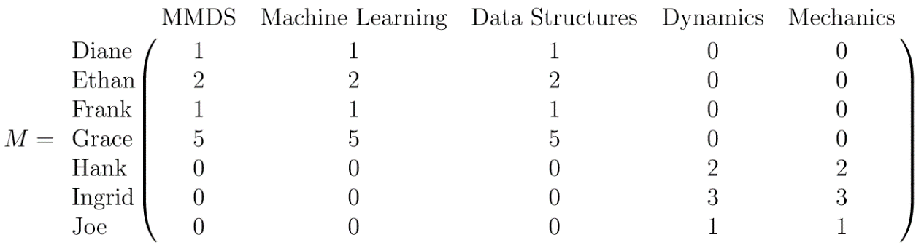
Matrix M represents the ratings of Engineering courses taken by Stanford students. Each row of M represents the given student’s set of ratings and the columns of M represent the classes. The labels for students and classes are provided along each row and column. An entry M_{ij} in M represents the student i’s rating for class j. Now, the SVD decomposition of matrix M is found to be as follows:
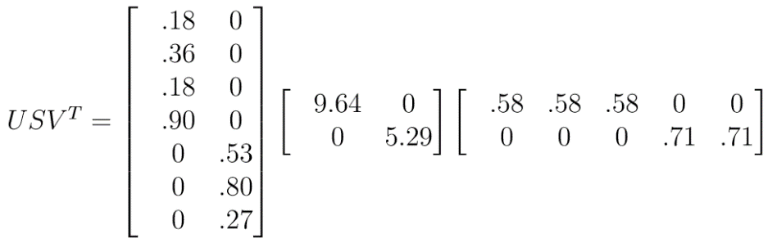
It’s pretty clear that there are two concepts of classes here: the ﬁrst three are Computer Science classes while the last two are Mechanical Engineering classes.
Suppose a new student named Tony has the following reviews: 4 for Machine Learning, 5 for Data Structures, and 2 for Dynamics. This gives a representation of Tony in the class space as [0 4 5 2 0].
  - (5%) What is the representation of Tony in the concept space?
  - (5%) Explain what this representation predicts about how much Tony would like the two remaining classes that he has not reviewed (MMDS and Mechanics).
- (6%) Suppose we are given a matrix R of recommendations. The element R_{iu} of this matrix corresponds to the rating given by user u to item i. The size of R is m×n, where m is the number of movies, and n the numbers of users. Most of the elements of the matrix are unknown because each user can only rate a few movies. Our goal is to find two matrices P and Q, such that $R≈QP^{T}$. The dimensions of Q are m×k, and the dimensions of P are n×k. k is a parameter of the algorithm. We define the error as
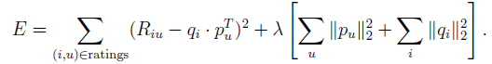
Let ε_{iu} denote the derivative of the error E with respect to R_{iu}. What is the expression for ε_{iu}? What are the update equations for q_{i} and p_{u} in the Stochastic Gradient Decent Algorithm?
- (12%) One of the most common and effective organizations for a link farm is shown below:

  - (4%) Let x denote the PageRank contributed by accessible pages and y be the PageRank of target page t. And rank of each “farm” page is $\frac{βy}{M}+\frac{1-β}{N}.$ Show that $y= \frac{βy}{1-β^{2}}+c\frac{M}{N},$ where $c= \frac{β}{1-β}$.
  - (8%) Suppose two spam farmers agree to link their spam farms. How would you link the pages in order to increase as much as possible the PageRank of each spam farm’s target page? One way of doing it is just having all boosting pages point to both of the targets, as presented in left figure. Another way of connecting the two target pages and removing all links, as shown in the right figure. Which one performs better? Explain your reason with some calculations as stated by (a).
