**Lab02 FPGA Emulation**

**106061218 Cheng-En Lee**

**1. Emulate the full adder.**

**Design Specification**

The idea of this experiment is 100% as same as that in lab 01. So I’ll skip the details of logic diagram.

(1) Input: x, y, cin.

(2) Output: cout, s.

(3) Block diagram:

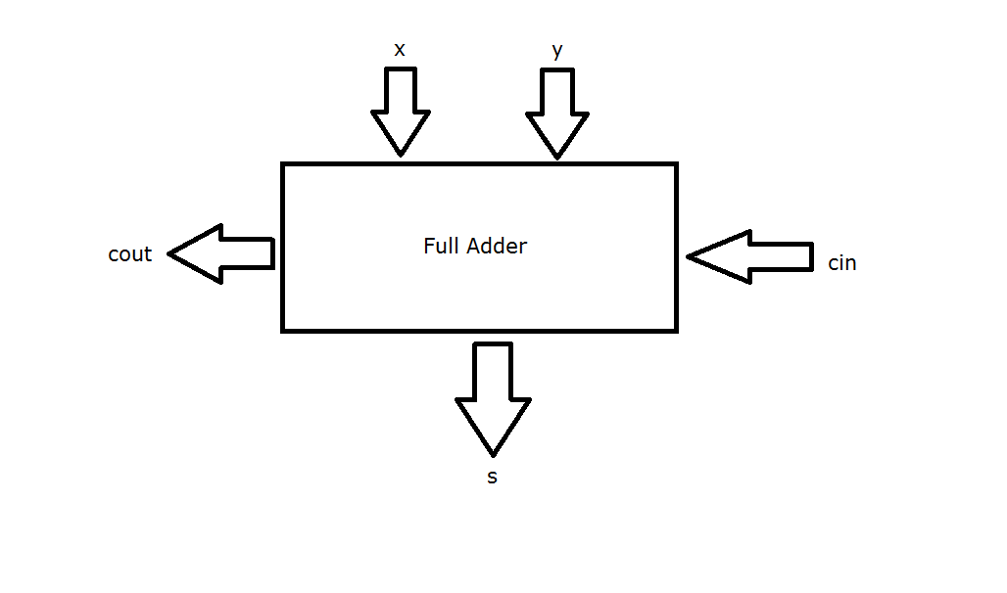

**Design Implementation**

(1) Logic function:

s = x^y^cin;

cout = (x&y) | (cin&(x^y));

(2) pins

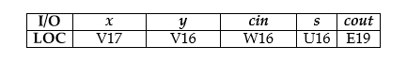

**2. Seven-segment display decoder**

**Design Specification**

(1) input:

bin [3:0] (The binary number input.)

(2) output:

segs [7:0] (Each segments of a single digit of 7-segment display.)

ssd_ctl [3:0] (Four digits of 7-segment display.)

d[3:0] (LEDs)

Since bin [3:0] is same as d[3:0], I’ll skip them in the following diagrams.

(3) block diagram

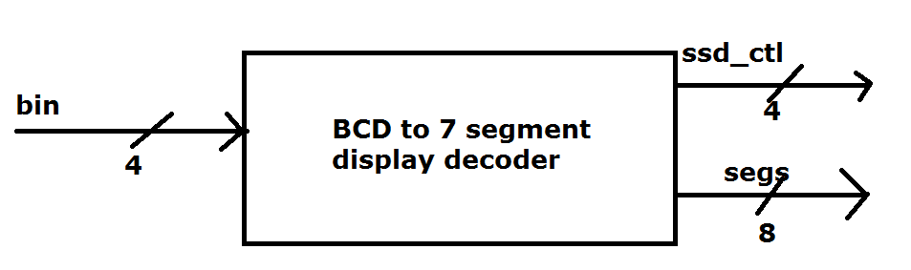

**Design Implementation**

We can regard this decoder as a MUX with default. The BCD - 7 segment display comparison table is showed as follow:

|  |  |  |
| --- | --- | --- |
| Decimal (SS_X) | BCD | 7-SD |
| 0 | 0000 | 00000011 |
| 1 | 0001 | 10001111 |
| 2 | 0010 | 00100101 |
| 3 | 0011 | 00001101 |
| 4 | 0100 | 10011001 |
| 5 | 0101 | 01001001 |
| 6 | 0110 | 01000001 |
| 7 | 0111 | 00011111 |
| 8 | 1000 | 00000001 |
| 9 | 1001 | 00001001 |
| (default) | 1010 | 00000001 |

In addition, the logic diagram shows more detail:

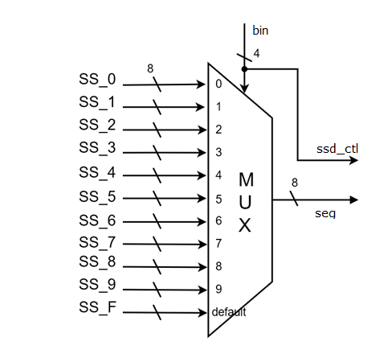

**Discussion**

(1) Adder

x = 0, y = 1, cin = 1 cin = x = y = 1

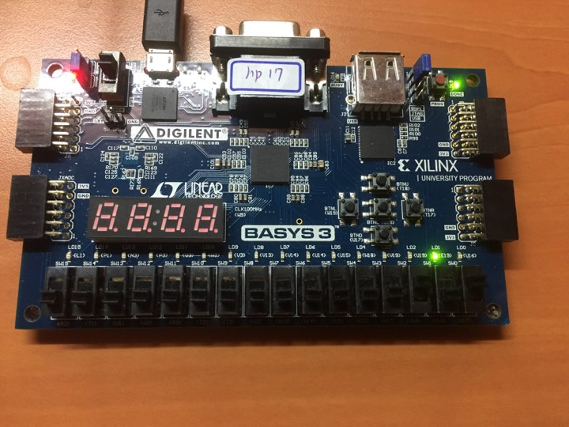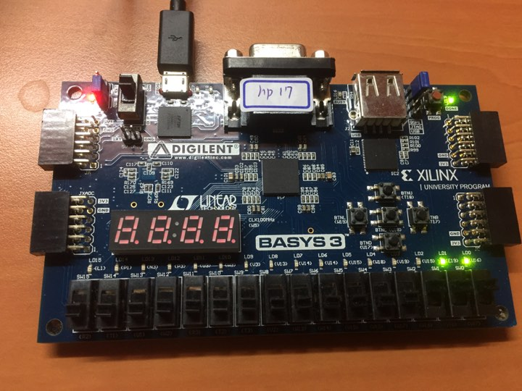

(2) 7-segment display

9487F

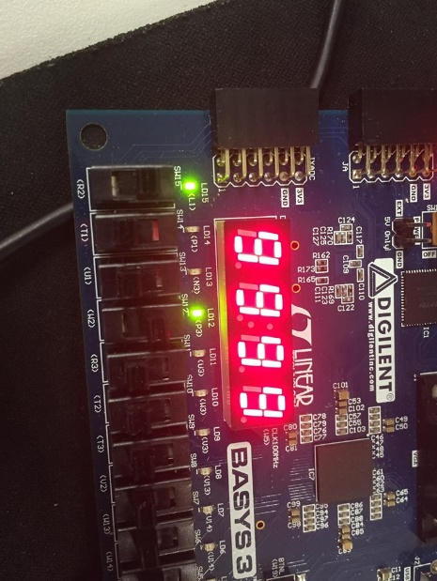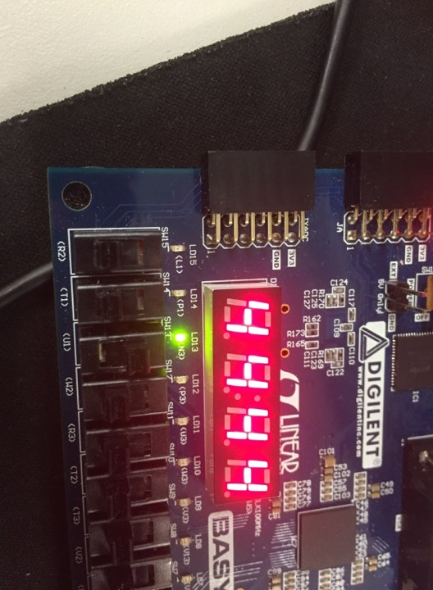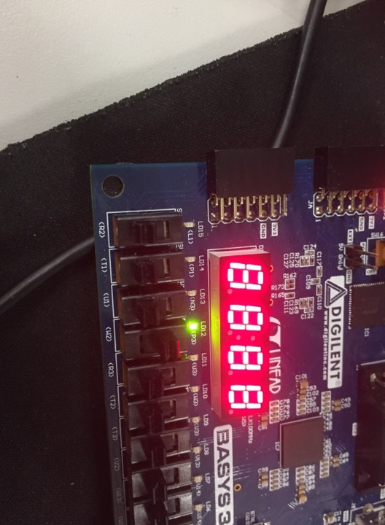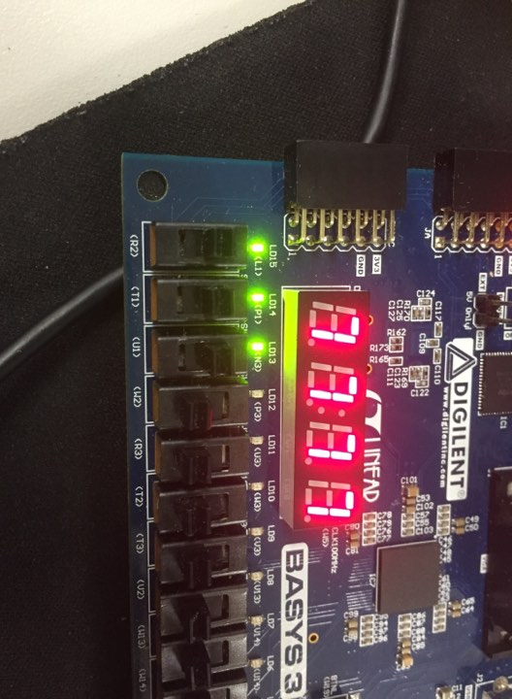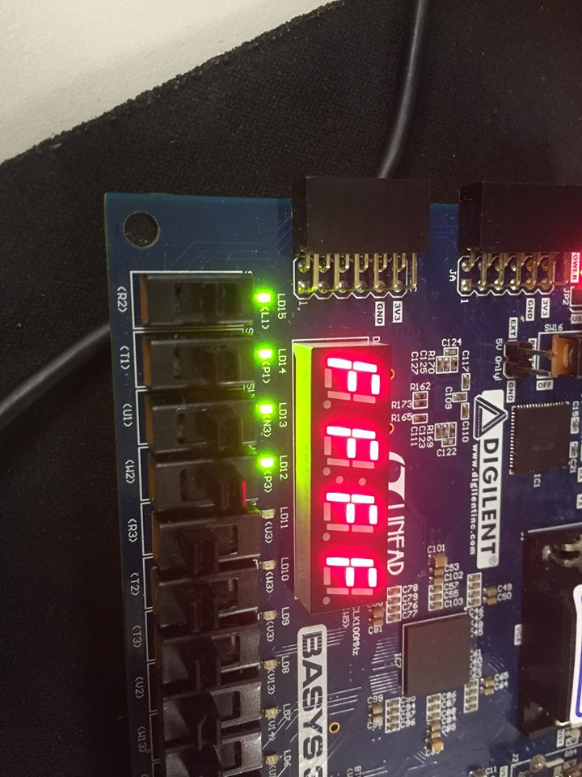

**Conclusion**

Be careful when you’re connecting the pins. It is easy-neglected but critical and could cause bugs.

The most important thing is that this is the first lab which has two modules. The lecturer told us that it is better to have only one module in one file. Otherwise, it will be time-wasting finding the modules you’ve typed. Also, it’s more easier to copy the codes or .v files when you have another project which is needed the same logic functions.

**References**

Hang-outs in class.