**Remotely sensed tree height and density explain global gliding vertebrate richness**

**Appendix S1: Supplementary Figures and Data Sources**

Running title: Global patterns of gliding vertebrates

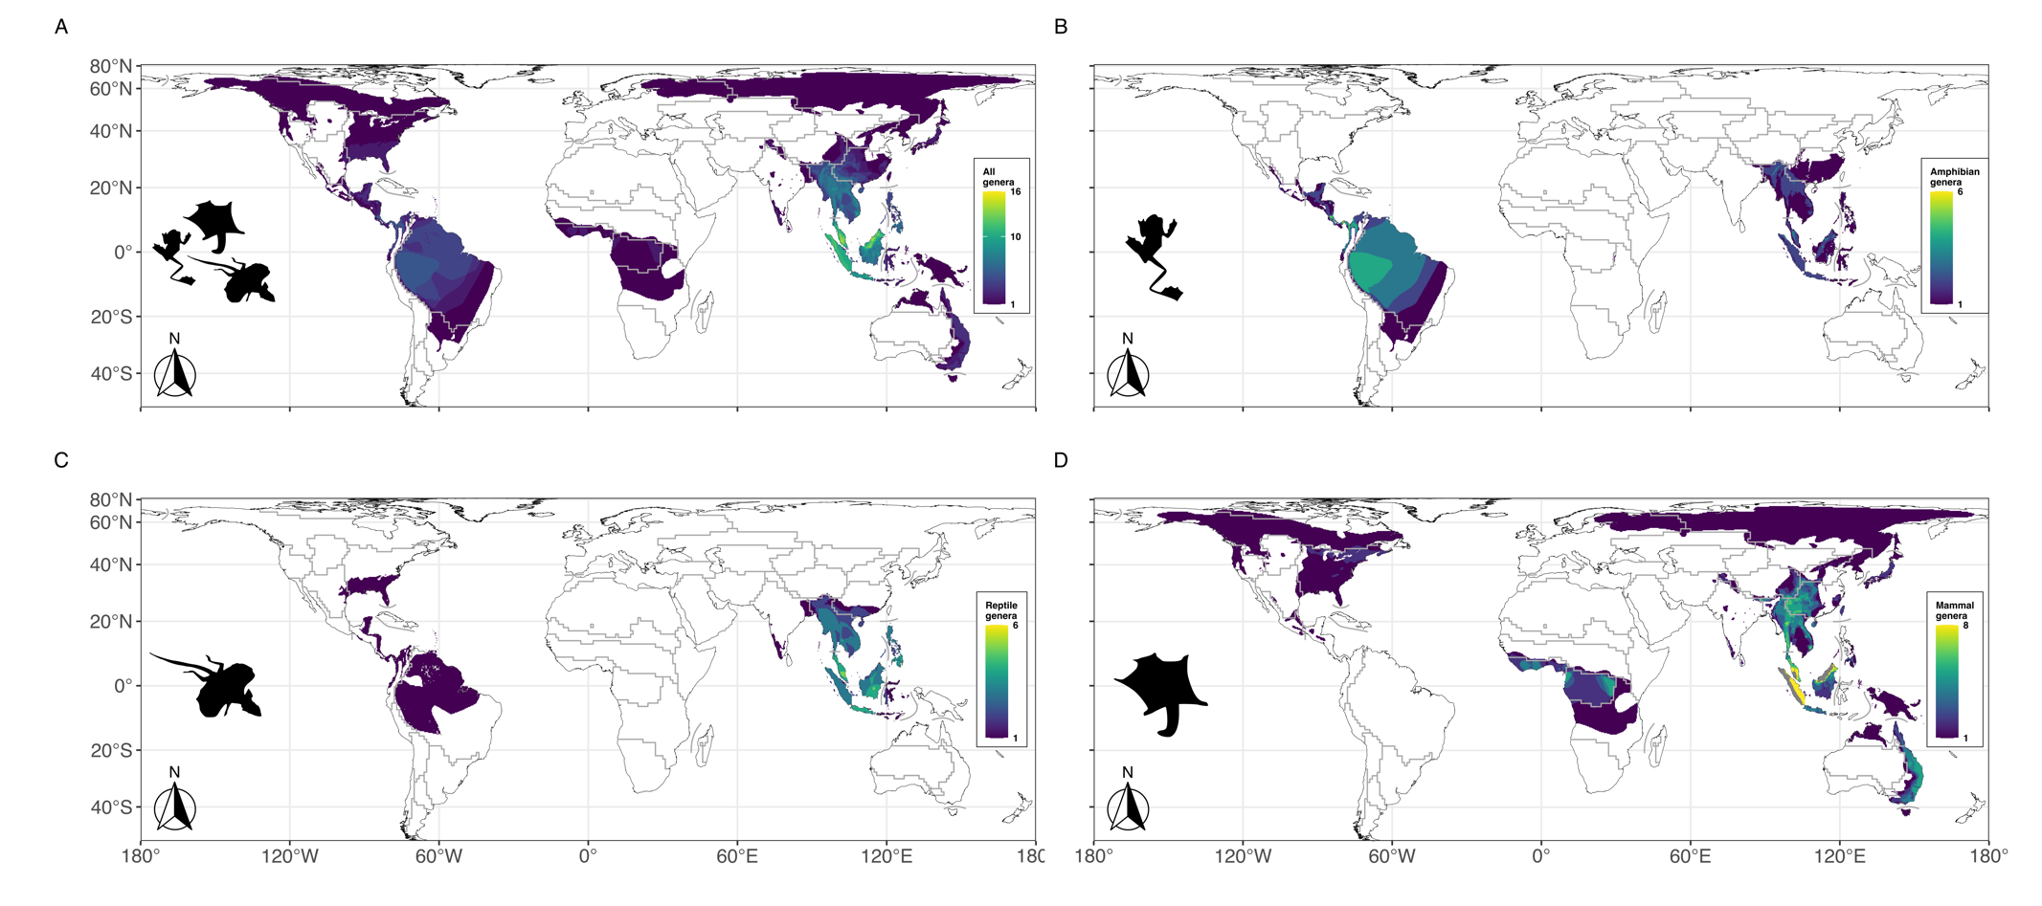

Figure S1. Global **genus** richness and distribution of all gliding vertebrates combined (A) and separated by class (B-D). Grey lines indicate biogeographical region borders according to Kreft and Jetz (2010).

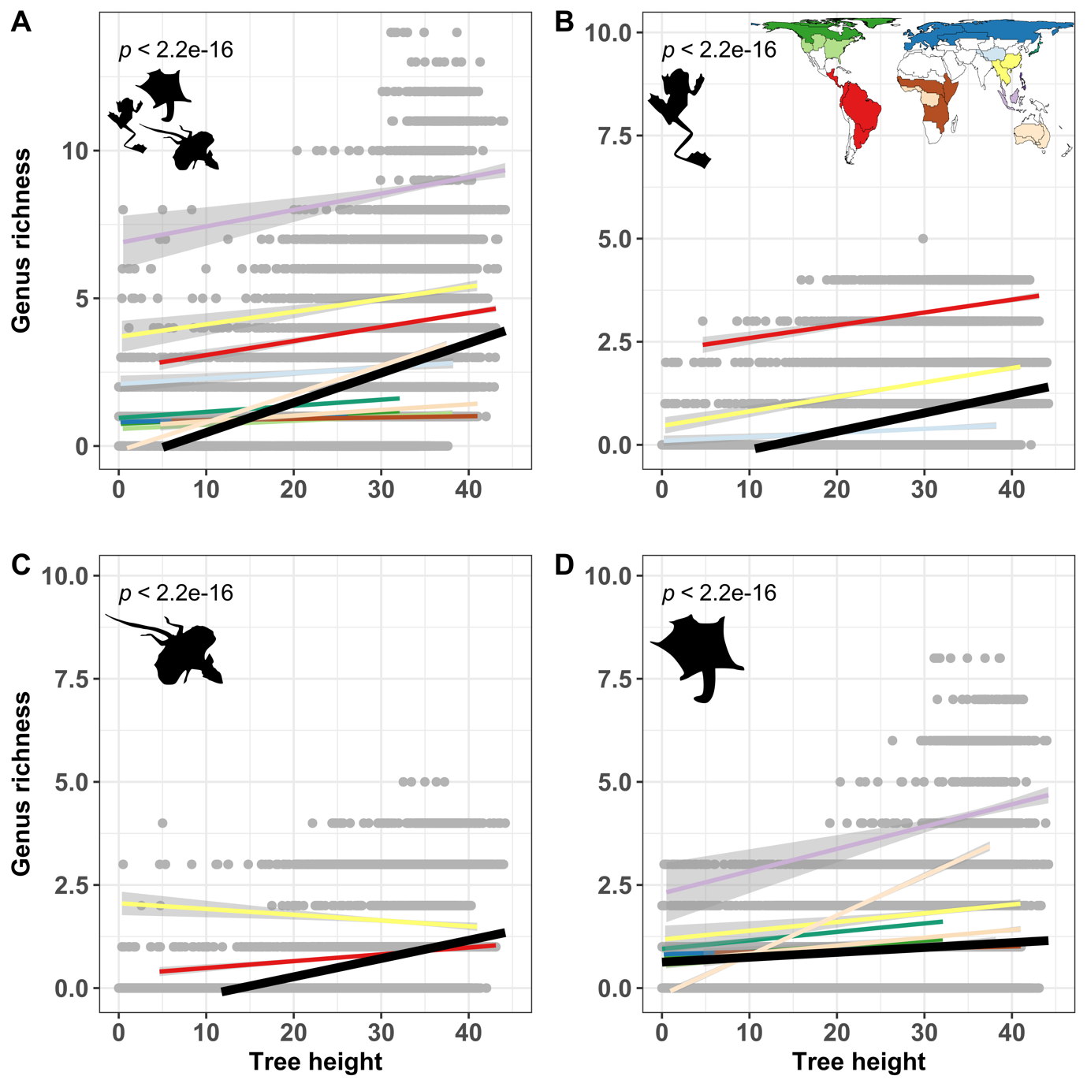

Figure S2. Relationship between tree height and **genus** richness for all gliding vertebrate **genera** (A) and separate classes (B-D). Black lines illustrate linear regressions for all species pooled together. Regressions for separate biogeographic regions (coloured lines, see map in top right corner as legend) were only considered when they were significant.

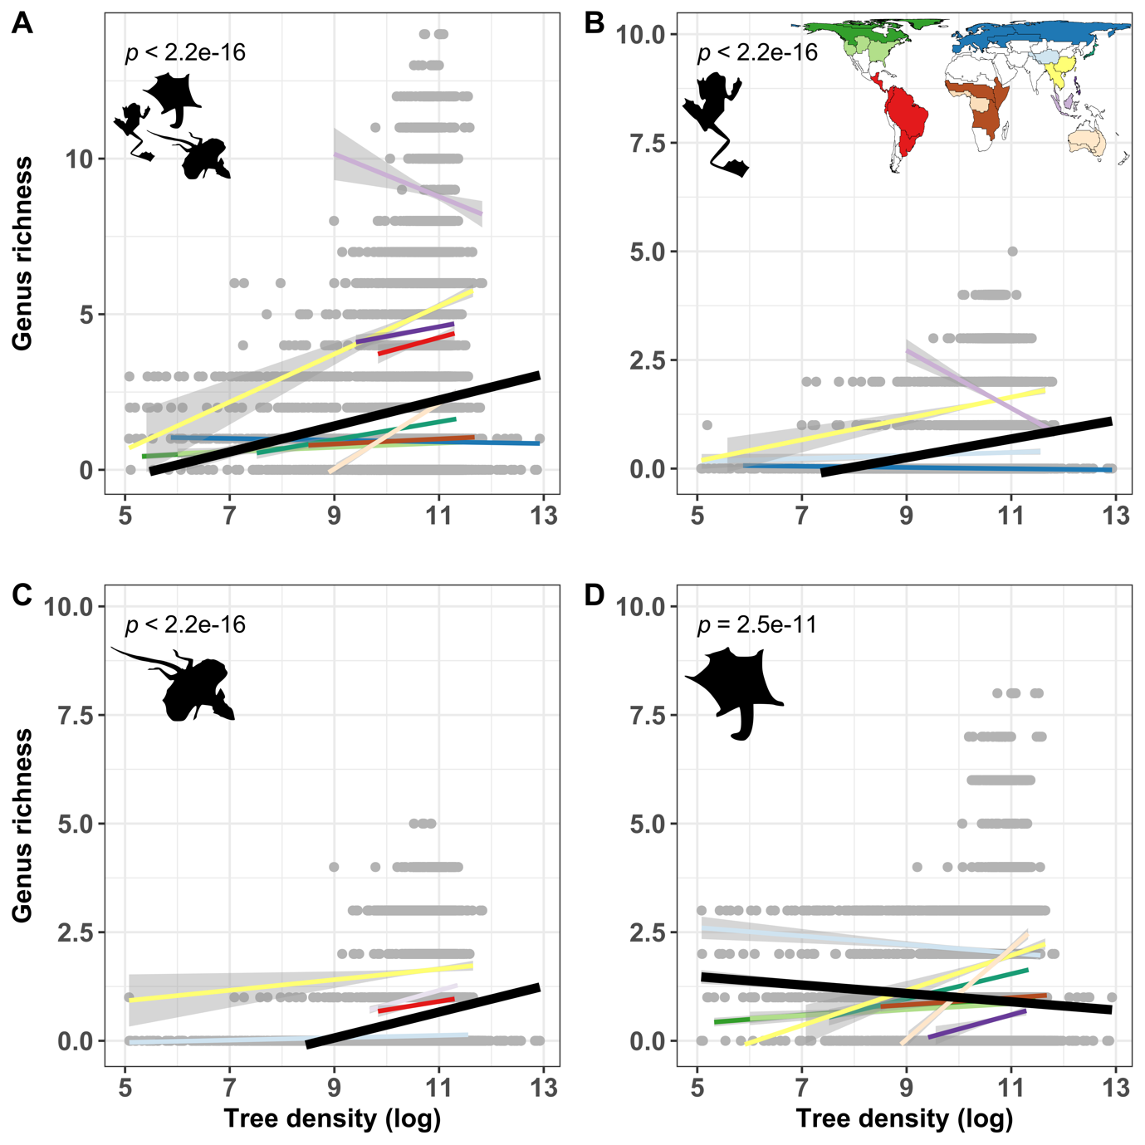

Figure S3. Relationship between tree density (log-transformed) and **genus** richness for all gliding vertebrate **genera** (A) and separate classes (B-D). Black lines illustrate linear regressions for all species pooled together. Regressions for separate biogeographic regions (BGRs, coloured lines, see map in top right corner as legend) were only considered when they were significant.

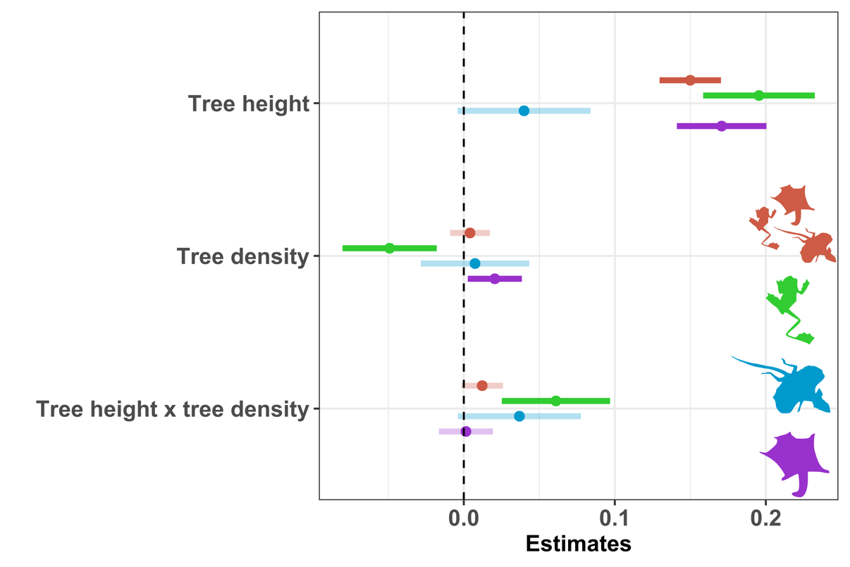

Figure S4. Standardized parameter estimates and confidence intervals from linear mixed effect models of gliding vertebrate **genus** richness for all **genera** pooled together (brown) and separated by class (green = amphibians, blue = reptiles and purple = mammals) at a **1x1** km spatial resolution.

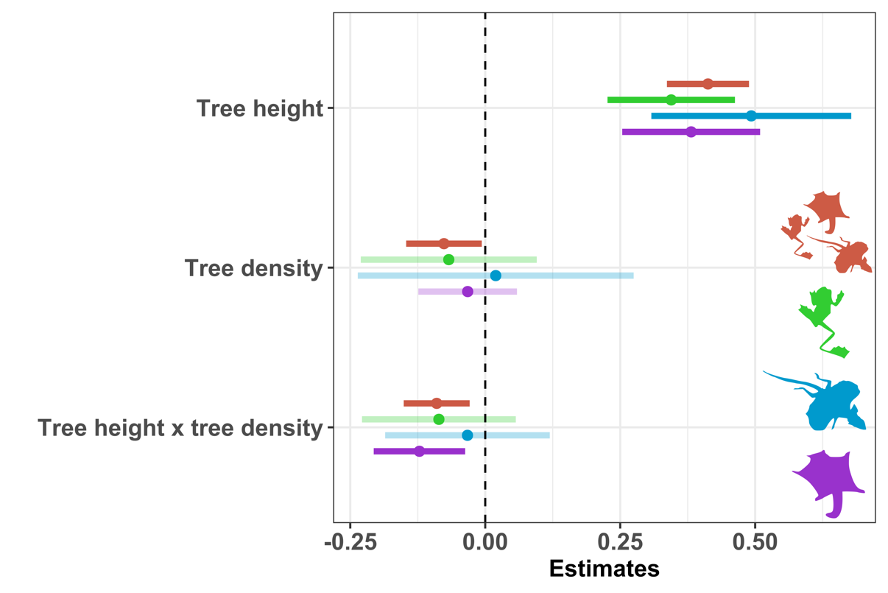

Figure S5. Standardized parameter estimates and confidence intervals from linear mixed effect models of gliding vertebrate **species** richness for all **species** pooled together (brown) and separated by class (green = amphibians, blue = reptiles and purple = mammals) at a **100x100** km spatial resolution.

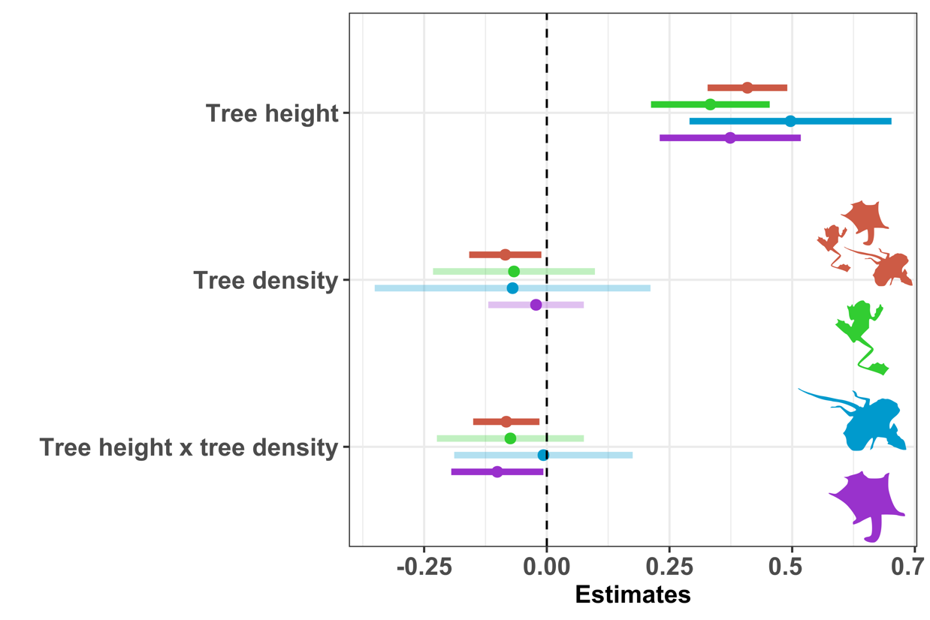

Figure S6. Standardized parameter estimates and confidence intervals from linear mixed effect models of gliding vertebrate **genus** richness for all **genera** pooled together (brown) and separated by class (green = amphibians, blue = reptiles and purple = mammals) at a **100x100** km spatial resolution.

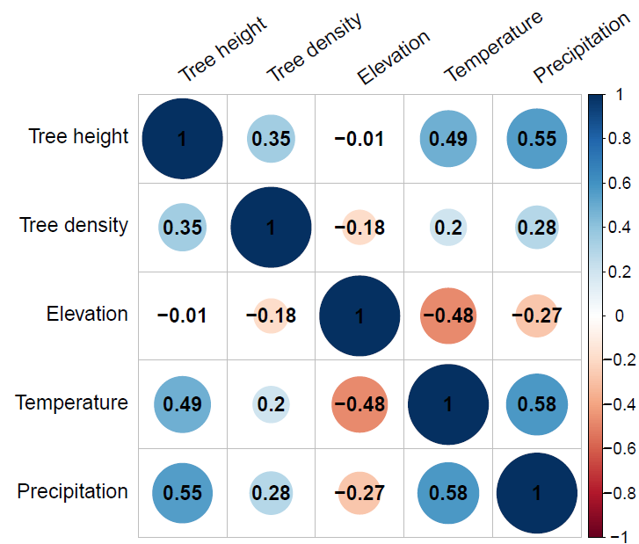

Figure S7. Correlation plot of five predictor variables used in generalised linear mixed effect models. All variables were scaled to unit variance and mean prior to analyses.

**List S8: Data Sources used for compiling the checklist of gliding vertebrates**

Arbogast, B. S., Schumacher, K. I., Kerhoulas, N. J., Bidlack, A. L., Cook, J. A., & Kenagy, G. J. (2017). Genetic data reveal a cryptic species of New World flying squirrel: Glaucomys oregonensis. Journal of Mammalogy, 98(4), 1027-1041.

Arnold, E. N. (2002). Holaspis, a lizard that glided by accident: mosaics of cooption and adaptation in a tropical forest lacertid (Reptilia, Lacertidae). Bulletin of The Natural History Museum. Zoology Series, 68(02), 155–163. doi:10.1017/s0968047002000171

Cremona, T., Baker, A. M., Cooper, S. J., Montague-Drake, R., Stobo-Wilson, A. M., & Carthew, S. M. (2020). Integrative taxonomic investigation of Petaurus breviceps (Marsupialia: Petauridae) reveals three distinct species. Zoological Journal of the Linnean Society.

Dudley, R., & De Vries, P. (1990). Tropical rain forest structure and the geographical distribution of gliding vertebrates. Biotropica, 22(4), 432–434.

Dudley, R., Byrnes, G., Yanoviak, S. P., Borrell, B., Brown, R. M., & McGuire, J. A. (2007). Gliding and the Functional Origins of Flight: Biomechanical Novelty or Necessity ? Annual Review of Ecology, Evolution, and Systematics, 38(1), 179–201. doi:10.1146/annurev.ecolsys.37.091305.110014

Emerson, S. B., & Koehl, M. R. (1990). The Interaction of Behavioral and Morphological Change in the Evolution of a Novel Locomotor Type: “Flying” Frogs. Evolution, 44(8), 1931–1946.

Emmons, L. H., & Gentry, A. H. (1983). Tropical forest structure and the distribution of gliding and prehensile tailed vertebrates. American Naturalist, 121(4), 513–524. Retrieved from http://www.jstor.org/stable/2460978%5Cnhttp://about.jstor.org/terms

Heinicke, M. P., Greenbaum, E., Jackman, T. R., & Bauer, A. M. (2012). Evolution of gliding in Southeast Asian geckos and other vertebrates is temporally congruent with dipterocarp forest development. Biology Letters, 8(6), 994–997. doi:10.1098/rsbl.2012.0648

Higham, T. E., Russell, A. P., & Niklas, K. J. (2017). Leaping lizards landing on leaves: Escape-induced jumps in the rainforest canopy challenge the adhesive limits of geckos. Journal of the Royal Society Interface, 14(131). doi:10.1098/rsif.2017.0156

Jackson, S. M. (2000). Glide angle in the genus Petaurus and a review of gliding in mammals. Mammal Review, 30(1), 9-30.

Jackson, S. M. (2012). Gliding mammals of the world. CSIRO Publishing.

Krishna, M. C., Kumar, A., Tripathi, O. P., Koprowski, J. L. (2016). Diversity, Distribution and Status of Gliding Squirrels in Protected and Non-protected Areas of Eastern Himalayas in India. Hystrix, the Italian Journal of Mammalogy, 27(2). https://doi.org/10.4404/hystrix-27.2-11688

Li, Q., Li, X. Y., Jackson, S. M., Li, F., Jiang, M., Zhao, W., ... & Jiang, X. L. (2019). Discovery and description of a mysterious Asian flying squirrel (Rodentia, Sciuridae, Biswamoyopterus) from Mount Gaoligong, southwest China. ZooKeys, 864, 147.

McCay, M. G. (2001). Aerodynamic stability and maneuverability of the gliding frog Polypedates dennysi. Journal of Experimental Biology, 204(16), 2817–2826.

McGregor, D. C., Padovan, A., Georges, A., Krockenberger, A., Yoon, H. J., & Youngentob, K. N. (2020). Genetic evidence supports three previously described species of greater glider, Petauroides volans, P. minor, and P. armillatus. Scientific Reports, 10(1), 1-11.

McGuire, J. A., & Dudley, R. (2011). The biology of gliding in flying lizards (genus Draco) and their fossil and extant analogs. Integrative and Comparative Biology, 51(6), 983–990. doi:10.1093/icb/icr090

Oliver, J. A. (1951). “Gliding” in Amphibians and Reptiles, with a Remark on an Arboreal Adaptation in the Lizard, Anolis carolinensis carolinensis Voigt. The American Naturalist, 85(822), 171–176. doi:10.1086/281666

Russel, A. P. (1979). The origin of parachuting locomotion in gekkonid lizards (Reptilia: Gekkonidae). Zoological Journal of the Linnean Society, 65(3), 233–249. doi:10.1111/j.1096-3642.1979.tb01093.x

Sanamxay, D., Douangboubpha, B., Bumrungsri, S., Xayavong, S., Xayaphet, V., Satasook, C., & Bates, P. J. (2013). Rediscovery of Biswamoyopterus (Mammalia: Rodentia: Sciuridae: Pteromyini) in Asia, with the description of a new species from Lao PDR. Zootaxa, 3686(4), 471-481.

Socha, J. J. (2011). Gliding flight in chrysopelea: Turning a snake into a wing. Integrative and Comparative Biology, 51(6), 969–982. doi:10.1093/icb/icr092