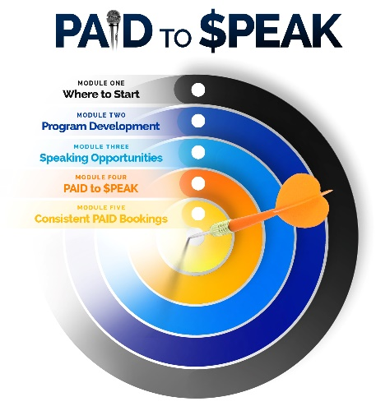
MODULE 1 Questions
Module 1 in my book will provide context to help you answer these questions below.

Envision you just finished presenting to a live audience. Immediately afterward, you are approached by people who were listening to you. Write two different comments below that you want them to be saying to you:
(1)
(2)

How do you want to inspire others through your speaking?

What is the ultimate problem you want to help audiences solve through your speaking?
The problem I am helping people solve through my presentation is …

Why should that be important to them?

As compared to five other speakers on your same topic, what makes you different? List below three differentiation factors: As compared to similar speakers what differentiates me is that I …
(1)
(2)
(3)

Think about powerful and inspirational experiences in your life. Even if you’re not ready to share those experiences yet, know that each experience is a potential story you can share with your audiences if we can align it with your message. Some of the most powerful experiences in my life, although painful and even embarrassing, I never wanted to share with an audience until just a few years ago. But when I started sharing and being more transparent, that’s when my audience connection and speaking business really took off in a new level. So think of your top 5 life experiences – whether tragic or triumphant - and give each a short title. Write down those titles below and more if needed:

Story title 1:

Story title 2:

Story title 3:

Story title 4:

Story title 5:

Every speaker needs a powerful Call to Action incorporated in their program. Meaning, what do you want your audience to do (that is actionable) after hearing you speak? A Call to Action isn’t what they need to feel. It’s what they are inspired to DO. List below some ideas you have for what your Call to Action could be. Be specific, measurable, and actionable. Be unique.
Call to Action 1:

Call to Action 2:

Call to Action 3:

So envision being on a plane and you are flying to a speaking engagement. The person sitting next to you strikes up conversation. After a few back and forth exchanges, they finally ask you that dreaded question, “So what do you do?” Write how you would respond to them as it relates to your speaking:
“I ….

Now after you tell them you speak, they are intrigued to learn more about you as a speaker. They ask, “So what do you speak on?” Write below how you would respond to that question:
“I ….

After completing this document, SAVE and SEND back to me at Kevin@KevinCSnyder.com

