Smart Service Development

Assignment 3

## Scoping and Structure

## Abstract

The topic of smart home technology gained importance over the last decade, introducing the concept of networking devices and equipment in domestic areas. Increasing demand for renewable energy and efficient usage creates a need for intelligent smart-home systems to contribute to the goals of EUs *Energy Efficiency Directive* as well as creating a sustainable, reliable, scalable application framework. On the one hand this framework integrates hardware peripherals accessed by an MQTT broker running on a Raspberry Pi. On the other hand a hardware and service engine provides logic and a database for the application. Control and state APIs are defined for standardized communication between hard- and software engines, wherein an asyncAPI is defined for data exchange between MQTT-Server and hardware engine. A user can access the smart home system by entering the right credentials on a website. The web server is created with the flask python library. A graphical dashboards provides the user with weather information requested from MET Norway Weather API v.3, status of sensors and relais and allows to set the status of actuators and define simple timer switching logic in an interactive way. Alternatively a user may also access the hardware engine directly via its exposed API. Overall this smart service is meant to be a contribution to solve the environmental and energy management challenges of the 21’st century.

**UML Component Diagram**

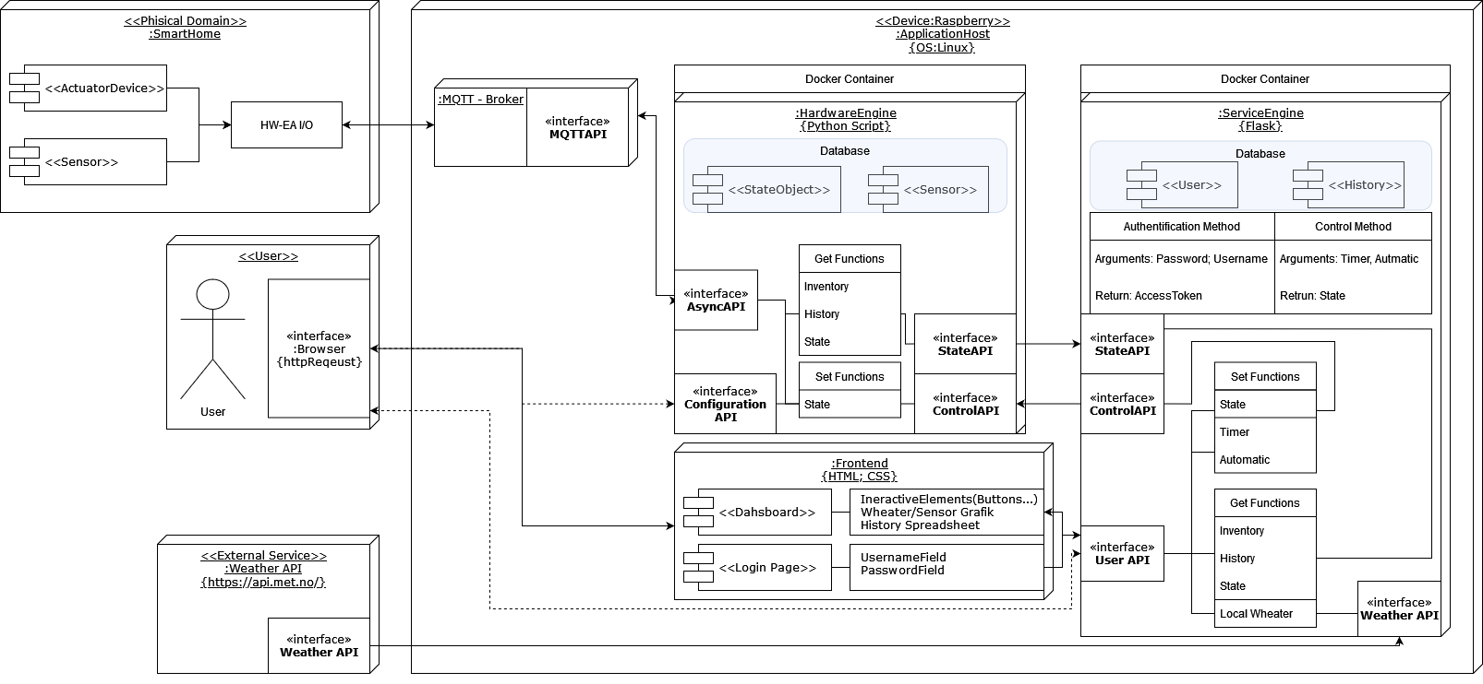

Figure 1: Component Diagram of all functions and APIs part of the smart home system

**UML Sequence Diagram**

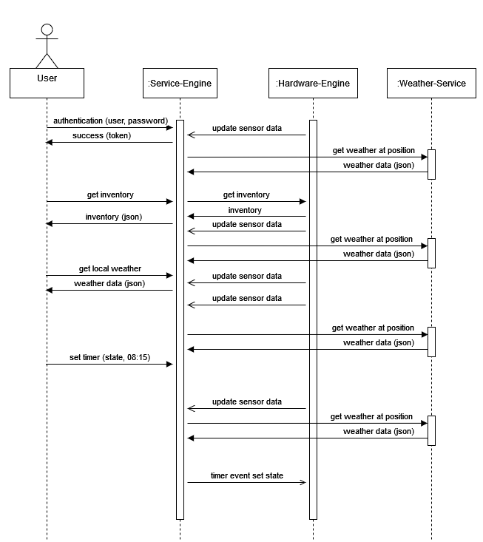

Figure 2: Sequence Diagram of all typical requests

## 

## List of Services

* Remote switching of relais
  + The user can set the state of all relays, which may control heaters in the smart home system.
* Temperature Sensor readings
  + Temperature data from a sensor in the smart home can be requested by the user
* Web dashboard as Graphical User Interface
  + Interactive elements and history in spreadsheet format is provided in a dashboard for the user as a visual interface for the user api.
* Local weather data
  + Get the actual weather data from the area in which the smart home service is installed. (Also displayed in the dashboard)