Ben Schreiber

Section A1 Lab A1

Question 1

The given study, regarding the change in interstate traffic fatalities as interstate speed limits increase, is an observational study; the researcher is not manipulating which states increase or retain their speed limits, but simply observing the change between the two years. Because of the nature of observational studies, population inferences can be made while causal inferences, or causation, cannot be made. In this case, the population of interest would be all highways in the world, and the findings of this study could be generalized to the whole population.

Question 2

|  |  |  |  |  |  |
| --- | --- | --- | --- | --- | --- |
| (a)  **Descriptives** | | | | | |
|  | Interstate Speed Limit Increase in 1996 | | | Statistic | Std. Error |
| Change in Number of Interstate Traffic Fatalities from 1995 to 1996 (%) | No Increase in Interstate Speed Limit | Mean | | -8.5632 | 7.11208 |
| 95% Confidence Interval for Mean | Lower Bound | -23.5051 |  |
| Upper Bound | 6.3788 |  |
| 5% Trimmed Mean | | -7.5202 |  |
| Median | | -9.7000 |  |
| Variance | | 961.052 |  |
| Std. Deviation | | 31.00085 |  |
| Minimum | | -80.00 |  |
| Maximum | | 44.10 |  |
| Range | | 124.10 |  |
| Interquartile Range | | 35.80 |  |
| Skewness | | -.222 | .524 |
| Kurtosis | | .480 | 1.014 |
| Increase in Interstate Speed Limit | Mean | | 13.7531 | 3.77115 |
| 95% Confidence Interval for Mean | Lower Bound | 6.0618 |  |
| Upper Bound | 21.4444 |  |
| 5% Trimmed Mean | | 13.5465 |  |
| Median | | 12.1000 |  |
| Variance | | 455.090 |  |
| Std. Deviation | | 21.33285 |  |
| Minimum | | -31.50 |  |
| Maximum | | 62.50 |  |
| Range | | 94.00 |  |
| Interquartile Range | | 31.18 |  |
| Skewness | | .123 | .414 |
| Kurtosis | | -.133 | .809 |

Table 1.1 – Descriptive Statistics for the Percentage change from 1995 to 1996 in interstate traffic fatalities for states the increased and did not increase their speed limit in 1996

The mean of the percentage change for states that did not increase their speed limit is -8.5632, with a standard deviation of 7.11208. The mean of the percentage change for states that did increase their speed limit is 13.7531, with a standard deviation of 3.77115. The mean of the states that did increase their speed limit is positive, while the mean of the states that did not increase their speed limit is negative; this appears to suggest that states that increased their speed limits on average saw an increase in traffic fatalities, while states that did not increase their speed limits on average saw a decrease in traffic fatalities from 1995 to 1996.

(b)

The 95% confidence interval of the mean percentage change in traffic fatalities for states that did not increase their speed limits in 1996 is (-23.5051, 6.3788).

The 95% confidence interval of the mean percentage change in traffic fatalities for states that did increase their speed limits is (6.0618, 21.4444).

The 95% confidence interval for states that did not increase their speed limits is wider, indicating a greater margin of error for the mean percentage.

The two confidence intervals have a small portion of overlap, as the lower bound of the confidence interval for states that did increase their speed limits is lower than the higher bound of the confidence interval for states that did not increase their speed limits. This means that at the 95% confidence level, we cannot be confident that there is a difference between the mean percentage change of traffic fatalities in states that increased their speed limits and the mean percentage change of traffic fatalities in states that did not increase their speed limits.

(c)

We can be 95% confident that there is an increase in the mean percentage of traffic fatalities in states that increased their speed limits, as the entire confidence interval is positive.

At the 95% confidence level, we cannot determine if there was an increase in the mean percentage of traffic fatalities in states that did not increase their speed limits, as the confidence interval goes from negative values to positive.

(d)

|  |  |  |  |  |  |  |
| --- | --- | --- | --- | --- | --- | --- |
| **One-Sample t-Test for states that did not increase their speed limits** | | | | | | |
|  | Test Value = 0 | | | | | |
| t | df | Sig. (2-tailed) | Mean Difference | 95% Confidence Interval of the Difference | |
| Lower | Upper |
| Change in Number of Interstate Traffic Fatalities from 1995 to 1996 (%) | -1.204 | 18 | .244 | -8.56316 | -23.5051 | 6.3788 |

|  |  |  |  |  |  |  |
| --- | --- | --- | --- | --- | --- | --- |
| **One-Sample t-Test for states that increased their speed limits** | | | | | | |
|  | Test Value = 0 | | | | | |
| t | df | Sig. (2-tailed) | Mean Difference | 95% Confidence Interval of the Difference | |
| Lower | Upper |
| Change in Number of Interstate Traffic Fatalities from 1995 to 1996 (%) | 3.647 | 31 | .001 | 13.75313 | 6.0618 | 21.4444 |

Based on the one-sample t-test for the states did not increase their speed limits, there is weak evidence to reject that the percentage change of fatalities is different than zero.

Based on the one-sample t-test for the states that did increase their speed limits, there is extremely strong evidence to reject that the percentage change of fatalities is different than zero.

Both of these statements are in agreement with the statements in part (c). The confidence interval for the states that did increase their speed limits did not contain zero, meaning that it is not possible for there to have been no change at the 95% confidence level. Similarly, the confidence interval for the states that did not increase their speed limits did contain zero, meaning that at the 95% confidence level, it is possible that there was not a change in the amount of traffic fatalities from 1995 to 1996.

(e)

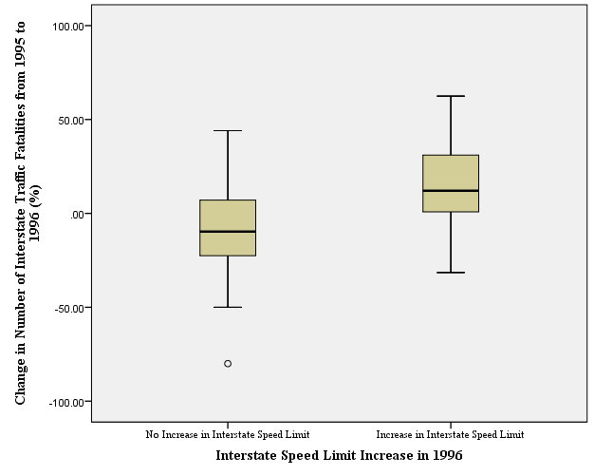

(f)

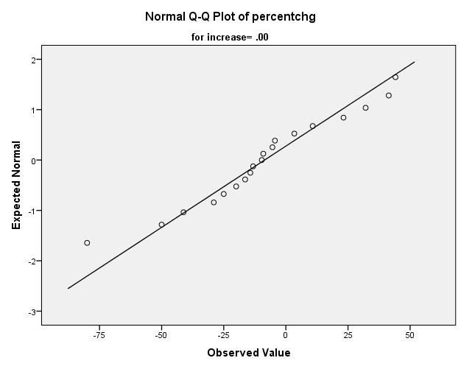

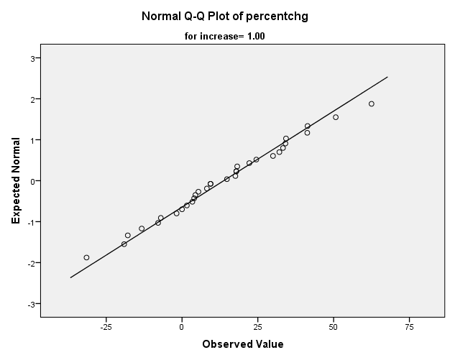

Question 3

(a)

|  |  |  |  |  |  |
| --- | --- | --- | --- | --- | --- |
| **Group Statistics** | | | | | |
|  | increase | N | Mean | Std. Deviation | Std. Error Mean |
| percentchg | 1.00 | 32 | 13.7531 | 21.33285 | 3.77115 |
| .00 | 19 | -8.5632 | 31.00085 | 7.11208 |

|  |  |  |  |  |  |  |  |  |
| --- | --- | --- | --- | --- | --- | --- | --- | --- |
| **Independent Samples Test** | | | | | | | | |
|  | | Levene's Test for Equality of Variances | | t-test for Equality of Means | | | | |
| F | Sig. | t | df | Sig. (2-tailed) | Mean Difference | Std. Error Difference | 95% Confidence Interval of the Difference | |
| Lower | Upper | |
| percentchg | Equal variances assumed | 1.388 | .244 | 3.044 | 49 | .004 | 22.31628 | 7.33241 | 7.58125 | 37.05131 | |
| Equal variances not assumed |  |  | 2.772 | 28.248 | .010 | 22.31628 | 8.05005 | 5.83303 | 38.79954 | |

5

(a)