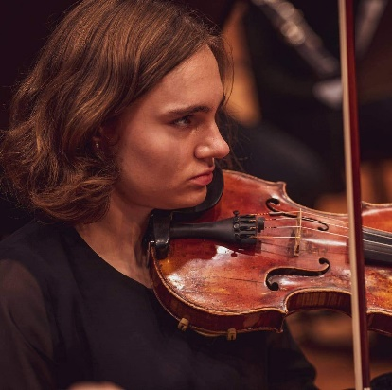Isabel Dhallé

# Background

Isabel Dhallé was born on 23 March 2001 in Turnhout, Belgium. She started to play the violin at the age of four applying the Suzuki Method. She is passionate about music and chamber music.

# Education

2004-2019 Suzuki method in the SAMWD Music school in Turnhout, Belgium  
 Graduated with 99%  
 Mr. Koen Rens

2013-2019 High school diploma in the subject of Latin and Greek culture and language

2019-present Royal Conservatoire of Antwerp  
 Graduated the first and second Bachelor year with greatest distinction  
 Prof. Guido de Neve

2020 Accepted to start in the conducting class of Ivo Venkov

# Experience

2008-2019 Master classes with different teachers such as, Erkki Palola (Finland), Brian Lewis (USA), Yasuki Nakamura (Australia), Deborah Moench (USA), Christophe Bossuat (France), Yoko Hoshino (Japan/Germany), Haruo Goto (Australia), Liana Mosca (Italy), Wilfried van Gorp (Belgium), Wim Meuris (Belgium), Anna Podhajska (Poland), Łukasz Błaszczyk (Poland),…

Music courses in many countries such as Lithuania, the Netherlands, France, Poland, Latvia, Spain, Germany, Switzerland and Japan

2016 Concert in the Royal Albert Hall in London

Concert for the International Festival Wratislavia Cantans in the National Forum of Music, NFM, in Wroclaw, Poland

2017 Chosen to play the Double Violin Concerto by J. S. Bach with orchestra Orfeo directed by Rik Ghesquière

2017-2019 Concertmaster of the orchestra of the music academy in Turnhout

2018 Solo concert with the orchestra of the music academy in Turnhout. She played Introduction and Rondo Capriccioso - C. Saint-Saëns

2019-2020 Member of the Euregio Youth Orchestra  
Concerts in the Netherlands and Belgium

2019 Chamber music course in Poland  
Lessons with Karol Marianowski (Poland), Łukasz Błaszczyk (Poland),…

Masterclass with Clive Brown (Austria)

Concerts with Con Spirito orchestra in the Blauwe Zaal in the Singel Antwerp. Jozef De Beenhouwer as a soloist

Accepted to participate in the Youth Orchestra of Flanders

2020 Concert in The Queen Elisabeth Hall in Antwerp with the female Virago Symphonic Orchestra

Masterclass with Maximilian Löhse (Germany)

Chamber music lessons with Eliane Rodrigues (Brasil)

2021 Chamber music Masterclass with Razvan Popovici (Romania)

Chamber music lessons with Guy Danel (France)

Chamber music lessons with Frank Agsteribbe (Belgium)

Concert directed by Diane Ketler (Latvia)

Don Giovanni Opera project with the European Opera Academy. Orchestra lead by Jan Schweiger (Austria) and Stage Director Louisa Muller (USA/Germany)

In August, she followed masterclasses with Alexei Moshkov (Russia) and Philippe Graffin (France)

Finalist of Imagine 2021, a competition of Jeugd en Muziek

2022 Masterclass with Roel Dieltiens (Belgium)