Dmaths 2.70 for OO ≥ 1.1 and SO ≥ 7.0: user guide

The licence is on the last page. Tip: print this document out.

You can also use the mailing list: mailto:users-en-subscribe@dmaths.com

See our site on www.dmaths.com

To hide the Dmaths bar : View > Toolbars and unclick Dmaths

You have five possibilities: quick macros, dialog boxes, text mode, blue macros, curve plotter.

Quick Macros:

Intuitive Dialog Boxes:

Text mode:

Blue Macros:

Tracing and Plotting curves:

Statistics and Plot Boxes:

How-to integrate a diagram into a text file or a drawing:

How to modify a graph:

Annexe Functions list

Write to me with your problems : Didier Dorange-Pattoret

Quick Macros:

They enable you to quickly write your mathematical formulas with a single mouse click or keyboard shortcut.

NB:

    - The separator for fractions is : { } obtained by clicking on or with Shift+F10.
    - The character $ will call the macro GraphicalFormula2 that is currently being used
    - Parts of formulas between two ampersands && will not be modified
    - Parts of formulas comprised between two § will be considered as ConverttoFormula
    - The separator for algebraic measurements and the norm is : !
    - The macro used will take the highlighted text as an argument, if you have done so, or else the final part of the paragraph from the cursor position where no text has been selected.
    - The buttons launch macros which allow to frame, change, increase or reduce the size of the selected formula, the formulas included in the selection or the whole document.
Think about using these macros:

SetBetweenParentheses | SetBetweenAccolades | SetinBlueRoot
 |  | ou Ctrl+Maj+Z | roo puis F3
CTRL+SHIFT+F10 | SHIFT+F10 | nroot{}{} | sqrt{}

If you have a problem, use the dialog boxes.
- MakeFormula:
- MakeVector:
- MakeAlgebra:
- MakeAngle:
- MakeLimit:
- MakeIntegral:
- MakeSum:
- MakeRoot:
- MakeSystem:
- MakeMatrix:
- A few examples

Brief Recall Table:

- MakeFormula:

Name | Icon | Keyboard Shortcut | Example: type | Result
MakeFormula |  | F10 | {2x+1}/{4x+1}-3

A few examples:

Type then click on or press F10 | You will get:
f(x)=1+1/x-1/{x^2+1}
{} can be obtained with or Shift+F10
f(x)=sqrt{x^2+1/{1+1}}
sqrt can be obtained with: roo then F3
1/2+&1/3&=5/6
the part between two & does not change
{x+1}/{(x+2)(x-5)}
A_n^p
S=left lbrace 1/2 right rbrace left lbrace right rbrace can be obtained with or Ctrl+Shift+Z
S= emptyset
emptyset can be obtained with esf then F3
S=[-1/2;+inf[
$${2x+1)/{x-1}<=35
$$f() = 1/
f(x)=(2x+1)(2x+1/2)

Go to top
- MakeVector:

Name | Icon | Keyboard Shortcut | Example: type | Result
MakeVector |  | Ctrl+Maj+V | AB

A few examples:
Type then click on  or Ctrl+Maj+V | You will get:
OG=-1/3(OA+OB+OC)

OC=OA∧OB
u∧(v∧w)
AB(-1;1/2)+BC(1/2;2)

2u(-1/2;5)
AB.AC=AB.AH
!!AB(-1;5)!!'=nroot{}{26}'
nroot can be obtained with roo then F3
Beware, this macro doesn't like square roots. If you have a problem, use the graphical macro or else:
AB(§sqrt{2}§/2;5)

3) MakeAlgebra:

Name | Icon | Keyboard Shortcut | Example: type | Result
MakeAlgebra |  | Ctrl+Maj+E | AB

A few examples:

Type then click on  or Ctrl+Maj+E | You will get:
OG=-1/3(OA+OB+OC)
AB(-1;1/2)+BC(1/2;2)=AC
$sqrt{2}$AB
Go to top

4) MakeAngle:

Name | Icon | Keyboard Shortcut | Example: type | Result
MakeAngle |  | Ctrl+Maj+A | ABC  (u;1/2v)

A few examples:

Type then click on  or Ctrl+Maj+A | You will get:
A+2B+3/2C=140°
(1/2u;-3/4v)+(v;w)=(u;w)+pi

- MakeLimit:

The character # allows overlaided formulas.

Name | Icon | Keyboard Shortcut | Example: type | Result
MakeLimit |  | Ctrl+Maj+L | mode1: 1/2;x/{x+1}  mode2: t;+inf;f(t)  mode1: 0#x>0;1/x  mode2: t;2#t<2;x^2

A few examples:

Type then Click on | You will get:
-{1/2}^+;(x/{x+1/2})
rem: ^+ pour 0⁺
-1;f(x)§=25+1/e§
remark: the sign § enables you to avoid treating the rest of the formula as a limit.
Go to top
6) MakeIntegral:

Name | Icon | Keyboard Shortcut | Example: type | Result
MakeIntegral |  | Ctrl+Maj+I | mode1: f(x)  mode2: 1/t;t  mode3: -{1/2};5;x/{x+1}  mode4: 1;nroot{}{2};f(t);t

A few examples:

Type then click on  or Ctrl+Maj+I | You will get:
1;x;1/t;t§=ln(x)§

7) MakeSum:

Name | Icon | Keyboard Shortcut | Example: type | Result
MakeSum |  | Ctrl+Maj+S | mode1: k^2  mode2: 0;+inf;(k^2+k)  mode3: k;0;n;k^2

A few examples:
Type then Click on or F10 | You will get:
k;1;n;k§={n(n+1)}/2§
NB: the § symbol freezes the rest of the formula so that it isn't handled by the sum equation.

8) MakeRoot:

Name | Icon | Keyboard Shortcut | Example: type | Result
MakeRoot |  | Ctrl+Maj+R | 5  3;27

A few examples:

Type then click on  or Ctrl+Maj+R | You will get:
3^2+4^2§=5§

9) MakeSystem: Beware, there are two modes: aligned systems or not, which can be selected with the option menu icon or the keyboard shortcut CTRL+MAJ+O.

Name | Icon | Keyboard Shortcut | Example: type | Result
MakeSystem |  | Ctrl+Maj+X | not aligned mode  x+2y=5;x-{1/2}y=-3/4
MakeSystem |  | Ctrl+Maj+X | aligned mode  x;+;2y;=;5;;x;-;{1/2}y;=;-3/4

NB: The corresponding graphical macro handles the length of the equations better:
Beware: in aligned mode, you have to fill the blanks with the character ` (Alt GR+`)
Example 2x;`;`;=;10;;x;+;y;=;3 to obtain:.

- MakeMatrix

Name | Icon | Keyboard Shortcut | Example: type | Result
MakeMatrix |  | Ctrl+Maj+M | -1;5;;5/2;4

NB: The corresponding graphical macro contains more options:

Go to top

11)A few examples:

example 1:
Type: f(x)=6x+$ then Click on . You will get a dialog box enabling you to insert an algebraic measurement.

example 2: In order to write a system with aligned columns use the macro Graphical Matrix

and choose the last option { :

example 3:
(gom[F3] A; gom[F3] B)=pi/6 selected then CTRL+Maj+A will give

example 4:

gom[F3] _ 1 gom[F3] _2 + gom[F3] gga[F3] = 15 u then CTRL+Maj+V will give:

Go to top
Summary table:

Name and Icon |  |  | Keyboard Shortcut
MakeFormula | f(x)=1/x |  | F10
MakeVector | AB |  | Ctrl+Maj+V
MakeAlgebra | AB |  | Ctrl+Maj+E
MakeAngle | ABC |  | Ctrl+Maj+A
 | (u,1/2v) |  | Ctrl+Maj+A
MakeLimit | 1/2;{x+1}/x |  | Ctrl+Maj+L
 | t;+infinity;(t^2+1) |  | Ctrl+Maj+L
MakeIntegral | f(x) |  | Ctrl+Maj+I
 | 1/t;t |  | Ctrl+Maj+I
 | -{1/2};3;x/{x+1} |  | Ctrl+Maj+I
 | 1;x;1/t;t |  | Ctrl+Maj+I
MakeRoot | 3;5 |  | Ctrl+Maj+R
MakeSum | k^2  0;+inf;(k^2+k)  k;0;n;k^2 |  | Ctrl+Maj+S
MakeSystem  To line up the = signs, limit the second members with * (function momentarily deactivated). The equations or inequations are separated by; | x+y=1;x-y=2  x+y=*1*;x-y<=*452* |  | Ctrl+Maj+X
MakeMatrix  Coeffficients are separated by ;  Lines are separated by ;; | 1;2;3;;4;5;6 |  | Ctrl+Maj+M
Go to top

Graphical Formula Dialog Boxes

Click on and you will get the GraphicalFormula2 dialog box:

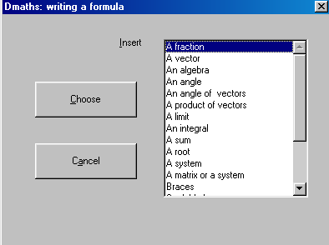
From there you can call other dialog boxes.

In each box, tick on Write Code Only, and you will be able to write the code without a formula.

Click on and you will get the dialog box GraphicalFormula:

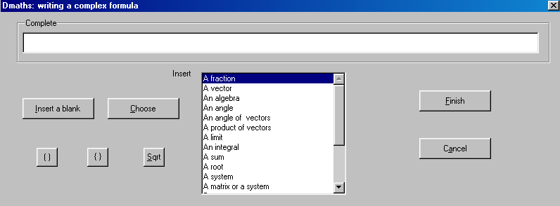

Go to top
Text mode Shortcuts

Function | Shortcut | Result | Select+F10
1 to 12 | 1 | Ex 1:
1L to 8L | 3le | Exercise 3:
2 k pi | 2kpi | +2k; k  ℤ
About | ab | ≈
Absolute Value | abs | |
Alpha | al | 
Arrow | fl | 
Barycentre | b3e | the barycentre of {(;);(;);(;)}
Belongs to | bt | ∈
Beta | be | 
Binomial coefficients | bc | left( binom{n}{k} right)
Binomial formula | bf | left(binom{n}{k} right)`p^{k}`q^{n-k}
Complex | c | ℂ
Delta | de | 
Different | dif | ≠
Does not belong to | ben | ∉
Empty Set | es | ∅
Epsilon | ep | 
Equivalent | eq | ⇔
Eta | et | 
Exponential function | ef | e^{`x`}
Exterior product | ep | ∧
f de x | fx | f(x)
f italic, g, h | f | f
Function | func | 
g de x | gx | g(x)
Gamma | ga | 
Gamma major | gam | 
Great C star | cs | ℂ∗
Great N | n | ℕ
Great N star | ns | ℕ∗
Great Q | q | ℚ
Great Q minus | qm | ℚ⁻
Great Q minus star | qms | ℚ^{-∗}
Great Q plus | qp | ℚ⁺
Great Q plus star | qps | ℚ^{+∗}
Great Q star | qs | ℚ∗
Great R | r | ℝ
Great R minus | rm | ℝ⁻
Great R minus star | rms | ℝ^{-∗}
Great R plus | rp | ℝ⁺
Great R plus star | rps | ℝ^{+∗}
Great R star | rs | ℝ∗
Great Z | z | ℤ
Great Z minus | zm | ℤ⁻
Great Z minus star | zms | ℤ^{-∗}
Great Z plus | zp | ℤ⁺
Great Z plus star | zps | ℤ^{+∗}
Great Z star | zs | ℤ∗
Greater than or equal to | ge | ≥
h de x | hx | h(x)
Implies | im | ⇒
Included | inc | ⊂
Infinite | inf | ∞
Inter | int | ∩
Intersection of a family of sets | ifs | {}intersection csub{i=1}csup{n}A_{i}
Lambda | la | 
Lambda major. | lam | 
Less than or equal to | ie | ≤
Logarithm of base a | lga | log_{a}(x)
m | minus | −
Mu | mu | 
Multiplier | x | ×
Multiply | p | ×
Norm | no | ||
Norm formula | nof | ldline widevec rdline
Not included | nin | ⊄
Nu | nu | 
Omega | om | 
Omega major | omm | 
Orthogonal Point | apg
Orthonormal point | apo
Perpendicular | pe | ⊥
Phi | ph | 
Phi major | phm | 
Pi | pi | 
Pi majuscule | pim | 
Point | ap | a point
Psi | ps | 
Psi major | psm | 
Rho | ro | 
Root | roo | sqrt{}
Round | rou | °
Serie (u_{n}) | uns | the series (u_{n})
Serie (v_{n}) | vns | the series (v_{n})
Serie (w_{n}) | wns | the series (w_{n})
Set def of f' | efp | E_{f'}
Set of def | ef | E_{f}
Sigma | si | 
Sigma major. | sim | 
Squarre | sq | □
Tau | ta | 
There exists | ex | ∃
Theta | th | 
Theta major. | thm | 
U₀ | u0 | u₀
u₁ up to u₅ | u1 … u5 | u₁
u_{n} | un | u_{n}
Union | uni | ∪
Union of a family of sets | ufs | {}union csub{i=1}csup{n}A_{i}
Whatever | we | ∀
x italique | x | x
X to the power of 2 | x2 | x²
X to the power of 3 | x3 | x³
X to the power of 4 | x4 | x⁴
X to the power of 5 | x5 | x⁵
X to the power of n | xn | x^{n}
Xi | xi | 
Xi major | xim | 
y italique | y | y

Extra shortcuts in formula mode:

Functions | Racc | Result | Example
Space | s | ` | To space out
Leading dots | ... | `` dotslow ``
Approximately equal to | approx | approx
Equivalent Relation | dlrarrow | dlrarrow
Italic | i | italic
Nitalic | ni | nitalic
Is included in  Is not included in | in  notin | x in cf then press F3

You only have to type the shortcut and then press F3.

For example: - « sun » followed by F3 will give : « the series (u_{n}) »
- « ap » followed by F3 will give: « a point »
- « c » followed by F3 will give « ℂ ».
Go to top

Blue Macros

SetBetweenParentheses | test | (test)
SetBetweenVariableAccolades | test | left lbrace test right rbrace
SettoBlueRoot | 25 | nroot{}{25}
SetBetweenSquareBrackets | test | [test] | Ctrl+Maj+Y
SetBetweenVariableParentheses | test | left( test right) | Ctrl+Maj+W
SetBetweenVariableSquareBrackets | test | left[ test right] | Ctrl+Maj+Z
SettoNormal | widevec u | ldline widevec u rdline
SettoAbsoluteValue | -1 | abs{-1}
Frame the text |  | test of frame  of frame  test
Italicizes the text before the cursor |  |  | Shift+F3
Overlines the text between the acccolades | overline{x+iy}=x–iy

Go to top

Drawing and Plotting curves

Use the macro button representing a graph : click on:

You can plot the curve of an equation, e.g. y = f(x) , parameterized or polar.
A plotter module is included
You will get the following dialog box (in English) :

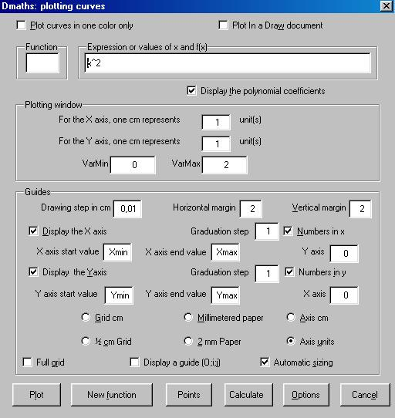

What you need to know :

- you can write your formulas using equation editor or Calc spreadsheet syntax. For example : the functioncould be written : ln left({%pi x^2+1} over {2 x^2+1}right) or ln((pi*x^2+2)/(2*x^2+1)) or log((pix^2+2)/(2x^2+1)). Mathematical, Statistical and Financial functions are implemented. Their list is in annexe here.
- The functions aren't case sensitive.
- You can use your local decimal separator or the point. If a formula as several parameters. They can be separated by a semi-colon or a comma (except if it's your local decimal separator.
- Only in formula, you can't use the scientific notation :1E10 will be interpreted as 1 x e x 10.
- You can use pi, e and a complete formula in Varmin, Varmax fields.
- To change the graph you've plotted :
Select it by clicking on it,
With the right mouse button choose : Group > Enter
Carry out your changes (e.g. add a caption)
Then, press the Shift key, and select the objects one by one with the mouse, and right mouse button click, choose : Group > Group
- Use the Options menu to set colors etc...
- To plot a straight line parallel to the Y axis use it's equation in reduced form e.g. x=2
- Xmin and XMax give the minimum and maximum guide points on the X axis. By default, these are the smallest X axis value, and the largest X axis value respectively, of the functions that have been entered.
- Ymin and Ymax give the minimum and maximum guide points on the Y axis. By default, these values are calculated by the software using the scan method.
- To use the Plotting function, just enter the known data coordinates of the curve in the expression window and separate them with semi-colons, e.g. if f(-1)=2; f(0)=4 and f(3)=1/2 one would write : -1;2;0;4;3;0,5. Then enter Varmin=-1 and Varmax=3
- A hyperbolic curve is written x(t);y(t). Then for Varmin and Varmax you enter "t" limits.
- A polar curve is written r(t);P. Then for Varmin and Varmax you enter the parameter limits.
- You can draw/plot up to nine curves and can combine curves defined by a function, straight lines parallel to the Y axis and curves defined by a set of points.
- The software automatically decides on the display window size as necessary.
- To obtain a guide point without a curve, leave the function window empty and then enter values for at least Xmin, Xmax, Ymin, Ymax.
- The 'points' button lets you position up to 9 guide points, the coordinates of which are known.

Example 1: The curve representing the exponential function and its tangent at X axis point 1.
Xmin=-3; Xmax=3; Ymin=-1 and Ymax=10
-5
-4
-3
-2
-1
0
1
2
3
10
9
8
7
6
5
4
3
2
1
0
-1

Go to top
Example 2: The hyperbolic curve x(t)=2cos(t) and y(t)=sin(t). VarMin=0; VarMax=6,5
Xmin=-3; Xmax=3; Ymin=-2 and Ymax=2. Option : ½ cm grid.
-3
-2
-1
0
1
2
3
2
1
0
-1
-2

Example 3: The polar curve r(t)=t with t ∈ [-3;3].

-2
-1
0
1
2
1
Example 4:

Plotter Module : A curve that passes through 9 points.
Enter io the window : -4;-4;-3;0;-2;2;-1;3;1;0;3;-3;4;-2;5;0;6;6

-6
-5
-4
-3
-2
-1
0
1
2
3
4
5
6
7
8
7
6
5
4
3
2
1
0
-1
-2
-3
-4
-5
Go to top
Example 5: The square function applied to [-8;8] without any window control.

-8
-7
-6
-5
-4
-3
-2
-1
0
1
2
3
4
5
6
7
8
63
60
57
54
51
48
45
42
39
36
33
30
27
24
21
18
15
12
9
6
3

Go to top

Statistics Module and Framed Diagrams

Click on the DiagBox: button. The following dialog box should appear :

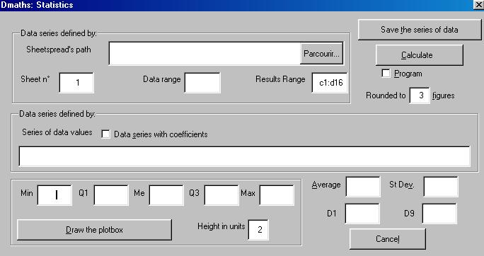
You can work with three different types of data series :

- A series defined by its values that can be saved to an Excel or OpenOffice.org Calc file.

- A series, the values of which are in a spreadsheet or displayed on screen. Saving the results is done in the same spreadsheet by setting the sheet and the ranges (data, results)

- A series in a Calc spreadsheet for which you can choose the path and filename.

To draw/plot just one framed diagram, just enter the Min and Max values.

See the example below:

Go to top
With the data below, you can get the following diagram to appear on screen :
Note : the second column contains the coefficients.

Screen :

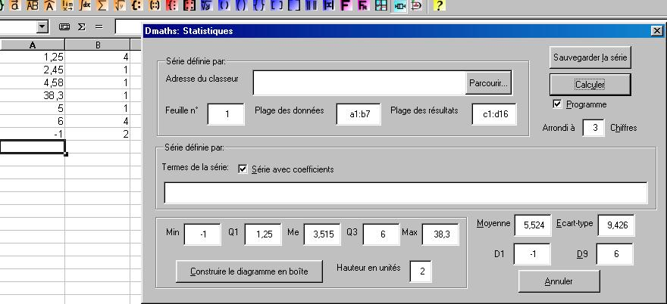

Diagram :
-5
0
5
10
15
20
25
30
35
40

Go to top

How to use the gallery
How to integrate a picture from the gallery

- Click on the button Gallery of the function bar
- Choose the theme 2Dmaths or 3Dmaths
- Select your picture then drag and drop in your document
A
B
C
D
O
4) In order to increase the picture size, keeping the ratios, select the picture then press the shift key and modify the picture.

How to add a picture to the gallery

- Draw the picture
- Select all then right click and choose Group in the context menu
- Select again with the mouse button pressed down
- When the cursor turns into a rectangle drag and drop.

Go to top

Tutorial

How-to integrate a diagram into a text file or a drawing

Didier Dorange-Pattoret (c)

Summary:

Part One: Getting and installing the Dia software

Part Two: Integrating diagrams into a text file in OpenOffice.org Writer

Part Three: Licence

Part One: getting and installing the Dia software
Dia is a program for creating diagrams based on the GTK+ libraries, distributed under the GPL
The home page for the project is located at : http://www.lysator.liu.se/~alla/dia/

On Linux: it is often included in the distribution. Mandrake 8.2 and 9.0 both include localized versions of Dia.
If needs be, you can find the RPMs and the source code on the official Dia site.
On Windows: you can find the software at the following address : http://dia-installer.sourceforge.net/

Part Two : Integrating diagrams into a text file in OpenOffice.org Writer
- Start Dia
Create a new diagram: File > New

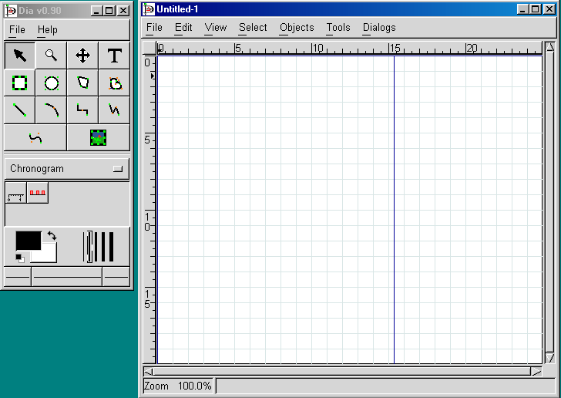
Go back
- Build your diagram ( pull down menu item Chronogram).

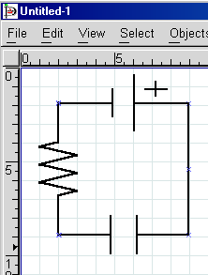
- (optional) If you wish to save the diagram as it appears on screen, save it in the Dia format, with the .dia file extension

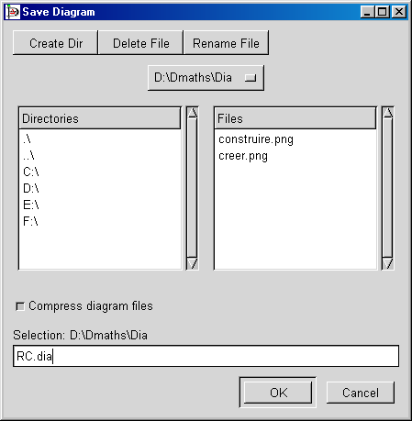
Go back
- Export the diagram in order to obtain a PNG formatted file
Choose: File > Export

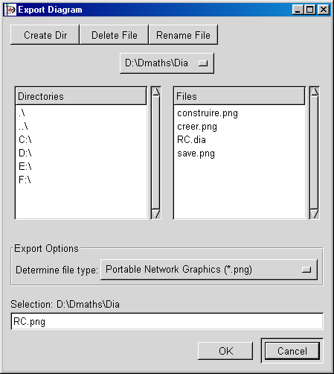
Alternative solution: if Dia is closed, navigate, using your file manager, to the dia file you've created, then with the right mouse button, select Creat png image
- In OpenOffice.org Writer, choose the file menu Insertion > Graphic > From file...
Select the .png file. This should give you:

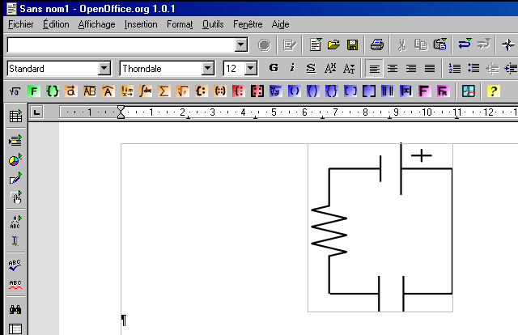
Go back
You will now have an inserted image in your text file.
You can assign a title to the image: select the image by clicking on it, then by pressing on the right mouse button choose the menu item Caption
You can alter the result with the drawing functions : add text, speech bubbles, etc.

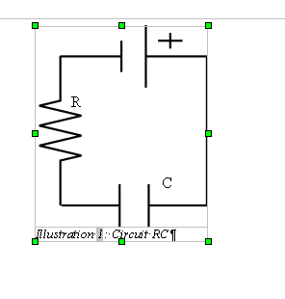
- You can always change your image using the more sophisticated functions available in OpenOffice.org Draw, by inserting it into a Draw document:
Menu item: File > New > Drawing then insert your image as above.
Create your own components. The image above was converted into a polygon
( Right mouse button > Convert > Polygon )
The components that you've created can be grouped: Keep the shift button pressed down, then click on each of the components one by one. Using the right mouse button, now select Group.
If you stretch you image, all of the components will now be stretched.
The next step is to import it into a text file as outlined above.
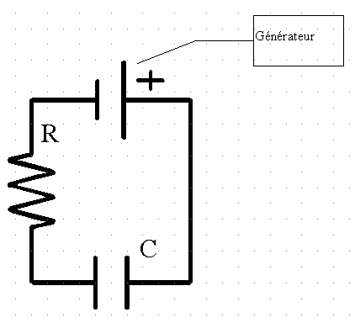
Go back
Part Three: Licence
This document is published under the terms and conditions of the the GNU Free Documentation Licence
© 2002 Didier Dorange-Pattoret
Translated by : Alex Thurgood (alex.thurgood@free.fr)

Go back

Insert geometric images built with Declic

Getting Declic:
You can find Declic on the website: http://emmanuel.ostenne.free.fr/ .

Inserting images made with Declic
Declic is an application made under Windows. For the moment the version for Gnu/Linux has less
potentiality (see the latest version on the site of Declic).
- Launch Declic, then build or insert an image.
Remark : to use again the same tool in Declic, press W .
- You can move the image up and left in the window by using drag and drop alongside of the drawing. You can crop the image below and right in the next step("Export").
- Using Windows :
- In File -> Export, choose "to Target " and define the size of the exported image.

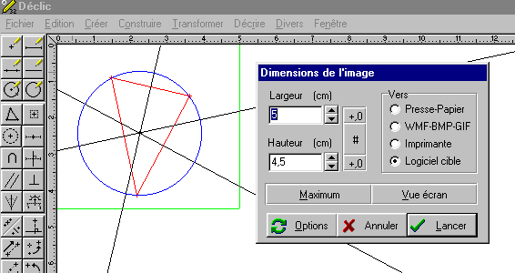
You can choose the application (ex: OpenOffice.org) via the button " Options", tab "Export". You can choose also a background (graduated in millimeters paper, etc.), the shape of the points, etc.
- (Optional) The drawing can be saved as file Declic (.fdc) in order to can modify it later without completely resume it.
- OpenOffice.org needs to be turned on. The object is inserted as vector graphics by clicking on "Launch".
Example:
Variant: you can export "to the clipboard" then paste in the document.
- For Gnu/Linux : (usable also using Windows). For the moment, the export is only possible in Bitmap. For example, you get:

- With File -> Export, choose "to BMP-PNG" (or "to WMF-BMP-GIF » using Windows) and define the size of the exported picture, then save the picture in a file (ex: circle.png).

- (Optionnal) You can save the drawing as file Declic (.fdc) in order to modify it later without completely resume it.
- Then, in the document OpenOffice.org, with
Insert -> Image -> From a File, insert the picture à l'endroit voulu.

How to modify a graphic

You can use the word processor or drawing module (copy/paste), the latter offering a wider range of possibilities, including rotation, 3D shapes ....

1) To add elements (with the drawing functions available in the toolbar on the left) :
- draw the additional elements, and place them on the graph
- then group everything (e.g. So that you can move them all as a single block) :
Press button , and draw a frame around all of the objects that you wish to group, then RMB and choose Group - Group from the context menu
(you could also select each element individually by holding down the Shift key and clicking on the left mouse button, but it's not very practical when there are a lot of elements).

2) In order to change the elements of a graph (thickness, line style, colour, ...)
- select the graph
- RMB, - Group - Ungroup
- Then you can choose any individual element and modify it (including text areas) ; you can also add new elements
- Regroup the objects again as in point 1
variante:
- RMB - Group - Entrer
- Then you can choose any individual element and modify it
- When you click outside the drawing, it has the effect of leaving the group (RMB Group – Leave Group)

This lets you draw lines of the same color, but having different styles, which is interesting when you want to print in black and white. Example :
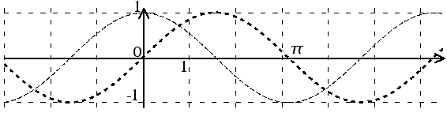
This graph was converted into a .png file before being inserted into this document. It would also enable you to paste it into a web page, or convert the text to Word without fear of losing the drawing (vector drawings are interpreted by the word processor and don't always get converted correctly between different software ; the same problem applies to formula created with OOo math). If you take care to zoom in on the drawing before converting it to an image, and then zooming out again after insertion, you can even get a reasonable print copy.

Note :
how-to: and use the image of the graph :

- Using Linux :
With Ksnapshot, you can make a screen grab, saved to .png format.
Open it with Kpaint or Gimp, choose the small area of interest, copy/paste the image into a new file, save as .png (this file then only contains the selected area).
Return to OpenOffice.org : insert image from file.

To insert the arrow in the text : first insert it wherever you like, then RMB on image : "Anchor as Character", then copy/paste wherever you want.

Instead of Kpaint, you could also use the Image Processing module of StarOffice5.2 that is really quite good (but which wasn't maintained in OpenOffice or StarOffice60 ).

- Using Mac OS X :
With /Applications/Utilities/Grab you can make a selection grab (⇧⌘A). It is saved as .tiff. Open it with Preview then export as .png.
You can open the file with The Gimp or Graphic Converter to edit it. But this is not necessary if the selected zone is not to small. Then complete as using Linux.

- Using Windows :
With the PrtScrn button you can put a screen copy into the clipboard. Next, paste it into any image editing software document (Gimp, Paint, Photo-Editor or StarOffice5.2), in order to choose the area of interest and make an image file that you can then insert into OpenOffice.

It is better to save your files as png because the compression and quality of the saved image are better than with gif. If you are working in monochrome, you can save the file as a 1 bit image (2 colors). I this way, the size of the image is greatly reduced (useful for posting to the web).
Go to top

Annexe Functions list

This is the list of mathematical, statistical and financial functions that you can use in your formulas when you want to draw a curve.
For an easer use, some functions have alias. For example, you can use both "sqr" and "sqrt".

Mathematical functions
Name | role
*, cdot, times | multiply
/, over, div | divide
e^ exp | exponential
^ | power
ln, log | Natural logarithm
log10, log_10, logten | Base-10 logarithm
Log2, log_2, logtwo | Base-2 logarithm
Sqrt, sqr | Square root
%pi, pi, e | Pi, e
Sin, cos, (tan, tg) | Sinus, cosine, tangent
cot, cotan, cotg | cotangent
sec | Secant
csc, cosec | Cosecant
(a,ar,arc) + trigonometric function | Inverse trigonometric function. For example : asin=arsin=arcsin = inverse sinus function
Trigonometric function +h | Hyperbolic function. Ex : arccosh= arccosine hyperbolic
fact, factorial | Factorial
Random, rand, rnd | Random value between 0 and 1
abs | Absolute value
sign | Sign of the number -1, 0 or 1
int | Round to the integer below
frac | frac(x)=x-int(x)
min | Minimum of a list of arguments. The list isn't restricted in number : min(2,1,3)=1
max | Maximum of a list of arguments. The list isn't restricted in number : max(2,1,3)=3

Statistical functions
Name | role
betadist(x; α; β; a; b; cumulative) | Beta distribution
betainv(p; α; β; a; b) | Inverse of the beta distribution
chidist(x; k) | right-tail values for a cumulative χ2-distribution
chisqdist(x; k; cumulative) | left-tail values for a density or cumulative χ2-distribution
chiinv(p; k) | inverse of the CHIDIST function
chisqinv(p; k) | inverse of the CHISQDIST function
confidence(α; σ; size) | confidence interval of a normal distribution
expondist(x; λ; cumulative) | exponential distribution
fdist(x; r1; r2) | F distribution
finv(p; r1; r2) | inverse of the F probability distribution
fisher(r) | Fisher transformation
fisherinv(z) | inverse of the FISHER transformation
gamma(x) | the GAMMA function
gammaln(x) | the natural logarithm of the gamma function
gammadist(x; α; β; cumulative) | gamma distribution
gammainv(p; α; β) | inverse of the Gamma distribution
gauss(x) | standard normal cumulative distribution
lognormdist(x; μ; σ) | cumulative lognormal distribution
loginv(p; μ; σ) | inverse of the lognormal distribution
normsdist(x) | standard normal cumulative distribution
normsinv(p) | inverse of the standard normal cumulative distribution
normdist(x; μ; σ; cumulative) | normal distribution
norminv(p; μ; σ) | normal cumulative distribution
phi(x) | standard normal probability distribution
tdist(x; r; mode) | t-distribution
tinv(p; r) | inverse of the t-distribution
weibull(x; k; λ; cumulative) | Weibull distribution

For more information about these functions, you can read the oo documentation here : Calc statistical functions

Financial functions
name | role
db(originalcost; salvagevalue; lifetime; year; months1styear) | depreciation of an asset for a given year using the fixed rate declining-balance method
ddb(originalcost; salvagevalue; lifetime; year; factor) | depreciation of an asset for a given year using the double (or other factor) declining-balance method
sln(originalcost; salvagevalue; lifetime) | depreciation of an asset in a single period using the straight-line depreciation method
syd(originalcost; salvagevalue; lifetime; year) | depreciation of an asset for a given year using the sum-of-years'-digits method
vdb(originalcost; salvagevalue; lifetime; start; end; factor; nostraightline) | depreciation of an asset for a given year using a variable declining-balance method
cumipmt(rate; numperiods; presentvalue; start; end; type) | total interest paid on a loan in specified periodic payments
cumipmt_add(rate; numperiods; presentvalue; start; end; type) | total interest paid on a loan in specified periodic payments
cumprinc(rate; numperiods; presentvalue; start; end; type) | total capital repaid on a loan in specified periodic payments
cumprinc_add(rate; numperiods; presentvalue; start; end; type) | total capital repaid on a loan in specified periodic payments
fv(rate; numperiods; payment; presentvalue; type) | future value with a subsequent stream of payments
ipmt(rate; period; numperiods; presentvalue; futurevalue; type) | portion of the periodic payment which is interest for a fixed rate loan or annuity
ispmt(rate; period; numperiods; principal) | interest paid in a period for a fixed rate loan
nper(rate; payment; presentvalue; futurevalue; type) | number of payment periods for an annuity
npv(discountrate; payment1; payment2; ... payment30) | net present value of regular cash payments
rate(numperiods; payment; presentvalue; futurevalue; type; guess) | interest rate for an annuity
rri(numperiods; presentvalue; futurevalue) | equivalent interest rate when an investment increases
duration(rate; present_value; future_value) | returns the duration needed to reach the future value
effective(nom_rate; num) | effective compounded IR given a nominal interest rate
effect_add(nom_rate; num) | effective compounded IR given a nominal interest rate
nominal(eff_rate; num) | nominal IR given the effective compounded IR
nominal_add(eff_rate; num) | nominal IR given the effective compounded IR

For more information about these functions, you can read the oo documentation here : Calc financial functions

Go to top

Dmaths version 2-20 supplement to the equation editor.
Copyright (C) 2003 Didier DORANGE-PATTORET
8,impasse du Châtelet 74100 AMBILLY FRANCE.
mail: mailto:ddorange@dmaths.com
This program is free, you may redistribute it and/or modify it according to the terms of the GNU General Public Licence, published by the Free Software Foundation (version 2 or any later version of your choice). To find out more, open a text file, type 'copie' then press F3.
This program is being distributed because it is potentially useful, but comes with no warranty whatsoever, either explicit ou implicit, with respect to its merchantability or adaptability for a specific purpose. Please see the GNU General Public Licence for more details. You can find out more by typing 'garantie' in a document then pressing F3.
You should have received a copy of the GNU General Public Licence at the same time as this program : where such was not the case, please write to The Free Software Foundation, Inc., 59 Temple Place, Suite 330, Boston, MA 02111-1307, États-Unis.
The licence can be read in the accompany file licence.sxw or at www.fsf.org
Translated from french to english by : Alex Thurgood (alex.thurgood@free.fr)

Go to top

