Springboard Capstone two:

“Classifying Permit Types from San Francisco Building Permit Data Using Machine Learning.”

Benoit Loze
18/07/2025
Table of Contents
1 Problem statement: 4
1.1 Problem: 4
1.2 Context: 4
1.3 Success Criteria: 4
1.4 Solution Scope: 4
1.5 Constraints: 4
2 Data wrangling: 5
2.1 Data inspection and definition: 5
2.2 Data cleaning: 5
2.3 Outliers detection: 5
2.4 Redundant features: 6
2.5 Partial duplicates: 6
2.6 Data save: 6
3 Exploratory data analysis - EDA: 7
3.1 Build data profiles and tables: 7
3.2 Explore data relationships: 7
Figure 1: Outliers detection, boxplots. 7
Figure 2: Outliers detection, histogram distribution. 7
Figure 3: Outliers log transformation. 9
Introduction:

Problem statement:

Problem:
To develop a supervised machine learning model to classify San Francisco building permit types (e.g., New Construction, Electrical) using structured features, targeting ≥80% accuracy on a held-out test set, within a 4-week timeline.

Context:
Municipal offices handle large volumes of permits. Automating permit classification using historical data can streamline workflows, detect anomalies, and optimize processing. The San Francisco Building Permits dataset (2013–2018, Kaggle) will be used.

Success Criteria:
- ≥80% classification “accuracy”.
- Complete Jupyter Notebook (data wrangling, EDA, preprocessing, modeling).
- Clear report and slide deck for non-technical stakeholders.

Solution Scope:
- Supervised classification only.
- Comparison of model types.

Constraints:
- Missing/inconsistent data.
- Potential class imbalance.
- Need for feature engineering.
- Assumes correct labeling in the source dataset.

Data wrangling:

Data inspection and definition:
- Loaded the dataset and reviewed general information.
- Inspected null values for each feature.
- Identified features with less than 5% missing values.
- Marked features expected to be in date format.
- Marked features expected to be categorical.
- Identified numerical features.
- Detected redundant features.
- Confirmed absence of fully duplicated rows.
- Identified presence of partial duplicates.

Data cleaning:
- Dropped features with more than 50% missing values.
- Removed rows with missing values in features having <5% nulls.
- Imputed missing values in numerical features:
  - Used mean values by default.
  - Used median for skewed distributions (e.g., Estimated Cost).
- Converted date-type columns and applied forward fill by Permit Number.
- For categorical features:
  - Detected and corrected fuzzy duplicate entries.
  - Corrected data types.
  - Imputed missing values using the mode (most frequent category).

Outliers detection:
- Flagged numerical features which are likely to contain outliers.
- Visualized distributions using boxplots and histograms.
- Counted outliers per numerical feature.

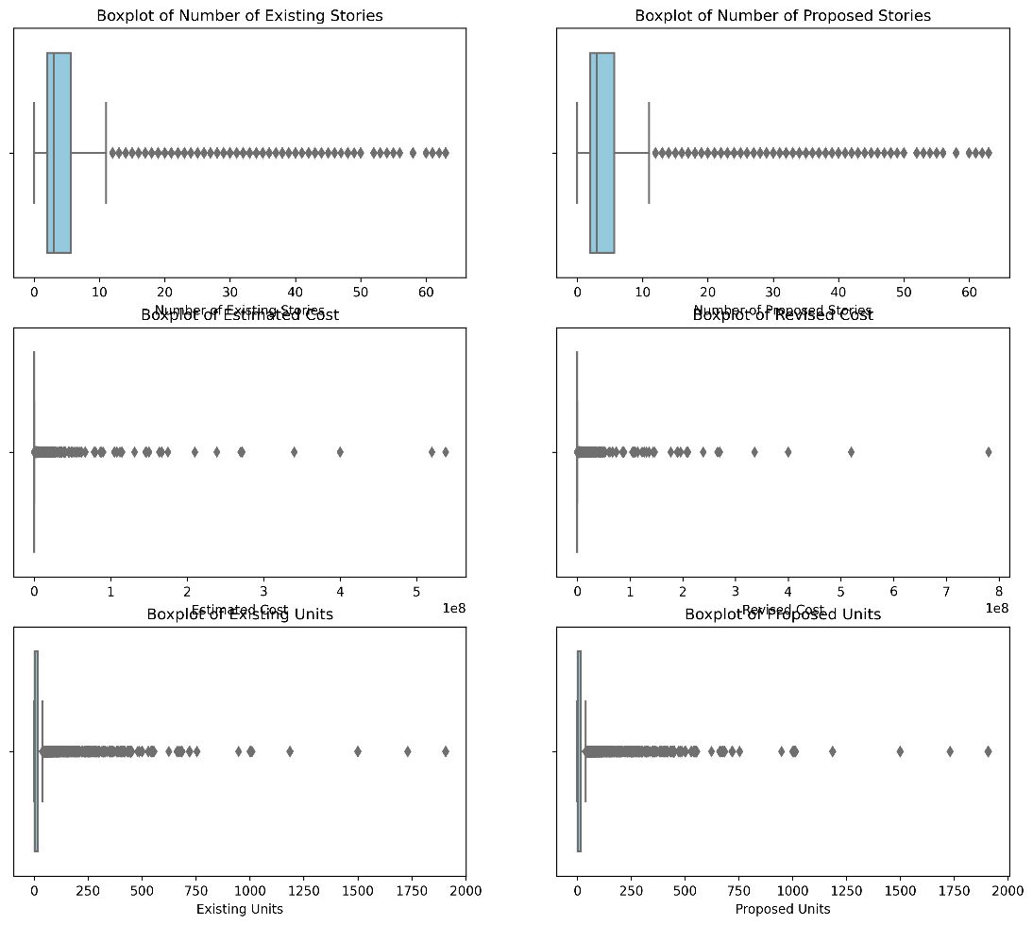
Figure 1: Outliers detection, boxplots.

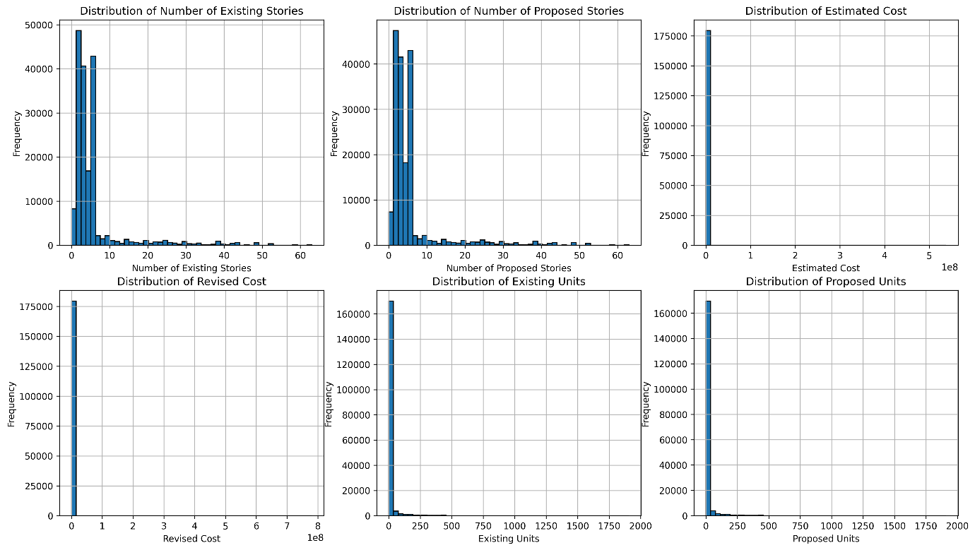
Figure 2: Outliers detection, histogram distribution.

Redundant features:
- Removed previously identified redundant features.

Partial duplicates:
- Logged presence of partial duplicates for further stages (EDA and preprocessing).

Data save:
- I save the cleaned data to a .csv file for further stages.

Exploratory data analysis - EDA:

Build data profiles and tables:
- Revision of the categorical data from the data wrangling phase.
- Revision of the outliers identified in the data wrangling phase:
- First, a distinction is made (split into two separate datasets) between “high-rise” and “low-rise” buildings. This makes plausible sense in construction and urban planning analysis as both building types behaves differently across costs, timeline, permitting and project types.
- Second, np.log1p() will be applied to normalize the skewness of the following features: Estimated Cost, Revised Cost, Existing Units, and Proposed Units. These variables are likely to be right-skewed due to their scale and distribution characteristics. Since they contain valuable information relevant to the predictive task, applying a log transformation helps reduce skewness, stabilize variance, and improve the performance and reliability of machine learning models.

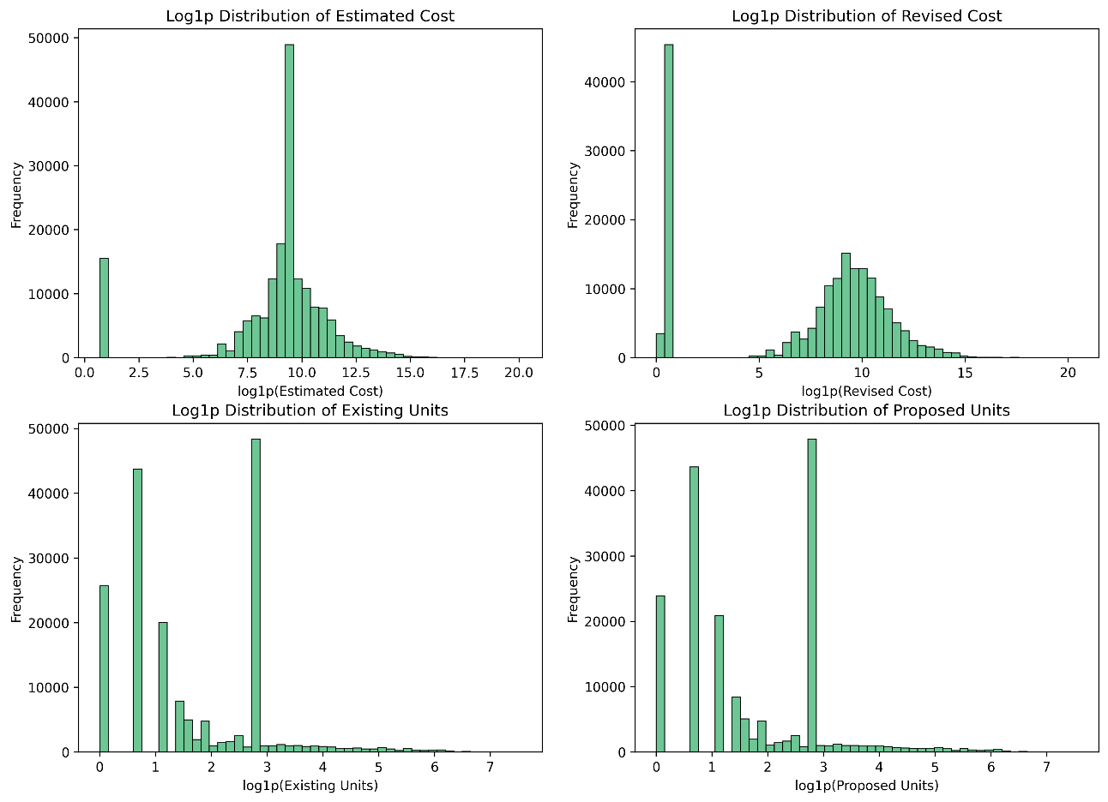
Figure 3: Outliers log transformation.

- Partial duplicates with the same Permit Number are retained, as they reflect meaningful variations (e.g., extensions or modifications) and contribute valuable information for classifying permit types.
- Retaining the original data ensures more precise input for learning. To avoid multicollinearity and preserve model reliability, range-based features are dropped, allowing the model to focus on the most informative variables.
- Inferential statistics: features preselection and feature engineering.
- Inferential statistics: the significance of each feature variable—whether categorical or numerical—has been evaluated with respect to the "Permit Type" target variable using appropriate statistical tests. A p-value threshold of 0.05 has been applied to determine statistical significance.

Explore data relationships:

