Springboard Capstone two:

“Classifying Permit Types from San Francisco Building Permit Data Using Machine Learning.”

Benoit Loze
18/07/2025
Table of Contents
1 Problem statement: 5
1.1 Problem: 5
1.2 Context: 5
1.3 Success Criteria: 5
1.4 Solution Scope: 5
1.5 Constraints: 5
2 Data wrangling: 6
2.1 Data inspection and definition: 6
2.2 Data cleaning: 6
2.3 Outliers detection: 6
2.4 Redundant features: 8
2.5 Partial duplicates: 8
2.6 Data save: 8
3 Exploratory data analysis - EDA: 9
3.1 Build data profiles and tables: 9
3.2 Explore data relationships: 10
3.3 Data save: 12
4 Data preprocessing: 13
4.1 Predictors check: 13
4.2 Target data check: 13
4.3 Categorical data handling: 13
4.4 Workflow explanation: 14
4.5 Data save: 15
Figure 1: Outliers detection, boxplots. 7
Figure 2: Outliers detection, histogram distribution. 7
Figure 3: Outliers log transformation. 9
Figure 4: Collinearity heatmap. 11
Figure 5: Categorical count plots. 11
Figure 6: Target feature, class imbalance. 13
Introduction:

Problem statement:

Problem:
To develop a supervised machine learning model to classify San Francisco building permit types (e.g., New Construction, Electrical) using structured features, targeting ≥80% accuracy on a held-out test set, within a 4-week timeline.

Context:
Municipal offices handle large volumes of permits. Automating permit classification using historical data can streamline workflows, detect anomalies, and optimize processing. The San Francisco Building Permits dataset (2013–2018, Kaggle) will be used.

Success Criteria:
- ≥80% classification “accuracy”.
- Complete Jupyter Notebook (data wrangling, EDA, preprocessing, modeling).
- Clear report and slide deck for non-technical stakeholders.

Solution Scope:
- Supervised classification only.
- Comparison of model types.

Constraints:
- Missing/inconsistent data.
- Potential class imbalance.
- Need for feature engineering.
- Assumes correct labeling in the source dataset.

Data wrangling:

Data inspection and definition:
- Loaded the dataset and reviewed general information.
- Inspected null values for each feature.
- Identified features with less than 5% missing values.
- Marked features expected to be in date format.
- Marked features expected to be categorical.
- Identified numerical features.
- Detected redundant features.
- Confirmed absence of fully duplicated rows.
- Identified presence of partial duplicates.

Data cleaning:
- Dropped features with more than 50% missing values.
- Removed rows with missing values in features having <5% nulls.
- Imputed missing values in numerical features:
  - Used mean values by default.
  - Used median for skewed distributions (e.g., Estimated Cost).
- Converted date-type columns and applied forward fill by Permit Number.
- For categorical features:
  - Detected and corrected fuzzy duplicate entries.
  - Corrected data types.
  - Imputed missing values using the mode (most frequent category).

Outliers detection:
- Flagged numerical features which are likely to contain outliers.
- Visualized distributions using boxplots and histograms.
- Counted outliers per numerical feature.

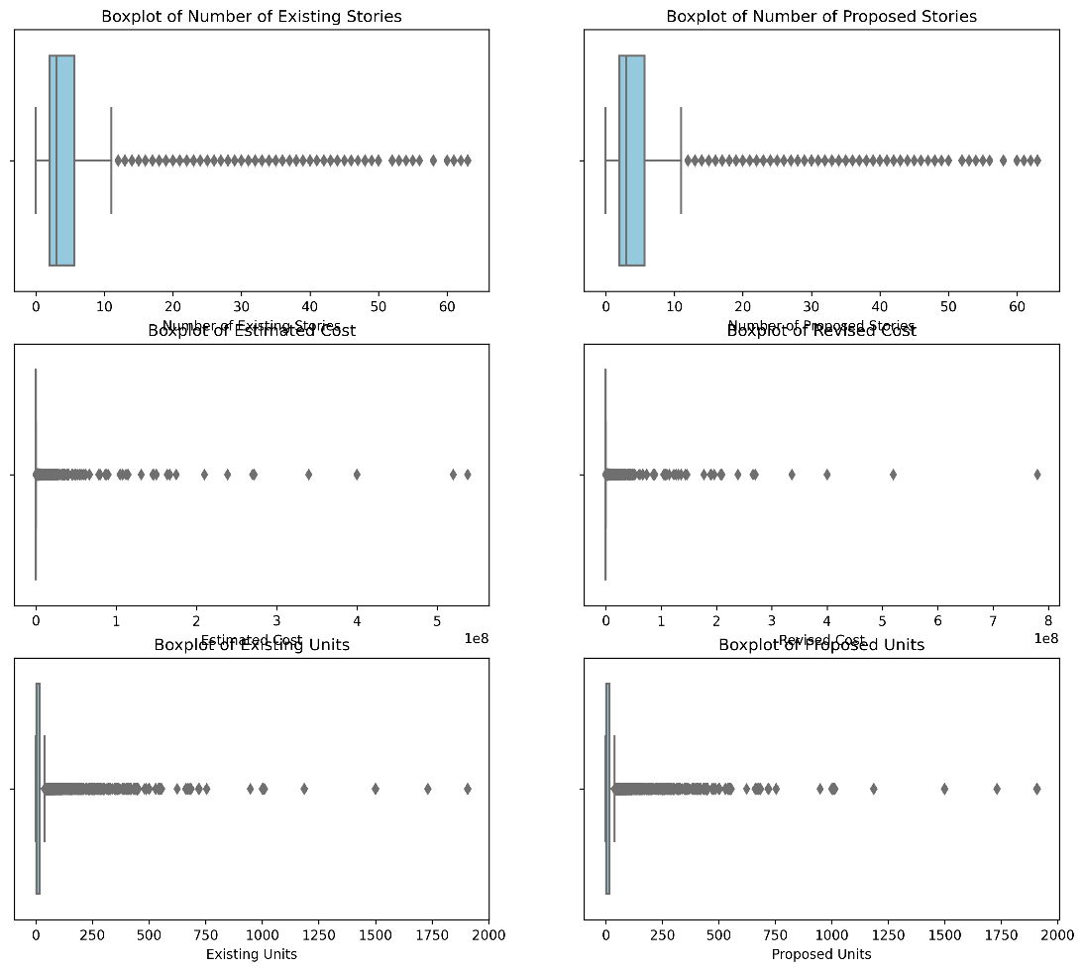
Figure 1: Outliers detection, boxplots.

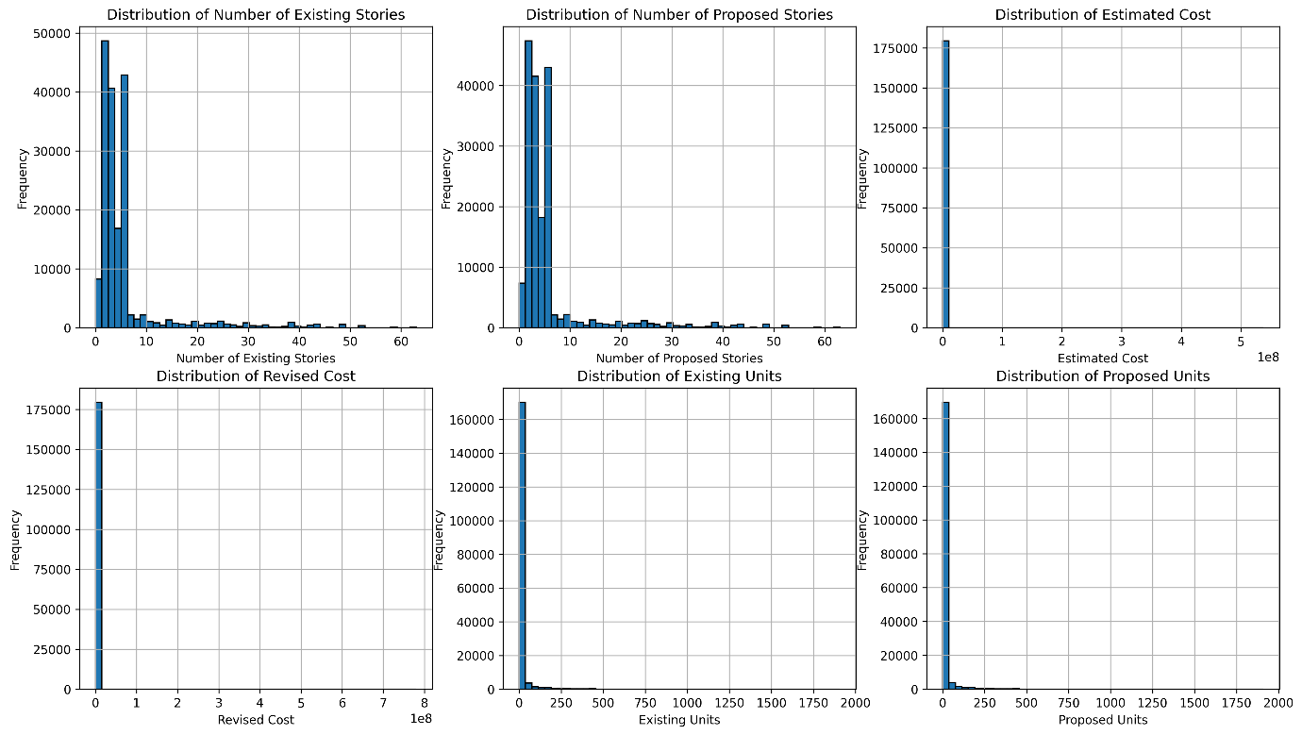
Figure 2: Outliers detection, histogram distribution.

Redundant features:
- Removed previously identified redundant features.

Partial duplicates:
- Logged presence of partial duplicates for further stages (EDA and preprocessing).

Data save:
- The cleaned data is saved to a .csv file for further stages.

Exploratory data analysis - EDA:

Build data profiles and tables:
- Revision of the categorical data from the data wrangling phase.
- Revision of the outliers identified in the data wrangling phase:
- First, a distinction is made (split into two separate datasets) between “high-rise” and “low-rise” buildings. This makes plausible sense in construction and urban planning analysis as both building types behaves differently across costs, timeline, permitting and project types.
- Second, np.log1p() will be applied to normalize the skewness of the following features: Estimated Cost, Revised Cost, Existing Units, and Proposed Units. These variables are likely to be right-skewed due to their scale and distribution characteristics. Since they contain valuable information relevant to the predictive task, applying a log transformation helps reduce skewness, stabilize variance, and improve the performance and reliability of machine learning models.

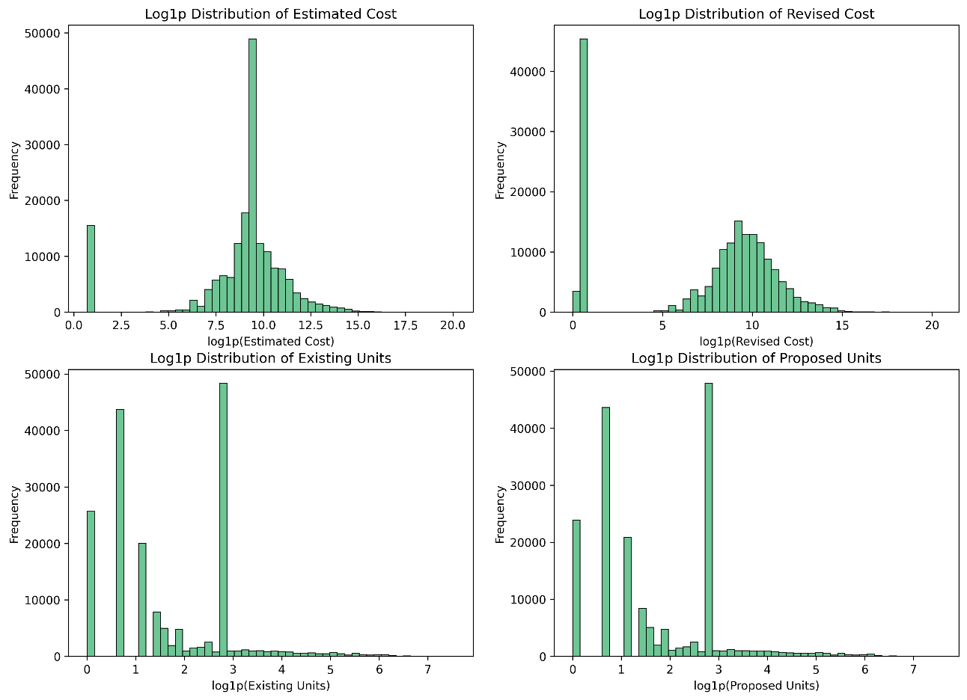
Figure 3: Outliers log transformation.

- Partial duplicates with the same Permit Number are retained, as they reflect meaningful variations (e.g., extensions or modifications) and contribute valuable information for classifying permit types.
- Retaining the original data ensures more precise input for learning. To avoid multicollinearity and preserve model reliability, range-based features are dropped, allowing the model to focus on the most informative variables.
- Inferential statistics: features preselection and feature engineering.
- Inferential statistics: the significance of each feature variable—whether categorical or numerical—has been evaluated with respect to the "Permit Type" target variable using appropriate statistical tests. A p-value threshold of 0.05 has been applied to determine statistical significance.

Explore data relationships:

- The final goal is to use Logistic Regression and Random Forest to classify the target variable, Permit Type.
- Logistic Regression assumes independence among predictors and is sensitive to multicollinearity, which can distort coefficient estimates and inflate standard errors.
- Random Forest is more robust to collinearity, but high correlation between features can still affect feature importance interpretation.

- To mitigate multicollinearity, it is good practice to drop one of the correlated features when the correlation coefficient exceeds 0.80.
The following feature pairs are affected:
- Revised Cost vs Estimated Cost.
- Proposed Construction Type vs Existing Construction Type.
- Proposed Units vs Existing Units.

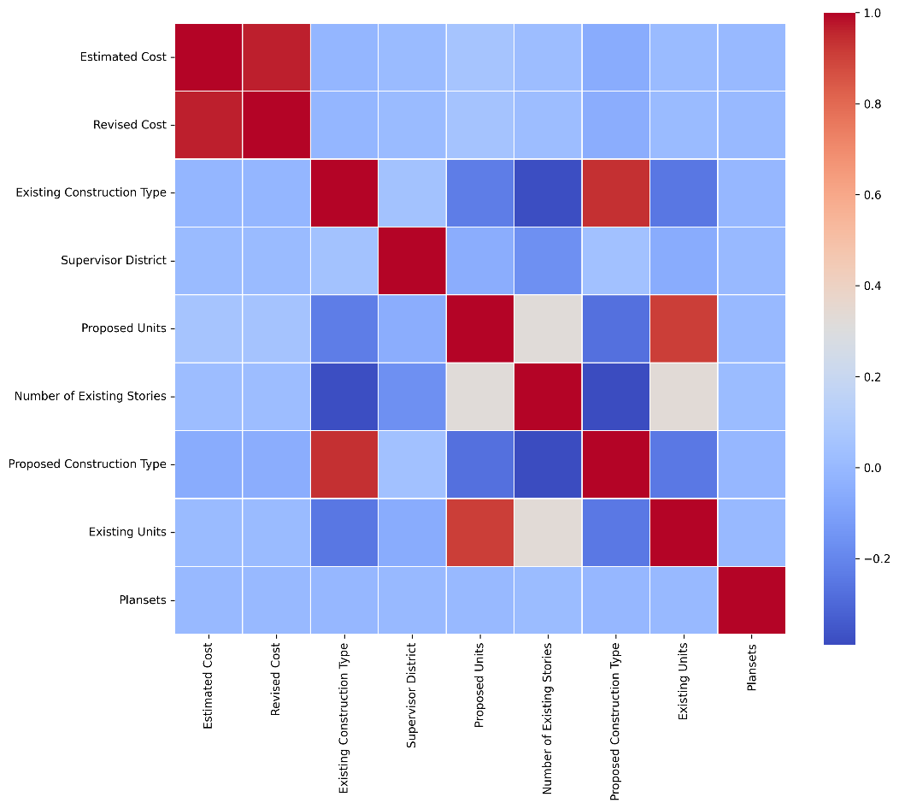

Figure 4: Collinearity heatmap.

- Verification of the data distribution of the categorical features with count plot.
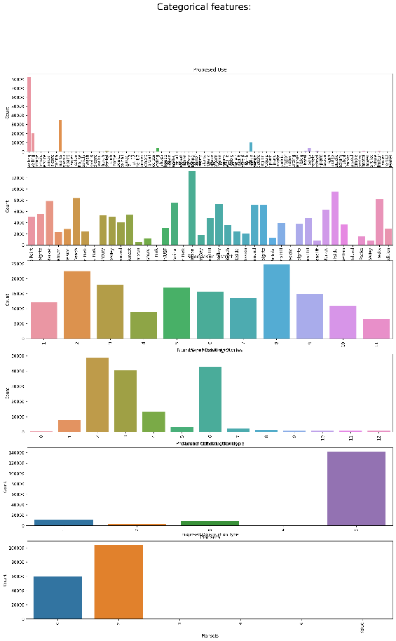
Figure 5: Categorical count plots.

- One hot encoding applied to the data. However, this step will be revised and refined in the further stage of data preprocessing.

Data save:
- The data is saved to a .csv file for further stages.

Data preprocessing:

Predictors check:
- The loaded dataset has been re-checked to ensure consistency and correctness.
- Numerical features with confirmed skewed distributions undergo log transformation to reduce skewness and enhance model performance.

Target data check:
- The distribution of the dependent variable reveals a clear class imbalance across the eight categories of Permit Type.
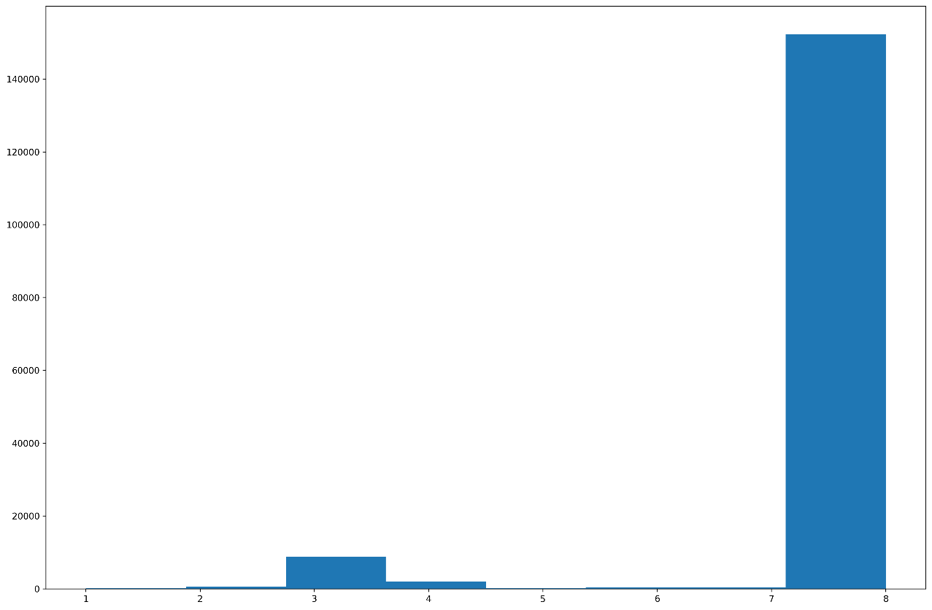
Figure 6: Target feature, class imbalance.

Categorical data handling:
- Regression models (e.g., linear or logistic regression) are favored by one-hot encoding.
- Tree-based models can natively handle categorical features.

Workflow explanation:
- A key priority in this workflow is to avoid data leakage, which can lead to artificially inflated model performance during training and failure when deployed in real-world scenarios. To maintain model integrity and generalizability, the following steps are applied:

- Data Splitting:
- The dataset is first split into training and test sets.
- Handling Class Imbalance (SMOTE Alternative):
- Initially, SMOTE (Synthetic Minority Oversampling Technique) was considered, but compatibility issues with the imblearn package prompted a shift.
- Instead, we now leverage the class_weight parameter in machine learning models to adjust for class imbalance during training.
- Categorical Feature Encoding:
- Tree-Based Models (e.g., Random Forest):
- Apply Target Encoding to categorical variables.
- The encoder is fit only on the training data to avoid leakage and applied consistently to test data.
- Regression-Based Models (e.g., Logistic Regression):
- Use One-Hot Encoding on categorical features.
- Align training and test datasets to ensure consistent feature columns across both.
- Feature Scaling:
- Scaling is applied only to regression-based models, as tree-based models are scale-invariant.
- Standard scaling techniques (e.g., StandardScaler) are fit on the training data only and then applied to the test data.
- This pipeline avoids data leakage, ensures compatibility with the current environment, and maintains a clear distinction between training and test data throughout preprocessing. It also adapts feature engineering techniques to suit the model type while handling class imbalance.

Data save:
- The data is saved to a .csv file for further stages.

Modelling:

