Springboard Capstone three

Documentation report:
“Classifying fake news using Kaggle datasets.”

Benoit Loze
25/08/2025
Table of Contents
1 Problem statement: 6
1.1 Problem: 6
1.2 Context: 6
1.3 Success Criteria: 6
1.4 Solution Scope: 6
1.5 Constraints: 6
2 Data wrangling: 7
2.1 Data cleaning: 7
2.1.1 Data inspection: 7
2.1.2 Missing values: 7
2.1.3 Duplicates: 7
2.1.4 Target label check: 7
2.2 Text normalization: 7
2.3 Data save: 7
3 Exploratory data analysis - EDA: 8
3.1 Target label balance: 8
3.2 Length of text: 8
3.3 Outliers’ detection: 9
3.4 Vocabulary richness: 9
3.5 Terms frequency: 10
3.6 Part of speech (POS) – proper nouns and other nouns: 10
3.6.1 Proper nouns vs other nouns ratio: 10
3.6.2 Proper nouns document frequency: 11
3.7 Named entities recognition (NER): 11
3.7.1 NER ratio: 11
3.7.2 NER frequency: 12
3.8 Polarity & subjectivity: 12
3.9 Readability: 12
3.10 General conclusion: 13
3.11 Data save: 13
4 Data preprocessing: 14
4.1 Predictors check: 14
4.2 Target data check: 14
4.3 Categorical data handling: 14
4.4 Workflow explanation: 15
4.5 Data save: 16
5 Modelling: 17
5.1 Regression-based model: 17
5.1.1 Hyperparameter tuning: 17
5.1.2 Performance metrics: 17
5.2 Tree-based model: 18
5.2.1 Hyperparameter tuning: 18
5.2.2 Performance metrics: 18
5.3 Model selection & key takeaways: 19
5.4 Data save: 19

Figure 1: Outliers detection, boxplots. 8
Figure 2: Outliers detection, histogram distribution. 8
Figure 3: Outliers log transformation. 10
Figure 4: Collinearity heatmap. 11
Figure 5: Categorical count plots. 12
Figure 6: Target features, class imbalance. 13
Figure 7: Multinomial logistic regression, Bayesian optimization, confusion matrix. 17
Figure 8: Random Forest, Bayesian optimization, confusion matrix. 18
Introduction & important note:
This report presents the development of a supervised machine learning model to classify building permit types in San Francisco using structured features from the 2013–2018 open permit dataset. Given the high volume and complexity of permit applications, automating permit type classification aims to improve processing efficiency and decision support within municipal workflows.
The project compares multinomial logistic regression with tree-based models (Random Forest), evaluates multiple preprocessing strategies to address class imbalance, and applies both randomized and Bayesian hyperparameter search.
The final model, Random Forest with Bayesian Optimization, achieved a strong F1 score (0.81) and demonstrated balanced precision and recall across all eight permit categories. The full modeling workflow, including data wrangling, EDA, preprocessing, and performance evaluation, is documented in this report.

The first fake news classification attempt was conducted based upon the Kaggle csv-format dataset downloaded from this url:
https://www.kaggle.com/datasets/mahdimashayekhi/fake-news-detection-dataset
However, its exploratory data analysis (EDA) stage insights and its modeling stage results did not yield any tangible outcomes. This was primarily because the provided text data lacked coherence and could therefore be considered erroneous.

The second fake news classification attempt was conducted based upon the Kaggle csv-format dataset downloaded from this url:
https://www.kaggle.com/datasets/saurabhshahane/fake-news-classification
This time its exploratory data analysis (EDA) stage ield some interesting insights supporting any future feature engineering. Besides, its modeling stage results performed better than random chance and were able to meet the initial success criteria.

This report is based on the utilization of the second fake news classification Kaggle dataset.

Problem statement:

Problem:
To develop a supervised learning model to sort and classify fake news from real news using structured features, targeting ≥85% accuracy on a held-out test set, within a 3-week timeline.

Context:
Misinformation or "fake news" can strongly influence political, social, and economic life, often in harmful or biased ways. Detecting and classifying fake news is therefore essential to reduce its spread and restore constructive debates. This project aims to classify news articles as “fake” or “real”, focusing on analyzing article text and headlines to identify linguistic patterns linked to misinformation.

Success Criteria:
- ≥85% classification “accuracy”.
- Complete Jupyter Notebooks (data wrangling, EDA, preprocessing, modeling).
- Clear documentation report and presentation slide deck for non-technical stakeholders.

Solution Scope:
- Kaggle csv-format datasets.
- Supervised classification with machine learning models, deep learning model and natural language processing (NLP) model.
- Comparison of model types.

Constraints:
- Missing/inconsistent data.
- Potential class imbalance.
- Potential need for feature engineering.
- Assumes correct labeling in the source dataset.

Data wrangling:

Data cleaning:

Data inspection:
- Loaded the dataset and reviewed general information.
- Inspected null values for each feature.

Missing values:
- Removed rows with missing values in features having <5% nulls.
- Check of their removal on the target label balance.

Duplicates:
- Identification of duplicates.
- Removal of duplicates.

Target label check:
- Final check of the target label balance.

Text normalization:
- Tokenization.
- Removal of punctuations, digits and stop words.
- Selection of words with at least one alpha character (to keep such word as covid-19, etc.).
- Final lemmatization and character lowering.
- Creation of two corresponding additional feature columns: “title_cleaned” & “text_cleaned”.

Data save:
- The initial “text”, “title” and “label” features are saved as a csv-format file for future use.
- The lemmatized and cleaned dataset is saved separately.

Exploratory data analysis - EDA:

Target label balance:
- Some imbalance of 11.50 %, favoring “fake news” over “real news”.
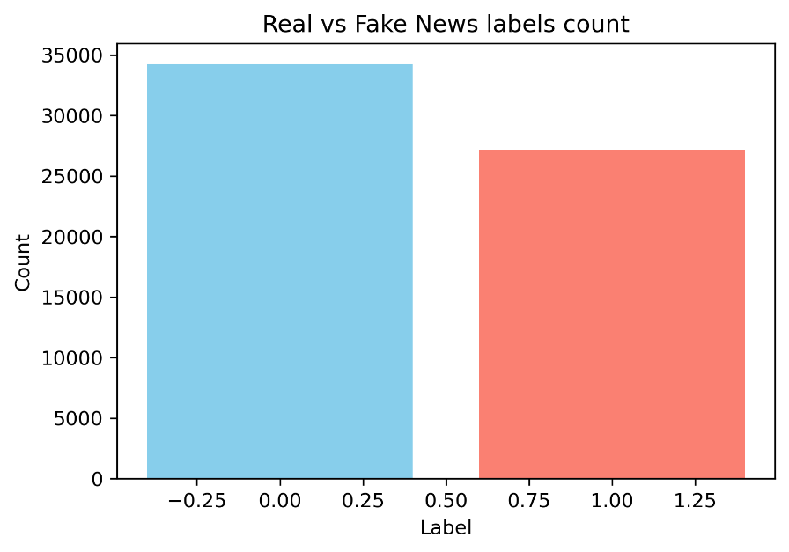

Length of text:
- Strong overlaps with however some slight differences in title and text length between both classes.
- Title length is somewhat shorter for “fake news”.
- Text length is somewhat longer for “fake news”.
- Overall, the length of text is a weak discriminator for classification.

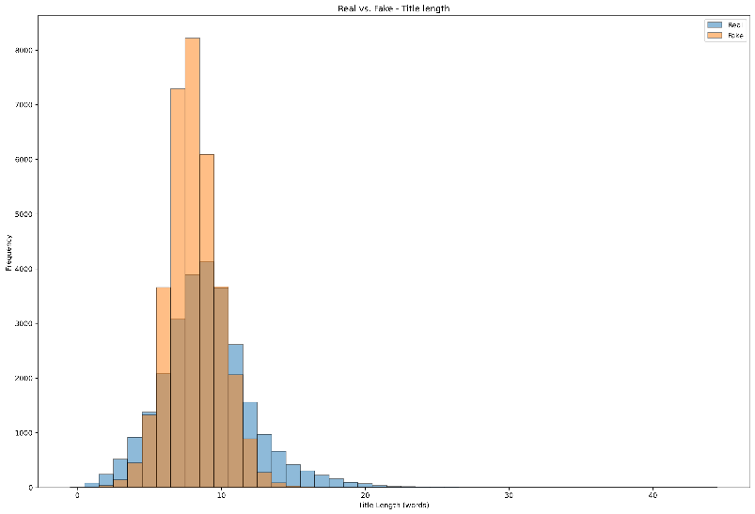

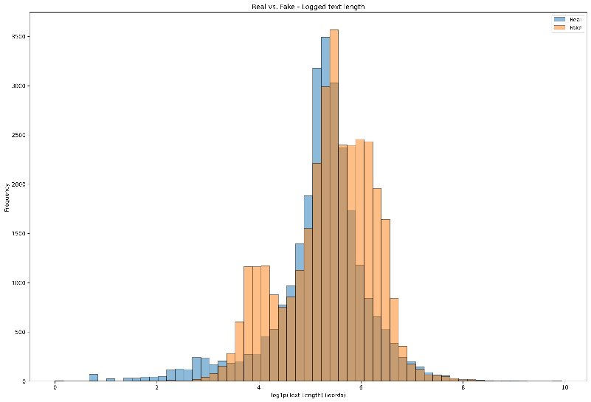

Outliers’ detection:
- The length of text showed the presence of outliers.
- The outliers for titles could be safely removed (< 5.00 %).
- The outliers for real text could not be safely removed (> 5.00%) and numpy.log1p() has been used for distribution comparison.
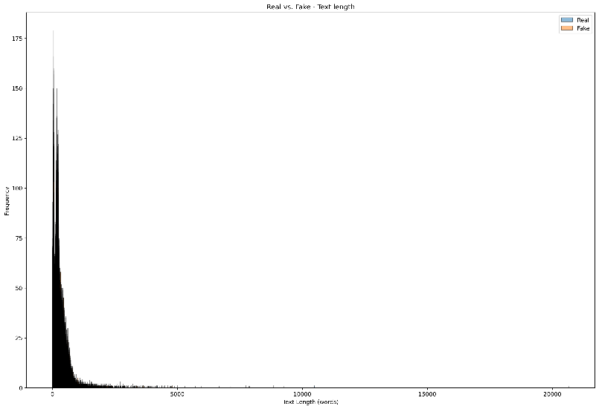

Vocabulary richness:
- “Real news” vocabulary richness index = 0.70.
- “Fake news” vocabulary richness index = 0.68.
- Overall, the vocabulary richness is a weak discriminator for classification.

Terms frequency:
- Strong overlaps between both classes in both title and text.
- Terms frequency is a weak discriminator for classification.
- However, there are some slight tendencies:
  - “Fake news” titles = institutional and geopolitical terms.
  - “Real news” text = campaign and opinion terms.
  - “Fake news” text = reporting style.
  - “Real news” text = social medias topics.
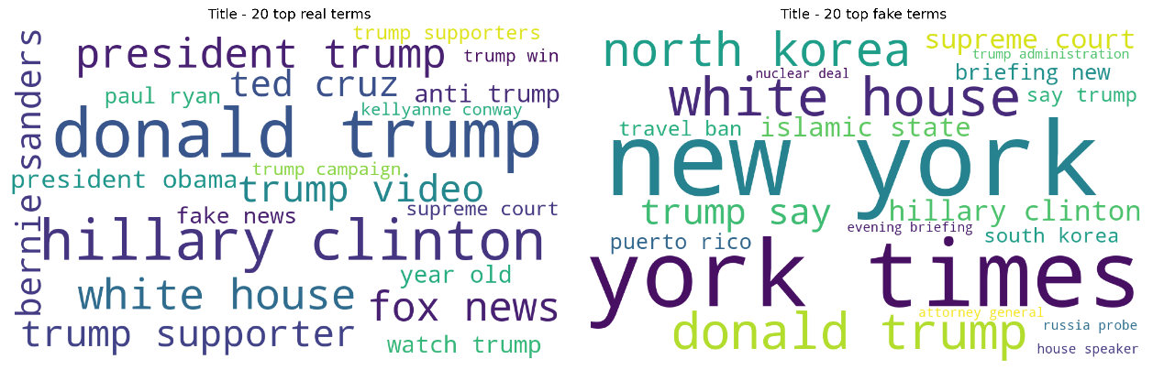

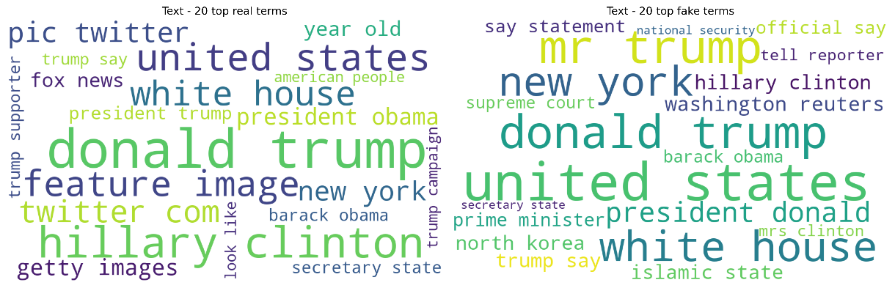

Part of speech (POS) – proper nouns and other nouns:

Proper nouns vs other nouns ratio:
- Title is a strong discriminator:
  - “Fake news” = generic nouns.
  - “Real news” = proper nouns.
- Text is a weak discriminator.
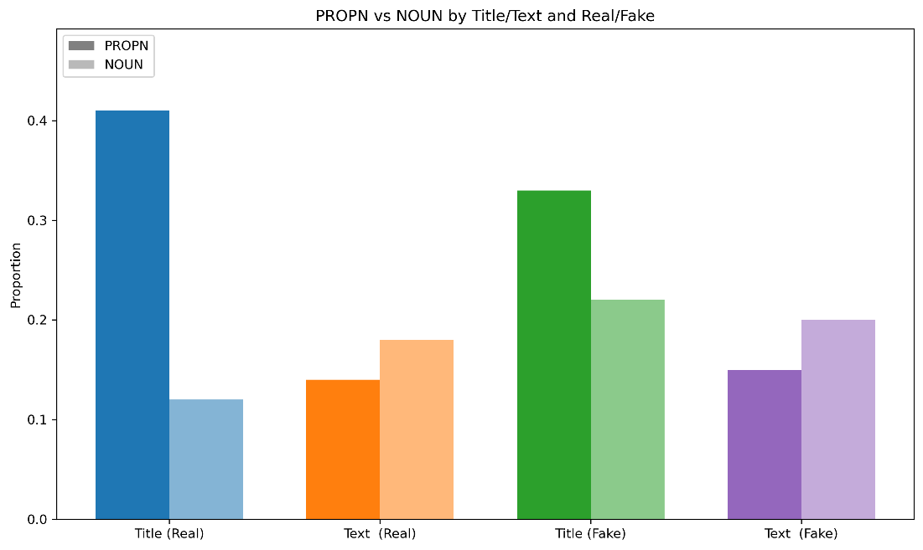

Proper nouns document frequency:
- Strong overlaps between both classes in both title and text.
- Proper nouns document frequency is a weak discriminator for classification.
- However, there are some slight tendencies:
  - “Fake news” title & text = institutional and “wired-style” terms.
  - “Real news” title & text = media & social medias terms. More sensational terms.
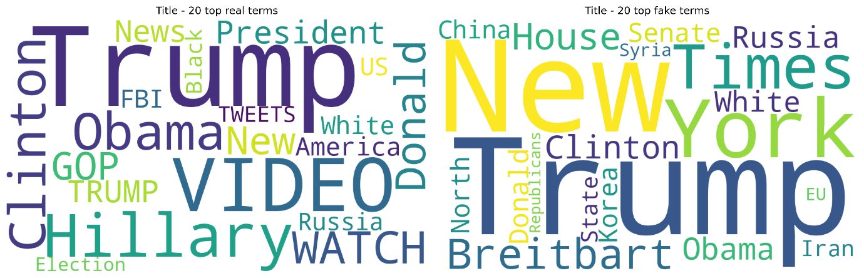

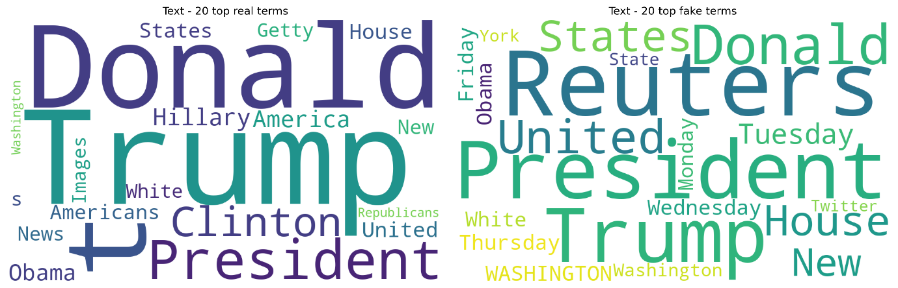

Named entities recognition (NER):

NER ratio:
- Title is a strong discriminator:
  - “Fake news” = higher named entities ratio.
- Text is a weak discriminator.

NER frequency:
- Strong overlaps between both classes in both title and text.
- NER frequency is a weak discriminator for classification.
- However, there are some slight tendencies:
  - “Fake news” title & text = institutional and “wire-style” terms.
  - “Real news” title & text = person-centric & social medias terms.

Polarity & subjectivity:
- Polarity:
  - Title =” fake news" reveal more polarity than "real news". This is a strong discriminator.
  - Text = “fake news" and "real news" show quite similar polarity. This is a weak discriminator.
- Subjectivity:
  - Title =” real news" reveal more subjectivity than "fake news". This is a strong discriminator.
  - Text= "real news" reveal more subjectivity than "fake news". This is a strong discriminator.

Readability:
- Text:
  - "Real news" = easier to read. This is a strong discriminator.
- Title:
  - "Fake news" are easier to read. This is a strong discriminator.

General conclusion:
In this “exploratory data analysis” (EDA) stage several potential features were explored:
- WEAK DISCRIMINATORS:
  - Length of text.
  - Vocabulary richness.
  - Terms frequency.
  - POS proper noun/other noun ratio text.
  - NER ratio text.
  - NER frequency.

- STRONG DISCRIMINATORS:
  - POS proper noun/other noun ratio title.
  - NER ratio title.
  - Polarity title.
  - Polarity text.
  - Subjectivity title.
  - Subjectivity text.
  - Readability title.
  - Readability text.

Data save:
- The data is saved to a .csv file for further stages.

Data preprocessing:

Important notes:
- Due to the limited reliability of the first dataset and the significant time required to address it, the insights uncovered during the “exploratory data analysis” (EDA) stage could not be fully integrated into this feature engineering and preprocessing stage. Incorporating these insights might have enhanced the performance of the machine learning models relative to the deep learning and transformer models. This limitation will therefore be carried forward as a final recommendation for future work.
- To avoid “data leakage” the data split is always performed before any important data manipulation.

Preparation for machine learning modeling:
- TFIDF vectorization.
- “Tile_cleaned” and “text_cleaned” features are vectorized separately.

Preparation for deep learning modeling:
- Tokenizer expect a series input, therefore, “title_cleaned” and “text_cleaned” are combined to preserve the signal from both features.

Preparation for transformer modeling:
- “Title_cleaned” and “text_cleaned” are combined to preserve the signal from both features.
- Target label preparation.
- Tokenizer setup.
- Tokenization & encoding.
- Dataset structuring (NumpyDataset).

Modelling:
- Instead of accuracy, the evaluation focused on more informative metrics:
- F1-score.
- Precision.
- Recall.
- Confusion Matrix.
- Models’ metrics files are all available in the subfolder: “model_metrics_files”.

Machine learning modeling – Random Forest:

Hyperparameter tuning – Bayesian optimization:
- “Bayesian optimization” best hyperparameters:
{'max_iter': 1000, 'C': 10}

Performance metrics:
- In both case of “Randomized Search” and “Bayesian Search”, the performance metrics and the confusion matrices are similar.
- The confusion matrices show:
- A large number of samples from the class 7 were misclassified either as class 2, class 4, class 6.
- A little bit more than half the class 7 was correctly predicted.
- This may show persistent confusion due to the class imbalance despite the balancing efforts.
- Some samples of class 2 were misclassified as the class 7.
- High recall compared to low precision can be explained is a sign that the model is overpredicting the dominant class.
- F1 score is the harmonic mean of precision and recall and precision drags the effectiveness down.
- The F1 score makes the model prediction moderate but in its lower range.

Figure 7: Multinomial logistic regression, Bayesian optimization, confusion matrix.

Machine learning modeling – Logistic Regression:

Hyperparameter tuning – Bayesian optimization:
- “Bayesian optimization” best hyperparameters:
{'max_iter': 1000, 'C': 10}

Performance metrics:
- Tree-based models, especially Random Forest, perform significantly better than logistic regression on imbalanced data.
- Bayesian search yields more balanced precision and recall compared to randomized search.
- Class 7 predictions improved: fewer misclassifications as class 2, raising precision.
- Class 2 sees some misclassification into class 7, slightly reducing recall.
- Despite tradeoffs, the F1 score remains strong, indicating overall robustness.
- Conclusion: Tree-based models, particularly with Bayesian optimization, handle imbalance more effectively and provide balanced performance across classes.
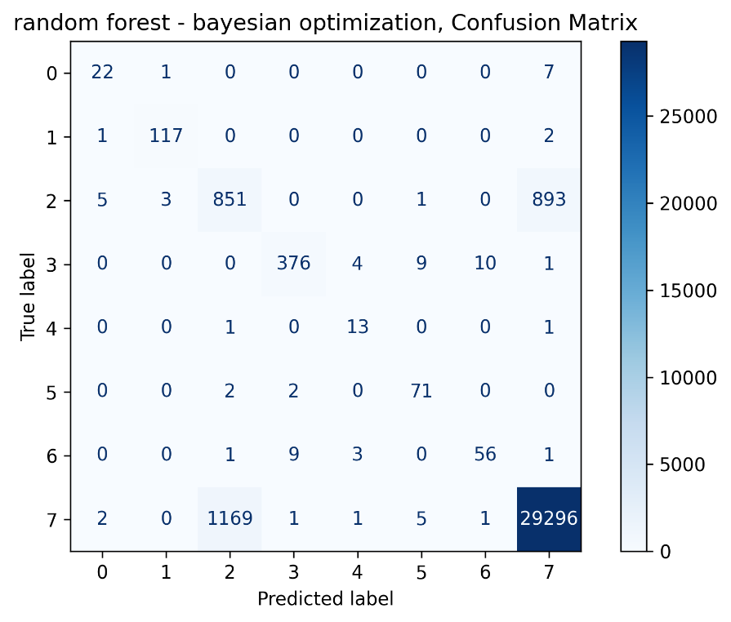
Figure 8: Random Forest, Bayesian optimization, confusion matrix.

Deep learning modeling – bi-LSTM:

Modeling:

Performance metrics:

Transformer modeling:

Modeling:

Performance metrics:

Model selection:

Recommendations & future work:

*********

