Springboard Capstone three

Documentation report:
“Classifying fake news using Kaggle datasets.”

Benoit Loze
25/08/2025
Table of Contents
1 Problem statement: 6
1.1 Problem: 6
1.2 Context: 6
1.3 Success Criteria: 6
1.4 Solution Scope: 6
1.5 Constraints: 6
2 Data wrangling: 7
2.1 Data cleaning: 7
2.1.1 Data inspection: 7
2.1.2 Missing values: 7
2.1.3 Duplicates: 7
2.1.4 Target label check: 7
2.2 Text normalization: 7
2.3 Data save: 7
3 Exploratory data analysis - EDA: 8
3.1 Target label balance: 8
3.2 Length of text: 8
3.3 Outliers’ detection: 9
3.4 Vocabulary richness: 9
3.5 Terms frequency: 10
3.6 Part of speech (POS) – proper nouns and other nouns: 10
3.6.1 Proper nouns and other nouns ratio: 10
3.6.2 Proper nouns document frequency: 11
3.7 Named entities recognition (NER): 12
3.7.1 NER ratio: 12
3.7.2 NER frequency: 12
3.8 Polarity & subjectivity: 13
3.9 Readability: 14
3.10 General conclusion: 15
3.11 Data save: 15
4 Data preprocessing: 16
4.1 Preparation for machine learning modeling: 16
4.2 Preparation for deep learning modeling: 16
4.3 Preparation for transformer modeling: 16
5 Modelling: 17
5.1 Machine learning modeling – Random Forest: 17
5.1.1 Hyperparameter tuning – Bayesian optimization: 17
5.1.2 Performance metrics: 17
5.2 Machine learning modeling – Logistic Regression: 18
5.2.1 Hyperparameter tuning – Bayesian optimization: 18
5.2.2 Performance metrics: 18
5.3 Deep learning modeling – bi-LSTM: 18
5.3.1 Modeling: 18
5.3.2 Performance metrics: 19
5.4 Transformer (DistilBERT)modeling: 20
5.4.1 Modeling: 20
5.4.2 Performance metrics: 21
5.5 Model selection: 21
6 Recommendations & future work: 22
Figure 1: target label balance. 8
Figure 2: length of text - title. 8
Figure 3: length of text - text. 9
Figure 4: length of text - text outliers. 9
Figure 5: terms frequency - title. 10
Figure 6: terms frequency - text. 10
Figure 7: proper nouns and other nouns ratio. 11
Figure 8: proper nouns document frequency - title. 11
Figure 9: proper nouns document frequency - text. 12
Figure 10: named entities (NER) ratio. 12
Figure 11: named entities (NER) frequency - title. 13
Figure 12: named entities (NER) frequency - text. 13
Figure 13: polarity and subjectivity. 14
Figure 14: readability - title. 14
Figure 15: readability - text. 15
Figure 16: confusion matrix - random forest. 17
Figure 17: confusion matrix - logistic regression. 18
Figure 18: deep learning model - loss. 19
Figure 19: deep learning model - accuracy. 20
Introduction & important note:
This report presents the development of a supervised machine learning model to classify and differentiate “fake news” from “real news”, based on a selected Kaggle dataset. Given the bias and the influence of “fake news” over the actual public debates, some detection tool might be of significant value.
The project compares four different models:
- Machine learning, random forest model.
- Machine learning, logistic regression model.
- Deep learning, bi-LSTM model.
- DistilBERT transformer model.
The selected model, DistilBERT transformer, achieved a strong F1 score (0.995) and demonstrated balanced precision and recall across both classes. The full “data science method” workflow, including problem statement, data wrangling, EDA, preprocessing, and performance evaluation, is documented in this report.

The first fake news classification attempt was conducted based upon the Kaggle csv-format dataset downloaded from this url:
https://www.kaggle.com/datasets/mahdimashayekhi/fake-news-detection-dataset
However, its exploratory data analysis (EDA) stage insights and its modeling stage results did not yield any tangible outcomes. This was primarily because the provided text data lacked coherence and could therefore be considered erroneous.

The second fake news classification attempt was conducted based upon the Kaggle csv-format dataset downloaded from this url:
https://www.kaggle.com/datasets/saurabhshahane/fake-news-classification
This time its “exploratory data analysis” (EDA) stage yield some interesting insights supporting any future feature engineering. Besides, its modeling stage results performed better than random chance and were able to meet the initial success criteria.

This report is based on the utilization of the second fake news classification Kaggle dataset.

Problem statement:

Problem:
To develop a supervised learning model to sort and classify fake news from real news using structured features, targeting ≥85% accuracy on a held-out test set, within a 3-week timeline.

Context:
Misinformation or "fake news" can strongly influence political, social, and economic life, often in harmful or biased ways. Detecting and classifying fake news is therefore essential to reduce its spread and restore constructive debates. This project aims to classify news articles as “fake” or “real”, focusing on analyzing article text and headlines to identify linguistic patterns linked to misinformation.

Success Criteria:
- ≥85% classification “accuracy”.
- Complete Jupyter Notebooks (data wrangling, EDA, preprocessing, modeling).
- Clear documentation report and presentation slide deck for non-technical stakeholders.

Solution Scope:
- Kaggle csv-format datasets.
- Supervised classification with machine learning models, deep learning model and natural language processing (NLP) model.
- Comparison of model types.

Constraints:
- Missing/inconsistent data.
- Potential class imbalance.
- Potential need for feature engineering.
- Assumes correct labeling in the source dataset.

Data wrangling:

Data cleaning:

Data inspection:
- Loaded the dataset and reviewed general information.
- Inspected null values for each feature.

Missing values:
- Removed rows with missing values in features having <5% nulls.
- Check their removal on the target label balance.

Duplicates:
- Identification of duplicates.
- Removal of duplicates.

Target label check:
- Final check of the target label balance.

Text normalization:
- Tokenization.
- Removal of punctuation, digits and stop words.
- Selection of words with at least one alpha character (to keep such word as covid-19, etc.).
- Final lemmatization and character lowering.
- Creation of two corresponding additional feature columns: “title_cleaned” & “text_cleaned”.

Data save:
- The initial “text”, “title” and “label” features are saved as a csv-format file for future use.
- The lemmatized and cleaned dataset is saved separately.

Exploratory data analysis - EDA:

Target label balance:
- Some imbalance of 11.50 %, favoring “fake news” over “real news”.
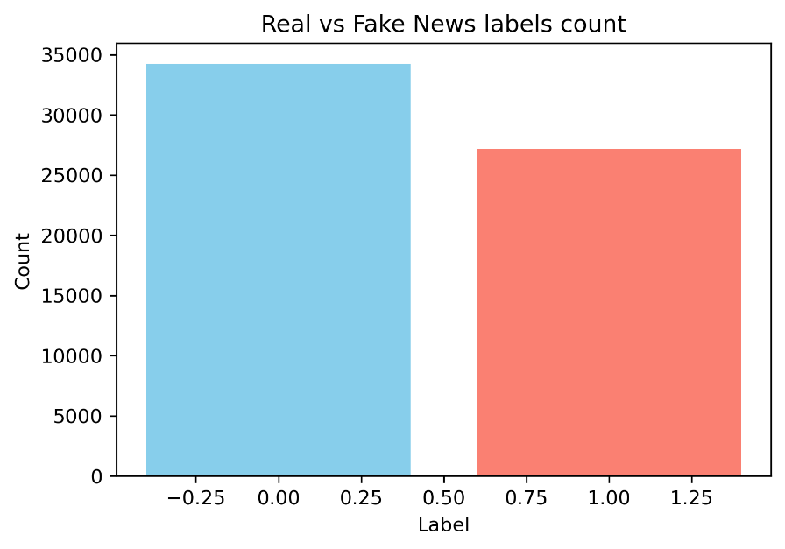
Figure 1: target label balance.

Length of text:
- Strong overlaps with however some slight differences in title and text length between both classes.
- Title length is shorter for “fake news”.
- Text length is longer for “fake news”.
- Overall, the length of text is a weak discriminator for classification.

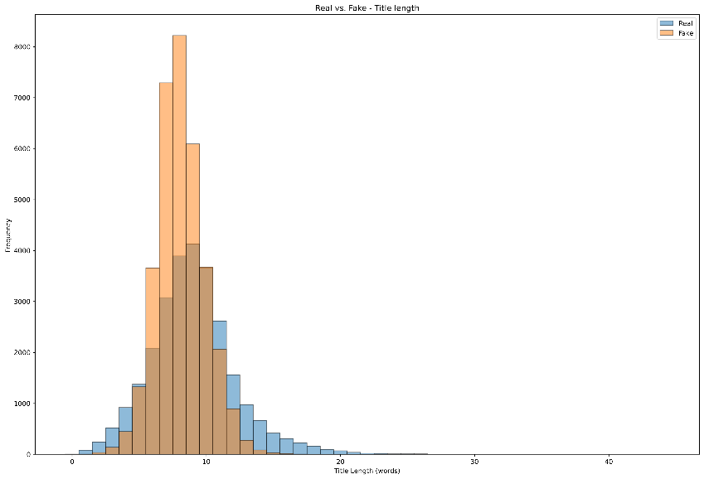
Figure 2: length of text - title.

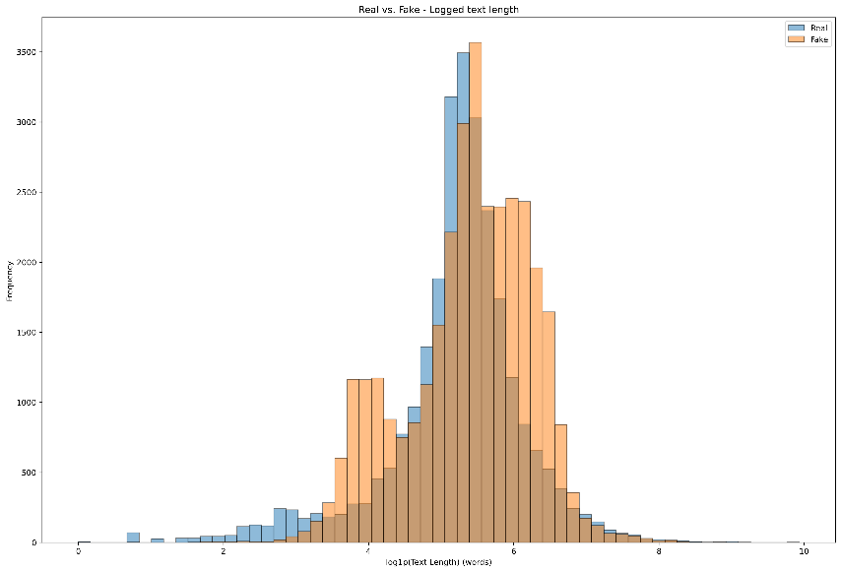
Figure 3: length of text - text.

Outliers’ detection:
- The length of text showed the presence of outliers.
- The outliers for titles could be safely removed (< 5.00 %).
- The outliers for real text could not be safely removed (> 5.00%) and numpy.log1p() has been used for distribution comparison.
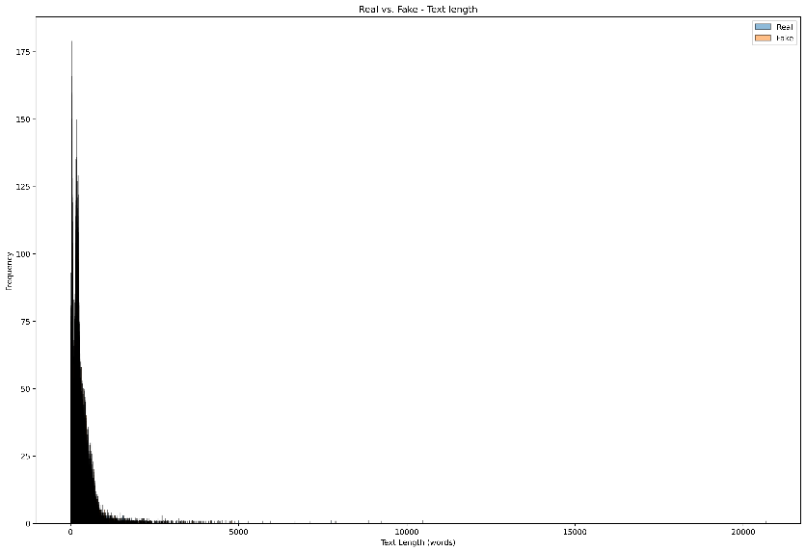
Figure 4: length of text - text outliers.

Vocabulary richness:
- “Real news” vocabulary richness index = 0.70.
- “Fake news” vocabulary richness index = 0.68.
- Overall, the vocabulary richness is a weak discriminator for classification.

Terms frequency:
- Strong overlaps between both classes in both title and text.
- Terms frequency is a weak discriminator for classification.
- However, there are some slight tendencies:
  - “Fake news” titles = institutional and geopolitical terms.
  - “Real news” text = campaign and opinion terms.
  - “Fake news” text = reporting style.
  - “Real news” text = social medias topics.
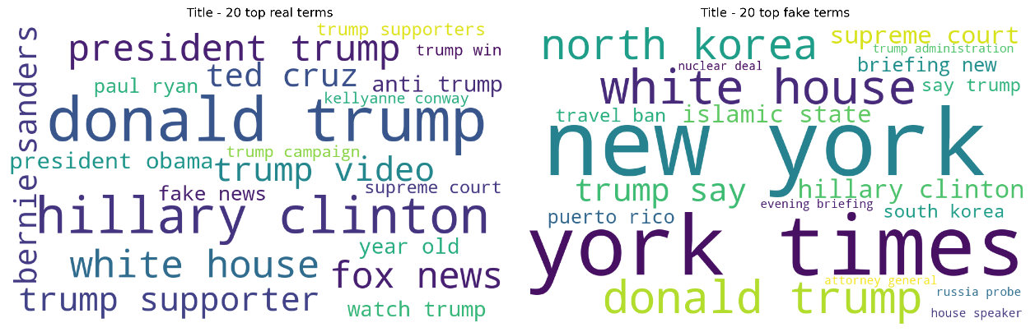
Figure 5: terms frequency - title.

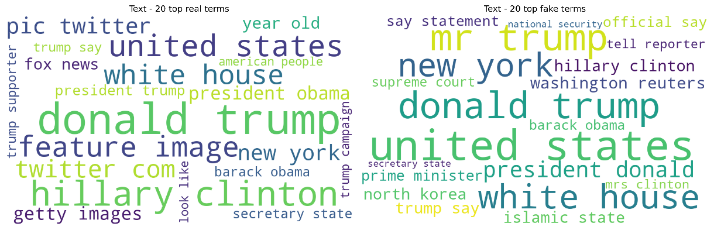
Figure 6: terms frequency - text.

Part of speech (POS) – proper nouns and other nouns:

Proper nouns and other nouns ratio:
- Title is a strong discriminator:
  - “Fake news” = generic nouns.
  - “Real news” = proper nouns.
- Text is a weak discriminator.
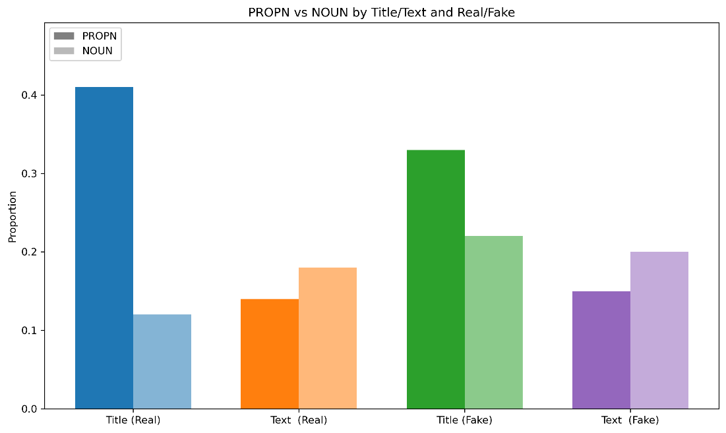
Figure 7: proper nouns and other nouns ratio.

Proper nouns document frequency:
- Strong overlaps between both classes in both title and text.
- Proper nouns document frequency is a weak discriminator for classification.
- However, there are some slight tendencies:
  - “Fake news” title & text = institutional and “wired-style” terms.
  - “Real news” title & text = media & social medias terms. More sensational terms.
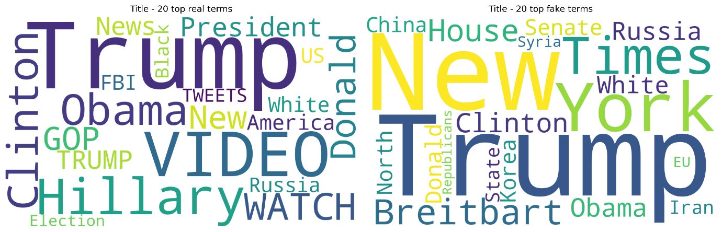
Figure 8: proper nouns document frequency - title.

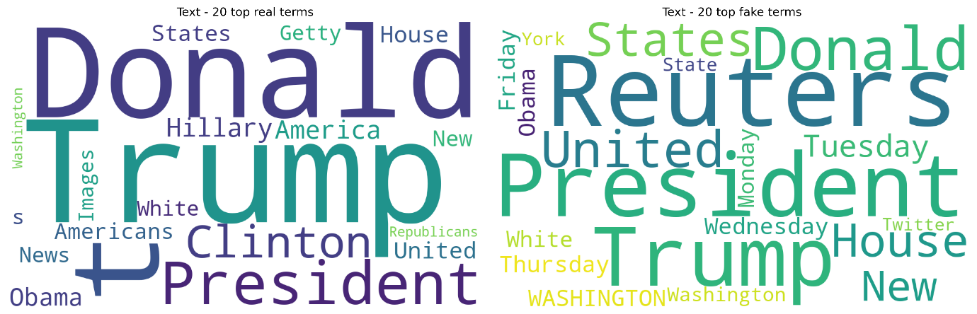
Figure 9: proper nouns document frequency - text.

Named entities recognition (NER):

NER ratio:
- Title is a strong discriminator:
  - “Fake news” = higher named entities ratio.
- Text is a weak discriminator.
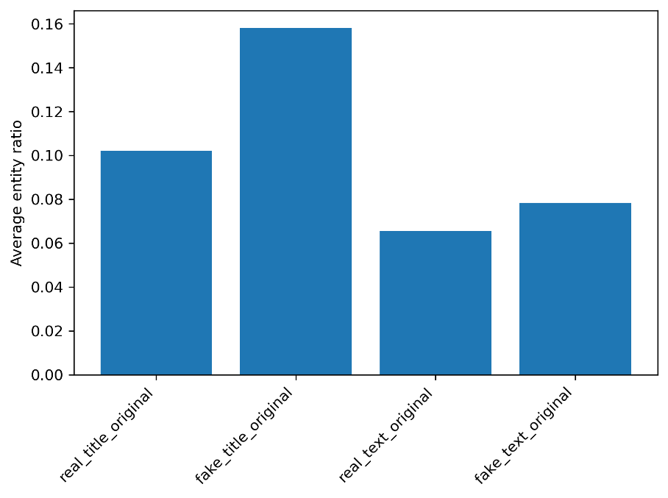
Figure 10: named entities (NER) ratio.

NER frequency:
- Strong overlaps between both classes in both title and text.
- NER frequency is a weak discriminator for classification.
- However, there are some slight tendencies:
  - “Fake news” title & text = institutional and “wire-style” terms.
  - “Real news” title & text = person-centric & social medias terms.
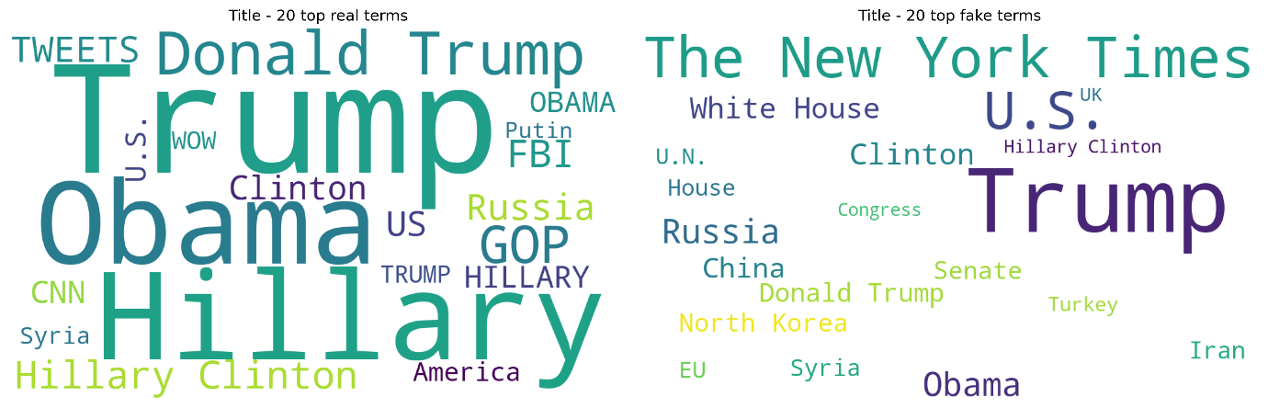
Figure 11: named entities (NER) frequency - title.

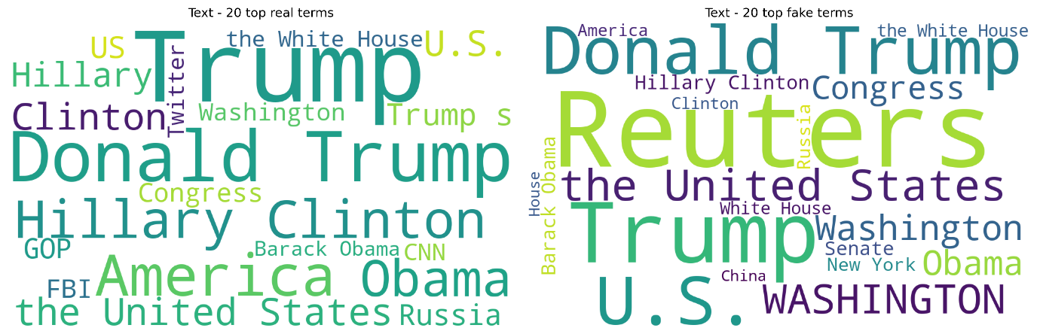
Figure 12: named entities (NER) frequency - text.

Polarity & subjectivity:
- Polarity:
  - Title =” fake news" reveals more polarity than "real news". This is a strong discriminator.
  - Text = “fake news" and "real news" show quite similar polarity. This is a weak discriminator.
- Subjectivity:
  - Title =” real news" reveals more subjectivity than "fake news". This is a strong discriminator.
  - Text= "real news" reveals more subjectivity than “fake news". This is a strong discriminator.

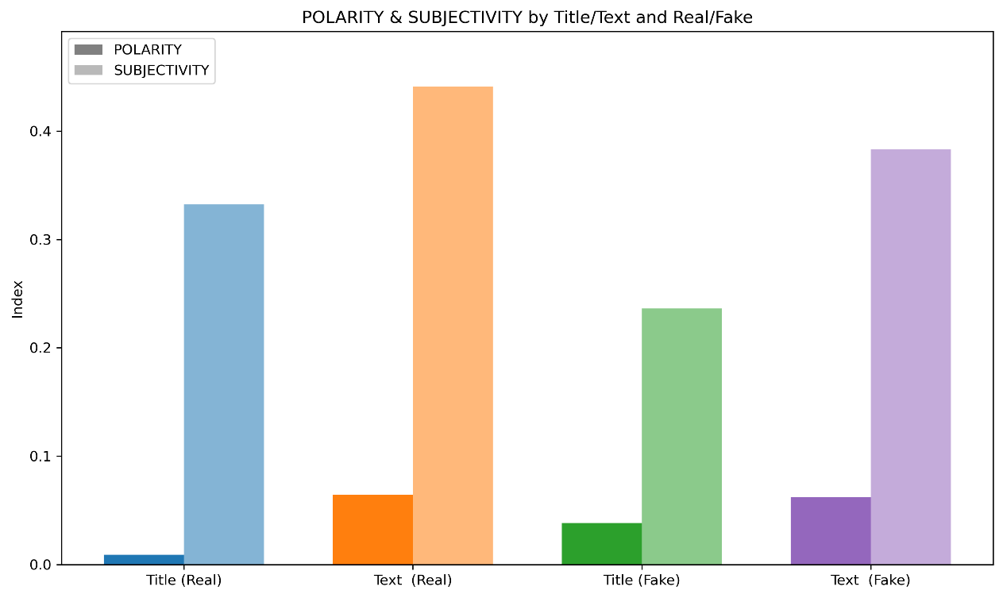
Figure 13: polarity and subjectivity.

Readability:
- Text:
  - "Real news" = easier to read. This is a strong discriminator.
- Title:
  - "Fake news" is easier to read. This is a strong discriminator.
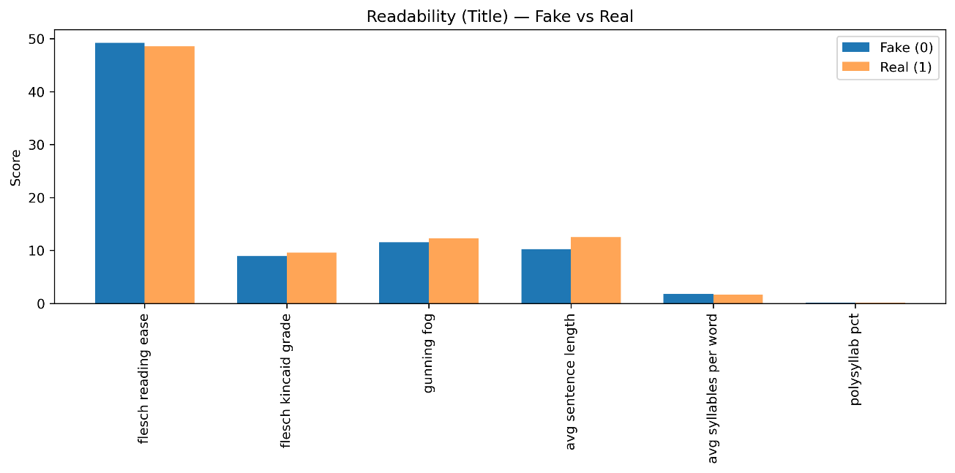
Figure 14: readability - title.

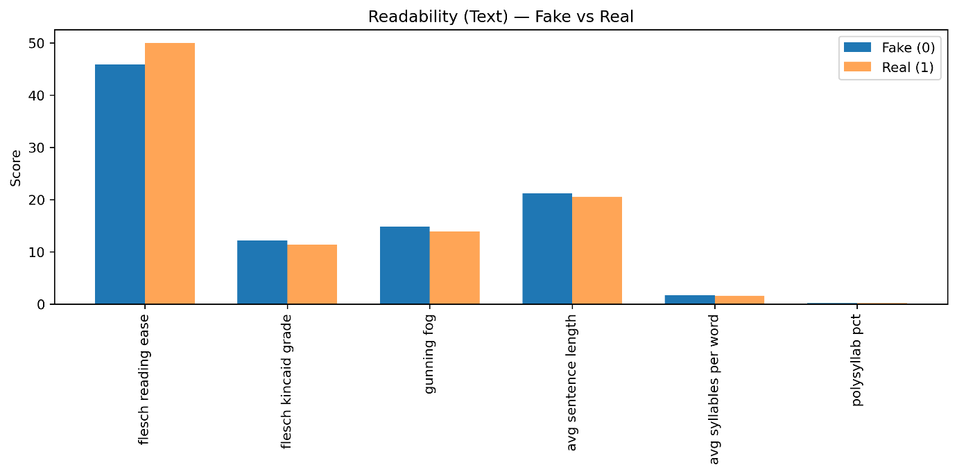
Figure 15: readability - text.

General conclusion:
In this “exploratory data analysis” (EDA) stage several potential features were explored:
- WEAK DISCRIMINATORS:
  - Length of text.
  - Vocabulary richness.
  - Terms frequency.
  - POS proper noun/other noun ratio text.
  - NER ratio text.
  - NER frequency.

- STRONG DISCRIMINATORS:
  - POS proper noun/other noun ratio title.
  - NER ratio title.
  - Polarity title.
  - Polarity text.
  - Subjectivity title.
  - Subjectivity text.
  - Readability title.
  - Readability text.

Data save:
- The data is saved to a .csv file for further stages.

Data preprocessing:

Important notes:
- Due to the limited reliability of the first dataset and the significant time required to address it, the insights uncovered during the “exploratory data analysis” (EDA) stage could not be fully integrated into this feature engineering and preprocessing stage. Incorporating these insights might have enhanced the performance of the machine learning models relative to the deep learning and transformer models. This limitation will therefore be carried forward as a final recommendation for future work.
- To avoid “data leakage” the data split is always performed before any important data manipulation.

Preparation for machine learning modeling:
- TFIDF vectorization.
- “Tile_cleaned” and “text_cleaned” features are vectorized separately.

Preparation for deep learning modeling:
- Tokenizer expect a series input, therefore, “title_cleaned” and “text_cleaned” are combined to preserve the signal from both features.

Preparation for transformer modeling:
- “Title_cleaned” and “text_cleaned” are combined to preserve the signal from both features.
- Target label preparation.
- Tokenizer setup.
- Tokenization & encoding.
- Dataset structuring (NumpyDataset).

Modelling:
- Instead of accuracy, the evaluation focused on more informative metrics such as F1-score, precision, and recall.
- Models’ metrics files are all available in the subfolder: “model_metrics_files”.

Machine learning modeling – Random Forest:

Hyperparameter tuning – Bayesian optimization:
- “Bayesian optimization” best hyperparameters:
{'bootstrap_val': 0.6940427677403537, 'criterion_val': 0.36209424928230194, 'max_depth': 122.37543851968115, 'max_features_val': 0.8033971429329204, 'min_samples_leaf': 1.7230892584472277, 'min_samples_split': 16.718529743887633, 'n_estimators': 673.6636487772938}

Performance metrics:
random forest, bayesian optimization, Classification Report:
precision recall f1-score support

0 0.91 0.95 0.93 6848
1 0.94 0.89 0.91 5431

accuracy 0.92 12279
macro avg 0.93 0.92 0.92 12279
weighted avg 0.92 0.92 0.92 12279

- Strong and well-balanced results among precision, recall and F1 scores.
- Model misses a little bit more class 1 (“real”) classification.
- F1 score = 92%.
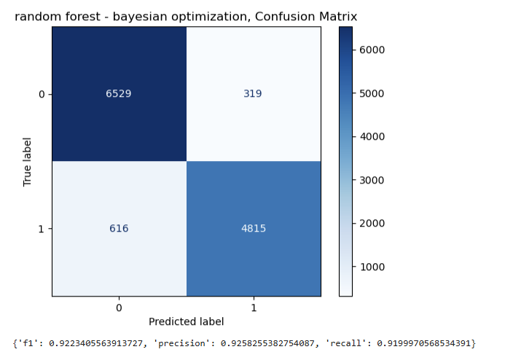
Figure 16: confusion matrix - random forest.
Figure 7: Multinomial logistic regression, Bayesian optimization, confusion matrix.

Machine learning modeling – Logistic Regression:

Hyperparameter tuning – Bayesian optimization:
- “Bayesian optimization” best hyperparameters:
{'C_log': 0.8662143796530829}

Performance metrics:
logistic regression, bayesian optimization, Classification Report:
precision recall f1-score support

0 0.96 0.96 0.96 6848
1 0.95 0.95 0.95 5431

accuracy 0.96 12279
macro avg 0.96 0.96 0.96 12279
weighted avg 0.96 0.96 0.96 12279

- Strong and very balanced results among precision, recall and F1 scores.
- The errors are low and symmetrical with no class favouring.
- F1 score = 96%
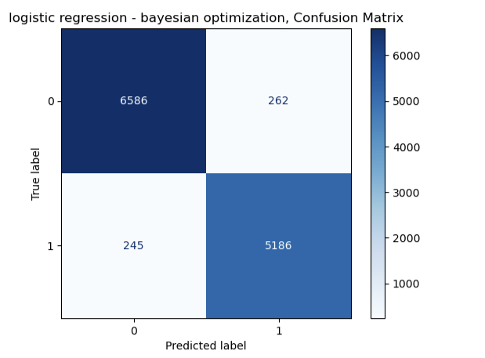
Figure 17: confusion matrix - logistic regression.

Deep learning modeling – bi-LSTM:

Modeling:
- Learned embedding.
- Initial number of epochs = 20.
- Overfitting counter measures and early stopping.
- Loss = “binary_crossentropy”.
- Optimizer = Adam with learning rate = 1e -3.

Performance metrics:
precision recall f1-score support

0 0.964 0.991 0.977 6848
1 0.988 0.953 0.970 5431

accuracy 0.974 12279
macro avg 0.976 0.972 0.973 12279
weighted avg 0.974 0.974 0.974 12279

F1-macro: 0.9734827962919322
ROC-AUC: 0.9976330874419437

- Best results so far among accuracy, F1 and ROC-AUC.
- Overall, the classes are balanced.
- Despite the counter measures, the curves below still show a moderate overfitting after 10 epoch, which justifies the implementation of "early stopping".
- F1 score = 97.4%

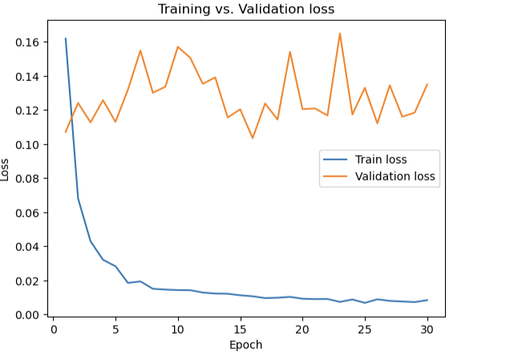
Figure 18: deep learning model - loss.

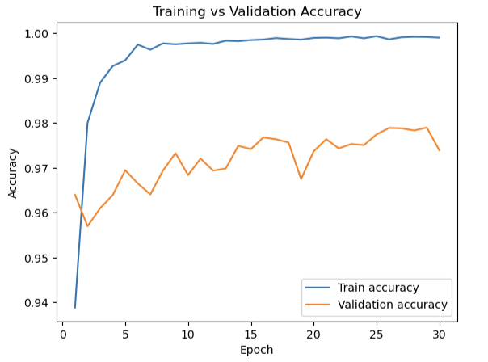
Figure 19: deep learning model - accuracy.

Transformer (DistilBERT)modeling:

Modeling:
- Use of local GPU for computation.
- Training arguments:
- output_dir="./out",
- evaluation_strategy="epoch",
- save_strategy="epoch",
- learning_rate=2e-5,
- per_device_train_batch_size=16,
- per_device_eval_batch_size=32,
- num_train_epochs=6,
- weight_decay=0.01,
- load_best_model_at_end=True,
- metric_for_best_model="auc",
- greater_is_better=True,
- logging_steps=50,
- report_to="none",
- seed=42,
- fp16=True,
- tf32=True,
- dataloader_pin_memory=False,
- dataloader_num_workers=0

Performance metrics:
precision recall f1-score support

0 0.996 0.995 0.995 6848
1 0.993 0.995 0.994 5431

accuracy 0.995 12279
macro avg 0.995 0.995 0.995 12279
weighted avg 0.995 0.995 0.995 12279

- Best final results and balanced among accuracy, F1 and ROC-AUC.
- Minimal and symmetrical errors among classes.
- F1 score = 99.5%

Model selection:
The transformer (DistilBERT) model is the selected model.

Recommendations & future work:
With an F1 score of 99.50%, the “DistilBERT” transformer model demonstrates strong potential for fake news detection. For better generalization, however, the model should be evaluated on additional datasets to ensure robustness beyond the one used in this study.
A critical aspect to consider is the quality and reliability of the input dataset, as limitations in the initial dataset directly impacted earlier stages of the project. This reinforces the need for careful dataset validation before modeling.
The “strong discriminators” identified during the exploratory data analysis (EDA) stage may provide a valuable first approach for characterizing the types of news present in the dataset. In future work, these features could be integrated into the feature engineering and preprocessing stage, potentially improving the performance of traditional machine learning models such as Random Forest and Logistic Regression. Furthermore, combining these engineered features with transformer embeddings may yield even higher robustness and accuracy.
Similarly, the slight class imbalance observed in the target label could be addressed by adjusting model parameters (e.g., “class_weight”) in addition to using the `stratify` parameter during the “train_test_split” stage.

*********

