

SIENA project
Hand-held sensor prototype

18.03.2021
Charrière Maxime and Enrile Andrea

Table of Content
1. Introduction 3
2. System overview 4
3. Main component 5
3.1. Raspberry Pi 4B, 4GB 5
3.2. Power supply monitoring 5
3.2.1. Li-Ion batteries 6
3.3. AD converter 6
3.4. GPS module 6
3.5. LCD touch screen 6
4. Software 7
4.1. Adafruit PiTFT 3.5’’ Touch Screen 7
4.2. PiJuice 7
4.3. Graphical User Interface 9
4.3.1. General overview 9
4.3.2. GUI Architecture 10
4.3.3. The different events 10
4.4. C program 11
4.4.1. How the program works 11
4.5. Testing with Touchscreen, ADC and PiJuice 12
5. Pinout of the system 12
6. Known issues 12
7. Conclusion 12
8. Different formats 13
8.1. Links 13
8.2. Citations 13
8.3. Figures 13
8.4. Reference 14

Introduction
The purpose of this project is the development of a hand-held, rechargeable battery-operated plant electrophysiology sensor that runs a diagnostic algorithm and alerts the user to the presence of a specific plant stressor.
Besides, contrary to the idea of the first version where the idea was to run the Machine Learning algorithms on a computer or a mobile phone, and the changes made on the component from the second version (mainly the change of ADC from the AD7770 to the AD7124-4) the principle of the last 2 versions (v2 and v3) are to run the model directly on the Raspberry Pi, in order to have a minimum of equipment.
The raspberry Pi is equipped with a touch screen. It is possible to launch a graphical interface on this touch screen and then be able to launch measurements in order to make a diagnosis on a plant.
The data is acquired and the result of the diagnosis is then stored directly locally on the RPi, but can also be sent directly to the Cloud so that the data can be reused and further processed.

System overview
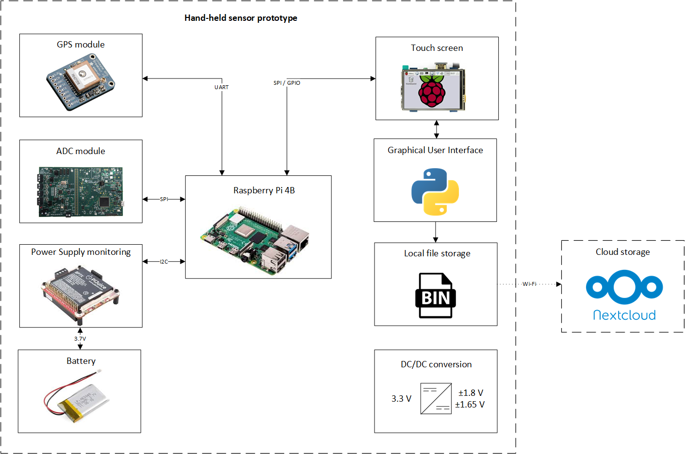
Figure 1 Schema a block of the system
The prototype itself consists of the Raspberry Pi, the AD7124-4, a 3.5 inches resistive touch screen LCD, a lithium-ion battery and power supply monitoring system, a GPS module as well as different DC/DC converters to power all the components. The processor communicates with the ADC as well as the resistive touch screen via the SPI protocol. A raspberry Pi having two lines of SPI, SPI6 is then used to communicate with the ADC and SPI1 is used to communicate with the touch screen. The GPS module communicates in UART with the Raspberry Pi, and the battery management is monitored using the I2C protocol. Finally, some GPIOs are also used with the touch screen.
The idea of use is as follows. We launch a graphical application directly on the Raspberry Pi. This graphical application can be launched directly using a shortcut or a button (sw3) on the side of the device. Thanks to this application, we can then configure the measurement (data rate, channels, measurement time) and then launch the measurement. At the end of the measurement, the processor will ideally runs a model in order to detect a possible stress on the plant (this is not implemented on the delivered system). The result is then sent directly to the graphical application and is also saved in a file. Finally, the measurement and result files can be saved directly to the Vivent Cloud (http://next.phytlsigns.com/). It is also possible to switch raspberry Pi on and off directly with the buttons (sw1: power on, sw2: power off).

The final prototype is composed by 4 distinct layers:
- A first layer containing the Raspberry Pi 4B, which is the processor of the handheld device.
- A second layer containing the power supply monitoring and the battery.
- A third layer being a homemade PCB with ADC, GPS, the different probes and all the data conversion part.
- A fourth layer containing the LCD touch screen.
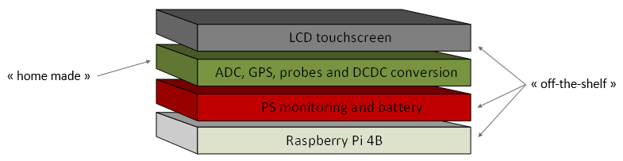
Figure 2 Schema of the 4 layers
Layers 1, 2 and 4 are products directly available on the market. They are off-the-shelf commercial solutions. This made development much easier and allowed us to have a prototype quickly. Layer 3 is a self-built PCB with the same dimensions as the raspberry Pi (credit card). So we will have a kind of Lego where we can stack the different layers, or even add layers if necessary.

Main component
This chapter will detail the most important elements of the system in order to have a better idea of their usefulness.

Raspberry Pi 4B, 4GB
A Raspberry Pi 4B was chosen as the processor for our system. The main reason is the compatibility with early Vivent devices (PISA project). As a result, many elements can be reused if necessary.
Furthermore, the 4GB version was used. Indeed, a ML model will be used to perform the diagnosis of a plant directly live. These algorithms being costly in terms of resources, it is important to have a powerful processor and a lot of RAM in order to increase the calculation speed. The 4GB version allows to obtain excellent results at a lower cost.
The disadvantage of this system is its high consumption. Therefore, an additional battery is necessary in order to respect the 8 hours of autonomy. This battery, relatively large, increases the size and weight of the device.

Power supply monitoring
To have a battery powered system, the PiJuice was used. PiJuice is a fully uninterruptable / uninterrupted power supply that will always keep the Raspberry Pi powered. It has a real time clock (RTC) for time tracking and scheduled tasks when the Pi is offline (as well as remote on/off of your Pi). It also has an integrated microcontroller (MCU) chip which will manage soft shut down functionality, a true low power deep sleep state and intelligent start up.
Thanks to this element, the battery can be recharged directly by USB, but also by solar and wind energy if necessary by adding the necessary elements.
Moreover, the PiJuice is self-monitoring and stops automatically when the power supply is too low for example. Everything is configurable by software directly through I2C communication.
Finally, the system has buttons to turn on/off the raspberry Pi or start other applications.

Li-Ion batteries
The PiJuice contains an onboard 1820 mAh “off the shelf” Lipo battery. This battery is not sufficient to guarantee the 8 hours of autonomy of the system. To increase the autonomy of the system, this battery can be replaced by a 5000mAh (Li-Ion) battery that can be placed directly on the connector of the PiJuice. However the 5000 mAh battery have a dimension that is much larger than the RPi itself (see figure 3).
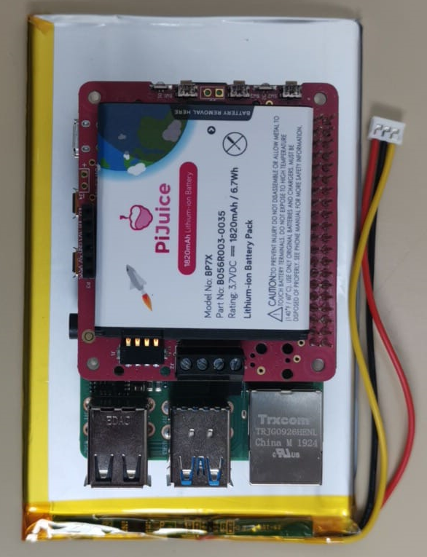
Figure 3 Battery comparison photo

AD converter
AD7124-4 was used for the acquisition of plant signals. This ADC was selected in cooperation with Vivent. Initially the system was using the AD7770 to be fully compatible with the previous project PISA, however, after a discussion was decided to change ADC with one that could achieve much lower data rates and that had less channels, as the handheld device needed only 2 channels instead of the 8 used for the previous project.
The AD7124-4 can have an output data rate for the full power mode starting at 9.38 SPS up to 19.2 kSPS, however if lower power mode are used it can goes down to a 1.17 SPS. This ADC can be set to single-ended or true differential inputs. In true differential mode the positive reference voltage can go up to AV_{DD} and the negative one down to AV_{SS} with a typical voltage reference of 2.5V. For this project the a voltage reference of ±1.65 V was used. This mean that the input voltage of the ADC is of ±1.65 V.
Given the low range, it is important to have a resistor network at the input to increase this range (however, you lose resolution).

GPS module
For each diagnosis, it is important to know where the measurement took place in order to be able to analyze it properly afterwards. For this an MTK3339 was used. This is a high-quality GPS module that can track up to 22 satellites on 66 channels, has an excellent high-sensitivity receiver (-165 dB tracking), and a built in antenna. It can do up to 10 location updates a second for high speed, high sensitivity logging or tracking.

LCD touch screen
A 3.5" display with 480x320 16-bit color pixels and a resistive touch screen is used to display the monitor and then start and use the graphical interface. It's designed to fit nicely Pi Model 4B as long as you don't mind the PCB overhangs the USB ports by 5mm. It can be plugged directly on the raspberry Pi thanks to the 40P connector.

Software
This section explains all the software part done briefly to have a good idea of the architecture.

Adafruit PiTFT 3.5’’ Touch Screen
To install the touch screen on the Raspberry, it is necessary to install some software. For this, you can follow the steps described under this link:
https://learn.adafruit.com/adafruit-pitft-3-dot-5-touch-screen-for-raspberry-pi/easy-install-2
After running the script to configure the screen, it is necessary to configure the PiTFT as HDMI Mirror. This will completely change the resolution of the HDMI display, even if you use an external display via the HDMI port afterwards. If you want to change this resolution again, perform the following commands: “Sudo raspi-config”. Then go to "Advanced Options" -> "Resolution" and choose the right resolution.

PiJuice
You first need to install the PiJuice sofware before you can use it. To do this, follow the different steps described in this link:
https://github.com/PiSupply/PiJuice
This link is also very useful to understand how the device and these different elements work. Thanks to PiJuice's graphical interface, several elements have been modified in order to work properly with the device.
Open the application using the icon in the top right corner. You then have the main window which gives various information about the battery and the system:
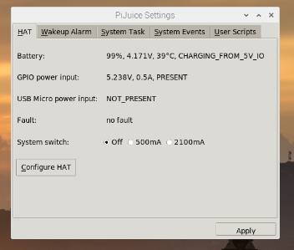
Under the "System Task" tab, one of the important elements is the minimum load which is 10%. This means that the system will shut down when the battery level drops below 10%. Another important element is the "Software Halt Power Off" set to 60 seconds. This means that 60 seconds after initiating the procedure to turn off the raspberry Pi, the PiJuice will completely cut the power supply to preserve the battery as much as possible.
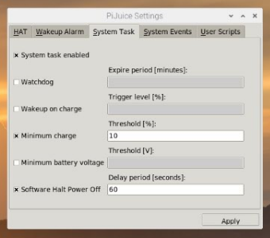
Under the HAT tab, go to "Configure HAT". An important item here is the configuration of the 3 buttons. You can see that SW1 is configured to turn on raspberry Pi, SW2 to turn off raspberry and SW3 with a do-it-yourself function (USER_FUNC1). The 3 buttons are only used in "single press" but other functions could be added by using "double press" or "long press" for example.
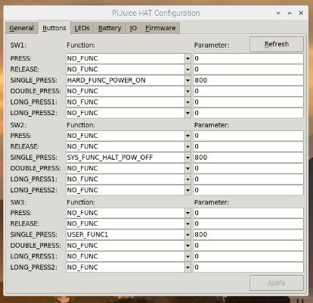
To configure the USER_FUNC1, go back to the main window and go to the "User Scripts" tab to define the function according to its path. This is only for executable scripts, so we had to add " # !/usr/bin/env python3 " at the beginning of the script and configure the file as executable thanks to the chmod command.
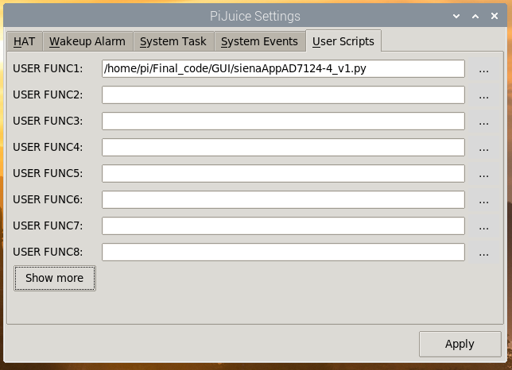
If you change the battery with a different one, it is necessary to go under "Configure HAT" then the "Battery" tab and select the right one in order to have a correct analysis of the PiJuice on the used battery.
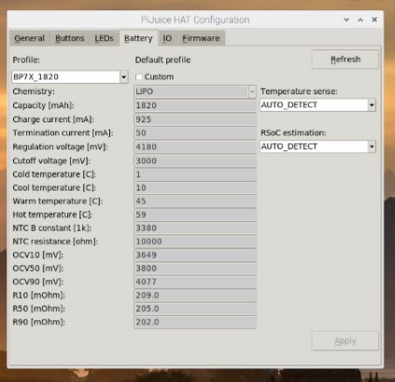
Many other parameters are configurable, don't hesitate to go to the documentation and modify other things if necessary for the project.

Graphical User Interface
The graphical interface has been made entirely in Python using Tkinter. The different paragraphs below briefly explain its functioning and architecture

General overview
This graphical interface is relatively simple and allows you to perform the following actions:
- Measurement configuration (data rate, channel used, duration of the measure).
- Display live position and time.
- Start a diagnosis and display the result of the diagnosis.
- Upload data and result to the cloud.
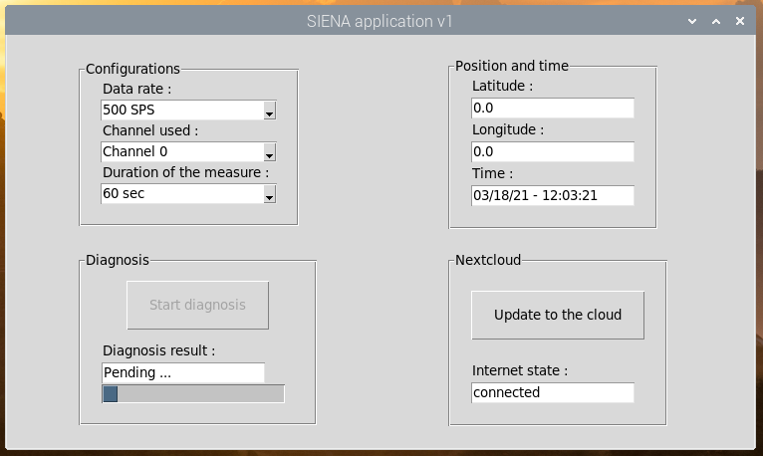

GUI Architecture
The architecture of the GUI was realized on the basis of the following article:
https://medium.com/@mattia512maldini/how-to-setup-correctly-an-application-with-python-and-tkinter-107c6bc5a45
This article is therefore a very good basis to start a clean and functional GUI. The resulting structure is somewhat similar to The Elm Architecture, or any variant of Model View Controller, really. It is built around two main functions: guiView and updateThread.
guiView simply builds the Tkinter window with the needed widgets. It will be called only once at the beginning; modifications on the interface, if any, can be done separately. It should return a collection of reference to widgets-related objects to allow for future reading or writing of the UI contents.
updateThread is a continuous loop that checks for UI events and performs any needed work. It will be ran on a separate thread, keeping interface updates safely separated.
But how will updateThread know of user-generated events? The ideal tool for this purpose is a queue, of which Python supports a thread-safe implementation included in the Queue module.
A queue is nothing but a FIFO (First-In First-Out) list that can be safely accessed by different execution threads. Tkinter callbacks will put messages in it when buttons are clicked or values are changed; the updateThread will poll it to know what has happened and respond accordingly.
Another important element is the "model" (declared as a SimpleNameSpace). The model is the element that contains data and data related logic: validation, reading and recording. It may, in its simplest form, contain only a single value, or a more complex data structure.

The different events
The different events that will appear are as follows:
- DIAGNOSIS: This event appears when the diagnosis button is clicked. It will then update all the data in the model according to what is displayed and selected on the GUI view. It will then start a new Thread that will run a diagnostic (C program) and wait until it receives the result.
- CLOUD: This event will create a new thread that will allow all unrecorded data to be recorded directly to the cloud. All the data in the "notOnCloud" folder will be saved to the cloud and moved to the "onCloud" folder.
- PERIODIC: This event is called periodically, every second. It will put the GUI view: the GPS position and the time will be updated every second, the time too. The progress bar will be updated every second also in case the "diagnosisThread" is running. Finally it will check the internet connection every second and update it.

C program
A C program was carried out to perform data acquisition and plant diagnosis. This language was preferred because it was the one used for the multi-channel device. Thanks to this, it was possible to take over part of the code.

How the program works
This C program is executed when the "Start diagnosis" button on the GUI is clicked. The idea of this program is as follows:
- First we start by retrieving the arguments coming directly from the GUI (samplingFrequency, channel and timeMeasure).

- We initialize the GPIOs as well as the SPI for the communication with the ADC.

- The ADC is initialized, according to the arguments passed as inputs (for the sampling frequency).

- Two messages queues are created. These are IPCs that will allow direct communication between the GUI (in python) and the C program. The message queues "msqidReceive" will allow to receive the GPS position sent directly from the GUI in Python. The message queue "msquidSend" will send the diagnostic result directly to the GUI in python.

- A new directory for the measurement is created, with the different files for the measurements (2 channels) and a file for saving all the measurement configurations and statistics, the GPS position and the diagnostic result.

- A new thread is started that will acquire the ADC data and save it in the measurement files. This thread is realized in an infinite loop. With a time condition to return from it. The time conition is given by the “timeMeasure” argument.

- Some information will be recorded in the measurement configuration file (number of samples, end time of the measurement, GPS position after receiving it through the queue message).

- For the prototype developed those steps are not made, but will be nice to have them implemented as follow:
  - We launch the learning machine model on the chosen channel (depending on the argument).
  - Once the algorithm is complete, we retrieve the result of the diagnosis, save it to the configuration file and send the result through the GUI queue message.

- We close the message queues, we close all files and the different interfaces.
A few library has been used for the AD7124-4 in order to interface it more easily. A makefile has also been made to convert the program into an executable.

Testing of the system
The system is fully functional with some minor issues (that can be seen in the section Known issues).
A few test were carried out on the system to ensure the proper functioning.
First, the homemade PCB was checked to ensure that all the voltages needed were correctly made by the LDOs. After that, some test and some code modification were made to have the system fully working in a true differential mode. A few code changes was needed as the system where the first version of the code was tested used a pseudo differential input. Once the software was fully functional, a few test were made to control that the specifications were met.
And lastly a signal measurement was made with a cardiac signal (just to not have the usual sinewave) to check that the ADC was able to convert the positive and negative voltages pf a signal, and that can be seen from the images below where we can clearly see that the oscilloscope measurement and the ADC measurement are practically identical.

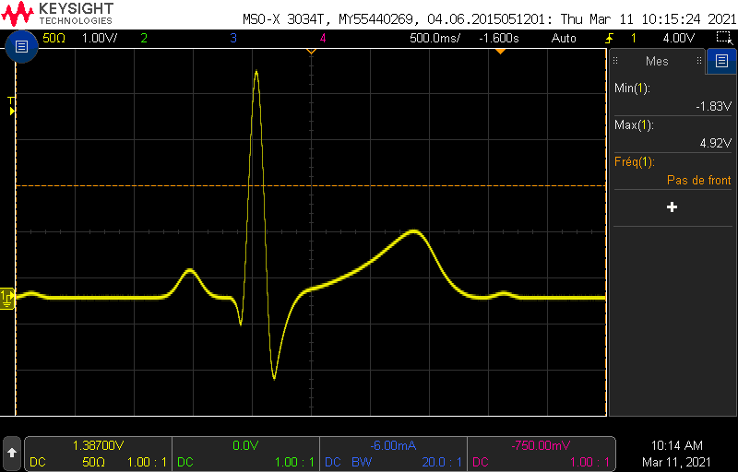

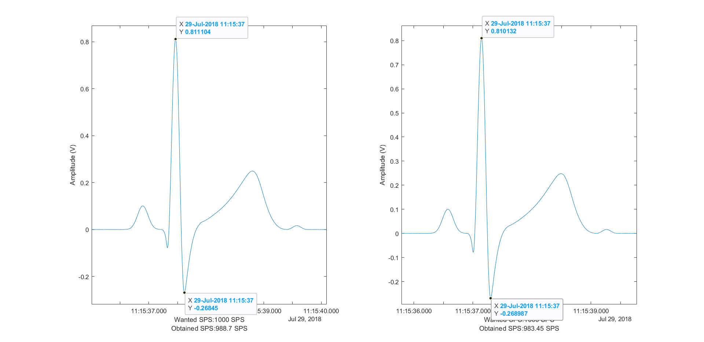

Pinout of the system
This section just explains the different system connections between the raspberry Pi 4B and the different peripherals. This is represented in the table below:

Pin number of raspberry Pi [#] | Connected to
1, 17 (+3.3V) | 1, 17 (+3.3V, homemade PCB)
2, 4 (+5V) | 2, 4 (+5V, homemade PCB)
6,9,14,20,25,30,34,39 (GND) | 6,9,14,20,25,30,34,39 (GND, homemade PCB)
8 (UART RX) | 8 (UART TX, MTK3339 on homemade PCB)
10 (UART TX) | 10 (UART RX, MTK3339 on homemade PCB)
35 (SPI6 MISO) | 35 (MISO, AD7124-4 on homemade PCB)
36 (SPI6 CS) | 36 (CS, AD7124-4 on homemade PCB)
38 (SPI6 MOSI) | 38 (MOSI, AD7124-4 on homemade PCB)
40 (SPI6 SCLK) | 40 (SCLK, AD7124-4 on homemade PCB)
2 (5V power) | Pijuice (5V power)
1 (3.3V power) | Pijuice (3.3V power)
6,9,14,20,25,30,34,39 (Ground) | Pijuice (GND)
3 (GPIO2 – I2C1 SDA) | Pijuice (SDA)
5 (GPIO3 – I2C1 SCL) | Pijuice (SCL)
2 (5V power) | PiTFT Plus 3.5’’ (5V power)
1 (3.3V power) | PiTFT Plus 3.5’’ (3.3V power)
6,9,14,20,25,30,34,39 (Ground) | PiTFT Plus 3.5’’ (GND)
12 (GPIO18) | PiTFT Plus 3.5’’ (Backlight Control)
18 (GPIO24) | PiTFT Plus 3.5’’ (RT Interrupt)
22 (GPIO25) | PiTFT Plus 3.5’’ (TFT Data/Command)
24 (GPIO8 – SPI0 CS0) | PiTFT Plus 3.5’’ (TFT Chip Select)
26 (GPIO7 – SPI0 CS1) | PiTFT Plus 3.5’’ (RT Chip Select)
19 (GPIO10 –SPI0 MOSI) | PiTFT Plus 3.5’’ (MOSI)
21 (GPIO9 – SPI0 MISO) | PiTFT Plus 3.5’’ (MISO)
23 (GPIO11 – SPI0 SCLK) | PiTFT Plus 3.5’’ (SCLK)

PCB Design and Schematics

Schematics
A few schematics were made with small adjustment based on the feedbacks received from Vivent. The following schematic is the one used to create the first homemade PCB.

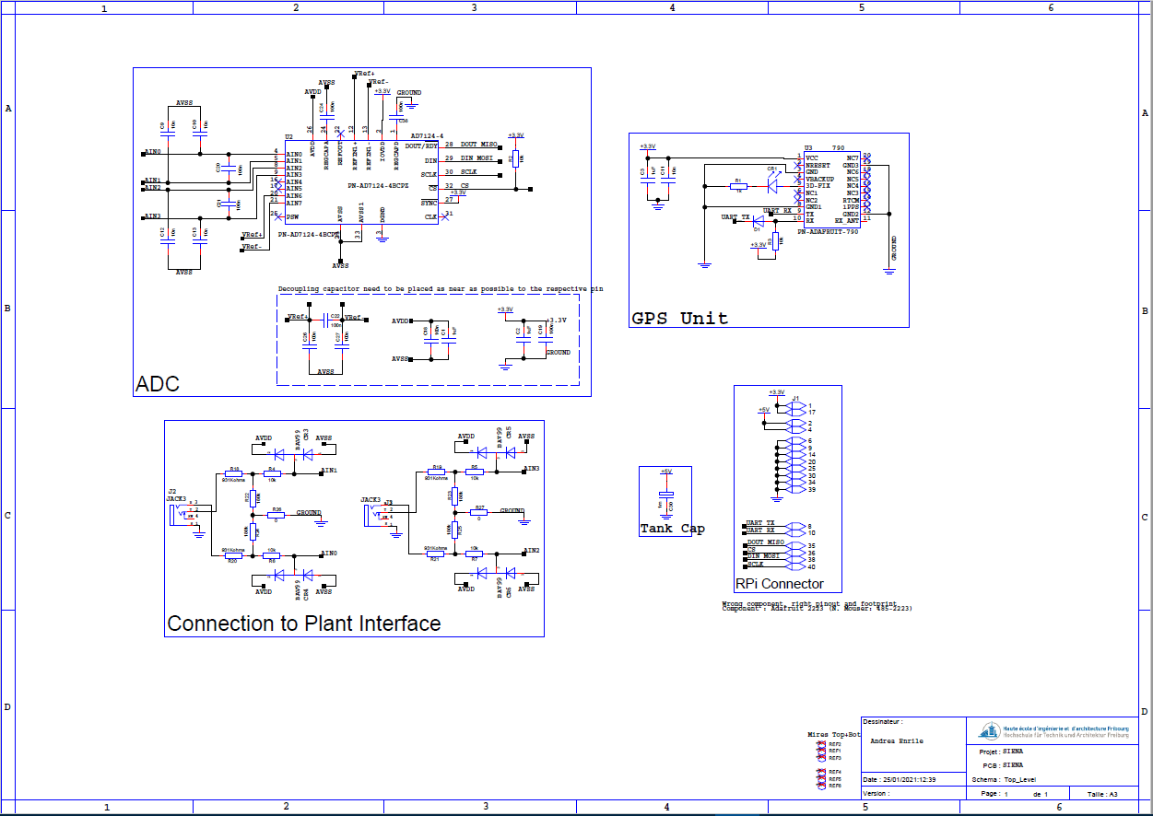
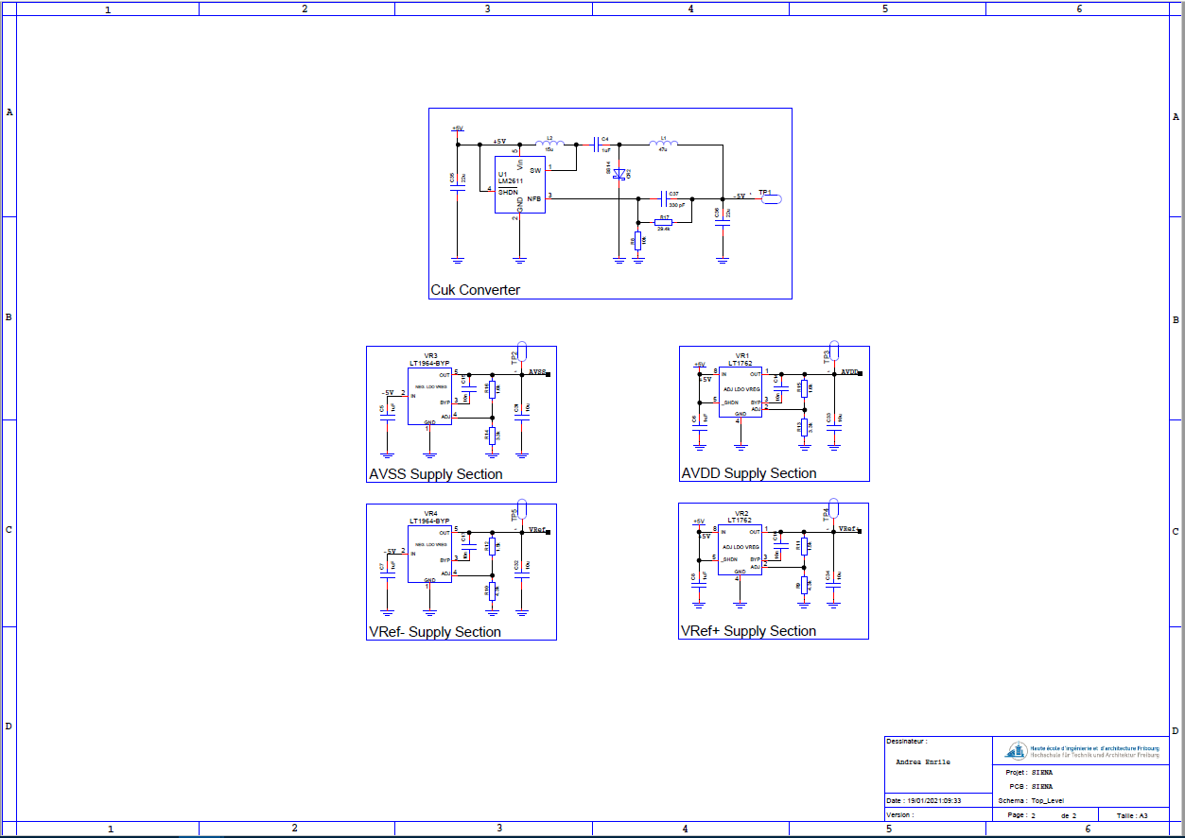

However, the schematic above had a few extra component to allow a few modification of the system. Mainly a resistor placed on the input resistor network to allow the resistor network to be ungrounded.

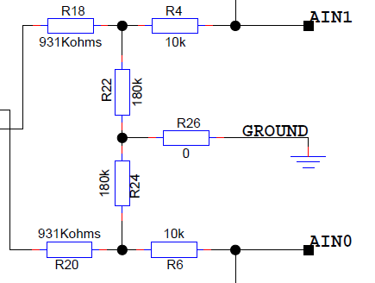
This resistor (R26) was placed because the network developed by Maxime used a ground connection placed on the center of the resistor network. However, the ADC used by Maxime had a VCM output that the new one don’t have. So, as it’s my first time working with true differential mode, I decided to use a 0 Ohm resistor just in case the ground connection was needed. In conclusion, and after the test, the ground resistor was not needed, and it can be removed from the schematics and PCB.

The latest version of the fabrication files and schematics can be found in the appendices of this report.

Known issues

Conclusion

