Smart Water Fountains

**Documentation:**

**Objectives:** The Smart Water Fountains project aims to promote water efficiency and public awareness by creating a real-time water fountain status system. This system will use IoT sensors to monitor water fountain usage, and a mobile app will provide users with information about nearby water fountains and their availability.

**IoT Sensor Setup:** For this project, we have set up IoT sensors at various water fountains to monitor their usage. Each IoT sensor is equipped with water flow sensors and a Wi-Fi module. These sensors collect data on water usage and transmit it to a central server for processing.

**Mobile App Development:** We have developed a mobile app for both Android and iOS platforms. The app allows users to:

* Find nearby water fountains on a map.
* See the real-time availability status of each fountain.
* Receive notifications when a nearby fountain becomes available.
* View historical water usage data.

**Raspberry Pi Integration:** A Raspberry Pi acts as the central server for data collection and processing. It receives data from IoT sensors, processes it, and updates the database. It also hosts a web-based dashboard for administrators to monitor the system's performance.

**Code Implementation:** The project's code is primarily written in Python and divided into three main components:

1. IoT Sensor Code: This code handles data collection from IoT sensors and sends it to the central server.
2. Raspberry Pi Code: The Raspberry Pi code collects, processes, and stores the data from IoT sensors in a database. It also hosts the web-based dashboard for administrators.
3. Mobile App Code: The mobile app code is written using languages suitable for Android and iOS platforms, such as Java (for Android) and Swift (for iOS).

**Digram:**

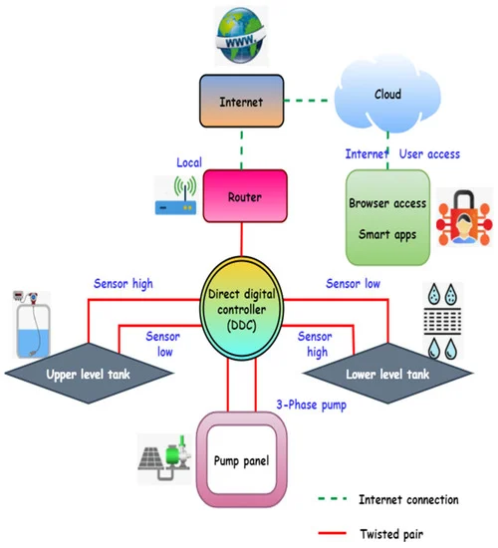

**Screen shots:**

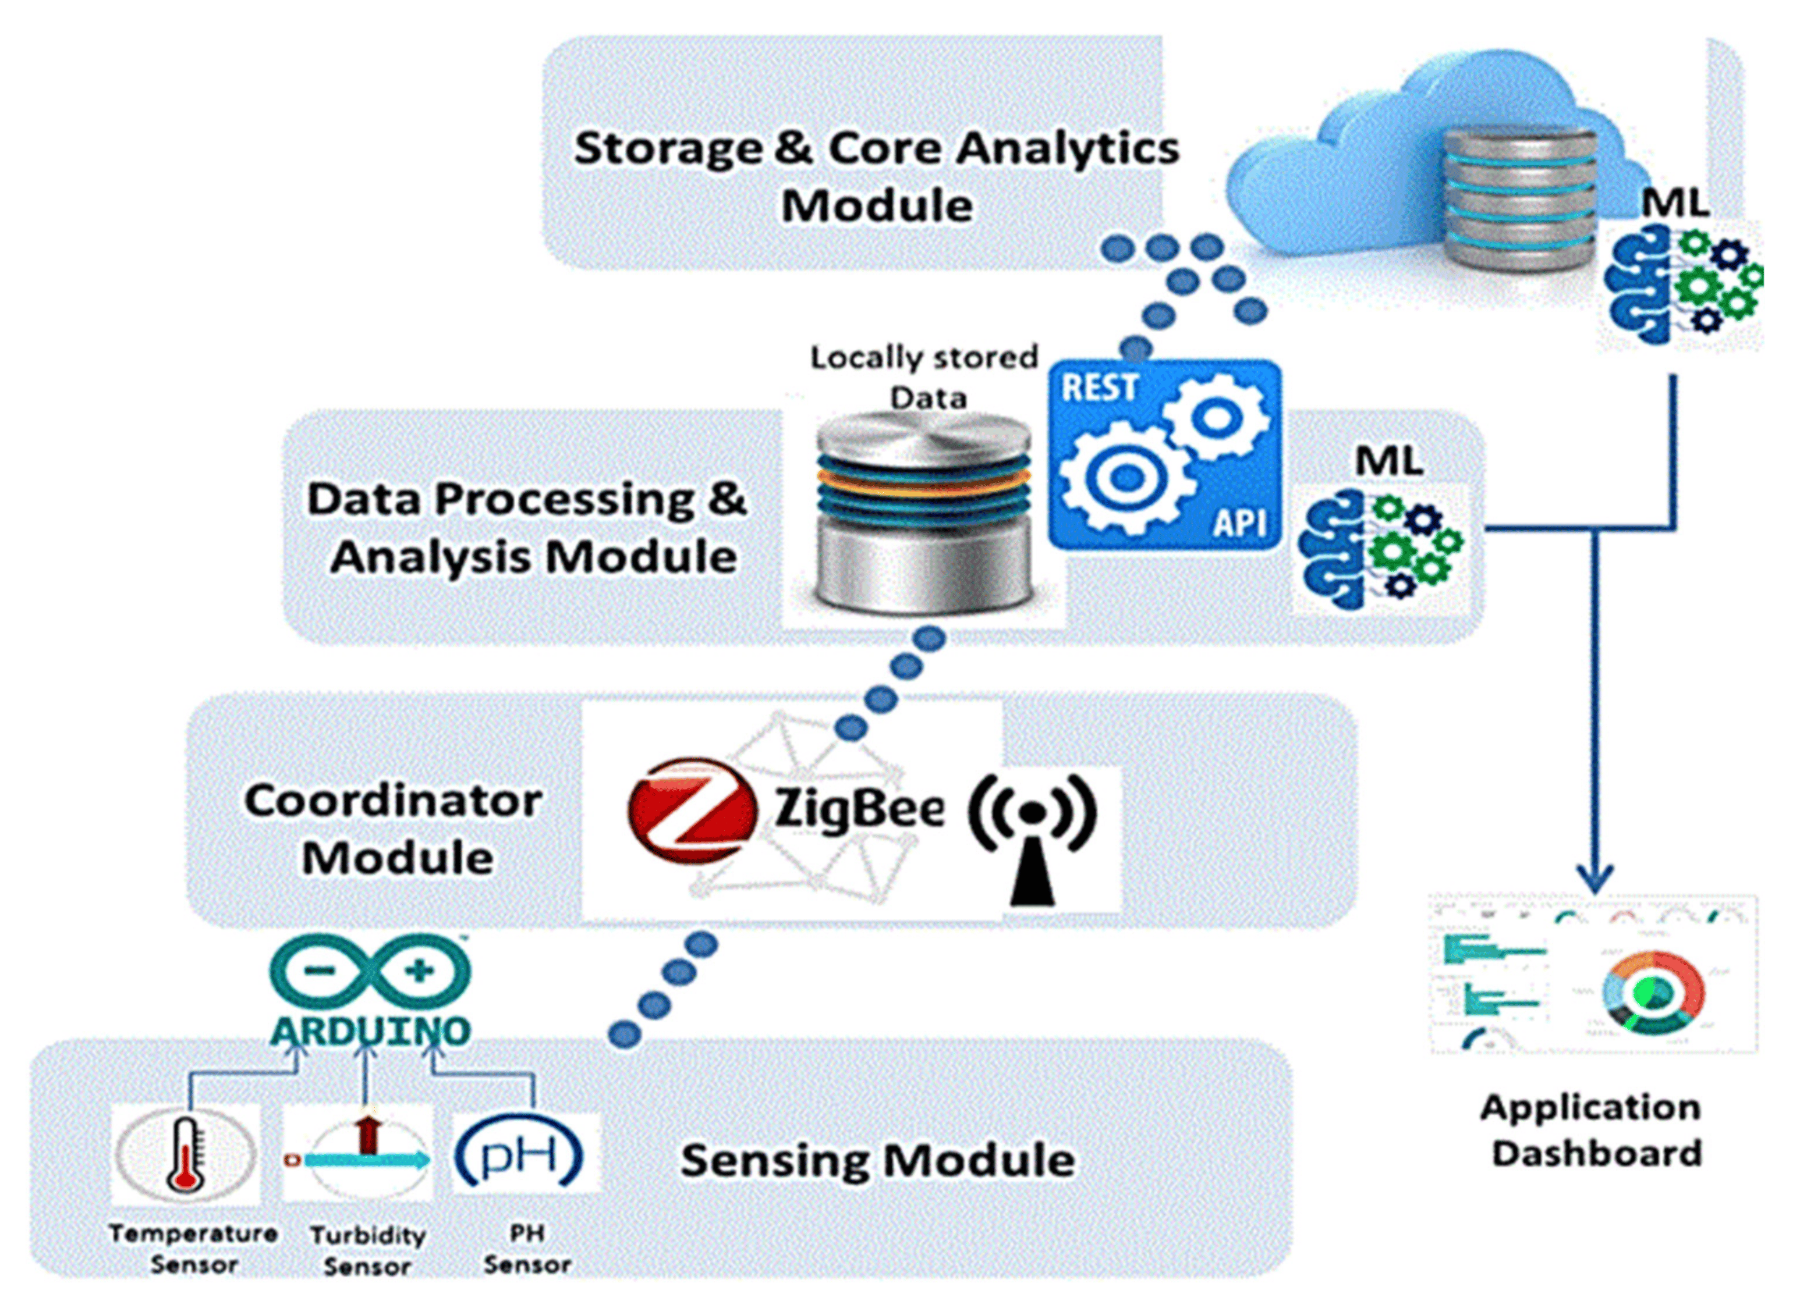

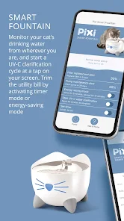

**Schematics of IoT Sensors Promotion of water efficiency and public awareness::**

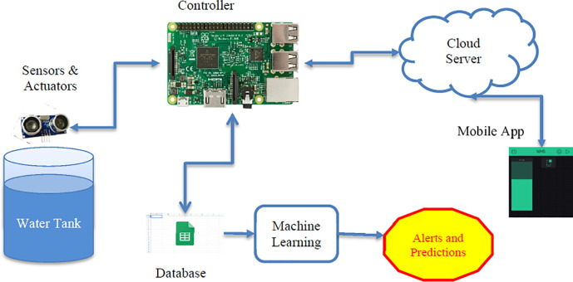

**Promotion of water efficiency and public awareness:**

The real-time water fountain status system promotes water efficiency and public awareness in the following ways:

**1.Efficient Use of Water:** By providing real-time information on the availability of water fountains, users can make informed decisions about where to fill their water bottles, reducing the wastage of water from running fountains.

**2.Behavioral Change:** The mobile app encourages people to choose water fountains over purchasing bottled water, reducing plastic waste and conserving resources.

**3.Data Insights:** The project collects and analyzes data on water usage, helping city planners make informed decisions about water infrastructure and identifying trends in water consumption.