CAPSTONE PROJECT

A. Document Formatting
• Document Size – Letter (8.5” x 11”)
• Font
o Style – Arial / Times New Roman
o Size – 12
• Line Spacings
o Title – 1.0
o Between Chapter number and Chapter Title – 1.0
o Between sentences – 1.5
o Between paragraphs – 12pt
• Margins
o Top – 1”
o Bottom – 1”
o Left – 1.5”
o Right – 1”
• Alignment
o Justify
o Indention in first line of every paragraph, 1 tab (1 inch in ruler)

B. Style
• Chapter Titles
o First Line – CHAPTER <number in roman numeral>
e.g. CHAPTER I
o Next Line – <chapter name>
e.g. INTRODUCTION

• Chapter Headings
o Heading format - <chapter number>.<heading order> <heading
title>
e.g. 1.1 BACKGROUND OF THE STUDY

• Chapter Subheadings
o Sub-heading format <chapter number>.<heading
order>.<subheading order> <subheading title>
e.g. 4.2.1 THEORETICAL FRAMEWORK

o Sub-heading content

• Chapter Content – Use “BSIT – CHAPTER CONTENT STYLE”

• Table of Contents – Use References > Table of Contents
o Line Space – 1.0

C. Additional Formatting
• Include introductory paragraphs in all chapters
• Page Numbers
o Exclude page number in the first page of each Chapter
o Exclude page number in Title Page
o Use roman numeral page numbering (small caps, aligned center)
starting from “Approval Sheet” page to “List of Acronyms” page
o Use hindu-arabic numeral page numbering (aligned right)
starting from “Chapter 1” to “Appendix” page

• Table Format (see example below)
o Position - Center
o Table Title – Upper left portion of the table
o Line Space – 1.0

• Figure Format (see example below)
o Position: Center
o Figure Title – Bottom center portion of the figure

D. Manuscript Outline

TABLE OF CONTENTS

PRELIMINARIES
Title Page
Transmittal Sheet
Approval Sheet
Acknowledgement
Table of Contents
List of Figures
List of Tables
Abstract

Chapter I
INTRODUCTION

Background of the Study

This section starts off with a general concept on computerization relevant to the capstone project. This will include related studies/systems in global, national and local settings; example on local setting may pertain to the client company (which is the focus of the study).

This section also discusses the context of the study and why it will be conducted. It will outline pertinent information like the client company, its business processes and the existing system being used in the company. The discussion should be able to clearly describe the prevailing problems encountered by the people in the company with regards to the existing system; such content will justify the intent of the proponents to improve the business processes and solve the occurring problems in the existing system through the conduct of the capstone project.

Objectives of the Study

This section begins with a general objective which corresponds to the title of the capstone project. The general objective will be exploded into specific objectives that will set how the proposed capstone project will be realized. Specific objectives should be SMART (specific, measurable, attainable, realistic and time-bounded).

Significance of the Study

This section discusses the importance of the capstone project to relevant entities and how these entities will benefit from it.

Example:

Students. This study will be beneficial to them since it will lessen their queuing time in obtaining a copy of their scholastic records.

Instructors. This study will help them in evaluating answer sheets easily, automatically generate reports on item analysis.

Future researchers. This will serve as basis for the revisions and upgrades of the study.

Scope and Delimitation

This section specifies the boundaries of the capstone project and what needs to be done to create an information system with required functions and specified features.

The scope defines the nature of the project, the deliverables to be produced as well as the technology tools that will be used in the capstone project.

The delimitation outlines the constraints of the project and the features and functions that will not be included in the finished information system.

Time and Place of the Study

This section sets the time frame of the capstone project and where will the project be conducted.

Operational Definition of Terms

This section enumerates and defines the relevant technical terms (not limited to the title) and how they are used in the capstone project.

Conceptual Framework

This section shows the blueprint of the information system to be produced, outlining the 3 phases: input, process and output.

Example of a conceptual framework for an IT capstone project

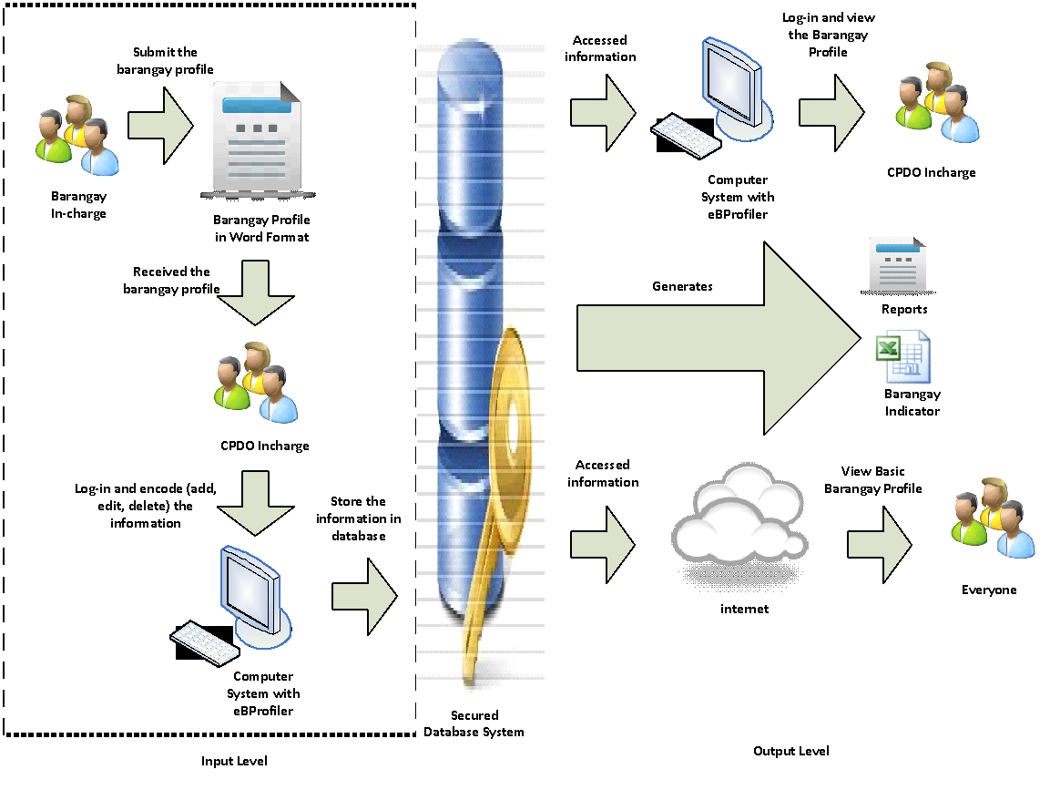

Chapter II
REVIEW OF RELATED LITERATURE, STUDIES AND SYSTEMS
This section discusses the literatures, studies and information systems that are relevant to the capstone project. Enumerated literature, studies and information systems will guide the proponents in the pursuit of the capstone project. Fluidity and continuity should be observed by proponents when doing the discussion.

The recency of the cited sources should be within 5 years. Sources may be from books, encyclopedias, almanacs, journals, magazines, manuscripts, unpublished theses and dissertations and other technical documents. Number of cited sources: minimum of 10.

Chapter III
METHODOLOGY

Software Development Framework

This section covers the background of the software process model to be used, the diagram of stages and the activities involved in every stage of the chosen process model.

This also includes discussion on the reasons why the proponents have chosen the process model and how it fits the capstone project activities the proponents strive to do.

Artifacts of the chosen framework shall be included in this section.

Software Requirements

This section will define in detail the exact features and functions of the information system/ app to be produced. It should be based on user perspective, functional requirements and non-functional requirements.

User Requirements

This part will outline the specific requirements of the client with regards to the features and functions of the information system. The user requirements should be clearly shown in the transcript of the interview with the client. The user requirements shall be conveyed through user stories.

Functional Requirements

These are statements of what the system should provide, how the system should react to particular inputs, and how the system should behave in particular situations. If necessary, proponents may also state what the system should not do.

Non-Functional Requirements

These are requirements that are not directly concerned with the specific functions and features of the system. These may include system properties such as performance, reliability, response time to queries, and store occupancy.

Software and Hardware Requirements

This subsection specifies the technology tools required to create the system and to implement/use the system.

Feasibility Issues

This subsection determines whether the proposed capstone project is viable or not, if it is doable based on technical and operational aspects, within the time constraints and if it is worth investing in. The result of the economic, technical, operational and schedule feasibility studies will be the basis whether the capstone project should proceed or not.

Economic Feasibility

This part discusses whether the capstone project is feasible financial-wise. This may include analysis of the costs and revenues the client company will incur while the system is being developed and implemented.

Technical Feasibility

This part discusses whether the capstone project is viable in terms of the new software and hardware setup needed to develop and implement the system.

Operational Feasibility

This part explains whether the capstone project will likely solve the business problems or take advantage of the opportunities to improve the current system in the client company. It should clearly state how viable the proposed system is when it comes to fitting into the client’s business operations.

Schedule Feasibility

This part discusses whether the capstone project will be finished and the system be implemented within the time frame. The proponents should determine if the planned activities will be successfully accomplished within the given time.

Work Breakdown Structures

A WBS is a deliverable-oriented hierarchical decomposition of the work to be executed by the project team to accomplish the project objectives (PMBOK Guide – 3rd Edition).

Example:

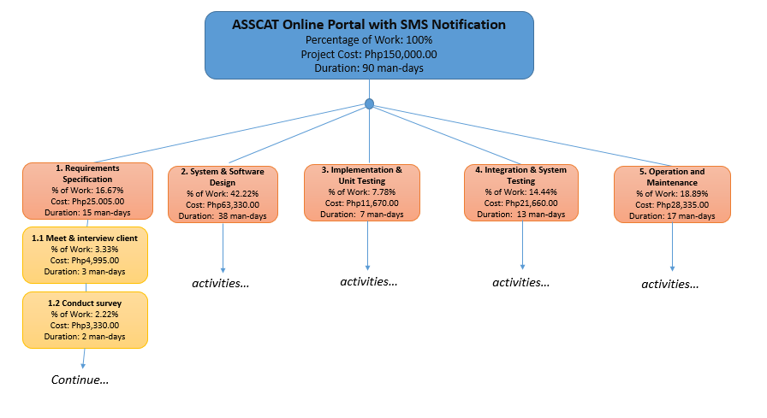

Cost Benefits Analysis

This subsection estimates and sums up the equivalent money value of the benefits and cost of the capstone project to the client company.

Example:
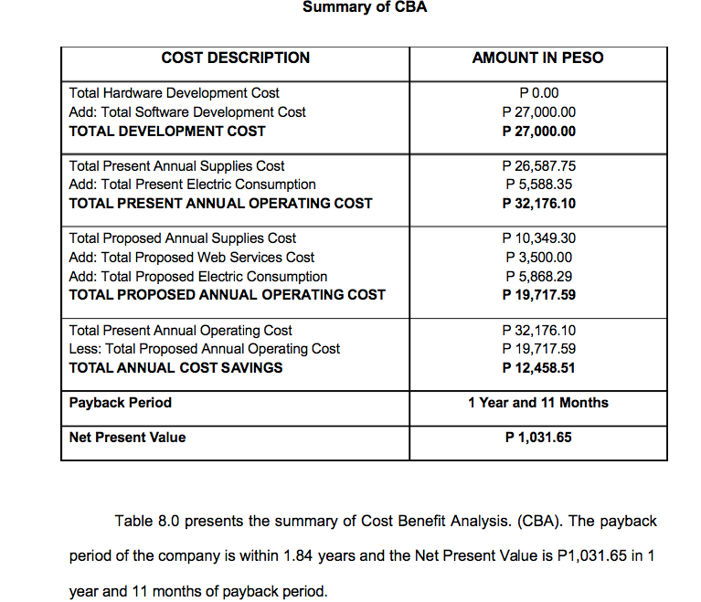
©cto
Risk Management

This section explains the anticipated risks that might affect the project schedule and/or the quality of the system, and the preventive and recovery measures to avoid and overcome the risks. Risks may include project team member turnover, management change, software and hardware unavailability, size underestimate, and requirements change.

Example:

Risk | Description | Level of Possibility | Strategy | Status
Turnover of manpower | When a team member drops off the class or stopped going to school altogether, leaving the other team members taking on more tasks than was originally planned | (High, medium or low) | The project manager or team leader may strategize by assigning at least 2 members in 1 particular task. When a member drops off the project, the other member who remained can still continue with the task. | (Avoided or encountered)

Testing Plan

Test Plan Title
Test Case ID | Test Case | Testing Resource  (Tester’s name and role) | Testing Approach | Test Schedule | Risks and Issues

Test Case ID
Test Case Name:
Tester:
Testing Schedule:
Test Scenario | Pre-conditions | Test Steps | Expected Results | Actual Results | Status  (Passed/ Failed)

Implementation Plan

This section defines the activities that need to be conducted to implement and deploy the system in the client company.

Deployment Diagram

Example:
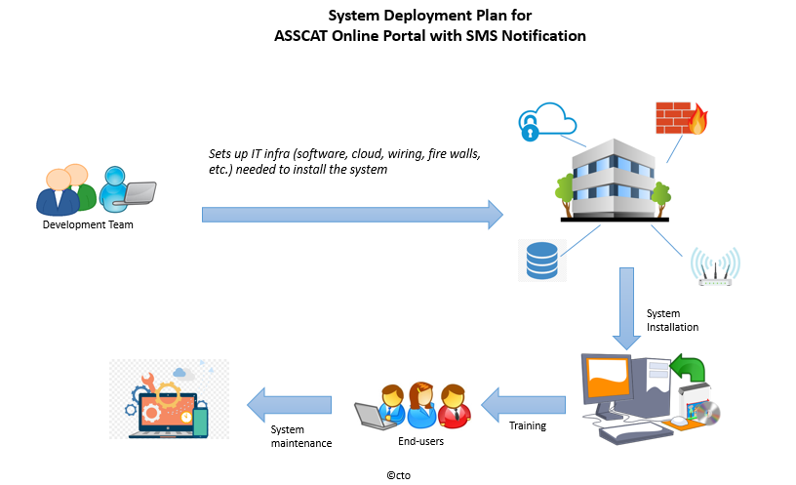

Chapter IV
SYSTEM DESIGN

This section features the data and system model of the system.

Use Case Diagram

Example:
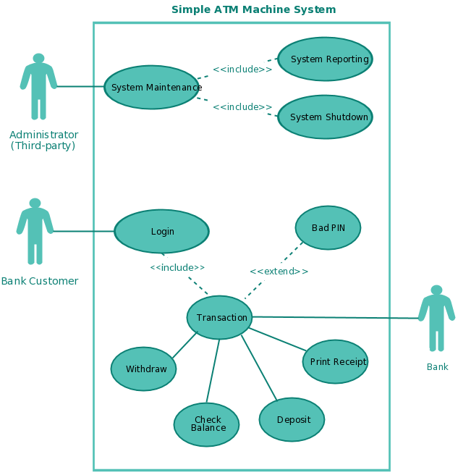

©cto

Use Case Description

Example:

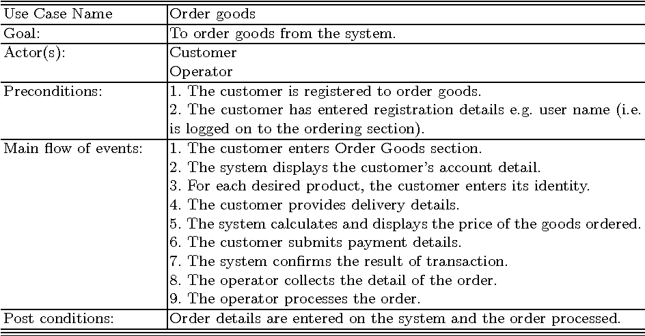
©cto

Sequence Diagram

Example of sequence diagram for view patient information:
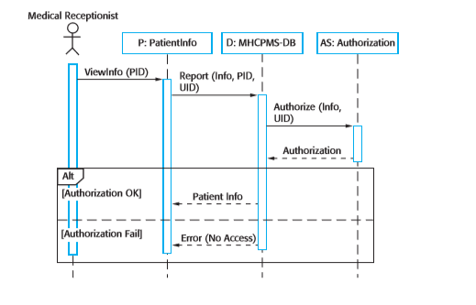

©Sommerville, Software Engineering 9th Ed

Prototype

This subsection includes screenshots of your system/ app.

Entity Relationship Diagram

Example:

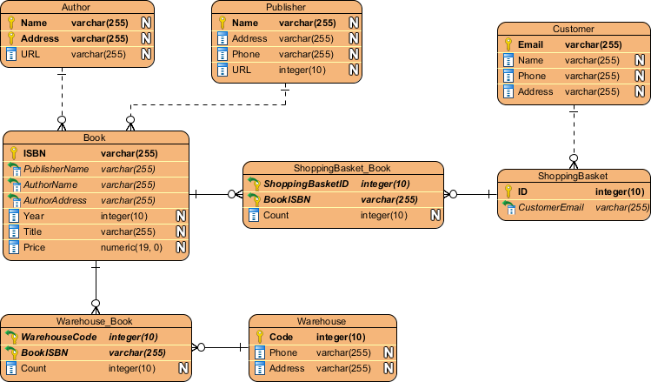
©cto
Data Dictionary

Example:

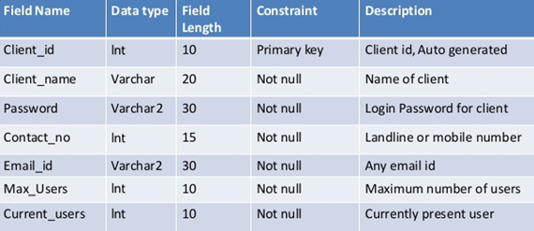
©cto

Chapter V
RESULTS AND DISCUSSION

This section discusses the findings, conclusion and recommendation of the proponents of the capstone project.

Findings

This subsection discusses the performance metrics (response time, throughput and accuracy), results of the user acceptance testing, the claims made in the objectives of the study, and the effectiveness of the use of peripherals and emerging tech tools (IoT, AI etc).

Conclusion

This subsection discusses the effectiveness of the chosen software process model, the project plan (Gantt chart, WBS, Implementation plan etc.) and aspects of the project that were discussed in the findings. Highlight the project’s success.

Recommendation

This section provides suggestions of the proponents in terms of future works, improvement, deployment and scaling to accommodate larger user base, policy implications and ethical considerations.

LITERATURE CITED

This section enumerates the sources and references cited in the technical document. Proponents should use APA format.

APPENDICES
Relevant Source Code
Evaluation/Survey Tool and Test Cases Documents
Sample Generated Outputs or Reports
ACM Format of the Document (should only be 2-3 pages)
1. Title Page
Title of the Project
Proponents
Affiliation (School, Program)
Date
2. Abstract
Concise overview of the project (150-200 words) which includes
problem statement, solution, methodology and key findings.
3. Introduction
Short Background
Problem Statement
4. Related Work
Review of Existing Literature
5. Methodology
Software Development Framework
Data Collection Method
Testing Techniques
Use Case Diagram with short Description
6. Results and Discussion
Present Key Findings
7. Conclusion
Summarize the main findings, highlight the contribution of your
project and discuss potential future improvements
8. References
Use ACM format

Approved Letter of Intent
Pictures Showcasing the Data Gathering and Investigation
Curriculum Vitae
Final Defense Results
——
User Manual*
Installation Guide
Screen Layouts

*This is a separate document. Size is half of a page (like a notebook) and in
soft bind.

