TOURISM ITINERARY – TORONTO, CANADA
Name: Benard Maina Nduati
Purpose of Visit: Tourism & Sightseeing
Travel Dates: October 10 – October 14, 2025
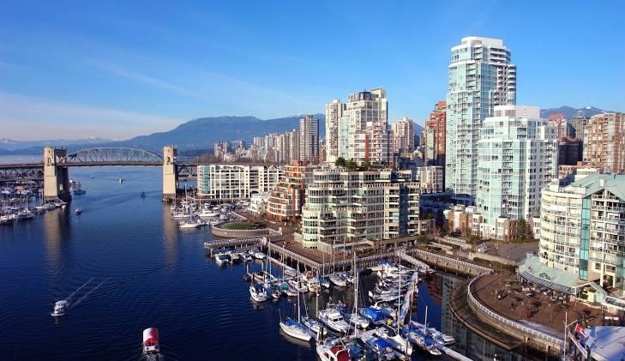
Destination:

Toronto, Ontario, Canada

Day 1 – Friday, October 10: Arrival and Orientation
- Arrival at Toronto Pearson International Airport (YYZ).
- Private or shuttle transfer arranged to hotel.
- Accommodation:
Hotel: Super 8 by Wyndham Toronto East ON
Address: 3280 Kingston Road, Scarborough, M1M 1P8, Toronto, Canada Rest and refresh after a long international flight.
- Evening Activity:
  - Light walk in downtown Toronto (accessible via transit or taxi).
  - Get a first impression of the cityscape, explore Yonge-Dundas Square, and enjoy light street food or a café snack.

Day 2 – Saturday, October 11: Iconic City Landmarks
- Morning: o Visit to the CN Tower, one of the tallest free-standing structures in the world. o Optional: Experience the EdgeWalk, a thrilling outdoor walk on the tower’s edge (advance booking required).
- Late Morning to Early Afternoon:
  - Explore Ripley's Aquarium of Canada, located at the base of the CN Tower.
  - View thousands of marine animals in a walk-through tunnel with moving sidewalks and educational exhibits.
- Afternoon:
  - Leisurely walk to the Harbourfront Centre, a lakeside area featuring galleries, performance venues, shops, and patios.
  - Optional: Rent a bike or enjoy a short boat cruise on Lake Ontario.
- Evening: o Dinner at a lakeside restaurant near the Harbourfront or Queen's Quay. o Return to hotel for rest.

Day 3 – Sunday, October 12: Niagara Falls Day Trip
- Early Morning Departure (approx. 8:00 AM):
  - Full-day guided tour to Niagara Falls, one of the world’s natural wonders.
  - Drive time: Approx. 1.5 hours each way.
- Activities in Niagara Falls:
  - Hornblower Niagara Cruise: Get up close to the base of the Horseshoe Falls. o Journey Behind the Falls: Walk through tunnels behind the roaring waterfalls.
  - Explore the Niagara Parks area, including the Floral Clock, Queen Victoria Park, and Clifton Hill.
- Optional Afternoon Activity:
  - Visit to Niagara-on-the-Lake, a charming town known for its wineries.
  - Participate in a wine tasting tour, including Ontario’s famous Icewine.
- Evening: o Return to Toronto and relax at the hotel.

Day 4 – Monday, October 13: Cultural & Market Exploration
- Morning Visit:
  - Royal Ontario Museum (ROM) – Explore exhibits in natural history, world cultures, dinosaurs, ancient civilizations, and Indigenous art.
- Midday:
  - Stroll through Kensington Market, a vibrant neighborhood filled with vintage shops, multicultural eateries, and street art.
  - Continue into nearby Chinatown, one of the largest in North America – ideal for a quick lunch of authentic Asian cuisine.
- Afternoon:
  - Visit the St. Lawrence Market, one of the world's top food markets. o Sample Canadian delicacies (peameal bacon sandwich, maple syrup products) and shop for local crafts and souvenirs.
- Evening: o Optional: Attend a performance at a nearby theatre or rest.

  - Walk along Yonge Street, Canada’s longest street.
- Evening:
  - Optional dinner at a local restaurant, or try poutine, Canada’s signature comfort food.

Day 8 – Tuesday, October14: Departure
- Morning:
  - Check-out from hotel.
  - Transfer to Toronto Pearson International Airport (YYZ).
- Flight:
  - Return flight to Nairobi, Kenya. o End of trip.

