**ISIN (ANNA) VS FIGI (BLOOMBERG)**

**Introduction**

As an security trader myself, the question resonates with me on a personal level. To me, standardisation or harmonisation of unique data fields (beyond the ticker name itself, which is not 100% unique, as I’ve come to realise in my course of doing equity analysis, including running ticker-specific computer simulation and prediction, and trading) is critical to ensure I (and my machine) correctly identify the security to trade.

Granularity and true uniqueness without competing identifiers, therefore, is something very much welcome so that traders like myself can really get on with our trading and not get caught up in the cross-hairs of all these different standards flogged by different agencies, unique identifiers, proxy wars and all the rest of it.

Without having used a Bloomberg terminal or their software platform since my uni days, which I feel to be an outdated product of a bygone era, I fail to see the point of their eventual argument to try to complement or, to be honest, replace what’s already working pretty well in the industry for as long as ISIN has been around. I’d just stick to ISIN, from both a RegTech practitioner’s standpoint as well as a trader’s standpoint.

To me, “if it ain’t broken, don’t fix it” is a maxim that I professionally subscribe to in my capacity as a Project Director, overseeing a myriad of multi-faceted software projects across multiple client sectors.

**Evolution**

By and large, FIGI’s arguments posit that the so-called inherent key gaps exist in ISIN’s framework that couldn’t be resolved, evolved or are dead-set against evolution to the level that warrant FIGI’s own solutioning. For example:

* ISIN’s standard is based on existing instances of ‘national numbers’ based on the retention of the national numbering systems followed by a larger 12 character identifier, incorporating an ISO country code and check digit.
* The use or anti-use cases against this standard are not really explained in detail – merely criticisms and second guesses of what’s already been stated and acknowledged by the Regulation Authority that “[ISIN originators will] continually adapt the ISIN guidelines for allocation and registration of ISINs to meet the needs of the market”.
* While scope creep is construed as something negative, the fact of the matter is a project of such complexity and chequering needs is often subject to revisions and iterations – and that’s not necessarily a negative thing. Quite the contrary, that ISIN continues to evolve with new features and enhancements in line with ISO 6166 is aligned with how complex systems and structures are modelled on. Evolve rather than dissolve, as I’d argue, since money is at the heart of it.

**Money**

* Technicalities aside, the monetary costs and investments to be incurred for adopting a new standard is often the reason behind the failure of achieving critical mass adoption that ISIN had arguably achieved in view of its 3,100 users spanning 420 institutions in at least 33 countries for identifying OTC derivatives.
* For the case of FIGI, it is purportedly provisioned for free under open data principles or open-source, without any cost recovery attachments or restrictions on access, distribution or redistribution of the identifier and the related metadata.
* Similarly, ISIN is introducing a new free, open ISIN look-up facility, which would have been launched.
* The papers don’t cover the hidden costs of adoption but, knowing Bloomberg, there could very well be the need to pay for additional services a la mode their terminals and other such Web 1.0 paraphrenia.
* Of course, the above free-to-use offering doesn’t preclude the real cost, ie, cost of fragmentation that results from having operational inefficiencies and standard fragmentation due to FIGI being introduced to the landscape and, if so adopted, the direct costs of adoption and implementation necessitated by infrastructural adaptations and system cutovers.
* This is the real debate that market participants would vote with their money: Either sticking to something that works by and large, excepting periodic updates or patches to suit evolving industry requirements, especially since all projects in an ongoing SDLC context are wont to be subject to, or moving on to a newer standard that is yet to be proven, presumably.

**Duplication of efforts**

* In spite of the claimed technical superiority of FIGI methodology, consisting of “a more contextual approach that, through incorporating and relating ISO and other metadata provides an interrelated web of extensible data more appropriate for modern data management, data quality, and data analytic approaches”, that comes across as pure marketing spiel, it’s actually visibly similar to ISIN.
* For example, both are essentially 12-character codes with an alpha 2 prefix and both use modulus 10 "Double-Add-Double" computation for the check digit.
* I’ve struggled to grasp the tangible technical benefits of pivoting away from ISIN to FIGI as a result without running the risk of creating unnecessary confusion, duplication of efforts and resultant operational inefficiencies and inconveniences caused to the market participants.

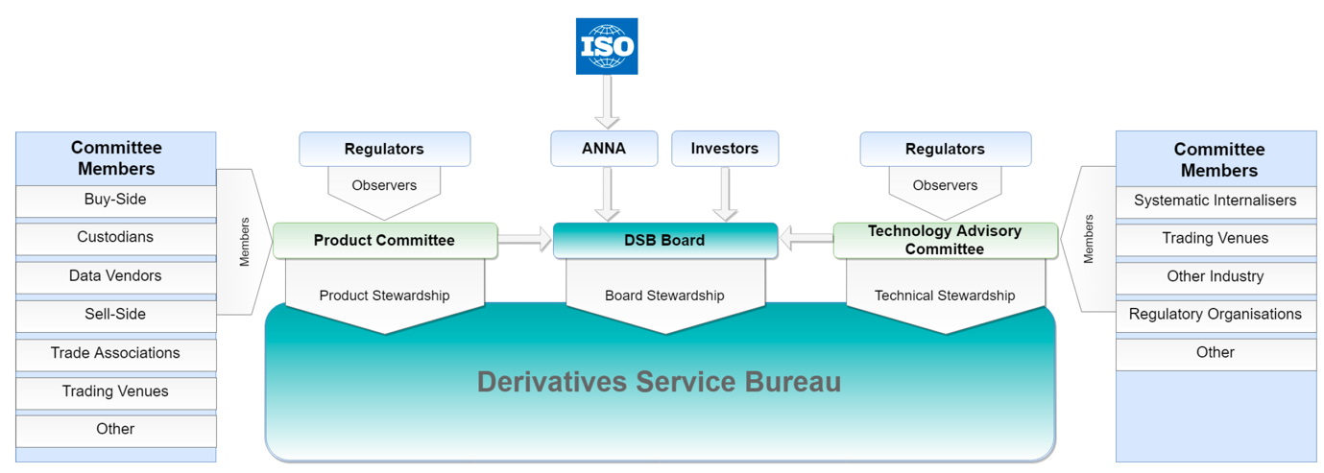

**Conflict of Interests**

* While the ISIN-originator, Derivatives Service Bureau, is cross sectionally representative of a wide range of market participants in the OTC derivatives/securities eco-system, including those from the buy and sell side, custodians, data vendors, trade associates, trading venues, systematic internalisers, regulatory organisations and other industry practitioners, the make-up on Bloomberg’s side isn’t quite clear and probably is quite limited to Bloomberg’s own stakeholders, most probably.
* How fair and neutral would that be is a legitimate concern? After all, there are other companies like Bloomberg, eg, Thomson Reuters, and they don’t necessarily all get into the business of issuing OTC security identifiers for the sake of machine readability as the only probable upside.
* With a lack of visibility and potential conflict of interest situation arising from adopting a Bloomberg-originated FIGI standard, it further lessen the compellingness of having another standard if there was any to begin with in the first place.

Conclusion

* Therefore, factoring in the above reasons and an ostensible lack of a real problem statement in the first place, there appears to be little need for the co-existence of both the ISIN and FIGI in the long run. FIGI is superfluous and, despite what it’s portrayed to be, more of a commercial attempt to grab market share rather than to alleviate any real pressing pain points.

“Finally within one page analyse how you may extend the figi to digital assets, like crypto currencies or derivatives on these underlyings”

* There definitely is a need to extend standardisation to all manners of digital tokens, such as asset tokens, payment tokens, utility tokens and hybrid tokens – similar to the securities aforementioned – because of their proliferation, usage and tradability across a multitude of digital exchanges, data aggregators, custodians, service providers and regulators.
* This will help bring about greater consistency, transparency, and efficiency.
* Using the unique identifier, say, with ‘x’ number of randomly generated alpha-numeric codes, to tie to each FIGI for each digital asset/token, the appropriate licensing or other identifiers, such as ISO’s Digital Token Identifier (DTI), can also be tied in to provide more greater granularity.
* In terms of granularity, while FIGI can embed the data related to said digital asset/token, the DTI will be more focusing on the technical aspects of a token, such as where it sits on the blockchain, its genesis block hash, UTC timestamp, and digital ledger type. Using blockchain-related technologies, the combination of FIGI and DTI can allow for every stakeholder to have a fuller picture of a digital asset/token.
* Whether these can include NFTs – a topic to be addressed rather than shunned given its immense popularity right now – is beyond the scope of this 1-pager; however, if the above can be grafted onto the NFT-originating sites as enabling the aforesaid outcomes, there could very well be grounds to have FIGI and DTI unique identifiers for NFTs as well.
* Once there’s a certain level of adoption, then there could be a roll-out of the APIs, similar to those used for non-digital securities/assets, which could include facilities so people can map thousands of FIGIs to other identifiers linked to digital assets as well.
* All the unique identifiers could easily be traced back and are immutable as a result of adopting these blockchain technologies, therefore, making it easier for the regulators to trace through a repository (blockchain) any irregularities to do with ML/FT purposes.
* This could portend higher controls and mitigation against financial bad actors keen to exploit this space, making it harder for them to obfuscate their illicit money trail and easier for regulators to catch them if any illegalities were found since there is now a bread crumb of data identifiers, which can also the authenticated names and identities of purchasers, etc.
* In summary, the work towards regulating digital assets/token is still in progress and much can be done to expedite it to fruition through the adoption of technologies as forementioned, with a view to benefit the entire eco-system and its stakeholders and, more importantly, the regulators themselves.