AGU 397 SUMMER INTERNSHIP
REPORT
SUBMITTED TO
THE DEPARTMENT OF INDUSTRIAL ENGINEERING OF
ABDULLAH GUL UNIVERSITY
IN PARTIAL FULLFILLMENT OF THE REQUIREMENTS
FOR THE DEGREE OF BACHELOR OF SCIENCE

ARGESIM TEKNOLOJI
24.08.2026-26-09-2026
By
Bensu TOPKÜL
2211021029
<Date of the Submission>
Kayseri / TURKEY
SUMMARY
This report covers a production quality control internship at Argesim Teknoloji A.Ş., a company in Çorum Technopark developing environmentally friendly smart measurement and control technologies. Previously, only Pareto analysis was used to evaluate production errors, identifying which error types were most frequent, but without tracking how errors evolved over time, whether processes were statistically in control, or when small, persistent shifts began.
This study developed variable sample size p-control charts for nine error categories in the production line: Mechanical Assembly, Mechanical Dyson, Cosmetic, Typesetting-Solder, Software (SW), Electronic-Function, Marking-Label, Mold Press Error, and ADC errors. Since the p-chart was insufficient for detecting small shifts in the low-error-rate Software and Electronic-Function processes, CUSUM and EWMA charts were additionally applied there. For Mold Press Error, assignable-cause points were identified and removed, and revised control limits were established.
As a result, the business can now identify not only which errors are most common, but also when processes go out of control and whether persistent small shifts occur.

TABLE OF CONTENTS
TABLE OF CONTENTS 3
LIST OF FIGURES 4
LIST OF TABLES 5
1. INTRODUCTION 6
1.1 Products 7
2. SYSTEM UNDER CONSIDERATION 9
3. METHODOLOGY 10
3.1. Problem Analysis 11
3.2. Literature Review 12
3.3. Project Plan 13
3.4. The Proposed Model 14
3.4.1. p-Control Graph Method 14
3.4.2. P-Control Graph Results by Error Types 15
3.4.3. CUSUM and EWMA Control Graphs 18
3.4.4. Revision of the Mold Press Error Process 21
4. CONCLUSION 23
5. BIBLIOGRAPHY 24
APPENDICES 25

LIST OF FIGURES
Figure 1 Company Emblem 6
Figure 2 External View of the Company 6
Figure 3 Picture of Irradiance Sensor 8
Figure 4 Picture of Irradiance Sensor 9
Figure 5 Pareto Analysis by Error Types 11
Figure 6 Mechanical Assembly p-Control Graph 15
Figure 7 Mechanical Dyson Error p-Control Graph 16
Figure 8 Cosmetic Error p-Control Graph 17
Figure 9 Typesetting-Solder Error p-Control Graph 17
Figure 10 Marking Error p-Control Graph 18
Figure 11 ADC Error p-Control Graph 18
Figure 12 Software SW Error p-Control Graph 19
Figure 13 Electronic-Function Error p- chart 19
Figure 14 Software Sw Error CUSUM and EWMA Control Graphs 21
Figure 15 Electronic-Function Error CUSUM and EWMA Control Graphs 22
Figure 16 Mold Press Error – p-Control Graph Before and After Revision 23

LIST OF TABLES
Table 1 Summary Table of the Nine Error Categories 12
Table 2 Project Plan 14
Table 3Values and Definition of Parameters 19

1. INTRODUCTION
Argesim Teknoloji A.Ş. was established in 2012 as an individual enterprise in Çorum with an R&D-oriented vision with limited capital. In 2018, the company moved to the Çorum Technopolis campus and accelerated its R&D activities and obtained international patents as a result of these studies. Continuing in Çorum organized industry since 2022, the Company develops smart and environmentally friendly measurement, monitoring and control technologies; With its brands such as PlugCo, Seven and BallastCo, it produces products such as pyranometers, wind speed and direction sensors, ballast and power electronic cards that require high technology, especially renewable energy and environmental monitoring systems [1]. The company has 85 workers with 4 industrial engineers.
Figure 1 Company Emblem

Figure 2 External View of the Company
Following an export-oriented growth strategy, Argesim Technology sells its products to more than 90 countries, from America to China, from Sweden to South Africa. Working with its young engineer staff, the company has adopted the mission of 'producing nature-friendly smart technologies for the benefit of humanity' [1]. The majority of the products; It goes through a multidisciplinary production flow consisting of mechanical assembly, electronic card typesetting (SMD/THT soldering), software/embedded system programming, mold printing/injection and final control/marking stages. This multi-stage structure leads to the diversification of error sources; mechanical, electronic, software and cosmetic errors can occur at different stations at the same time.
Before the internship, the quality team only classified the errors detected at the end of daily/weekly production and determined the most common error type with Pareto analysis. Although this approach showed which error was prioritized, it did not show when a process got statistically out of control over time, when an assignable cause came into play, or whether a permanent but small shift in the average error rate occurred. The purpose of this report; is to provide the quality team with a monitoring system that provides both retrospective and early warning by applying statistical process control (IPC) tools to nine different error categories and processes.

1.1 Products
Within the scope of the observations carried out at the production line and quality control stations during the internship, the production flow of the smart measurement and monitoring sensors produced by the company under the SEVEN Sensor brand was examined on-site. As a result of the observations made at the mold printing, mechanical assembly, electronic card typesetting, software loading and final control stations, the production processes of the following product groups were evaluated:
- Weather Stations – complete meteorological monitoring systems installed at solar power plant (SPP) sites, compatible with various inverter brands.
- Irradiance Sensor and Thermopile Pyranometer – are precision measuring devices that measure solar irradiance and pass through the electronic card typesetting line.
- Albedometer and Temperature Sensors (Ambient/Panel) – PT1000 based temperature measurement modules.
- Wind Speed and Direction Sensors – are products that are combined with a rotary measuring head ('Dyson' type mechanism) on a mechanical assembly line; this station was identified as the source of the 'Mechanical Dyson Error' records examined in the internship report.
- Humidity, Dust, Rain, Snow and Cloud Sensors – constitute the complementary product group for environmental monitoring.
- Compact/Mini Weather Station and Silo Level Sensor – are produced as integrated solutions for small-scale projects.
The common production flow of these products; It consists of the production of body parts with mold printing, joining the body and moving mechanisms during the mechanical assembly phase, soldering the electronic cards on the typesetting line, performing the function test by loading the software, ADC calibration, cosmetic control and finally marking/labeling stages. The value stream diagram of a product as an example are explained below.
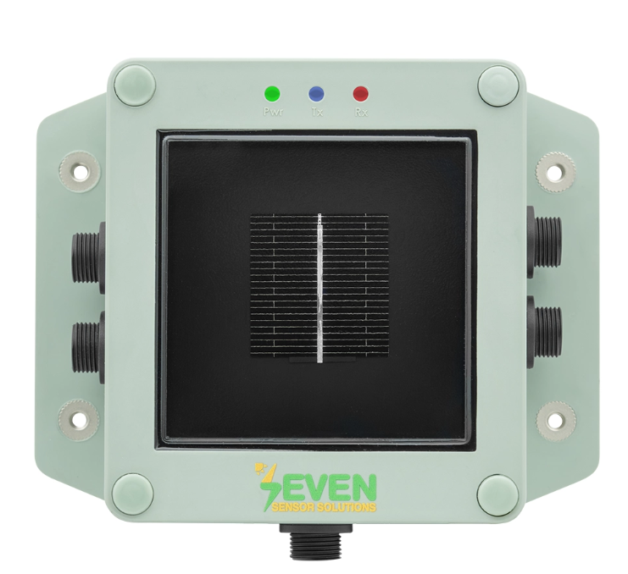
Figure 3 Picture of Irradiance Sensor
Below is the value flow chart of the product, which includes the production and control processes.
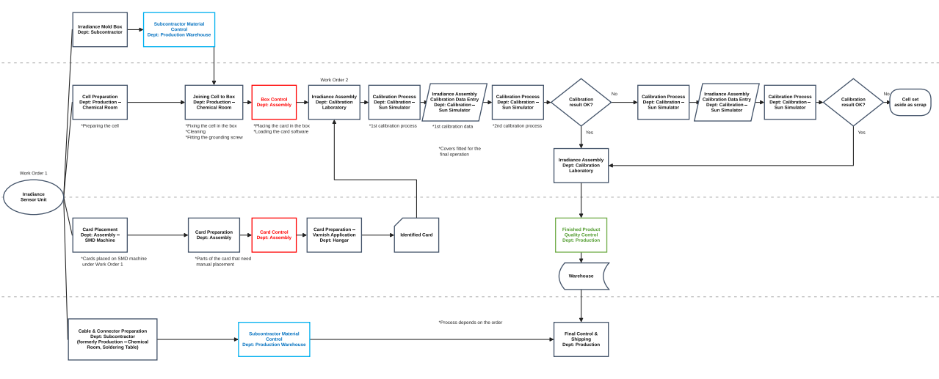
Figure 4 Picture of Irradiance Sensor

2. SYSTEM UNDER CONSIDERATION
The production flow of a product in Argesim Technology; It consists of the stages of producing plastic and metal body parts with mold printing/injection, assembling the body, cover and moving mechanisms (for example, rotatable 'Dyson' type mechanisms of wind direction/speed measurement heads) at mechanical assembly stations, soldering SMD/THT components in the electronic card typesetting line, loading the software (embedded SW) of the cards and performing function tests, entering ADC (analog-digital converter) calibration values, performing the cosmetic control of the product and finally making it ready for shipment with marking/labeling.
At each stage, the quality control team records the number of products checked daily and the number found to be defective. Thus, two basic data are obtained on a daily basis for each defect category: the number of products checked (sample size, n) and the number of defective products (d). The sample size varies between 1 and 800 every day depending on the production volume; this situation does not make it appropriate to use classical control graphs that assume a fixed sample size directly, and requires a p-control graph approach with a control limit that varies on a daily basis. In addition, the p-graph is used to monitor the proportion of non-conforming (defective) units produced by a process . Unlike x̄-R or x̄-s cards, it is preferred when each unit gives only a binary result as "suitable / non-conforming", instead of a measurable (continuous) quality characteristic .
The nine categories of defects examined can be grouped according to their source as follows:
- Mechanical Assembly Defect – changes in the body/cover assembly due to measurement, leakage or injection
- Mechanical Dyson Error – mounting errors in the rotatable measuring head (wind speed/direction) mechanism
- Cosmetic Defect – scratches, dents, or visual defects on the hull surface
- Typesetting-Solder Error – Solder and component placement errors in SMD/THT electronic board production
- Software (SW) Error – errors in embedded software installation/parameter setting
- Electronic-Function Error – the board fails the electrical function test
- Marking-Label Error – label, calibration value, or marking discrepancies on the product
- ADC Error – incorrect entry of analog-to-digital converter calibration values
- Mold Printing Defect – surface and measurement errors of plastic/metal parts during the mold printing/injection stage
Within the scope of the internship, these nine datasets were combined in a single work file; date, number checked, number of errors, error rate (p), upper control limit (UCL) and lower control limit (LCL) were calculated on a separate worksheet for each category, and a root cause note (e.g. 'There is Movement in the Injection Parts', 'No Stone Resistance Installed') was added together with the quality engineers.

3. METHODOLOGY
It plays a decisive role in terms of quality, profitability, time saving and waste reduction in production. In this section, the analysis of the current situation (Pareto analysis), the literature review on the subject, the project plan and finally the details of the p-control graph, CUSUM and EWMA methods applied are presented.

3.1. Problem Analysis
The method used before the internship consisted solely of Pareto analysis: the total number of defects in the nine defect categories was compared to determine the most recurring defect types. In the 8-month period under review, there were a total of 1,490 defective product records, a significant proportion of which were grouped into just two categories (Mechanical Assembly and Mechanical Dyson Defect). As seen in Figure 5, these two categories account for approximately 88% of the total defects and are distributed in accordance with the Pareto principle.
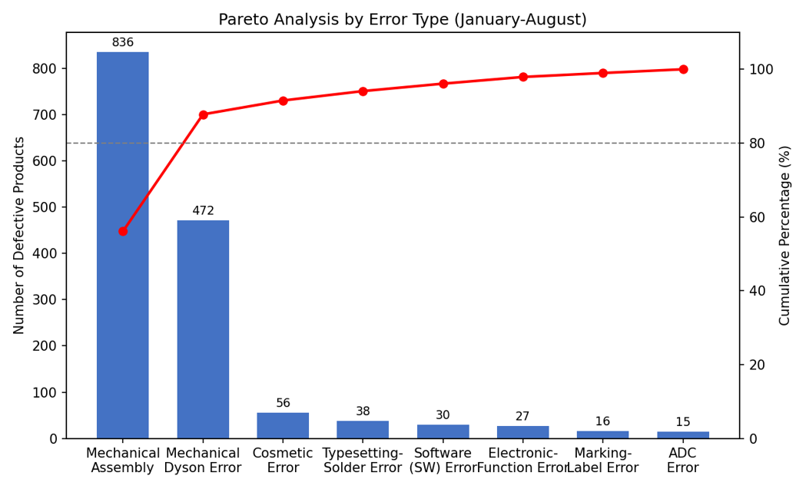
Figure 5 Pareto Analysis by Error Types
While Pareto analysis is valuable for prioritization, it falls short on its own: it does not show (i) the date on which an error spike began, (ii) whether the increase is due to a random fluctuation or an assignable cause, and (iii) whether a process with a low error rate is actually gradually worsening. Therefore, in the second phase of the study, it was decided to create statistical process control (IPC) graphs separately for each category. Table 1 summarizes the total number of checked products, the number of defective products, the average error rate, and the number of days/batches out of control for the nine error categories.
Table 1 Summary Table of the Nine Error Categories
Error Category | Checked (pcs) | Faulty (quantity) | Mean p (%) | Out-of-Control Day/Party
Mechanical Assembly | 5.558 | 836 | 15,04 | 26 / 147 (%17,7)
Mechanical Dyson Error | 5.509 | 472 | 8,57 | 25 / 150 (%16,7)
Cosmetic Error | 4.842 | 56 | 1,16 | 5 / 91 (monthly group)
Typesetting-Solder Error | 4.665 | 38 | 0,81 | 12 / 149 (%8,1)
Software (SW) Error | 5.931 | 30 | 0,51 | 0 / 146 (%0,0)*
Electronic-Function Error | 4.663 | 27 | 0,58 | 0 / 147 (%0,0)*
Marking-Label Error | 4.495 | 16 | 0,36 | 8 / 148 (%5,4)
ADC Error | 4.530 | 15 | 0,33 | 7 / 146 (%4,8)
Mold Printing Error | 8.788 | 201 | 2,29 | 4 / 29 (%13,8)

3.2. Literature Review
The three main tools used in the study, the p-control graph, CUSUM, and EWMA, are the classical methods of statistical process control (IPC).
The concept of the control graph was first developed by Walter A. Shewhart at Bell Telephone Laboratories in the 1920s, aiming to distinguish whether the variability in the output of a process is due to a 'random/common cause' or an 'assignable/specific cause' [2]. If a process is affected only by common causes, it is statistically controlled and its future behavior can be predicted; on the other hand, when an assignable cause comes into play, the process mean or variability changes permanently and requires intervention. The p-control graph used for discrete (qualitative) data requires the upper and lower control limits (UCL, LCL) to be calculated separately for each point, while the centerline (p̄) remains constant when the sample size (n) is not constant at each observation point; in this study, the variable limit p-control graph was preferred because the sample size varies between 1 and 800 days by day [3].
Classical Shewhart plots capture large and sudden jumps in the average of the process quickly; however, they are less sensitive to small and persistent shifts (e.g., slow shift of the average error rate from 0.5% to 1%) because they only use the information of the last observation point. To address this limitation, E. S. Page proposed the CUSUM (cumulative sum) control plot in 1954. By cumulatively summing the deviation of each observation from the target value, CUSUM carries the information of all past observations; in this way, small shifts grow in total over time, exceeding the decision limit (H) and being detected early [4].
S. W. Roberts developed the EWMA (exponentially weighted moving average) control graph in 1959, which gives exponentially decreasing weights to past observations. The EWMA statistic is calculated by weighting the current observation with the weighted coefficient λ (0 < λ ≤ 1); as λ becomes smaller, the graph becomes more sensitive to small shifts, but more slowly reacts to large spikes than the Shewhart graph [5]. Montgomery notes that CUSUM and EWMA perform closely together, but EWMA is generally easier to interpret and apply for quality engineers [3].
In this study, CUSUM and EWMA methods were used as a complement for Software (SW) Error and Electronic-Function Error processes, which already have a low error rate and do not show any non-control points in the classical p-control graph. In addition, the ISO 7870-2 standard provides an internationally accepted framework for the design and interpretation of Shewhart control graphs and was referenced in the control limit calculations in this study [6]. The approach of recalculating the control limits by eliminating the assignable causal points applied in the Mold Press Error process is based on the principle of 'bringing the process to statistical control' defined in Juran's Quality Manual [7].

3.3. Project Plan
The project was carried out within the framework of a four-week work plan. Table 2 summarizes the weekly phases.
Table 2 Project Plan
Project Plan | 1. Week | 2. Week | 3. Week | 4. Week
Determination of the project and examination of the existing Pareto analysis | X
Standardizing the data collection process |  | X
P-control graph and calculation of control limits for each error category |  | X | X
Applying CUSUM/EWMA analysis for low-error processes |  |  | X
Revision of the Mold Press Error process and reporting of results |  |  |  | X

3.4. The Proposed Model

3.4.1. p-Control Graph Method
$p_{İ} = d_{İ} / n_{İ}d_{İ}n_{İ}$It was calculated as the error rate for each day (: incorrect quantity on day i, : checked quantity on day i). The general average error rate of the process, p̄, was found by dividing the total number of errors by the total number of checks over the entire period.
$$p̄ = \sum{d_{i}} / \sum{n_{i}}$$
Since the sample size varies from day to day, a separate standard deviation for each point
$$σ_{i} = \sqrt{[p̄(1-p̄)/n_{i}]}$$
calculated and determined as control limits. For this reason, UCL and LCL are not seen as a fixed line in the graphs, but as a 'ladder'-shaped boundary that narrows and widens according to the sample size: on days when a small number of products are controlled, the limits are wide, and on days when a large number of products are controlled, they are narrow.
$${UCL}_{i} = p̄ + 3σ_{i},{LCL}_{i} = max(0, p̄ - 3σ_{i})$$

3.4.2. P-Control Graph Results by Error Types
In the Mechanical Assembly process, 26 days (17.7%) were out of control in 147 days of data (Figure 6). The most notable deviation occurred on February 18, when 800 out of 806 products were defective, and the error rate reached 99.3%; at this point, together with the quality engineers, the root cause 'There is Play in the Injection Parts' was reached, i.e., a set-up shift in the mold/injection equipment was identified as the root cause. Even excluding this single point, the average error rate of the process still remains high compared to other categories, confirming that the mechanical assembly station should be the primary target in continuous improvement efforts.
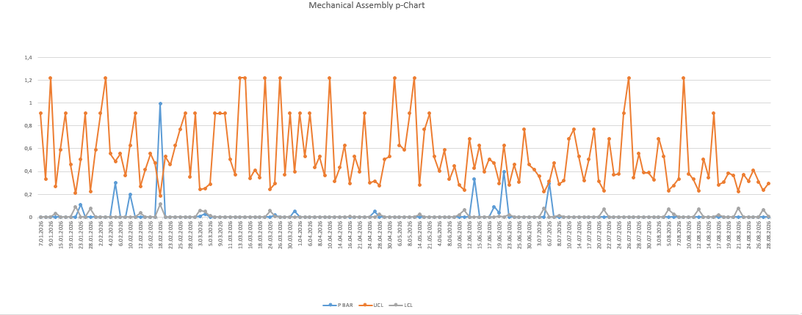
Figure 6 Mechanical Assembly p-Control Graph

During the mechanical Dyson Error, 25 out of 150 days (16.7%) were out of control. In 17 of the out-of-control points, the note 'Dayson Error' was entered; this indicates the existence of a recurring, systematic problem in the assembly of the rotatable measuring head mechanism. In contrast to the odd randomly distributed deviations, the recurrence of the same root cause over and over again suggests the need for a permanent design or work instruction revision at this station.
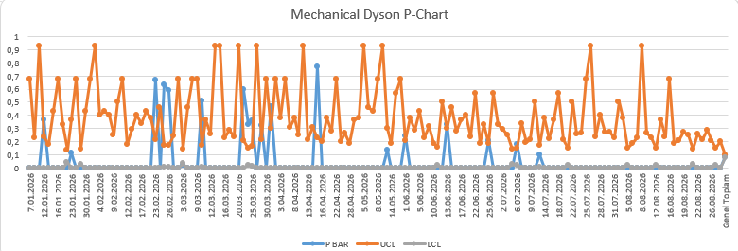
Figure 7 Mechanical Dyson Error p-Control Graph
In the Cosmetic Defect process, data were kept together with monthly product group information, and 56 defects (1.16%) were detected in 4,842 checked products. In the notes of the out-of-control points, the words 'scratch on mechanical structure/cable' stand out as a recurring theme, suggesting that cosmetic defects mostly occur during transportation, handling or packaging.
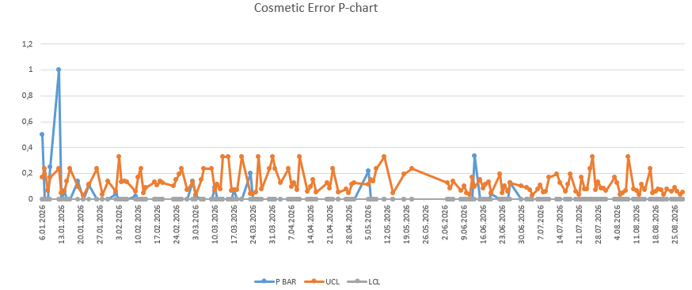
Figure 8 Cosmetic Error p-Control Graph

During the Typesetting-Solder Failure process, 12 of 149 days (8.1%) were out of control. When the notes are examined, it is seen that a significant part of the errors are due to assembly negligence such as 'no stone resistor installed/not soldered'; this is a finding that may require operator training on the typesetting line or a review of the scope of automatic optical control (AOI).
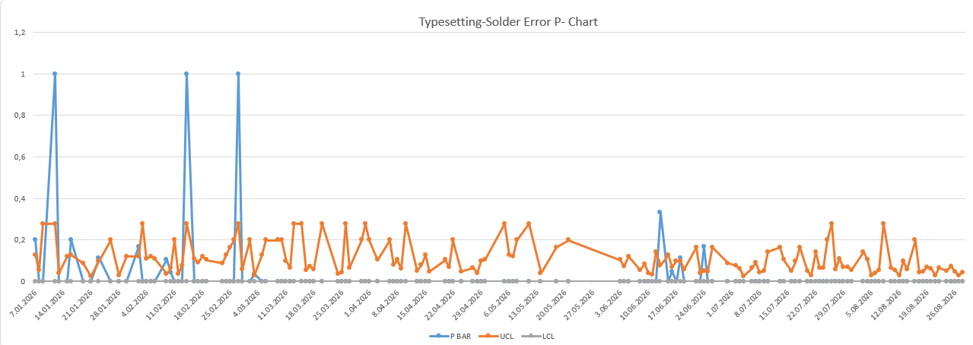
Figure 9 Typesetting-Solder Error p-Control Graph
8 out of 148 days (5.4%) were out of control in the Marking-Label Error process and 7 out of 146 days (4.8%) in the ADC Error process. Although the error rate was low (0.36% and 0.33% respectively) in both processes, repetitive input/calibration errors such as 'ADC values were entered highly' and 'marking was done incorrectly because the calibration value was written incorrectly' are seen in the notes; these findings indicate that the measurement/calibration step should be supplemented with double control (poka-yoke).
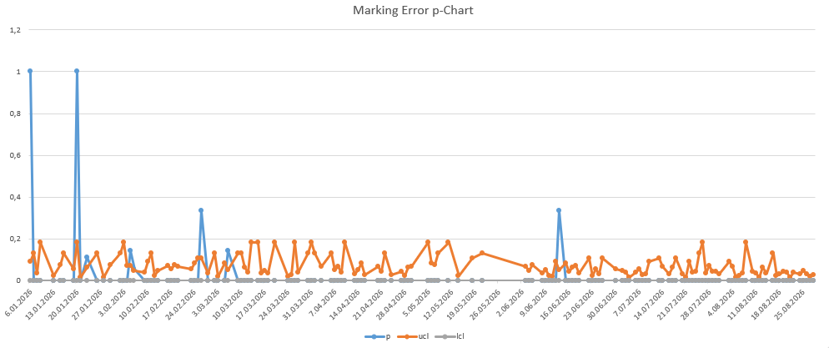
Figure 10 Marking Error p-Control Graph
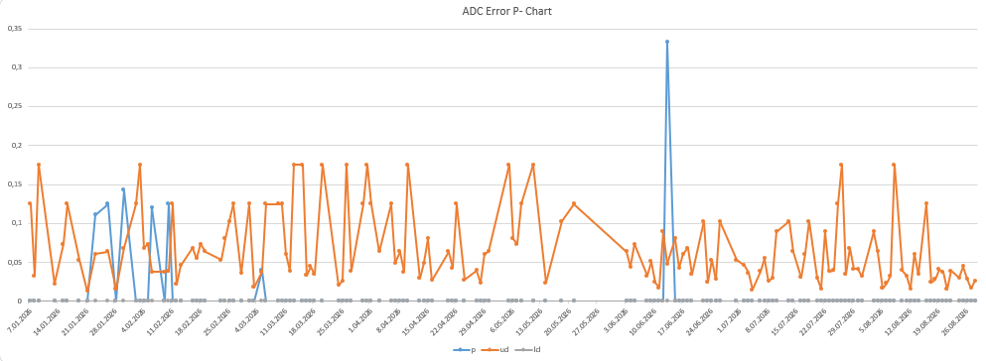
Figure 11 ADC Error p-Control Graph

3.4.3. CUSUM and EWMA Control Graphs
In the Software (SW) Error and Electronic-Function Error processes, not a single out-of-control point was seen in the p-control graph; however, since the error rate of these two processes is already very low (0.51% and 0.58%, respectively), the power of the classical p-control graph to capture small and permanent shifts is limited. Therefore, for both processes, CUSUM and EWMA statistics were calculated based on standardized deviation as the sample size varies from day to day.
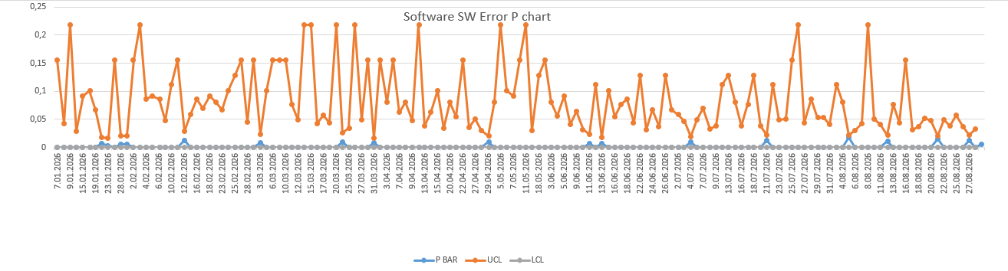
Figure 12 Software SW Error p-Control Graph
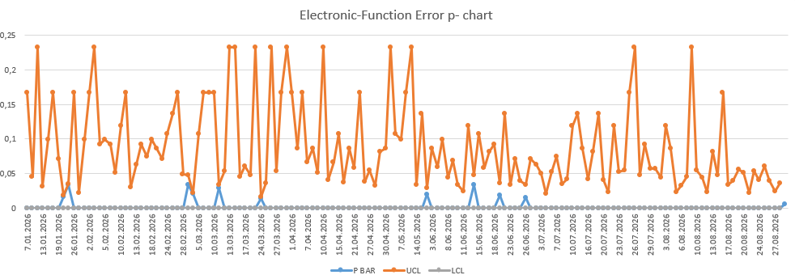
Figure 13 Electronic-Function Error p- chart
CUSUM statistics are updated cumulatively every day as and on; When the C⁺ or C⁻ value exceeds the H limit, the process is considered to have entered a permanent shift in the positive or negative direction. The EWMA statistic is calculated as and determined by control limits. Figure 14 and Figure 15 show the CUSUM and EWMA graphs of the Software (SW) Error and Electronic-Function Error processes, respectively.
$$c_{i}^{+}​=max[0, x_{i}​-({μ​}_{0}+K)+C_{i-1}^{+}​]C_{i}^{-}=max[0, (μ_{0}​-K)-x_{i}​+C_{i-1}^{-}​]E_{i} = λ*z_{i} + \left(1-λ\right)*z_{i-1}±L·√[λ/(2-λ)]$$

Table 3Values and Definition of Parameters
Parameter | Description | Value
k | CUSUM reference value (acceptable drift half, in σ) | 0,5
H | CUSUM decision interval (alarm limit, in σ) | 5
λ | EWMA weighting coefficient | 0,2
L | EWMA control limit coefficient (in σ) | 3

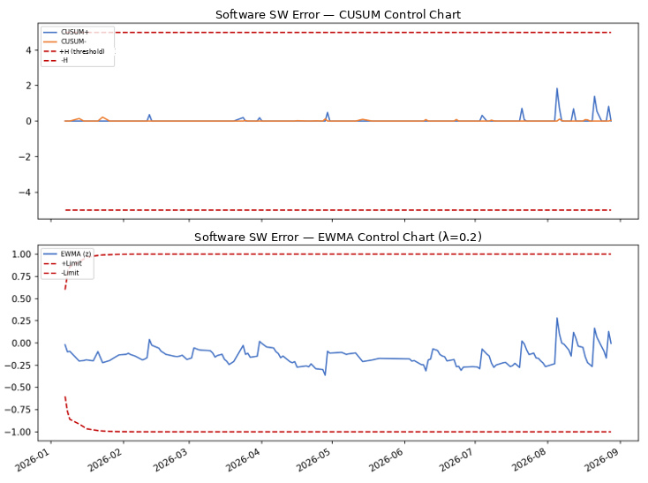
Figure 14 Software Sw Error CUSUM and EWMA Control Graphs

During the Software (SW) Error process, it is seen that CUSUM and EWMA statistics are significantly below the decision limits (±H, ±Limit) throughout the period; even the highest C⁺ value remained well below the H=5 limit. This confirms that the process is statistically under control in terms of both short-term jumps and long-term permanent shifts. Nevertheless, a slight upward trend in CUSUM+ towards August is noted, and it is recommended to continue monitoring this trend.
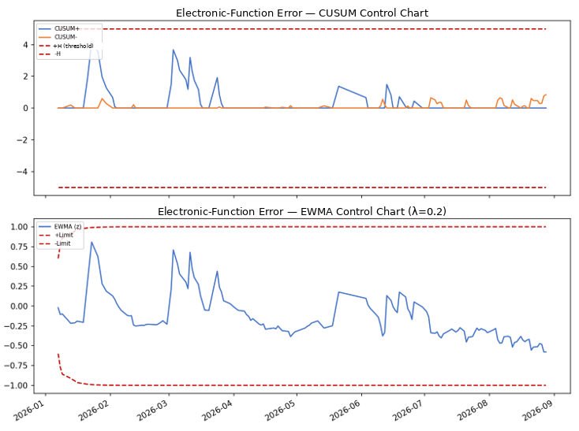
Figure 15 Electronic-Function Error CUSUM and EWMA Control Graphs
Similarly, in the Electronic-Function Error process, the CUSUM and EWMA values remained within the decision limits. On January 23, on a day when the sample size was small, a temporary jump in the EWMA value was observed, but this jump did not exceed the limit and returned to the mean in the following days. In conclusion, the CUSUM/EWMA analysis confirms the 'within control' result given by the p-control graph and also shows that these two processes do not require any additional intervention at the moment, but should continue to be monitored with CUSUM/EWMA due to the low error rate.

3.4.4. Revision of the Mold Press Error Process
Unlike other categories, in the Mold Press Error process, sampling is not done daily, but in larger batches (300-500 pieces/control). 4 of the 29 control points (13.8%) were out of control according to the original control limits, and one of these points was graded as 'assignable cause'. Including these assignable cause points in the calculation of p̄ and σ carries the risk of obscuring the real performance of the process by making the control limits appear wider than they actually are.
Therefore, the points with assignable causes were excluded from the calculation, the p̄ and control limits were recalculated, and a revised p-control graph was created. This approach coincides with the principle of 'bringing the process to statistical control' as defined in Juran's Quality Manual [7]. Control limits calculated without eliminating assignable causes do not reflect the true co-cause variability of the process.
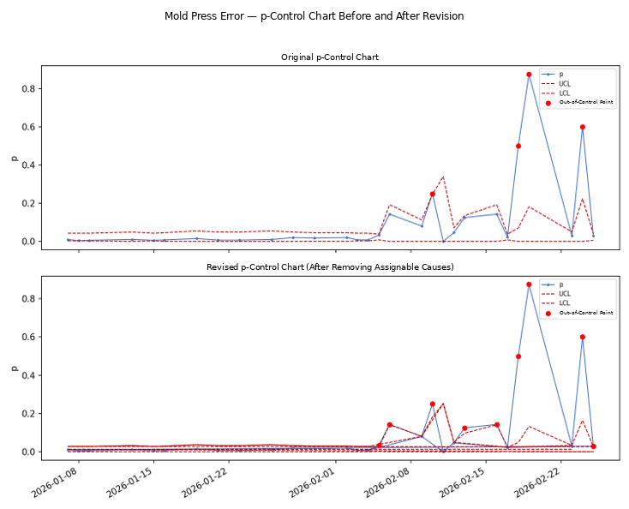
Figure 16 Mold Press Error – p-Control Graph Before and After Revision

After the revision, the control limits were calculated narrower than the original and closer to the process average; this allows the true natural variability of the process to be represented more accurately. However, according to the revised limits, some points (especially the two high error rate batches at the end of February) remain out of control; a root cause note has not yet been entered for these points, and it is recommended that the quality team retrospectively review these batches and, if necessary, associate them with the mold maintenance record. The revision study has once again demonstrated that the approach of 'out of control = signal that needs to be investigated and caused' = should be adopted, not 'out of control = automatically ignored'.

4. CONCLUSION
Within the scope of this internship project, statistical process control tools were applied to nine different error categories of Argesim Teknoloji A.Ş. Before the internship, it was possible to determine which error was more common only with Pareto analysis, but with this study, the behavior of each process over time, the dates of the points that were out of control and, where possible, the root causes were made visible.
The findings are summarized as follows: The Mechanical Assembly (15.0%) and Mechanical Dyson Error (8.6%) categories have both the highest error rate and the most frequent out-of-control frequency (17.7% and 16.7%, respectively), and are the areas that should be prioritized in improvement efforts; in particular, the recurring 'Dayson Error' note in the Dyson mechanism indicates a persistent design/instruction problem. Typesetting-Solder, Marking-Label, and ADC errors are low (below 1%), while repetitive notes at out-of-control points (solderless resistance, incorrect calibration input) indicate the need for operator training and poka-yoke. Software and Electronic-Function errors were statistically controlled in both the p-control graph and the CUSUM/EWMA analysis, but it was recommended to continue monitoring these two processes with CUSUM/EWMA due to low error rates. The revised control limits obtained by eliminating the points with assignable reasons in the Mold Press Error process reflected the real variability of the process more accurately, but it was revealed that the batches that were out of control after the revision should be investigated.
As a result, the combination of p-control graph, CUSUM and EWMA methods has given the quality team a multi-layered monitoring structure that can answer not only the question of 'which error is more common', but also 'when and why the error got out of control' and 'is the process slowly deteriorating'.

5. BIBLIOGRAPHY
[1] Argesim Teknoloji Anonim Şirketi Corporate Profile. Çorum Technopark, OSB / Çorum. Access: kariyer.net company profile.
[2] Shewhart, W. A. (1931). Economic Control of Quality of Manufactured Product. New York: D. Van Nostrand Company.
[3] Montgomery, D. C. (2020). Introduction to Statistical Quality Control (8th ed.). Hoboken, NJ: John Wiley & Sons.
[4] Page, E. S. (1954). Continuous Inspection Schemes. Biometrika, 41(1/2), 100–115.
[5] Roberts, S. W. (1959). Control Chart Tests Based on Geometric Moving Averages. Technometrics, 1(3), 239–250.
[6] ISO 7870-2:2013. Control Charts — Part 2: Shewhart Control Charts. Geneva: International Organization for Standardization.
[7] Juran, J. M., & Godfrey, A. B. (1999). Juran's Quality Handbook (5th ed.). New York: McGraw-Hill.

APPENDICES
Appendix A1. All quality datas and Paraeto analysis
Kalite Kontrol Tablosu Ocak-Ağustos 2026.xlsx

Appendix A2. P-Charts, CUSUM-EWMA Analysis Worksheet and Calculation Parameters
p-chart-revize-CUSUM-EWMA (1).xlsx

