Rockbuster Stealth

# Data Dictionary



Bente Bruun, 8.11.2023

1. Table of Contents
2. Rockbuster Stealth …………………………………………………..…..3
3. Entity Relationship Diagram.………….……………….…………..…….3
4. Key/Legend………………………………………………………..……….3
5. Film-Related Data…………………………………………………..……..4
   * + 1. Table:Film…………………………………………………….….…..4
       2. Table: Actor……………………………………………………..…...5
       3. Table: Film_actor……………………………………………..……..6
       4. Table: category………………………………………………………7
       5. Table: film_category…………………………………………………8
       6. Table: language……………………………………………………...9
       7. Table: Inventory…………………………………………………….10
6. Transactions……………………………………………………………….11
   * + 1. Table: Payment…………………………………………………….11
       2. Table: Rental ……………………………………………………….12
7. Location…………………………………………………………………….13
   * + 1. Table: Address ……………………………………………………..13
       2. Table: City…………………………………………………………...14
       3. Table: Country………………………………………………………15
8. Operational Data ………………………………………………………….16
   * + 1. Table: Customer ……………………………………………………16
       2. Table: Staff ………………………………………………………….17
       3. Table: Store …………………………………………………………18

Rockbuster Stealth

Rockbuster Stealth LLC is a movie rental company that used to have stores around the world. Facing stiff competition from streaming services such as Netflix and Amazon Prime, the Rockbuster Stealth management team is planning to use its existing movie licenses to launch an online video rental service in order to stay competitive.

The data set contains information about Rockbuster’s customers, staff members, film inventory, sales data, and locations of people and stores.

**Entity Relationship Diagram**

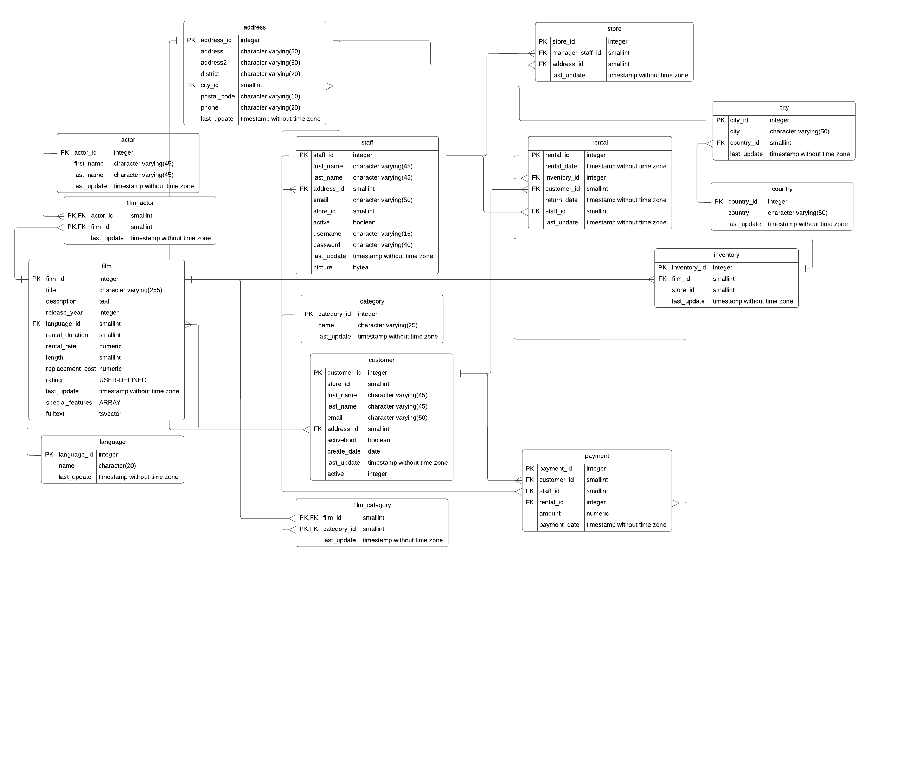

**Key/Legend**

* = Unique Primary Key

 = Foreign Key

**Film-Related Data**

Film Table:

|  |  |  |  |
| --- | --- | --- | --- |
| Keys | Colum | Data Type | Description |
| Old Key with solid fill | film_id | integer | Unique film ID |
|  | title | character varying(255) | Film title name |
|  | description | text | Film full description |
|  | release_year | year | Year of film release |
| Old Key outline | language_id | smallint | Unique language ID |
|  | rental_duration | smallint | Average rental duration of the film |
|  | rental_rate | numeric(4,2) | Rental usage rate |
|  | length | smallint | Film length in minutes |
|  | replacement_cost | numeric(5,2) | Price of film replacement |
|  | rating | mpaa_rating | Film mpaa rating |
|  | last_update | timestamp(6) without time zone | Date and time of last update |
|  | Special features | text() | Different film features included with film |
|  | fulltext | tsvector | Key description text of film and count of word |

Links to:

|  |  |
| --- | --- |
| Table Name | Join |
| language | film.language_id = language.language_id |

Links from:

|  |  |
| --- | --- |
| Table Name | Join |
| film_actor | film_actor.film_id = film.film_id |
| film_category | film_category_film_id = film.film_id |
| inventory | inventory.film_id = film.film_id |

# Actor Table:

|  |  |  |  |
| --- | --- | --- | --- |
| Keys | Colum | Data Type | Description |
| Old Key with solid fill | Actor_id | Integer | Unique actor key |
|  | First_name | Character varying (45) | Actors first name with 45 characters limit |
|  | Last_name | Character varying (45) | Actors last name with 45 characters limit |
|  | Last_update | Timestamp without timezone | Time and date of last update |

Links from:

|  |  |
| --- | --- |
| Table Name | Join |
| film_actor | film_actor.actor_id=actor.actor_id |

Film Actor Table:

|  |  |  |  |
| --- | --- | --- | --- |
| Keys | Column | Data Type | Description |
| Old Key with solid fillOld Key outline | actor_id | smallint | Unique actor ID |
| Old Key with solid fillOld Key outline | film_id | smallint | Unique film ID |
|  | last_update | Timestamp (6) without timezone | Time and date of last update |

Links to:

|  |  |
| --- | --- |
| Table Name | Join |
| film | film_actor_id=film.film_id |
| actor | film_actor.actor_id= actor.actor_id |

Category Table:

|  |  |  |  |
| --- | --- | --- | --- |
| Keys | Colum | Data Type | Description |
| Old Key with solid fill | category_id | integer | Unique category ID |
|  | name | character varying(25) | Name of type of category |
|  | last_update | timestamp(6) without time zone | Date and time of last update |

Links from:

|  |  |
| --- | --- |
| Table Name | Join |
| film_actor | film_actor.category_id=category.category_id |

Film Category Table:

|  |  |  |  |
| --- | --- | --- | --- |
| Keys | Colum | Data Type | Description |
| Old Key with solid fill | film_id | smallint | Unique film ID |
| Old Key with solid fill | category_id | smallint | Unique category ID |
|  | last_update | timestamp(6) without time zone | Time and Date of last update |

Links to:

|  |  |
| --- | --- |
| Table Name | Join |
| film | film.film_id= film_category.film_id |
| category | category.category_id=film_category.category_id |

Language Table**:**

|  |  |  |  |
| --- | --- | --- | --- |
| Keys | Colum | Data Type | Description |
| Old Key with solid fill | language_id | serial | Unique language ID |
|  | name | character(20) | Specific language of origin |
|  | last_update | timestamp(6) without time zone | Time and date of last update |

Links to:

|  |  |
| --- | --- |
| Table Name | Join |
| film | film.language_id=language.language_id |

Inventory Table:

|  |  |  |  |
| --- | --- | --- | --- |
|  | Colum | Data Type | Description |
| Old Key with solid fill | inventory _ID | integer | Unique inventory ID |
| Old Key outline | film_id | smallint | Unique film ID |
| Old Key outline | store_id | smallint | Unique store ID |
|  | last_update | timestamp(6) without time zone | Time and Date of last update |

Links to:

|  |  |
| --- | --- |
| Table Name | Join |
| film | film.film_id=inventory.film_id |
| store | Store.store_id=inventory.store_id |

Links from:

|  |  |
| --- | --- |
| Table Name | Join |
| rental | rental_inventory_id=inventory.inventory_id |

**Transactions**

Payment Table

|  |  |  |  |
| --- | --- | --- | --- |
|  | Columns | Data Type | Description |
| Old Key with solid fill | payment_id | serial | Primary Key for Payment Record |
| Old Key outline | customer_id | smallint | Unique Customer ID number |
| Old Key outline | staff_id | smallint | Unique staff identificator |
| Old Key outline | rental_id | integer | Unique rental indentificator |
|  | amount | numeric(5,2) | Price of payment |
|  | payment_date | timestamp(6) without time zone | Year, day, month, and time of payment |

Links to:

|  |  |
| --- | --- |
| Table Name | Join |
| customer | customer.customer_id=payment.customer_id |
| staff | staff.staff_id=payment.staff_id |
| rental | rental.staff_id=payment.staff_id |

Rental Table

|  |  |  |  |
| --- | --- | --- | --- |
|  | Colum | Data Type | Description |
| Old Key with solid fill | rental_id | integer | Unique ID number used for primary key for rentals. |
|  | rental_date | timestamp(6) without time zone | Date and time of rental |
| Old Key outline | inventory_id | integer | Unique inventory ID |
| Old Key outline | customer_id | smallint | Unique customer ID |
|  | return_date | timestamp(6) without time zone | Date of latest to return product. |
| Old Key outline | staff_id | smallint | Unique Staff ID |
|  | last_update | timestamp(6) without time zone | Date and time of last update of product status |

Links to:

|  |  |
| --- | --- |
| Table Name | Join |
| inventory | Inventory.inventory_id=rental.inventory_id |
| customer | customer.customer_id=rental. customer _id |
| staff | staff.staff _id=rental.staff_id |

Links from:

|  |  |
| --- | --- |
| Table Name | Join |
| payment | payment.rental_id=rental_rental_id |

**Location**

Address table

|  |  |  |  |
| --- | --- | --- | --- |
|  | Colum | Data Type | Description |
| Old Key with solid fill | Address_id | integer | Unique address key |
|  | Address | character varying (50) | Full adress |
|  | Address2 | character varying (50) | Full backup address |
|  | District | character varying (20) | District of |
| Old Key outline | City_id | smallint | Unique city key |
|  | Postal_code | character varying (10) | Postal code 10 digits limit |
|  | Phone | character varying (20) | Phonenumber |
|  | Last_update | timestamp without timezone | Time and date of last update |

Links to:

|  |  |
| --- | --- |
| Table Name | Join |
| city | city.city_id=address.city_id |

Links from:

|  |  |
| --- | --- |
| Table Name | Join |
| customer | customer.address_id=address.address_id |
| staff | staff.address_id=address.address_id |
| store | store.address_id=address.address_id |

City Table

|  |  |  |  |
| --- | --- | --- | --- |
|  | Colum | Data Type | Description |
|  | city | serial | Full name of city |
| Old Key with solid fill | city_id | character varying(50) | Unique city ID |
| Old Key outline | Country_id | smallint | Unique country ID |
|  | last_update | timestamp(6) without time zone | Time and date of last update |

Links to:

|  |  |
| --- | --- |
| Table Name | Join |
| country | country.country_id=city.country_id |

Links from:

|  |  |
| --- | --- |
| Table Name | Join |
| address | Address.city_id=city.city_id |

Country Table

|  |  |  |  |
| --- | --- | --- | --- |
|  | Colum | Data Type | Description |
| Old Key with solid fill | country_id | serial | Unique country ID |
|  | country | character varying(50) | Full name of country |
|  | last_update | timestamp(6) without time zone | Time and date of last update |

Links from:

|  |  |
| --- | --- |
| Table Name | Join |
| city | city.country_id=counry.country_id |

**Operational Data**

Customer Table

|  |  |  |  |
| --- | --- | --- | --- |
|  | Colum | Data Type | Description |
|  | Columns | Data Type | Description |
| Old Key with solid fill | customer_id | Integer | Unique customer ID |
|  | store_id | smallint | Unique store ID |
|  | first_name | character varying(45) | Customer first name |
|  | last_name | character varying(45) | Customer last name |
|  | email | character varying(50) | Customer Email |
| Old Key outline | address_id | smallint | Unique address ID |
|  | activebool | boolean | True or False on activity |
|  | create_date | date | Date customer account was created |
|  | last_update | timestamp(6) without time zone | Time and date of last update |
|  | active | integer | 1 or 0 to indicate activity |

Links to:

|  |  |
| --- | --- |
| Table Name | Join |
| address | adress.address_id=customer.address_id |

Links from:

|  |  |
| --- | --- |
| Table Name | Join |
| rental | rental.customer_id=customer.customer_id |
| payment | payment.customer_id=customer.customer_id |

Staff

|  |  |  |  |
| --- | --- | --- | --- |
|  | Colum | Data Type | Description |
| Old Key with solid fill | Staff_id | Integer | Unique staff key |
|  | First_name | Character varying (45) | First name of employee |
|  | Last_name | Character varying (45) | Employees last name with 45 characters limit |
| Old Key outline | Address_id | smallint | Unique address key |
|  | email | Character varying (50) | Email of employee |
|  | Store_id | smallint | Unique store key |
|  | Active | boolean | True or false if still active Employee |
|  | Username | Character varying (16) | Employees username |
|  | password | Character varying (40) | Employees password |
|  | Last_update | Timestamp(6) without timezone | Time and date of last update |
|  | Picture | bytea | Binary data of picture |

Links to:

|  |  |
| --- | --- |
| Table Name | Join |
| address | address.address_id=staff.address_id |

Links from:

|  |  |
| --- | --- |
| Table Name | Join |
| payment | payment.staff_id=staff.staff_id |
| rental | Rental.staff_id=staff.staff_id |
| Store | Store.manager_staff_id=staff.staff_id |

Store

|  |  |  |  |
| --- | --- | --- | --- |
| Keys | Columns | Data Type | Description |
| Old Key outline | Store_id | serial | Unique ID for the store |
| Old Key with solid fill | Manager_staff_id | smallint | Unique ID for the manager |
| Old Key with solid fill | Address_id | smallint | Uniqie ID for the store address |
|  | Last_update | Timestamp(6) without timezone | When the information was last updated |

Links to:

|  |  |
| --- | --- |
| Table Name | Join |
| **Address** | **adress.address_id=store.address_id** |
| **Staff** | **Staff.staff_id=store.manager_staff_id** |