StopMove
Version 1.8 | Ashita v4 addon | how-to guide and read me
Download: https://github.com/Benthere407/StopMove/releases/latest
Project page: https://github.com/Benthere407/StopMove
Tested on a current LandSandBoat (LSB) server running locally.

Overview

What it does
StopMove blocks your numpad (and optionally W/A/S/D) movement keys while you are casting, so you can't walk and interrupt a spell by accident. It can also switch Multisend follow off for the length of the cast and back on afterwards, and it puts a small ON/OFF widget on screen, one row per character, for people running two clients. With Hold position while casting on, a key that slips through for a frame can no longer nudge your position enough for the server to interrupt the spell.
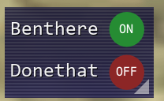
Screenshot: the widget, stacked layout with circle badges, in the "FFXI menu (striped blue)" style. Characters shown: Benthere and Donethat.
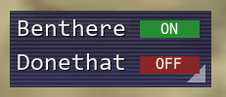
Screenshot: the same widget with square badges.
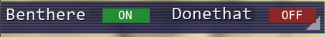
Screenshot: the "Inline (long and skinny)" layout, with the name right next to its ON/OFF badge.

Built with AI
StopMove was made with Claude (Anthropic's AI assistant). Benthere407 described what was wanted and tested each version in game; Claude wrote the code. The full source is in the zip as plain Lua, so anyone can read it.

What it works with
Item | Details
Client | Ashita v4 (Lua addon). Not for Windower.
Tested on | v1.8 tested on a current LandSandBoat (LSB) server running locally.
Renderer | The widget uses Ashita's built-in ImGui, so it should work with whatever renderer Ashita supports.
Optional | Multisend (by ThornyFFXI) if you want the follow on/off feature. Used only through its /ms follow command.
Also used with | The author runs it next to LegacyAC. No conflicts known.

Install and uninstall

How to install
- Unzip stopmove.zip. You get a folder called stopmove containing stopmove.lua.
- Copy the whole stopmove folder into your Ashita addons folder, so that this file exists: <Ashita folder>\addons\stopmove\stopmove.lua
- In game, type /addon load stopmove. The widget appears at the left of the screen.
- To load it automatically, add the line /addon load stopmove to your Ashita startup script (usually <Ashita folder>\scripts\default.txt, or whichever script your profile runs).
- Running two clients? Do this once; both clients share the same Ashita folder. Load it on each client.

How to uninstall
- In game: /addon unload stopmove.
- Delete the line /addon load stopmove from your startup script, if you added it.
- Delete the folder <Ashita folder>\addons\stopmove.
- Optional: delete the settings folder <Ashita folder>\config\addons\stopmove (saved look, position and ON/OFF state).

How to use StopMove

The widget
The box shows one row per character: the name on the left and an ON/OFF badge on the right. Green means ON, red means OFF, and orange "LOCK" shows while a cast is protecting you.
- Click the badge to switch that character on or off. With two clients running, either box can switch either character.
- Drag the box by its background to move it. Drag the small triangle in the bottom-right corner to make it bigger or smaller; the text and badges scale with it.
- Click "UI" at the bottom-left of the box, right-click the box, or type /stopmove to open the settings window.
- If the box ends up off-screen or huge, type /stopmove resetbox.
- Its position, size and ON/OFF state are remembered per character.

What happens when you cast
Step | What the addon does
1 | You press a spell. If Wait until stopped is on and your character is still moving (running, auto-running or following), the cast request is held until you have stood still for the spell cast delay, then it is sent. It is never held longer than the max hold.
2 | If Multisend follow is ticked, the addon sends your "Cast starts" command (default /ms follow off).
3 | If Release held movement keys is on, movement keys you are holding are released. If Hold position while casting is on, the spot you are standing on is remembered.
4 | From the moment the game confirms the cast has begun until it finishes or is interrupted, the numpad movement keys (and W/A/S/D if ticked) are blocked, both as key presses and in the keyboard state the game reads each frame. Small slips of less than 1 yalm are not sent to the server, so they cannot interrupt the cast.
5 | When the cast ends the keys unlock straight away. The "Cast ends" command (default /ms follow on) is sent after the unlock wait: 0 seconds after a finished cast and 10 seconds after an interrupted one by default.
6 | Safety net: nothing stays locked longer than max cast lock (6 seconds by default), the lock clears when you zone, and it also clears if the server has not confirmed the cast within 3 seconds.

Setting (Timing section) | Default | Meaning
Spell cast delay (s) | 0.15 | How long you must stand still before a held cast is sent.
Max hold (s) | 1.0 | Longest a cast is held; it is sent anyway after this.
Max cast lock (s) | 6.0 | Hard cap on the lock and the follow-off.
Unlock wait: cast completed (s) | 0.0 | Delay before follow turns back on after a finished cast.
Unlock wait: cast interrupted (s) | 10.0 | Same, after an interrupted cast.

The settings window
Open it with /stopmove, the UI button, or a right-click on the box. Every change is saved automatically. Sections, top to bottom:
Section | What is in it
General | Enabled for this character; Turn On/Off Widget (hide or show the box); Lock box position and size; UI button (puts a UI button on the widget); Release now (releases the stop-cast lock and allows movement when pushed); Low profile widget (first letter of each name plus ON/OFF only).
Casting actions | Disable keyboard movement (numpad 8/2/4/6); Also disable WASD keys; Release held movement keys at cast start; Hold position while casting; Multisend follow with two editable boxes, "Cast starts" and "Cast ends". A blank command sends nothing.
Timing | Wait until stopped on/off and the five timers shown above.
Layout | Stacked (one row each) or Inline (long and skinny, name then status side by side); rotation 0 / 90 / 180 / 270 degrees; Fit box to content.
Box | Background opacity and Content opacity (names, text and badges) as two separate sliders; background and border colour; border width; Background style: solid colour or FFXI menu (striped blue), with Classic FFXI window frame, Name turns orange while locked, Stripes and stripe strength; background width and height adjustments.
Character name text | Colour, bold, size, drop shadow, and an optional outline (colour and width).
ON / OFF text | Shape: Square or Circle; Show ON / OFF / LOCK text in the badge (untick for colour only); text colour, bold, size, drop shadow, optional outline; colours of the ON, OFF and LOCK badges.
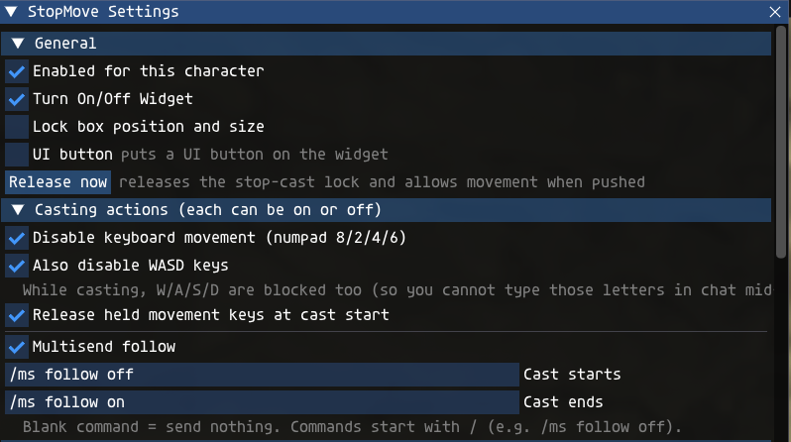
Screenshot: the settings window, General and Casting actions sections.
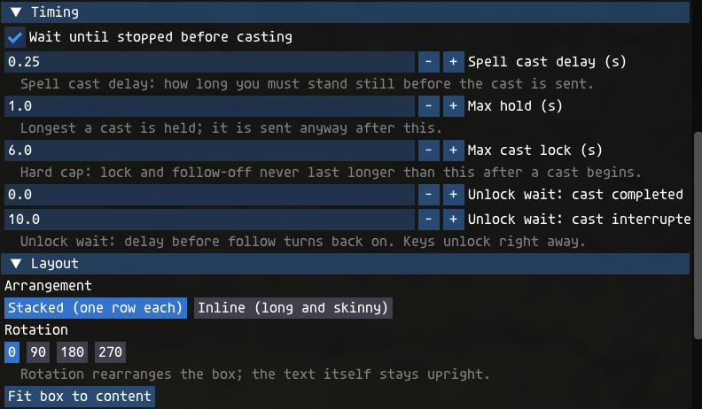
Screenshot: the Timing and Layout sections.
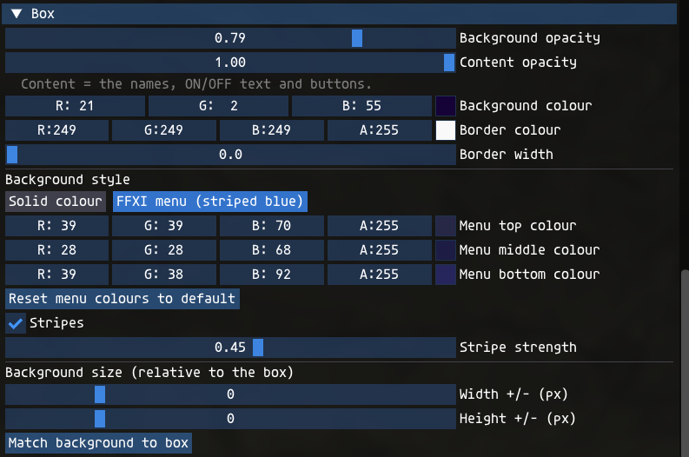
Screenshot: the Box section (opacity, colours, background style, FFXI menu colours, background size).
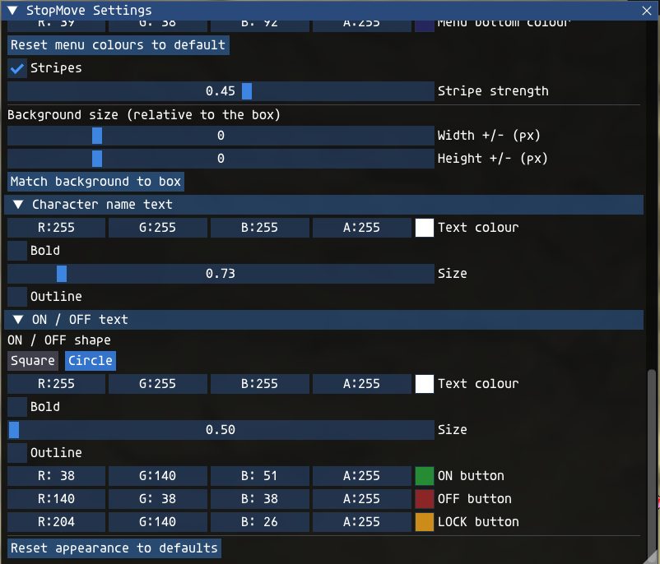
Screenshot: lower part of the Box section, then Character name text and ON / OFF text (window scrolled down).
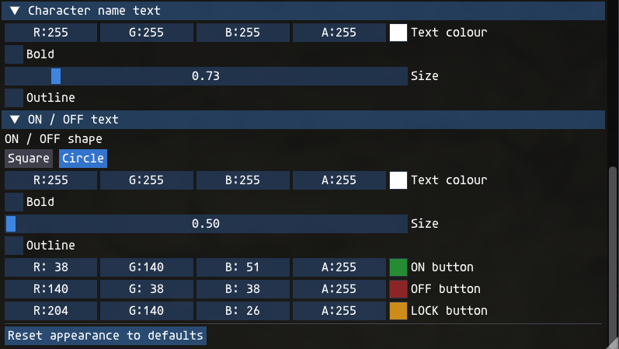
Screenshot: Character name text and ON / OFF text, with the Square / Circle shape selector.

Looks: layout, rotation, shape and background
FFXI menu style. Choosing "FFXI menu (striped blue)" resets the menu colours to the defaults every time you click it. The defaults were measured from the in-game Magic menu: grey-purple at the top, darker through the middle, bluer at the bottom, with dark 2-pixel stripes every 4 pixels. You can then change the top, middle and bottom colours and the stripe strength. "Reset menu colours to default" puts them back.
Background size. The width and height sliders make the background bigger or smaller than the box, anchored at its top-left corner. "Match background to box" sets both back to zero.
Rotation rearranges the box, but the text stays upright. At 90 degrees the stacked layout becomes a wide strip with the names on top and the badges underneath; 180 reverses the order; 270 puts the badges on top.
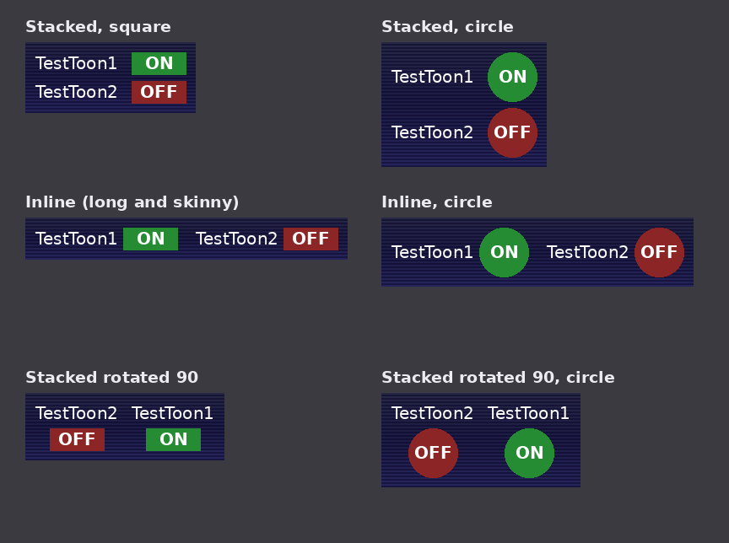
Illustration (drawn for this guide, not an in-game screenshot): the layouts, the square and circle badges, and a 90-degree rotation.

Using two clients
- Load the addon on both clients (/addon load stopmove). They must use the same Ashita folder.
- After a moment each box shows both characters. Until then the second row says "(no 2nd client)".
- Click a character's badge, in either box, to switch just that character on or off.
- Each character keeps its own box position, size and ON/OFF state. Look and timing settings are shared and update on both within about a second.
- Key blocking and Multisend commands only ever act on the client that is casting.

Commands
Command | What it does
/stopmove | Opens or closes the settings window.
/stopmove on / /stopmove off | Turns StopMove on or off for the character you type it on.
/stopmove resetbox | Puts the widget back at normal size in the top-left corner.
/addon load|unload|reload stopmove | Ashita's own commands to load, unload or reload the addon.

Where your settings are saved
Everything is plain text in <Ashita folder>\config\addons\stopmove\:
- settings.txt: looks, timers and Multisend commands (shared by both clients).
- char_<name>.txt: that character's widget position, size and ON/OFF state.
- client_<name>.txt and cmd_<name>.txt: tiny files the two clients use to see and switch each other. They are safe to delete when the game is closed.
To start fresh, unload the addon and delete that folder.

Troubleshooting
Problem | Try this
I can't see the widget | Type /stopmove and tick Turn On/Off Widget. If it is off-screen, type /stopmove resetbox.
Numpad keys are not blocked while casting | Check the character's badge says ON, Disable keyboard movement is ticked, and you are using the numpad keys. Gamepad and mouse movement are never blocked.
My spell is interrupted even though I do not move | Tick Hold position while casting (Casting actions). If you move with W/A/S/D, also tick Also disable WASD keys. Moving more than 1 yalm, or moving with a gamepad, still interrupts the cast as it should.
I move with W/A/S/D | Tick Also disable WASD keys. Note that W/A/S/D are then blocked in chat while a cast is in progress.
Follow keeps going during casts | Make sure Multisend follow is ticked and the "Cast starts" box holds the right command (default /ms follow off). Other follow addons are not controlled.
Follow comes back too soon or too late | Change Unlock wait: cast interrupted or cast completed in the Timing section.
Second row says "(no 2nd client)" | Load the addon on both clients, with the same Ashita folder, and give it a few seconds after login.
A badge looks wrong in Circle shape | If the circle can't be drawn on your setup, the addon falls back to squares by itself. Switch back to Square in the ON / OFF text section.
My settings did not save | Look for settings.txt and char_<name>.txt in <Ashita folder>\config\addons\stopmove\ and check that the folder is not read-only.

About

Credits
- Written by Claude (Anthropic), directed and tested by Benthere407.
- Built on the Ashita v4 addon API and the Dear ImGui interface that ships with Ashita (AshitaXI).
- Multisend by ThornyFFXI is supported by sending its documented /ms follow command. None of its code is included.

Safety
- One plain-text Lua file. No .exe or .dll. The zip is a normal zip, not self-extracting.
- SHA-256 of stopmove.zip: 4ff2e40e710b783aedb00162ec59a122c7e0b2e0fce99184a61edd3619fc426a
- No account details, tokens or logins are in the file. It does not use the network.
- It does not cast, target, move, heal or follow for you. It is keyboard-only: gamepad and mouse movement are not blocked.
- For transparency: with "Wait until stopped" on, it briefly holds your own cast request and re-sends it unchanged; it can send simulated key-release events for movement keys you are holding; and with "Hold position while casting" on, it keeps your outgoing position at the spot where the cast began while you have drifted less than 1 yalm. All three can be switched off in the settings window.

Bugs and questions
Report bugs or ask questions on the GitHub Issues page: https://github.com/Benthere407/StopMove/issues

Package details and version history
Item | Details
File in the zip | stopmove/stopmove.lua (about 67 KB, 1,568 lines, plain text)
SHA-256 stopmove.zip | 4ff2e40e710b783aedb00162ec59a122c7e0b2e0fce99184a61edd3619fc426a
SHA-256 stopmove.lua | 2cbba3c75c8ebb1fa669f1422935978fd4d80e5cfdf1df6c30685894bf52af43
Changes since v1.2 (up to v1.8) | Hold position while casting, so tiny position slips no longer interrupt a cast (v1.8); movement keys also cleared from the keyboard state the game reads each frame while casting (v1.8); Low profile widget; option to hide the ON/OFF/LOCK text in the badge; drop shadow for name and ON/OFF text; Classic FFXI window frame; name turns orange while locked; the lock clears by itself if the server never confirms the cast within 3 seconds.
Changes in v1.2 | Option to also disable W/A/S/D; menu background colours re-measured from the Magic menu (with a middle colour and 2px stripes every 4px); "cfg" is now "UI"; "Show on-screen box" is now "Turn On/Off Widget"; notes added beside "UI button" and "Release now"; ON/OFF badge can be a circle.

