BRD Section 1
AI Customer Support Chatbot System
Business Requirements Document
Document Status
Final
Prepared for
Portfolio Demonstration
Prepared by
Ben Vicky
Version 1.0
Date
July 2026

Document Purpose
This Business Requirements Document (BRD) defines the business needs, objectives, requirements, and expected outcomes for the development of an AI-powered Customer Support Chatbot System.
The document provides a structured understanding of the business problem, proposed solution, stakeholder expectations, functional requirements, non-functional requirements, and success criteria required to successfully implement the chatbot solution.
The BRD serves as a reference document for business stakeholders, project teams, developers, AI specialists, testers, and other individuals involved in designing, implementing, and validating the solution.

1. Document Control
Document Information | Details
Document Name | Business Requirements Document
Project Name | AI Customer Support Chatbot System
Document Type | Business Requirements Document (BRD)
Version | 1.0
Status | Final
Author | Ben Vicky
Created Date | July 2026
Review Frequency | At major project milestones

2. Version History
Version | Date | Author | Description
0.1 | July 2026 | Ben Vicky | Initial BRD draft created
1.0 | July 2026 | Ben Vicky | Updated and structured portfolio version

3. Approval History
Role | Name | Approval Status | Date
Project Sponsor | TBD | Pending | TBD
Product Owner | TBD | Pending | TBD
Business Analyst | Ben Vicky | Prepared | July 2026
Technical Lead | TBD | Pending | TBD

4. Executive Summary
Contents
BRD Section 1 1
Document Purpose 1
1. Document Control 2
2. Version History 2
3. Approval History 2
4. Executive Summary 3
4. Document Metadata 7
SECTION 2: BUSINESS CONTEXT 8
2.1 Business Background 8
2.2 Business Problem Statement 8
2.3 Business Objectives 9
2.4 Business Case 10
Operational Benefits 10
Financial Benefits 10
Customer Benefits 10
Strategic Benefits 11
2.5 Project Scope 11
2.6 Out of Scope 11
Section Summary 12
SECTION 3 – STAKEHOLDER & PROCESS ANALYSIS 13
3.1 Stakeholder Analysis 13
3.2 Stakeholder Roles and Responsibilities 14
3.3 Stakeholder Communication Matrix 14
3.4 User Personas 15
Persona 1 – Customer 15
Persona 2 – Customer Support Agent 15
Persona 3 – System Administrator 15
3.5 Current State (As-Is) Process 16
Current Process 16
Current Challenges 16
3.6 Future State (To-Be) Process 16
Future Process 17
3.7 Business Process Improvements 17
3.8 Business Value Summary 17
Expected Benefits 18
Section Summary 18
SECTION 4 – FUNCTIONAL & NON-FUNCTIONAL REQUIREMENTS 19
4.1 Introduction 19
4.2 Functional Requirements 19
4.3 AI Functional Requirements 20
4.4 Non-Functional Requirements 21
4.5 Business Rules 21
4.6 Assumptions 22
4.7 Constraints 22
4.8 Acceptance Criteria Summary 23
4.9 Requirements Traceability Note 23
Section Summary 23
SECTION 5 – SOLUTION REQUIREMENTS 25
5.1 Solution Overview 25
5.2 High-Level Solution Components 25
5.3 AI Solution Requirements 26
5.4 Prompt Engineering Requirements 26
5.5 Conversation Design Requirements 27
Standard Conversation Flow 27
5.6 Data Requirements 28
5.7 Integration Requirements 28
5.8 Security and Privacy Requirements 28
5.9 Reporting and Monitoring Requirements 29
5.10 Solution Architecture Summary 29
Section Summary 30
SECTION 6 – VALIDATION & GOVERNANCE 31
6.1 Validation Strategy 31
6.2 Testing Strategy 31
6.3 Reporting & Analytics Requirements 32
6.4 Key Performance Indicators (KPIs) 32
6.5 User Acceptance Criteria 33
6.6 Risk Management Summary 33
6.7 Assumptions and Dependencies 34
Project Assumptions 34
Project Dependencies 34
6.8 Change Management 35
Change Management Process 35
6.9 Training & Support 35
6.10 Deployment Readiness Checklist 36
6.11 Governance Model 36
Section Summary 37
SECTION 7 – APPENDICES & SUPPORTING DOCUMENTATION 38
7.1 Introduction 38
7.2 Glossary of Terms 38
7.3 Acronyms 39
7.4 Reference Documents 40
7.5 Supporting Project Artifacts 41
7.6 Document Cross-Reference Matrix 41
7.7 Future Enhancements 42
7.8 Document Maintenance 42
7.9 Document Sign-Off 43
7.10 Appendix Index 43
Final BRD Conclusion 43
Appendix A – Project Charter 45
Appendix B: Workflow Diagram 46
Appendix C: BPMN 2.0 Process Diagram 49
Appendix D: Conversation Flow Diagram 50
Appendix E: Use Case Diagram 53
Appendix F: Data Flow Diagram (DFD) 54
Appendix G: Wireframes 55
Appendix H: Requirements Traceability Matrix (RTM) 56
Appendix I: Risk Register 57
Appendix J: User Acceptance Testing (UAT) 58
Appendix K: Prompt Library 59
Appendix L – AI Evaluation Rubric 60

Organizations are increasingly adopting digital solutions to improve customer experience, reduce operational costs, and provide faster support services. Traditional customer support methods often require customers to wait for available agents, especially during periods of high request volume.
The AI Customer Support Chatbot System project aims to develop an intelligent conversational assistant capable of handling customer inquiries, providing accurate responses, assisting with common support requests, and escalating complex issues to customer support agents when necessary.
The chatbot will leverage Large Language Model (LLM) technology, knowledge retrieval mechanisms, and predefined business rules to provide customers with fast, consistent, and reliable support.
The proposed solution will improve customer satisfaction by reducing response times, increase operational efficiency by automating repetitive support tasks, and enable support teams to focus on more complex customer issues.
The system will include:
- Customer-facing chatbot interface
- AI-powered intent recognition
- Knowledge base retrieval
- Automated response generation
- Confidence-based escalation
- Human agent handoff
- Conversation history tracking
- Customer feedback collection
- Performance analytics
This project supports the organization's objective of implementing scalable AI-driven customer service solutions while maintaining quality, security, and customer trust.

4. Document Metadata
Attribute | Description
Project Category | Artificial Intelligence / Customer Support Automation
Document Classification | Portfolio Project Documentation
Intended Audience | Business Stakeholders, Product Owners, Developers, AI Specialists, QA Testers
Related Documents | Workflow Diagram, BPMN Diagram, Use Case Diagram, DFD, Wireframes, RTM, UAT, Prompt Library

SECTION 2: BUSINESS CONTEXT

2.1 Business Background
Customer support plays a critical role in maintaining customer satisfaction, strengthening brand loyalty, and ensuring positive user experiences. As organizations continue to expand their digital services, customer inquiries have increased significantly across multiple communication channels. Many organizations continue to rely heavily on customer support agents to respond to customer requests, resulting in increased operational costs, inconsistent response quality, and delays during periods of high demand.
The advancement of Artificial Intelligence (AI), Natural Language Processing (NLP), and Large Language Models (LLMs) has created new opportunities for organizations to automate customer interactions while maintaining high-quality service delivery. AI-powered chatbots are capable of understanding customer intent, retrieving relevant information from organizational knowledge bases, and providing accurate responses in real time.
This project proposes the implementation of an AI Customer Support Chatbot System that will automate routine customer inquiries, provide instant responses using approved knowledge sources, and seamlessly transfer complex or sensitive cases to customer support agents when necessary. The solution is intended to improve customer experience, increase operational efficiency, reduce repetitive workloads for support teams, and provide continuous service availability.
The chatbot will integrate with the organization's knowledge base and business processes while maintaining data security, conversation history, performance monitoring, and feedback collection. By combining AI automation with customer support escalation, the organization can deliver a scalable, reliable, and customer-focused support experience.

2.2 Business Problem Statement
The organization currently experiences several operational challenges within its customer support function. Customers often encounter delays before receiving assistance, particularly during peak service hours. Customer support agents spend a significant portion of their time responding to repetitive questions that could otherwise be automated, reducing their availability to resolve more complex customer issues.
The absence of an intelligent self-service solution also limits the organization's ability to provide support outside standard business hours, leading to reduced customer satisfaction and increased support costs.
The primary business problems identified include:
- Long customer waiting times before receiving assistance.
- High operational costs associated with manual customer support.
- Repetitive inquiries consuming valuable support agent time.
- Inconsistent responses provided by different support representatives.
- Limited support availability outside business hours.
- Difficulty measuring chatbot performance due to the absence of centralized analytics.
- Increasing customer expectations for immediate digital assistance.
Without an automated AI-powered support solution, these challenges are expected to continue as customer demand increases.

2.3 Business Objectives
The primary objective of this project is to design and implement an AI-powered Customer Support Chatbot capable of delivering fast, accurate, secure, and scalable customer assistance while improving operational efficiency.
The project objectives are as follows:
Objective ID | Business Objective | Success Measure
BO-001 | Reduce average customer response time | Response time reduced to less than 3 seconds for standard inquiries
BO-002 | Automate repetitive customer inquiries | At least 70% of common inquiries handled without human intervention
BO-003 | Improve customer satisfaction | Customer Satisfaction (CSAT) score of 90% or higher
BO-004 | Reduce support workload | Decrease repetitive support tickets by at least 50%
BO-005 | Improve response consistency | AI provides standardized responses based on approved knowledge
BO-006 | Improve support availability | 24/7 chatbot availability
BO-007 | Enable intelligent escalation | Complex issues transferred to customer support agent within defined service levels
BO-008 | Support continuous improvement | Customer feedback and chatbot analytics collected for ongoing optimization

2.4 Business Case
The implementation of the AI Customer Support Chatbot System provides significant business value by combining artificial intelligence with existing customer support operations. The solution is expected to reduce operational expenses, improve service quality, and enhance the overall customer experience.
Key business benefits include:

Operational Benefits
- Reduced workload for customer support agents.
- Faster response times for routine customer inquiries.
- Standardized responses based on approved business knowledge.
- Continuous support availability regardless of business hours.

Financial Benefits
- Reduced customer support operating costs.
- Improved utilization of customer support resources.
- Lower costs associated with repetitive customer inquiries.

Customer Benefits
- Immediate responses to frequently asked questions.
- Improved customer satisfaction through faster issue resolution.
- Consistent communication across all customer interactions.
- Simplified escalation process for complex issues.

Strategic Benefits
- Supports the organization's digital transformation strategy.
- Demonstrates adoption of AI-driven business solutions.
- Provides performance metrics for continuous service improvement.
- Creates a scalable platform capable of supporting future business growth.

2.5 Project Scope
The scope of this project includes the design, development, implementation, testing, and evaluation of an AI-powered Customer Support Chatbot capable of assisting customers with routine inquiries while integrating with organizational knowledge resources.
The following capabilities are included within the project scope:
In Scope
AI-powered chatbot interface
Customer question processing
Intent recognition using AI
Knowledge base retrieval
AI-generated customer responses
Confidence score evaluation
Human agent escalation
Conversation history management
Customer feedback collection
Analytics and reporting dashboard
Administrator knowledge base management
Performance monitoring

2.6 Out of Scope
The following items are not included within the initial release of this project:
Out of Scope
Voice-based virtual assistant integration
Telephone call automation
Social media customer support channels
Multi-language chatbot support
Payment processing capabilities
Customer Relationship Management (CRM) replacement
Predictive sales recommendations
Marketing campaign automation
Autonomous business decision making
Integration with unsupported third-party platforms

Section Summary
The Business Context establishes the foundation for the AI Customer Support Chatbot project by describing the current business environment, identifying the operational challenges, defining the objectives of the proposed solution, presenting the business justification for investment, and clearly outlining both the project scope and exclusions. This section provides stakeholders with a shared understanding of the business need and sets the context for the detailed requirements presented in the following sections of the Business Requirements Document.

SECTION 3 – STAKEHOLDER & PROCESS ANALYSIS

3.1 Stakeholder Analysis
Successful delivery of the AI Customer Support Chatbot project depends on collaboration between business stakeholders, technical teams, customer support representatives, and end users. Each stakeholder group has specific responsibilities and expectations throughout the project lifecycle.
The following stakeholders have been identified as key participants in the planning, development, implementation, testing, and ongoing management of the solution.
Stakeholder | Role | Responsibilities | Level of Influence
Project Sponsor | Executive Sponsor | Approves project funding, strategic direction, and final delivery | High
Product Owner | Business Representative | Defines business priorities and approves requirements | High
Business Analyst | Requirements Owner | Elicits, documents, validates, and manages business requirements | High
Project Manager | Project Lead | Oversees project planning, execution, communication, and risk management | High
AI/ML Engineer | AI Solution Developer | Designs and develops the chatbot intelligence, prompt logic, and AI integrations | High
Software Developer | System Developer | Develops chatbot interfaces, APIs, and backend components | High
UI/UX Designer | User Experience Designer | Designs chatbot interfaces and user experience | Medium
QA/Test Engineer | Quality Assurance | Performs functional, integration, and user acceptance testing | Medium
Customer Support Agents | End Users | Handle escalated customer requests and provide operational feedback | Medium
Customers | Primary Users | Interact with the chatbot to obtain support services | High
System Administrator | System Administrator | Manages chatbot configuration, users, permissions, and monitoring | Medium

3.2 Stakeholder Roles and Responsibilities
The following table summarizes the primary responsibilities of each stakeholder throughout the project lifecycle.
Stakeholder | Planning | Design | Development | Testing | Deployment | Support
Project Sponsor | ✓ |  |  |  | ✓
Product Owner | ✓ | ✓ |  | ✓ | ✓ | ✓
Business Analyst | ✓ | ✓ | ✓ | ✓ | ✓ | ✓
Project Manager | ✓ | ✓ | ✓ | ✓ | ✓ | ✓
AI Engineer |  | ✓ | ✓ | ✓ | ✓ | ✓
Software Developer |  | ✓ | ✓ | ✓ | ✓ | ✓
QA Engineer |  |  |  | ✓ | ✓ | ✓
Customer Support Agents |  | ✓ |  | ✓ | ✓ | ✓
Customers |  | ✓ |  | ✓ | ✓ | ✓

3.3 Stakeholder Communication Matrix
Effective communication ensures that stakeholders remain informed throughout the project.
Stakeholder | Information Required | Communication Method | Frequency
Project Sponsor | Project progress and major risks | Executive Meeting | Monthly
Product Owner | Requirements status | Review Meeting | Weekly
Business Analyst | Requirement updates | Workshops | Weekly
Development Team | Functional requirements and changes | Sprint Planning | Weekly
QA Team | Test plans and defects | Test Review Meeting | Weekly
Customer Support Team | Training and rollout updates | Team Meeting | Before Deployment
Customers | Product updates | Email / Website Notifications | As Required

3.4 User Personas
The AI Customer Support Chatbot is designed to serve multiple user groups, each with different goals and expectations.

Persona 1 – Customer
Attribute | Details
Role | Customer
Primary Goal | Receive quick and accurate assistance
Pain Points | Long waiting times, repetitive support processes
Needs | Fast responses, accurate information, easy escalation to a human agent

Persona 2 – Customer Support Agent
Attribute | Details
Role | Support Representative
Primary Goal | Resolve complex customer issues
Pain Points | High volume of repetitive inquiries
Needs | Receive only complex cases, view conversation history, resolve escalated requests efficiently

Persona 3 – System Administrator
Attribute | Details
Role | System Administrator
Primary Goal | Manage chatbot configuration and performance
Pain Points | Maintaining knowledge accuracy and monitoring system health
Needs | Manage users, update knowledge base, review analytics, monitor chatbot performance

3.5 Current State (As-Is) Process
The existing customer support process relies primarily on manual interactions between customers and customer support agents.

Current Process
- Customer contacts customer support.
- Customer waits in a queue.
- Customer support agent becomes available.
- Customer explains the issue.
- Support agent investigates the request.
- Agent searches documentation or knowledge resources.
- Agent provides a response.
- Issue is resolved or escalated internally.
- Conversation is manually documented.
- Customer leaves the support session.

Current Challenges
- Long waiting times.
- High operational costs.
- Inconsistent responses.
- Repetitive manual work.
- Limited support availability.
- Difficulty tracking customer satisfaction.
- Limited reporting and analytics.

3.6 Future State (To-Be) Process
The proposed AI-powered chatbot introduces automation into the customer support process while maintaining seamless human escalation for complex cases.

Future Process
- Customer opens chatbot.
- Customer submits a question.
- AI validates the input.
- AI identifies customer intent.
- AI retrieves relevant information from the knowledge base.
- AI generates a response.
- AI evaluates confidence.
- If confidence is high, the chatbot responds immediately.
- If confidence is low, the conversation is transferred to a customer support agent.
- Support agent reviews the conversation history.
- Human agent resolves the issue.
- Customer provides feedback.
- Conversation data is stored for analytics and continuous improvement.

3.7 Business Process Improvements
The proposed solution introduces several improvements over the current manual process.
Current Process | Future Process
Manual customer support | AI-assisted customer support
Long waiting times | Immediate responses for routine inquiries
Human handles all requests | AI handles common requests; humans handle complex issues
Limited business hours | 24/7 chatbot availability
Manual knowledge lookup | Automated knowledge retrieval
Inconsistent responses | Standardized AI-generated responses
Manual reporting | Automated analytics and dashboards
Limited performance insights | Real-time performance monitoring

3.8 Business Value Summary
The AI Customer Support Chatbot will deliver measurable improvements across customer experience, operational efficiency, and business performance.

Expected Benefits
- Improved customer satisfaction.
- Reduced response times.
- Lower operational costs.
- Better utilization of support agents.
- Increased consistency in customer communication.
- Continuous service availability.
- Enhanced reporting and analytics.
- Scalable customer support operations.
- Support for future AI capabilities and business growth.

Section Summary
This section identifies the key stakeholders involved in the project, defines their roles and responsibilities, analyzes the current and future customer support processes, and demonstrates how the AI Customer Support Chatbot improves operational efficiency and customer experience. It provides the organizational and process context needed before presenting the detailed system requirements in the next section.

SECTION 4 – FUNCTIONAL & NON-FUNCTIONAL REQUIREMENTS

4.1 Introduction
This section defines the functional and non-functional requirements for the AI Customer Support Chatbot System. These requirements describe the expected behavior, capabilities, quality attributes, and business rules that the proposed solution must satisfy.
Each requirement is uniquely identified to support traceability throughout the project lifecycle and to ensure alignment with design, testing, implementation, and user acceptance activities.

4.2 Functional Requirements
The following functional requirements define the core capabilities of the chatbot.
Requirement ID | Functional Requirement | Priority
FR-001 | The system shall allow customers to initiate a chatbot conversation. | High
FR-002 | The chatbot shall validate user input before processing requests. | High
FR-003 | The chatbot shall identify customer intent using AI. | High
FR-004 | The chatbot shall retrieve relevant information from the knowledge base. | High
FR-005 | The chatbot shall generate responses using approved business knowledge. | High
FR-006 | The chatbot shall escalate low-confidence conversations to a customer support agent. | High
FR-007 | The chatbot shall maintain conversation history. | Medium
FR-008 | The chatbot shall allow customers to end a conversation at any time. | Medium
FR-009 | The chatbot shall collect customer feedback after each interaction. | Medium
FR-010 | The chatbot shall record interaction logs for reporting and analytics. | High
FR-011 | The system shall support administrator login. | High
FR-012 | Administrators shall manage the chatbot knowledge base. | High
FR-013 | Administrators shall add new FAQ articles. | Medium
FR-014 | Administrators shall edit existing knowledge articles. | Medium
FR-015 | Administrators shall archive obsolete knowledge articles. | Medium
FR-016 | The chatbot shall notify users when clarification is required. | Medium
FR-017 | The chatbot shall support multiple conversation sessions. | Medium
FR-018 | The chatbot shall generate conversation transcripts. | Medium
FR-019 | The chatbot shall display escalation confirmation messages. | Medium
FR-020 | The system shall generate operational analytics and reports. | Medium

4.3 AI Functional Requirements
These requirements define how the AI component should behave.
Requirement ID | AI Requirement
AI-001 | The AI shall respond using only approved organizational knowledge.
AI-002 | The AI shall avoid fabricating information when confidence is low.
AI-003 | The AI shall politely request clarification when customer input is ambiguous.
AI-004 | The AI shall detect unsupported requests and escalate them appropriately.
AI-005 | The AI shall maintain a professional and respectful tone.
AI-006 | The AI shall preserve conversation context during a session.
AI-007 | The AI shall decline unsafe or prohibited requests.
AI-008 | The AI shall recommend customer support when required.
AI-009 | The AI shall log confidence scores for analytics.
AI-010 | The AI shall support continuous improvement through monitored feedback.

4.4 Non-Functional Requirements
These requirements define the expected quality attributes of the solution.
Requirement ID | Non-Functional Requirement | Priority
NFR-001 | Standard chatbot responses shall be delivered within 3 seconds under normal operating conditions. | High
NFR-002 | The system shall maintain an uptime of at least 99.5%. | High
NFR-003 | Customer data shall be encrypted during transmission and storage. | High
NFR-004 | Access to administrative functions shall require authentication. | High
NFR-005 | User interfaces shall be responsive across desktop and mobile devices. | Medium
NFR-006 | Conversation history shall be retained according to organizational policy. | Medium
NFR-007 | The system shall maintain detailed audit logs. | Medium
NFR-008 | The chatbot shall support concurrent customer sessions. | Medium
NFR-009 | System components shall be scalable to accommodate increased demand. | Medium
NFR-010 | Error messages shall be user-friendly and avoid exposing technical details. | Medium

4.5 Business Rules
The chatbot must comply with the following business rules.
Rule ID | Business Rule
BR-001 | Only approved knowledge sources may be used to generate responses.
BR-002 | Customer data shall be handled in accordance with applicable privacy policies.
BR-003 | Complex issues must be escalated to a customer support agent.
BR-004 | All conversations shall be logged for quality assurance and reporting.
BR-005 | Customer feedback shall be collected after completed conversations.
BR-006 | Administrative changes to the knowledge base shall be logged.
BR-007 | The chatbot shall never generate misleading or intentionally false information.
BR-008 | Users may terminate conversations at any time.

4.6 Assumptions
The following assumptions have been made during requirements definition:
- The knowledge base contains accurate and up-to-date information.
- Users have internet access to interact with the chatbot.
- Customer support agents are available during escalation.
- Required integrations will be available before deployment.
- Business stakeholders will approve the documented requirements before development begins.

4.7 Constraints
The project is subject to the following constraints:
- Development must be completed within the approved project timeline.
- Budget limitations may affect future enhancements.
- The chatbot depends on the availability of the AI platform and supporting APIs.
- Only approved knowledge sources may be used for response generation.
- The initial release will support text-based conversations only.

4.8 Acceptance Criteria Summary
The solution will be considered acceptable when the following conditions have been met:
Acceptance ID | Acceptance Criteria
AC-001 | Customers can successfully initiate conversations.
AC-002 | AI accurately identifies customer intent for supported scenarios.
AC-003 | Responses are generated using approved knowledge.
AC-004 | Unsupported or low-confidence requests are escalated correctly.
AC-005 | Conversation history is stored successfully.
AC-006 | Customer feedback is collected after each session.
AC-007 | System meets defined performance and availability targets.
AC-008 | User Acceptance Testing (UAT) is completed successfully with stakeholder approval.

4.9 Requirements Traceability Note
Each requirement defined in this section will be traced throughout the project lifecycle using the Requirements Traceability Matrix (RTM). This ensures that every business requirement is linked to its corresponding design artifacts, implementation activities, test cases, and user acceptance criteria, supporting complete end-to-end traceability.

Section Summary
This section establishes the detailed functional, AI-specific, and non-functional requirements for the AI Customer Support Chatbot System. It also defines the governing business rules, project assumptions, constraints, and acceptance criteria that will guide solution design, development, testing, and deployment. Together with the previous sections, these requirements provide a clear foundation for implementing a secure, reliable, and business-aligned chatbot solution.

SECTION 5 – SOLUTION REQUIREMENTS

5.1 Solution Overview
The AI Customer Support Chatbot System is an intelligent customer service solution designed to automate routine customer interactions while maintaining seamless collaboration with customer support agents. The solution combines Artificial Intelligence (AI), Natural Language Processing (NLP), Large Language Models (LLMs), knowledge retrieval mechanisms, and predefined business rules to deliver accurate, consistent, and timely responses.
The chatbot operates through a conversational interface that accepts customer queries, identifies user intent, retrieves relevant information from the approved knowledge base, generates context-aware responses, and escalates conversations to customer support agent when confidence levels fall below acceptable thresholds.
The solution supports continuous learning through analytics and customer feedback while maintaining security, privacy, and governance standards.

5.2 High-Level Solution Components
The proposed solution consists of the following major components.
Component | Description
Customer Interface | Allows customers to interact with the chatbot through a web or mobile interface.
AI Engine | Interprets customer intent, generates responses, and manages conversation flow.
Prompt Management Layer | Stores and manages approved prompts used by the AI model.
Knowledge Base | Contains FAQs, policies, procedures, and business documentation used to answer customer questions.
Escalation Module | Transfers complex conversations to customer support agents.
Conversation History Repository | Stores conversation transcripts for auditing and analytics.
Analytics Dashboard | Provides performance metrics, chatbot usage statistics, and customer satisfaction insights.
Administration Portal | Enables administrators to manage knowledge articles, prompts, users, and reports.

5.3 AI Solution Requirements
The AI component shall support intelligent customer interactions while ensuring responses remain accurate, safe, and aligned with organizational policies.
Requirement ID | AI Solution Requirement
ASR-001 | The AI shall interpret customer intent using Natural Language Processing (NLP).
ASR-002 | The AI shall generate responses using approved organizational knowledge.
ASR-003 | The AI shall maintain conversational context throughout an active session.
ASR-004 | The AI shall provide clarification when customer requests are ambiguous.
ASR-005 | The AI shall calculate a confidence score before returning responses.
ASR-006 | Low-confidence responses shall trigger human escalation.
ASR-007 | Unsafe or prohibited requests shall be declined with appropriate messaging.
ASR-008 | AI responses shall maintain a professional, respectful, and customer-friendly tone.
ASR-009 | AI decisions shall be logged for evaluation and continuous improvement.
ASR-010 | AI performance shall support periodic review and optimization.

5.4 Prompt Engineering Requirements
The chatbot shall utilize standardized prompt engineering practices to ensure consistent AI behavior and reliable responses.
Requirement ID | Prompt Engineering Requirement
PE-001 | System prompts shall define the Chabot’s role and responsibilities.
PE-002 | Prompts shall instruct the AI to use only approved knowledge sources.
PE-003 | Prompts shall discourage fabricated or speculative responses.
PE-004 | Escalation prompts shall be triggered for unsupported requests.
PE-005 | Prompt templates shall maintain a consistent communication style.
PE-006 | Prompts shall support context retention during conversations.
PE-007 | Prompts shall encourage clarification when customer requests are incomplete.
PE-008 | Prompt versions shall be documented and managed under version control.

5.5 Conversation Design Requirements
The chatbot conversation flow shall align with the Conversation Flow Diagram and Workflow Diagram developed for this project.

Standard Conversation Flow
- Customer initiates conversation.
- Chatbot greets customer.
- Customer submits request.
- AI validates the request.
- Intent detection is performed.
- Relevant knowledge is retrieved.
- AI generates a response.
- Confidence score is evaluated.
- If confidence is high, the response is delivered.
- If confidence is low, the conversation is escalated.
- Customer support agent resolves the issue.
- Customer provides feedback.
- Conversation is stored for reporting and analytics.

5.6 Data Requirements
The solution shall manage several categories of business data.
Data Entity | Description
Customer Profile | Basic customer information used to personalize interactions.
Customer Query | Questions submitted by customers during conversations.
Knowledge Articles | Approved business information used to answer customer inquiries.
Conversation History | Complete transcripts of customer interactions.
AI Confidence Score | Confidence level assigned to each AI-generated response.
Escalation Records | Details of conversations transferred to customer support agent.
Customer Feedback | Satisfaction ratings and comments collected after conversations.
Analytics Data | Metrics used to monitor chatbot performance and usage.

5.7 Integration Requirements
The chatbot shall integrate with internal and external systems to support business operations.
Integration | Purpose
Knowledge Base | Retrieve approved business information.
AI Model | Generate intelligent conversational responses.
CRM System | Access customer information when authorized.
Ticketing System | Create support tickets for escalated issues.
Analytics Platform | Capture chatbot performance metrics.
Authentication Service | Validate administrator access.

5.8 Security and Privacy Requirements
The chatbot shall comply with organizational security standards and protect customer information throughout the conversation lifecycle.
Requirement ID | Security Requirement
SEC-001 | Customer information shall be encrypted during transmission and storage.
SEC-002 | Administrative access shall require authentication and authorization.
SEC-003 | Sensitive customer information shall not be exposed in chatbot responses.
SEC-004 | Conversation logs shall be protected from unauthorized access.
SEC-005 | System activity shall be recorded within audit logs.
SEC-006 | User sessions shall expire after periods of inactivity.
SEC-007 | Personal information shall be managed according to applicable privacy regulations.
SEC-008 | The chatbot shall reject malicious or unsafe user inputs where appropriate.

5.9 Reporting and Monitoring Requirements
The solution shall provide reporting capabilities to support operational monitoring and continuous improvement.
Report | Purpose
Chat Volume Report | Monitor daily and monthly conversation volumes.
Customer Satisfaction Report | Measure customer feedback and satisfaction trends.
Escalation Report | Monitor conversations transferred to customer support agent.
AI Accuracy Report | Evaluate the quality and accuracy of AI-generated responses.
Knowledge Usage Report | Identify the most frequently accessed knowledge articles.
Performance Dashboard | Display key operational metrics and KPIs.

5.10 Solution Architecture Summary
The AI Customer Support Chatbot solution follows a layered architecture consisting of:
- Presentation Layer (Customer Interface)
- Application Layer (Conversation Management)
- AI Processing Layer (LLM and Prompt Management)
- Knowledge Retrieval Layer
- Business Logic Layer
- Integration Layer
- Data Storage Layer
- Analytics and Monitoring Layer
This architecture supports scalability, maintainability, and future enhancements while enabling seamless integration with organizational systems.

Section Summary
This section describes the proposed AI Customer Support Chatbot solution, including its architecture, AI capabilities, prompt engineering approach, conversation design, data management, integration points, security controls, and reporting requirements. These solution requirements provide a blueprint for designing and implementing a secure, scalable, and business-aligned chatbot that satisfies the functional and non-functional requirements defined earlier in the BRD.

SECTION 6 – VALIDATION & GOVERNANCE

6.1 Validation Strategy
The AI Customer Support Chatbot System shall undergo comprehensive validation to ensure that all business, functional, and non-functional requirements have been successfully implemented. Validation activities will be conducted throughout the project lifecycle, including requirements reviews, solution design validation, functional testing, integration testing, User Acceptance Testing (UAT), and AI response evaluation.
The validation process aims to confirm that the delivered solution meets stakeholder expectations, satisfies business objectives, and performs reliably under expected operating conditions.
The project will adopt a risk-based validation approach, prioritizing high-impact business functions such as intent recognition, knowledge retrieval, AI response generation, and escalation to customer support agents.

6.2 Testing Strategy
The following testing activities shall be performed before production deployment.
Test Type | Purpose | Responsible Team
Requirements Review | Validate completeness and accuracy of business requirements | Business Analyst
Unit Testing | Verify individual software components | Developers
Integration Testing | Validate communication between integrated systems | Development Team
System Testing | Confirm end-to-end system functionality | QA Team
AI Evaluation Testing | Assess AI response quality, safety, and grounding | AI Evaluation Team
User Acceptance Testing (UAT) | Validate business requirements with stakeholders | Business Users
Regression Testing | Ensure new changes do not impact existing functionality | QA Team
Performance Testing | Measure system responsiveness, scalability, and stability | QA Team
Security Testing | Validate authentication, authorization, and data protection | Security Team

6.3 Reporting & Analytics Requirements
The chatbot solution shall provide operational reports and dashboards that support monitoring, decision-making, and continuous improvement.
Report Name | Description | Frequency
Daily Chat Volume Report | Total customer conversations handled by the chatbot | Daily
AI Accuracy Report | Percentage of correct AI-generated responses | Weekly
Customer Satisfaction (CSAT) Report | Customer feedback scores and comments | Weekly
Escalation Report | Number and percentage of conversations transferred to customer support agent | Weekly
Knowledge Base Usage Report | Frequently accessed knowledge articles | Monthly
Performance Dashboard | Consolidated operational KPIs | Real-Time

6.4 Key Performance Indicators (KPIs)
The success of the chatbot solution shall be measured using the following KPIs.
KPI | Target
Average Response Time | Less than 3 seconds
AI Response Accuracy | Greater than or equal to 90%
Customer Satisfaction (CSAT) | Greater than or equal to 90%
Automation Rate | At least 70% of customer inquiries resolved without human intervention
Escalation Accuracy | Greater than or equal to 95%
Knowledge Retrieval Accuracy | Greater than or equal to 95%
System Availability | Greater than or equal to 99.5%
UAT Pass Rate | 100% of critical business scenarios passed

6.5 User Acceptance Criteria
The AI Customer Support Chatbot shall be considered acceptable when the following conditions have been satisfied.
Acceptance ID | Acceptance Criterion
UAC-001 | Customers can initiate chatbot conversations successfully.
UAC-002 | AI accurately identifies supported customer intents.
UAC-003 | Responses are generated using approved knowledge sources.
UAC-004 | Unsupported or low-confidence requests are escalated correctly.
UAC-005 | Customer feedback is successfully collected.
UAC-006 | Conversation history is stored accurately.
UAC-007 | Administrative functions operate as expected.
UAC-008 | All critical UAT test cases pass successfully.

6.6 Risk Management Summary
Project risks shall be monitored throughout implementation using the Risk Register. High-priority risks will be reviewed regularly and appropriate mitigation actions will be implemented.
Risk Category | Example Risk | Mitigation Strategy
Technical | AI produces inaccurate responses | Improve prompts, expand knowledge base, perform AI evaluation
Operational | Knowledge base becomes outdated | Establish periodic content reviews
Security | Unauthorized access to administrative functions | Enforce authentication and role-based access control
Performance | Increased chatbot response time | Monitor system performance and optimize infrastructure
Business | Low customer adoption | Provide user education and monitor customer feedback

6.7 Assumptions and Dependencies

Project Assumptions
- Approved business requirements remain stable throughout development.
- The AI platform remains available during implementation.
- Knowledge base content is accurate and maintained.
- Stakeholders provide timely reviews and approvals.
- Required integrations are accessible before deployment.

Project Dependencies
- Availability of the AI model.
- Availability of the organizational knowledge base.
- Integration with authentication services.
- Integration with CRM and ticketing systems.
- Completion of UAT before production deployment.

6.8 Change Management
To maintain project integrity, all changes to approved requirements shall follow a formal change management process.

Change Management Process
- Change request submitted.
- Business impact assessed.
- Technical feasibility evaluated.
- Stakeholder review conducted.
- Approval or rejection documented.
- Approved changes incorporated into project documentation.
- RTM and UAT updated accordingly.
- Version history updated.

6.9 Training & Support
Prior to production deployment, relevant stakeholders shall receive training on system usage and administration.
Audience | Training Topics
Customer Support Agents | Human escalation workflow, conversation review, ticket management
Administrators | Knowledge base management, prompt updates, user administration, reporting
Business Users | Dashboard usage and performance monitoring
Technical Team | Deployment, maintenance, monitoring, troubleshooting

6.10 Deployment Readiness Checklist
The chatbot solution shall be considered ready for production deployment when the following activities have been completed.
Activity | Status
Business Requirements Approved | ☐
Functional Requirements Implemented | ☐
Non-Functional Requirements Verified | ☐
AI Prompt Library Approved | ☐
Knowledge Base Validated | ☐
Security Testing Completed | ☐
Performance Testing Passed | ☐
UAT Successfully Completed | ☐
AI Evaluation Approved | ☐
Stakeholder Sign-Off Obtained | ☐

6.11 Governance Model
Project governance ensures accountability, transparency, and effective decision-making throughout the project lifecycle.
Governance Role | Responsibility
Project Sponsor | Strategic oversight and funding approval
Product Owner | Business prioritization and acceptance
Business Analyst | Requirements management and stakeholder communication
Project Manager | Project planning, execution, and reporting
Technical Lead | Technical architecture and implementation oversight
QA Lead | Quality assurance and testing governance
AI Evaluation Lead | AI response quality assessment and continuous improvement

Section Summary
This section defines the validation, governance, reporting, and operational controls that will support the successful implementation and long-term management of the AI Customer Support Chatbot System. It establishes the testing strategy, key performance indicators, acceptance criteria, risk management approach, change management process, training plan, deployment readiness checklist, and governance framework. These elements ensure that the solution can be delivered, validated, and maintained in a controlled and measurable manner while supporting continuous improvement.

SECTION 7 – APPENDICES & SUPPORTING DOCUMENTATION

7.1 Introduction
This section contains supporting information referenced throughout the Business Requirements Document (BRD). The appendices provide additional context, define important terminology, identify supporting project artifacts, and establish document references that assist stakeholders during implementation, testing, deployment, and future maintenance activities.
The documents listed within this section form part of the complete project documentation package and should be maintained alongside the BRD throughout the project lifecycle.

7.2 Glossary of Terms
The following glossary defines key business, technical, and AI-related terms used throughout this document.
Term | Definition
Artificial Intelligence (AI) | Technology that enables computer systems to perform tasks that normally require human intelligence.
Large Language Model (LLM) | An AI model trained on large amounts of text to understand and generate natural language.
Natural Language Processing (NLP) | AI technology used to understand and interpret human language.
Chatbot | Software application that communicates with users through natural language conversations.
Knowledge Base | Central repository containing approved organizational information used to answer customer inquiries.
Prompt | Instruction provided to the AI model to guide response generation.
Intent | The objective or purpose behind a customer's message.
Confidence Score | Numerical value indicating the AI's confidence in its generated response.
Escalation | Transfer of a conversation from the chatbot to a customer support agent.
Conversation History | Stored record of customer interactions with the chatbot.
User Acceptance Testing (UAT) | Testing performed by business users to confirm the solution meets business requirements.
Requirements Traceability Matrix (RTM) | Document linking business requirements to design, implementation, and testing artifacts.

7.3 Acronyms
Acronym | Meaning
AI | Artificial Intelligence
API | Application Programming Interface
BA | Business Analyst
BRD | Business Requirements Document
BPMN | Business Process Model and Notation
CRM | Customer Relationship Management
CSAT | Customer Satisfaction
DFD | Data Flow Diagram
FAQ | Frequently Asked Questions
KPI | Key Performance Indicator
LLM | Large Language Model
NLP | Natural Language Processing
QA | Quality Assurance
RTM | Requirements Traceability Matrix
SLA | Service Level Agreement
UAT | User Acceptance Testing
UI | User Interface
UX | User Experience

7.4 Reference Documents
The following documents support the successful implementation of the AI Customer Support Chatbot System.
Document ID | Document Name | Purpose
REF-001 | Project Charter | Defines the project's objectives, scope, stakeholders, and success criteria.
REF-002 | Business Requirements Document | Defines the business and solution requirements.
REF-003 | Workflow Diagram | Illustrates the end-to-end operational workflow.
REF-004 | BPMN 2.0 Diagram | Models the business process using BPMN standards.
REF-005 | Conversation Flow Diagram | Defines the chatbot conversation paths and decision points.
REF-006 | Use Case Diagram | Shows system actors and their interactions with the chatbot.
REF-007 | Data Flow Diagram (DFD) | Illustrates the movement of data between system components.
REF-008 | Wireframes | Presents the proposed user interface design.
REF-009 | Requirements Traceability Matrix (RTM) | Maps requirements to design and testing activities.
REF-010 | Risk Register | Documents project risks, impact, and mitigation strategies.
REF-011 | User Acceptance Testing (UAT) | Defines business acceptance test scenarios.
REF-012 | Prompt Library | Contains approved AI prompts and conversation templates.
REF-013 | AI Evaluation Rubric | Defines criteria for assessing AI response quality.

7.5 Supporting Project Artifacts
The following deliverables have been developed as part of the project and support the successful delivery of the chatbot solution.
Artifact | Status | Purpose
Project Charter | Completed | Defines project initiation and objectives.
Business Requirements Document | Completed | Documents business and solution requirements.
Workflow Diagram | Completed | Illustrates operational workflow.
BPMN 2.0 Diagram | Completed | Models the business process.
Conversation Flow Diagram | Completed | Defines chatbot conversation paths.
Use Case Diagram | Completed | Shows interactions between actors and the system.
Data Flow Diagram | Completed | Illustrates system data movement.
Wireframes | Completed | Demonstrates proposed interface layouts.
Requirements Traceability Matrix | Completed | Ensures end-to-end traceability.
Risk Register | Completed | Tracks project risks and mitigation strategies.
User Acceptance Testing Document | Completed | Defines acceptance test scenarios.
Prompt Library | Completed | Documents AI prompt engineering assets.
AI Evaluation Rubric | Completed | Defines AI quality assessment standards.

7.6 Document Cross-Reference Matrix
This matrix demonstrates the relationship between major project artifacts.
BRD Section | Supporting Document
Business Context | Project Charter
Stakeholder & Process Analysis | Workflow Diagram, BPMN Diagram
Functional Requirements | RTM
Conversation Requirements | Conversation Flow Diagram
Solution Design | Use Case Diagram
Data Requirements | Data Flow Diagram
User Interface | Wireframes
Validation & Governance | UAT, Risk Register, AI Evaluation Rubric

7.7 Future Enhancements
The following enhancements are outside the scope of the initial release but may be considered in future project phases.
- Voice-enabled customer interactions.
- Multi-language chatbot support.
- Sentiment analysis for customer conversations.
- AI-powered knowledge article recommendations.
- Integration with social media messaging platforms.
- Predictive customer support analytics.
- Omnichannel customer engagement.
- Personalized AI recommendations based on customer history.

7.8 Document Maintenance
This BRD shall be reviewed periodically to ensure it remains accurate and aligned with evolving business needs.
Activity | Frequency | Responsible Role
Requirements Review | Quarterly | Business Analyst
Knowledge Base Review | Monthly | Product Owner
Prompt Library Review | Monthly | AI Engineer
Risk Register Review | Monthly | Project Manager
UAT Review | Before each major release | QA Lead
AI Evaluation Review | Quarterly | AI Evaluation Lead

7.9 Document Sign-Off
The following stakeholders acknowledge that the contents of this Business Requirements Document have been reviewed and approved.
Role | Name | Signature | Date
Project Sponsor | __________________ | __________________ | __________
Product Owner | __________________ | __________________ | __________
Business Analyst | Ben Vicky | __________________ | __________
Project Manager | __________________ | __________________ | __________
Technical Lead | __________________ | __________________ | __________
QA Lead | __________________ | __________________ | __________

7.10 Appendix Index
Appendix | Description
Appendix A | Project Charter
Appendix B | Workflow Diagram
Appendix C | BPMN 2.0 Diagram
Appendix D | Conversation Flow Diagram
Appendix E | Use Case Diagram
Appendix F | Data Flow Diagram
Appendix G | Wireframes
Appendix H | Requirements Traceability Matrix (RTM)
Appendix I | Risk Register
Appendix J | User Acceptance Testing (UAT)
Appendix K | Prompt Library
Appendix L | AI Evaluation Rubric

Final BRD Conclusion
The AI Customer Support Chatbot System Business Requirements Document provides a comprehensive definition of the project's business objectives, stakeholder needs, functional and non-functional requirements, solution design considerations, governance framework, and supporting documentation. Together with the accompanying diagrams and project artifacts, this BRD establishes a clear foundation for designing, implementing, validating, and maintaining an AI-powered customer support solution.
The document is intended to serve as a single source of truth for stakeholders throughout the project lifecycle and demonstrates a structured, business-focused approach to AI solution delivery.

Appendix A – Project Charter
The Project Charter formally authorizes the AI Customer Support Chatbot project and defines its objectives, scope, stakeholders, high-level deliverables, assumptions, constraints, risks, timeline, and success criteria. It serves as the foundation for all subsequent project planning and execution activities.
- AI Customer Support Chatbot Project Charter (Version 1.0)..docx

Appendix B: Workflow Diagram

Appendix B: AI Customer Support Chatbot Workflow Diagram
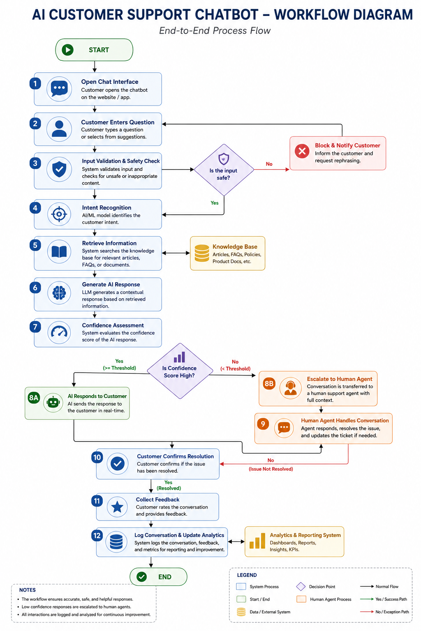
Figure B-1 Workflow Diagram
"The workflow diagram illustrates the end-to-end process of how customer inquiries are received, processed by the AI chatbot, evaluated, and either resolved automatically or escalated to a customer support agent."

Appendix C: BPMN 2.0 Process Diagram

Appendix C: BPMN 2.0 Customer Support Process Model
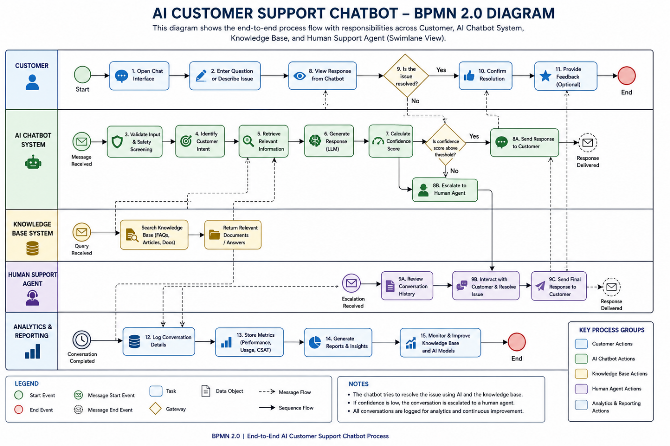
Figure C-1 BPMN Process Diagram
"This BPMN diagram represents the business process flow between customers, the AI chatbot system, and customer support agents."

Appendix D: Conversation Flow Diagram

Appendix D: AI Chatbot Conversation Flow

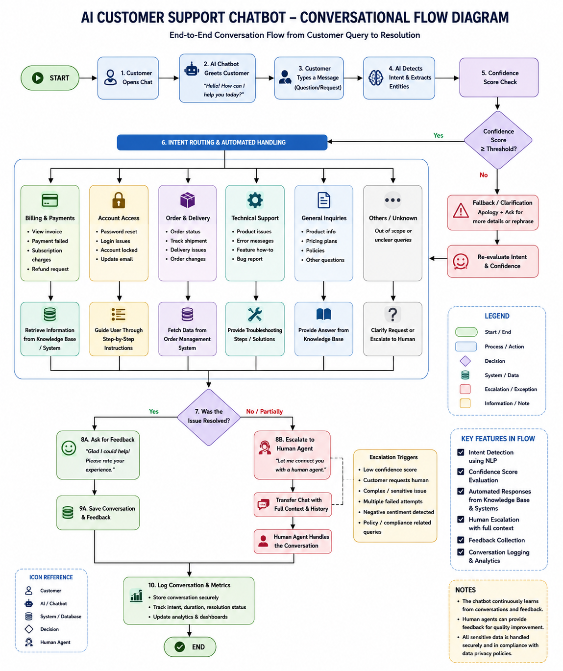
Figure D-1 Conversation Flow
"This diagram shows the decision paths followed during customer interactions, including intent recognition, response generation, clarification requests, and escalation scenarios."

Appendix E: Use Case Diagram

Appendix E: AI Customer Support Chatbot Use Case Diagram
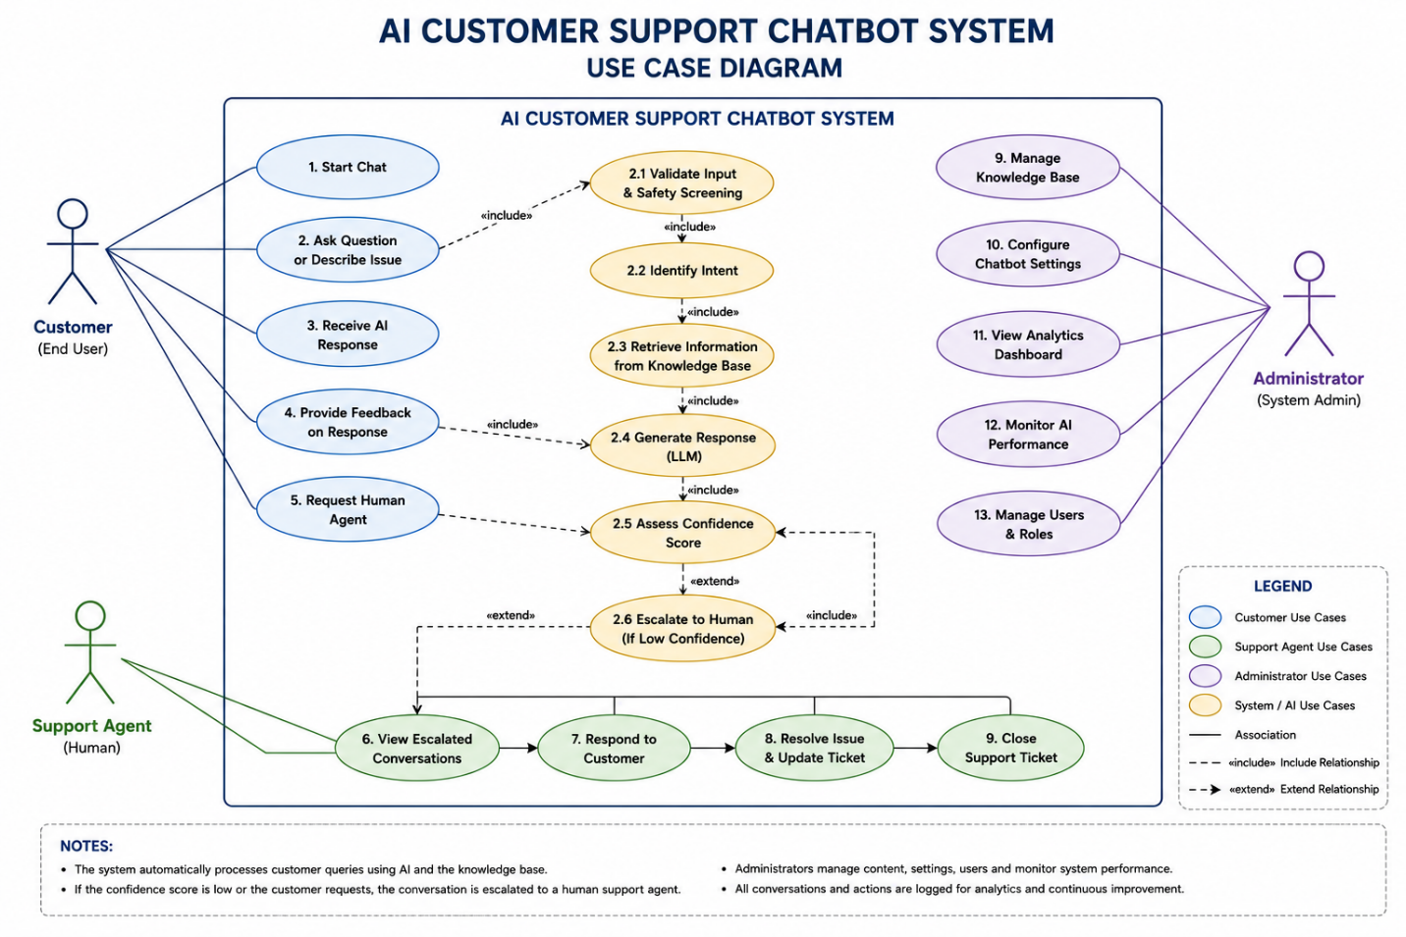
Figure E-1 Use Case Diagram
"This use case diagram illustrates the relationship between system users and the chatbot functionalities they interact with."

Appendix F: Data Flow Diagram (DFD)

Appendix F: Data Flow Diagram
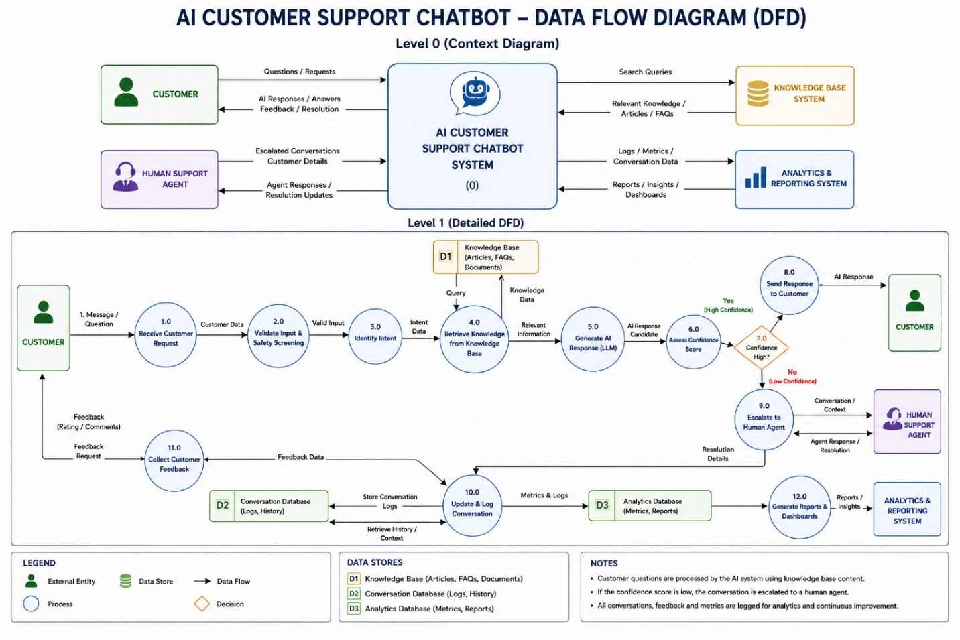
Figure F-1 Data Flow Diagram
"This diagram illustrates how information moves between customers, the chatbot system, knowledge base, support agents, and external systems."

Appendix G: Wireframes
Appendix G: Chatbot User Interface Wireframes
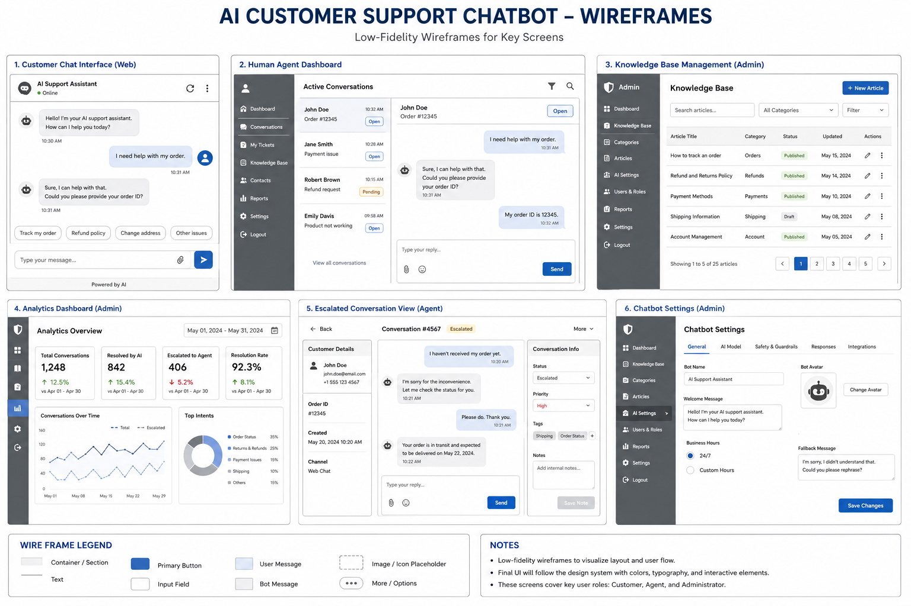
Figure G-1 Customer Chat Screen

Appendix H: Requirements Traceability Matrix (RTM)

AI_Customer_Support_Chatbot_RTM.docx

Appendix I: Risk Register
AI_Customer_Support_Chatbot_Risk_Register.xlsx

Appendix J: User Acceptance Testing (UAT)
AI_Customer_Support_Chatbot_UAT_Test_Cases.xlsx

Appendix K: Prompt Library
AI_Customer_Support_Chatbot_Prompt_Library.docx

Appendix L – AI Evaluation Rubric
AI Evaluation Rubric.docx

