胰岛素 单机小项目



/\* explain what this code does here: This is the part of the code that is in charge of the GUI of the pump. It has a button to insert insulin, a button to charge the pump, and a field that displays the current time, the current battery level, the current insulin level, the current blood sugar level, and the current status of the pump. \*/

生成的代码未通过编译

删除二叉搜索树算法题



生成的代码



在代码中未出现中文以及汉语拼音及其缩写的情况下有时会生成中文

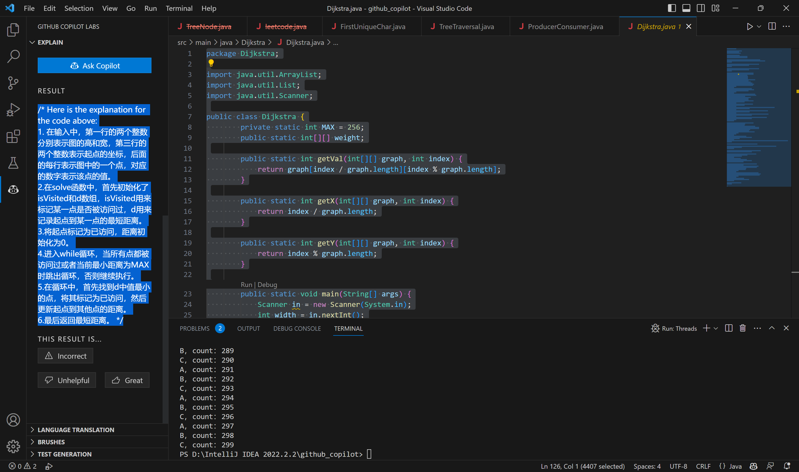

迪杰斯特拉算法无法生成