Exercise 1  
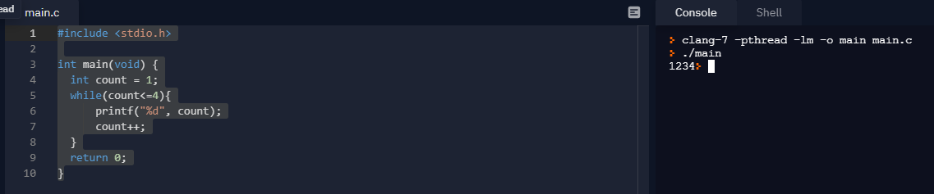

Exercise 2  
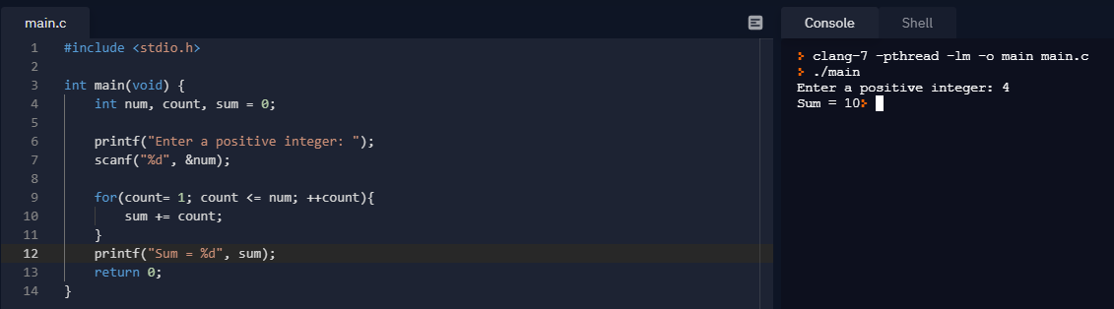

Exercise 3  
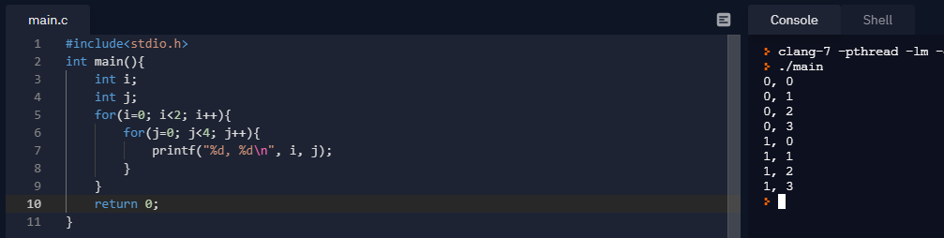

Exercise 4  
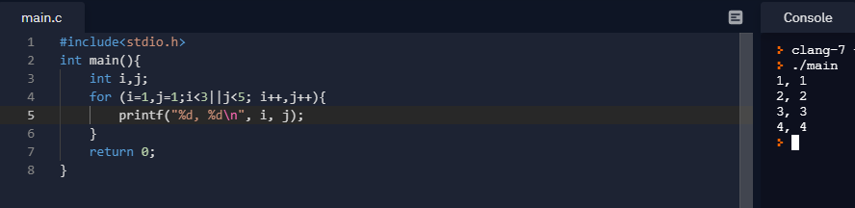

Exercise 5  
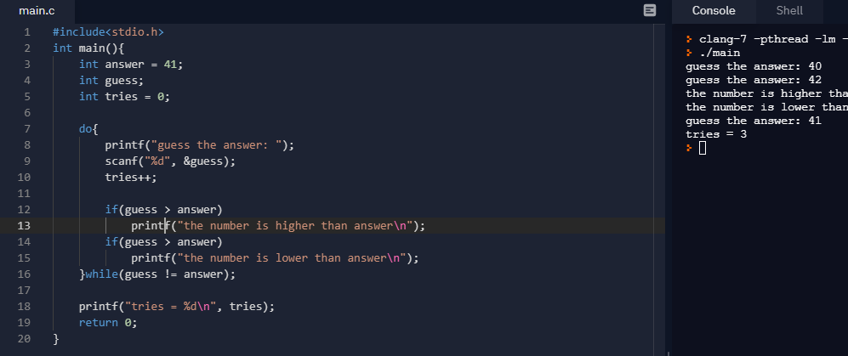

Exercise 6  
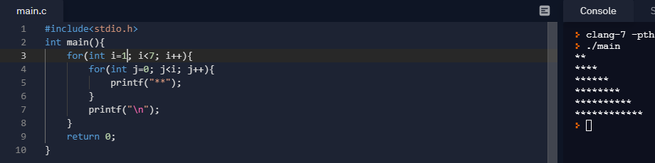

Exercise 7  
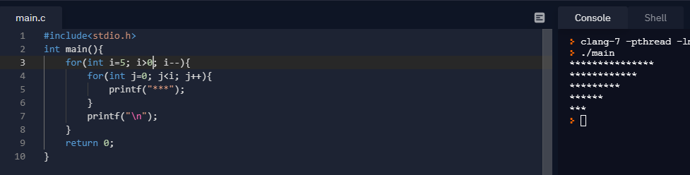

Exercise 8  
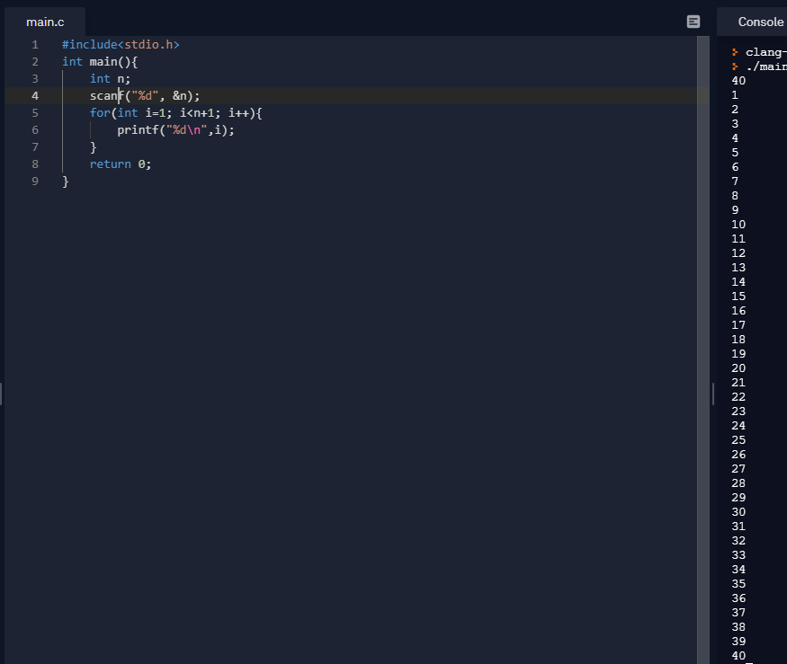

Exercise 9  
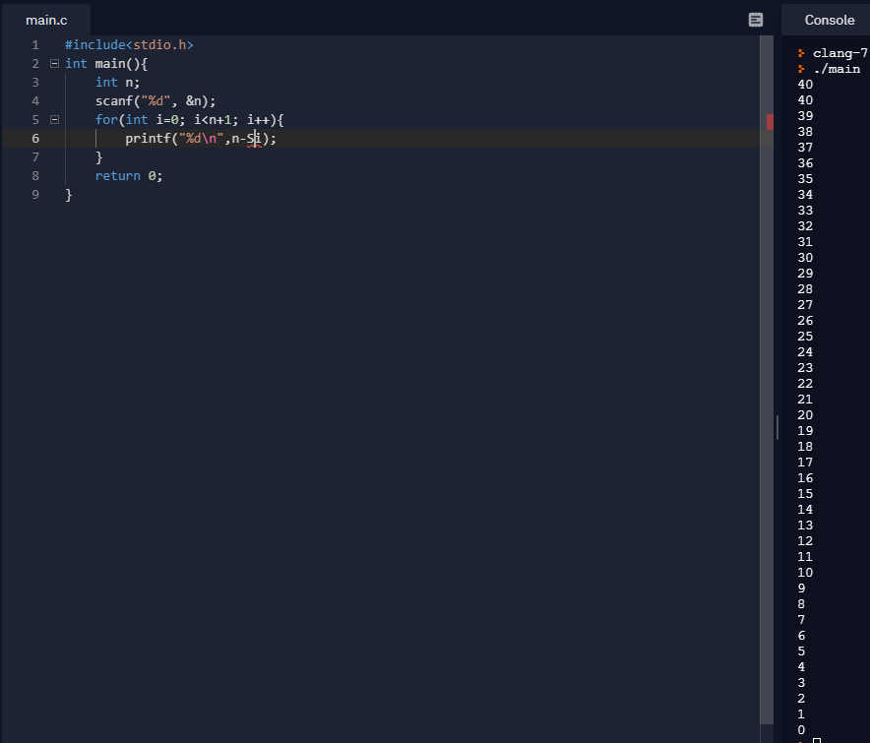

Exercise 10  
