HKUPSY
Experiment1
Use Case Descriptions (Design Model)

Wayne
12/21/2010

Use Case Diagram
This section shows the realization use case diagram for the system. There are five use cases, “DoExperiment”, “DoPractice”, “ConductTrial”, “ShowPreTrialScene”, and “Configure”. And there are two actors, “Subject” and “Researcher”
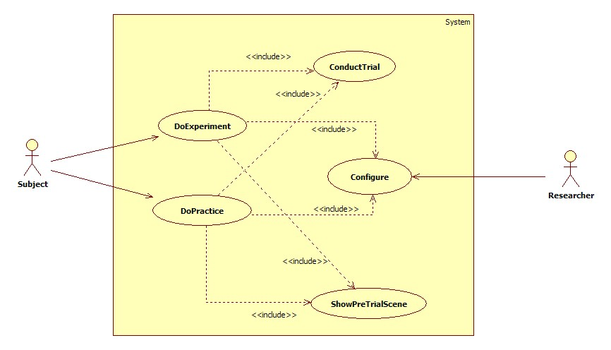

Use Case Description
In this section, I will discuss the detailed use case descriptions of all five use cases.
Use Case Name: | DoExperiment
Use Case Number: | #1
Actors: | Subject, Researcher
Description: | Subject does the experiment
Pre-condition: | Subject is prepared for the test
Post-condition: | N/A
Assumption: | Researcher set the experiment mode in the configuration; Subject knows the procedure of the test by practice, and will exactly follow the procedures.
Typical course of events | Actors | System
Typical course of events | Step 1. Initiate the use case when the system is ready for the actor to carry out the experiment, and researcher opens the program.  Step 2. Include use case #3 “Configure”.  Step 4. Include use case #5 “ConductTrial”.  Step 13. Press the spacebar. | Step 3. Include use case #4 “ShowPreTrialScene”.  Step 5. Cancel all bindings on keyboard and mouse.  Step 6. Open the file with pre-set output filename during the configuration for writing if it is not opened.  Step 7. Gather information from the trial and the random object. The information includes the number of the trial, the number of the object, slant, height, rotation speed, tilt, radius, original aspect ratio on z-axis, the aspect ratio on z-axis after subjecting by the subject. Write them to the file using ASCII text.  Step 8. Increase trial ID by 1.  Step 9. Compare current trial ID and max number of trials in one section. If current trial ID is at least max number of trials in one section, increase current section number by 1, and then set current trial ID to 0.  Step 10. Compare current section number with max section number if it is increased by 1.  Step 11. Display a line of string “Experiment finished” on the screen with black background.  Step 12. Bind the spacebar with the function of exiting the program.  Step 14. Close the output file, release used memory, exit the program, and conclude the use case.
Alternative course of events | Step 10. If current section number is at least max section number, go back to step 3.

Use Case Name: | DoPractice
Use Case Number: | #2
Actors: | Subject, Researcher
Description: | Subject does the practice
Pre-condition: | N/A
Post-condition: | N/A
Assumption: | Researcher set the practice mode in the configuration
Typical course of events | Actors | System
Typical course of events | Step 1. Initiate the use case when the system is ready for the actor to carry out the experiment, and researcher opens the program.  Step 2. Include use case #3 “Configure”.  Step 4. Include use case #5 “ConductTrial”.  Step 13. Press the spacebar. | Step 3. Include use case #4 “ShowPreTrialScene”.  Step 5. Cancel all bindings on keyboard and mouse.  Step 6. Clear the screen with background. Show the 2D-View of the object with original aspect ratio.  Step 7. Show the 2D-View of the object with the adjusted aspect ratio overlapped with the previous one.  Step 8. Increase trial ID by 1.  Step 9. Compare current trial ID and max number of trials in one section. If current trial ID is at least max number of trials in one section, increase current section number by 1, and then set current trial ID to 0.  Step 10. Compare current section number with max section number if it is increased by 1.  Step 11. Display a line of string “Experiment finished” on the screen with black background.  Step 12. Bind the spacebar with the function of exiting the program.  Step 14. Close the output file, release used memory, exit the program, and conclude the use case.
Alternative course of events | Step 10. If current section number is at least max section number, go back to step 3.

Use Case Name: | Configure
Use Case Number: | #3
Actors: | Researcher
Description: | Researcher sets the configuration of the experiment before it starts
Pre-condition: | N/A
Post-condition: | N/A
Assumption: | The experiment scene will not show up until finishing the configuration
Typical course of events | Actor | System
Typical course of events | Step 1. Initiate the use case when the system is started and ready for configuration  Step 3. Set the configurations by filling the blanks, and selecting the choices. After that, researcher clicks on “Start” button. | Step 2. Show the configuration window. The first line is the blank for the subject ID. The second line is the mode of the experiment, which has two choices, “Experiment” or “Practice”. When “Practice” is selected, the output filename blank is disabled since we do not output the results for practice. The third line is the blank for filling in the number of sections, and number of trials in each section. Show the total number of the trials as well at the end of the line. This number will be updated whenever the number of sections or the number of the trials changes. The fourth line has two choices for selecting the mode of 2D projection. Two choices are available, “orthogonal” and “perspective”. The fifth line is the blank for the output filename. The filename can be automatically changed according to a given rule while any related setting changed. The default rule is “SubjectID-ExperimentID-DateTime-ExperimentName”. Researcher also can change the filename manually.  Step 4. Validate if the all the blanks are filled in.  Step 5. Validate if the output file has been already existed. If so, pop up a window noticing the output file is existed, and whether to overwrite that file. There are two buttons on the window, One is “yes” meaning overwriting the file, and the other one is “no” meaning not overwriting the file.  Step 6. Initialize the system using the configurations, initialize the glut for later displaying, and end the use case.
Alternative course of events | Step 4. If any blank is not filled in, notice the researcher the missed ones. Then go back to Step 3.  Step 5. If the researcher chooses “no”, go back to Step 3 to let the researcher choose another output filename.

Use Case Name: | ShowPreTrialScene
Use Case Number: | #4
Actors: | Subject
Description: | The system shows “Press spacebar to start the next trial”, and also shows the progress in terms of the sections when the start of each section.
Pre-condition: | There are still trials to do for the subjects
Post-condition: | N/A
Assumption: | N/A
Typical course of events | Actor | System
Typical course of events | Step 1. Initiate the use case after finishing the configuration, or finishing one trial.  Step 6. Conclude the use case, after pressing the spacebar to continue to the next trial. | Step 2. Cancel all binding events on keyboard and mouse, e.g. “Key pressed”, “mouse move”, and so on.  Step 3. Build up the string “Press spacebar to start the next trial”.  Step 4. Check if it is the first trial of the current section. If it is, concatenate the string of progress, e.g. “Current section is 2, total sections is 4, 50% finished”, after the string in Step 3  Step 5. Clear and render the screen with the string. Bind the spacebar with the function of starting the trial.
Alternative course of events

Use Case Name: | ConductTrial
Use Case Number: | #5
Actors: | Subject
Description: | Given original 3D-view of the object, the subject adjusts the aspect ratio on z-axis of the 2D-view of its distorted shape (a random aspect ratio on z-axis) by pressing up arrow and down arrow keys.
Pre-condition: | N/A
Post-condition: | N/A
Assumption: | N/A
Typical course of events | Actor | System
Typical course of events | Step 1. Initiate the use case #4 is finished.  Step 8. Adjust the aspect ratio by pressing up arrow key and down arrow key.  Step 10. Confirm the adjustment by pressing the spacebar. | Step 2. Cancel all binding events on keyboard and mouse, e.g. “Key pressed”, “mouse move”, and so on.  Step 3. Choose a random object from the object base. Set random parameters, including height, initial aspect ratio, tilt, rotation speed, max rotation degree, and texture, to the object.  Step 4. Clear the screen.  Step 5. Render the 3D-view of the object on the left part of the screen. At the first time the object is rendered, the object does not rotate. At i_{th} time the object is rendered, where i > 1, first calculate the time elapsed from the (i-1)_{th} time to i_{th} time, and then calculate the degree need to rotate. If the current rotation degree is larger than the max rotation degree, reverse the rotation direction.  Step 6. Render the 2D-view on the right part of the screen. At the first time, its aspect ratio on z-axis is the same as original aspect ratio.  Step 7. Bind the up arrow key to the function increasing the aspect ratio on z-axis of the object in the 2D-view. Bind the down arrow key to the function decreasing the aspect ratio on z-axis of the object in the 2D-view.  Bind the spacebar to the function of confirming adjustment. This step is only been executed once.  Step 9. Call corresponding functions to adjust the aspect ratio, but do not render it until the screen is refreshed according to the refresh rate.  Step 11. Conclude the use case.
Alternative course of events | Step 8 – 9. The screen is refreshed due to the refresh rate we set, go to step 5 after finish the step.  Step 10. Subject can go back to Step 8 without executing step 10.

