HKUPSY
Experiment1
Use Case Descriptions

Wayne
12/15/2010

Use Case Diagram
This section shows the use case diagram for the system. There are three use cases, “DotheExperiment”. “DothePractice”, and “Configure”. And there are two actors, “Subject” and “Researcher”
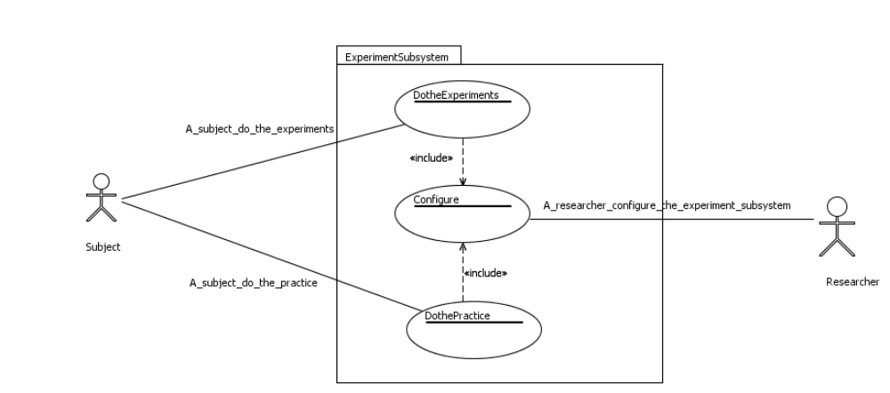

Use Case Description
In this section, I will discuss the detailed use case descriptions of all three use cases.
Use Case Name: | Do the experiment
Use Case Number: | #1
Actors: | Subject, Researcher
Description: | Subject does the experiment
Pre-condition: | N/A
Post-condition: | N/A
Assumption: | Researcher set the experiment mode in the configuration
Typical course of events | Actors | System
Typical course of events | Step 1. Initiate the use case when the system is ready for the actor to carry out the experiment.  Step 2. Include use case #3 “Configure”.  Step 5. Press the space bar to start the experiment.  Step 8. Press up-arrow key or down-arrow key to adjust the shape of the 2D-view, such as pressing the up-arrow key for increasing the radius, and the down-arrow key for decreasing the radius.  Step 10. Press the space bar to confirm the modification, or go back to Step 8 to adjust again.  Step 12. Check if it is the end of the experiment. | Step 3. Show the string “Press Space Bar to Start”.  Step 4. Check if it is the start of a new section.  Step 6. Choose one object from the object base randomly, and randomly choose the parameters for the object, such as slant, rotation speed, height, tilt, project method in 2D-view and so on.  Step 7. Show the 3D-view of the object at the left part of the screen, and continually rotate it by the y-axis back and forth; Show the 2D-view of the object from the y-axis (top of the object) on the right part of the screen, using selected projection mode. The shape of the 2D-view may be distorted (zoomed, enlarged, using a random radius etc.).  Step 9. Update the adjusted 2D-view according to the key the subject pressed.  Step 11. Record the all available information of the trial, such as trial number, object number, initial aspect ratio, aspect ratio after adjustment, and so on.  Step 13. Show “Experiment finished” and exit the program.
Alternative course of events | Step 4. If it is the start of the new section, also show the progress on the screen in terms of sections, including current section number, and total number of sections.  Step 12. If it is not the end of the experiment, go back to step 3

Use Case Name: | Do the practice
Use Case Number: | #2
Actors: | Subject, Researcher
Description: | Subject does the practice
Pre-condition: | N/A
Post-condition: | N/A
Assumption: | Researcher set the practice mode in the configuration
Typical course of events | Actors | System
Typical course of events | Step 1. Initiate the use case when the system is ready for the actor to carry out the experiment.  Step 2. Include use case #3 “Configure”.  Step 5. Press the space bar to start the experiment.  Step 8. Press up-arrow key or down-arrow key to adjust the shape of the 2D-view, such as pressing the up-arrow key for increasing the radius, and the down-arrow key for decreasing the radius.  Step 10. Press the space bar to confirm the modification, or go back to Step 8 to adjust again.  Step 12. Check if it is the end of the experiment. | Step 3. Show the string “Press Space Bar to Start”.  Step 4. Check if it is the start of a new section.  Step 6. Choose one object from the object base randomly, and randomly choose the parameters for the object, such as slant, rotation speed, height, tilt, project method in 2D-view and so on.  Step 7. Show the 3D-view of the object at the left part of the screen, and continually rotate it by the y-axis back and forth; Show the 2D-view of the object from the y-axis (top of the object) on the right part of the screen, using selected projection mode. The shape of the 2D-view may be distorted (zoomed, enlarged, using a random radius etc.).  Step 9. Update the adjusted 2D-view according to the key the subject pressed.  Step 11. Show the correct 2D-view of the object along with the one by the adjustment of the subject overlapped. The correct one should be in a different line style or color.  Step 13. Show “Practice finished” and exit the program.
Alternative course of events | Step 4. If it is the start of the new section, also show the progress on the screen in terms of sections, including current section number, and total number of sections.  Step 12. If it is not the end of the experiment, go back to step 3

Use Case Name: | Configure
Use Case Number: | #3
Actors: | Researcher
Description: | Researcher sets the configuration of the experiment before it starts
Pre-condition: | N/A
Post-condition: | N/A
Assumption: | N/A
Typical course of events | Actor | System
Typical course of events | Step 1. Initiate the use case when the system is started and ready for configuration  Step 3. Researcher sets and confirms the configuration on the configuration window. | Step 2. Show the configuration windows. The window contains setting for the mode of the experiment (practice or not), number of sections, number of trials in each section, whether using orthogonal projection or perspective projection or both in 2D-views, subject id, and automatically generated suggested output filename and so on.  Step 4. Initialize the system using the configuration and end the use case.
Alternative course of events | N/A

