ListenBrainz Data Warehouse Design Document
Scalable Capital – Senior Data Engineer Assignment
Author: Benzihar Stanley
Version: 1.0

Document Purpose
The purpose of this document is to explain the architectural decisions, assumptions, dimensional model, ETL design and implementation strategy used to build a data warehouse for the ListenBrainz dataset using DuckDB for the Senior Data Engineer position with Scalable Capital.

Table of Contents
- Objective
2. Scope
3. Overall Solution Architecture
4. Source System Overview
5. Source Data Analysis
5. Assumptions
6. Architecture
7. Bronze Layer
8. Silver Layer
9. Gold Layer
10. Dimensional Model
11. Fact Design
12. Key Strategy
13. ETL Flow
14. Data Quality
15. Performance Considerations
16. Future Enhancements
17. Conclusion

1. Objective
Design a scalable analytical warehouse that ingests raw ListenBrainz events, preserves source fidelity, transforms the data into reusable business entities, and exposes analytical datasets suitable for reporting.

2. Scope
- Ingest NDJSON files
- Store raw data in Bronze
- Parse and validate JSON
- Build dimensions and fact tables
- Support analytical SQL queries
- Maintain auditability through load metadata

3. Source System Overview
Each JSON document represents one listening event. The event contains transactional information (user and timestamp) together with descriptive music metadata such as artist, release and recording.

4. Source Data Analysis
Key observations:
• Every JSON record represents a listening event.
• recording_msid, artist_msid and release_msid behave as stable business identifiers.
• MBIDs are optional and frequently null.
• Artist names are not reliable identifiers because formatting varies.
• One release contains many recordings.
• One recording appears in many listening events.
Business Grain:
One row = One user listening to one recording at one timestamp.

5. Assumptions
• Source timestamps are UTC.
• A recording belongs to one artist and one release.
• Surrogate keys are generated inside the warehouse.
• Duplicate events are detected during ETL.
• Source files are immutable after ingestion.

6. Solution Architecture

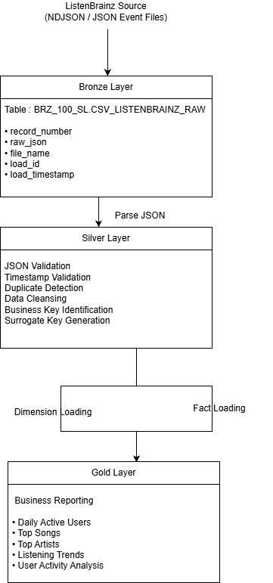

7. Bronze Layer
Purpose: preserve raw data exactly as received. Raw JSON, file metadata, load_id and load_timestamp are stored without transformation. This supports lineage, replayability and troubleshooting.

8. Silver Layer
Purpose: transform JSON into structured entities. Perform validation, extract business keys, populate dimensions and generate surrogate keys before loading the fact table.

9. Gold Layer
Purpose: provide business-facing datasets and SQL views such as Daily Active Users, Top Songs, Top Artists, Listening Trends and User Behaviour.

10. Dimensional Model (Preferred Snowflake)
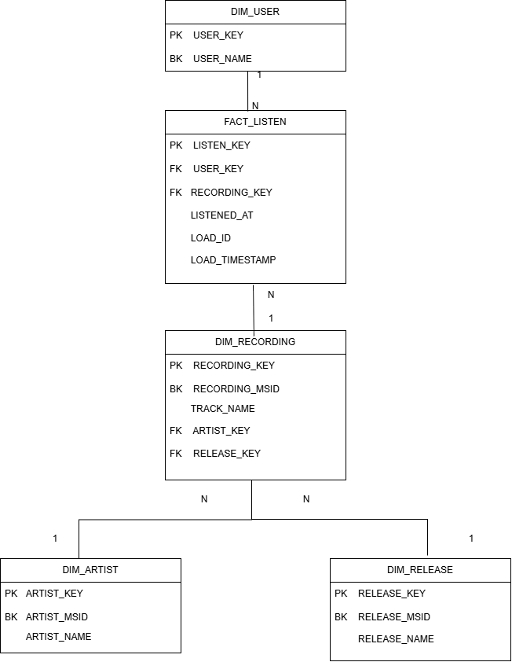

11. Business Keys vs Surrogate Keys
Business keys uniquely identify source entities. Surrogate keys are generated to ensure warehouse stability, improve join performance and isolate the warehouse from changes in source identifiers.

12. ETL Flow
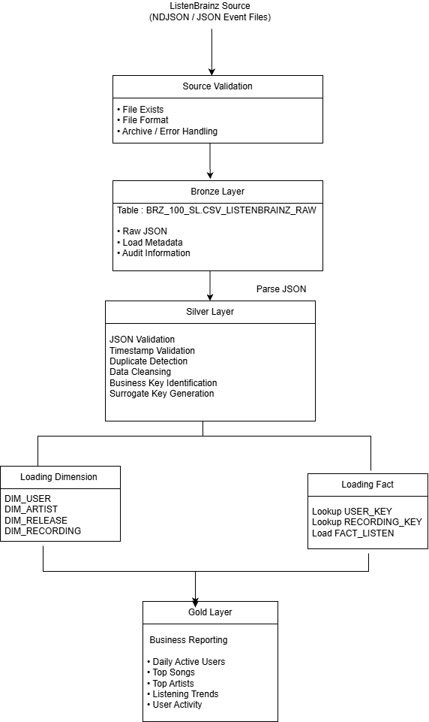

13. Data Quality Rules
Mandatory fields:
• user_name
• listened_at
• recording_msid
Validation:
• JSON structure
• Timestamp format
• Duplicate detection
• Null handling
• ETL audit logging

14. Performance Considerations
• Batch loading
• Surrogate key lookups
• Reusable SQL
• Incremental processing
• Partitioning strategy for large datasets
• Appropriate indexing if migrated to enterprise databases

15. Risks and Mitigations
Risk: Duplicate source events.
Mitigation: Business key validation.
Risk: Missing metadata.
Mitigation: Unknown dimension members.
Risk: Schema evolution.
Mitigation: Versioned ETL and metadata-driven mapping.

16. Future Enhancements
• Slowly Changing Dimensions
• Airflow orchestration
• Automated data quality monitoring
• Unit testing
• CI/CD pipeline
• Cloud deployment
• Metadata catalog and lineage

17. Conclusion
The proposed solution follows common enterprise data warehousing practices by separating raw ingestion, transformation and analytical presentation. The model is scalable, maintainable and supports future extension while preserving data lineage and auditability.

Appendix A - Snowflake Schema
DIM_USER
│
FACT_LISTEN
│
DIM_RECORDING
/ \
DIM_ARTIST DIM_RELEASE

Appendix B - ETL Pipeline
JSON Files
↓
Bronze
↓
Validation
↓
Dimensions
↓
Fact
↓
Gold

