Inhaltsverzeichnis
- Loop Invariants

Loop Invariants

The loop invariant of insertion sort:
Sub array A[1...j-1] consists of the elements originally in A[1...j-1] but in a sorted order

The stages for Insertion Sort:
- Initialization
Goal: show that the invariant holds before the first iteration, like the base case for mathematical induction.
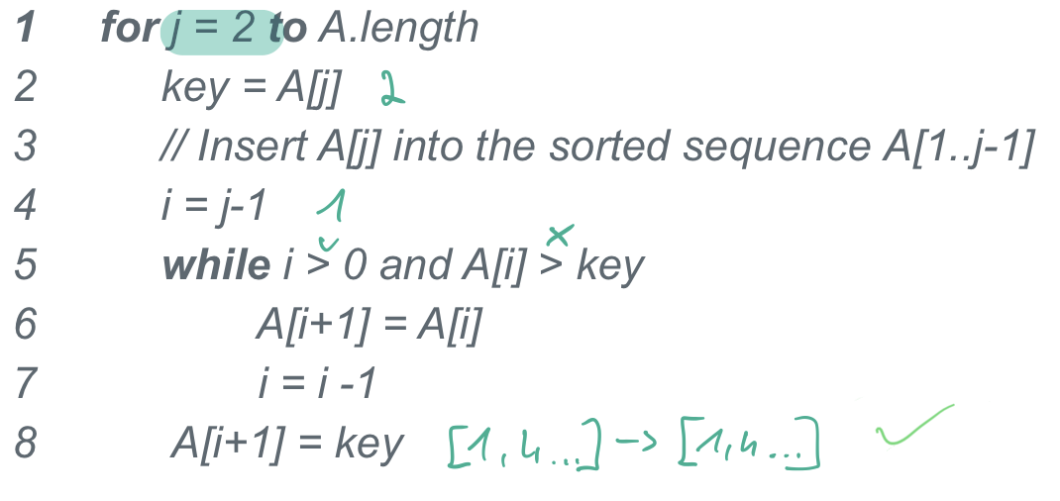

- Maintenance
Goal: show that each iteration maintains the loop invariant
  - The body of the for loop works by moving A[j – 1], A[j – 2], A[j – 3] by one position to the right
  - It finds the proper position for A[j]
  - It inserts the value of A

- Termination
Goal: show that the invariant holds when the loop terminates
  - j > len(A) = n, also j = n + 1
  - Sub array A[1...j-1] = A’[1...j-1] and A[1...n] = A’[1...n]
  - A[1...n] is the complete array
=> The algorithm is correct

The loop invariant of Linear Search:
Does an array A[1...j] contain a given number n?
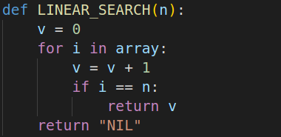
- Initialization
Does a given number n exist in the array A[1...j], beginning from n = 1?
If I > j, the array does not contain the number n and the function returns “NIL”
- Maintenance
  - The for loop iterates through the numbers in the given array. After each iteration, a number v will be increased by one, beginning with 1.
  - If the iterator I matches the given number n, the function returns the number v as the index of the matched number n in the given array.
  - Otherwise the for loop exists and the function returns “NIL”
- Termination
When I = j and no match is found, the function returns “NIL”
Otherwise it returns the index of the matched value.
=> The algorithm is correct

Divide-and-conquer approach

Recursive algorithms
To solve a given problem, they cal themselves recursively one or more times to deal with subproblems.
Key steps:
- Divide
the problem into a number of subproblems that are smaller instances of the same problem.
- Conquer
the subproblems by solving them recursively.
- Combine
the solutions to the subproblems into the solution for the original problem.

Algorithms and Complexity
When an algorithm contains a recursive call, we can describe it’s running time by a recurrence equation, which shows the overall running time on a problem of size n in terms of the running time on smaller inputs.

Recurrence equation
Let Merge Sort be the „dummy“
Let T(n) be the running time on a problem of size n:
- If the size n ≤ c (e.g. Array of size 1 ≤ some constant) → Θ(1)
- Let’s say that we have a subproblem (size= 1/b). It takes T(n/b) to solve one subproblem of size n/b. It takes a*T(n/b) to solve all of them.
- D(n) = time to divide the problem into subproblems. C(n) = time to combine the solutions of the subproblems into the solution of the original problem.

T(n) = { Θ(1) if n ≤ c
a*T(n/b) + D(n) + C(n) otherwise

