CPE301 – SPRING 2019

Design Assignment 1A

Student Name: Serak Gebremedhin

Student #: 2000862766

Student Email: gebremed@unlv.nevada.edu

Primary Github address: https://github.com/Ber-geb/effective-octo-reaction.git

Directory: DesignAssignments\DA1A

Submit the following for all Labs:

1. In the document, for each task submit the modified or included code (only) with highlights and justifications of the modifications. Also, include the comments.
2. Use the previously create a Github repository with a random name (no CPE/301, Lastname, Firstname). Place all labs under the root folder ESD301/DA, sub-folder named LABXX, with one document and one video link file for each lab, place modified asm/c files named as LabXX-TYY.asm/c.
3. If multiple asm/c files or other libraries are used, create a folder LabXX-TYY and place these files inside the folder.
4. The folder should have a) Word document (see template), b) source code file(s) and other include files, c) text file with youtube video links (see template).

1. **COMPONENTS LIST AND CONNECTION BLOCK DIAGRAM w/ PINS**

Atmega328p was not used during this design assignment since there was only a simulation and debugging required.

1. 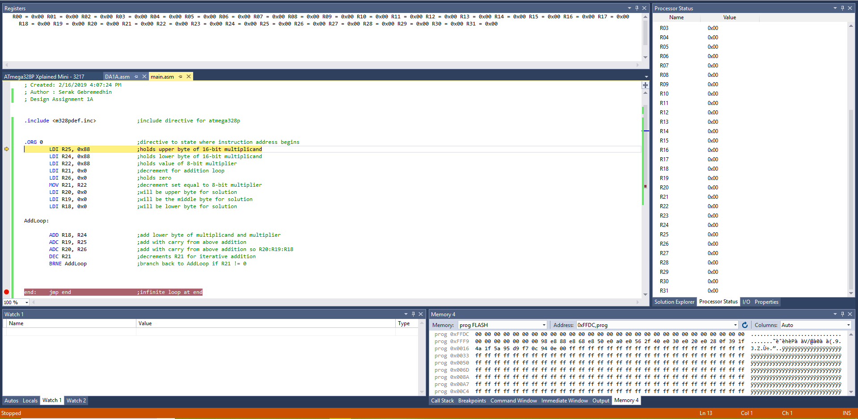**INITIAL/MODIFIED/DEVELOPED CODE OF TASK 1/A**

This shows Atmel Studio 7 at the beginning of the debugging. All registers have zero values.

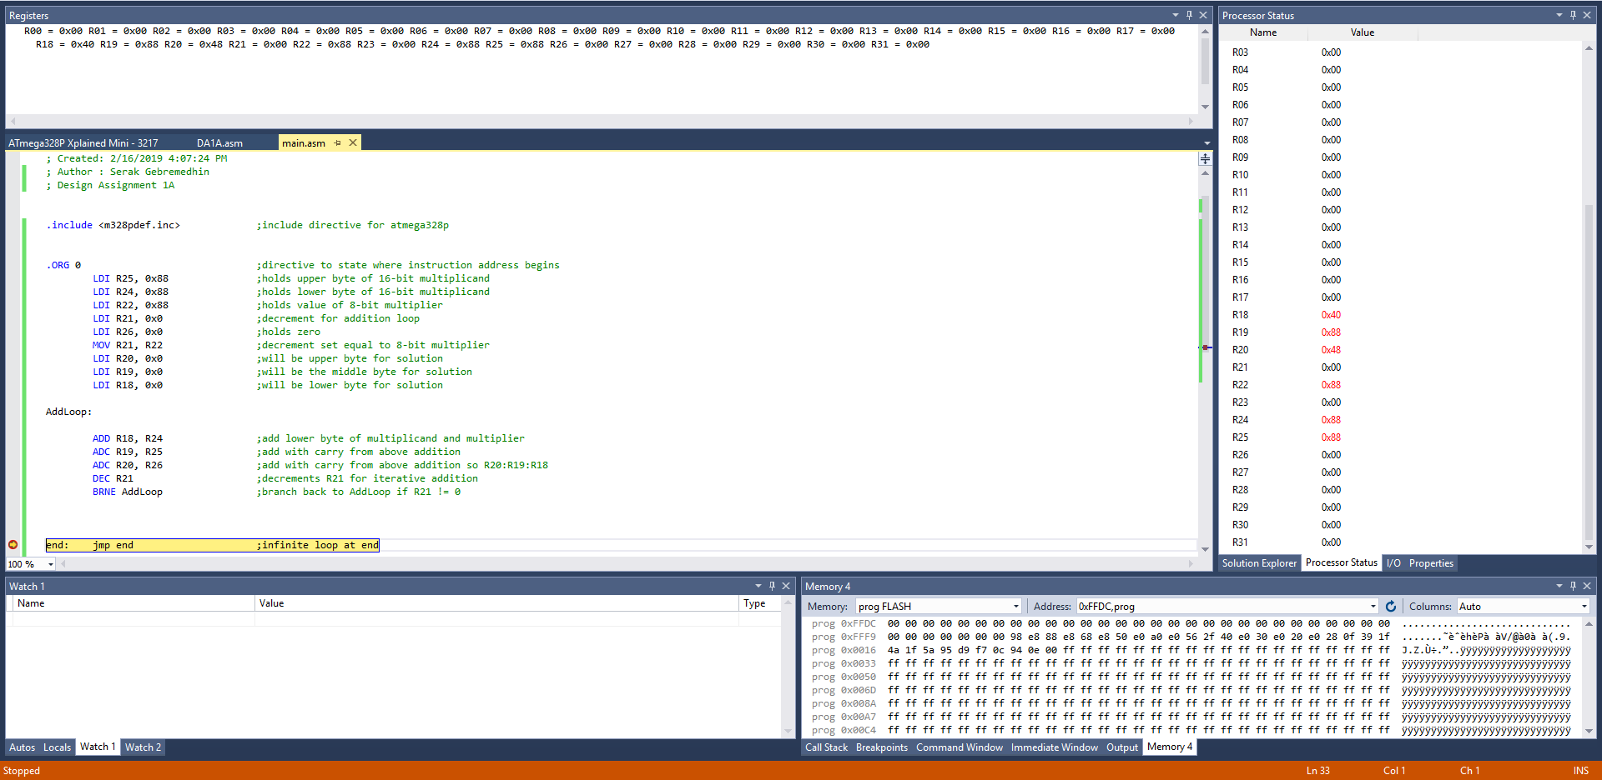This shows Atmel Studio 7 with the source file assembly code at the end of the debugging. The breakpoint was set to the infinite loop at the end, and the values of the registers are shows on the right and top of the interface.

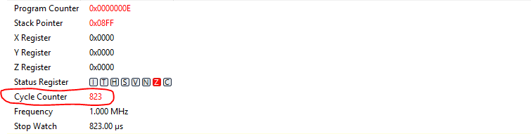

This shows the number of cycles for the program. If the frequency was set to 16 MHz with 823 cycles, then $Execution time=\frac{16MHz}{832 cycles}=0.01944 s$.

1. **DEVELOPED MODIFIED CODE OF TASK 2/A from TASK 1/A**

There was no modification of any code. The initial code is the only code made for this assignment.

1. **SCHEMATICS**

There is no schematics for this design assignment.

1. **SCREENSHOTS OF EACH TASK OUTPUT (ATMEL STUDIO OUTPUT)**

Screenshots for code are provided above in 2.

1. **SCREENSHOT OF EACH DEMO (BOARD SETUP)**

No demo for this DA.

1. **VIDEO LINKS OF EACH DEMO**

https://youtu.be/_lIE092MZ8Y

1. **GITHUB LINK OF THIS DA**

https://github.com/Ber-geb/effective-octo-reaction.git

**Student Academic Misconduct Policy**

<http://studentconduct.unlv.edu/misconduct/policy.html>

“This assignment submission is my own, original work”.

Serak Gebremedhin