CPE301 – SPRING 2019

Design Assignment 1B

Student Name: Serak Gebremedhin

Student #: 2000862766

Student Email: gebremed@unlv.nevada.edu

Primary Github address: https://github.com/Ber-geb/effective-octo-reaction.git

Directory: effective-octo-reaction/DesignAssignments/DA1B/

Submit the following for all Labs:

1. In the document, for each task submit the modified or included code (only) with highlights and justifications of the modifications. Also, include the comments.
2. Use the previously create a Github repository with a random name (no CPE/301, Lastname, Firstname). Place all labs under the root folder ESD301/DA, sub-folder named LABXX, with one document and one video link file for each lab, place modified asm/c files named as LabXX-TYY.asm/c.
3. If multiple asm/c files or other libraries are used, create a folder LabXX-TYY and place these files inside the folder.
4. The folder should have a) Word document (see template), b) source code file(s) and other include files, c) text file with youtube video links (see template).

1. **COMPONENTS LIST AND CONNECTION BLOCK DIAGRAM w/ PINS**

Atmega328P was not used for this design assignment.

1. **INITIAL/MODIFIED/DEVELOPED CODE OF TASK 1/A**

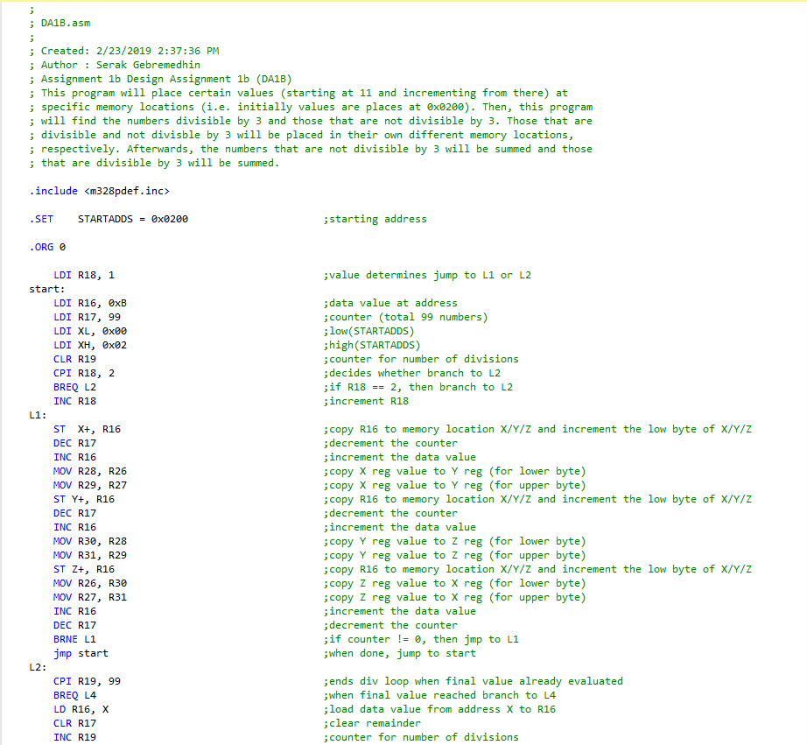

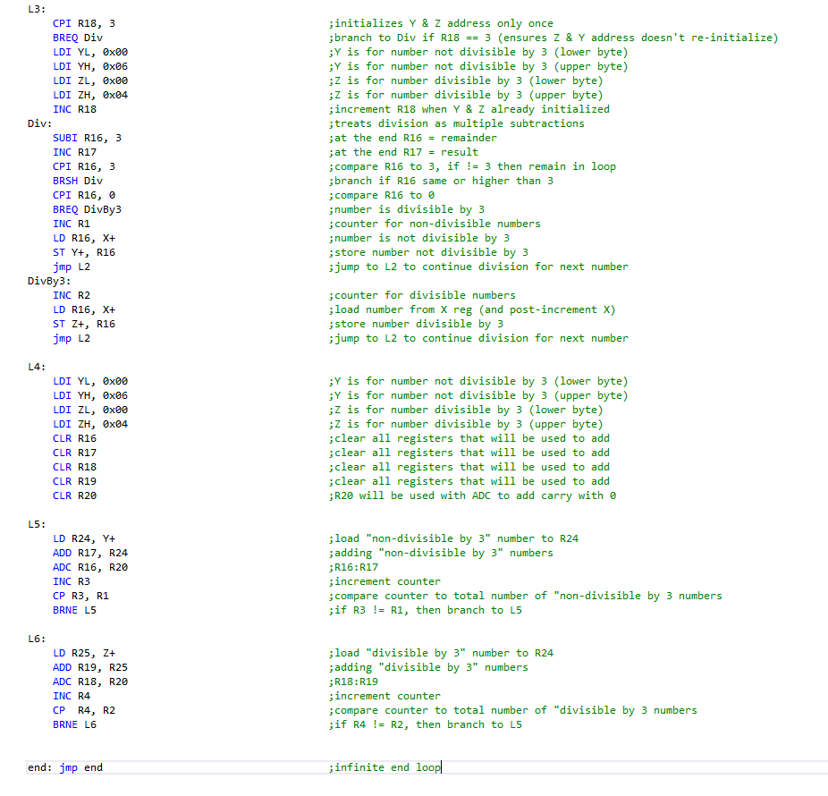

1. **DEVELOPED MODIFIED CODE OF TASK 2/A from TASK 1/A**

There is no modified code for this design assignment.

1. **SCHEMATICS**

There are no schematics for this design assignment.

1. **SCREENSHOTS OF EACH TASK OUTPUT (ATMEL STUDIO OUTPUT)**

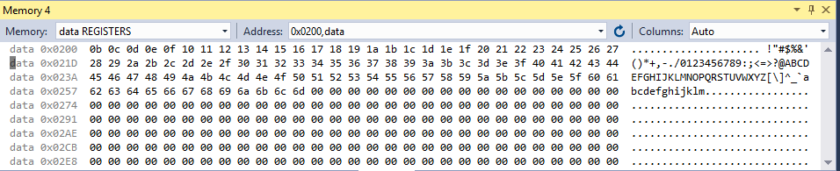

This shows the data register memory for the addresses beginning at 0x0200.

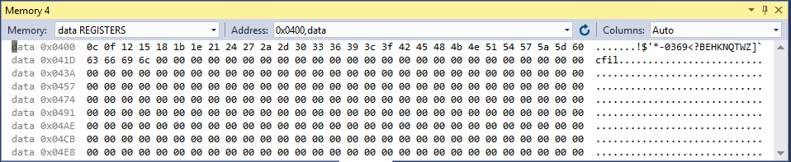

This shows the data register memory for the addresses beginning at 0x0400.

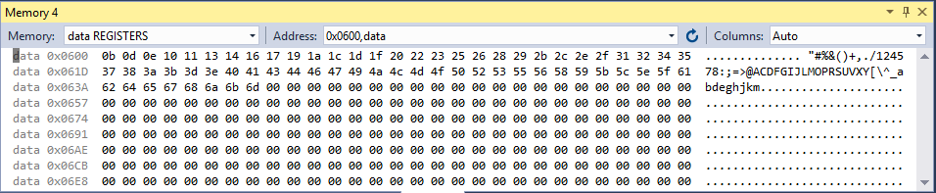

This shows the data register memory for the addresses beginning at 0x0600.

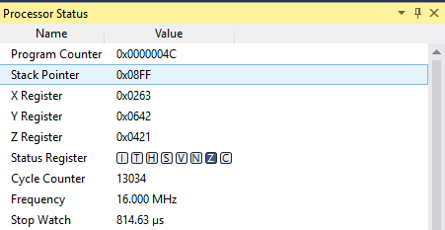

This shows the processor status, including the stop watch when the frequency is equal to 16 MHz and the cycle counter is at 13034 clock cycles which is equal to 814.63 microseconds. (**Solution for Task 5**)

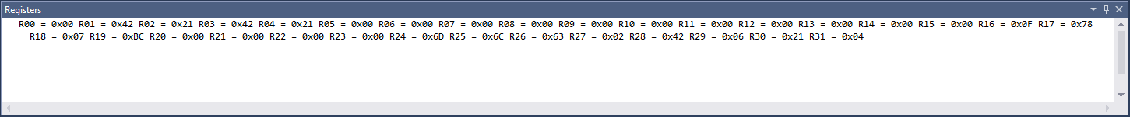This shows the values of the registers at the end of the debugging.

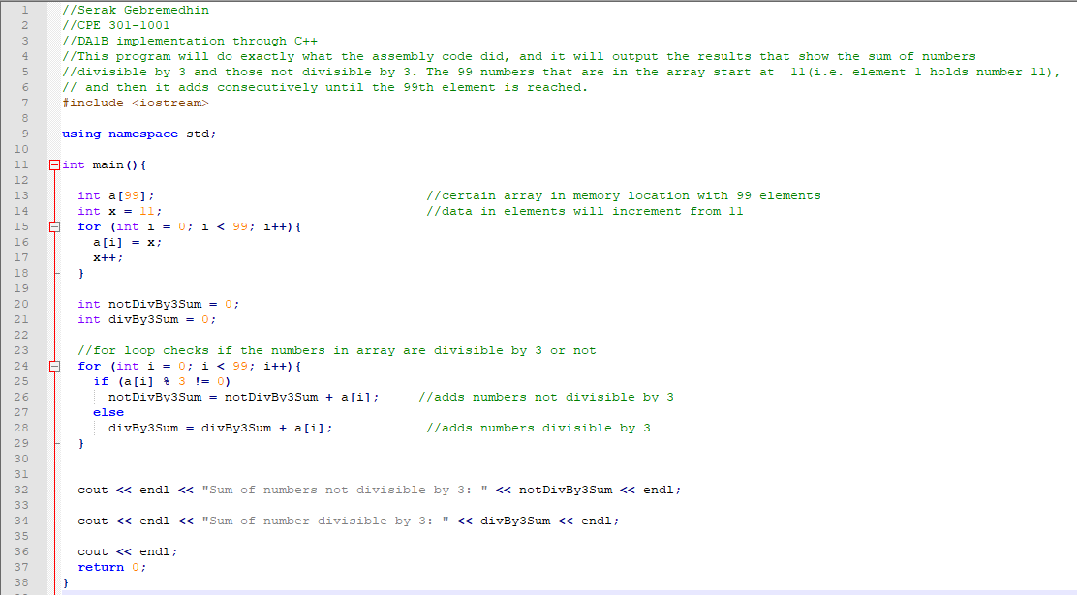

This shows the C++ code using the same type of algorithm as the assembly code in Atmel Studio 7. Though the architecture for the C++ code is different, the same idea is used in the code shown above as the assembly code.

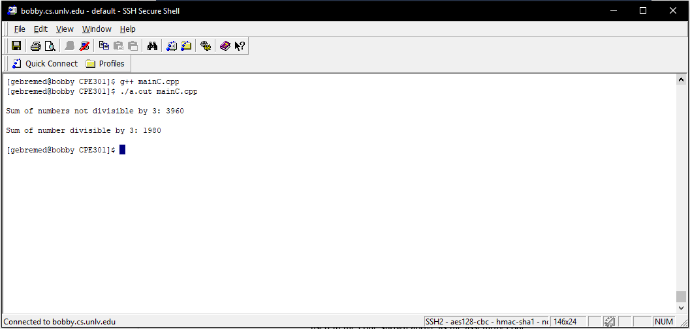

This shows the output for the C++ implementation of the code (the picture shown before this).

1. **SCREENSHOT OF EACH DEMO (BOARD SETUP)**

The Atmega328P was not used for this design assignment.

1. **VIDEO LINKS OF EACH DEMO**

https://youtu.be/ZRlddZXGc7Y

1. **GITHUB LINK OF THIS DA**

https://github.com/Ber-geb/effective-octo-reaction.git

**Student Academic Misconduct Policy**

<http://studentconduct.unlv.edu/misconduct/policy.html>

“This assignment submission is my own, original work”.

Serak Gebremedhin