CPE301 – SPRING 2019

Design Assignment 2A

Student Name: Serak Gebremedhin

Student #: 2000862766

Student Email: gebremed@unlv.nevada.edu

Primary Github address: https://github.com/Ber-geb/effective-octo-reaction

Directory: effective-octo-reaction/DesignAssignments/DA2A/

Submit the following for all Labs:

1. In the document, for each task submit the modified or included code (only) with highlights and justifications of the modifications. Also, include the comments.
2. Use the previously create a Github repository with a random name (no CPE/301, Lastname, Firstname). Place all labs under the root folder ESD301/DA, sub-folder named LABXX, with one document and one video link file for each lab, place modified asm/c files named as LabXX-TYY.asm/c.
3. If multiple asm/c files or other libraries are used, create a folder LabXX-TYY and place these files inside the folder.
4. The folder should have a) Word document (see template), b) source code file(s) and other include files, c) text file with youtube video links (see template).

1. **COMPONENTS LIST AND CONNECTION BLOCK DIAGRAM w/ PINS**

List of Components used

Block diagram with pins used in the Atmega328P

1. **INITIAL/MODIFIED/DEVELOPED CODE OF TASK 1/A**

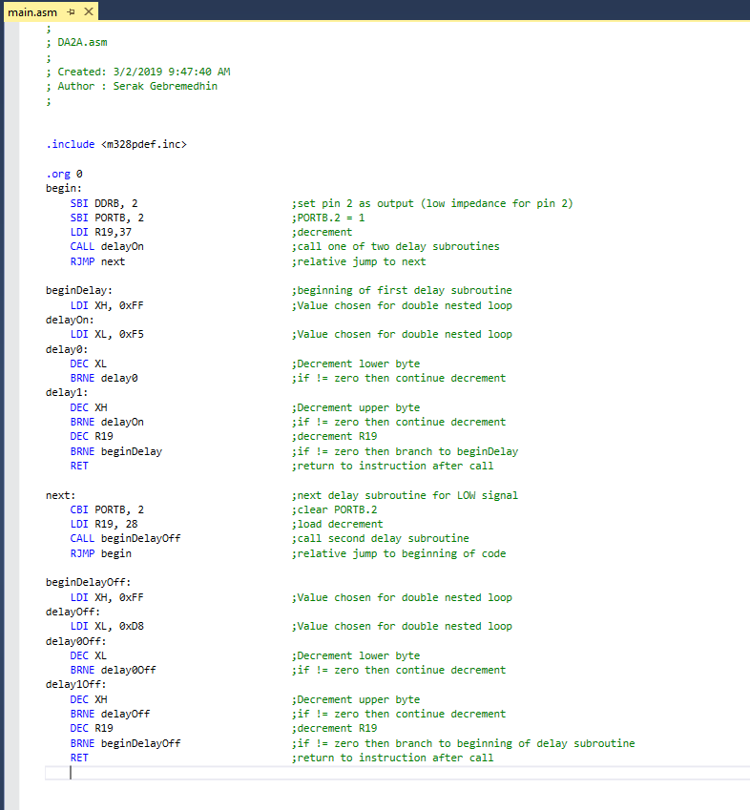

This shows the main source code for Task 1 in assembly.

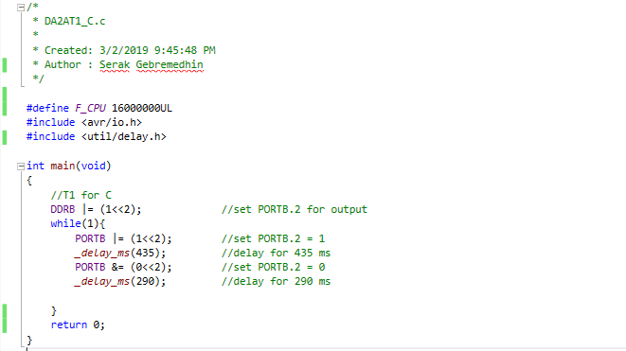

This shows the main source code for Task 1 in C.

1. **DEVELOPED MODIFIED CODE OF TASK 2/A from TASK 1/A**

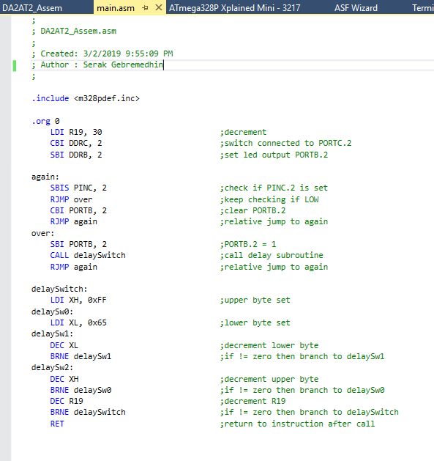

This shows the “modified” code for Task 2 in assembly. This code is not really modified from Task 1, but it does use similar ports.

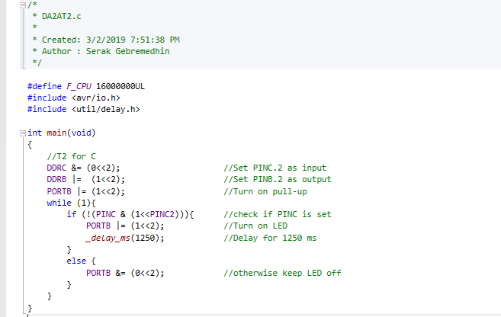

This is the “modified” code for Task 2 in C. This code is not really “modified” from Task 1, but it uses similar ports for output.

1. **SCHEMATICS**

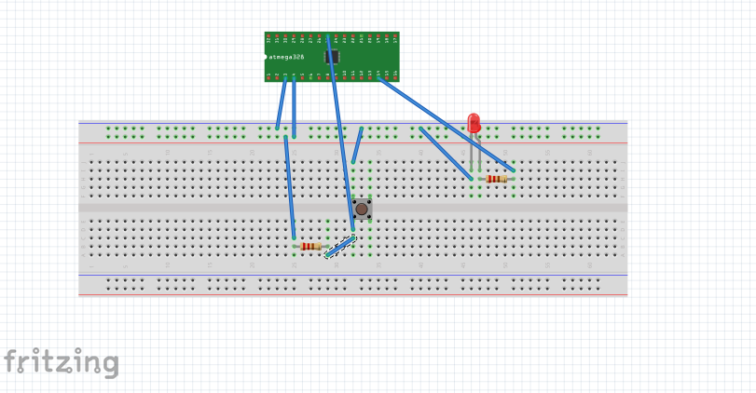

This shows the schematic of the setup for this Design Assignment (specifically for task 2). One important thing to note is the fact that the MCU in the schematic is not the AtMega328P Xplained Mini but the Atmega328.

1. **SCREENSHOTS OF EACH TASK OUTPUT (ATMEL STUDIO OUTPUT)**

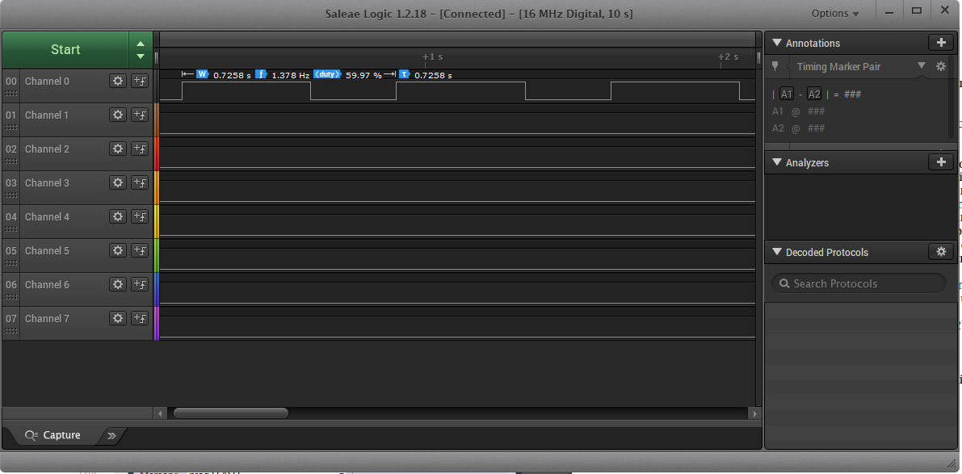

This shows the Logic Analyzer waveform for Task 1 in assembly.

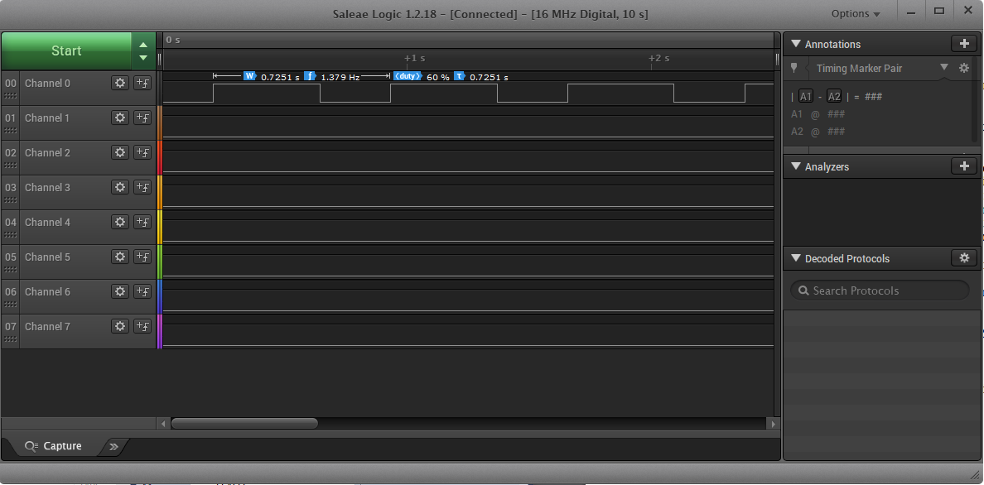

This shows the Logic Analyzer waveform for Task 1 in C.

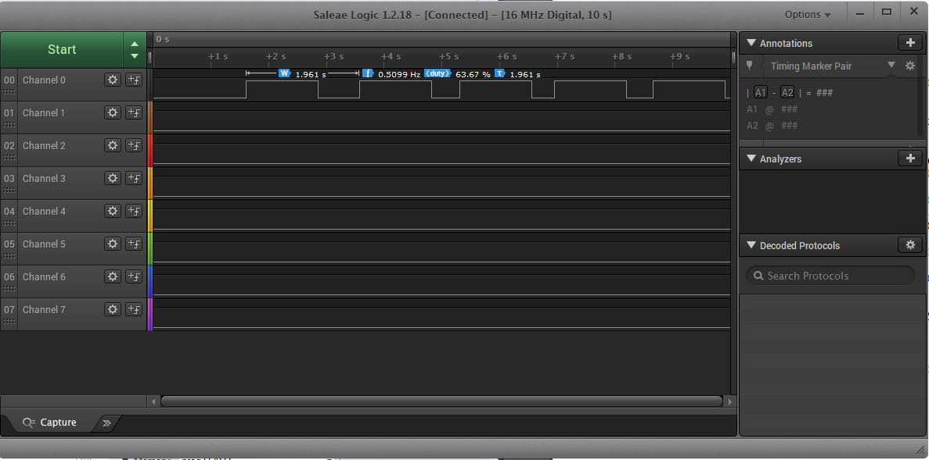

This shows the Logic Analyzer waveform for Task 2 in assembly.

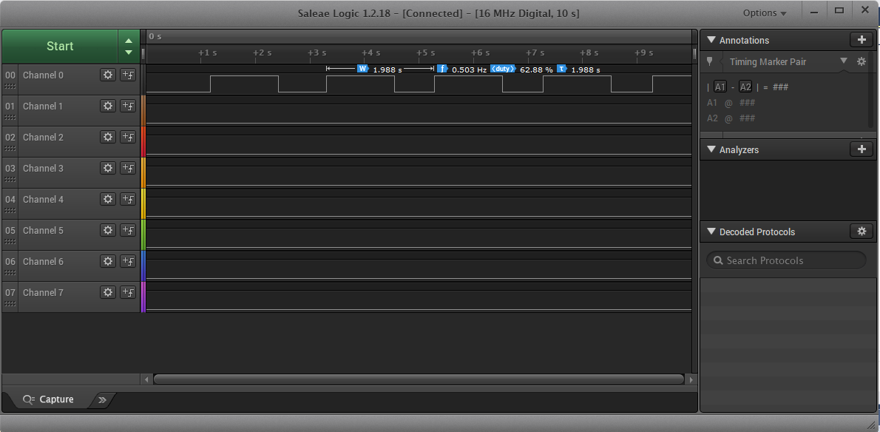

This shows the Logic Analyzer waveform for Task 2 in C.

1. **SCREENSHOT OF EACH DEMO (BOARD SETUP)**

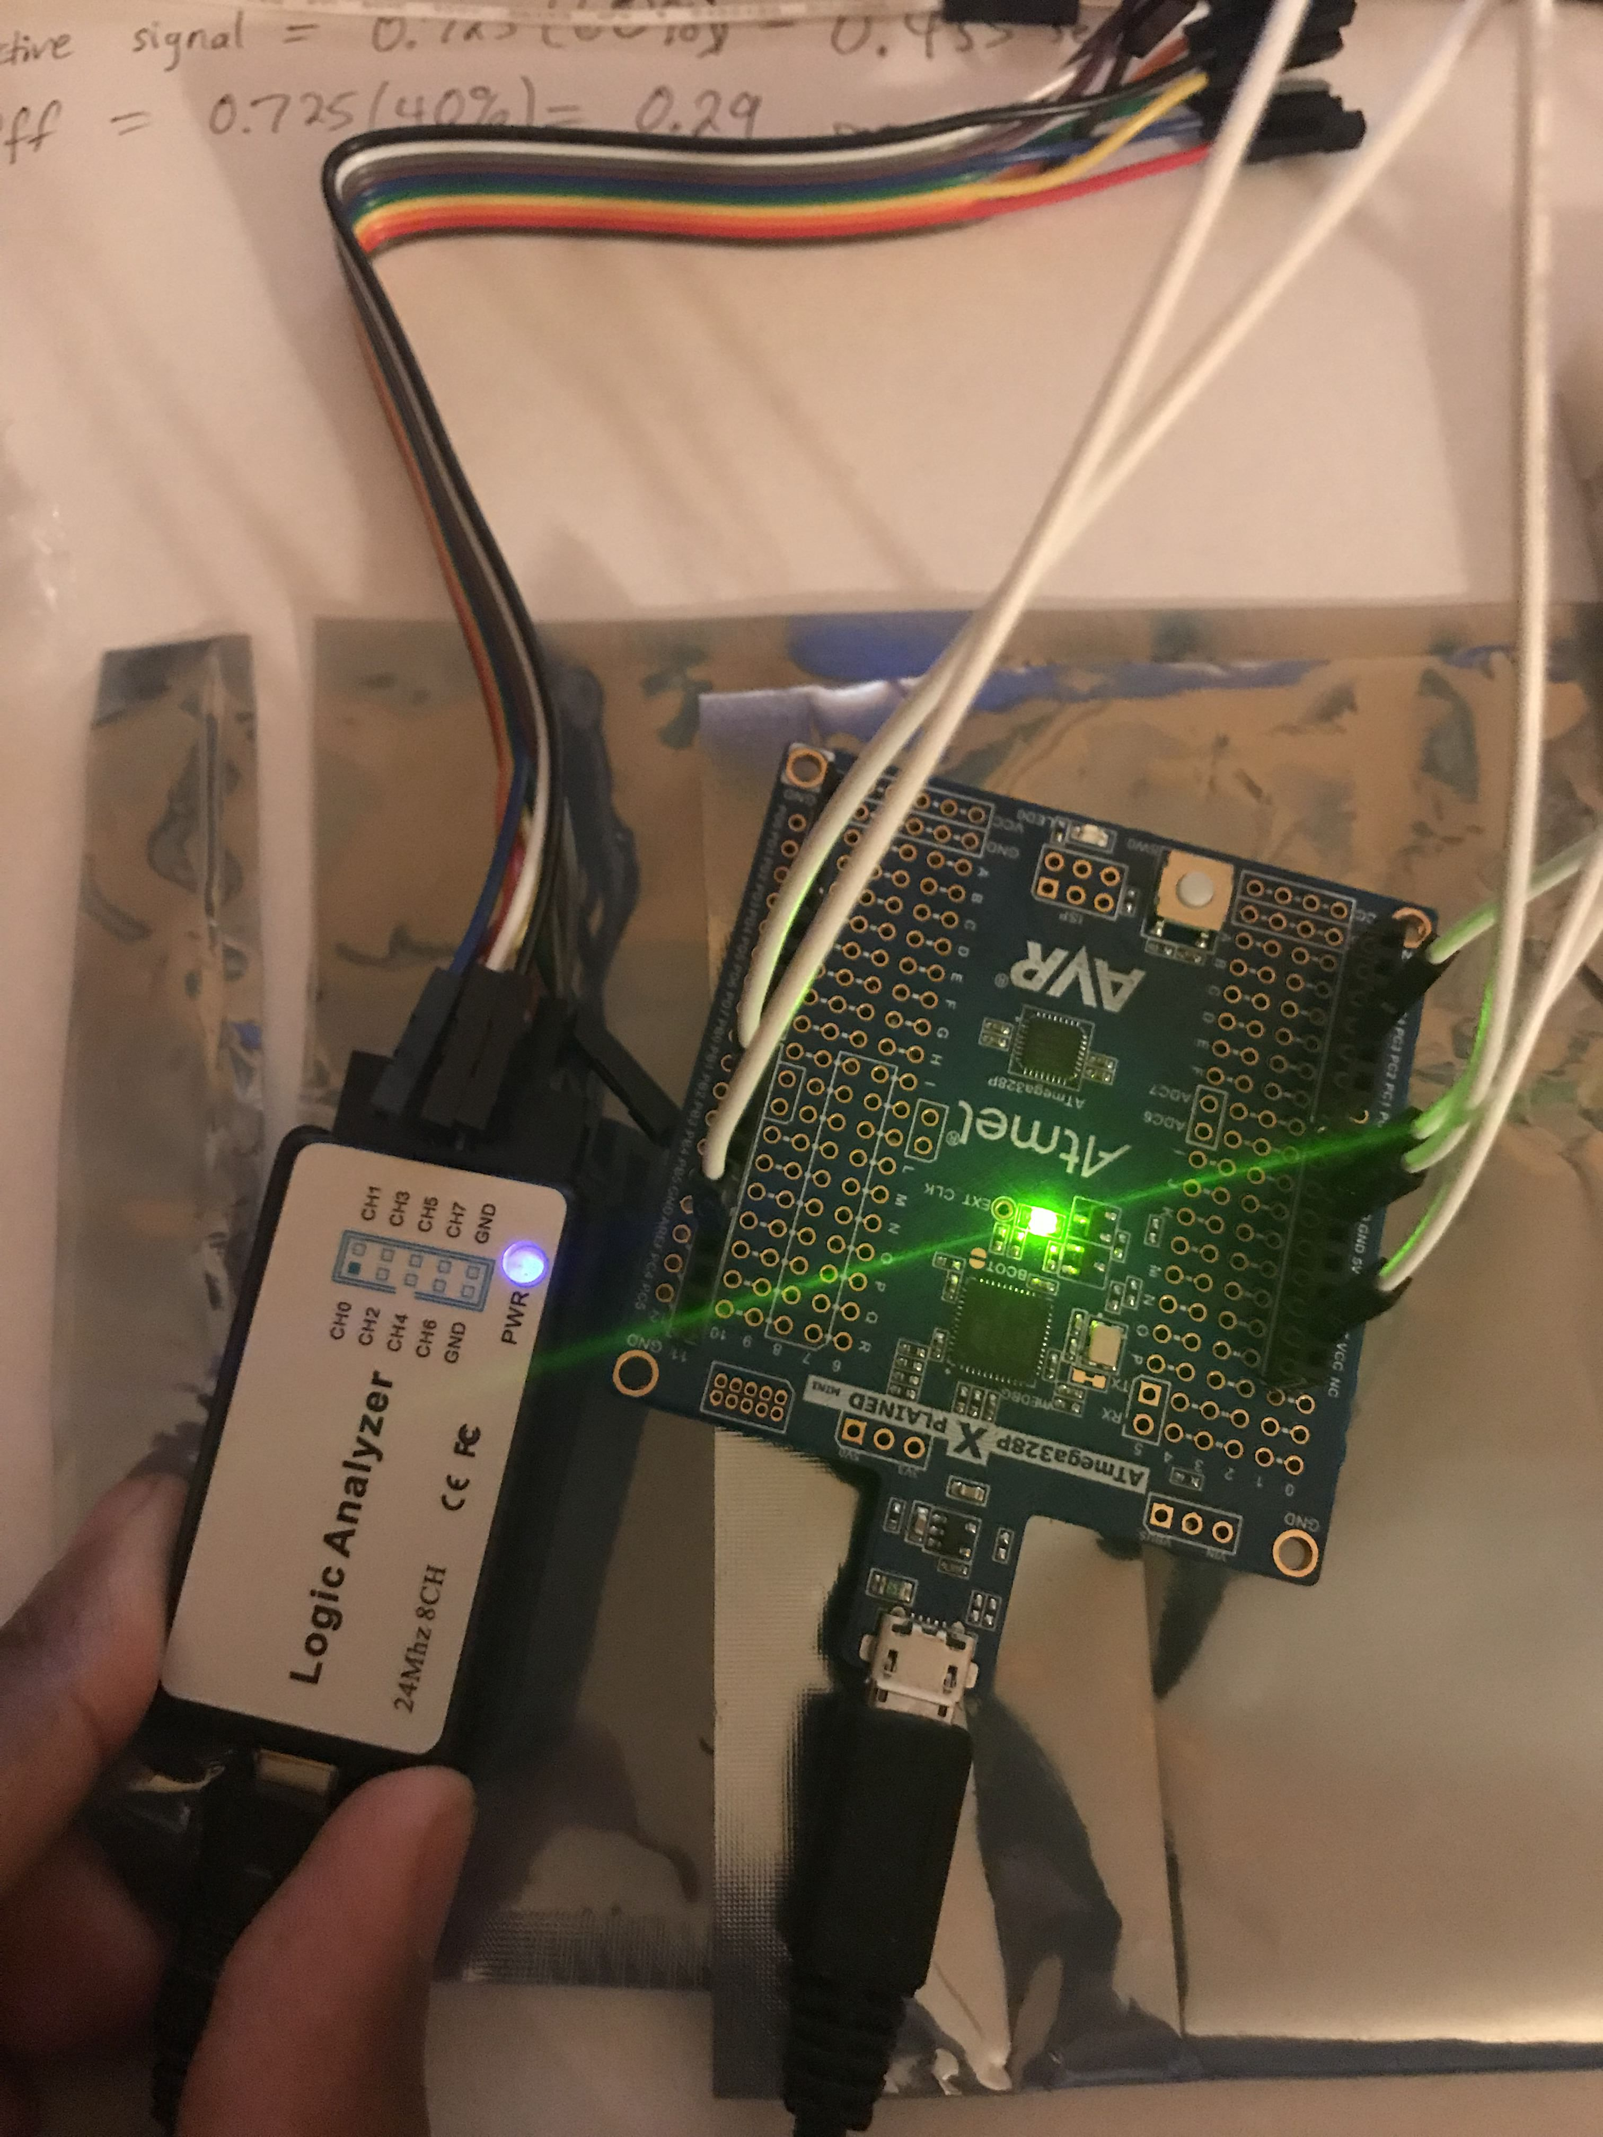

This shows the logic analyzer and the Atmega328P used for both Task 1 in C and assembly. This is what helps generate the waveforms for the output of the ports.

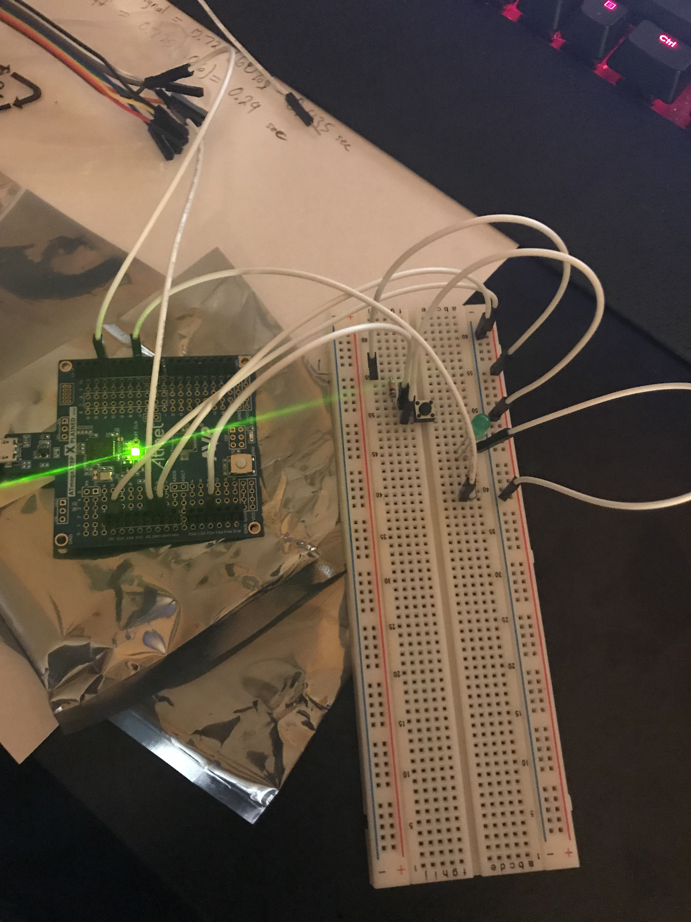

This shows the breadboard with the mini push-button switch and two resistors as well as the Atmega328P MCU. This setup is used for Task 2 for both assembly and C code.

1. **VIDEO LINKS OF EACH DEMO**

There is only one video for both tasks, but the video will highlight which task its currently showing.

https://youtu.be/VJevImRbkfM

1. **GITHUB LINK OF THIS DA**

https://github.com/Ber-geb/effective-octo-reaction

**Student Academic Misconduct Policy**

<http://studentconduct.unlv.edu/misconduct/policy.html>

“This assignment submission is my own, original work”.

Serak Gebremedhin